Agile Project Management Plan
Local Community Skill Exchange and Help Board
Group F | Syed Abdullah Maaz | Fahad Ahmed

Agile (Scrum) plan for building a community platform where neighbors post help requests and offers, match by location, chat, and rate each other. The project runs in 2 sprints of 2 weeks each.

Agile Sprint Diagram
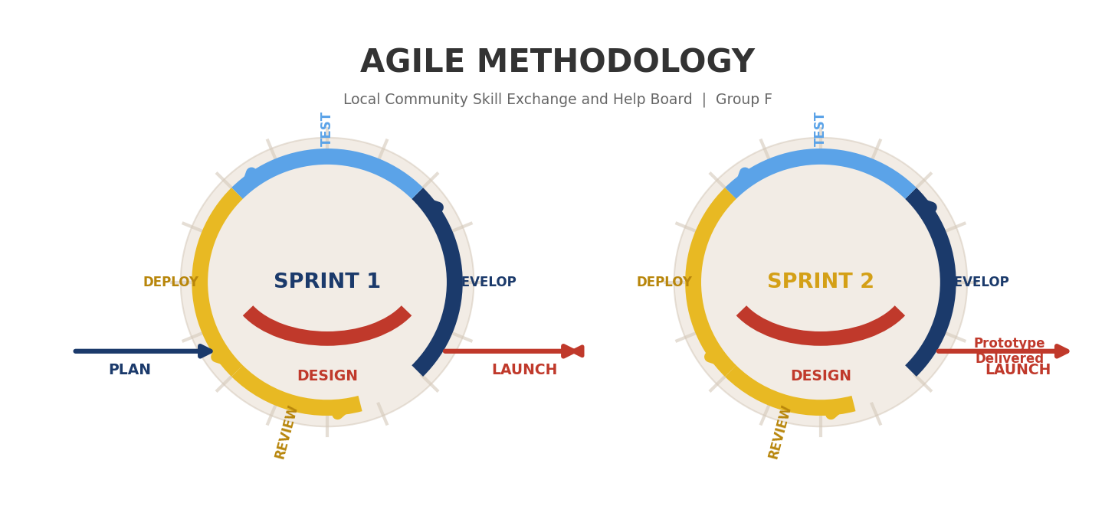

Sprint Summary
Sprint | Duration | Objective | Outcome
Sprint 1 | Week 1–2 | Set up project and build user accounts & listings | Users can register, create profiles, and post/browse help listings
Sprint 2 | Week 3–4 | Add search, chat, ratings, and deploy | Full working prototype with chat, ratings, and safety features

Sprint 1 — User Accounts & Listings
Tasks | Deliverables
Set up Django + PostgreSQL | Working dev environment
User registration & email verification | Members can sign up and log in
Profile page (skills, suburb, photo) | User profiles with basic info
Create and browse help listings | Post 'I need help' / 'I can help' listings
Admin moderation panel | Admin can manage users and posts
Unit tests (pytest-django) | 12 tests passing

Sprint 2 — Matching, Chat & Ratings
Tasks | Deliverables
Nearby search by suburb/postcode | Location-based listing filter
Real-time chat (Django Channels + Redis) | Matched users can chat live
Rating and review system | Star ratings shown on profiles
Report and block user features | Safety controls for the community
Email match notifications | Users notified of new matches
Integration testing & deployment | 18 tests passing, prototype live

Activity Log & Progress Updates
Week | Sprint | Activity | Status
Week 1 | Sprint 1 | Sprint planning, project setup, user auth | Done
Week 2 | Sprint 1 | Profiles, listings, admin panel, unit tests | Done
Week 2 | Sprint 1 | Sprint review & retrospective | Done
Week 3 | Sprint 2 | Sprint planning, nearby search, chat setup | Done
Week 4 | Sprint 2 | Ratings, report/block, testing, deployment | Done
Week 4 | Sprint 2 | Sprint review & retrospective | Done

Sprint Reviews & Retrospectives
Sprint | Review (Demo) | Retrospective
Sprint 1 | Demo: register user, create profile, post listing, browse home page | Went well: clear task split, on-time delivery. Improve: create wireframes earlier
Sprint 2 | Demo: search nearby, chat live, leave rating, report user, deploy prototype | Went well: chat worked first try, all tests pass. Improve: allow more time for deployment

Final Outcome: A working prototype where users register, post and browse help listings, search nearby, chat in real time, leave ratings, and admins moderate content — ready for software engineering assessment.

