INSTITUTE OF INFORMATION TECHNOLOGY
JAHNGIRNAGAR UNIVERSITY
Savar,Dhaka-1320


Course Title: PROJECT SUPERVISION
Course Code: IT 300
Project Title: Personnel Maintenance System

Project Supervisor: Md. Fazlul Karim Patwary
Associate Professor
IIT, JU
Signature:

Submitted By:
Name Roll
1.Ahmed Abdal Shafi Rasel 837
2.Abu Sayed Islam 845
3. Md. Torikur rahman 861
4.Kazi Moinul Hossain 862
5.Syed Abdullah Maaz 2041
6.Md. Anwar Hossain 2237

Submission Date: 14th June,2012

Project dedication

To our →

BELOVED Parents & RESPECTED Teachers

ABSTARCT

This project named “Personnel Maintenance System” is used to keep maintenance of all the needed information of a company’s employees. The project is written in JAVA programming language. We have used the Jframe form from the Swing GUI forms. The project provides Admin with the privilege to Update or, Delete information of employees. The others may inquire for a certain ID. The code is connected to Database system for information storage. The project will be helpful in maintaining a personnel database for a typical company.

INDEX
Serial No. | Contents | Page No.
01 | Introduction
02 | Methodology
03 | Requirement
04 | Flowchart
05 | Code and Code Analysis
06 | Screen Shot
07 | Future Plan
08 | Conclusion
09 | Reference

Introduction

Today’s business companies are much more sophisticated in terms of their maintenance of their financial and personnel information. That’s why the need for using software based maintenance system has increased. In this project as beginners in JAVA language we have provided with a project that would be helpful in maintenance system of a general company.
This project provides database management of information. We can keep all the needed information like ID no,name,age,contact name,designation etc. Only admins are given the privilege to Update or, Delete from a person’s information. The accessibility is also password protected. This project includes three main type of operations: Insertion of a new employee’s information, Inquiry of stored employee, Update/Deletion of a employee’s information. As the project is made using Jframe form of JAVA, it is also quite flexible to modify for certain purpose.

Methodology

The project is completed through some well planned methodological steps. The fundamental steps are given below:
1.Requirements analysis and definitions: The project’s service, constraints and goals are established by consultations of system’s core users.
2.Algorithm and Flowchart formation: The project’s main outline is then made formal by creating algorithms and flowcharts.
3.Subdividing project by modules: As a group project the project is then subdivided and each project member is asked finalize his assignment.
4.Implementation as a whole: After the required work had been done, the project is implemented as whole and edited for any further improvement.
5.Documentation: Given all the required steps being completed the project is documented for presentation and the project report is made complete.

In the whole process we have been assisted by our teachers especially our project supervisor.

Requirements

1.Java Compiler(Netbeans/eclipse)
2.Database Editor
3.Java Virtual Machine

Start
FLOWCHART

WelcomeScreen

If admin
If others
If exit

No Yes No

Yes
Login/Admin
Login/Others

Yes Yes
If (ID & Passwords match)
If(ID matches)

No No

choice
Inquiry

END
If inquiry
If updel
If insert
If exit

inquiry
Update/delete
insert

Code and Code Analysis

public class WelcomeScreen
public class WelcomeScreen extends javax.swing.JFrame {// Creates new form WelcomeScreen
public WelcomeScreen() { //WelcomeScreen method
setTitle("Welcome Screen"); //Screen title
initComponents(); //initializes components
}
private void adminButtonActionPerformed(java.awt.event.ActionEvent evt) {
// TODO add your handling code here:
if(evt.getSource()==adminButton){
loginforadmin log=new loginforadmin();
log.setVisible(true); //show loginforadmin
}
setVisible(false); //hide previous frame
}

private void othersButtonActionPerformed(java.awt.event.ActionEvent evt) {
// TODO add your handling code here:
if(evt.getSource()==othersButton){
Query qr=new Query();
qr.setVisible(true); //show Query
} //othersButton activator
setVisible(false); //hide previous frame
}

private void exitButtonActionPerformed(java.awt.event.ActionEvent evt) {
// TODO add your handling code here:
if(evt.getSource()==exitButton){
System.exit(0);
} //exitButton activator
}
public static void main(String args[]) { //main method
java.awt.EventQueue.invokeLater(new Runnable() { //Screen runner
public void run() {
new WelcomeScreen().setVisible(true);
}
});
}
// Variables declaration
private javax.swing.JButton adminButton;
private javax.swing.JButton exitButton;
private javax.swing.JLabel jLabel1;
private javax.swing.JButton othersButton;
// End of variables declaration
}

Public class loginforadmin

import javax.swing.JOptionPane; //For creating different message dialogue
public class loginforadmin extends javax.swing.JFrame { //Creates new form loginforadmin
String name="Moinul"; //Define administrator name
String password="admin"; //Define pasword
public loginforadmin() { //loginforadmin method
setTitle("Get Loggedin"); //Screen title
initComponents(); //Initializes components
}
private String String(String text) { //String method
throw new UnsupportedOperationException("Not yet implemented") //Exception handlingprinter
}
private void nameTextActionPerformed(java.awt.event.ActionEvent evt) {
// TODO add your handling code here:
nameText.setText(""); //set name in textfield
}

private void lginButtonActionPerformed(java.awt.event.ActionEvent evt) {
// TODO add your handling code here:
if (evt.getSource() == lginButton) {
try {
if (name.equals(nameText.getText()) && password.equals(passText.getText())) {
Options opt = new Options();
opt.setVisible(true); //show Options screen
} //lginButton activator
else {
JOptionPane.showMessageDialog(null, "Incorrcet Combination of user name and password.Please try again", "Warning Message", JOptionPane.WARNING_MESSAGE);
} //Message dialogue printer
}
catch (Exception x) { //Exception handling
System.out.println("Exception" + x);
}
}
setVisible(false); //hide previous frame
}

private void bckButtonActionPerformed(java.awt.event.ActionEvent evt) {
// TODO add your handling code here:
if(evt.getSource()==bckButton){
WelcomeScreen wc=new WelcomeScreen();
wc.setVisible(true);
} //bckbutton activator
setVisible(false); //hide previous frame
}

private void passTextActionPerformed(java.awt.event.ActionEvent evt) {
// TODO add your handling code here:
passText.setText(""); //set password in textfield
}
public static void main(String args[]) { //main method
java.awt.EventQueue.invokeLater(new Runnable() { //Screen Runner
public void run() {
new loginforadmin().setVisible(true);
}
});
}

// Variables declaration
private javax.swing.JButton bckButton;
private javax.swing.JLabel jLabel1;
private javax.swing.JLabel jLabel2;
private javax.swing.JLabel jLabel3;
private javax.swing.JButton lginButton;
private javax.swing.JTextField nameText;
private javax.swing.JPasswordField passText;
// End of variables declaration
}
public class Query

import java.awt.Component; //Demonstrate label
import java.sql.Connection; //For database connection
import java.sql.DriverManager; //For loading driver manager
import java.sql.PreparedStatement; //For loading statements into database
import java.sql.ResultSet; //For Loading results into database
import java.sql.SQLException; //Database exception handler
import java.util.logging.Level; //For handling database exception
import java.util.logging.Logger; //same task
import javax.swing.JOptionPane; //For different message dialogue

public class Query extends javax.swing.JFrame { // Creates new form Query
private Component jframe;
public Query() { //Query method
initComponents(); //initializes component
}
private void lginButtonActionPerformed(java.awt.event.ActionEvent evt) {
// TODO add your handling code here:
int id=Integer.parseInt(this.idField.getText());
if(evt.getSource()==lginButton){
Connection conection=null; //For implementing database
try {
try {
// TODO add your handling code here:
Class.forName("sun.jdbc.odbc.JdbcOdbcDriver"); //Specifying driver
} catch (ClassNotFoundException ex) { //Exception handler
Logger.getLogger(MainScreen.class.getName()).log(Level.SEVERE, null, ex);
}
// connect to database
java.sql.Connection connection = DriverManager.getConnection("jdbc:odbc:Ps" );

// create Statement to query database
java.sql.Statement stmt = connection.createStatement();
ResultSet resultSet = null;
PreparedStatement statement = connection.prepareStatement("SELECT * from persons where personnel_id = "+Integer.parseInt(idField.getText()));
resultSet = statement.executeQuery();
if (resultSet.next()) {
MainScreen ms=new MainScreen();
ms.setVisible(true);
} //lginButton activator
else{
JOptionPane.showMessageDialog(null,"No match found"); //Message dialogue
}
} catch (SQLException ex) { //database exception handler
Logger.getLogger(MainScreen.class.getName()).log(Level.SEVERE, null, ex);
}
}
}

private void bckButtonActionPerformed(java.awt.event.ActionEvent evt) {
// TODO add your handling code here:
if (evt.getSource() == bckButton) {
WelcomeScreen wc = new WelcomeScreen();
wc.setVisible(true); //Show WelcomeScreen
} //bckButton activator
setVisible(false); //Hide previous frame
}
public static void main(String args[]) { //main method
java.awt.EventQueue.invokeLater(new Runnable() { //Screen runner
public void run() {
new Query().setVisible(true);
}
});
}

// Variables declaration
private javax.swing.JButton bckButton;
private javax.swing.JPasswordField idField;
private javax.swing.JLabel jLabel1;
private javax.swing.JLabel jLabel2;
private javax.swing.JButton lginButton;
// End of variables declaration
}
public class Options

import java.awt.event.WindowAdapter; //For adapting radio buttons
import java.awt.event.WindowEvent; //For activating radio buttons
import javax.swing.ButtonGroup; //For creating radio buttons
import javax.swing.JOptionPane; //For different message dialogue
public class Options extends javax.swing.JFrame { // Creates new form Options
public Options() { //Options method
setTitle("OPTIONS"); //Screen title
initComponents(); //initializes components
}
private void newentryButtonActionPerformed(java.awt.event.ActionEvent evt) {
// TODO add your handling code here:
if(newentryButton.isSelected()){
NewEntry nen=new NewEntry();
nen.setVisible(true); //Show NewEntry
} //newentryButton activator
setVisible(false); //Hide Previous frame
}

private void inquiryButtonActionPerformed(java.awt.event.ActionEvent evt) {
// TODO add your handling code here:
if(inquiryButton.isSelected()){
MainScreen ms=new MainScreen();
ms.setVisible(true); //show MainScreen
} //inquiryButton activator
setVisible(false); //Hide Previous frame
}

private void backButtonActionPerformed(java.awt.event.ActionEvent evt) {
// TODO add your handling code here:
if(evt.getSource()==backButton){
loginforadmin lgin=new loginforadmin();
lgin.setVisible(true); //show loginforadmin
} //backButton activator
setVisible(false); //Hide Previous frame
}

private void cancelButtonActionPerformed(java.awt.event.ActionEvent evt) {
// TODO add your handling code here:
if(evt.getSource()==cancelButton){
System.exit(0);
} //canceButton activator
setVisible(false); //Hide Previous frame
}

private void updelButtonActionPerformed(java.awt.event.ActionEvent evt) {
// TODO add your handling code here:
if(updelButton.isSelected()){
updel up=new updel();
up.setVisible(true); //show updel
} //updelButton activator
setVisible(false); //Hide Previous frame

}
public static void main(String args[]) { //main method
java.awt.EventQueue.invokeLater(new Runnable() { //Screen runner
public void run() {
new Options().setVisible(true);
}
});
}

// Variables declaration
private javax.swing.JButton backButton;
private javax.swing.JButton cancelButton;
private javax.swing.JRadioButton inquiryButton;
private javax.swing.JLabel jLabel1;
private javax.swing.JRadioButton newentryButton;
private javax.swing.JRadioButton updelButton;
// End of variables declaration
}
public class NewEntry

import java.awt.Component; //For demonstrating label
import java.beans.Statement; //For beans statements
import java.sql.Connection; //For connecting database
import java.sql.DriverManager; //For specifying driver manager
import javax.swing.JOptionPane; //For different message dialogue
import javax.swing.SwingConstants; //For creating swingconstants
import javax.swing.JFrame; //For creating new jframe
public class NewEntry extends javax.swing.JFrame {
private Component jframe; // Creates new form NewEntry
public NewEntry() { //NewEntry method
setTitle("New Info Inserter"); //Screen title
initComponents(); //initializes components
}
private void submitButtonActionPerformed(java.awt.event.ActionEvent evt) {
// TODO add your handling code here:
if (evt.getSource() == submitButton) { // Confirm addition of information to database
int choice = JOptionPane.showConfirmDialog(jframe,"Add this information to the database?","Persons",JOptionPane.YES_NO_OPTION); //message dialogue
// If YES
if(choice == JOptionPane.YES_OPTION) {
try { // load database driver class
Class.forName( "sun.jdbc.odbc.JdbcOdbcDriver");

// connect to database
java.sql.Connection connection = DriverManager.getConnection("jdbc:odbc:Ps" );

// create Statement to query database
java.sql.Statement statement = connection.createStatement();
// Add new acount to Master table
java.sql.Statement stmt = connection.createStatement();
stmt.executeUpdate( //Insertion of new data into database
"INSERT INTO persons(first_name,last_name,middle_name,nickname,gender,maritalstatus,age,address,res_phone_no,off_phone_no,cell_number,email_address,company_name,dept_name)VALUES "+"('"

+firstnameText.getText()
+"','"+lastnameText.getText()
+"','"+middlenameText.getText()
+"','"+nicknameText.getText()
+"','"+genderText.getText()
+"','"+maritalstatusText.getText()
+"','"+ageText.getText()
+"','"+addressText.getText()
+"','"+res_phone_noText.getText()
+"','"+off_phone_noText.getText()
+"','"+cell_numberText.getText()
+"','"+email_addressText.getText()
+"','"+company_nameText.getText()
+"','"+dptnameText.getText()
+"')");

JOptionPane.showMessageDialog(null,"Data Entered into Database Successfully");
firstnameText.setText("");
lastnameText.setText("");
middlenameText.setText("");
nicknameText.setText("");
genderText.setText("");
maritalstatusText.setText("");
ageText.setText("");
addressText.setText("");
res_phone_noText.setText("");
off_phone_noText.setText("");
cell_numberText.setText("");
email_addressText.setText("");
company_nameText.setText("");
dptnameText.setText("");
//clearing all textfields
statement.close(); // Close statement
connection.close(); // Close connection
} // end try
// detect problems interacting with the database
catch ( java.sql.SQLException sqlException ) {
JOptionPane.showMessageDialog( null, sqlException.getMessage(), "Database Error",
JOptionPane.ERROR_MESSAGE ); //message dialogue
System.exit( 1 );
}
catch ( ClassNotFoundException classNotFound ) { //Exception handling JOptionPane.showMessageDialog( null, classNotFound.getMessage(), "Driver Not Found",
JOptionPane.ERROR_MESSAGE ); //message dialogue
System.exit( 1 );
}
}
// If NO
else{
firstnameText.setText("");
lastnameText.setText("");
middlenameText.setText("");
nicknameText.setText("");
genderText.setText("");
maritalstatusText.setText("");
ageText.setText("");
addressText.setText("");
res_phone_noText.setText("");
off_phone_noText.setText("");
cell_numberText.setText("");
email_addressText.setText("");
company_nameText.setText("");
dptnameText.setText("");
}
}
}
private void clearButtonActionPerformed(java.awt.event.ActionEvent evt) {
// TODO add your handling code here
if(evt.getSource()==clearButton){
firstnameText.setText("");
lastnameText.setText("");
middlenameText.setText("");
nicknameText.setText("");
genderText.setText("");
maritalstatusText.setText("");
ageText.setText("");
addressText.setText("");
res_phone_noText.setText("");
off_phone_noText.setText("");
cell_numberText.setText("");
email_addressText.setText("");
company_nameText.setText("");
dptnameText.setText("");
//clearing all textfields
}
}

private void cancelButtonActionPerformed(java.awt.event.ActionEvent evt) {
// TODO add your handling code here:
if(evt.getSource()==cancelButton){
System.exit(0);
} //cancelButton activator
}
private void backButtonActionPerformed(java.awt.event.ActionEvent evt) {
// TODO add your handling code here:
if(evt.getSource()==backButton){
Options opt=new Options();
opt.setVisible(true); //Show Options
} //backButton activator
setVisible(false); //Hide frame
}
public static void main(String args[]) { //main method
java.awt.EventQueue.invokeLater(new Runnable() { //Screen runner
public void run() {
new NewEntry().setVisible(true);
}
});
}
// Variables declaration - do not modify
private javax.swing.JTextField addressText;
private javax.swing.JTextField ageText;
private javax.swing.JButton backButton;
private javax.swing.JButton cancelButton;
private javax.swing.JTextField cell_numberText;
private javax.swing.JButton clearButton;
private javax.swing.JTextField company_nameText;
private javax.swing.JTextField dptnameText;
private javax.swing.JTextField email_addressText;
private javax.swing.JTextField firstnameText;
private javax.swing.JTextField genderText;
private javax.swing.JLabel jLabel1;
private javax.swing.JLabel jLabel10;
private javax.swing.JLabel jLabel11;
private javax.swing.JLabel jLabel12;
private javax.swing.JLabel jLabel13;
private javax.swing.JLabel jLabel14;
private javax.swing.JLabel jLabel16;
private javax.swing.JLabel jLabel2;
private javax.swing.JLabel jLabel3;
private javax.swing.JLabel jLabel4;
private javax.swing.JLabel jLabel5;
private javax.swing.JLabel jLabel6;
private javax.swing.JLabel jLabel7;
private javax.swing.JLabel jLabel8;
private javax.swing.JLabel jLabel9;
private javax.swing.JTextField lastnameText;
private javax.swing.JTextField maritalstatusText;
private javax.swing.JTextField middlenameText;
private javax.swing.JTextField nicknameText;
private javax.swing.JTextField off_phone_noText;
private javax.swing.JTextField res_phone_noText;
private javax.swing.JButton submitButton;
// End of variables declaration
}
public class updel

import java.awt.Component; //For demonstrating label
import java.beans.Statement; //For beans statements
import java.sql.Connection; //For connecting database
import java.sql.DriverManager; //For specifying driver manager
import java.sql.PreparedStatement; //For loading statements into database
import java.sql.ResultSet; //For Loading results into database
import java.sql.SQLException; //Database exception handler
import java.util.logging.Level; //For handling database exception
import java.util.logging.Logger; //same task
import javax.swing.JOptionPane; //For different message dialogue
import javax.swing.SwingConstants; //For creating swingconstants
import javax.swing.JFrame; //For creating new jframe
public class updel extends javax.swing.JFrame { //Creates new form updel
private int id;
private Component jframe;
public updel() { //updel method
initComponents(); //initialize components
}
private void bckButtonActionPerformed(java.awt.event.ActionEvent evt) {
// TODO add your handling code here:
if (evt.getSource() == bckButton) {
Options opt = new Options();
opt.setVisible(true); //Show Options
} //bckButton activator
setVisible(false); //Hide previous frame
}
private void showButtonActionPerformed(java.awt.event.ActionEvent evt) {
// TODO add your handling code here:
id = Integer.parseInt(this.idText.getText());
if (evt.getSource() == showButton) {
Connection conection = null;
try {
try {
// TODO add your handling code here:
Class.forName("sun.jdbc.odbc.JdbcOdbcDriver"); //Specifying driver
} catch (ClassNotFoundException ex) { //Exception handler
Logger.getLogger(MainScreen.class.getName()).log(Level.SEVERE, null, ex);
}
// connect to database
java.sql.Connection connection = DriverManager.getConnection("jdbc:odbc:Ps");
// create Statement to query database
java.sql.Statement stmt = connection.createStatement();
ResultSet resultSet = null;
PreparedStatement statement = connection.prepareStatement("SELECT * from persons where personnel_id = " + Integer.parseInt(idText.getText()));
resultSet = statement.executeQuery();
if (resultSet.next()) { //collecting informations from created database
firstnameText.setText(resultSet.getString(2));
lastnameText.setText(resultSet.getString(3));
middlenameText.setText(resultSet.getString(4));
nicknameText.setText(resultSet.getString(5));
genderText.setText(resultSet.getString(6));
maritalstatusText.setText(resultSet.getString(7));
ageText.setText(resultSet.getString(8));
addressText.setText(resultSet.getString(9));
res_phone_noText.setText(resultSet.getString(10));
off_phone_noText.setText(resultSet.getString(11));
cell_numberText.setText(resultSet.getString(12));
email_addressText.setText(resultSet.getString(13));
company_nameText.setText(resultSet.getString(14));
dptnameText.setText(resultSet.getString(15));
} else {
JOptionPane.showMessageDialog(null, "No data found"); //Message dialogue
}
} catch (SQLException ex) { //database exception handler
Logger.getLogger(MainScreen.class.getName()).log(Level.SEVERE, null, ex);
}
}
}
private void cancelButtonActionPerformed(java.awt.event.ActionEvent evt) {
// TODO add your handling code here:
if (evt.getSource() == cancelButton) {
System.exit(0);
} //cancelButton activator
}
private void clearButtonActionPerformed(java.awt.event.ActionEvent evt) {
// TODO add your handling code here:
if (evt.getSource() == clearButton) { //Clearing all the textfields
firstnameText.setText("");
lastnameText.setText("");
middlenameText.setText("");
nicknameText.setText("");
genderText.setText("");
maritalstatusText.setText("");
ageText.setText("");
addressText.setText("");
res_phone_noText.setText("");
off_phone_noText.setText("");
cell_numberText.setText("");
email_addressText.setText("");
company_nameText.setText("");
dptnameText.setText("");
}
}

private void updatebuttonActionPerformed(java.awt.event.ActionEvent evt) {
// TODO add your handling code here:
if (evt.getSource() == updatebutton) {
//Confirm addition of information to database
int choice = JOptionPane.showConfirmDialog(jframe, "Update this information to the database?", "persons", JOptionPane.YES_NO_OPTION); //Message dialogue

// If YES
if (choice == JOptionPane.YES_OPTION) {
try {
// load database driver class
Class.forName("sun.jdbc.odbc.JdbcOdbcDriver");
// connect to database
java.sql.Connection connection = DriverManager.getConnection("jdbc:odbc:Ps");
// create Statement to query database
java.sql.Statement stmt = connection.createStatement();
//Update of existing information
stmt.executeUpdate(" UPDATE persons SET "
+ "first_name = '" + firstnameText.getText() + "',"
+ "last_name = '" + lastnameText.getText() + "',"
+ "middle_name = '" + middlenameText.getText() + "',"
+ "nickname= '" + nicknameText.getText() + "',"
+ "gender= '" + genderText.getText() + "',"
+ "maritalstatus='" + maritalstatusText.getText() + "',"
+ "age = '" + ageText.getText() + "',"
+ "address = '" + addressText.getText() + "',"
+ "res_phone_no= '" + res_phone_noText.getText() + "',"
+ "off_phone_no= '" + off_phone_noText.getText() + "',"
+ "cell_number= '" + cell_numberText.getText() + "',"
+ "email_address= '" + email_addressText.getText() + "',"
+ "company_name= '" + company_nameText.getText() + "',"
+ "dept_name= '" + dptnameText.getText() + "'"
+ "WHERE personnel_ID = " + idText.getText().toString());
JOptionPane.showMessageDialog(null, "Data Updated into Database Successfully");
stmt.close();
connection.close(); // Close connection
setVisible(true); // Hide frame
} //updateButton activator
// end try
// detect problems interacting with the database
catch (java.sql.SQLException sqlException) {
JOptionPane.showMessageDialog(null,
sqlException.getMessage(), "Database Error",
JOptionPane.ERROR_MESSAGE); //Message dialogue
System.exit(1);
} catch (ClassNotFoundException classNotFound) { //Exception handler
JOptionPane.showMessageDialog(null,
classNotFound.getMessage(), "Driver Not Found",
JOptionPane.ERROR_MESSAGE);
System.exit(1);
}
} // If NO
else { //Clearing all text fields
idText.setText("");
firstnameText.setText("");
lastnameText.setText("");
middlenameText.setText("");
nicknameText.setText("");
genderText.setText("");
maritalstatusText.setText("");
ageText.setText("");
addressText.setText("");
res_phone_noText.setText("");
off_phone_noText.setText("");
cell_numberText.setText("");
email_addressText.setText("");
company_nameText.setText("");
dptnameText.setText("");
setVisible(false); // Hide Frame
}
}
}
private void delbuttonActionPerformed(java.awt.event.ActionEvent evt) {
// TODO add your handling code here:
if(evt.getSource()==delbutton){
int choice = JOptionPane.showConfirmDialog(jframe,"delete this information to the database?","Student Information",JOptionPane.YES_NO_OPTION);//Message dialogue
// If YES
if(choice == JOptionPane.YES_OPTION)
{
try {
// load MS Access driver
Class.forName("sun.jdbc.odbc.JdbcOdbcDriver");
// Setup connection to DBMS
Connection conn = DriverManager.getConnection("jdbc:odbc:Ps");
// Create statement
java.sql.Statement stmt = conn.createStatement();
stmt.executeUpdate("DELETE FROM persons "+
" WHERE personnel_ID = " + idText.getText().toString());//Deletion from database JOptionPane.showMessageDialog(null,"Data Deleted from Database Successfully");
//Clearing all text fields
idText.setText("");
firstnameText.setText("");
lastnameText.setText("");
middlenameText.setText("");
nicknameText.setText("");
genderText.setText("");
maritalstatusText.setText("");
ageText.setText("");
addressText.setText("");
res_phone_noText.setText("");
off_phone_noText.setText("");
cell_numberText.setText("");
email_addressText.setText("");
company_nameText.setText("");
dptnameText.setText("");
stmt.close();
conn.close();

} catch (SQLException ex) { //Database exception handler
JOptionPane.showMessageDialog( null, ex.getMessage(), "Database Error",
JOptionPane.ERROR_MESSAGE );
Logger.getLogger(updel.class.getName()).log(Level.SEVERE, null, ex);
} catch (ClassNotFoundException ex) { //Exception handler
Logger.getLogger(updel.class.getName()).log(Level.SEVERE, null, ex);
}
}
}
}
public static void main(String args[]) { //main method
java.awt.EventQueue.invokeLater(new Runnable() { //Screen runner
public void run() {
new updel().setVisible(true);
}
});
}
// Variables declaration - do not modify
private javax.swing.JTextField addressText;
private javax.swing.JTextField ageText;
private javax.swing.JButton bckButton;
private javax.swing.JButton cancelButton;
private javax.swing.JTextField cell_numberText;
private javax.swing.JButton clearButton;
private javax.swing.JTextField company_nameText;
private javax.swing.JButton delbutton;
private javax.swing.JTextField dptnameText;
private javax.swing.JTextField email_addressText;
private javax.swing.JTextField firstnameText;
private javax.swing.JTextField genderText;
private javax.swing.JTextField idText;
private javax.swing.JLabel jLabel10;
private javax.swing.JLabel jLabel11;
private javax.swing.JLabel jLabel12;
private javax.swing.JLabel jLabel13;
private javax.swing.JLabel jLabel14;
private javax.swing.JLabel jLabel15;
private javax.swing.JLabel jLabel16;
private javax.swing.JLabel jLabel2;
private javax.swing.JLabel jLabel3;
private javax.swing.JLabel jLabel4;
private javax.swing.JLabel jLabel5;
private javax.swing.JLabel jLabel6;
private javax.swing.JLabel jLabel7;
private javax.swing.JLabel jLabel8;
private javax.swing.JLabel jLabel9;
private javax.swing.JTextField lastnameText;
private javax.swing.JTextField maritalstatusText;
private javax.swing.JTextField middlenameText;
private javax.swing.JTextField nicknameText;
private javax.swing.JTextField off_phone_noText;
private javax.swing.JTextField res_phone_noText;
private javax.swing.JButton showButton;
private javax.swing.JButton updatebutton;
// End of variables declaration
}
public class MainScreen

import java.sql.Connection; //For connecting database
import java.sql.DriverManager; //For specifying driver manager
import java.sql.PreparedStatement; //For loading statements into database
import java.sql.ResultSet; //For Loading results into database
import java.sql.SQLException; //Database exception handler
import java.util.logging.Level; //For handling database exception
import java.util.logging.Logger; //same task
import javax.swing.JOptionPane; //For different message dialogue

public class MainScreen extends javax.swing.JFrame { //Creates new form MainScreen
int id;
String sql = "";
public MainScreen() { //MainScreen method
setTitle("Provided Infos"); //Screen title
initComponents(); //initialize components
}
private void idTextActionPerformed(java.awt.event.ActionEvent evt) {
// TODO add your handling code here:
id=Integer.parseInt(this.idText.getText()); //id setting on textfield
}
private void showButtonActionPerformed(java.awt.event.ActionEvent evt) {
// TODO add your handling code here:
id=Integer.parseInt(this.idText.getText());
if(evt.getSource()==showButton){
Connection conection=null;
try {
try {// TODO add your handling code here:
Class.forName("sun.jdbc.odbc.JdbcOdbcDriver"); //Specifying driver
} catch (ClassNotFoundException ex) { //Exception handler
Logger.getLogger(MainScreen.class.getName()).log(Level.SEVERE, null, ex);
}

// connect to database
java.sql.Connection connection = DriverManager.getConnection("jdbc:odbc:Ps" );

// create Statement to query database
java.sql.Statement stmt = connection.createStatement();
ResultSet resultSet = null;

PreparedStatement statement = connection.prepareStatement("SELECT * from persons where personnel_id = "+Integer.parseInt(idText.getText()));
resultSet = statement.executeQuery();
if (resultSet.next()) { //collecting informations from created database
firstnameText.setText(resultSet.getString(2));
lastnameText.setText(resultSet.getString(3));
middlenameText.setText(resultSet.getString(4));
nicknameText.setText(resultSet.getString(5));
genderText.setText(resultSet.getString(6));
maritalstatusText.setText(resultSet.getString(7));
ageText.setText(resultSet.getString(8));
addressText.setText(resultSet.getString(9));
res_phone_noText.setText(resultSet.getString(10));
off_phone_noText.setText(resultSet.getString(11));
cell_numberText.setText(resultSet.getString(12));
email_addressText.setText(resultSet.getString(13));
company_nameText.setText(resultSet.getString(14));
dptnameText.setText(resultSet.getString(15));

} //showButton activator
else{
JOptionPane.showMessageDialog(null,"No data found"); //message dialogue
}
} catch (SQLException ex) { //database exception handler
Logger.getLogger(MainScreen.class.getName()).log(Level.SEVERE, null, ex);
}

}
}

private void bckButtonActionPerformed(java.awt.event.ActionEvent evt) {
// TODO add your handling code here:
if (evt.getSource() == bckButton) {
WelcomeScreen wc = new WelcomeScreen();
wc.setVisible(true); //show WelcomeScreen
}
setVisible(false); //Hied previous frame
} //bckButton activator

private void cancelButtonActionPerformed(java.awt.event.ActionEvent evt) {
// TODO add your handling code here:
if(evt.getSource()==cancelButton){
System.exit(0);
} //cancelButton activator
}

private void clearButtonActionPerformed(java.awt.event.ActionEvent evt) {
// TODO add your handling code here
firstnameText.setText("");
lastnameText.setText("");
middlenameText.setText("");
nicknameText.setText("");
genderText.setText("");
maritalstatusText.setText("");
ageText.setText("");
addressText.setText("");
res_phone_noText.setText("");
off_phone_noText.setText("");
cell_numberText.setText("");
email_addressText.setText("");
company_nameText.setText("");
dptnameText.setText("");
} //clearing all textfields
public static void main(String args[]) { //main method
java.awt.EventQueue.invokeLater(new Runnable() { //Screen runner
public void run() {
new MainScreen().setVisible(true);
}
});
}

// Variables declaration
private javax.swing.JTextField addressText;
private javax.swing.JTextField ageText;
private javax.swing.JButton bckButton;
private javax.swing.JButton cancelButton;
private javax.swing.JTextField cell_numberText;
private javax.swing.JButton clearButton;
private javax.swing.JTextField company_nameText;
private javax.swing.JTextField dptnameText;
private javax.swing.JTextField email_addressText;
private javax.swing.JTextField firstnameText;
private javax.swing.JTextField genderText;
private javax.swing.JTextField idText;
private javax.swing.JLabel jLabel1;
private javax.swing.JLabel jLabel10;
private javax.swing.JLabel jLabel11;
private javax.swing.JLabel jLabel12;
private javax.swing.JLabel jLabel13;
private javax.swing.JLabel jLabel14;
private javax.swing.JLabel jLabel15;
private javax.swing.JLabel jLabel16;
private javax.swing.JLabel jLabel2;
private javax.swing.JLabel jLabel3;
private javax.swing.JLabel jLabel4;
private javax.swing.JLabel jLabel5;
private javax.swing.JLabel jLabel6;
private javax.swing.JLabel jLabel7;
private javax.swing.JLabel jLabel8;
private javax.swing.JLabel jLabel9;
private javax.swing.JTextField lastnameText;
private javax.swing.JTextField maritalstatusText;
private javax.swing.JTextField middlenameText;
private javax.swing.JTextField nicknameText;
private javax.swing.JTextField off_phone_noText;
private javax.swing.JTextField res_phone_noText;
private javax.swing.JButton showButton;
// End of variables declaration }

SCREENSHOT:

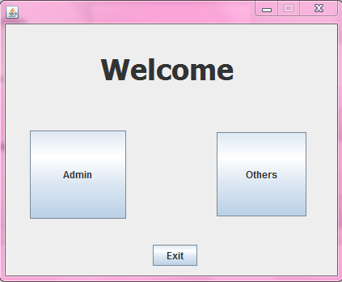

[FIG-1]
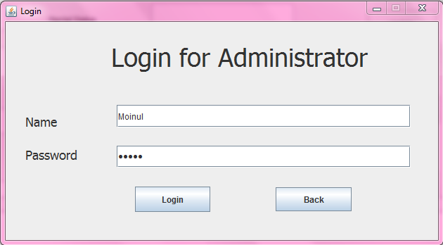
[FIG-2]
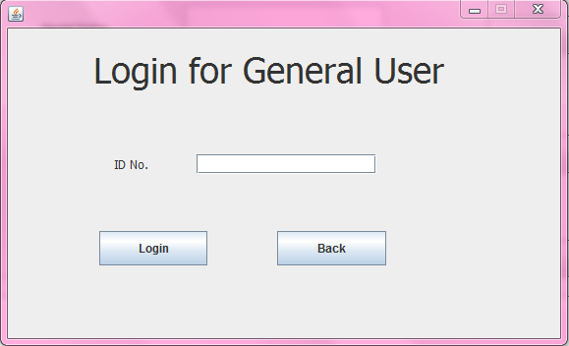
[FIG-3]

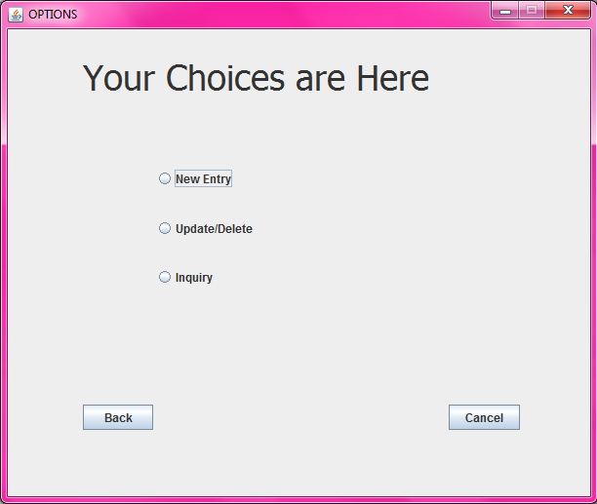
[FIG-4]
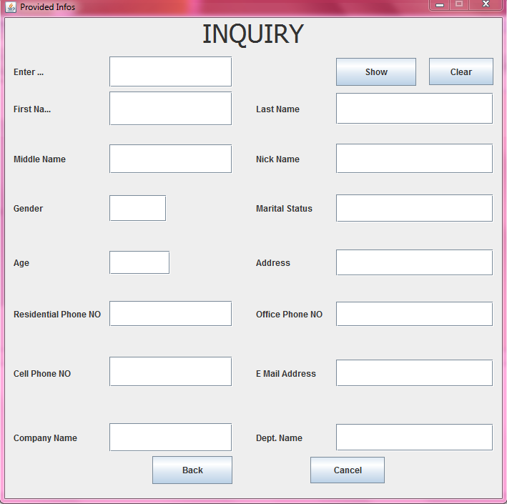

[FIG-5]

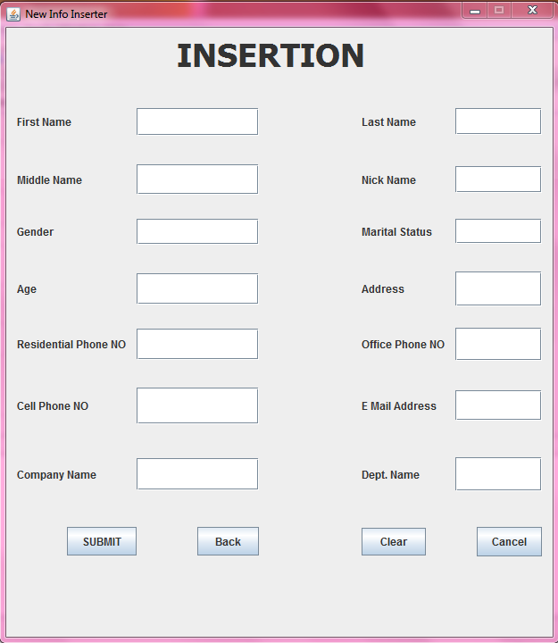

[FIG-6]

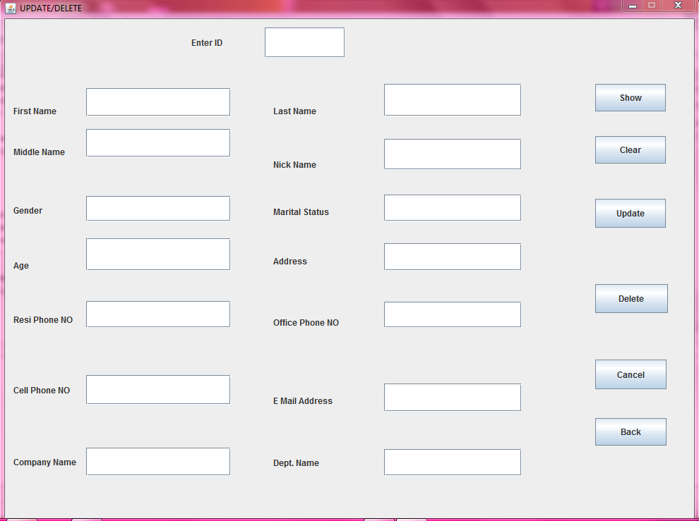

[FIG-7]

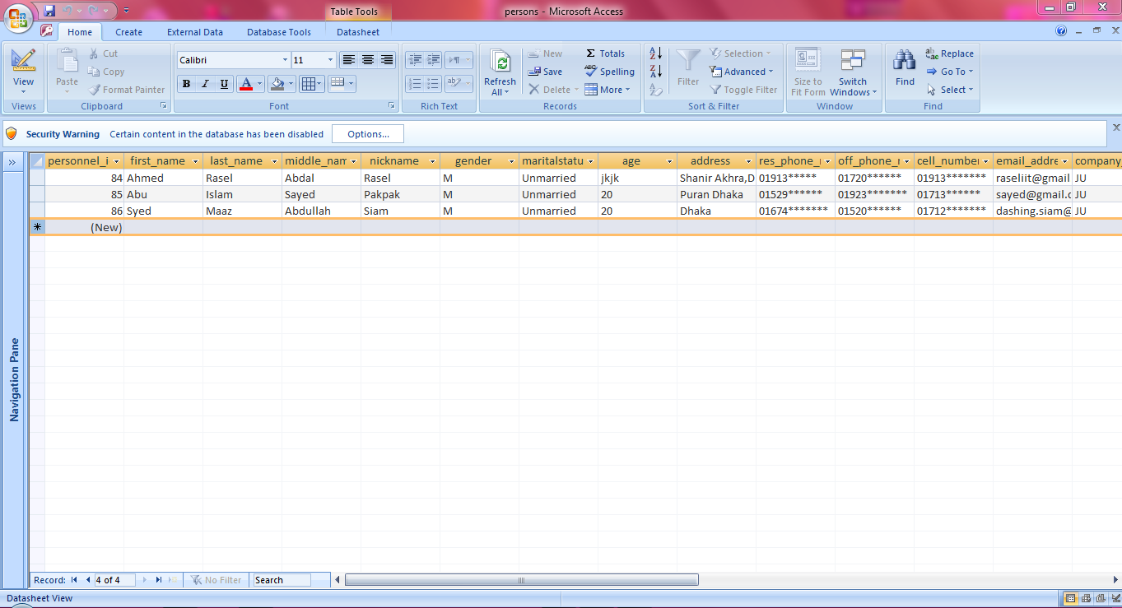
[FIG-8]

Future Plan

As beginners in JAVA language our project has some limitation which we wish to improve in our future. Some aspects that we want to improve are:

1.We can improve this maintenance system with more security measures.

2.We wish to include more personal information like identification picture ctc.

3.The personnel information could be classified as private information and public information.

Conclusion

JAVA is a great programming language that can make programming a lot of fun. All throughout the project it was a great experience of teamwork and enthusiasm. The programming project we made was the result of our co-operation. We also the thank our project supervisor for his support. The project may have some limitations.But the inspiration and motivation that is provided through this project will help us in near future to improve on what we have done. In the end we thank all related to the project for their support.

Reference

[A]Books:
[1] Schildt, H; “The Complete Reference Java”;(Seven Edition) .
[2] Ivor Hortons Beginning Java 2 (Fifth Edition ).
[3] Introduction to Algorithms (Third Edition).

[B]Websites:
[4] http://www.topcoder.com/tc Algorithm Tutorials:
Dynamic Programming: From novice to advanced
[6]http://www.google.com/java programming

