A PROJECT ON
DYNAMIC PROGRAMMING

This work is submitted to the Institute of Information Technology (IIT), Jahangirnagar University in partial fulfillment of the requirements for the 3rd Semester B.Sc. (Hons.) in Information Technology.

Submitted By
Shoma Khanom
Class Roll: 829
Exam Roll: 110351
Session: 2010-11
3rd Semester

Semester
Semester

Saoreen Rahman
Class Roll: 1333
Exam Roll: 110353
Session: 2010-11
3rd Semester

Nilufar Yeasmin
Class Roll: 1994
Exam Roll: 110344
Session: 2010-11
3rd Semester

Khadija Islam
Class Roll: 1995
Exam Roll: 110345
Session: 2010-11
3rd Semester

Dhonita Tripura
Class Roll: 2183
Exam Roll: 110347
Session: 2010-11
3rd Semester

Course No.: IT-300 (Project Work)

Supervised By

Shamim Al Mamun
Lecturer
Institute of Information Technology,
Jahangirnagar University,
Savar, Dhaka-1342, Bangladesh.

Institute of Information Technology
Jahangirnagar University
June 14, 2012

Index:
Topics | Page No.
1. Abstract ………………………….. | 01
2. Introduction……………................ | 01
3. Project organization……................ | 01
4. Methodology ……………………. | 02
5. Required functions………………. | 02
6. Code Description……………… | 04
7. . Code Analysis……………….. | 07
8. Screen shot………………… | 08
9. Future scope……………………… | 09
10. Conclusion……………………… | 11
11 Reference……………………….... | 11

1. Abstract:

The project aims at implementing a program using java language.The project demonstrates the creation of a user interface of a system, without the use of java package . Our program is a implementation of LCS(Longest Common Subsequence),Levenshtein Distance or Edit distance as well as finding out the Subsequence of a given sequence.These algorithms are designed and implemented on the basis of dynamic programming.

2. Introduction:

In the age of technology, computer is a wonderful creation. Now we can not imagine a single day without the help of computer. Computer is being used in many sectors like education, governance, business, science, technology, communication, entertainment etc.

Project motivation:

3. Project organization:
Given two not null strings s1 and s2;
We will Calculate:
i)A string SA that is the longest Common Subsequence of s1 and s2.
ii)A string SB that is the string of minimum length that contains both s1 and s2 as subsequence.
iii)Calculate the Levenshtein distance(defined later) of s1 and s2.

4. Methodology:
We will use dynamic programming to implement those algorithms. Because a naïve algorithm will cost exponential time complexity.
Suppose we have two not null strings s1 and s2;
Then we will Calculate:
i)A string SA that is the longest Common Subsequence of s1 and s2.
ii)A string SB that is the string of minimum length that contains both s1 and s2 as subsequence.
iii)Calculate the Levenshtein distance(Edit distance) of s1 and s2.
To evaluate the above Algorithms
i)At first we will find a recursive solution.
ii)Then we will show that it has overlapping sub problems that can be handled by memorization.

5. Required functions:

Jcreator compilar is used by us for the implementation of finding LCS & EDIT DISTANCE.MAIN class contains the main( ) method with some user-defined sub-functions under some java package java util; java io; java lang; java math. In the program four class have been used named as MAIN class,LCS class,EDIT class,SUBSEQUENCE class.Here all the classes contains some methods.
Classes and their functionalities:
Main Class:
Functionality:
- Defining main method and run the project
- Read Input fro the console
- Write output into file.

Methods Used:
i)Main method only.

Class Name : EDIT
Functionality
i) Find Levenshtein distance of the given strings
ii)Print the operations done on the first string.

Methods Used
i)rec(int,int) : executes the recurrent relation and memorizes the result.
ii)Findpath(int,int) :Print the operations needed to convert first string into second string.
iii)RUNEDIT(void) : Printing outputs and calling other functions.
iv)EDIT(String,String) : constructor of the class.

Class Name : LCS
Functionality
i)Find the length of the LCS of the given strings
ii)Print the LCS of the given string.
Methods Used
i)rec(int,int) : executes the recurrent relation and memorizes the result and thus finds the length of the LCS. Also stores the direction for finding the LCS.
ii)Findpath(int,int) :Print the LCS of the given strings.
iii)RUNLCS(void) : Printing outputs and calling other functions.
iv)LCS(String,String) : constructor of the class.

Class Name : SUBSEQUENCE
Functionality
i)Finding a string that has the minimum length and that contains both the given strings as subsequence.
ii)Finds the minimum length as well.
iii)Also show how many possible strings there could be for the given strings.
Methods Used
i)recure(int,int) : Finds the minimum length of our expected string.
ii)countways(String,int,int,int) Another recursive function that finds total number of solutions and memorize one of them.
iii)RUN_SUBSEQUENCE(void) : Printing outputs and calling other functions.
iv)SUBSEQUENCE(String,String) : constructor of the class.

7. Code Description
In this code “Three” operations have been done.
At first, ”Longest Common Subsequence(LCS)” has been find out.
Secondly, ”Edit Distance” has been find out.
At Last, “Common Subsequence” has been find out.
Here some package has been used named “import java.util.*”, “import java.io.*,” “import java.lang.*”,”import java.math.*”.
# import java.util.*: This package contains those classes, interfaces and their method whose characteristics are date, properties, vector etc. For example: AbstracCollection, Arrays, calendar, date, timer, vector and many more.
# import java.io.*:This package contains the basic function of a program. For example: compiler ,class, Character, package, System, Thread, Runtime and many more.
# import java.lang.*:This package contains those classes, interfaces and their methods which use input, output and file operations. For example: BufferedReader, CharArrayReader, DataInputStream, File, OutputStream, Writer and many more.
# import java.math.*: This package contains classes and method which support mathematical calculation.For example: double pow( ), long min( ), double sqrt( ) and many more.

# “main” Method:
In main class objects of three classes named LCS, Edit, Subsequence are created and have been called under try….catch method. All three are declared as public.
# LCS class:
Three methods have been used in this class. They are:
1.rec(int i, int j): In this method if the position of given strings I and j are at “0”, it returns 0 which is the base case.If I and j are already visited then the result of visited position are stored in dp[i][j].If the position are at (i-1) and (j-1) then it rec(i-1, j-1),otherwise it will return to Math.max(a,b);where a= rec(i, j-1) and b(i-1, j).
2.FINDPATH(int x, int y): This method has set the direction of LCS. If(x=0, y=0),it will return 0.For the position (i-1, j-1) the direction “2” has been set and for (i, j-1) and(j, i-1),the direction “1” has been set.
3.RUNLCS( ): This method print the resultant matrix and Direction for the given strings calling the other function.
# EDIT class:
In EDIT class three methods and a constructor EDIT(String x, String y) are also used. They are:
1.rec(int x, int y): This method mainly convert the 1st string to 2nd string using deletion, insertion, replacement operation. When the position i=0 it returns dp[i][j]=j and when j=0 it returns dp[i][j]=i; Here a=1+rec(i-1,j) for deletion,b=1+rec(i, j-1) for an insertion and c=value+rec(i-1, j-1) for substitution.
2.FINDPATH( int x, int y): In this method direction of EDIT are set.When an deletion occurs it returns dir[i][j]=1, for insertion is dir[i][j]=2 and when there is no change direction is dir[i][j]=3.
3.RUNEDIT( ): This method print the resultant and direction matrix for Edit Distance, Levenshtein Distance and sequence of operation for given input.

# SUBSEQUENCE class:
In this class two methods have been used. They are:
1.recure(int in1, int in2):
2.countways( String s, int cn, int in1,int in2) :
3.RUN_SUBSEQUENCE( ): This method is used to print the expected sequence length and one of the subsequence of given sequence.

8. Code Analysis:
Subsequence:
A subsequence is a sequence that can be derived from another sequence by deleting some elements without changing the order of the remaining elements. For example, the sequence <A,B,D> is a subsequence of <A,B,C,D,E,F>.But<A,D,B> is not because it breaks the order of the given sequence since D has come before C.
Common subsequence:
Given two sequences X and Y, a sequence G is said to be a common subsequence of X and Y, if G is a subsequence of both X and Y. For example, if
X=<A,B,C,D,E>
Y=<A,C,G,F,E>
Then a common subsequence of X and Y could be Z=<A,C>.
Longest common subsequence:
This would not be the longest common subsequence, since Z only has length 2, we have another subsequence ZL=<A,C,E> of length 3 and that is the LCS of X and Y.
X=<A,B,C,D,E>
Y=<A,C,G,F,E>
A common subsequence of X and Y could be
Z=<A,C>
And the longest common subsequence of X and Y could be
Zlcs=<A,C,E>
In this way here two strings ‘kitten’ and ‘sitting’ are inputed and find the resultant matrix for the strings, that is given below :
s i t t i n g
0 0 0 0 0 0 0 0
k 0 0 0 0 0 0 0 0
I 0 0 1 1 0 1 1 1
t 0 0 1 2 2 2 2 2
t 0 0 1 2 3 3 3 3
e 0 0 1 2 3 3 3 3
n 0 0 0 0 0 0 4 4
The Direction matrix for the give a strings:
s i t t i n g
0 0 0 0 0 0 0 0
k 0 1 1 1 1 1 1 1
i 0 1 2 1 0 2 1 1
t 0 1 0 2 2 1 1 1
t 0 1 0 2 2 1 1 1
e 0 1 0 0 0 1 1 1
n 0 0 0 0 0 0 2 1

The length of LCS is 4
And the Sequence is: I t t n
End of Longest Common Subsequence.

Levenshtein distance(Edit Distance):
The Levenshtein distance between two strings is defined as the minimum number of edits needed to transform one string into the other, with the allowable edit operations being insertion, deletion, or substitution (replacement) of a single character. It is named after Vladimir Levenshtein, who considered this distance in 1965.
Flollowing this process here is shown two strings ‘kitten’ and ‘sitting’ resultant matrix.
The Resultant matrix for the given strings:
s i t t i n g
0 1 2 3 4 5 6 7
k 1 1 2 3 4 5 6 7
i 2 2 1 2 3 4 5 6
t 3 3 2 1 2 3 4 5
t 4 4 3 2 1 2 3 4
e 5 5 4 3 2 2 3 4
n 6 6 5 4 3 3 2 3

The Direction matrix for the given strings:
In the derection matrix for three operation three different digits are used.
- 1 for Deletion operation.
- 2 for Insertion operation.
- 3 for Substitution or Replecement.

s i t t i n g
0 0 0 0 0 0 0 0
k 0 3 2 2 2 2 2 2
i 0 1 3 2 2 2 2 2
t 0 1 1 3 2 2 2 2
t 0 1 1 1 3 2 2 2
e 0 1 1 1 1 3 2 2
n 0 1 1 1 1 1 3 2

Levenshtein distance for given input is: 3
Sequence of Operations;
In the derection matrix when one character of a string match with the other character of another string no need to insert or delete operation that’s mean no change ,if don’t match replacement operation occurs, otherwise insert new character to delete the needed character. Here a table is given below to show the operation:-

k | s | Replace!!!
i | i | No change!!!
t | t | No change!!!
t | t | No change!!!
i | i | Replace!!!
e | n | No change!!!
n | g | Insert!!!

End of Levenshtein distance.
Finding Shortest Sequence of which Given Sequences are its Subsequence.
The expected sequence has length 9
There are 4 different solutions.
<ksitteing> is one of them.

9. Screen Shot:
Screen shot:9.1
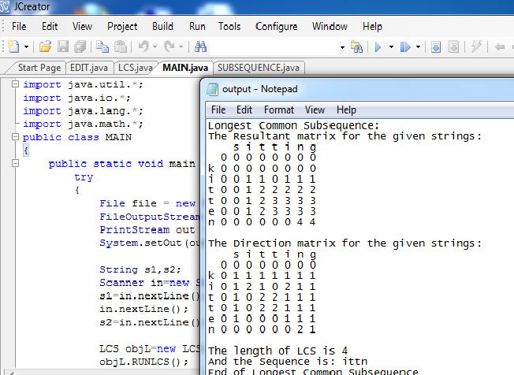

Screen shot:9.2
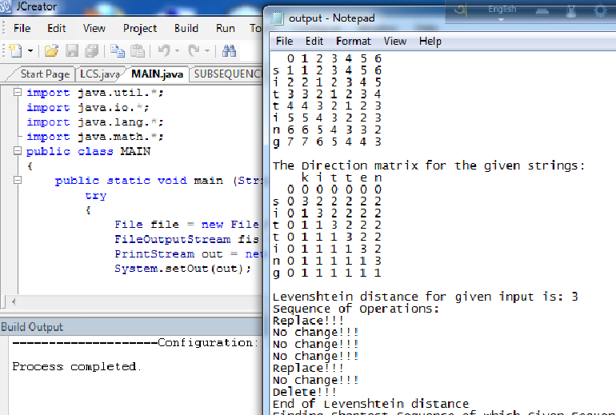

10. Conclusion:

Instead of some top-down or bottom up approach we have chose recursion with memorization technique to solve overlapping sub problems. Because, the recursive definition varies from problem to problem and it very hard to come up with an iterative solution always. Rather it is pretty easy to code once we get the recursive definition and the state of that problem and the base case that solves the basic sub problems.

11. Future scope:
- In mathematics finding LCS of two given sequence is often needed.
- In genetic engineering finding a DNA pattern from two or more DNA patterns LCS algorithm is used.
- Levenshtein distance is rapidly used as spell checker algorithm or to find closed word from a dictionary for a given word.

Reference:
[1] Schildt, H; “The Complete Reference Java”;(Seven Edition) .
[2] Ivor Hortons Beginning Java 2 (Fifth Edition ).
[3] Introduction to Algorithms (Third Edition).
[4] http://www.topcoder.com/tc Algorithm Tutorials:
Dynamic Programming: From novice to advanced
[5] www.wikipidia.org/

