Part 1 — Relative References

Q1. Calculate Sales
In the Sales column, calculate:
Units × Unit Price
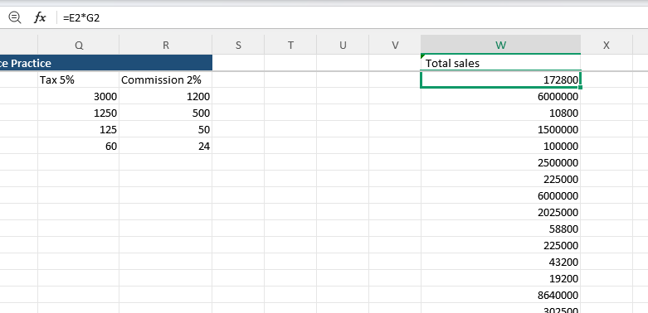

Q2. Create a new column called Sales After Discount
Assume every sale receives a 5% discount.
Calculate:
Sales − (Sales × 5%)
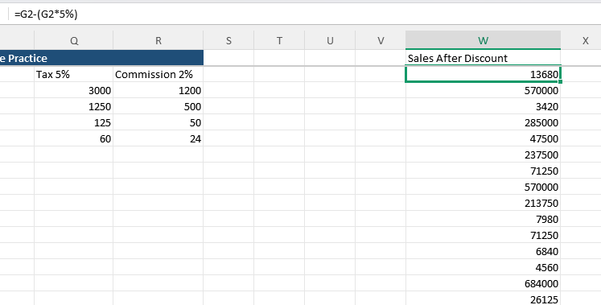

🟢 Part 2 — Absolute References

Q3. Tax Calculation
Use the Tax Rate from the Settings section.
Calculate:
Sales × Tax Rate
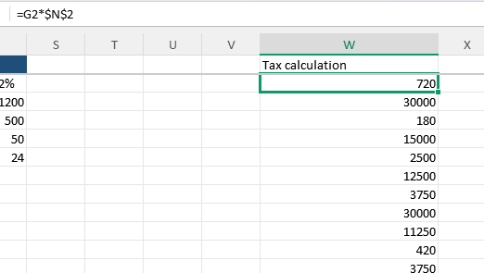

Q4. Commission Calculation
Use the Commission Rate from the Settings section.
Calculate:
Sales × Commission Rate
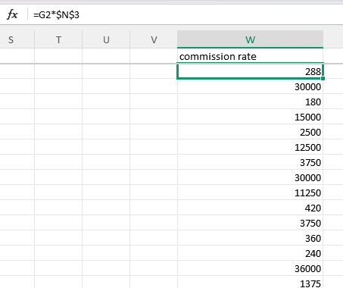

🟢 Part 3 — Basic Formulas
Create a Summary section.

Q5. SUM
Calculate:
- Total Units
- Total Sales
- Total Target
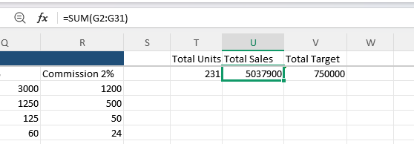

Q6. AVERAGE
Calculate:
- Average Units
- Average Sales
- Average Target
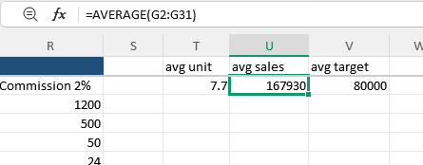

Q7. MIN
Find:
The lowest Sales value.
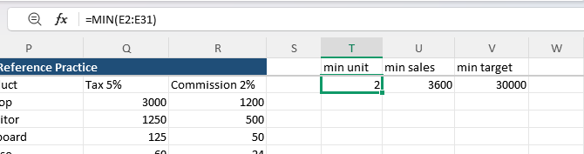

Q8. MAX
Find:
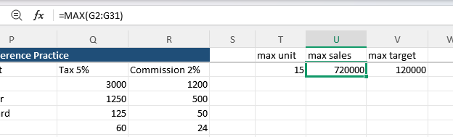

Q9. COUNT
Count:
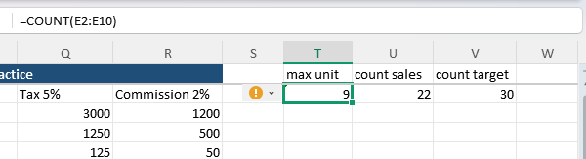

🟢 Part 4 — IF

Q10. Performance
Use the Performance column.
Rule:
If Sales >= Target → Achieved
Otherwise → Not Achieved
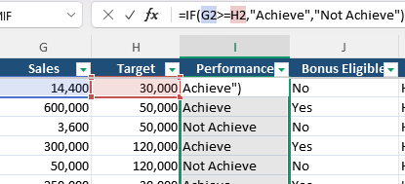

Q11. Sales Level
Create a new column called Sales Level.
Use these rules:
Sales | Result
>= 100,000 | Excellent
>= 50,000 | Good
< 50,000 | Needs Improvement
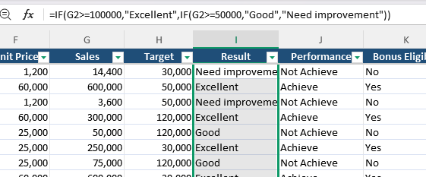

🟢 Part 5 — AND

Q12. Bonus Eligibility
An employee receives a bonus only when:
Sales >= Target AND Units >= 5
Return:
- Yes
- No
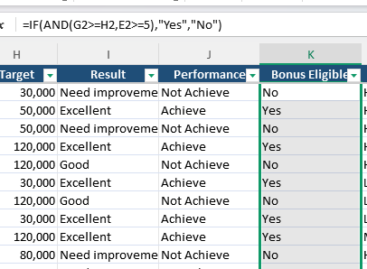

🟢 Part 6 — OR

Q13. Warning
Create a column called Warning.
An employee should receive a warning when:
Department = Support OR Priority = High
Return:
- Warning
- OK
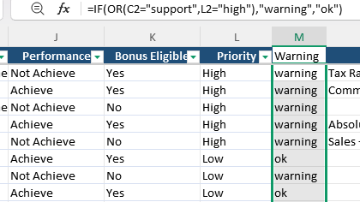

🟡 Part 7 — Sorting

Q14. Sort by Sales
Sort the dataset:
Highest Sales → Lowest Sales
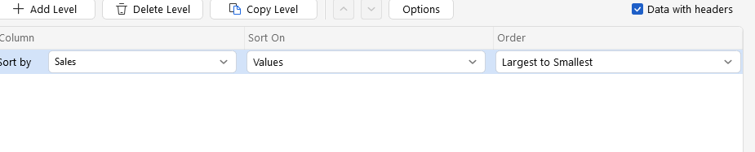
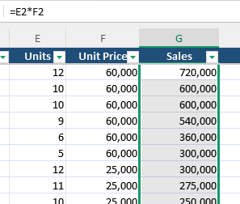

Q15. Sort by Employee
Sort:
Employee name A → Z
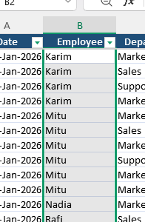

🟡 Part 8 — Filtering

Q16. Filter by Performance
Show only:
Achieved:How many employees achieved their target?
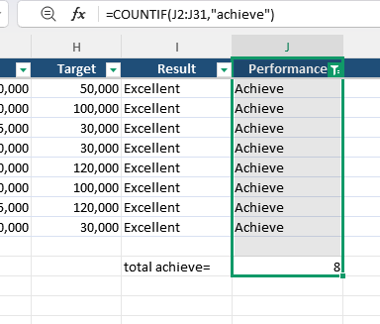

Q17. Filter by Product
Show only:
Laptop
Then identify the total number of Laptop sales records.
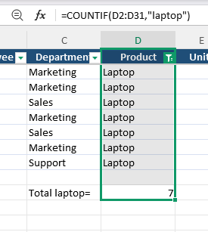

Q18. Multiple Filters
Show records where:
Department = Sales
AND
Performance = Achieved
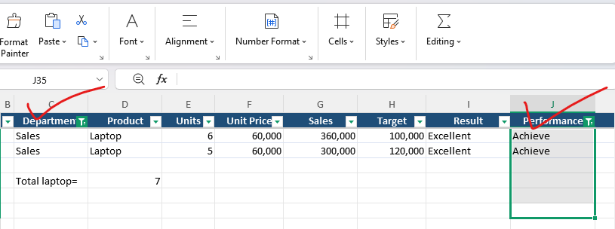

🟡 Part 9 — Excel Tables

Q19. Convert the dataset into an Excel Table
Make sure the table:
- Has headers
- Has filter buttons
- Has alternating row formatting
- Automatically expands when you add a new row
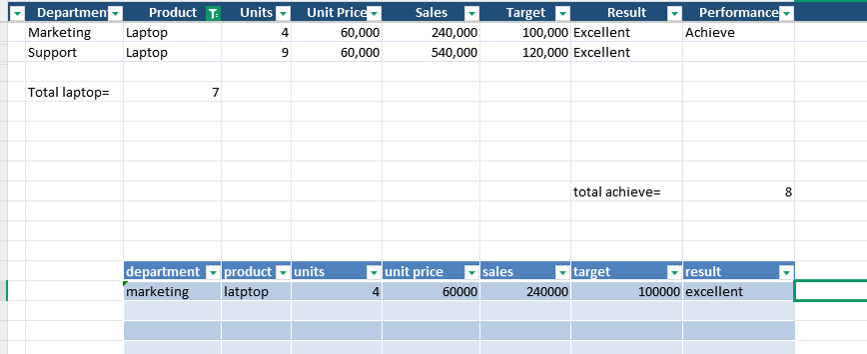

Create the Table
With the data selected:
Press Ctrl + T
A Create Table box will appear.

Then add one new sales record at the bottom.
Check whether the table automatically includes it.

🟡 Part 10 — Conditional Formatting

Q20. Highlight High Sales
Apply conditional formatting to Sales.
Rule:
Sales > 80,000
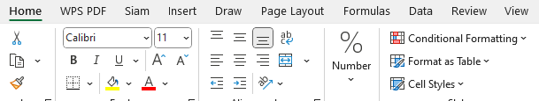

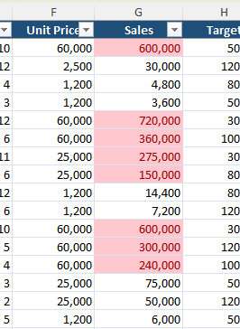

Q21. Highlight Low Sales
Apply another rule:
Sales < 50,000
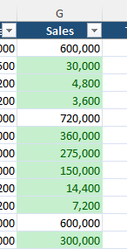

Q22. Highlight Performance
Format:
- Achieved
- Not Achieved
so they are visually easy to distinguish.
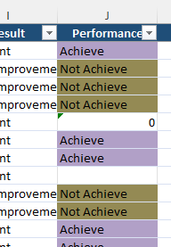

Q23. Highlight High Priority
Highlight rows where:
Priority = High
Challenge: Try to format the entire row, not just the Priority cell.
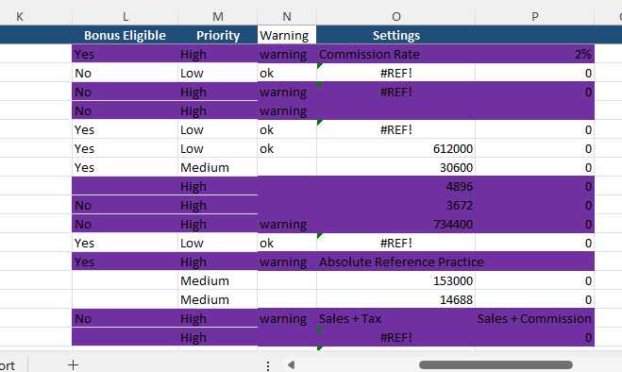

🟡 Part 11 — Data Validation

Q24. Priority Dropdown
For the Priority column, allow only:
High
Medium
Low
Users should select the value from a dropdown instead of typing it.
Not work properly

Q25. Create a Product Dropdown
Create a dropdown containing:
Laptop
Monitor
Keyboard
Mouse
Use it when entering a new record.
Not work properly.

🟡 Part 12 — Freeze Panes

Q26. Freeze the Header
Freeze the top row.
Then scroll down through the dataset.
The column headers should remain visible.
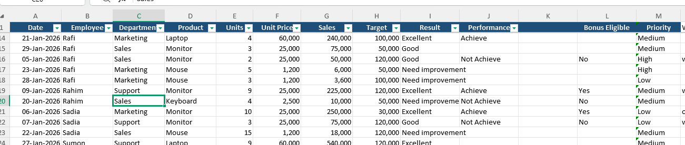

🟡 Part 13 — Worksheet Formatting

Q27. Make the worksheet professional
Format your Practice_Data sheet so that it is easy to read.
You should:
- Format dates properly
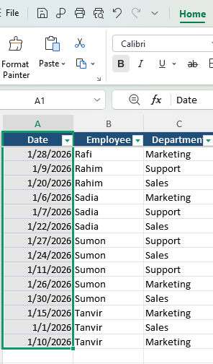
- Format prices/sales as numbers
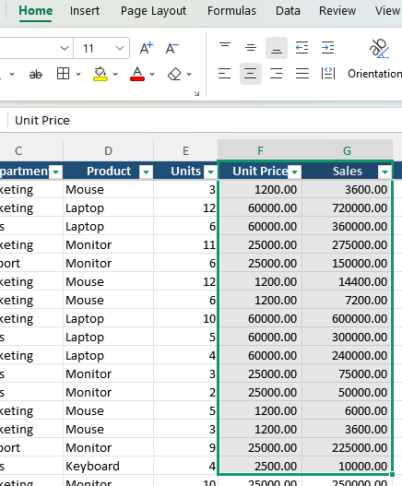
- Make headers clear
- Adjust column widths
- Use appropriate alignment
- Keep consistent formatting
- Remove unnecessary blank space

- Freeze the header row

Goal: Someone should be able to open the workbook and immediately understand the data.

🔵 Part 14 — Basic Charts

Q28. Sales by Employee
Create a Column Chart showing:
Employee vs Sales
Give it a meaningful title:
Sales Performance by Employee
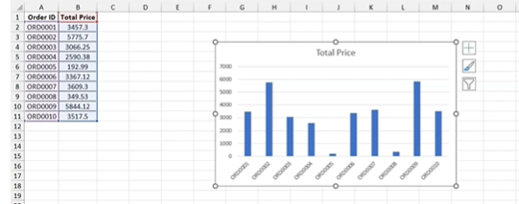

Q29. Product Sales
Create a summary showing:
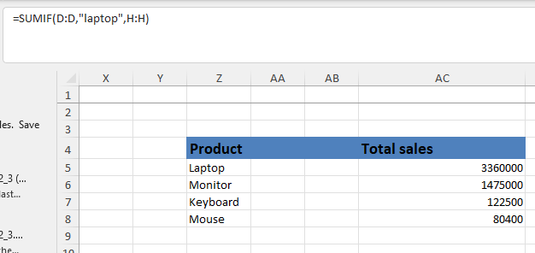
Then create a Bar Chart from this summary.
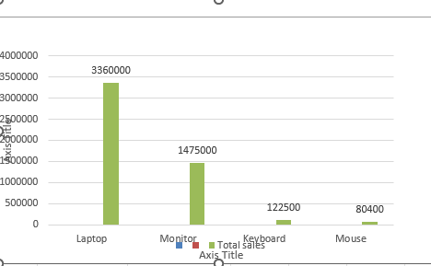

🔵 Part 15 — Final Report
Now create a new sheet called:

Final_Report
At the top, write:
SALES PERFORMANCE REPORT
Then create these KPI/summary values:
Metric | Value
Total Sales | ?
Average Sales | ?
Minimum Sales | ?
Maximum Sales | ?
Total Units | ?
Number of Sales Records | ?
Achieved Employees | ?
Then include:
