NEW SOFT CUBE
A Structural Compression Algebra
Definitions Theorems Proofs Encoders Benchmarks Failures and Research Boundary
Document status
Comprehensive technical synthesis of the NSC project through 18 August 2026 It distinguishes proved mathematics from numerical tests representational equivalence architectural hypotheses and unverified physical claims

Siamak
Independent Research
Version 1.0 | 18 August 2026

Abstract
New Soft Cube or NSC is a research program centered on structural and representational compression Its primitive object is a relational transformation Delta rather than a particle energy memory register or physical time In its finite dimensional linear realization a transformation is generated by a matrix G through U of Delta equal to exp of Delta G This compact form yields exact composition conservation determinant and two dimensional closure theorems under explicit assumptions
The same algebra can represent oscillatory optical propagation and hyperbolic one dimensional relativistic transport These are rigorous representations of known mathematics and physics They do not establish NSC as a new fundamental theory Synthetic benchmark work found strong compactness and sample efficiency in a hidden absorption task A public nanophotonics benchmark then exposed an important limit compact constrained exponential models compressed strongly but lost predictive fidelity while a less constrained polynomial surrogate performed well
This monograph consolidates the full formal core the radical Delta series the Möbius correction the optical and relativistic encoders the black hole and Higgs hypotheses the benchmark ledger the compression results and all important negative findings Its governing rule is that compression success cannot be restated as physical proof

1 Research Objective and Claim Taxonomy

1 1 Primary objective
The primary practical objective of NSC is to replace a larger description with a smaller reusable algebra while preserving the information required for a declared task Relevant resources include parameter count training samples computation time memory description length and the number of separate domain specific constructions
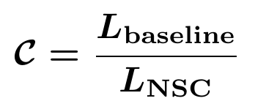
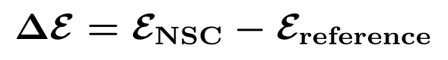
Compression and fidelity are separate axes A tiny model with poor blind accuracy is a compression result but an application failure A faithful model that is merely a renamed standard solver is representational equivalence but not a compression advantage

1 2 Four evidence levels
Label | Meaning | Permitted claim
MATH PROVED | Derived from definitions and stated axioms | Theorem within the declared representation
INTERNAL PASS | Independent numerical code reproduces the identity | Implementation consistency
REPRESENTATION | Known physics encoded and reconstructed | Equivalent formulation
BLIND EMPIRICAL | Frozen model predicts hidden data | Evidence within the tested domain
HYPOTHESIS | Encoder decoder or physical identification is missing | Research proposal only

Hard boundary
No result in this document establishes that Delta is the unique primitive of nature No laboratory validation universal physics Higgs mechanism black hole solution dark matter model or fundamental status for NSC has been established

2 Genealogy of the Model
The earlier Soft Cube phase used both R and Delta as organizing symbols The canonical radical brick was R equal to square root two plus square root three Later auditing removed R from the primitive layer In NSC version 0.1 Delta became the primitive relational transformation and R remained only an emergent calibration reference
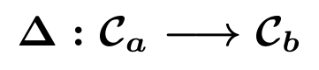
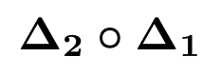
- Delta is not assumed to be a particle charge energy memory address or ordinary message carrier
- No independent history register is assumed Past information survives only through present correlations
- The evolution parameter is initially relational and is not identified with physical time without an encoder
- Noncommutativity is allowed when the underlying transformations are genuinely ordered It is not mandatory

3 Linear Generator Realization

3 1 Axioms
Let V be a finite dimensional vector space This is a modeling assumption rather than an ontological statement Let G be a linear generator and Delta a scalar relational step
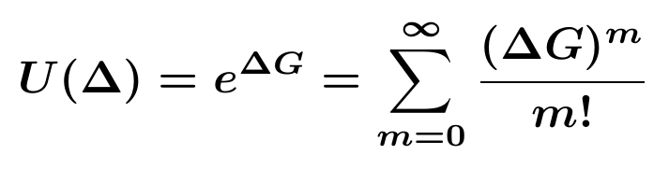
For conservation statements let H be a nondegenerate Hermitian or bilinear form If finite dimensionality linearity or exponential representation is removed the following results do not automatically survive

3 2 Composition theorem
The proof follows because scalar multiples of the same generator commute For distinct generators the corresponding equality requires commutation or an explicitly path ordered product
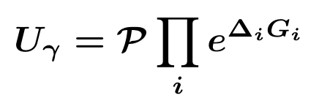

3 3 Invariant form theorem
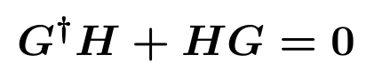
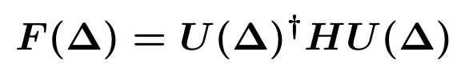
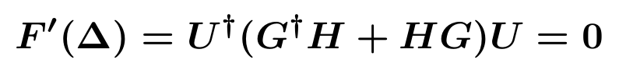
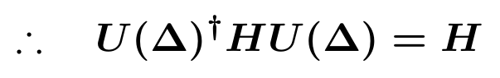
This proof is exact and does not depend on numerical approximation It is conditional on the existence of the selected form H and on the generator condition

3 4 Determinant theorem
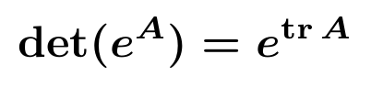
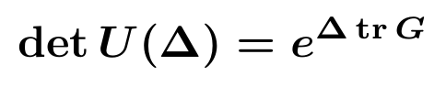
A trace free generator therefore produces a unit determinant transformation

4 Exact Two Dimensional Closure
For a trace free two by two generator
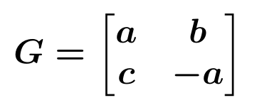
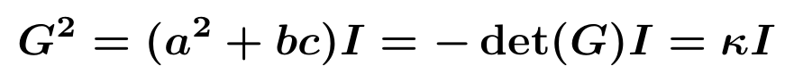
Every higher power collapses to a linear combination of I and G The exponential therefore has three exact classes
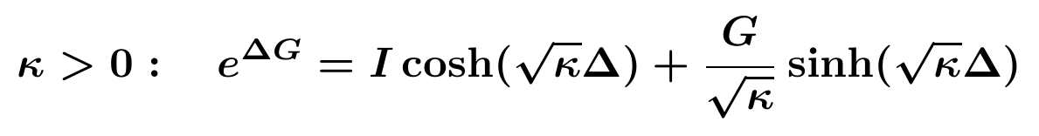
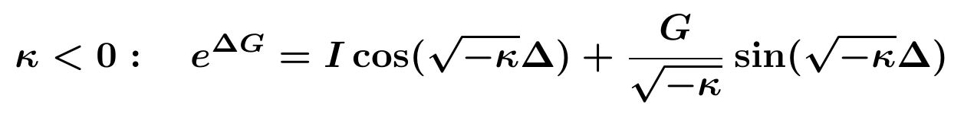
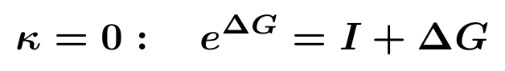
Central mathematical observation
Oscillatory and hyperbolic transport are sign classes of the same two dimensional trace free generator theorem This unifies their representation but does not prove that the physical systems share a new underlying substance

5 Order Noncommutativity and Holonomy

5 1 Weak order law
For two generators A and B and a small parameter epsilon the Baker Campbell Hausdorff expansion gives
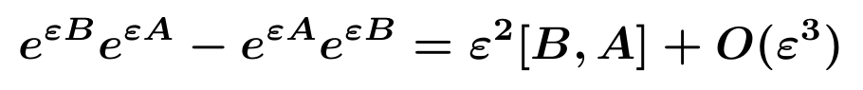
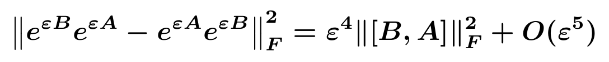
The power four appears because a second order amplitude difference is squared It is a known Lie algebra consequence and not an independent physical law discovered by NSC If the commutator vanishes the difference is exactly zero

5 2 Holonomy diagnostic
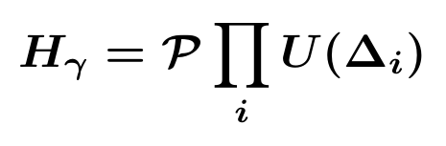
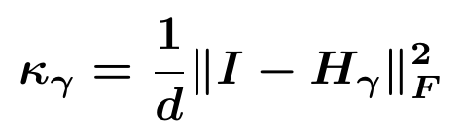
Holonomy is a candidate summary of path dependent relational history Its capacity injectivity and decodability have not been proved It cannot yet replace an explicit record R in general
COMPUTATIONAL CHECK The formal verification suite passed 16 of 16 identities The measured weak order exponent was 3.9970759368 The commuting null maximum was 5.18 × 10⁻³¹

6 Layered Optics

6 1 Optical generator
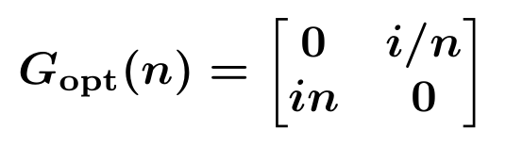
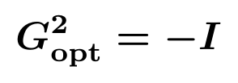
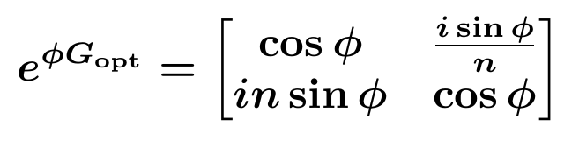
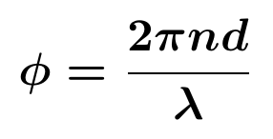
This is exactly the characteristic matrix of a homogeneous optical layer at normal incidence For a stack of layers the state matrix is the ordered product
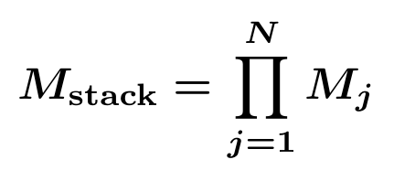
For incident index n0 and substrate index ns with M entries a b c d
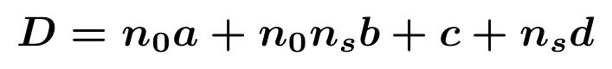
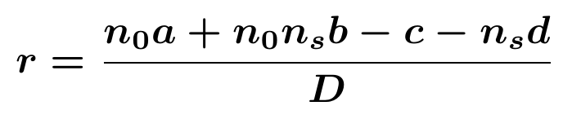
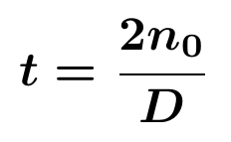
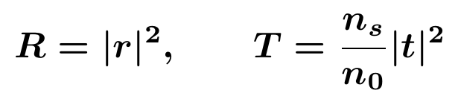

6 2 Exact status
The implemented NSC optics encoder calls the same layer matrix as the standard transfer matrix method NSC composition is the same ordered product and its decoder is the same reflectance and transmittance calculation Exact agreement is therefore established as representational equivalence
Not a new optical proof
The current implementation does not show that NSC is computationally lighter than a specialized transfer matrix solver It proves that the NSC language can reproduce that solver exactly

6 3 Benchmark sequence A1 through W8
Stage | Verdict | Meaning
A1 v0.1 | FAIL | Weak scale protocol defect
A1 v0.2 | PASS | Representational equivalence only
W1 | PASS | Physics informed representation advantage
W2 v0.1 | FAIL | Local minimum
W2 v0.2 | INVALID | Exact target included as a start
W2 v0.3 | PASS | Anti leakage recovery
W3 | PASS | Free function recovery of q(n)=n
W4 | PASS | Phase law and 2π scale recovery
W5 v0.1 | FAIL | Linear extrapolation instability
W5 A and B | PASS PASS | Operator recovery and independent seed
W6 v0.1 v0.2 | PASS PASS | Hidden generator from observables
W7 v0.1 v0.2 | FAIL FAIL | Noise and extrapolation instability
W7 R A and B | PASS PASS | Frozen bc=1 invariant restored robustness
W8 v0.1 v0.2 | PASS PASS | Hidden absorption and blind spectral gap

W8 used a hidden extinction function k of wavelength measurement noise and a blind interval from 620 to 700 nanometers Independent seed replication recovered the absorption channel with blind RMSE near 0.0031 in the earlier locked runs This remains synthetic validation rather than laboratory evidence

7 One Dimensional Relativistic Transport

7 1 Hyperbolic generator
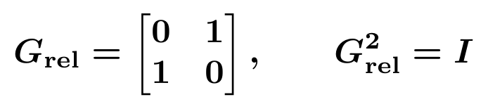
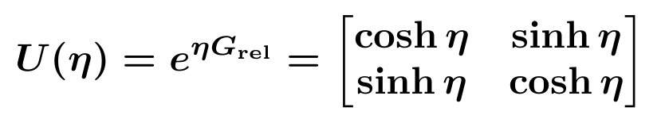
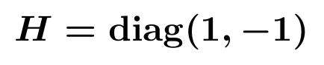
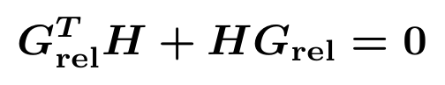
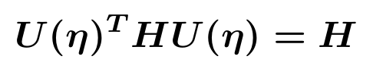
For X equal to the column vector A B the invariant is
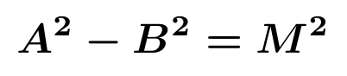
Using light cone coordinates R equal to A plus B and C equal to A minus B

7 2 Blind benchmark
The frozen core consisted of points Delta a generator and U equal to exp of Delta G The Lorentz matrix hyperbolic functions Minkowski metric signature and true generator were withheld The model inferred an invariant form from the approximate null space of G transpose H plus H G and projected G into the exact H preserving algebra
Run | NSC RMSE | Euler baseline | MLP baseline | Metric result
v0.2 corrected | 0.00127 | approximately 3 | approximately 4.8 | H approximately diag(1 −1)
v0.3 independent seed | 0.000385 | approximately 3 | approximately 4.8 | Residual approximately 10⁻¹⁴

This is evidence for cross domain transport and invariant metric recovery inside the synthetic benchmark It is not a derivation of special relativity from a deeper physical NSC principle

8 Radical Delta Series and the Pi Approximation

8 1 Radical brick
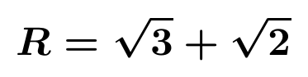
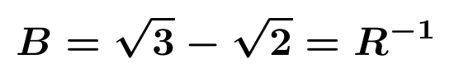
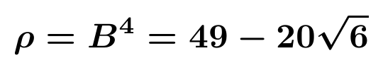
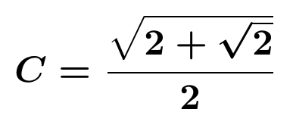

8 2 RHMC Delta series
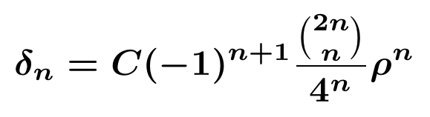
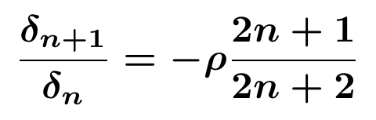
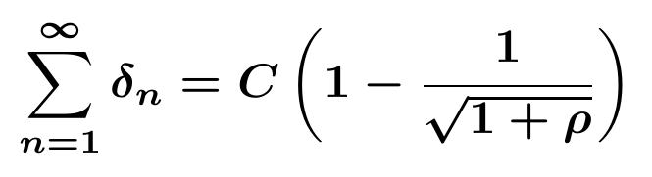
The recurrence follows from the ratio of central binomial coefficients The closed sum follows from the binomial expansion of one plus rho to the power minus one half

8 3 Conditional memory law
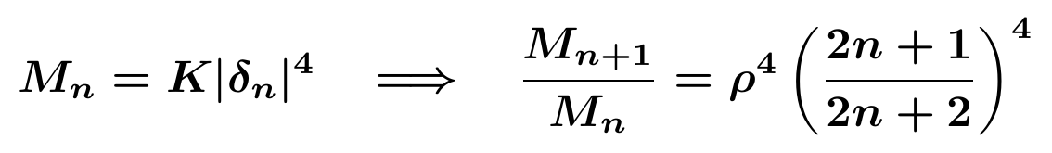
The series and recurrence are proved The fourth power memory definition and any physical memory interpretation are modeling assumptions

8 4 Numerical Pi construction
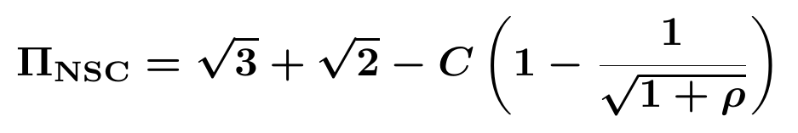
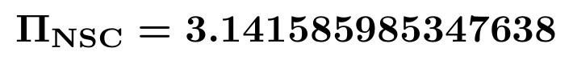
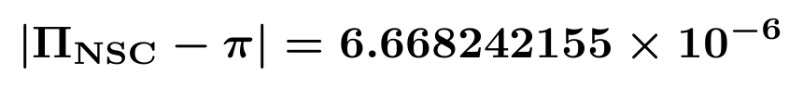
The relative error is about 2.12 parts per million This is a numerical approximation rather than an identity The special selection n equal to 3 and the radical structure still require independent justification Family tests showed that neighboring n values do not share the same accuracy
Naming correction
The construction is properly called the RHMC Delta binomial series It should not be called an Euler series unless an explicit Euler formula transformation or product connection is proved

9 Möbius Geometry
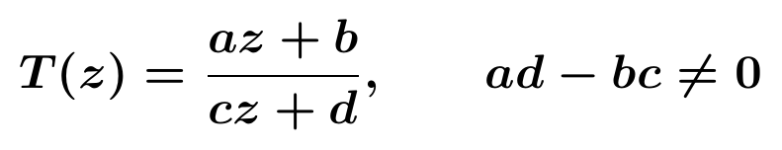
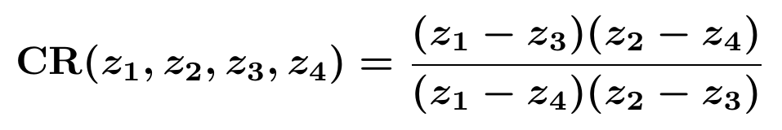
The earlier claim that a Möbius cross ratio changes with Delta to the fourth power is false A Möbius transformation preserves the four point cross ratio exactly Order effects must instead be measured in the difference between two compositions their final points matrices or holonomy

10 Black Hole and Horizon Architecture

10 1 Conditional information preserving partition
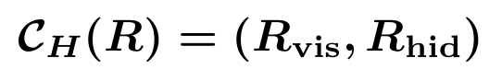
The proposed architecture interprets horizon formation as closing an access channel rather than destroying a complete relational state If the expanded map retains hidden relations and is injective then information is preserved at the architectural level
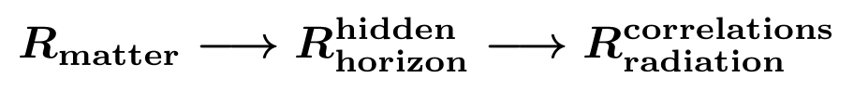

10 2 What is missing
- A gravitational state space and a metric encoder
- A quantum channel for Hawking radiation
- A decoder showing recoverability of hidden correlations
- A Page curve entropy temperature and evaporation dynamics
- A demonstration that the full map is physically injective
Correct claim
NSC proposes a conditional information preserving architecture It has not solved the black hole information paradox

11 Higgs Field Mass and Matter Hypotheses
Earlier exploratory work described a softened vacuum point and a Delta induced transition into stable particle like structure In the corrected NSC framework these statements are hypotheses requiring explicit encoders and decoders
A valid Higgs application must reproduce the scalar potential spontaneous symmetry breaking vacuum expectation value gauge and Yukawa couplings particle masses and measured spectra The numerical scale 125 GeV cannot be inserted as a fitted target and then reported as a prediction
- No NSC Higgs potential has been independently derived
- No mapping from Delta to particle mass has been validated
- No collider observable has been predicted blind
- The phrase softened vacuum remains an architectural metaphor
CURRENT STATUS HYPOTHESIS not a proved physical result

12 Other Exploratory Domains

12 1 Time
NSC does not assume physical time as a primitive A proposed time observable may be a path cost or accumulated relational depth
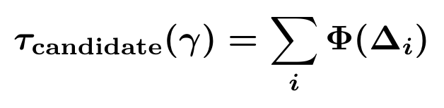
The function Phi a clock calibration and recovery of relativistic time have not been uniquely derived

12 2 Dark matter
A holonomy or weak electromagnetic projection has been proposed as an analogy for hidden relational structure No mass abundance collision cross section gravitational lensing signal or rotation curve has been derived The status is hypothesis only

12 3 Orbital closure and chemistry
Closure geometry has been explored as a possible representation of orbitals No energy spectrum quantum numbers chemical bonding rule or experimental prediction has been established

12 4 Network observations
Earlier random network experiments produced entropy like values near 2.70 to 2.72 and were compared with Euler number e The audit rejected convergence to e because the statistic generator null model and scaling law were not frozen sufficiently These values remain numerical observations

13 Compression Benchmarks

13 1 Hidden absorption efficiency
Metric | NSC | Generic MLP
Parameters | 14 | 4546
Parameter ratio | 0.0030796 | 1
Minimum samples to target RMSE | 250 | Not reached at 8000
RMSE at 250 samples | 0.004861 | 0.081683
Inference on 5000 samples | 0.000752 s | 0.003582 s

The verdict was PASS for compactness and sample efficiency against the tested generic MLP Timing was reported but was not a preregistered pass criterion The baseline did not standardize outputs and was not a maximally tuned adversary The result therefore cannot establish universal superiority

13 2 Official nanophotonics gate
The public RCWA xyY dataset contained 8411 samples with four geometry variables and three color variables The official split used 6000 training 1000 validation and 1411 blind test samples
Model | Parameters | Blind RMSE | Blind MAE | Verdict
MLP reference | 4675 | 0.037187 | 0.026686 | Reference
Degree 7 polynomial proxy | 993 | 0.032300 | 0.021501 | Compact success but not NSC proof
Commuting exponential NSC | 67 | 0.090546 | 0.067144 | Fidelity FAIL
Noncommuting exponential NSC | 83 | 0.133224 | 0.101134 | Operational FAIL

The polynomial proxy showed that the dataset is compressible It cannot automatically be labeled NSC because its polynomial coefficients are unconstrained The true commuting exponential model compressed by about seventy times but lost accuracy The noncommuting model also failed and did not converge within eighty iterations
A key modeling lesson emerged period diameter gap and height are simultaneous geometric features rather than an ordered physical sequence Forcing them into an ordered product of transformations had no physical justification Ordered Delta composition should be reserved for genuine layers events or path segments

14 Formal Verification
An independent verification script checked sixteen identities and all sixteen passed within floating point tolerance
- Generator composition
- Invariant form preservation
- Determinant identity
- Two dimensional closure
- Oscillatory optical class
- Hyperbolic relativistic class
- Weak order exponent and commuting null
- RHMC recurrence and closed sum
- Möbius cross ratio preservation
NUMERICAL LIMIT A numerical pass verifies the implementation of a mathematical identity It does not validate a physical encoder

15 Remove Freeze Fit Protocol
The corrected research workflow prevents known physics or target constants from being silently inserted and later rediscovered
Stage | Action | Pass condition
A0 | Define encoder decoder and holdout | No target answer used
A1 | Reconstruct with all reference physics | Error comparable to reference solver
F | Freeze algebra parameters scale preprocessing and seed | Version and hash fixed
W | Remove data boundary condition parameter then equation | Beat same degree baselines
I | Generate prediction from frozen NSC only | Hidden target comparison
R | Accept reject or restrict claim | No tuning after result

15 1 Invalidity conditions
- A target constant or equivalent ratio enters the encoder normalization domain or sample selection
- An exact solution is included among optimization starts
- The baseline is weaker by construction or lacks basic scaling
- A physical claim has no units scale encoder or decoder
- A result appears only for one seed one selected n or one definition of a statistic
- A known theorem from BCH Möbius geometry transfer matrices or relativity is relabeled as new NSC physics

16 Locked Findings and Corrections
Statement | Final status
Delta is a relational transformation | Retained as model primitive
Two dimensional generator classification | MATH PROVED
Weak squared order law scales as epsilon fourth power | MATH PROVED in the weak limit
Layered optics is reproduced exactly | REPRESENTATIONAL EQUIVALENCE
One dimensional Lorentz transport and metric recovery | SYNTHETIC CROSS DOMAIN PASS
RHMC recurrence and closed series | MATH PROVED
Radical construction equals pi | REJECTED approximation only
Möbius cross ratio changes under Delta fourth power | REJECTED
Horizon architecture solves information paradox | DOWNGRADED to conditional architecture
Higgs mass and matter are derived | UNVERIFIED HYPOTHESIS
Network statistic converges to e | UNVERIFIED NUMERICAL OBSERVATION
NSC always preserves fidelity while compressing | REJECTED by official benchmark variants

17 Current Research Program

17 1 What is genuinely valuable now
- A compact generator language connecting composition invariants order and holonomy
- A formal two dimensional closure theorem that covers oscillatory and hyperbolic classes
- A disciplined remove freeze fit protocol
- Evidence that some optical inverse problems admit strong physics informed compression
- Negative results that identify when ordered composition is inappropriate

17 2 Priority experiments
- Use real public experimental optical spectra with a preregistered split and an independent reference solver
- Distill a physical RCWA or Maxwell solver into an NSC state while enforcing measurable invariants
- Compare against strong specialized solvers rather than generic neural networks alone
- Measure the Pareto frontier between parameter count blind error fit time and inference time
- Test noncommutative composition only on genuinely ordered layers or paths
- Require a concrete encoder decoder units and novel observable before reopening Higgs horizon or dark matter claims

17 3 Falsification criteria
NSC should be rejected for a task if a same size standard baseline is consistently more accurate if compression destroys the task relevant invariant if the required encoder is equivalent to the full reference solver with no reduction or if a claimed physical prediction cannot be stated before observing the target

18 Conclusion
NSC now has a coherent mathematical core under explicit assumptions Its strongest theorem is the finite dimensional generator structure with exact composition invariant form preservation determinant control and two dimensional oscillatory hyperbolic nilpotent classification Its strongest applied result is compact physics informed recovery in synthetic layered optical absorption Its strongest methodological result is a clear separation between compression representation and physical proof
The public nanophotonics benchmark is equally important because it blocked an exaggerated conclusion NSC compressed strongly but the tested constrained exponential forms lost predictive fidelity This establishes the central research question not whether NSC can become small but which invariants must survive so that smallness remains useful
Final verdict
NSC is presently a mathematically coherent structural compression research program It is not yet a validated fundamental physical theory

Appendix A Symbol Glossary
Symbol | Meaning
Δ | Relational transformation parameter or step
G | Linear generator
U(Δ) | Exponential representation exp(ΔG)
H | Invariant bilinear or Hermitian form
κ | Two dimensional closure scalar equal to minus det G for trace free G
P | Path ordering operator
H_γ | Holonomy along path gamma
R T | Optical reflectance and transmittance or context specific light cone variables
ρ | 49 minus 20 square root 6
C | square root of 2 plus square root 2 divided by 2
δₙ | nth RHMC Delta series term

Appendix B Reproducibility Ledger
Benchmark 1 was locked on 18 August 2026 with a research maturity score of 81 out of 100 This score describes maturity rather than probability of fundamental truth A1 through W8 files seeds thresholds failures invalid runs and hashes are frozen Any change requires a new version
Benchmark 2 independent metric discovery used seed 26082627 with 20000 training samples and 10000 test samples The training Delta range was minus 0.03 to 0.03 and blind ranges were minus 2.5 to minus 0.4 and 0.4 to 2.5
Benchmark 3 efficiency used seed 26082691 with training sizes from 250 to 8000 and 5000 test samples The declared target RMSE was 0.015 Its fairness boundary was comparison with a generic MLP rather than a specialized inverse transfer matrix solver

Appendix C Selected References
- Abelès F 1950 Recherches sur la propagation des ondes électromagnétiques sinusoïdales Annales de Physique 12 596 to 640
- Byrnes S J 2020 Multilayer optical calculations arXiv 1603 02720
- Danis B S and Zayim E 2025 TMMax high performance modeling of multilayer thin film structures using JAX Journal of Open Source Software 10 9088
- Ma T Tobah M Wang H and Guo L J 2022 Benchmarking deep learning based models on nanophotonic inverse design problems Opto Electronic Science 1 210012
- Jung U Jang D Kim S and Kim J 2025 Improving the performance of optical inverse design of multilayer thin films using CNN LSTM tandem neural networks arXiv 2506 10044
- Danis B S and colleagues 2026 Inverse Engineering of Optical Constants in Photochromic Micron Scale Hybrid Films arXiv 2602 16180
- Internal project archive NSC Benchmark 1 Locked Checkpoint 18 August 2026
- Internal project archive NSC Formal Mathematical Core version 1 0 18 August 2026
- Internal project archive NSC Independent Technical Audit version 0 4 18 August 2026
- Internal project archive NSC Compression Goal Checkpoint 18 August 2026

