Machine Learning Algorithms for Predictive Modelling in Cardiovascular Health Monitoring

Table of Contents
Abstract 1
Chapter 1 3
Introduction 3
1.1 Introduction 3
1.2 Problem Statement 5
1.3 Research Question 6
1.4 Research Objective 7
1.5 Significance of the Study 8
1.6 Scope and Limitations 9
1.7 Thesis Organization 9
1.8 Summary of the Chapter 11
Chapter 2 13
Background and Literature Review 13
2.1 Overview of Cardiovascular Health 13
2.2 Importance of Studying Cardiovascular Diseases (CVDs) 13
2.3 Global Impact of Cardiovascular Diseases 14
2.4 What is the Cardiovascular System? 15
2.5 Role of the Heart in Circulation 16
2.6 Types of Cardiovascular Diseases 17
2.7 Causes and Risk Factors of Cardiovascular Diseases 17
2.8 How Cardiovascular Diseases Occur (Pathophysiology) and Prevention 18
2.9 The Role of Technology and AI in Cardiovascular Health 19
2.10 Summary of this Background 20
2.11 Overview of Cardiovascular Disease (CVD) and its Impact 21
2.12 ML-Based Risk Prediction Paper 21
2.13 Feature Selection and Importance Analysis in CVD Paper 23
2.14 Deep Learning Applications in CVD Prediction Paper 24
2.15 The novelty of our thesis 26
2.16 Summary of the Literature Review 26
Chapter 3 28
Methodology 28
3.1 Overview of Research Methodology 28
3.1.1 Data Collection and Description 28
3.1.2 Data Preprocessing and Feature Engineering 28
3.1.3 Model Selection and Training 29
3.1.4 Model Evaluation 29
3.1.5 System Building 30
3.2 Dataset Description 32
3.2.1 Data Collection and Sources 32
3.2.2 Dataset Attributes and Features 32
3.2.3 Data Cleaning and Preprocessing 34
3.3 Feature Selection and Importance Analysis 35
3.3.1 Correlation Analysis 35
3.3.2 Recursive Feature Elimination 36
3.3 Machine Learning Model Selection 36
3.4.1 Logistic Regression 36
3.4.2 Gradient Boosting 37
3.4.3 XGBoost 38
3.4.4 LightGBM 39
3.5 Hyperparameter Tuning, GridSearchCV and Cross-Validation 40
3.6 Evaluation Metrics Used 40
3.6.1 Accuracy 41
3.6.2 Precision, Recall, F1-Score 41
3.7 Software and Tools Used 42
3.8 Summary of the Chapter 43
Chapter 4 45
System Structure 45
4.1 System Implementation and Model Deployment 45
4.2 System Architecture 46
4.3 Interface of this System 47
4.4 Deployment Challenges 51
Chapter 5 52
Experimental Results and Analysis 52
5.1 Data Analysis and Visualization 52
5.1.1 Feature Visualization 55
5.1.2 Dimensionality Reduction and Feature Analysis 71
5.2 Feature Correlation and Importance Results 73
5.3 Performance Comparison of ML Models 75
5.3.1 LightGBM 76
5.3.2 Gradient Boosting 78
5.3.3 XGBoost 79
Chapter 6 81
Findings and Conclusion 81
6.1 Decreasing The dataset Complexity 81
6.2 Real World Application 81
6.3 Conclusion 82
6.4 Challenges and Limitations 83
6.5 Future Work 84
References 85
Appendix 88
https://github.com/siamarefin/CardioVascular-Disease-Prediction 88

List of Figures
Figure 1:WorkFlow 28
Figure 2: Initial Dataset 29
Figure 3: Preprocessed Dataset 33
Figure 4: Logistic Function 35
Figure 5: Gradient Boosting 36
Figure 6: XGBoost 37
Figure 7: LightGBM 38
Figure 8: System Architecture Diagram 44
Figure 9: Home page top 45
Figure 10: home page bottom 46
Figure 11: prediction page 47
Figure 12: Prediction with advice 47
Figure 13: Correlation Matrix 51
Figure 14: Age Distribution by Cardiovascular Disease Status 52
Figure 15: Boxplot of Age by Cardiovascular Disease 53
Figure 16: Gender Distribution by Cardiovascular Disease 54
Figure 17: Distribution of Gender 54
Figure 18: ap_hi 55
Figure 19: ap_lo 56
Figure 20: Cholesterol 57
Figure 21: Distribution of cholesterol 58
Figure 22: Glucose 59
Figure 23: Distribution of glucose 59
Figure 24: Smoke 60
Figure 25: Distrubution of Smoke 61
Figure 26: Alcohol Consumption 62
Figure 27: Distribution of Alcohol 62
Figure 28: Physical Activity 63
Figure 29: Distribution of Active 64
Figure 30: BMI 65
Figure 31: Blood Pressure Category 66
Figure 32: Distribution of bp_category 67
Figure 33: t-SNE plot 68
Figure 34: UMap plot 69
Figure 35: Factor Analysis Visualization 70
Figure 36: Recursive Feature Elimination Ranking 71
Figure 37: Model Comaprison 73
Figure 38: Train vs Validation Accuracy – LightGBM 74
Figure 39: Confution Matrix of LightGBM 75
Figure 40: Train vs Validation Loss - Gradient Boosting 76
Figure 41: Train vs Validation Loss – XGBoost 77

List of Tables
Table 1: Cardiovascular Disease (CVD) Statistical Data 3
Table 2: Comparison of ML-Based Risk Prediction Models 21
Table 3: Feature Selection and Importance Analysis in CVD Paper 23
Table 4: Comparison of Deep Learning Applications in CVD Prediction Paper 24
Table 5:Feature Analysis 31
Table 6: Distribution of categorical features 49
Table 7: LightGBM classification report 74
Table 8: Gradient Boosting Classification Report 75
Table 9: XGBoost Classification Report 76
Table 10: Comparison Table 78

List of Abbreviations
Abbreviations | Full Forms
CVD | Cardiovascular Disease
ECG | Electrocardiogram
SVM | Support Vector Machine
KNN | K-Nearest Neighbors
RFE | Recursive Feature Elimination
BMI | Body Mass Index
ML | Machine Learning
XGB | Extreme Gradient Boosting
SHAP | Shapley Additive Explanations
CV | Cross Validation
AUC-ROC | Area Under the Receiver Operating Characteristic Curve
AI | Artificial Intelligence
FastAPI | Web framework used for building APIs
Naïve Bayes | A machine learning algorithm
LSTM | Long Short-Term Memory
CNN | Convolutional Neural Network

Abstract
Cardiovascular diseases is an important cause of death across the globe leading to millions of deaths each year. Early diagnose and risk assessment is important to decrease complications and get better the prognosis of patients. Diagnostic approaches of tradition based on the clinical examination and laboratory investigations don’t still allow to reveal CVD at the earliest stage. ML offers an approach to improve predictive accuracy of cardiac risk by analyzing several health factors and detecting patterns that point to potential risk. This paper's contribution is a CVDs Prediction System with the help of ml and an efficient feature reduction approach, which applies XGBoost for making accurate predictions. An individual’s CVD risk is then determined using a model trained on structured patient data such as systolic and age, cholesterol levels, diastolic blood pressure, BMI, and glucose levels.
In the optimization model, feature selection methods are utilized to improve the model performance also enhance interpretability. The backend uses FastAPI and allows the predictive model and user interface to communicate in a user-friendly way; in turn, the frontend is developed with HTML, CSS, and ensures great user experience. The competing model has a predictive accuracy of 73%, which is better than other conventional methods which shows the robustness of the classification of the method. Users can enter their health metrics and be told in real time what their level of risk is via the app’s intuitive interface. The system recommends personal ways such as lifestyle changes, dietary improvement and daily health checks for the person to take preventive action when he/she is identified to be at high risk. Machine learning is demonstrated to be able to predict cardiovascular disease risk successfully and is an expandable and high-efﬁcient way for the early diagnosis. Since the system is based on Git, version control is guaranteed and all files become available, transforming it into a practical solution for healthcare applications.

Chapter 1

Introduction

1.1 Introduction
CVD leads to more deaths worldwide than any other cause, more people are killed by CVDs each year than by anything else. It is estimated that 17.9 million people died from CVD in 2016, which was 31% of all deaths worldwide [44]. Epidemiology The increasing incidence of CVDs results from sedentary life style, unhealthy dietary habits, and genetic as well as environmental influences. No setting is more urgent in this phenomenon than low and middle-income countries that have limited access to health care and prevention services. WHO reported that >75% of mortality due to CVD is recognized in the developing world, in result of the late diagnosis and little availability of treatments for the people [44]. They are an array of diseases, among them coronary artery disease, arrhythmias, stroke and heart failure. Generally, risk factors are classified as modifiable, or non-modifiable. Controllable risk factors are high blood pressure, high cholesterol, diabetes, smoking, overweight or obesity, poor diet and inactivity. Non-modifiable immutable factors consist of age, gender, genetic heritage and family history regarding heart illness. It is important to recognize them in order to identify and intervene at risk.
Thus, early detection for the prevention of CVDs is crucial to reduce their morbidity and mortality. Current strategies such as ECGs, stress testing, and blood work do not detect CVD with consistent reliability and are dependent on clinical experts. In addition, these traditional methods are mostly and only based on the diagnosis of symptoms at that time-so the early diagnosis may be not able to be realized in many case for treatment of the late stage and is less effective as well.
Predictive tools, among which we found AI and ML, have been increasingly employed for this purpose, thanks to its capability to manage and analyze large datasets, and to the opportunity to contribute to revealing patterns that may be indicative of the presence of disease. Machine Learning Models relies on data analytic and high-performance computation approaches to improve the precision of CVD risk assessment. The experiments can be performed on a variety of patient specific parameters and may be used in interventions. DL models such as CNNs and LSTMs have been successfully used in classifying towards CVD. Various studies have applied ML algorithms for predicting CVD. Noteworthy, ML models have been reported to outperform traditional statistical methods for predicting CVD risk. Even when AI was used to assist clinicians in providing and supporting the clinical decision making, it brought down the errors caused from human clinicians and bettered the patient outcomes.
Therefore, the use of ML to predict CVD could change both clinical practice and healthcare in that it would bring in the more predictive diagnostic and targeting capability of CVD than currently existing approaches process through the non-invasive and accurate method for CVD diagnosis and targeting. In this paper, we explore the performance of ML algorithms to identify high-risk patients, with a focus on introducing and optimizing the feature selection process and improving performance by predicting CVD risk estimates.
Table 1: Cardiovascular Disease (CVD) Statistical Data [44]
Statistic | Global Data | Low- and Middle-Income Countries | High-Income Countries
Annual Deaths from CVD | 17.9 million | 75% of CVD-related deaths | 25% of CVD-related deaths
Percentage of Global Deaths Due to CVD | 31% | 75% | 25%
Top Causes of CVD | Coronary artery disease, Stroke, Heart failure, Arrhythmias | Coronary artery disease, Stroke | Coronary artery disease, Heart failure
Modifiable Risk Factors | Hypertension, Smoking, Obesity, Poor diet, High cholesterol, Diabetes,Lack of physical activity | Hypertension, High cholesterol, Smoking, Poor diet, Lack of access to healthcare | Hypertension, High cholesterol, Obesity, Lack of physical activity
Non-Modifiable Risk Factors | Age, Genetics, Family history, Gender, of heart disease | Age, Family history, Genetic predisposition, Gender | Age, Gender, Family history
Early Detection Methods | ECG, Stress tests, Blood tests | Limited access to diagnostic tools | Advanced diagnostics available
Predicted Rise in CVD Prevalence (by 2030) | 40% increase in global prevalence | 50% increase in low- and middle-income regions | Stabilization or slight decrease
Impact of AI/ML in CVD Prediction | Promising accuracy improvements, particularly in early detection and diagnosis | Can help address limited healthcare access and improve prediction accuracy | Further optimization in clinical practice

1.2 Problem Statement
CVDs are a class of diseases of both the blood vessels and the heart. These include coronary heart disease, cardio vascular disease and peripheral arterial disease (blood flow to the limbs). Other varieties are caused by bacterial infections like rheumatic heart disease, or structural defects like congenital heart disease, while when these clots are transported via the bloodstream into the lungs deep vein thrombosis can lead to fatal blood clots.
Blockages in blood vessels are a common cause of heart attacks and stroke, and are often due to fatty deposits that constrict the flow of blood in arteries. The other major cause of strokes is when a blood vessel in the brain breaks and begins bleeding, or when a blood clot otherwise blocks circulation. The negative behaviors are smoking, dietary behaviors, lack of physical activity, overconsumption of alcohol, and composure to factors from the environment such as air pollution that CVDs. These could in turn produce intermediate conditions such as but not limited to hypertension, hyperglycemia, hypercholesterolemia, obesity and cardiovascular stress, which in turn, will determine in part, whether a CVD occurs. Prevention No smoking, lower salt intake, more fruits and vegetables, regular activity, not drinking alcohol in excess. Public health policies that can reduce the number of CVD cases will do so by giving people the choices they need to stay healthy and policies that advocate for clean air. In addition to lifestyle, poverty, mental stress, urbanization and aging are also systemic causes that lead to this burgeoning cardiovascular risk.
The clinical manifestations of CVD may often be hidden until there is a heart attack or stroke. Heart attack symptoms may include: Chest pain Discomfort in your arms, left shoulder, back, neck, jaw or stomach shortness of breath Nausea feeling light-headed Cold sweat Stroke symptoms that may include: Sudden weakness of the face, arm, leg or one side of the body Loss of vision in one or both eyes Confusion Trouble speaking or understanding Sudden trouble walking, dizziness, loss of balance or lack of coordination Severe headache, with no known cause Loss of consciousness or fainting. It is essential that medical assistance be instantaneous for survival.

1.3 Research Question
CVD is a leading cause of global mortality and morbidity. Classical diagnostics based on physical signs can be ineffective in early CVDs detection, and new data-driven methodologies are needed. In this study, we aim to build a ML model to predict CVD risk from existing structured patient record. The intention of this study is to improve the performance for CVDs prediction model based on machine learning and to enhance the accuracy for predicting CVDs by employing other feature selection tools like RFE and using the implementation and comparisons of different supervised learning algorithms. The research questions guiding this study are:
Research Question 1: Which statistical methods and ML algorithms can be used to detect main CVD risk factors from the Kaggle CVD dataset?
Research Question 2: How do CVD prediction performance of various ML models (Logistic Regression, Decision Trees, Random Forest) compare, and how is model’s accuracy affected by feature selection?
Research Question 3: How does reducing dataset complexity with RFE-selected features affect the performance and accuracy of CVD prediction models?

1.4 Research Objective
The main Focus of this paper is to propose an accurate and interpretable ML model for predicting CVD through the structured data of the patients. The specific aims to be addressed in this study are:
Objective 1: Analysis of the data and identification of the features
Analyzing Kaggle CVD dataset to discover the significant factors that may impact CVD risk factor by using statistic methods and machine learning – such as correlation analysis, mutual information analysis, clinical research discovery. Features selection procedure can then be build upon this.
Objective 2: Machine Learning Model Application and Optimization
To use various ML models, for instance, LR, DT and RF to predict CVD risk and observe performance comparison. Feature selection methods as RFE will be applied to improve the effectiveness and efficiency of the model.
Objective 3: Evaluation Model and Building a System for Prediction
To benchmark ML performance using all features to RFE selected top features approach in terms of accuracy. The goal is to enhance model efficiency in prediction, by simplifying the dataset. The optimal model will then be validated whether the reduced feature set model could predict CVD risk accurately and efficiently. After building the models, we build a system for real time predictions.
By meeting these aims, this study will help pave the road to AI-based healthcare, improving early detection, risk assessment and prevention of cardiovascular diseases.
The uniqueness of our thesis originates from the use of feature engineering on CVD healthcare dataset. Through the use of an advanced feature selection technique we were able to select and preserve the most crucial risk-contributing factors for the development of CVD prediction models and the system. This process simplified the dataset and improved the model performance which resulted in better prediction scores. Our work shows that feature engineering can significantly enhance ML models in providing a better, more efficient and accurate solution for early CVD risk detection, which can also contribute to the development of AI-based healthcare solutions.

1.5 Significance of the Study
CVDs are the leading cause of death worldwide, and it is critical to diagnose it in time to save patients and prevent further complications. Such research is novel because CVD risk prediction utilizing ML is a data-driven predictive model approach that can aid healthcare professionals in early detection and prevention.
The current diagnosis of CVD relies on clinical examination combined with the laboratory results, which may not be able to detect CVD at early stage. ML models have learning capability to analyze data, discover the hidden pattern, and generate an early risk alert for timely intervention. Machine learning methods, especially after features are fine-tuned using different feature-selecting strategies will improve the prediction performance as compared with the traditional statistical models. The application aims at building an efficient in assessing CVD risk prediction model with the three kinds of complex algorithms.
Timely diagnosis of CVD using ML-based models could avoid expensive and complex intervention solutions, and alleviate healthcare systems burden caused due to it. Additionally, the risk prediction can be further translated into clinic or even to remote medicine environment. This study aims to identify the most influential clinical variables related to CVD risk using FS and model interpretation methods. It would also be important to know these risk factors to be able to design well directed prevention and treatment programs.
Findings of this study could bridge the gap between AI. By building an interpretable and efficient ML-based prediction model, this research represents a first step toward the integration of AI-powered tools into the clinical flow to achieve more accurate decision support of clinical professionals. In summary, this study demonstrates the potential of machine learning to revolutionize cardiovascular risk estimation as an affordable, accurate and scalable strategy for early medical intervention and prevention.

1.6 Scope and Limitations
CVD identification is through ML models based on structured patients' data. The goal of the work is to identify risk factors, employ feature selection and test various ML models for the better predictive ability. The experiment is performed on Kaggle CVD dataset, a clinical records of patients provided with different health attributes. Various supervised learning algorithms of LR, DT, RF, SVM are also employed. Feature selection: One may utilize method like RFE to make the model more efficient and interpretable. The performance of the different ML models will be evaluated through evaluation metrics Accuracy, Precision, Recall, F1 score. The aim of this study is to develop an interpretable and clinically significant ML model to support healthcare experts to experience the risk and early diagnosis of CVD.
Although the study has contributed to the advancement of CVD prediction via the ML there are some limitations that must be addressed as follows: Limitations of the present study Dataset: We have used a single publicly available dataset but probably not representative of all populations. The data set might be biased and so the model can not be generalized. Generalization of the model: The developed ML models could not be generalized to other regional and demographic specific database except after further validation. Prospective validation in a clinical setting is needed for such an application. Ethical Privacy Concerns The treatment of patient data in maximum of the ML based applications involving privacy and security risks. For practical clinical application, it is necessary to comply with the rules of healthcare data security. Computational Resources Requirement: ML models like DL-based models have a high computational load for its training. It is harmful to the scalability of the model in low-resource health sector.
By recognizing these scope and limitation, this study provides a structured approach for evaluating the effectiveness of ML in CVD prediction, while illuminating psychological challenges that should be addressed in subsequent research.

1.7 Thesis Organization
This thesis is organized in a manner comprising seven chapters with each containing an important part related to our study of machine learning based prediction modeling for CVD. The structure of the paper leads the reader from the problem statement to the methods, results and conclusions.
Chapter 1: Introduction
This chapter gives context and motivation for the research, emphasizing the importance of CVDs and the applications of ML in predictive health care. It defines the research question, objectives, scope, limitations, and significance of the study, providing a rationale for the research.
Chapter 2: Background and Literature Review
Chapter 2 covers cardiovascular health and explains the heart, heart diseases, risk factors, and developmental processes. It defines the prevention, diagnostic and treatment. The AP advances are also discussed along with the use of AI and technology in cardiovascular care. In this chapter, we have included a detailed literature review on researches carried out for the prediction of CVD using ML. It presents the description of the traditional CVD diagnosis, advancements in ML for CVD diagnosis, feature selection method and deep learning techniques. A literature review is also provided as the comparison to fill the research gaps and to convince the research significance of the research.
Chapter 3: Methodology
This chapter describes the research approach, including data collection, preprocessing, and feature selection techniques used in the study. It explains the ML models applied, evaluation metrics, and software tools used. The methodological framework ensures reproducibility and clarity in the study’s implementation.
Chapter 4: System Structure
The development and implementation of the Cardiovascular Disease Prediction System is described in this chapter . It deals with implementation and architecture of the system and of the user interface, and emphasizes on the way how the machine learning models are integrated with the frontend and backend components. The deployment issues, which may burn into problems such as scalability and performance loss, are also addressed in the paper.
Chapter 5: Experimental Results and Analysis
We present a discussion of the findings from CVD prediction using ML models in this chapter. It is introduced a comparative performance analysis of different algorithms using benchmark evaluation metrics accuracy, precision, recall, F1-score. It even incorporates graphic forms such as feature importance plots and confusion matrices to get a sense of how a model is performing. Development and Application of a Risk Assessment Tool for Cardiovascular Disease. This area covers: data pre-processing, model selection, front-end back-end integration cloud deployment. Models used are Logistic Regression, Random Forest and XGBoost incorporated with Flask for backend API and a reactive UI. The chapter present deployment concerns, the testing process, and the security examination of to ensure the effectiveness and applicability of the system.
Chapter 6: Findings and Conclusion
The main contribution of this chapter is a result. Displayed is the outcome of applying various ML models to the task of predicting CVD risk. We compare all-feature and the RFE-based models, and found that the former reduce the complexity of the dataset and led to our method being computationally scalable.
This is the last chapter of this book itinerary. It summarizes the main issues addressed in the previous chapters and the contributions of the study to the field of ML-based healthcare, as well as its limitations. It also gives recommendations for future work, including more superior dataset quality and better model explainability and real-world application of ML-based CVD prediction. The structured approach of study is also verified to cover the all part research work summary. A clear picture of how ML can sense CVDs in early stage and how ML can assist risk assessment is presented.

1.8 Summary of the Chapter
Finally in this chapter, we reviewed the CVD and its implications on world health. It emphasized the drawbacks of the current diagnostic techniques2 and proposed the idea of ML models for CVD risk prediction. Problem definition analysis: The problem statement describes the challenge of early case detection, the need for superior models and the opportunity which ML methods have to meet it. The purpose of the study was explicitly mentioned to analyze Kaggle CVD dataset, utilize multiple ML techniques, implement feature selection techniques, and compare models using measurements. The aim of this research is to provide an interpretable ML model for helping healthcare workers to evaluate the risk.
They also mentioned the significance of the study, such as early detection of ML and improvement of diagnostic accuracy and prognosis prediction with lower costs of healthcare, as well as the real-world clinical application of the proposed ML method. The novelty of our project is to cover this gap, developing ML-based DSS decision support tools for use in real-life medical practice, in clinics, hospitals, and health care centers. Research Domain was specified and use of structured clinical data models supervised learning and feature selection to enhance prediction was reported. Limitations of the study were also acknowledged, including those of the dataset, difficulty in model generalizability, issues related to privacy and computational issues.
The final part informed the reader about how the thesis was organized by introducing the five chapters: introduction and review of literature, methodology, analysis and findings, and conclusion. This chapter serves as the foundation for the subsequent chapters, taking the reader through the aims, and objectives of ML-based applications in cardiovascular disease prediction.

Chapter 2

Background and Literature Review

2.1 Overview of Cardiovascular Health
Cardiovascular health is the condition of your heart and blood vessels, and how well they are able to circulate blood, oxygen, and nutrients throughout your body. Cardiovascular performance is indispensable to life, and when compromised, to regulate normal body function. The system consists of the heart, the arteries, the veins, and the capillaries which, by gas-exchange between the blood and tissues and between the blood and the air in the lungs, constantly purify the blood and give to it a new lease of life. When it is functioning as it should, the person is full of life, energy, robust and healthy [11].
Achievement of successful CV health is based on the integration of healthy behavior’s pattern and conducive medical control systems, including a healthy diet, physical activity, stress control and early detection of CV diseases. Poor cardiovascular health is associated with increased risk of CVDs and is the leading cause of disease burden and mortality worldwide. CDVs consist of all conditions of the heart and blood vessels such as ischemic heart disease, heart failure, arrhythmia and stroke [12]. As these diseases scatter healthcare systems around the world, understanding about cardiovascular health is very important for prevention, early detection, and management of these diseases.
As medical technology and science have become more developed, it has become easier to prevent and treat cardiovascular disease. ML and AI for prediction and enhancement in accurate diagnosis of the CVD risk factors is becoming a potential path. If we include these new strategies with the older preventive concepts, we can markedly reduce the incidence and impact of CVD. [13].

2.2 Importance of Studying Cardiovascular Diseases (CVDs)
CVDs continue to be the number one cause of death globally. According to the World Health Organization (WHO), CVDs caused 17.9 million deaths every year around the world, representing 31% of all global deaths [44]. The necessity to study CVDs as a subject is thus they have made a remarkable impact on the human health, economy, and health care systems.
CVD-related research informs risk factors and disease mechanisms. These are modifiable risk factors but also non-modifiable ones, including unhealthy diet, physical inactivity, smoking and heavy alcohol use, as well as non-modifiable factors, such as genetics, age and sex. Such knowledge would assist in the development of effective measures for prevention and control by researchers and for policy decision by health officers [15]. Progress in cardiological research leads to more accurate diagnostic methods and treatments. For instance, echocardiography, angiography and biomarkers aid in early diagnosis and treatment. In addition, newer therapeutic strategies, including minimally invasive surgeries, catheter-based interventions and personalized medicine, have revolutionized patient outcomes [16].
However, CVDs are economically burdensome for health systems around the world. The cost of caring for cardiovascular disease, hospitalization, medicines, and long‐term care, are considerable and present substantial stress to national health budgets. Combatting the epidemic through prevention and early intervention can lower the number of expensive treatments needed and save on long-term care costs [17]. AI and machine learning tools in healthcare have changed the game for the prediction and management of CVD. Prediction models making use of AI assist in identifying high-risk patients and giving warnings at the early stage for early intervention. Furthermore, the use of blockchain in EHR management is secure and efficient for data processing, which enhances patient care as well as the efficiency of medical research [18].

2.3 Global Impact of Cardiovascular Diseases
Cardiovascular diseases are a huge global burden, affecting millions of people irrespective of socio-economic conditions. Prevalence varies in different parts of the world because of lifestyle, genetics, and inequalities in access to healthcare. Cardiovascular diseases are still the leading global cause of death. In low- and middle-income countries more than 75% of the cardiovascular-associated mortality occurs, mainly due to poor access to health services and preventive approaches [19]. The burden of ischemic heart disease and stroke has rapidly increased during recent decades, becoming the major causes of cardiovascular mortality. Although high-income countries have benefited from the reduction of CVD-related mortality rates thanks to improved health care, LMICs have faced increase in CVD incidence due to fragile medical facilities, and exposure to risk factors [20]. There is also an enormous economic impact of CVDs. Cardiovascular diseases are estimated to cost the U.S. economy over $363 billion each year, among men direct medical costs and indirect costs due to CVD [21]. In Europe, also, costs related to CVD reach around €210 billion annually, including both CVD-related healthcare spending and loss of economic productivity [22].
Economically, the situation is worse in ‘developing’ countries where there is the burden of CVD disease in those in the most productive years of work, causing familial financial burden and loss of man-hours. Public health campaigns, worksite wellness and policy can improve these economic burdens as they address heart disease. Substantial differences in cardiovascular health exist by demographic group. Health and access to care and educational status Socioeconomic status is an independent factor associated with CV risk. Individuals from low-income levels are more likely to be at higher risk of CVD because they are frequently associated with poor nutrition and lack of access to healthcare [23].

2.4 What is the Cardiovascular System?
Elaborate system of the heart, blood vessels, and blood as the body's circulatory system that transports oxygen, nutrients, hormones, and metabolic wastes. It is critical for the maintenance of homeostasis, thermoregulation, and disease prevention by immune response [27]. The heart, a hollow muscle, is the center of the cardiovascular system situated in the chest cavity between the lungs. It consists of four chambers – the upper two known as atria and the lower two as ventricles. The heart is a 2 pump body, one pump sends oxygenated blood throughout the body and the other pump sends deoxygenated blood to the lungs for oxygen exchange [29]. There are two principal components of the cardiac cycle, one is Systole, the contraction phase as the ventricles pump blood and the other is Diastole, the heart chambers are filled with blood or relaxed.
The heart rate is regulated by the sinoatrial (SA) node and is termed the heart’s intrinsic pacemaker. Electric impulses caused by SA node rhythms keep rhythmic contraction which works effectively for the blood flowing [32]. Artery The arteries are a system of tubes in the body that carry the blood from the heart to the rest of the body. There are 3 major types of them: Arteries Narrow blood vessels that convey oxygenated blood from the heart to the body. Veins, They transport blood from the body back into the heart. Capillary, Smallest blood vessel in which the exchange of oxygen and nutrients and waste between the blood and the tissue occurs [33].
Arteries have big, muscular walls that are elastic enough to absorb this pressure, which comes from the heart’s pumping. The largest of these vessels (aorta) divides to arteries and arterioles that supply the different organs [34]. Veins are thinner walled and contain valves to stop blood flowing backward. The vena cava is the body's largest vein carrying deoxygenated blood from body to heart. The deep veins carry the majority of the blood load compared with the superficial veins, which are located close to the skin [35]. Capillaries are the smallest of the blood vessels and run throughout the body, serving to carry and transfer blood and oxygen from heart to tissue. They link arterioles with venules, with the primary function of maintaining the supply of oxygen and nutrients to and from tissues, as well as the removal of waste[36].
Blood is a specialized fluid connective tissue composed of:
- Plasma – A liquid matrix that carries nutrients, hormones, and waste.
- Red Blood Cells (RBCs) – Carry oxygen via hemoglobin.
- White Blood Cells (WBCs) – Part of the immune system, fighting infections.
- Platelets – Assist in blood clotting and wound healing [37].
Blood circulates in two primary pathways:
- Systemic Circulation – Delivers oxygenated blood to tissues.
- Pulmonary Circulation – Exchanges carbon dioxide for oxygen in the lungs [38].
The balance between these pathways ensures efficient oxygenation and metabolic waste removal.

2.5 Role of the Heart in Circulation
The heart works as a central pump in the circulatory system that incessantly pushes blood through the body. It functions in two integrated networks: Pulmonary Circulation Deoxygenated blood is pumped by the right side of the heart to the lungs to pick up oxygen and give off carbon dioxide. From here the oxygenated blood returns to the left atrium. Systemic Circulation – The left side of the heart delivers oxygenated blood throughout the body by way of the aorta. After having reached the tissues, the blood transports the oxygen and nutrients back towards the heart again [39]. Good circulation is essential for normal blood pressure, tissue perfusion and organ function. Pathologies of the heart or blood vessels, including atherosclerosis, hypertension, and heart failure, alter circulation leading to serious adverse outcomes [40].

2.6 Types of Cardiovascular Diseases
CVDs represent a major global health concern, encompassing conditions such as coronary artery disease, hypertension, stroke, heart failure, arrhythmias, and peripheral artery disease. CAD, often caused by atherosclerosis, restricts blood flow to the heart and can result in angina or heart attacks. Hypertension, or high blood pressure, is a silent yet severe contributor to heart disease and stroke. Stroke, caused by blocked or ruptured brain arteries, can lead to permanent disability or death. Heart failure occurs when the heart cannot pump effectively, causing symptoms like fatigue and fluid retention. Arrhythmias are irregular heart rhythms that may lead to dizziness or sudden cardiac arrest, while PAD affects blood flow to limbs, often causing pain and increasing the risk of stroke. These diseases have common risk factors: poor diet, lack of exercise, smoking and genetic tendency. Preventive measures by way of healthy lifestyle and regular monitoring and medical treatment are important. The rapidly increasing worldwide burden of CVDs demands attention to public health intervention, healthcare accessibility, and technologies such as AI to facilitate early detection and personalized therapy. Addressing disparities and increasing awareness are critically needed to improve global mortality and overall CVH.

2.7 Causes and Risk Factors of Cardiovascular Diseases
Cardiovascular diseases are influenced by modifiable and non-modifiable risk factors. Modifiable risks, which can be controlled through lifestyle changes and medical care, include poor diet, physical inactivity, smoking, excessive alcohol intake, obesity, and metabolic disorders. Diets high in fats, salt, and sugar contribute to hypertension and atherosclerosis. Regular exercise improves circulation and heart function, and avoiding tobacco and limiting alcohol significantly lower cardiovascular threats. Managing weight and metabolic conditions such as diabetes is also essential for heart health. Non-modifiable risk factors age, genetics, and gender also impact cardiovascular risk. Aging increases arterial stiffness and plaque buildup, while a family history of heart disease heightens susceptibility due to genetic influences. Gender differences, especially post-menopause in women, affect disease prevalence and symptom presentation, emphasizing the need for tailored care.
Although non-modifiable risks cannot be changed, focusing on modifiable factors is key to prevention. Advances in technology, like wearable devices and AI diagnostics, improve early detection and personalized care. However, disparities in healthcare access and awareness remain barriers. A global, multidisciplinary approach is essential to reduce the burden of cardiovascular diseases and improve population health outcomes.

2.8 How Cardiovascular Diseases Occur (Pathophysiology) and Prevention
Cardiovascular diseases are the outcome of intricate pathological perturbations, mainly originated from atherosclerosis an endogenous chronic inflammatory condition characterized by the formation of plaque in arteries. Endothelial injury, which can be initiated by hypertension and hypercholesterolemia, results in foam cell accumulation and arteriolar stenosis. Plaque rupture may lead to formation of a blood clot, which can be fatal if it blocks blood flow. Blockages in coronary arteries of this kind lead to myocardial infarctions (heart attacks), when oxygen-starved muscle tissue in the heart is destroyed. The blockage of arteries in the brain can also cause ischemic strokes, presenting with symptoms of numbness, speaking difficulty, or paralysis.
By contrast, hemorrhagic strokes from the rupture of brain vessels from high blood pressure or aneurysms result in bleeding and high pressure inside the skull, often with devastating consequences. Both types of strokes are emergencies clot busters for ischemic strokes and surgery for hemorrhagic strokes. Knowledge of these pathophysiologic mechanisms emphasize the importance of early prevention and management of risk factors, lifestyle modifications, as well as medical surveillance. AI and precision medicine have also made it easier to detect the very early stages of the disease and to give customized care. Nevertheless, the prevalence of CVD worldwide is still high as a consequence of asymptomatic disease development and a lack of awareness. 490 Public education, periodic control and access to health care are key to reducing the burden of CVD and advancing future health.
Prevention of CVD is important to decrease CVD-related morbidity and mortality, and it is conducted at three levels; primary, secondary, and tertiary prevention. Healthy lifestyle habits in the general population (e.g., Mediterranean or DASH diet, physical activity, nonsmoking, and reduced alcohol intake) represent the main focus of primary prevention. These service helps to reduce the risk associated with cardiovascular issues.
There are thus two axes of prevention, primary and secondary: the former is aimed at prevention of disease while exiting the chain of transmission and involves the subset of the general population in which the risk of the disease is small while the latter is targeted at disease and involves those individuals in whom risk is not small. Routine testing for blood pressure, cholesterol, and blood glucose also asses and allow control of hypertension, hyperlipidemia and diabetes major risk factors for cardiac disease which the U.S. Preventive Services Task Force found evidence of cardiac disease mortality reduction. These risks are managed with lifestyle adjustments and medication, such as statins and antihypertensives.
Tertiary prevention is intended for those already suffering from CVD. The goal is to keep the disease from getting worse or developing complications using medications, surgery and, for some, a cardiac rehab program that includes supervised exercise, diet counseling and emotional support. Combining public health measures and digital technologies, AI-core risk assessment tools and wearable health devices, leads to more efficient prevention. Even with those tools, the persistence of disparities in healthcare access is problematic. An intensive and integrated approach between individuals, communities, and health systems is essential to reduce cardiovascular disease burden worldwide.

2.9 The Role of Technology and AI in Cardiovascular Health
Tech innovations, like AI, wearables, and blockchain are revolutionizing CVD Diagnosis, Monitoring, and Therapy. By analyzing big data sets, AI allows for early detection, since it can recognize patterns and offer predictions of heart diseases like arrhythmia or heart failure. AI also uses data from medical imaging, health records and genetics to offer individual risk assessments and treatment recommendations.
Wearable health-monitoring equipment’s such as smart watches and portable ECGs enable the real-time monitor of heart rate, blood pressure and other vital signs, leading to the early prevention and long-term control of CVDs. These also represent the devices for the big health research as well as decreasing the hospital readmission by remote patient monitoring. It empowers patients to manage data access, facilitates sharing of real-time records among clinicians, and increases efficiency in emergency and insurance claim processing. Blockchain also supports secure, anonymized data sharing for clinical research.
Even with their advantages, they face challenges that include expense, availability and red tape. Continuous innovations and partnership is the way to the mainstream adoption. Indeed, AI, wearables are revolutionizing cardiovascular care and providing more precise, proactive and patient-centric approaches to reducing the worldwide impact of a fundamentally preventable and reversible disease.

2.10 Summary of this Background
It covers the types of CVDs, risk factors, causes, prevention, management, diagnosis and technology of CVDs. CVDs comprise diseases such as coronary artery disease, hypertension, stroke, heart failure, arrhythmias, and peripheral artery disease, each with a high contribution to the global burden for morbidity and mortality. Risk-factors are divided into modifiable and non-modifiable. It study on prevention, based on the block model of health, which promotes the adoption of healthy lifestyles, monitoring, and public health directives. The pathophysiology in the case of atherosclerosis is apparent: plaque formation results in heart attacks and strokes through clot formation and arterial obstruction.
Diagnosis is made from ECGS, echocardiograms, angiography, and biomarkers, and treatment may consist of lifestyle modifications, medications, surgical intervention, and, in extreme cases, implantable devices. The chapter study on the increasing importance of AI, wearables, and blockchain in early diagnosis, monitoring, personalized treatment, and security of data. This technology facilitates more precise and convenient CVD treatment. Even in the era of advanced medical therapies, inequities in healthcare and risk factor trends continue to exist, which emphasizes the importance of integrating technology- and evidence-based interventions that are primarily aimed at risk prevention to attenuate the global burden of CVD.

2.11 Overview of Cardiovascular Disease (CVD) and its Impact
Cardiovascular diseases (CVD) are a group of heart and blood vessel disorders, such as coronary artery disease, heart failure, stroke and hypertension. CVD is leading cause of deaths worldwide -an estimated 17.9 million people die from CVD every year, representing 31% of all global deaths as per world health organization [44]. The global burden of CVD is progressively rising due to an aging population, lack of physical activity, poor food habit, and increased obesity as well as diabetes. CVDs are often caused by fatty deposits in the arteries (atherosclerosis) which in turn reduce blood flow and increase the risk of heart attacks and strokes. Hypertension, hyperlipidemia, smoking, diabetes, obesity and genetic susceptibility are the most frequent CVD risk factors. Lifestyle related risk factors like poor eating habits and sedentary behavior also contribute significantly to CVD.
With increasing burden of cardiovascular disease, incorporation of machine learning in healthcare provides hope to early detection, better risk prediction, and more informed clinical decision-making. We here assess the applicability of ML methods to improve the accuracy in CVD prediction based on feature selection and classifiers, in support of a more effective strategy for the prevention and intervention of the disease.

2.12 ML-Based Risk Prediction Paper
This work employs Decision Tree, Random Forest, KNN, and SVM on the Kaggle CVD dataset. SVM and the relatively high word-embedding features achieve the highest accuracy rate (73%) and F1-score. Cholesterol, BP, glucose, smoking, and physical activity are the important predictors from feature importance [1]. A paper contrasts SVM, Naïve Bayes, Gradient Boosting and Logistic Regression for predicting CVD. It comes up with cholesterol, hypertension, age, and glucose as important features. Feature selection contributes to both the model performance and accuracy [2]. This study uses 70,000 patients’ data and employs Voting Classifiers, KNN, and Random Forest. Here the blood pressure, cholesterol, glucose and age are the key features. The best accuracy is performed by the Voting Classifier [3]. The interpretable CVD prediction in this study is compared using LR, DT, and RF. The primary features are blood pressure, cholesterol, smoking and obesity. LR model is the most clinically interpretable model[7]. In this study, we use Logistic Regression, Random Forest, SVM, and XGBoost to predict long-term CVD events. It prioritizes hypertension, cholesterol, glucose, and heart rate as the most influential predictors, drawing attention to the importance of feature selection method in enhancing model performance[9]. Here we herein target early warning indicators of CVD, using a combination of CatBoost, Random Forest and Decision Trees. Cholesterol, systolic BP, glucose, and BMI are considered to be an important risk factors. CatBoost is able to achieve the greatest accuracy 91% [10].
Table 2: Comparison of ML-Based Risk Prediction Models
Criteria | Paper [1] | Paper [2] | Paper [3] | Paper [7] | Paper [9] | Paper [10]
Dataset Used | Kaggle CVD Dataset | Clinical Dataset | 70,000 Patient Records | Clinical Dataset | Clinical Dataset with Risk Scores | Clinical Dataset
ML Models Applied | Decision Tree, Random Forest, KNN, SVM | SVM, Naive Bayes, Gradient Boosting, Logistic Regression | Voting Classifier, KNN, Random Forest | Logistic Regression, Decision Trees, Random Forest | Logistic Regression, Random Forest, SVM, XGB | CatBoost, Random Forest, Decision Trees
Feature Selection Methods | Feature Importance Analysis | Ensemble Methods & Feature Selection | Correlation Analysis | Feature Importance Ranking | Feature Selection Techniques | Feature Selection Techniques
Key Predictors | Cholesterol, Blood Pressure, Glucose, Smoking, Physical Activity | Cholesterol, Hypertension, Age, Glucose Levels | Blood Pressure, Cholesterol, Glucose, Age | Blood Pressure, Cholesterol, Glucose, Smoking, Obesity | Hypertension, Cholesterol, Glucose, Heart Rate | Cholesterol, Systolic BP, Glucose, BMI
Best Performing Model | SVM | Ensemble Methods | Voting Classifier | Logistic Regression | Extreme Gradient Boosting (XGB) | CatBoost
Accuracy (%) | 73% | Varies | Highest Accuracy in Study | Varies | Varies | 91%
Key Findings | SVM outperforms others in feature selection and ML model comparison | Feature selection enhances classification accuracy | Voting Classifier outperforms individual models in feature selection | Logistic Regression provides best interpretability for clinical use | Feature selection improves ML model accuracy for long-term prediction | Feature selection and model optimization significantly enhance accuracy

2.13 Feature Selection and Importance Analysis in CVD Paper
In this paper, a feature selection has been carried out with the help of the efficient Blue Whale Optimization algorithm which helps the ML models to work better. In [3], Random Forest, Naive Bayes and SVM are used and the before and after performance of the classifiers is evaluated for feature selection. It is concluded after the analysis of the results that the BWO enhance the accuracy of the model by retaining only relevant features and discarding irrelevant features when creating the model for clinical terms like blood pressure, cholesterol, and HRV. They emphasize the need to select the most useful features to improve the prediction accuracy data, and therefore are closely related to our work in feature importance analysis [4] useful references. This paper uses GridSearchCV in order to interpret machine learning model. It examines the feature relevance and performs model training and optimization such as Random Forest, Extra Trees and Logistic Regression. The analysis indicates that blood pressure, cholesterol levels, and glucose, in addition to exercise, have a considerable role in CVD risk. The Extra Trees classifier is one of the better models with an accuracy of 98.57%. This paper complements our study by showing that feature selection can improve prediction performance while making it possible to interpret results, which is essential when considering medical uses [5].
This paper studies feature selection methods including both RFE and Mutual Information to help identify main clinical factors associating with CVD prediction. For RF, LR, and KNN, we compare the model performance for selected features and all features. In the experiment, we demonstrate that the removing of relatively features gives rise to efficient model in par with the high accuracy. The study finds that cholesterol, hypertension, and age are the most significant predictors. This is consistent with our own work where the emphasis is on feature selection and ML model performance improvement [6]. In this paper, we investigate how ensemble learning methods such as Bagging and Boosting enhance the prediction accuracy of CVD.
The paper compares RF, AdaBoost and GB and concludes that when trained on top ranked features, models that use boosting outperform traditional classifiers. It leverages feature selection techniques for the purpose of data reduction in the course of model training. The results agree that choosing important attributes such as cholesterol, glucose, hypertension is the best way to get better prediction. This result is also in line with our findings of feature importance and machine learning model evaluation [8].

Table 3: Feature Selection and Importance Analysis in CVD Paper
Criteria | Paper [4] | Paper [5] | Paper [6] | Paper [8]
Feature Selection Method | Blue Whale Optimization (BWO) | GridSearchCV, SHAP (SHapley Additive exPlanations) | Recursive Feature Elimination (RFE), Mutual Information | Bagging and Boosting Classifiers
ML Models Applied | Random Forest, Naïve Bayes, SVM | Random Forest, Extra Trees, Logistic Regression | Random Forest, Logistic Regression, KNN | Random Forest, AdaBoost, Gradient Boosting
Key Predictors Identified | Cholesterol, Hypertension, Heart Rate Variability | Blood Pressure, Cholesterol, Glucose, Physical Activity | Cholesterol, Hypertension, Age | Cholesterol, Glucose Levels, Hypertension
Best Performing Model | SVM | Extra Trees Classifier | Random Forest | Gradient Boosting
Accuracy (%) | Improved After BWO | 98.57% | Varies | Higher Accuracy than Traditional Models
Key Findings | BWO enhances model accuracy by removing irrelevant features. | Feature selection ensures high predictive accuracy and explainability. | Eliminating less significant features improves model efficiency. | Boosting classifiers improve performance by focusing on top-ranked features.

2.14 Deep Learning Applications in CVD Prediction Paper
In this paper, we investigate the use of RNN and LSTM to detect heart diseases. The authors employ patient-level data available in a dataset and develop deep learning models that are able to find out implicit features in medical domain. Results show that time-aware models, in form of LSTMs, perform significantly better for identifying time-dependent trends of heart disease risk compared to commonly-used ML algorithms. Deep learning outperforms traditional methods such as DT and LR by having better accuracy and lower misclassification rates. Our work showed that the deep learning methods may be useful to diagnose CVD in the early stage, which has integrated into a better prediction of healthcare[11]. This paper is concentrated on the application of deep learning model in analyzing ECG images for cardiovascular disease detection. CNNs are used to learn important patterns from raw ECG wave and provide assistance in diagnosis automation and precision. Results show that, compared to manual ECG analysis, the CNN-based models improves diagnostic accuracy in clinical use.
Integrating deep learning will enhance real-time CVD detection and make it more appropriate for remote patient monitoring. The findings demonstrate that deep learning networks, notably CNNs, appear to have a major role in future CVD diagnosis, while decreasing the high dependence of manual interpretation [12]. This article covers how deep learning and, in particular, CNNs and transfer learning, improve the detection of cardiovascular disease in the medical images. The research utilizes deep learning techniques to interpret echocardiograms and cardiac MRIs, resulting in increased accuracy in diagnosis compared to conventional methods. The results demonstrate that the deep learning–based models can better and more consistently recognize abnormalities than humans. Furthermore, the study highlights the potential of AI-based imaging technology for early detection and risk stratification. This study further confirms that deep learning is changing the face of cardiac diagnosis, accelerating and improving medical decision-making [13].

Table 4: Comparison of Deep Learning Applications in CVD Prediction Paper
Criteria | Cardiovascular Disease Prediction Using Deep Learning Algorithm | Exploring ML & DL in ECG Image Analysis for CVD Diagnosis | ML in CVD: Clinical Applications & Relevance to Cardiac Imaging
Focus Area | Use of RNN and LSTM for CVD prediction | Deep learning for ECG waveform analysis | Deep learning for echocardiogram & cardiac MRI analysis
Methodology | Trained deep learning models on patient records | Uses CNN to extract features from ECG images | CNNs and transfer learning applied to cardiac imaging
Key Findings | LSTM models outperform traditional ML in identifying heart disease risk patterns | CNNs outperform manual ECG interpretation and reduce diagnostic errors | Automated models detect abnormalities with higher precision than human experts
Advantages | Higher accuracy, better temporal pattern recognition | Automates diagnosis, enhances real-time detection | Faster and more accurate medical decisions
Challenges | Requires large datasets, computationally expensive | Dependence on high-quality ECG data, requires clinical validation | Challenges in generalization across different imaging modalities
Future Scope | Improving model efficiency and integrating real-time monitoring | Enhancing real-time analysis and telemedicine integration | Advancing AI-driven imaging systems for early diagnosis

2.15 The novelty of our thesis
The uniqueness of our thesis originates from the use of feature engineering on CVD healthcare dataset. Through the use of an advanced feature selection technique we were able to select and preserve the most crucial risk-contributing factors for the development of CVD prediction models and the system. This process simplified the dataset and improved the model performance which resulted in better prediction scores. Our work shows that feature engineering can significantly enhance ML models in providing a better, more efficient and accurate solution for early CVD risk detection, which can also contribute to the development of AI-based healthcare solutions.

2.16 Summary of the Literature Review
In this chapter, we provided an overview of different machine learning (ML) approaches that have been applied in CVD risk prediction, including risk prediction models, deep learning and feature selection algorithms. Algorithm: ML-based prediction models such as Decision Trees, Random Forest, SVM, which is able to predict the outcome with incorporation of patient-individual data, lead to better predictive accuracy. DL algorithms, such as CNNs and LSTMs, improve diagnostic performance with ECG and medical images. Univariate feature selection And the feature selection methods, such as RFE, work by pinpointing the important risk factors. The research verifies the effectiveness that ML improves the early detection of CVD, providing higher accuracy thus generating more efficiency making it a key tool in modern health care.

Chapter 3

Methodology

3.1 Overview of Research Methodology
In this work, we use ML based algorithm to predict a CVD in the structured data of patients. The approach is guided through a standard process from data acquisition and preprocessing, to the selection of features, model training to the evaluation and analysis. The research methods employed are listed as follows figure 1: Workflow.
Firstly, when we identify the problem, we fixed our objective for our thesis. Then we go to google scholar, Research Gate and other information website, then we collect our resources such that research papers and articles, topics description. With all the resources available, we try to figure out our methodology.

3.1.1 Data Collection and Description
Data collection is the first step for our study. Basically, we find a public dataset which is very informative and related with cardiovascular system. The dataset is extracted and provided with reference to Kaggle CVD dataset [46] and contains structured clinical data profile of subjects age, gender, BMI, cholesterol, systolic and diastolic blood pressure, glucose level, smoking, drinking and physical activities. The target variable cardio refers to the presence or absence of cardiovascular disease in a patient.

3.1.2 Data Preprocessing and Feature Engineering
After the data collection, we must preprocess it. Because we observe that our raw dataset have many noises. In the data preprocessing phase, the dataset was carefully examined for missing values, and appropriate imputation techniques were applied to handle any gaps. Duplicate records were identified and removed to ensure data integrity. Numerical variables were then standardized using the Standard Scaler () function to normalize their scales. For feature selection, Recursive Feature Elimination combined with a Random Forest classifier was employed to identify the top five most important features influencing cardiovascular disease prediction.
For Feature Engineering and extract the top ranking feature, we use RFE techniques which play very important role in this research.

3.1.3 Model Selection and Training
Multiple classification algorithms were trained including Logistic Regression, Decision Tree, Random Forest, Gradient Boosting, SVM, KNN, XGBoost, LightGBM. The data set was split into a 70:30 training and testing split with the scikit-learn library’s train_test_split() function.
The models were implemented with GridSearchCV, which enables hyperparameter tuning and helps to automatically identify what hyperparameter sequence is most efficient. We fit the models over a grid of hyperparameters that included the regularization strength and optimization solvers. To avoid overfitting and obtain a more general estimate of its accuracy, the model performance was tested on distinct parts of the data using a 5 times repeated random 5-fold cross validation. Applying this method, we chose the best parameter set according to the maximum mean validation accuracy among all the folds. Performance was assessed on a hold-out test set after tuning hyperparameters with multiple evaluation metrics. The classification report was printed that contains precision, recall, F1-score, and support for both positive and negative classes, and provides an intuitive sense of how the model is performing in terms of the ability to correctly classify an instance of cardiovascular diseases. The findings also highlight the necessity of a careful hyperparameter tuning and model validation procedure for achieving high Predictive Accuracy in CVD-association prediction.

3.1.4 Model Evaluation
The model was tested with a few base performance metrics like accuracy, precision, recall, F1-score and confusion matrix to compare model performance and to discover the good classifier for prediction of CVD. Furthermore, the confusion matrix was used to evaluate the true positive, true negative, false positive, and false negative numbers of the model and to analyze any misclassifications. The model results graph was created to illustrate how the accuracy of the model change as I played with different hyperparameters both the training and Validation. These were some of the indicators of good model tuning, with low level of overfitting and the ability of the model to generalize well on new, out of sample data.

3.1.5 System Building
After building the predictive methods, a UI system was constructed to support real-time cardiovascular disease risk predictions. This interface enables the users with a way to interact where-in they can enter data about their health on their own, and it will be processed by the machine learning models beneath and will return the risk assessments instantly. The UI is designed to offer an easy-to-use and easily accessible venue for participants to gain valuable understanding about the health of their cardiovascular system.
Ensuring a structured process for developing and validating machine learning models for prediction of cardiovascular diseases, thus optimizing predictive power and clinical relevance.
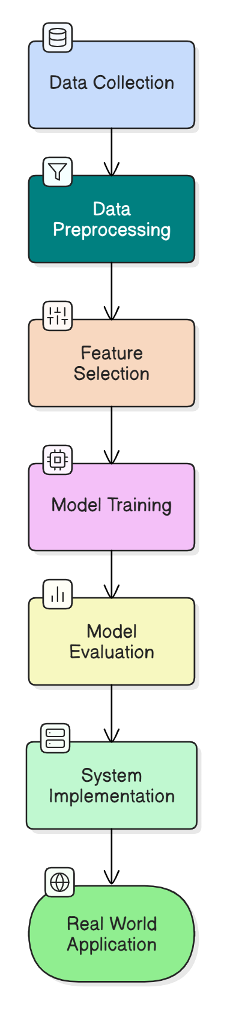
Figure 1:WorkFlow

Dataset Description

3.2.1 Data Collection and Sources
Materials The dataset in this study was obtained from two publicly available repositories, UCI ML Repository and Kaggle. The dataset is available at [46]. The data set was collect from the UCI Machine Learning Repository and Kaggle, so it was a well-organized and trustworthy dataset of patient records. Data All patient information was de-identified to ensure patient confidentiality and in accordance with the strangers act for data utilization. This dataset comes with important clinical attributes including age, gender, blood pressure, cholesterol, glucose, smoking, alcohol consumption and physical activity that is vital in training and validating machine learning models for heart disease prediction.
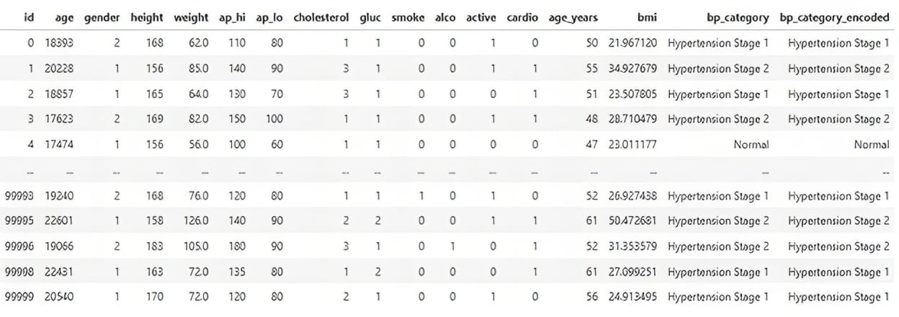

Figure 2: Initial Dataset

3.2.2 Dataset Attributes and Features
The dataset used in this study consists of structured patient records encompassing various clinical attributes relevant for predicting cardiovascular disease. These features include demographic details such as age originally recorded in days and later converted to years for better interpretability and gender, categorized as male or female. Physical measurements include height in centimeters, weight in kilograms, and Body Mass Index, which is derived by dividing weight by the square of height. Blood pressure indicators consist of systolic blood pressure (ap_hi), representing the highest arterial pressure during heartbeats, and diastolic blood pressure (ap_lo), the lowest pressure between heartbeats. Biochemical indicators include cholesterol and glucose levels, both recorded as categorical variables indicating normal, above normal, or well above normal values. Lifestyle factors such as smoking status, alcohol consumption, and physical activity are represented as binary variables, indicating the presence or absence of these behaviors. The target variable, cardio, denotes the presence or absence of cardiovascular disease. Collectively, these features serve as the foundation for training machine learning models aimed at enabling early diagnosis and effective risk assessment of cardiovascular disease.
Table 5:Feature Analysis
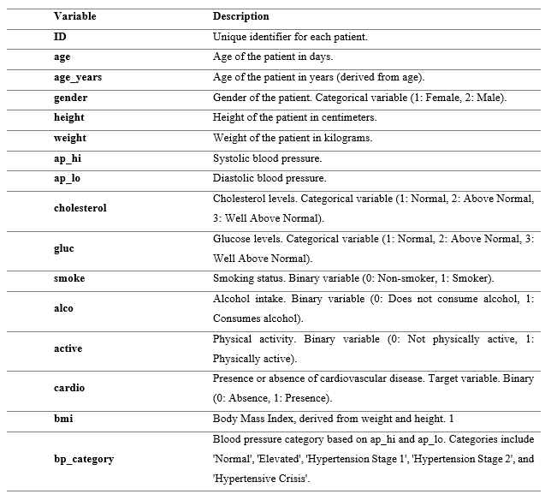

3.2.3 Data Cleaning and Preprocessing
To keep the data in sufficient quality for the machine learning models, we used some preprocessing techniques to clean and prepare our data. These steps are comprised of missing value treatment, categorical variable encoding, outlier removal and numerical feature scaling.
The dataset was checked for missing values using summary statistics and visualization techniques. Missing values were imputed using mean, median, or mode depending on the nature of the variable to maintain data integrity. The dataset contains categorical features such as cholesterol, glucose levels, gender, and lifestyle habits. Label Encoding was used to convert these categorical values into numerical representations, making them suitable for machine learning models. Outliers were identified using statistical methods, including interquartile range analysis and visualization techniques such as box plots. Extreme values in features like systolic and diastolic blood pressure were corrected or removed to prevent model bias and improve accuracy. Standardization was applied to numerical features such as age, height, weight, and BMI to ensure uniform feature distribution. Min-Max Scaling was used to normalize blood pressure values, preventing dominance of high-range features over others.
After data cleaning and preprocessing, the dataset was refined to improve the performance and reliability of ML models, ensuring that training and predictions were based on consistent and accurate data.
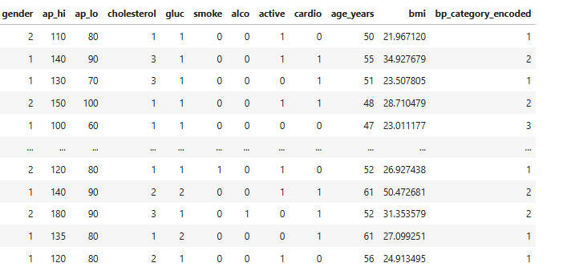
Figure 3: Preprocessed Dataset

3.3 Feature Selection and Importance Analysis

3.3.1 Correlation Analysis
Correlation-analysis is applied to ascertain the strength and direction of associations between variables in a dataset. In the context of machine learning, it is useful to determine how features are associated with the output variable, and innocent feature selection. Correlations can be within the range of -1 to 1 from -1 to 1: A perfect positive relationship is when as one variable goes up, the other variable has a perfectly straight-line tendency to go up with it. A correlation near -1 shows that there is a negative relationship between the two variables. A correlation of zero says there is no association.
To predict who’s going to develop cardiovascular disease, correlation analysis is used to show whether factors like blood pressure, cholesterol, and glucose levels are strongly associated with disease risk, which also helps the model to perform better.

3.3.2 Recursive Feature Elimination
RFE is a feature selection technique in ML. It proceeds by iteratively pulling away the least informative features and keeping only the most relevant features. RFE is a feature selection technique in Machine Learning which is used to select the most important features that could be of use in training a model. It is in a recursive manner because it trains a model, ranks the features importance and removes the lowest one in every iteration. This process repeats to the desired number of features. RFE reduces overfitting and simplifies the model by discarding irrelevant or redundant data and also makes the model more interpretable. As RFE is commonly used in combination with algorithms such as Random Forest or Support Vector Machines, it is also popular for high performance and accurate predictions in medical and financial forecasting [45].
In the context of cardiovascular disease prediction, RFE can remove non-informative features to make the model more efficient, to mitigate overfitting, and to gain interpretability and prediction performance for critical risk factors like blood pressure, cholesterol, BMI, and glucose.
This correlation and RFE approach will be helpful for extracting our top important feature. While our target feature is cardio, so it is important to find out which feature is the most related with our target value cardio.

Machine Learning Model Selection

3.4.1 Logistic Regression
Logistic Regression is a statistical classification algorithm and is implemented for binary classification problems, like the prediction of cardiovascular disease. It makes a weighted sum of input features, passed through a sigmoid activation function that outputs a probability between 0 and 1. If the probability is greater than some threshold, the observation is given a positive label and a negative label otherwise. The model is then trained usually by gradient descent or maximum likelihood estimation to reduce the classification loss. While Logistic Regression is interpretable and computationally efficient, it has difficulty handling the complex, non-linearly separable data and therefore Machine Learning, Data exploration, Python, Jupyter Notebook, Seaborn, Scikit-learn ,Its predictive power is limited in the dataset with complicated feature interactions.
.
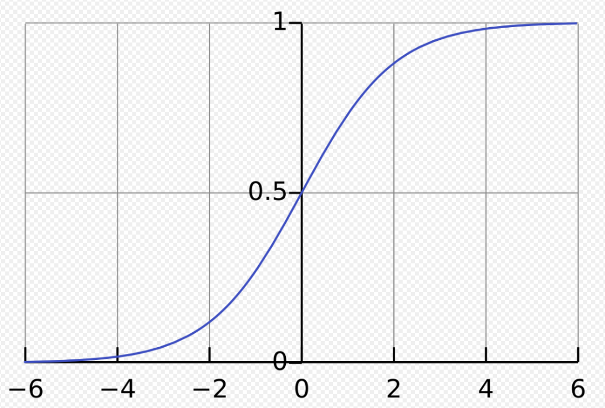
Figure 4: Logistic Function

3.4.2 Gradient Boosting
Gradient Boosting is a prediction model in the form of an ensemble of weak prediction models, usually Decision Trees. The idea is that instead of just training trees independently and then averaging all of them, trees are built sequentially where each tree tries to correct the errors made by the previous one. It does so by optimizing a loss function using Gradient Descent, which is effective for non-linear datasets. The final prediction is obtained from the sum of predictions of all weak learners weighted by the weight of the weak learner. GBM is suitable for structured data such as predicting the risk of CVDs because it is able to model feature interactions, however it is computationally expensive, and overfit easily when the model is not well tuned.
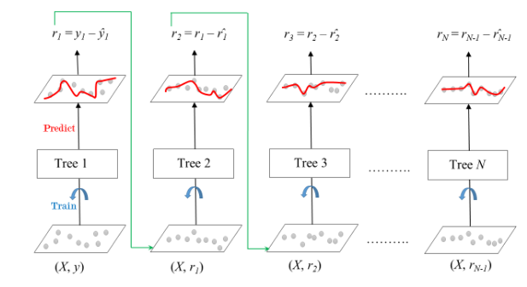
Figure 5: Gradient Boosting

3.4.3 XGBoost
XGBoost Optimized gradient boosting that is both efficient, flexible and portable by combining the best features of the best tree boosting tools to provide efficient estimation of customized configurations. It adds Decision Trees one by one, and each new tree helps to correct errors made by previously trained combination of trees. Unlike typical boosting methods, in XGBoost, L1 (Lasso) and L2 (Ridge) regularization are employed to avoid overfitting, which makes it more suitable for high-dimensional data. Furthermore, XGBoost is memory efficient and can be trained in parallel, which greatly speeds up the training process. Because it has the advantages of stronger uncertainty, scalability and computational efficiency, XGBoost has been used extensively in predictive healthcare, cardiovascular disease risks among them.
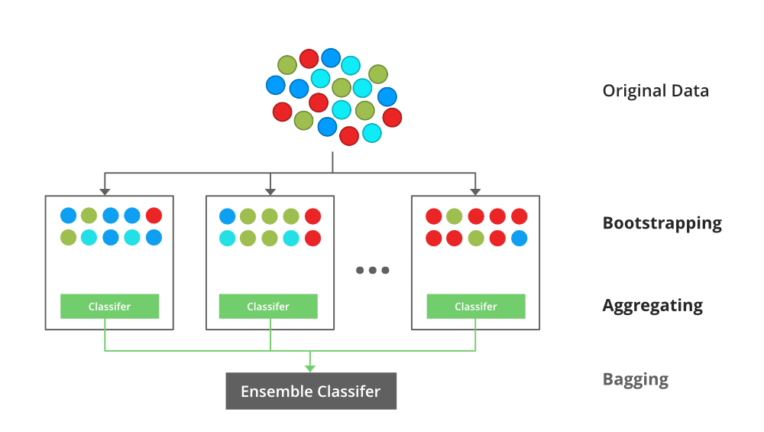
Figure 6: XGBoost

3.4.4 LightGBM
LightGBM is a very efficient implementation of gradient boosting which has been shown to outperform other models as it uses a novel way of growing the tree. LightGBM grows trees by leafing out not by branching out like most level-wise tree growth. A branch with the highest reduction in loss is split first. This, along with binned histogram, leads to faster computation with high accuracy. These optimizations make LightGBM suitable for large and high-dimensional datasets, which are typically found in cardiovascular disease prediction requiring a fast and accurate classification model.
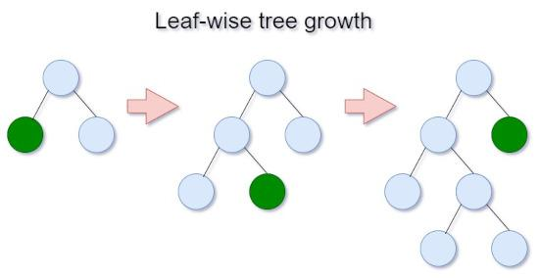
Figure 7: LightGBM

3.5 Hyperparameter Tuning, GridSearchCV and Cross-Validation
Tuning the hyperparameters of models is the most important step for optimizing a machine learning model. We applied GridSearchCV in this study to comprehensively search among different hyperparameter combinations and to determine the best set of them for each model. GridSearchCV does this by searching through specified parameter values to fit the model and perform cross-validation to find the optimal model. This procedure improves model prediction accurately and prevents over-fitting through searching for appropriate hyperparameter of the model to balance model complexity and generalization on unseen data.
Cross-validation is one of the methods to evaluate how well a machine-learnt model performs and generalizes. It consists of splitting the dataset into parts, training on some of them, and testing on the other. This aids in reducing overfitting and yields a more robust estimate of model performance.

3.6 Evaluation Metrics Used
To validate the performance of ML models in CVDs prediction, several evaluation metrics are used. These metrics provide insights into model accuracy, class-wise performance, and overall classification reliability. The three primary evaluation methods used in this study are accuracy, precision-recall-F1 score, and ROC curve analysis.

3.6.1 Accuracy
Accuracy is the most basic evaluation metric and measures the proportion of correctly predicted instances out of the total observations. It is calculated as:
$Accuracy=\frac{TP+TN}{TP+TN+FP+FN}$ (1)

where TP (True Positives) and TN (True Negatives) are correctly classified cases, and FP (False Positives) and FN (False Negatives) are misclassified cases. While accuracy is useful in balanced datasets, it can be misleading in imbalanced datasets, where one class dominates the other. In such cases, accuracy alone may not provide a comprehensive understanding of model performance.

3.6.2 Precision, Recall, F1-Score
Since cardiovascular disease prediction involves an imbalanced dataset, accuracy alone is not sufficient. Instead, precision, recall, and F1-score provide a better measure of class-wise performance. Precision represents the proportion of correctly predicted positive cases among all cases predicted as positive
$Precision=\frac{TP}{TP+FP}$ (2)
A higher precision indicates fewer false positives, which is important in healthcare to minimize misdiagnosis. Recall (Sensitivity) measures how well the model identifies actual positive cases:
$Recall=\frac{TP}{TP+FN}$ (3)
A high recall means fewer false negatives, which is crucial for ensuring that high-risk patients are correctly diagnosed.
F1-Score is the harmonic means of precision and recall, balancing both metrics:
$F1=2×\frac{Precision×Recall }{Precision+Recall}$ (4)
The F1-score is particularly useful when a trade-off is needed between precision and recall, ensuring a balanced model performance.

3.7 Software and Tools Used
A number of software tools were used in the construction of the cardiovascular disease prediction system in order to perform effective data processing, model generation, and analysis. Python was selected as the primary programming language due to its common use in the field of data science and machine learning as well as the availability of a rich set of libraries. The Pandas library was utilized for data manipulation and cleaning, which is very effective to work with big datasets using its great data structure as DataFrame. Matplotlib was used for graphics and visualization of data and research results, which allowed creating sophisticated charts and graphs to interpret feature distributions and model's behavior.
NumPy was essential for numerical calculations and matrix operations and became a backbone for dealing with mathematical functions and data manipulation operations required in the pre-processing and feature engineering stages. The Scikit-learn library was crucial for implementing and evaluating machine learning models, which provided multitask classifiers, a wide range of classification algorithms, feature selection algorithms, such as Recursive Feature Elimination (RFE), and metrics for estimating model performance.
The Jupyter Notebook was used for development and experimentation as an interactive environment containing live code, rich text, and visualizations. This configuration significantly improved the reproducibility and transparency of the workflow analysis. And it helped that Google Colab offers free resources, in cloud CPUs, where more complex models could be built and trained without being bottlenecked by personal hardware. It also allowed researchers to easily share and collaborate, making it an invaluable tool both in the initial development and presentation of the project.
Collectively, these software tools comprised a powerful, flexible workflow ecosystem to handle everything from data preprocessing to model deployment, delivering high-quality, efficient, and reproducible research.

3.8 Summary of the Chapter
This chapter details the used approach to predict CVDs by using machine learning models. The methodology of the research was categorized into several phases these are data collection, preprocessing, feature, model development, and testing.
Introduction A publicly available Kaggle dataset for cardiovascular disease was used to describe the method of data collection. It consists of relevant medical characteristics such as age, blood pressure, cholesterol level, BMI and exercise as predictors. The pre-processing process is composed of missing values it deals with addressing, encoding of categorical variables, schedule outliers, and numerical features scaling to convert the quality data into a good way to train.
We also make use of feature selection techniques to improve model performance. Correlation was used to identify the relationship between variables and RFE was employed to eliminate non-related attributes in a stepwise manner. PCA was applied for feature selection to reduce dimensions and simplify the computation, but also to keep good variability in the data.
So here we tried few machine learning models like Logistic Regression, Gradient Boost, XGBoost and LightGBM. The architecture and their method of operation of both models had been described, indicating their suitability to process structured data like CVD prediction. Hyperparameters were optimized using GridSearchCV to facilitate better performance and generalization that the models were trained and fine-tuned for.
The performance of the model was tested with several performance tr ad-Off analysis metrics. Accuracy tells us the overall performance while Precision, Recall & F1 score tells us class wise performance.
This chapter provides a generic guideline for the development of machine learning based risk prediction of CVDs in terms of the feature-perspective, the model-perspective and the evaluation-perspective, namely feature selection, model construction, and evaluation measure selection. In the following chapter we will present the experimental results and performance analysis for the models built using this approach.

Chapter 4

System Structure

4.1 System Implementation and Model Deployment
We go through the border picture of the Cardiovascular Disease Prediction System application. The development pipeline consists of many parts including data preprocessing, model selection, frontend and backend development, and model deployment. This chapter offers a complete overview over building, integrating and deploying the system in a real-world scenario.
Project which uses ML algorithms to predict probability of having a heart disease based on the health of the patient. The frontend allows the user to input data and is also connected with the trained model for making inferences, thanks to a backend API that takes charge of processing the input data. The trained model is deployed in a cloud server, allowing the users to download predictions on-the-fly.
To ensure seamless and efficient performance of the cardiovascular disease prediction system, a combination of advanced technologies and tools was utilized. The machine learning models employed included Logistic Regression, Random Forest, and XGBoost, chosen for their strong predictive capabilities and suitability for structured clinical data. For integrating these models into a functional application, the backend was developed using the Flask framework, which provides a lightweight and flexible API to handle data processing and model inference. On the frontend, technologies such as HTML, CSS, and JavaScript were used to create a responsive and user-friendly interface, enabling users to input their health information easily and receive real-time predictions. This chapter also describes any points on challenges related to deployment (on maintaining the performance of the model, making the API efficient and keeping the user data safe). It additionally covers testing techniques for supporting model accuracy and system reliability.

4.2 System Architecture
The Cardiovascular Disease Prediction System has a modular construction, which consists of several modules to facilitate the workflow from user data input to prediction generation. We have designed the system to be user-centric, scalable and efficient using frontend technologies, a FastAPI backend, an XGBoost machine learning model and Git integration for deployment.
The frontend takes advantage of HTML, CSS and Javascript to allow you the best user-interface possible. With this interface they can introduce their health measurements, systolic and diastolic blood pressure, cholesterol, BMI, and age. The front-end has an attractive design, navigation style, and is responsive to various devices. It talks to the backend to submit input data and get predictions.
The backend is written with FastAPI, a modern, fast (high-performance) web framework for building APIs. FastAPI effectively takes in incoming user requests, preprocesses the data and make calls to the deployed machine learning model for predictions. The API is designed to check user input, summarize the data and immediately present attributable information. It provides secure and efficient communication between the frontend and the ML model.
The prediction model was constructed using machine learning, employing the XGBoost (Extreme Gradient Boosting) method, a highly efficient gradient-boosting algorithm. XGBoost is highly performant in classification and particularly well-adapted for structured data. The model is trained on health data associated with cardiovascular diseases and fine-tuned for accuracy. It receives preprocessed input features and makes predictions about whether a person is likely to have CVD. The trained model is saved and connected to the back end to become an operational model.
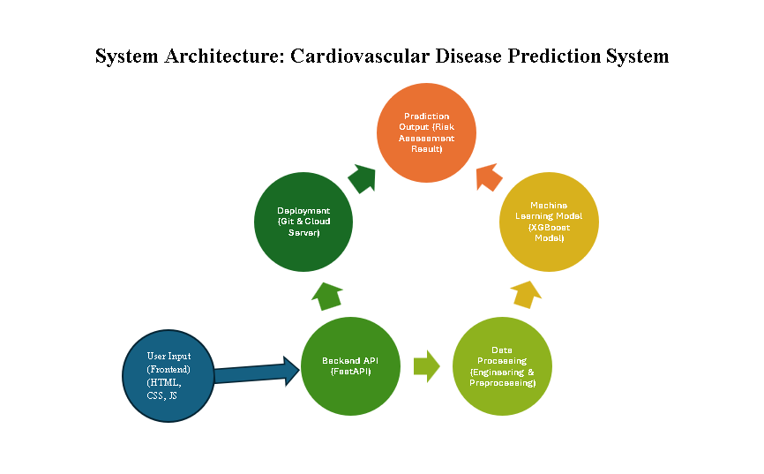
The entire system, including the backend API and machine learning model, is managed and maintained using a CI/CD pipeline integrated with Git for version control. Git enables efficient tracking of changes and ensures consistency throughout the development process. Continuous Integration and Continuous Deployment (CI/CD) automate the testing and release workflows, improving reliability and speeding up updates. For deployment, Azure cloud services are utilized, providing a scalable and secure platform to host the application, allowing users to access the system seamlessly in real time. The design of the system architecture achieves an optimal data flow from user input to model prediction, with the frontend, backend, and ML model being connected in a clear manner. Combining FastAPI computationally fast API response times which XGBoost in accurate prediction, the system is a dependable tool for CVD risk prediction.

Figure 8: System Architecture Diagram

4.3 Interface of this System
Cardiovascular Disease Prediction System's User interface, the user interface of cardiovascular disease Prediction System is built using simple and minimal design, with responsive web design with visually good and nice feel. The palette is designed to give a clean professional appearance but still symbolizes medical and technology.
The main color scheme is soft, with green, blue and white gradients, to fall in line with a healthy theme and to create a trustful web brand look. Blue commonly represents trust and dependability, making it an excellent choice for medical use, and green is the color of health and wellness. A gradient from said colors give the interface that desired modern touch.
It is organized accordingly by making the user experience very user friendly. The input form for health information is made with clean labeled fields, and clean spacing to enhance readability. Buttons receive rounded edges and a pleasant hover effect, creating a very nice user experience. The predict button is clearly distinguished with an accent color.
For prediction results, the system offers a neat and dynamic view. For users at risk, the interface displays red warning with personalized health advice. If the user is considered healthy, a green confirmation message is reported with some advice to keep a healthy heart.
The entire system is fully responsive, compatible with desktops, tablets and mobiles. The page resizes depending on the screen size and is compatible with any device. Everything is nicely styled with some cool hover states, animations, and little shadows.
The mixture of a well thought out design, the usage of well-chosen colors and smooth elements, the system thus becomes easy to use while maintaining an engaging and pleasurable experience for the user doing predictions.
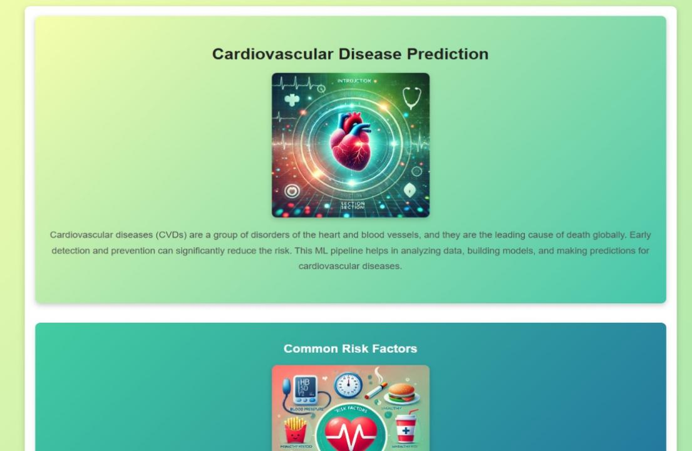
Figure 9: Home page top

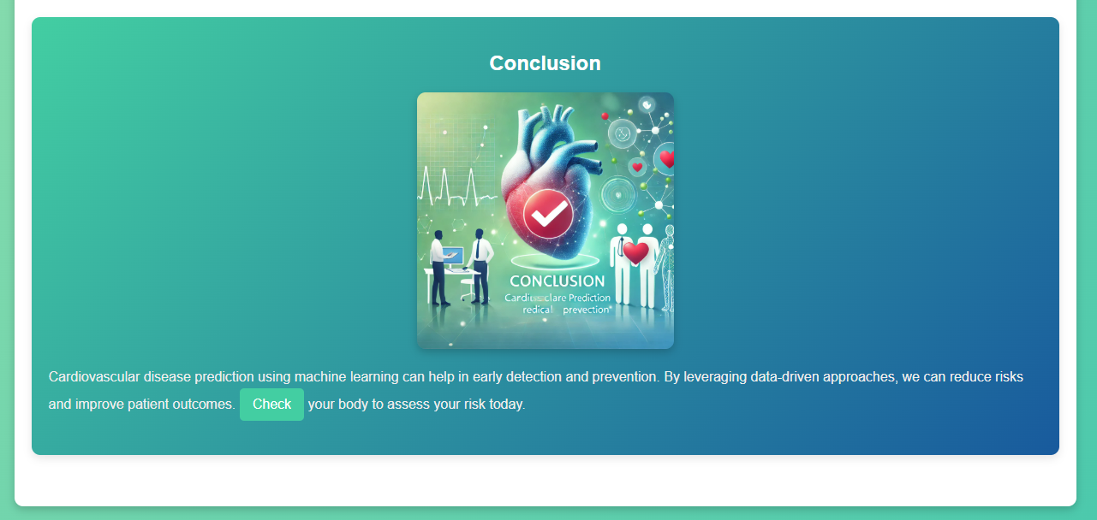
Figure 10: home page bottom
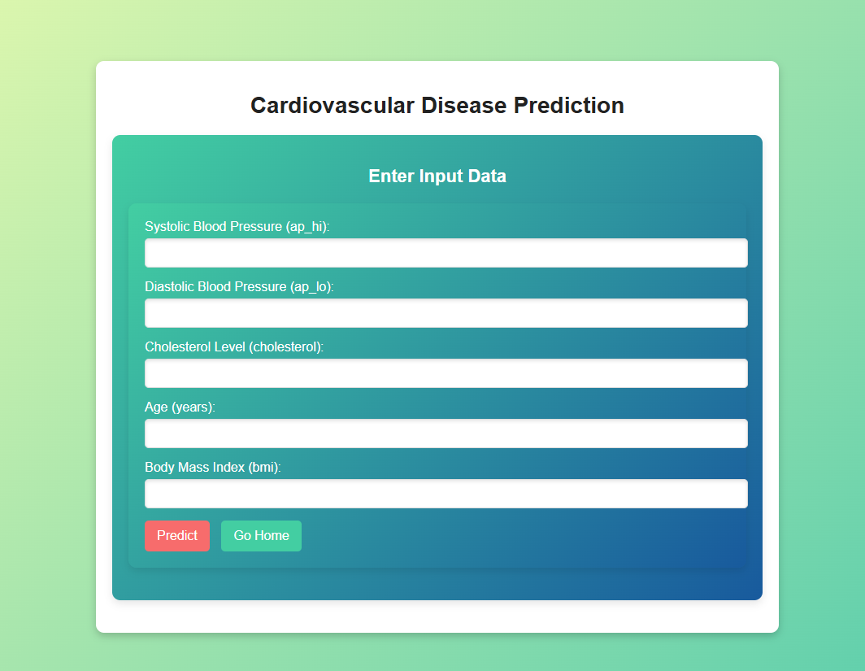
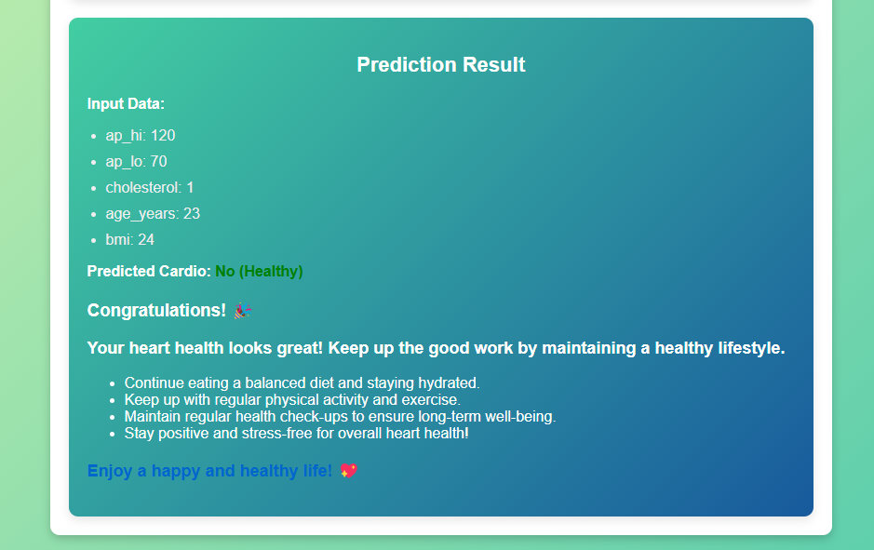
Figure 11: prediction page

Figure 12: Prediction with advice

4.4 Deployment Challenges
Running machine learning models comes with a number of technical and operational challenges. One large hurdle is that to be able to use Git, manage pipelines, and other CI/CD tasks. It takes an expert in versioning, building and testing automation, and orchestrating multi-stage deployment workflows. Seamless and tried and tested integration for each development phase can also be a challenge and configuration is trickier.
Moreover, running the system on Azure cloud services bring its challenges as well. There are vast number of tools and services in Azure, that make Azure super powerful but challenging at times to set up an infrastructure where all pieces like computer, storage, networking etc. are plugged in well together. It is complex to administer this connected world so that it is reliable, scalable and secure. Other challenges still include the ability to scale the deployment to accommodate fluctuations in workload and to have this machine learning model working efficiently with cloud resources. It is essential to be carefully allocated resources, which means that you should control CPU, memory, GPU use to achieve low latency and high throughput.
In addition, it is necessary that model performance does not degrade as time passes. This includes updating the model with new data in real-time or near real-time, detecting model drift, and retraining as needed to maintain accuracy. Maintaining the service from a deployment standpoint and still providing high availability and responsiveness in the presence of these updates is another level of complexity. Solving these challenges is critical to building a stable, scalable, and maintainable machine learning system that can have a real impact on health care.

Chapter 5

Experimental Results and Analysis

5.1 Data Analysis and Visualization
The dataset contains 68,205 instances where each sample contains 17 attributes related to patients’ demographic details, clinical measurements, and lifestyle behaviors. Quality check reveals no missing or duplicate data which makes the data is in the consistent state. The features are age, height, weight, blood pressure, cholesterol, glucose, smoker, and activity, and cardio is the target variable. Distribution for numerical and class balance for categorical variables were evaluated. A statistical summary was then provided for trend detection and suspect outliers. Once the data is clean, the next steps involve feature selection, model training and testing.
Table 6: Distribution of categorical features
Index | Column | Value | Cardio=0 | Cardio=1
0 | gender | 1 | 22593 | 21834
1 |  | 2 | 11940 | 11838
2 | cholesterol | 1 | 28953 | 22269
3 |  | 2 | 3721 | 5470
4 |  | 3 | 1859 | 5933
5 | gluc | 1 | 30477 | 27550
6 |  | 2 | 2068 | 2930
7 |  | 3 | 1988 | 3192
8 | smoke | 0 | 31346 | 30880
9 |  | 1 | 3187 | 2792
10 | alco | 0 | 32629 | 31952
11 |  | 1 | 1904 | 1720
12 | active | 0 | 6270 | 7129
13 |  | 1 | 28263 | 26543
14 | bp_category | Elevated | 2100 | 1001
15 |  | Hypertension Stage 1 | 21927 | 17823
16 |  | Hypertension Stage 2 | 3176 | 12761
17 |  | Normal | 7330 | 2087
18 | bp_category_encoded | Elevated | 2100 | 1001
19 |  | Hypertension Stage 1 | 21927 | 17823
20 |  | Hypertension Stage 2 | 3176 | 12761
21 |  | Normal | 7330 | 2087
The table provides a distribution of categorical features based on the presence or absence of cardiovascular disease.
- Gender: The dataset is nearly balanced across both genders, with male and female patients showing similar CVD distributions.
- Cholesterol: Higher cholesterol levels (2 and 3) are more common in patients with cardio=1, indicating a strong relationship with CVD.
- Glucose Levels: Patients with glucose level 1 form the majority, but higher glucose levels 2 and 3 are more frequent in CVD-positive cases.
- Lifestyle Factors: Smoking and alcohol consumption do not show a significant difference between CVD and non-CVD patients. However, physically active individuals have a slightly lower occurrence of CVD.
- Blood Pressure Categories: Hypertension Stage 1 and Stage 2 are dominant in CVD patients, confirming high blood pressure as a key risk factor.
This analysis highlights critical features influencing CVD, which will be further explored in feature importance and model evaluation.

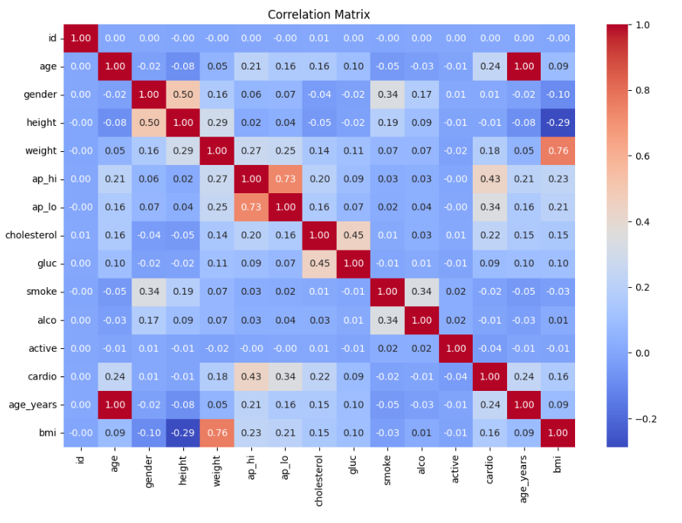
Figure 13: Correlation Matrix
The correlation matrix provides insights into the relationships between different features in the dataset. Key observations include:
Strong Correlation: Systolic (ap_hi) and diastolic (ap_lo) blood pressure show a strong correlation (0.73), indicating their direct dependency. Similarly, weight and BMI (0.76) are highly correlated.
Moderate Correlation with CVD (cardio): Systolic blood pressure (0.43) has the highest positive correlation with cardiovascular disease, confirming it as a key risk factor. Age (0.24) also shows a moderate correlation, meaning older individuals are more likely to have CVD. Cholesterol (0.22) and diastolic blood pressure (0.21) have noticeable associations with CVD risk.
Weak or No Correlation: Gender, height, smoking, and alcohol consumption show low correlation values, suggesting minimal impact on CVD prediction. This correlation analysis helps in feature selection, allowing the removal of less significant variables and prioritizing key predictors for model training.

5.1.1 Feature Visualization
Age
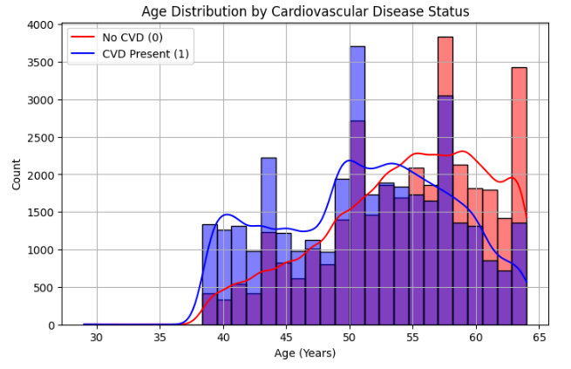
Figure 14: Age Distribution
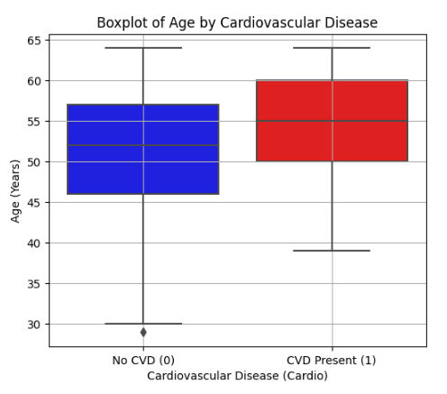
Figure 15: Boxplot of Age

The distribution of age among the CVD and Non-CVD group is presented in Figure 14. The histogram shows that younger people (less than 40 years) have lower CVD frequency, and CVD cases are relatively rare in this age group; and that the number of CVD cases increases sharply over 40 years old. The density of CVD present peaks to around 50–60 years, showing that elder people are easy to suffer CVD. On the other hand, the No CVD density, the density remains relatively homogeneous in various age groups.
Figure 15 shows a boxplot of actual age distributions for patients with and without CVD. The CVD diagnosis population has a visible higher median age as compared to the non-CVD diagnosis population. The interquartile range of CVD is concentrated at 50-60 years, indicating that the age is a strong determinant in CVD risk. Further some young people are seen as outliers as to imply that CVD is more prevalent among older people, it can also found in the younger population.

Gender
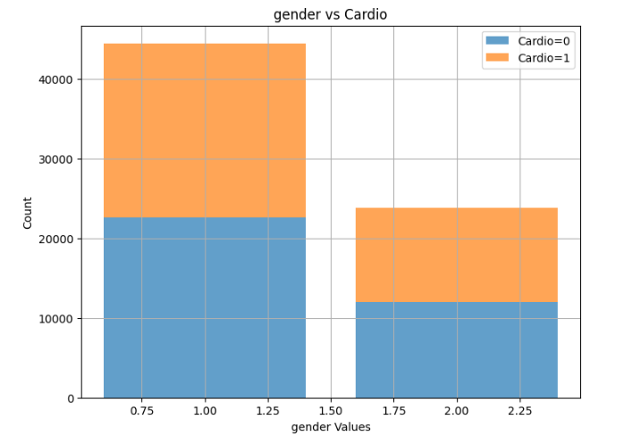
Figure 16: Gender Distribution
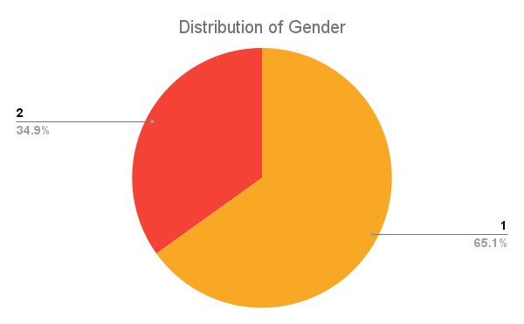
Figure 17: Distribution of Gender

Figure 16 illustrates the gender-specific distribution of CVD. The bar plot shows that there are more observations for men than women, and there are more cases of CVD for gender 2. There are relatively similar number of men and women with and without CVD, but the prevalence of other CVD risk factors also is almost the same, indicating that gender alone might not be the main predictor of CVD.
Figure 17 shows gender distribution in the data set, with 65.1% males, and 34.9% females. This implies that the dataset is skewed towards males, but the gender imbalance with respect to CVD is still in equilibrium. Additional analyses of gender in combination with other risk factors, such as age, blood pressure, and cholesterol values, might shed more insight into its effect on the risk of CVD.

Systolic Blood Pressure (ap_hi) and Diastolic Blood Pressure (ap_lo) :
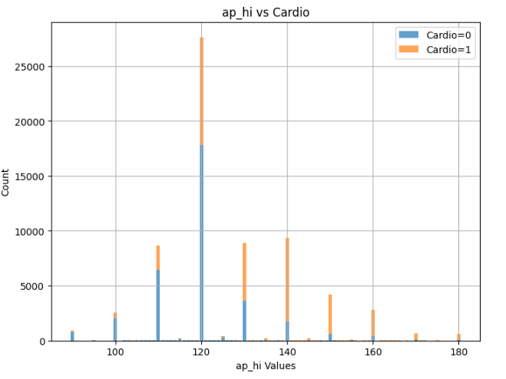
Figure 18: Systolic Blood Pressure

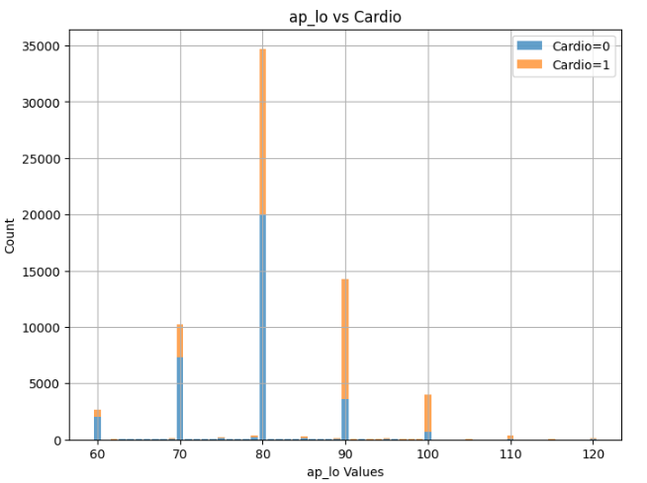
Figure 19: Diastolic Blood Pressure
Figure 18 describes the distribution of systolic blood pressure values with cardiovascular disease. Most people have a systolic blood pressure of 120 mm Hg, but there are many CVD-positive cases. The cardiovascular disease cases increase with SBP over 130 mmHg suggesting that there is a high association of high SBP with cardiovascular diseases.
The distribution of ap_lo values for patients with and without CVD is presented in Figure 19. Most subjects present a diastolic BP of 80 mmHg, and the number of CVD cases is larger in this group. Physical activity as diastolic BP exceeds 90 mmHg, the prevalence of CVD patients increases, indicating again that elevated blood pressure is a significant risk factor for CVD. These observations further support the role of control of hypertension in decreasing the risk of CVD.
Cholesterol

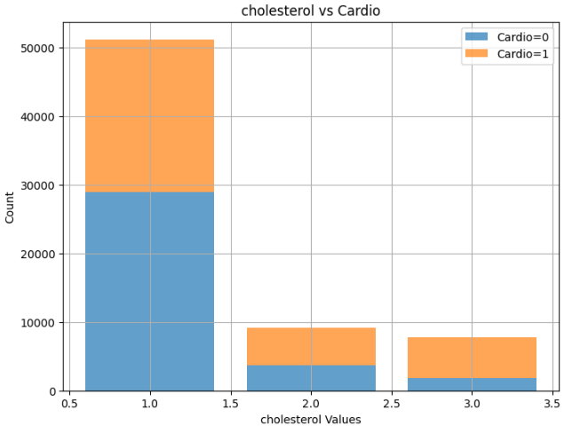
Figure 20: Cholesterol vs Cardio

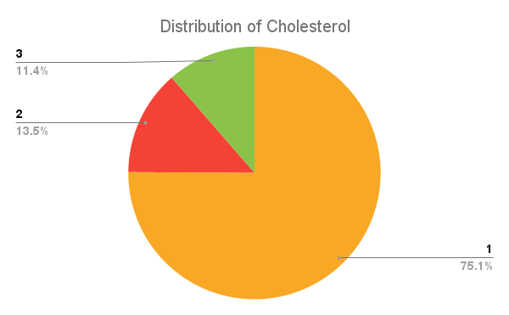
Figure 21: Distribution of cholesterol
Figure 20 illustrates the relationship between cholesterol levels and cardiovascular disease (cardio. As cholesterol levels increase (2 and 3), the proportion of CVD cases rises, indicating that higher cholesterol levels are associated with a greater risk of CVDs.
Figure 21 shows the overall distribution of cholesterol levels in the dataset. About 75.1% of individuals have normal cholesterol (1), 13.5% have slightly elevated cholesterol (2), and 11.4% have significantly high cholesterol (3). Since individuals with cholesterol levels 2 and 3 have a higher occurrence of CVD, this confirms that high cholesterol is a key risk factor for CVDs.
Glucose
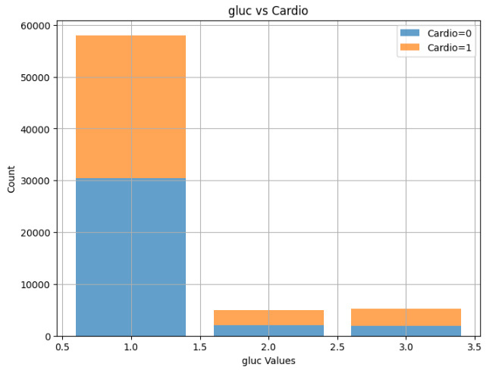
Figure 22: Glucose
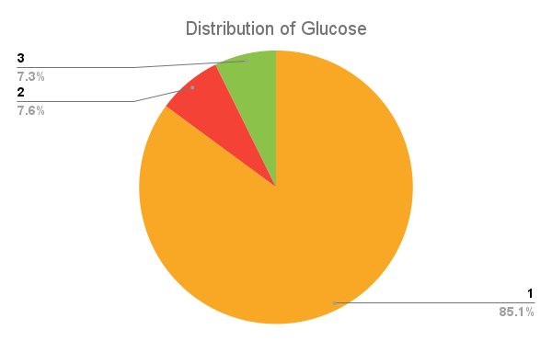
Figure 23: Distribution of glucose
Figure 22 shows the distribution of glucose levels for those suffering from and not (cardio=0) a cardiovascular disease. Most people have normal glucose levels, and many have CVD. Indeed, there is a rise of the ratio of the number of people with CVD to that of people without CVD with higher than normal and much higher than normal glucose, showing that higher glucose is related with higher risk of CVD.
Overall glucose-level distribution for the dataset is shown in figure 23. Approximately 85.1% are normoglycemic, 7.3% and 7.6% are at mildly and highly elevated levels of blood glucose. Respondents in levels 2 and 3 have a high relative percentage of CVD and thus we can see that for them high blood glucose, perhaps associated with diabetes, represents a major risk of CVD.

Smoking
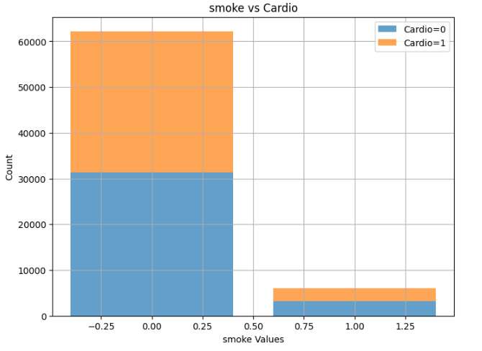
Figure 24: Smoke
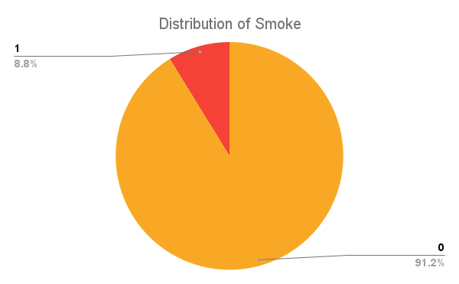
Figure 25: Distribution of Smoke
Figure 24 depicts the association between smoking status and cardiovascular disease. Most people are non-smokers and we have CVDs-positive and negative almost equally in the data set. There are smokers in this dataset, but their CVDs incidence is not different from that of the non-smokers. The distribution of smoking status in the sample is illustrated in Figure 25. -Estimated 91.2% are nonsmokers, 8.8% are smokers. As the proportion of CVDs cases does not significantly differ between smokers and non- smokers, this would indicate that in this dataset smoking is not an independent key risk factor for CVDs. Yet, smoking is still known to be a major factor contributing to CVDs, and its effects could be more apparent when combined with other risk factors such as high cholesterol and blood pressure and diabetes.
Alcohol Consumption

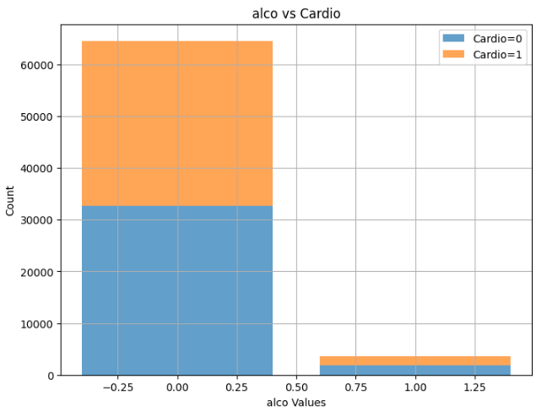
Figure 26: Alcohol Consumption

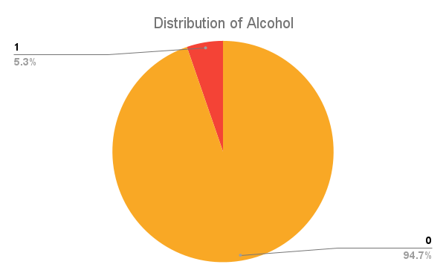
Figure 27: Distribution of Alcohol
In Figure 26, the association between alcohol intake and cardiovascular disease is given. Most of the people in the dataset were non-drinkers, and their distribution within the CVD-positive and CVD-negative cases is quite even. Few drink alcohol and there is no clear relationship between drinking and CVD in this dataset. Specifically, we have not statistically significant difference in the rate of CVD between those who drink and those who do not.
The alcohol intake distribution is shown in Figure 27. Individuals who do not drink account for approximately 94.7%, compared to those who drink 5.3%. As the proportion of CVD cases does not differ substantially in drinkers and non-drinkers, this would indicate that alcohol drinking alone may not be an independent strong risk factor for CVD in these data. But together with other risk factors such as high cholesterol, obesity and hypertension it seems to have more of an effect.
Physical Activity
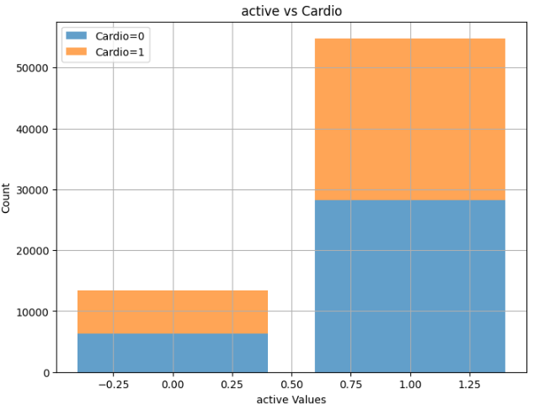
Figure 28: Physical Activity
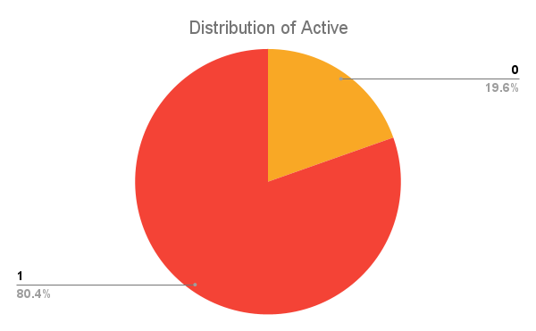
Figure 29: Distribution of Active
Figure 28 depicts the relation of physical activity with cardio. Most of the people in the dataset are active and amongst them, there is a large proportion of CVD-positive cases. Again, but when it comes to physically inactivity, the percentage of CVD cases out of everyone is a bit higher than 50%, meaning that if no one exercises, it will also potentially higher their risk to get affected by CVD.
Figure 29 describes the distribution of physical activity types in the dataset. 80.4% are physically active and 19.6% are inactive. The findings indicate that CVD affects both active and inactive subjects, although inactive individuals may be at greater risk of having CVD. Regular exercise is still key to minimizing your risk of getting heart disease as well as keeping your heart healthy.

- BMI vs. Cardio
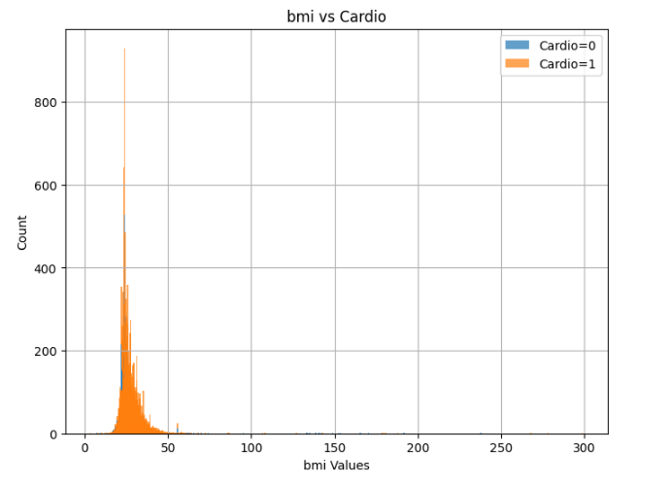
Figure 30: BMI

Figure 30 shows the distribution of Body Mass Index values in relation to cardiovascular disease. Most individuals in the dataset have BMI values ranging between 20 and 40, with a noticeable concentration of CVD cases in the higher BMI range. This trend suggests that individuals with higher BMI are more likely to develop cardiovascular disease, supporting the well-established link between obesity and heart disease.
Additionally, there are a few extreme BMI values above 100, which could be outliers or data anomalies. Despite this, the graph confirms that higher BMI is a potential risk factor for CVD, emphasizing the importance of maintaining a healthy weight for cardiovascular health.

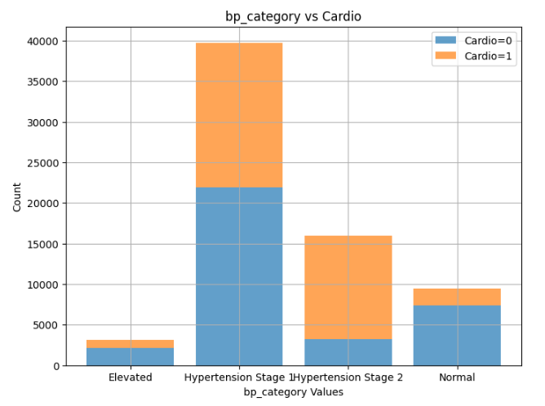
- Blood Pressure Category vs. Cardio

Figure 31: Blood Pressure Category

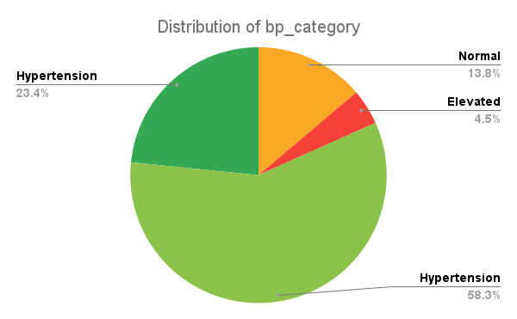
Figure 32: Distribution of bp_category

Figure 31 illustrates the distribution of blood pressure categories among individuals with and without cardiovascular disease. Most individuals fall under Hypertension Stage 1, and a significant portion of them have CVD. Hypertension Stage 2 also shows a high proportion of CVD cases, further confirming that higher blood pressure is a strong risk factor for cardiovascular disease. Individuals with normal blood pressure have a lower occurrence of CVD, while those classified as elevated have the least cases, indicating a progression in risk with increasing blood pressure levels.
Figure 32 presents the overall distribution of blood pressure categories in the dataset. About 58.3% of individuals are in Hypertension Stage 1, 23.4% in Hypertension Stage 2, 13.8% have normal blood pressure, and 4.5% fall in the elevated category. Since a large portion of CVD cases are concentrated in Hypertension Stage 1 and 2, this reinforces that hypertension is a major contributor to cardiovascular disease risk.

5.1.2 Dimensionality Reduction and Feature Analysis
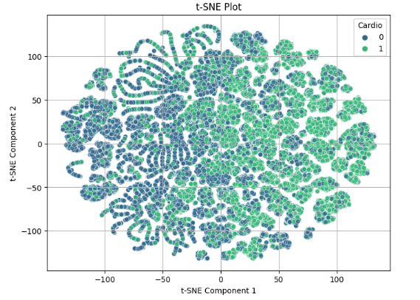
Figure 33: t-SNE plot

The t-SNE plot shows the distribution of CVD-positive and CVD-negative cases in a two-dimensional space. The presence of multiple well-separated clusters indicates that some features effectively differentiate individuals with cardiovascular disease. However, there is still overlap between the two classes, suggesting that while feature selection has improved separation, additional optimization may be needed for classification.

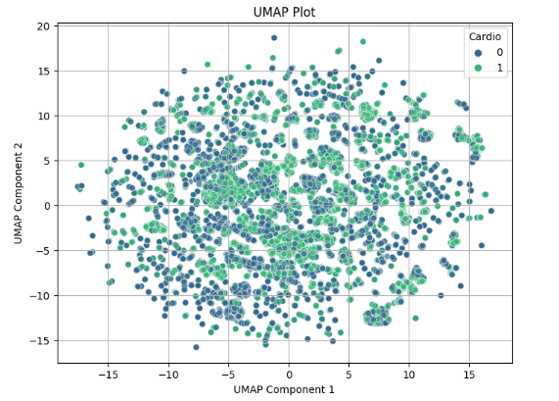
Figure 34: UMap plot
The Uniform Manifold Approximation and Projection plot provides a different perspective on feature distribution. Compared to t-SNE, the UMAP representation appears more evenly spread, indicating that the dataset has complex interdependencies between features. The degree of overlap suggests that cardiovascular disease prediction may not rely on a single feature but a combination of multiple health parameters.

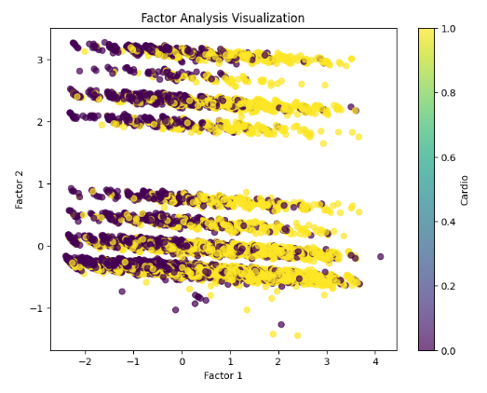
Figure 35: Factor Analysis Visualization
The Factor Analysis visualization represents data distribution based on key latent variables. The color gradient from dark purple to yellow indicates the progression from non-CVD to CVD cases. The structured alignment of data points suggests that selected features, such as blood pressure, cholesterol, and BMI, significantly contribute to distinguishing between classes. However, some variance remains, indicating that additional fine-tuning of features could further enhance predictive accuracy. These visualizations confirm that high blood pressure, cholesterol, and BMI play a key role in CVD classification, but some overlap between classes still exists. A combination of feature selection, advanced modeling techniques, and additional clinical indicators may be necessary to achieve higher prediction accuracy.

5.2 Feature Correlation and Importance Results
In this section, we analyze the relationship between different features and their significance in predicting cardiovascular disease. Feature selection plays a crucial role in improving model performance by eliminating irrelevant or less significant variables. This study utilizes RFE with a RF Classifier to identify the most influential predictors of cardiovascular disease.

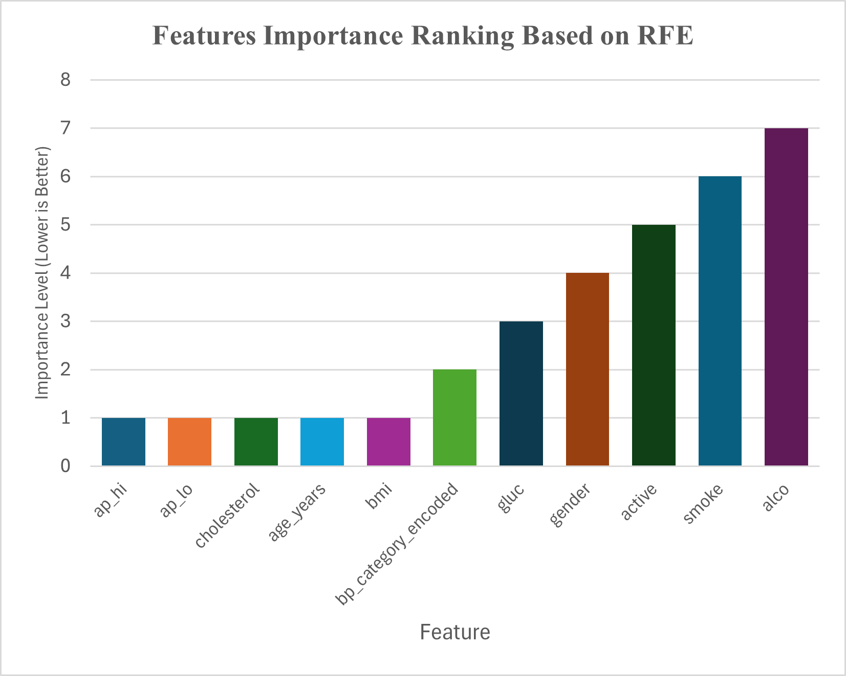
Figure 36: Recursive Feature Elimination (RFE) ranking

The Recursive Feature Elimination ranking highlights the most significant features for predicting cardiovascular disease, where a lower ranking indicates greater importance to model performance. Among the top-ranked features, systolic blood pressure emerges as the most critical predictor, reflecting the strong link between hypertension and cardiovascular risk. Diastolic blood pressure also plays a vital role, further emphasizing the importance of blood pressure in disease prediction. Other key factors include cholesterol levels, which influence metabolic health, age, which remains a significant risk factor with increased susceptibility in older individuals, and body mass index, associated with obesity-related heart conditions. Features with moderate importance include blood pressure category, which classifies individuals into normal, elevated, or hypertensive groups, and glucose levels, where elevated values are linked to metabolic disorders such as diabetes that contribute to cardiovascular disease. Conversely, lifestyle-related features such as gender, physical activity, smoking, and alcohol consumption were found to have lower predictive power compared to these clinical and physiological indicators.

5.3 Performance Comparison of ML Models
Based on the feature importance analysis using Recursive Feature Elimination and subsequent model evaluation, the five most significant predictors of cardiovascular disease were identified to optimize model performance while reducing complexity. These key features include systolic blood pressure a strong indicator of hypertension and a major risk factor for cardiovascular disease; diastolic blood pressure which provides important insights into overall blood pressure and cardiovascular health; cholesterol levels, directly associated with increased heart disease risk; age, as older individuals are more susceptible to developing cardiovascular disease; and body mass index (BMI), reflecting the impact of obesity on cardiovascular conditions. To assess the predictive effectiveness, multiple machine learning classification algorithms were applied, and their test accuracy scores were compared. Among these, LightGBM, Gradient Boosting, and XGBoost emerged as the top-performing models, demonstrating superior accuracy in predicting cardiovascular disease.

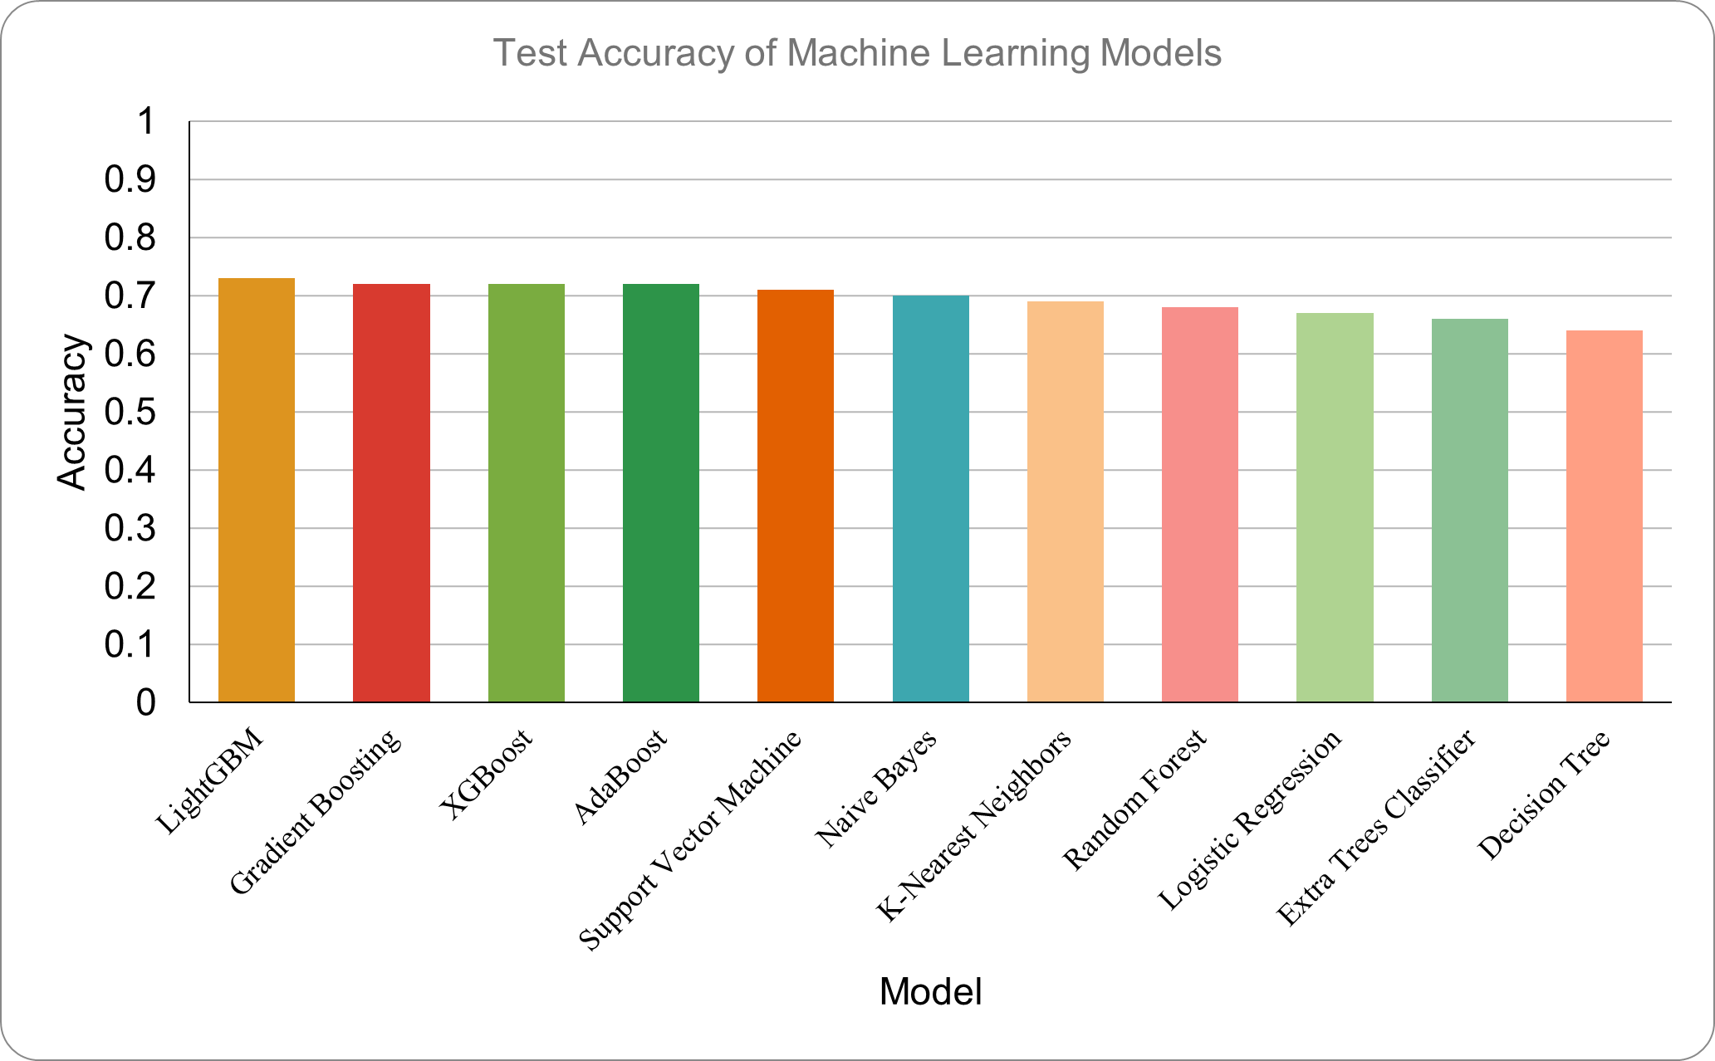
Figure 37: Model Comparison

5.3.1 LightGBM
LightGBM outperformed all other models, achieving the highest test accuracy. Its ability to handle large datasets efficiently and capture complex feature interactions contributed to its superior performance.

Table 7: LightGBM classification report
Metric/Class | Precision | Recall | F1-Score | Support
0 | 0.71 | 0.79 | 0.75 | 10395
1 | 0.75 | 0.67 | 0.71 | 10067
Accuracy |  |  | 0.73 | 20462
Macro Avg | 0.73 | 0.73 | 0.73 | 20462
Weighted Avg | 0.73 | 0.73 | 0.73 | 20462
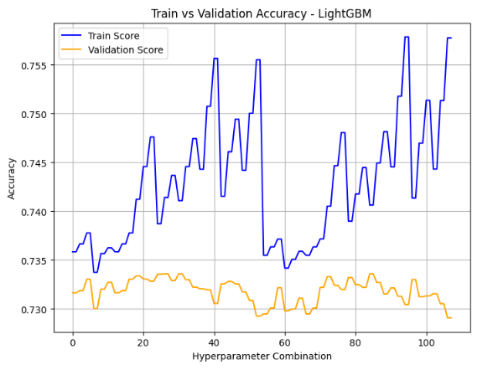
Figure 38: Train vs Validation Accuracy LightGBM
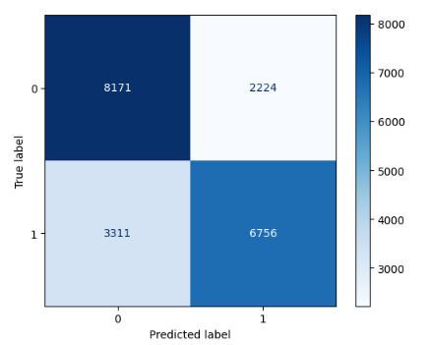
Figure 39: Confusion Matrix of LightGBM

5.3.2 Gradient Boosting
Gradient Boosting performed almost as well as LightGBM. It effectively reduces bias and variance through iterative learning, making it highly suitable for structured medical datasets.
Table 8: Gradient Boosting Classification Report
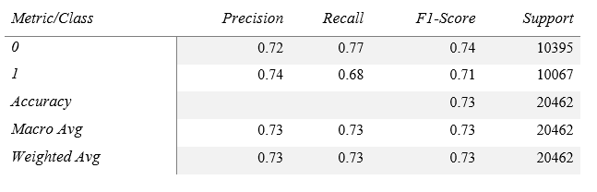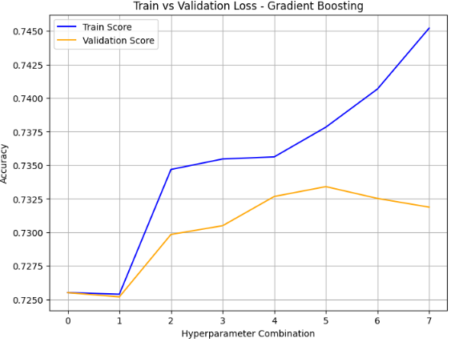
Figure 40: Train vs Validation Loss - Gradient Boosting

5.3.3 XGBoost
XGBoost delivered comparable results to Gradient Boosting, demonstrating strong generalization capabilities. Its ability to minimize overfitting and optimize computation efficiency made it one of the best-performing models.
Table 9: XGBoost Classification Report
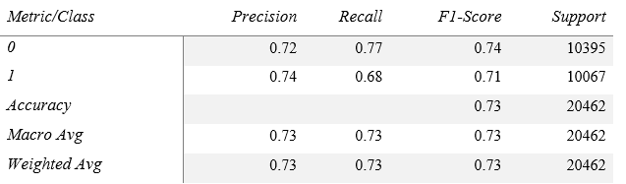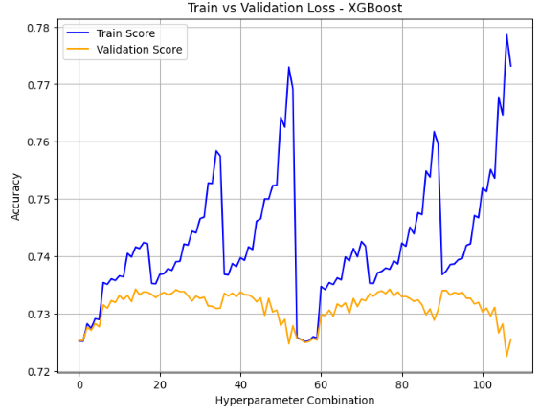
Figure 41: Train vs Validation Loss – XGBoost

Chapter 6

Findings and Conclusion

We concentrate here on how the second and third aims of the study were accomplished, namely the siding over of machine learning algorithms for CVD prediction and the optimization of these algorithms using feature selection methods. These two aims are at the heart of the research, which will help to create a reliable and effective CVD prediction system.

6.1 Decreasing The dataset Complexity
We run machine learning models such as LightGBM, Gradient Boosting, and XGBoost, to estimate the CVD risk. We initially developed the language models using a 17-feature input set. By performing RFE to keep only the most significant factors, and down sampling the data to 5 factors, we were able to reduce our dataset to 5 factors. Performance of the models was not affected by simplifying the features by sub setting the dataset, suggesting that the reduced feature set did not eliminate relevant information from the model. The prediction time of our model has been decreased by using this technique. Selected Key Features with RFE is ap_hi (systolic blood pressure), ap_hi (systolic blood pressure), cholesterol, age_years, bmi.
Table 10: Comparison Table
Model | Accuracy with 17 Features | Accuracy with 5 features
LightGBM | 0.73 | 0.73
Gradient Boosting | 0.73 | 0.73
XGBoost | 0.73 | 0.73

One of our main contributions is that we achieve the same accuracy with 5 features. So, we do not need the whole dataset to build the models which is decreasing our model complexity and model predictions time.

6.2 Real World Application
For practical purposes of clinical CVDs prediction, we realized a Web-interface for the application of our ML model, where relevant clinical-biological variables can be entered, and the online prediction can be called. With our best model of 73% accuracy, we take in data (blood pressure, cholesterol, age, BMI) and we predict whether the person is at risk of cardiovascular disease. It can be easily incorporated in clinical routine, and it is fast, accurate and scalable. The system could be used for aiding early recognition and prevention of this disease, better clinical decision making and patient outcomes by reducing the complexity of the dataset and focusing on the actionable features.


Figure 42: Real World Application Interface

6.3 Conclusion
The objective of this study was to construct the machine learning-based cardiovascular disease Prediction System by utilizing a patient's health-related datasets in order to predict the probability of CVD. The study can develop a good predictive model with XGBoost with a higher classification ability than its counterparts such as LR, RF. The software was developed with a FastAPI backend to process user input and the Python-based pre-trained model, and with the frontend to have a user-friendly interface for providing input and taking the results.
Research findings show ML, and ensemble learning techniques improve cardiovascular disease prediction accuracy substantially. It is observed that systolic and diastolic blood pressure, cholesterol, BMI and age are the key factors contributing significantly to CVD risk. The generalization ability of the trained model was examined by testing with multiple performance estimates, indicating that it was reliable in prediction of cardiovascular risk.
The model was easily deployed in Azure which could be accessed for real time predictions. A responsive page-based layout and intuitively displayed elements were developed for the user interface to maintain clarity for the user who enters his/her health data. The results validate the promise of AI-based predictive models in health care, for early detection and risk stratification in CVDs, that can help in early warning and diagnostic accuracy, thereby enhancing preventive and clinical care.

6.4 Challenges and Limitations
Despite the successful implementation of the system, several challenges were encountered during both development and deployment. One major limitation was related to the dataset, which was sourced from publicly accessible repositories and may not fully represent real-world clinical populations. Additionally, data imbalance in certain health parameters necessitated the use of techniques such as resampling and feature engineering to enhance model performance. Generalization of the model also posed challenges; although XGBoost demonstrated satisfactory accuracy on the test set, its performance on unseen clinical data could vary due to differences in demographic characteristics. Validation across diverse ethnicities, age groups, and medical conditions remains essential. Computational constraints were another concern, as retraining complex models like XGBoost and Gradient Boosting frequently demands significant processing power, and hyperparameter tuning proved time-consuming when evaluating multiple models. Deployment challenges included integrating the FastAPI backend with the machine learning model, which required careful management of dependencies to avoid compatibility issues. While the user interface is responsive and efficient, there is room for improvement in simplicity and user enjoyment. Incorporating additional visualizations, interactive graphs, and feedback mechanisms could further enhance the overall user experience.

6.5 Future Work
To further develop the Cardiovascular Disease Prediction System, the following improvements are needed that the dataset should be expanded with more comprehensive and representative clinical data from multiple hospitals and health care systems to increase the robustness and generalization of prediction models. Real-time patient data from wearable health tracking devices, such as smartwatches or fitness trackers including recent physiological measurements would facilitate more dynamic and precise risk predictions by supplementing the dataset.
Future works could further consider incorporating advanced deep learning models such as neural networks, CNNs, and LSTMs to capture the challenging nonlinear temporal and spatial information in CVD. Ensemble learning algorithms wrapped with deep learning structures like the above deep ensemble can lead to even better predictive power and be able to handle more types of data. There could be challenges when migration the system to elastic cloud computing platforms like AWS, that must support real-time inference and massive user accessing. Containerization with tools such as Docker and orchestration frameworks like Kubernetes can help to simplify and standardize deployment processes, maintain version control, and optimize resource utilization across various environments. A better UI/UX is important for mass adoption. Adding dashboards that are interactive with rich visual reports will allow users to 'see' their levels and risk factors more clearly. Enabling multi-language support will increase accessibility, and allowing chatbot assisted and voice input processing will improve usability, particularly to target users with low literacy and persons with disabilities.

References
- J. Gupta, "The Accuracy of Supervised Machine Learning Algorithms in Predicting Cardiovascular Disease," 2021 International Conference on Artificial Intelligence and Computer Science Technology (ICAICST), Yogyakarta, Indonesia, 2021, pp. 234-239,
- K. G. Dinesh, K. Arumugaraj, K. D. Santhosh and V. Mareeswari, "Prediction of Cardiovascular Disease Using Machine Learning Algorithms," 2018 International Conference on Current Trends towards Converging Technologies (ICCTCT), Coimbatore, India, 2018, pp. 1-7,
- M. Shahiduzzaman, N. H. Biswas, M. Momin and R. Sikdar, "Prognosis of Cardiovascular Disease Using Machine Learning Procedures," 2022 International Conference on Advancement in Electrical and Electronic Engineering (ICAEEE), Gazipur, Bangladesh, 2022, pp. 1-6,
- N. K. Chauhan and N. Kaur, "Predicting Cardiovascular Diseases Using Machine Learning Integrated with Feature Selection Through Blue Whale Optimization," 2023 10th IEEE Uttar Pradesh Section International Conference on Electrical, Electronics and Computer Engineering (UPCON), Gautam Buddha Nagar, India, 2023, pp. 464-469, doi: 10.1109/UPCON59197.2023.10434597.
- O. M. Moushi, N. Ara, M. Helaluddin and H. S. Mondal, "Enhancing the Accuracy and Explainability of Heart Disease Prediction Models through Interpretable Machine Learning Techniques," 2023 International Conference on Information and Communication Technology for Sustainable Development (ICICT4SD), Dhaka, Bangladesh, 2023, pp. 1-6,
- J. Digumarthi, V. M. Gayathri and R. Pitchai, "Recognition of Heart Disease Based on Primitive Parameters Using Machine Learning Model," 2023 7th International Conference on Electronics, Communication and Aerospace Technology (ICECA), Coimbatore, India, 2023, pp. 649-653,
- N. Prakash, M. Mahesh and P. Gouthaman, "Cardiovascular Disease Risk Assessment using Machine Learning," 2023 International Conference on Inventive Computation Technologies (ICICT), Lalitpur, Nepal, 2023, pp. 249-256,
- S. K. Debnath, S. Malik, G. Kaur, S. Bagchi, A. M. Soomro and A. Naeem, "Prediction Accuracy Improvement for Cardiovascular Diseases Using Machine Learning Algorithm," 2023 10th IEEE Uttar Pradesh Section International Conference on Electrical, Electronics and Computer Engineering (UPCON), Gautam Buddha Nagar, India, 2023, pp. 1032-1037,
- K. Tsarapatsani et al., "Machine Learning Models for Cardiovascular Disease Events Prediction," 2022 44th Annual International Conference of the IEEE Engineering in Medicine & Biology Society (EMBC), Glasgow, Scotland, United Kingdom, 2022, pp. 1066-1069,
- Abhishek, H. V. Bhagat and M. Singh, "A Machine Learning Model for the Early Prediction of Cardiovascular Disease in Patients," 2023 Second International Conference on Advances in Computational Intelligence and Communication (ICACIC), Puducherry, India, 2023, pp. 1-5,
- E. Braunwald, Heart Disease: A Textbook of Cardiovascular Medicine. Philadelphia, PA: Elsevier, 2019.
- P. Libby et al., "Mechanisms of acute coronary syndromes and their implications for therapy," New England Journal of Medicine, vol. 368, no. 21, pp. 2004-2013, 2013.
- Y. LeCun, Y. Bengio, and G. Hinton, "Deep learning," Nature, vol. 521, pp. 436–444, 2015.
- World Health Organization, "cardiovascular diseases (CVDs)," WHO, 2023. [Online]. Available: https://www.who.int/health-topics/cardiovascular-diseases.
- A. Roth et al., "Trends in cardiovascular mortality by country," Lancet, vol. 393, pp. 107–115, 2019.
- A. S. Go et al., "heart disease and stroke statistics—2023 update," Circulation, vol. 147, no. 4, pp. e93-e621, 2023.
- J. N. Wilkins, "The Economic Burden of Cardiovascular Disease: Implications for Public Health," American Journal of Cardiology, vol. 128, no. 2, pp. 123–130, 2022.
- M. J. Mack, "Minimally invasive and robotic surgery in cardiac surgery," JACC: Cardiovascular Interventions, vol. 13, no. 1, pp. 138-149, 2020.
- J. P. Desai et al., "Global burden of cardiovascular diseases: The rising impact in low-income and middle-income countries," The Lancet Global Health, vol. 8, no. 2, pp. e229-e230, 2021.
- R. Gupta et al., "Epidemiology and causation of coronary heart disease and stroke in India," Heart, vol. 104, no. 3, pp. 231-237, 2018.
- American Heart Association, "cardiovascular disease: Economic Impact and Cost Analysis," AHA Report, 2022. [Online]. Available: https://www.heart.org/.
- European Society of Cardiology, "Cardiovascular Disease Prevention in Europe," ESC Report, 2021. [Online]. Available: https://www.escardio.org/.
- M. J. Perry, "Socioeconomic status and cardiovascular disease risk: A review of the evidence," American Journal of Public Health, vol. 112, no. 6, pp. 980-987, 2022.
- V. Vaccarino et al., "Sex Differences in Acute Coronary Syndrome: Clinical Presentation and Outcomes," JAMA Cardiology, vol. 6, no. 9, pp. 982-990, 2021.
- World Health Organization, "The Global Hearts Initiative: A Strategy for Cardiovascular Disease Prevention," WHO, 2023. [Online]. Available: https://www.who.int/initiatives/global-hearts.
- S. Mamoshina, A. Ozerov, I. Cortell, and A. Zhavoronkov, "Applications of deep learning in biomedicine," Molecular Pharmaceutics, vol. 15, no. 10, pp. 4312–4318, 2018.
- J. K. Perk et al., The Cardiovascular System: An Introduction to Structure and Function, 2nd ed. Oxford, UK: Oxford University Press, 2021.
- W. R. Milnor, Hemodynamics of the Circulatory System, 3rd ed. Cambridge, MA: Harvard University Press, 2019.
- R. S. Ross, "Anatomy and physiology of the human heart," Journal of Cardiovascular Medicine, vol. 29, no. 3, pp. 215-225, 2021.
- S. Chatterjee and P. Ram, "The electrical activity of the heart and its significance," Circulation Research, vol. 125, no. 6, pp. 1121-1135, 2022.
- D. J. Skorton et al., The Cardiac Cycle and Its Disorders, New York, NY: Springer, 2020.
- J. M. Jones, "Blood vessels: Structure and function," British Journal of Physiology, vol. 46, no. 1, pp. 85-102, 2019.
- J. T. Smith et al., "Role of the capillary network in metabolic exchange," Journal of Vascular Research, vol. 58, no. 4, pp. 312-328, 2021.
- L. K. Peterson, Blood and Its Components: Functions and Disorders, London, UK: Academic Press, 2020.
- M. P. Fuster et al., "Regulation of systemic and pulmonary circulation," European Heart Journal, vol. 42, no. 5, pp. 843-856, 2022.
- D. L. Mann et al., Braunwald's Heart Disease: A Textbook of Cardiovascular Medicine, 11th ed. Philadelphia, PA: Elsevier, 2019.
- J. R. Kaplan and A. J. Manuck, "The role of stress in cardiovascular disease," Cardiovascular Research, vol. 43, no. 3, pp. 156-165, 2020.
- J. A. Cohn, "Red blood cells and their role in oxygen transport," American Journal of Hematology, vol. 112, no. 5, pp. 987-1002, 2021.
- M. H. Laughlin, Cardiovascular Physiology in Exercise, New York, NY: Springer, 2022.
- S. R. Patel, J. L. Malhotra, and P. N. Martin, "Cardiovascular implications of hypertension and its management," Journal of Hypertension Research, vol. 57, no. 4, pp. 678-693, 2021.
- T. Soni, S. Mehta, and P. Kumar, "Machine Learning Applications in Cardiovascular Disease Prediction: A Review of Recent Advances," IEEE Access, vol. 12, pp. 56321-56339, 2024.
- M. S. Hossain, R. Akter, and T. Islam, "Predicting Cardiovascular Disease Using Machine Learning: A Comparative Analysis of Classification Algorithms," IEEE Transactions on Biomedical Engineering, vol. 71, no. 2, pp. 178-189, 2024.
- S. R. Badada, A. Singh, and R. Sharma, "Ensemble Learning for Cardiovascular Risk Prediction: Performance and Feature Importance," IEEE Journal of Biomedical and Health Informatics, vol. 27, no. 1, pp. 91-104, 2023.
- World Health Organization, Cardiovascular diseases (CVDs), Jun. 11, 2021. [Online]. Available: https://www.who.int/news-room/fact-sheets/detail/cardiovascular-diseases-(cvds)
- F. Pedregosa et al., “Scikit-learn: Machine Learning in Python,” Journal of Machine Learning Research, vol. 12, pp. 2825–2830, 2011. [Online]. Available: https://scikit-learn.org/stable/modules/generated/sklearn.feature_selection.RFE.html
- https://www.kaggle.com/datasets/colewelkins/cardiovascular-disease

Appendix
https://github.com/siamarefin/CardioVascular-Disease-Prediction

