Project

On



**“Premier League Football”**

**Database Management System**

**Prepared by**

|  |  |
| --- | --- |
| Name | ID |
| Talukder, Jamilush Siam | 14-25484-1 |
| Mazumder, Pronay | 15-29318-1 |
|  |  |

**Submitted to**

**NASHIA AHMED NABILA**

**Assistant Professor,**

**American International University - Bangladesh**

**Ka-66/1, Kuratoli Road, Kuril, Khilkhet, Dhaka 1229, Bangladesh**

**Subject: Advanced Database Management System [Section: C]**

**INDEX**

Table of Contents

Chapter 01 3

Proposal of the System 3

Chapter 02 4

Entity Relationship Diagram of the System 4

Chapter 03 5

Use Case Diagram 5

Chapter 04 6

Activity Diagram 6

Chapter 05 7

Normalization up-to 3NF 7

Chapter 06 8

Schema Of the Final Tables 8

# 

# Chapter 01

# Proposal of the System

**Situation:** Soccer enthusiasts who always love to keep themselves updated find it difficult to search the information needed on a daily basis. The track record of every player and team are found on different websites thus it is almost impossible to check all the websites and collect all the data when needed. Moreover it will really time consuming if someone wants to find out specific information regarding a specific player.

**Proposed Solution:** The laborious work of searching the record of players/teams can be eradicated by creating well defined database. It will allow a user to find any data regarding soccer in seconds hence make life easier.

**Steps Involved:**

1. Creating an E-R diagram.
2. Creating a use case diagram.
3. Creating an activity diagram.
4. Removing anomalies up-to 3NF
5. Creating table and schemas.

**Benefits:**

1. Anyone can find desired information about players/team within few seconds.
2. All information in a single database system.

# Chapter 02

# Entity Relationship Diagram of the System

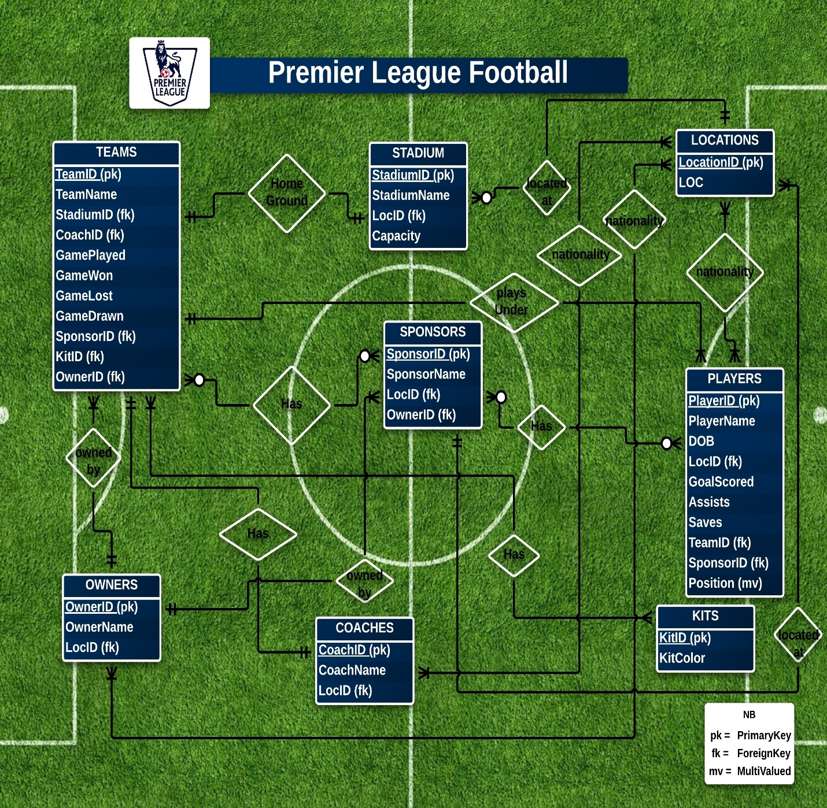

# Chapter 03

# Use Case Diagram

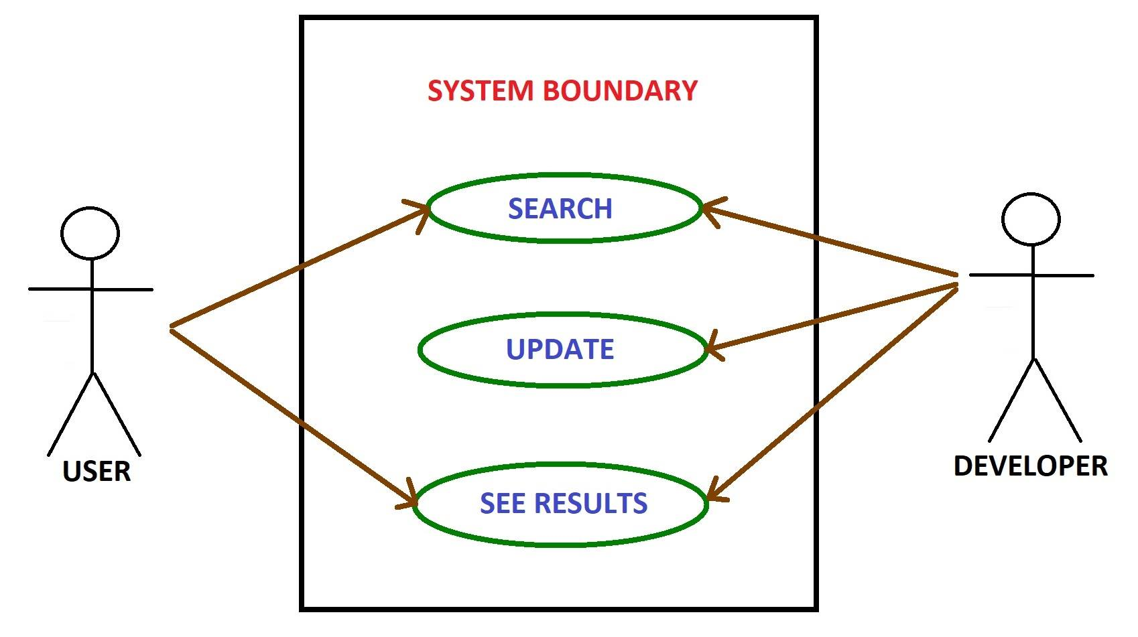

# Chapter 04

# Activity Diagram

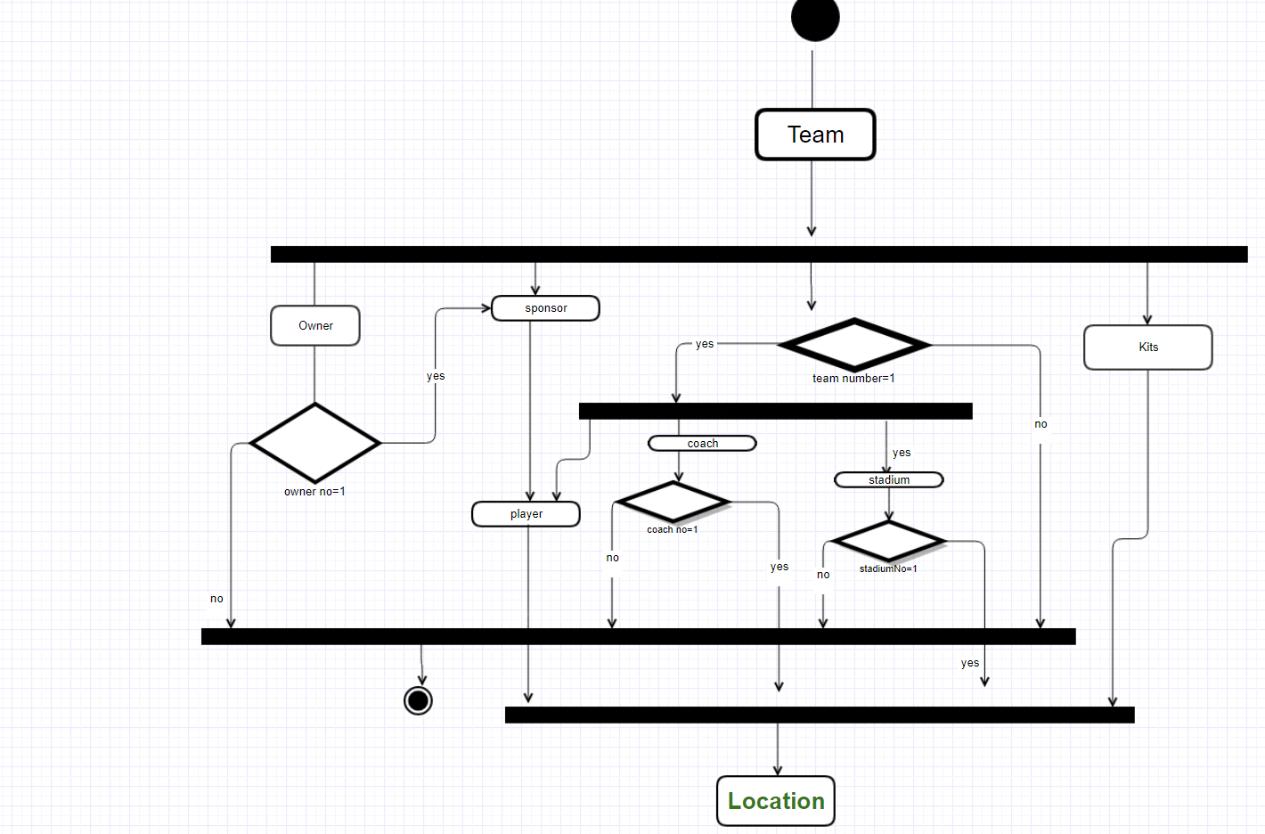

# Chapter 05

# Normalization up-to 3NF

Already all the relations are normalized up to 3NF except the players table.

Here in Players table,

**UNF:**

PlayerID, PlayerName, DOB, LocID, GoalScored, Assists, Saves, TeamID, SponsorID, **Position**

Here, Position is a multivalued attribute. So in 1NF that will be removed and will be replaced with a composite primary key of the same name.

**1NF:**

PlayerID, PlayerName, DOB, LocID, GoalScored, Assists, Saves, TeamID, SponsorID, Position

Now there is a partial dependency. To remove that we will create a new table named POSITIONS where the primary key of the players table and the position will together form a composite primary key.

**2NF:**

**Players_Table:** PlayerID, PlayerName, DOB, LocID, GoalScored, Assists, Saves, TeamID, SponsorID

**Positions_Table:** PlayerID, POS

There is no transitive dependency.

**3NF:**

**Players_Table:** PlayerID, PlayerName, DOB, LocID, GoalScored, Assists, Saves, TeamID, SponsorID

**Positions_Table:** PlayerID, POS

In each of the relation that is connected to Players_Table, such as with Teams_Table, Sponsors_Table, Locations_Table this normalization of Players_Table will occur only.

All the rest of the table are already normalized up to 3NF.

# Chapter 06

# Schema Of the Final Tables

|  |  |
| --- | --- |
| Table_Name | Schema |

