Proview Installation Guide Ubuntu
Release Ubuntu 9.10
System Requirements:
Platform: x86
Kernel >= 2.6.29

Package pwr47
Download the development package pwr47 and save to disk. It is saved in the Desktop catalog by default and viewed with an icon on the desktop.
Doubleclick on the pwr47 package icon to install the development package.

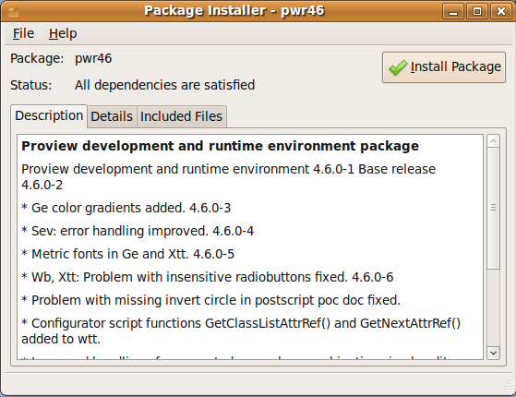
Click on the Install Package button to start the installation.
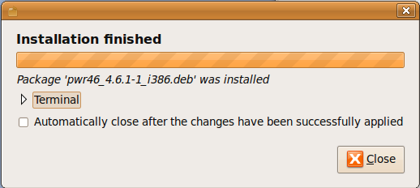

Login as user pwrp and start the Project Administrator by clicking on the Proview desktop icon.
If you are new to Proview, read the Proview Getting Started Guide available at www.proview.se

Package pwrdemo
Download the pwrdemo package and save to disk. It is saved in the Desktop catalog by default and viewed with an icon on the desktop.
Doubleclick on the pwrdemo package icon to install the demo project.
Click on the Install Package button to start the installation.
When the installation is finished, login as user pwrp and click on on the Pwrdemo icon on the desktop.
The runtime monitor for the demoproject is now started. Start the runtime environment by clicking on the 'Start Runtime' button.
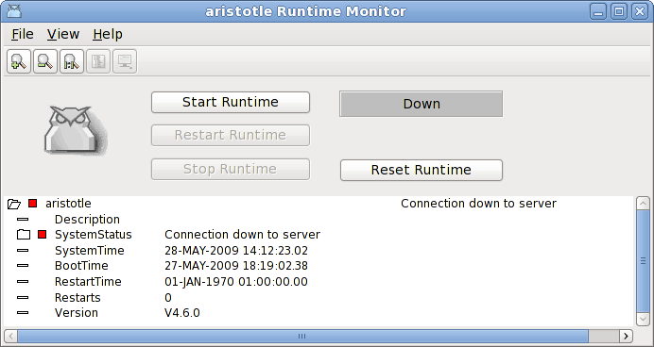
Fig Runtime monitor
When the label has switched from 'Down' to 'Running' activate File/Start Operator Environment in the menu. The operator window is now opened.
Fig Operator window
Acknowledge the alarms by clicking on the tick buttons to the left (this will remove the beep). Activate the PwrDemo, LevelControl and TemperatureControl buttons to view the demo project graphs.

Package pwrrt
Download the pwrrt package and save to disk. It is stored in the Desktop catalog by default and viewed with an icon on the desktop.
Doubleclick on the pwrrt package icon to install the runtime package.

The runtime package should be installed "stand-alone" without the pwr47-package.
A linux-system with the pwrrt-package is your control- or HMI-system. Proview will be started automatically at boot-time.

Package pwrsev
Install mysql-client and mysql-server.
Download the pwrsev package and save to disk. It is stored in the Desktop catalog by default and viewed with an icon on the desktop.
Doubleclick on the pwrsev package icon to install the package.
The storage environment package should be installed "stand-alone" without the pwr47 or pwrrt package.

