Proview Installation Guide Debian
Debian distribution: Debian Lenny/Sid
System Requirements
Platform: x86
Kernel >= 2..6.24
glibc: >= 2.7.14

Package pwr46
Dependencies
libgtk2.0-0 >= 2.12.11-4
libasound2 >= 1.0.16-2
libdb4.6 >= 4.6.21-11
libdb4.6++ >= 4.6.21-11
libmysqlclient15off >= 5.0.51a-15
g++ >= 4:4.3.2-2

Download the pwr46 development package and save to disk. By default it is stored in home catalog. Open a terminal and become root

> su

Install some packages with for example apt-get

> apt-get install gcc
> apt-get install g++
> apt-get install libmysqlclient15off

Install the downloaded package with dpkg

> dpkg -i pwr46_4.6.x-x_ix86.deb

If some dependencies still are missing they are installed (together with pwr46) by the command

> apt-get install -f
Login as user pwrp and start the Project Administrator by clicking on the Proview desktop icon.
If you are new to Proview, read the Proview Getting Started Guide available at www.proview.se

Package pwrdemo
The demo package installs a Proview project that contains a demo of the dynamics and components of the HMI, some application examples, a level and a temperature control, and some examples of basecomponent.
The development package pwr46 has to be installed before installing the pwrdemo package.
Download the debian package and install with dpkg

> dpkg -i pwrdemo46_4.6.x-x_ix86.deb

Login as user pwrp and click on on the Pwrdemo icon on the desktop.
The runtime monitor for the demoproject is now started. Start the runtime environment by clicking on the 'Start Runtime' button.
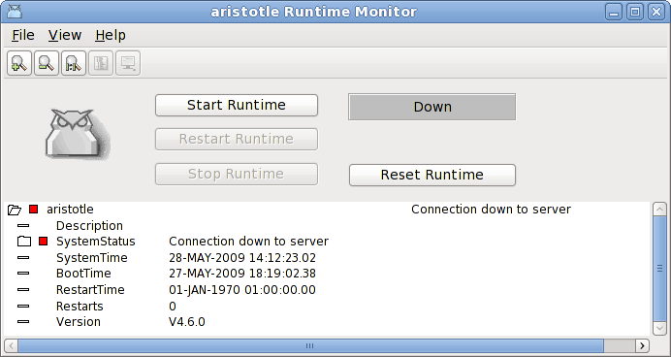
Fig Runtime monitor
When the label has switched from 'Down' to 'Running' activate File/Start Operator Envronment in the menu. The operator window is now opened.
Fig Operator window
Acknowlege the alarms by clicking on the tick buttons to the left (this will remove the beep). Activate the PwrDemo, LevelControl and TemperatureControl buttons to view the demo project graphs.

Package pwrrt
Dependencies:
libgtk2.0-0 >= 2.12.11-4
libasound2 >= 1.0.16-2
libdb4.6 >= 4.6.21-11

Download your selected debian-package and install it as:

> dpkg -i pwrrt_4.6.x-x_i386.deb

The runtime package should be installed "stand-alone" without the pwr46-package.
A linux-system with the pwrrt-package is your control-system. Proview will be
started automatically at boot-time.

Package pwrsev
Install mysql-client and mysql-server.

Download the pwrsev package and install with dpkg. dpkg doesn't check any depedencies. You have to check that these packages are installed
libgtk2.0-0 >= 2.12.11-4
libasound2 >= 1.0.16-2
libdb4.6 >= 4.6.21-11
libmysqlclient15off >= 5.0.51a-15

> dpkg -i pwrsev_4.6.x-x_i386.deb

The storage environment package should be installed "stand-alone" without the pwr46 or pwrrt package.

