Proview Installation Guide Suse
Suse distribution: openSuse 11.1
System Requirements:
Platform: x86
Kernel: >= 2.6.6
glibc: >= 2.5

Package pwr46
Start the Software Manager by activating Install Software in the menu, and install the packages
- gcc
- gcc-c++
- db43
- libmysqlclient15
- xorg-x11-fonts

Download the pwr46 package and save to disk. The package is downloaded to the Desktop directory as default, thus beeing viewed with an icon on the desktop.Doubleclick on the pwr46 icon on the desktop.
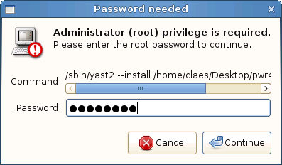
Enter the root password and click on continue.
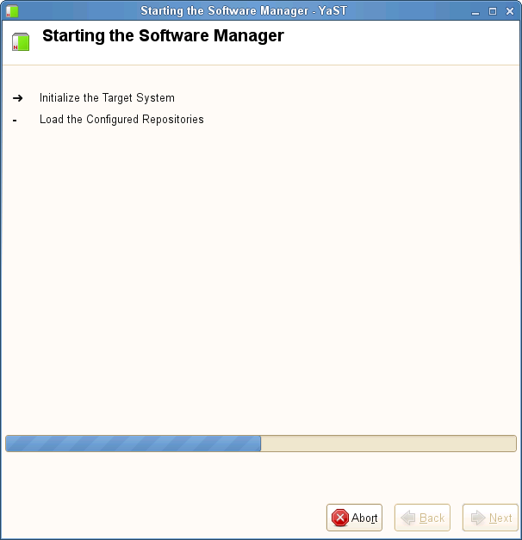
The package is now beeing installed.

Package pwrdemo
Download the pwrdemo package and save to disk. The package is downloaded to the Desktop directory as default, thus beeing viewed with an icon on the desktop.Doubleclick on the pwrdemo icon on the desktop to start the installation.
When the installation is finished, login as user pwrp and click on on the Pwrdemo icon on the desktop.
The runtime monitor for the demoproject is now started. Start the runtime environment by clicking on the 'Start Runtime' button.
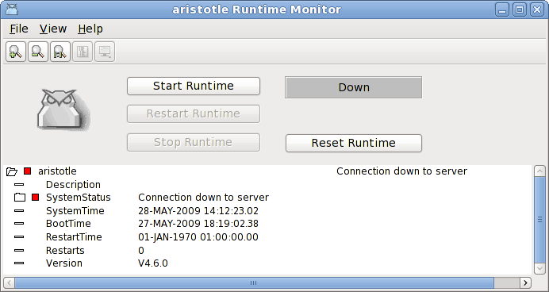
Fig Runtime monitor
When the label has switched from 'Down' to 'Running' activate File/Start Operator Envronment in the menu. The operator window is now opened.
Fig Operator window
Acknowlege the alarms by clicking on the tick buttons to the left (this will remove the beep). Activate the PwrDemo, LevelControl and TemperatureControl buttons to view the demo project graphs.

Package pwrrt
Start the Software Manager by activating Install Software in the menu, and install the packages
- db43
- xorg-x11-fonts
Download the pwrrt package and save to disk. The package is downloaded to the Desktop directory as default, thus beeing viewed with an icon on the desktop.Doubleclick on the pwrrt icon on the desktop to start the installation.
The runtime package should be installed "stand-alone" without the pwr46-package.
A linux-system with the pwrrt-package is your control-system. Proview will be started automatically at boot-time.

Package pwrsev
Start the Software Manager by activating Install Software in the menu, and install the packages
- db43
- mysql-server
- mysql-client
- xorg-x11-fonts
Download the pwrsev package and save to disk. The package is downloaded to the Desktop directory as default, thus beeing viewed with an icon on the desktop.Doubleclick on the pwrrt icon on the desktop to start the installation.
The storage environment package should be installed "stand-alone" without the pwr46 or pwrrt package.

