

Release Notes V5.2

2014 12 02

Copyright SSAB EMEA AB 2014

Permission is granted to copy, distribute and/or modify this document
under the terms of the GNU Free Documentation License, Version 1.2
or any later version published by the Free Software Foundation;
with no Invariant Sections, no Front-Cover Texts, and no Back-Cover Texts.

Table of Contents
Upgrading to Proview V5.2.0 5
New functions 5
Inc3p MaxWindup 5
PID controller 5
Bumbless Manual/Auto switching for P and PD controllers 5
Limited windup for parts of output 5
MinWindup and MaxWindup 5
Event selection on type 5
Core plc program 7
Profibus FDL 7
Default OpPlace attribute 7
Start of Xtt without operator window and navigator 7
Display alarms in Ge graphs 7
Ge dynamics DigTextColor and TimeoutColor 8
Graph borders added to Xtt command 'open graph' 8
Plc trace, not updated objects are dimmed 9
Build configuration 9
BuildDirectory 9
BuildCopy 9
BuildMake 9
BuildExec 9
Export 9
Import 9
Build and distribution of configuration files 10
Data reference type 11
Data reference value 11
Plc help texts 11
Fault tolerant time functions 13
New time plc objects 14
New data reference plc objects 14
New string plc objects 15
New Classes 15
AlarmTable 15
DataRefv 15
GetDataRefv 15
StoDataRefv 15
CStoDataRefv 15
GetDataRefp 15
StoDataRefp 15
CstoDataRefp 15
BuildConfig 16
Import 16
ApplImport 16
Export 16
ApplExport 16
BuildDirectory 16
BuildCopy 16
BuildMake 16
BuildExecute 16
HelpText 16
HelpTextL 17
AtSel 17
AtMux 17
AtDemux 17
AtMin 17
AtMax 17
AtLimit 17
DtSel 17
DtMux 17
DtDemux 17
DtMin 17
DtMax 17
DtLimit 17
DataSel 18
DataMux 18
DataEqual 18
DataNotEqual 18
S trSel 18
StrMux 18
StrEqual 18
StrNotEqual 18
StrAdd 18
StrTrim 18
StrParse 18
Pb_FDL_SAP 18
Pb_FSL_DataTransfer 18
Modified Classes 19
Upgrade procedure 19

Upgrading to Proview V5.2.0
This document describes new functions i Proview V5.2.0, and how to upgrade a project from V5.1.0 to V5.2.0.

New functions

Inc3p MaxWindup
Inc3p has a new attribute, MaxWindup, to avoid infinite accumulation at unsutible parameters. If MaxWindup > 0 the time to action (Acc) is limited to +- MaxWindup.

PID controller
Functions for bumpless switching and limited windup is added to the PID controller in the PID and CompPID objects.
Note!
To get the same PID function as in previous versions, set
PDAbsFlag = 1
WindupMask = BPID
MaxWindup = same value as MaxOut
MinWindup = save value as MinOut

Bumbless Manual/Auto switching for P and PD controllers
The new attribute PDAbsFlag makes bumpless switching from manual to auto possible also for P and PD controllers. Setting PDAbsFlag to zero will give the new function where and offset is calculated in manual mode that is added to the output when the controller is switched to auto.
Setting PDAbsFlag to 1 will give the old function.

Limited windup for parts of output
The new attribute WindupMask specifies which parts of the output has limited windup. WindupMask can be set to I, BI, PBI or BPID. BPID will give the old function.
With I or BI, windup for P disturbancies are eliminated. This was previously achieved by setting MaxOut to 110%.

MinWindup and MaxWindup
The new attributes MinWindup and MaxWindup can be used for example with servo valve control with leakage compensation and limited I part.

Event selection on type
Previously the event selection in operator places has been done only on position in the object tree. Now the EventType has been extended with six new types: MaintenanceAlarm, SystemAlarm, UserAlarm1, UserAlarm2, UserAlarm3 and UserAlarm4, and the event selection can also be made on these types. With the new attribute EventSelectType the types of event that shoud be displayed is specified. The EvenSelectType is present the the OpPlace, AlarmCategory and WebHandler objects.
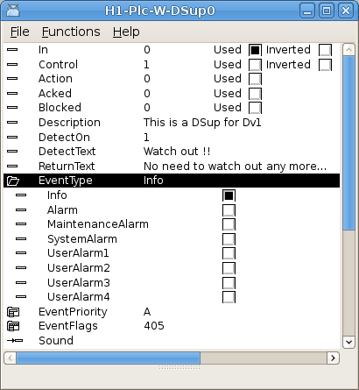
Fig Available event types in a DSup object
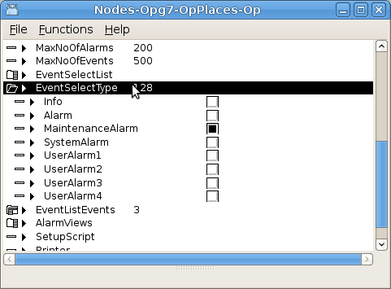
Fig Displayed event types in an OpPlace object
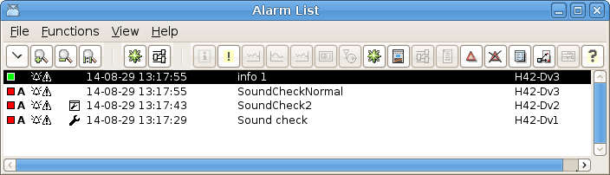
Fig System and maintenance types are marked with a wrench

Core plc program
Operator stations often doesn't need a plc program, but to get all functionallity it has been adviced to create a dummy plc. This is no longer necessary as the core plc program wil be started if there is no PlcPgm's configured. The core plc program should be configured with a PlcProcess and a PlcThread object.
One advantage with the core plc progam is that operator stations can easier be configured for other platforms than the development station. The dummy plc program doesn't need to be built one the development station any more.

Profibus FDL
The Profibus FDL is a lower level in the Profibus protocol than the previously implemented DP. It can be used to communicate with Siemens S5 and S7 systems. The FDL implementation is an interface to the Sofing Profiboard card. The Softing card is configured, as for DP, with a Pb_Profiboard object. Below this the FDL service access point and data transfer is configured with Pb_FDL_SAP and Pb_FDL_DataTransfer objects. See the documentation for these classes for more information.

Default OpPlace attribute
Previously the default OpPlace object, ie the OpPlace used when no other is specified, was indicated with the name 'OpDefault'. Now an attribute, IsDefaultOp, should be set in the OpPlace object instead, and the OpDefault can be given an arbitrary name.
Note! When upgrading the IsDefaultOp attribute should be set in all OpDefault objects.

Start of Xtt without operator window and navigator
Previously either the operator window or navigator was opened when rt_xtt was started, and one of them functioned as the main window. No it's possible to hide both, and the first AutoStart graph will function as main window instead. This makes it possible to design the operator window as a graph in the Ge editor. With the AlarmTable described below, also alarms can be viewed in the graph.

Display alarms in Ge graphs
With the AlarmTable object it's possible to display alarms in a Ge graph.
The AlarmTable object is placed under an OpPlace object and will gain it's alarm from this OpPlace, ie the event selections for the opplace will also be applied on the AlarmTables. It is possible restrict the alarm selection even further with the Member, EventType and EventPriority attributes. The alarm information is stored in array attributes which can be displayed in a Ge table.
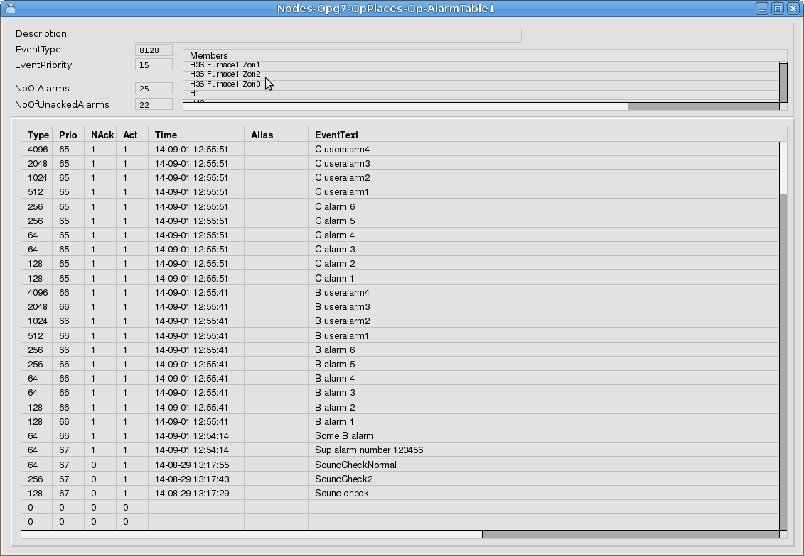
Fig AlarmTable object graph

Ge dynamics DigTextColor and TimeoutColor
Two new type of dynamics are added in 5.2. DigTextColor changes the color of a text, and TimeoutColor changes the color of an object if the subscription is not updated within a specified time.
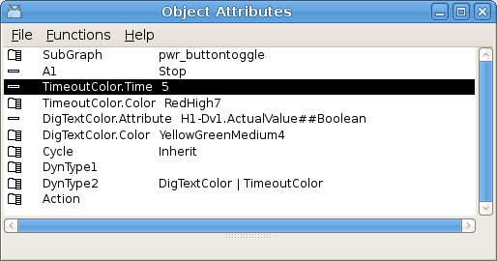
Fig Dynamic DigTextColor and TimeoutColor

Graph borders added to Xtt command 'open graph'
It now possible to specify the borders of the graph with the /x0 /y0 /x1 /y1 qualifiers in the comands 'open graph' and 'set subwindow'. The qualifier values will overwrite the values given in Graph attributes for the graph, thus making it possible to display different parts of the graph for different operators or on different nodes. For the 'set subwindow' command this function is implemented for graphs in a multiview cell, not for Ge window objects.

Plc trace, not updated objects are dimmed
Plc trace are now checking the SubscriptionOldness property and function objects with old subscriptions are dimmed.

Build configuration
The build configuration makes it possible to handle
- building of applications, with execution of makefiles and copying of include files.
- copying of graph files.
- copying of configuration files from $pwrp_cnf.
- importing files from other projects.
- exporting files to other projects.
The build is configured in the directory volume under a BuildConfig object, See Fig 1.
Other objects in the build configuration are

BuildDirectory
Configures how a directory, eg $pwrp_appl or $pwrp_pop is built. The actions executed when building the directory is specified with BuildCopy, BuildMake and BuildExecute object.

BuildCopy
Copies a file, or a number of files specified with wildcard from the source directory to the build tree.

BuildMake
Executes a make file.

BuildExec
Executes a shell command.

Export
Configures files that should be exported to other projects. Normally files are exported to a common directory from where they are imported by other projects. Specific files to export is configured with ApplExport objects.

Import
Configures files that is imported from other projects. Specific files are imported with ApplImport objects.

The build, export and import can be performed automatically when building a node, by configuring BuildBeforeNode or BuildAfterNode in the Option attribute of the BuildDirectory, Import and Export objects.
To perform an selective build, export or import, the Build Directories, Import and Export window is opened from the Functions menu in the configurator.
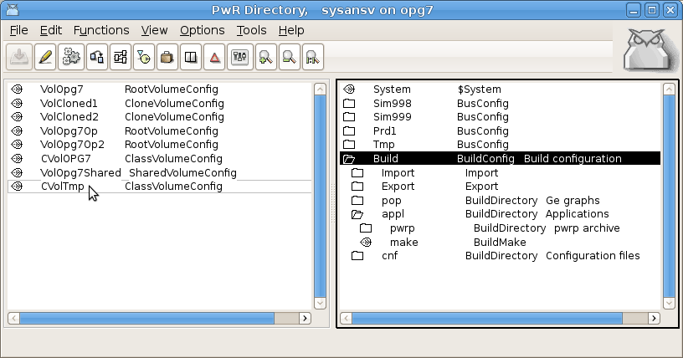
Fig 1 The build configuration

Build and distribution of configuration files
The build and distribution of configuration files is more strict regarding the separation in source and build tree. Now all configuration files reside in $pwrp_cnf, and in $pwrp_cnf there can be one subdirectory per node. Under each node there can be one subdirectory for each linux user on the node. No files should be distributed directly from $pwrp_cnf, they should first be copied to $pwrp_load in the build tree. When the node is built, a corresponding node and user structure is created under $pwrp_load, and files are copied from $pwrp_cnf to $pwrp_load. The files handled by the build methods are
$pwrp_cnf/xtt_help.dat → $pwrp_load/
$pwrp_cnf/'node'/xtt_help.dat → $pwrp_load/'node'/
$pwrp_cnf/'node'/'user'/xtt_help.dat → $pwrp_load/'node'/'user'/
$pwrp_cnf/xtt_setup.rtt_com → $pwrp_load/
$pwrp_cnf/'node'/xtt_setup.rtt_com → $pwrp_load/'node'/
$pwrp_cnf/'node'/'user'/xtt_setup.rtt_com → $pwrp_load/'node'/'user'/
$pwrp_cnf/Rt_xtt → $pwrp_load/
$pwrp_cnf/'node'/Rt_xtt → $pwrp_load/'node'/
$pwrp_cnf/'node'/'user'/Rt_xtt → $pwrp_load/'node'/'user'/
$pwrp_cnf/pwrp_stop.sh → $pwrp_load/
$pwrp_cnf/'node'/pwrp_stop.sh → $pwrp_load/'node'/
$pwrp_cnf/pwrp_alias.dat → $pwrp_load/

The copying is made when the node is built, but can also be made separateley with the configurator command 'build cnf /node='. All copying can also be disabled from the configurator options dialog, in case one preferes to this with make files or scripts.

Data reference type
The type pwrs:Type-$DataRef is used for data references in all objects handling data references, eg NmpsCell, DataArithm, DataCollect etc. The type contains a pointer and an attribute reference and the c declaration in pwr.h is
typedef struct {
pwr_tVoid *Ptr pwr_dAlignLW; //!< Private plc pointer to data object.
pwr_tAttrRef Aref pwr_dAlignLW; //!< Attribute reference to data object.
} pwr_tDataRef;

In NmpsCell objects, the previous pointer and object id, for example Data1P,and Data1ObjId, is replaced by a DataRef named Data1. If these are used in any c-code, they should be replaced by the corresponding DataRef elements, eg
Data1P → Data1P.Ptr
Data1_Objid → Data1P.Aref.Objid

Plc objects to fetch and store an attribute of type DataRef are GetDataRefp, StoDataRefp and CstoDataRefp. Also a signal object that stores a data reference is added, see below.

Data reference value
A new signal object to store a data reference is added, DataRefv. The data reference can be fetched for example with a GetData or from a data output of a NmpsCell.
Plc objects to fetch and store a DataRefv are GetDataRefv, StoDataRefv and CStoDataRefv.
If the DataRev references a dynamic object, the pointer is invalid if the object is deleted. The user is responsible to assure that the pointer is not used if the object is deleted.

Plc help texts
The plc objects HelpText and HelpTextL are added to view and generate help texts from plc documents. The help texts inserted in these objects are viewed in the plc document, and can also be viewed in the help browser.
The text can contain tags to format the text and to insert images and links. Images will not be displayed in the plc document, they will only be shown in the help browser. Neither will links work in the plc document. The supported tags are
<h1> Large header
<h2> Header
<image> Display an image.
<link> Link to another help text topic

The maximum text size is for the HelpText object 1023 characters, and for HelpTextL 8191 characters.
The help texts will be concatenated to one help text file for the volume, when the volume is built. The file will contain one topic for each plc window, that contains the text from all HelpText objects in the window. The texts are displayed in the order the HelpText objects are found in the database.

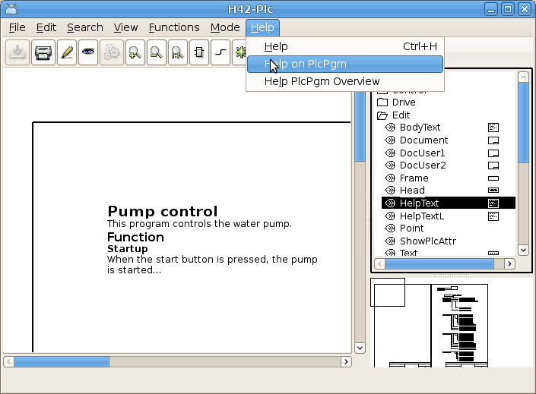
Fig Help text example
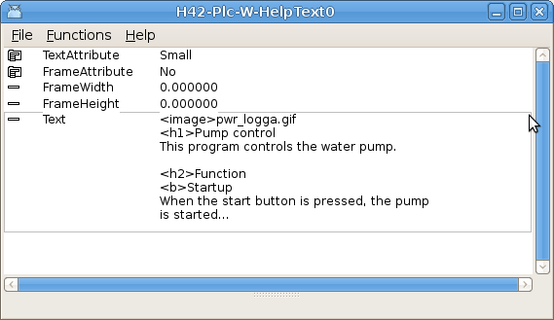
Fig Edited text
The help texts are viewed in the help browser, by activating help in the popup menu for the PlcPgm object, or from 'Help on PlcPgm' in the plc editor menu. Also in runtime the text can be displayed in the same way. The text in the help browser first shows a list of all subwindows with links to the help texts of the subwindows.
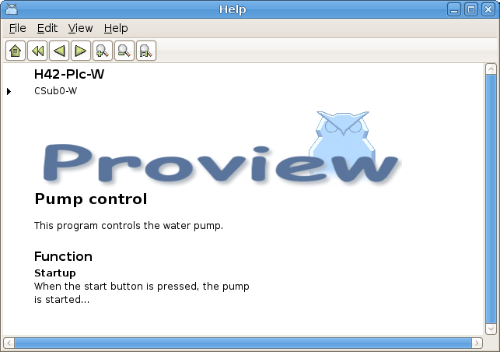
Fig Text in help browser
From 'Help PlcPgm Overview' in the plc editor menu, a list of all the PlcPgm's in the volume is displayed with description and links to the help texts of each PlcPgm.
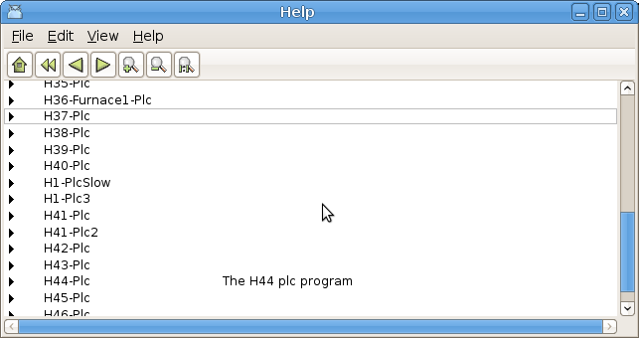
Fig Help PlcPgm overview

Fault tolerant time functions
The previous time functions in Proview terminates the program if an invalid time is detected. A new set of functions that continues the execution is added to the time archive. Instead of terminating, the constants pwr_cNotATime or pwr_cNotADeltaTime is returned when an erroneous time is detected. The new functions are
time_Aadd_NE()
time_Acomp_NE()
time_Adiff_NE()
time_Asub_NE()
time_Dabs_NE()
time_Dadd_NE()
time_Dneg_NE()
time_Dsub_NE()
time_Dcomp_NE()

The function is equivalent to the previous functions without the _NE suffix, except for the handling of invalid times.
Also time_DToFloat() and time_DToFloat64 are modified and returns NAN for invalid deltatime input, and time_FloatToD() and time_Float64ToD() returns pwr_cNotADeltaTime for invalid float input.
The new fault tolerant functions are inserted in all PLC objects handling absolute and delta times. The constans pwr_cNotATime and pwr_cNotADeltaTime are displayed in xtt as 'NotATime' and 'NotADeltaTime'.

New time plc objects
A number of new time plc objects are added.
AtSel | Select one of two absolute times.
AtMux | Absolute time multiplexer.
AtDemux | Absolute time demultiplexer.
AtMin | Absolute time minimum function.
AtMax | Absolute time maximum function.
AtLimit | Absolute time limiter.
DtSel | Select one of two delta times.
DtMux | Delta time multiplexer.
DtDemux | Delta time demultiplexer.
DtMin | Delta time minimum function.
DtMax | Delta time maximum function.
DtLimit | Delta time delimiter.

New data reference plc objects
A number of new data reference plc objects are added.
DataSel | Select one of two data references.
DataMux | Data reference multiplexer.
DataEqual | Check of two data references are equal.
DataNotEqual | Check if two data references are not equal.

New string plc objects
A number of new string plc objects are added.
StrSel | Select one of two strings.
StrMux | String multiplexer.
StrEqual | Check if two strings are equal.
StrNotEqual | Check if two strings are not equal.
StrAdd | Add a number of strings.
StrTrim | Remove leading and trailing spaces in a string.
StrParse | Parse a string.

New Classes

AlarmTable
Object placed under an OpPlace object that contains a table with alarms or events

DataRefv
Signal object contaning a data referens value of type DataRef. It contains a pointer to the data object, and the attribute referens of the data object.

GetDataRefv
Plc object to fetch a DataRefv.

StoDataRefv
Plc object to store a DataRefv.

CStoDataRefv
Plc object for conditional storage of a DataRefv.

GetDataRefp
Plc object to fetch the value of a DataRef attribute.

StoDataRefp
Plc object to store a data reference to a DataRef attribute.

CstoDataRefp
Conditional storage of a data referens to a DataRef attribute.

BuildConfig
The BuildConfig is the root object for the build configuration. This object is placed in the directory volume as toplevel object in the node view.
The build configuration makes it possible to handle
- building of applications, with execution of makefiles and copying of include files.
- copying of graph files.
- copying of configuration files from $pwrp_cnf.
- importing files from other projects.
- exporting files to other projects.

Import
Configuration of imported files from other projects or external modules.

ApplImport
Configuration of specific files to import.

Export
Configuration of files to export to other projects.

ApplExport
Configuration of specific files to export.

BuildDirectory
Configures how a directory, eg $pwrp_appl or $pwrp_pop is built. The actions executed when building the directory is specified with BuildCopy, BuildMake and BuildExecute objects.

BuildCopy
Copies a file, or a number of files specified with wildcard from the source directory to the build tree.

BuildMake
Executes a make file.

BuildExecute
Executes a shell command.

HelpText
Plc object for documentation in plc sheet and help text browser.

HelpTextL
Same as HelpText with larger text buffer (8191 characters).

AtSel
Plc object. Select one of two absolute times.

AtMux
Plc object. Absolute time multiplexer.

AtDemux
Plc object. Absolute time demultiplexer.

AtMin
Plc object. Absolute time minimum function.

AtMax
Plc object. Absolute time maximum function.

AtLimit
Plc object. Absolute time limiter.

DtSel
Plc object. Select one of two delta times.

DtMux
Plc object. Delta time multiplexer.

DtDemux
Plc object. Delta time demultiplexer.

DtMin
Plc object. Delta time minimum function.

DtMax
Plc object. Delta time maximum function.

DtLimit
Plc object. Delta time delimiter.

DataSel
Plc object. Select one of two data references.

DataMux
Plc object. Data reference multiplexer.

DataEqual
Plc object. Check of two data references are equal.

DataNotEqual
Plc object. Check if two data references are not equal.

S trSel
Plc object. Select one of two strings.

StrMux
Plc object. String multiplexer.

StrEqual
Plc object. Check if two strings are equal.

StrNotEqual
Plc object. Check if two strings are not equal.

StrAdd
Plc object. Add a number of strings.

StrTrim
Plc object. Remove leading and trailing spaces in a string.

StrParse
Plc object. Parse a string.

Pb_FDL_SAP
IO Rack obeject configuring a FDL service access point for Softing Profiboard card.

Pb_FSL_DataTransfer
IO Card object configuring a FDL data transfer.

Modified Classes

Upgrade procedure
The upgrading has to be done from a V5.1 version. If the project has a lower version, the upgrade has to be performed stepwise following the schema
V2.1 -> V2.7b -> V3.3 -> V3.4b -> V4.0.0 -> V4.1.3 ->V4.2.0->V4.5.0->V4.6.0->V4.7.0->V4.8.6->(V5.0.0)->V5.1.0->V5.2

Enter the administrator and change the version of the project to V5.2.0. Save and close the administrator.

Enter the directory volume and save.
I you have any class volumes, enter the class editor and build the volume.
Enter the configurator for each root volume and activate 'Function/Update Classes' and build.
Note ! The update procedure upgrade.sh doesn't have to be executed.
Modify OpPlace, PID and CompPID objects
- set the IsDefaultOp attribute in the OpDefault OpPlace object to 1.
- set PDAbsFlag = 1, WindupMask = BPID, MaxWindup = same vaue as MaxOut and MinWindup = same value as MinOut in PID and CompPID objects.

