

MPC controller

2020 02 27

Copyright © 2005-2020 SSAB EMEA AB

Permission is granted to copy, distribute and/or modify this document
under the terms of the GNU Free Documentation License, Version 1.2
or any later version published by the Free Software Foundation;
with no Invariant Sections, no Front-Cover Texts, and no Back-Cover Texts.

Table of Contents
Introduction 4
MPC controller 4
Prediction 5
Model 8
Prediction configuration 8
Time steps and splits 8
Iterations 9
Tuning 9
Model correction 9
Out value ramp close 10
Out value delay 10
Prediction attributes 10
Model correction attributes 11
Out value ramp close attributes 11
Linear regression model 11
Level control example 12
Linear regression attributes 17
MLP model 17
Flow control example 17
Monitor object 22
MLP model attributes 23

Introduction
This document describes the implementation of an MPC controller in ProviewR.

MPC controller
An MPC (Model Predictive Control) controller contains a model of the process and uses this model to calculate the future response for different controller outputs. The optimal output, ie the output that gives the smallest difference between the set value and process value, is then selected and used as the next output for the controller.
In the example below, the level control from the demo project, the MPC is compared with a traditional PID controller.
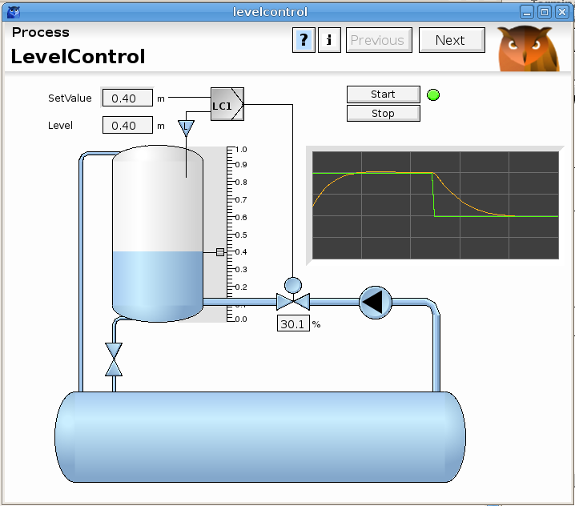
Fig 1 Level control
A step response from a PID is displayed in the figure below. The yellow output curve is mainly proportional to the error, ie the difference between the set value and process value. It reaches a high value immediately after the step and then gradual decreases as the error decreases.
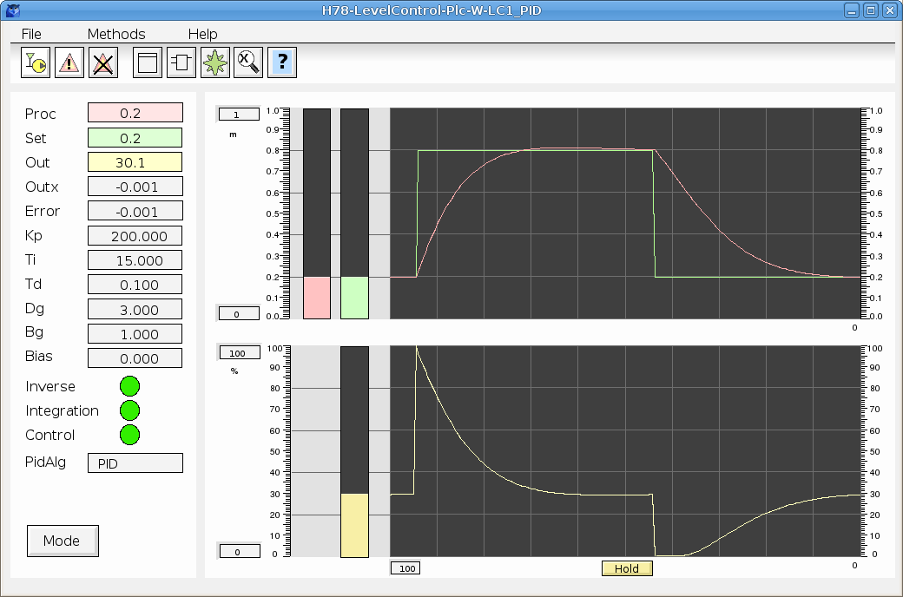
Fig 2 Step response for PID
The MPC controller below has an entirely different approach. The output reaches the maximum value right after the step, and stays there until shortly before the process value reaches the set value.
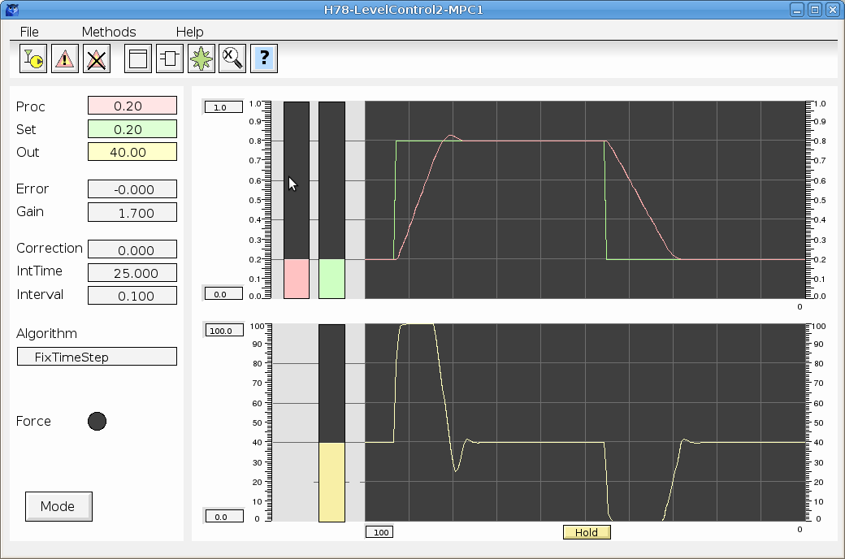
Fig 3 Step response for MPC

This is very close the the optimal behavior for a controller and shows the advantage of having the capability to foresee the future.

Prediction
The prediction is made iteratively by using the model to calculate the process value from the output value a number of time steps ahead. In the example below, 5 time steps is used, and in the initial step, 5 paths are calculated from the current output value. In the next and following time steps, each path is split in another five paths. This makes a total sum of = 3125 paths, and for each path the corresponding process value path is calculated. In the lower graph the setvalue is drawn, which in this case is a step function, and a number of calculated process value paths. The most optimal path is regarded to be the one with the smallest area between the setvalue and processvalue (the gray area in the figure), and this path is chosen for the next iteration. In the next iteration (right graph below), the spread of the output paths is narrowed around the previously optimal path, and a new optimal path is calculated. Further iterations can give even more optimal paths.
In the end, it’s actually only a small fraction of the first timestep that is used. The new output is set to the value at the next scantime of the controller, which is normally much shorter than a timestep. Then in the next scan, a new optimal path is calculated and the initial fraction of this path is used till the next scan.
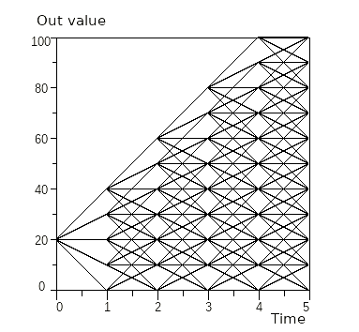
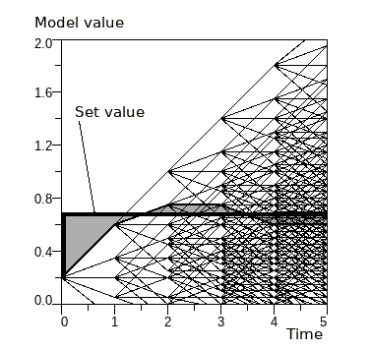
Fig 4 Outvalue and corresponding calculated model value
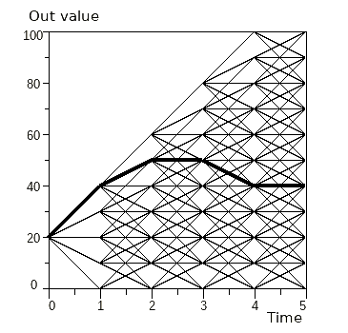
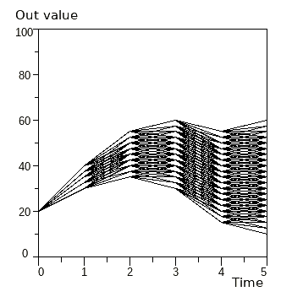
Fig 5 Optimal outvalue path and outvalue paths for next iterations
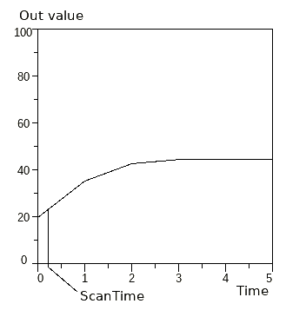
Fig 6 Final optimal output path
The figure below shows the prediction for the level control shortly after a change of the set value. The right diagrams shows the predicted process value (red) and out value (yellow). Shortly before the process value reaches the set value, the optimal out value path is to decrease the out value with the fastest possible ramp.
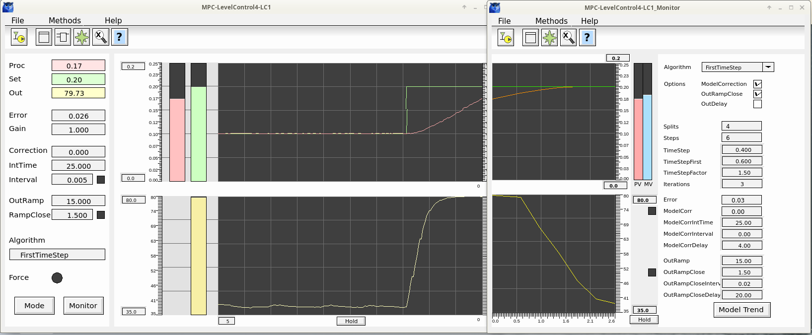
Fig 7 Level control prediction
A snapshot a few seconds later shows the real outcome. Note that the time scale for the predictive curve and the past curve differs.
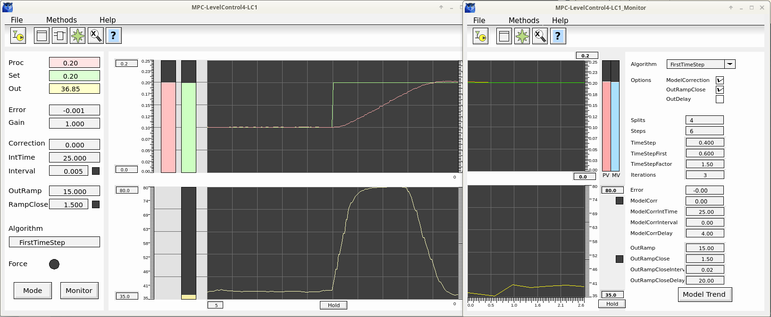
Fig 8 Level control outcome

Model
To calculate the process value for the different output paths, a model is used. The model takes the output value as input, but can also take a number of other parameters. In the level control example above, both the speed of the pump and the output flow are inputs to the model.
Two different types of models are implemented for the MPC, linear regression and a neural network with an MLP. These are described later in more detail.

Prediction configuration

Time steps and splits
The prediction is configured with the number of time steps, and the number of splits in each time step. This is done in the attributes Steps and Splits. Note that the number of paths are growing exponentially, both with the number of splits and the number of steps, and so is also the required CPU capacity. In the figure below there are 5 time steps of equal size, and 5 splits.
Fig 9 Time steps and splts
The sum of the time steps is called the horizon, and this is how far in the future the controller can see. There are three algorithms with different size of the time steps.
First there is FixTimeStep where all the steps are of equal size, and the size is set in the TimeStep attribute.
Then there is FirstTimeStep where the first step is different from the others. The first is set in TimeStepFirst and the others will have the size of TimeStep. A shorter first time step will speed up the controller, and a longer will slow it down and make it more stable.
Finally there is the ProgressiveTimeStep, where the size of the first step is TimeStep and the following time steps have the size of the previous multiplied with the factor in TimeStepFactor. If TimeStep is 1 second and TimeStepFactor is 1.5, the time steps will be 1, 1.5, 2.25, 3.37, 5.1 with a horizon of 13.2 seconds.
The algorithm is set in the Algorithm attribute and can be modified in runtime. Also the TimeStep, TimeStepFirst and TimeStepFactor can be modified in runtime. Splits and Steps though can not be modified in runtime.

Iterations
The number of iteration to perform are configured in the Iterations attribute. The default value is 3 and the CPU load will increase proportionally with the number of iterations.

Tuning

Model correction
It’s inevitable that the model, at least for some combinations of parameters, will differ from the real process value. In the predictive algorithm there is nothing that compensates for this, the controller will strive for the somewhat erroneous model value and stay there. To remove this residual error, an integration term is added to the model value. The term integrates the error, ie the difference between the process value and the set value. If this term is active all the time, it will in high degree disturb the prediction result. There for a window can be specified where the integration is active, and also a delay time where the integration is activated a certain time after the process value has entered the window.
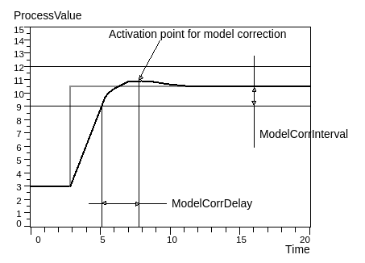
Fig 10 Model correction

The model correction is configured with the attributes

Out value ramp close
One way of tuning the controller is to adjust the maximum ramp of the out value. If the response from the controller is to fast, small oscillations can occur also in steady states. A lower value of the max ramp can remove these oscillations. The max ramp is set in the OutRamp attribute.
To keep the controller fast it is possible to reduce the ramp when the controller as reached a steady state. This is done with the OutRampClose function. When the process value is close to the set value, the out value ramp is reduced. Also a time delay can be configured, see figure below.
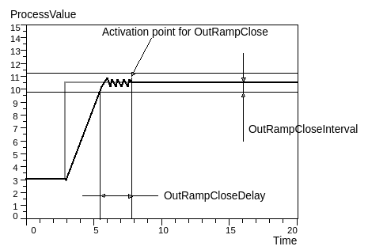
Fig 11 Out value ramp close
A range around the set value is configured with the OutRampCloseInterval attribute. When the process value is inside this range, and the OutRampCloseDelay time has elapsed, the maximum ramp is reduces to the value in the OutRampClose attribute.

Out value delay
If there is a delay between the time the out value is set, to the time it is affecting the process, this delay can be configured in the OutDelay attribute. This means that the out value from the controller, is fetched from an earlier point in the prediction.
The delay time should be less than the first time step.

Prediction attributes
Attribute | Description
Steps | Number of time steps in the prediction. The number of paths, and the CPU load will grow exponentially with Steps.
Splits | Number of new OutValue paths in each time step.
Algorithm | The algorithm used in the predictive calculation.  - FixTimeSteps: all time steps are of equal length. The lenght is specified in attribute TimeStep.  - ProgressiveTimeStep_ the first time step has the size specified in the attribute TimeStep, the next timesteps has the sizes of the previous multiplied by the value in TimeStepFactor.  - FirstTimeStep: The first step has the length in FirstTimeStep, and the following the length in TimeStep.
TimeStep | Length of the time step in the predictive calculation in seconds.  For algorithm FixTimeStep all the timesteps has this size.  For algorithm FirstTimeStep all the timesteps has this size, except the first that has the size in the attribute FirstTimeStep.  For algorithm ProgressiveTimeStep the first timestep has this size, and the following are increased by the TimeStepFactor value.
TimeStepFirst | The length of the first time step when algorithm FirstTimeStep is used.
TimeStepFactor | Factor for increment of the time step when algorithm ProgressiveTimeStep is used.
Iterations | Number of iterations.

Model correction attributes
Attribute | Description
ModelCorr | Model correction value.
ModelCorrIntTime | Model correction integration time.
ModelCorrInterval | Distance from the SetValue when the model correction should be activated.
ModelCorrDelay | Delay time for activation of the correction.
ModelCorrActive | Indicates that model correction is active.

Out value ramp close attributes
Attribute | Description
OutRampClose | Maximum ramp of out value when the error is less than OutRampCloseInterval.  Minor fluctuations at steady state can in some cases be reduced by increasing the ramp. Note that the interval should be kept small as this restriction is not part of the prediction.
OutRampCloseInterval | Distance from the SetValue when the output ramp is restricted to OutRampClose.
OutRampCloseDelay | Delay of out value.  Is used when there is a delay in the actuator for the control signal. The OutDelayTime should not exceed the size of the first time step in the prediction. It should also not exceed OutDelayMaxTime.
OutRampCloseActive | Indicates that out ramp close is active.

Linear regression model
In linear regression the model value y, is calculated from a number of input values - . y is supposed to have linear dependencies of the input values with the formula
y = +++ + … +
where are- constants that are calculated when the model is created. In our model, y is the process value, the out value from the controller, and - other parameter that influences the process value.
Many processes are not linear, but by linearizing the the input parameters, linear regression can be used also for these processes.

Level control example
In this example we will create a model a level control. The difference from the level control example above is that we are now controlling the speed of the pump P1 instead of the control valve.

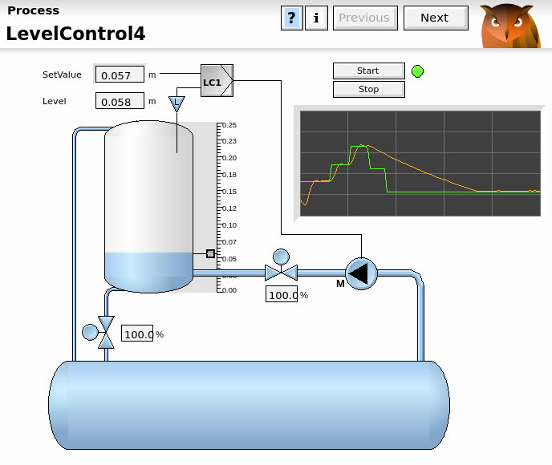
Fig 12 Level control
The level can be calculated from the integral for the input flow minus the integral for the output flow
L = -

We are setting the speed of the pump from the controller, and unfortunately it’s not linear to the input flow, so we have to insert a conversion table to convert from speed to flow.
We assume that the out flow is proportional to output valve position.
The linearization we have to perform, is first to convert the pump speed to flow, then integrate the
flow and also integrate the out valve position.
We start with making an Xtt log while driving the pump at different speeds. The tank level, the reference to the pump, and the order to the outflow control valve are logged. The log file is opened in the multivariate analyzer and the curves are shown in the figure below.
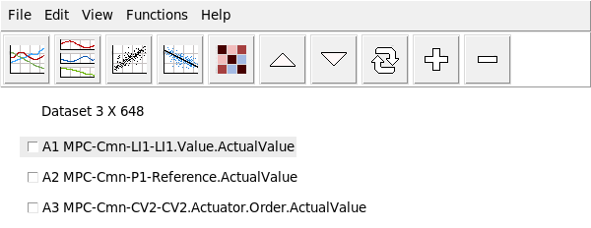
Fig 13 Logged attributes, tank level, pump reference and order to outflow control valve

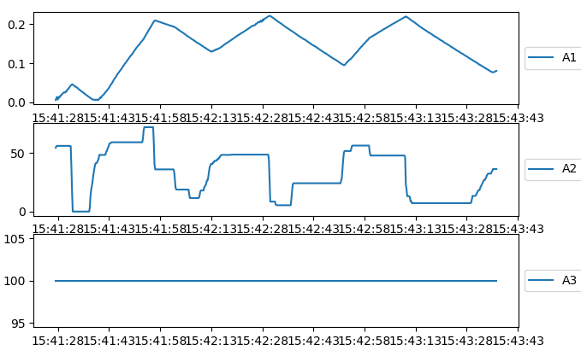
Fig 14 Curves for the logged values
Before the model is created with linear regression, the nonlinear attributes has to be linearized. The relation between reference and flow for the pump follows the curve below. From this an interpolation tables is created and written in a csv file, pump_curve.dat. From the Convert item/Curve function in the analyser, the curve is applied to the pump reference column.

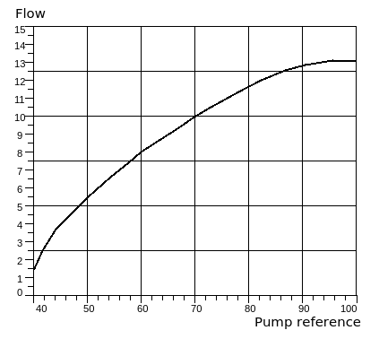
Fig 15 Speed to flow conversion curve
0, 0
38, 0
40, 2.57
42, 3.61
44, 4.08
46, 5.1
48, 5.96
50, 6.55
55, 7.3
60, 8.11
65, 9.1
70, 10.1
75, 11.1
80, 12.12
85, 12.9
90, 13.1
100, 13.1
Fig 16 Speed to pump conversion table, pump_curve.dat
Next step is to integrate both the input and output flow, thus column A2 and A3 are integrated with the Convert item/Integral function. The linearization is now complete and the dataset is displayed in the figure below.
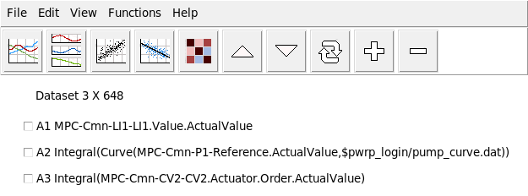
Fig 17 Linearized dataset
The model is now created with the Linear regression function and the result is displayed below. The score 0.986 is acceptable, and the coefficients is 0.004324, is 0.002375 and is -0.00006. These values will be inserted into the CompMPC object.
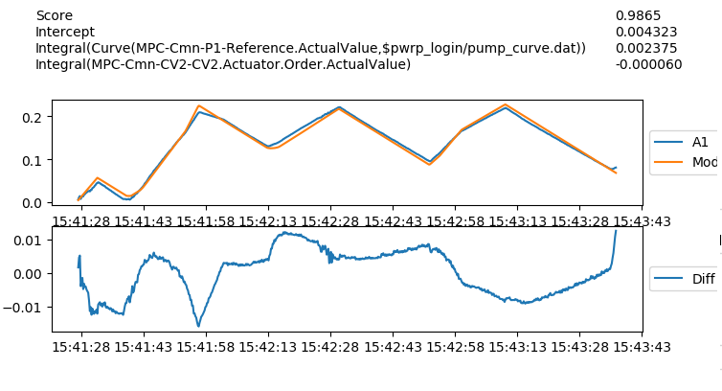
Fig 18 The linear regression model
When using the model in the MPC controller, the input data for the controller have to be linearized in the same way as when the model is created. The controller is configured in the ProviewR database with a CompMPC object in the plant hierarchy, and a CompMPC_Fo in the plc program.
The coefficients for the linear regression are inserted into the CompMPC object, into the attribute Coeff0, into AttrCoeff[0] and into AttrCoeff[1].
The pump reference to flow conversion is configured in TightAttrRelation[0] which is set to Curve. This means a conversion will be made with interpolation in from a Table object connected to the C1 input of the function object. Thus the points of the conversion table in inserted in to the Pump2 table object that is connected to the C1 input.
The integration of the in and out flow are configured in the BaseAttrRelation[0] and BaseAttrRelation[1] which are both set to Integral.
Setting NoOfAttr to 2 completes the model configuration of the controller.
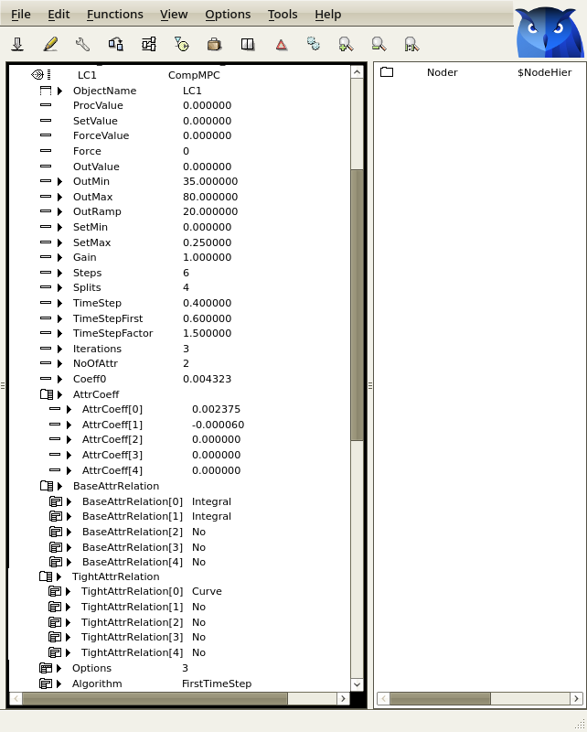
Fig 19 Configuration of CompMPC object
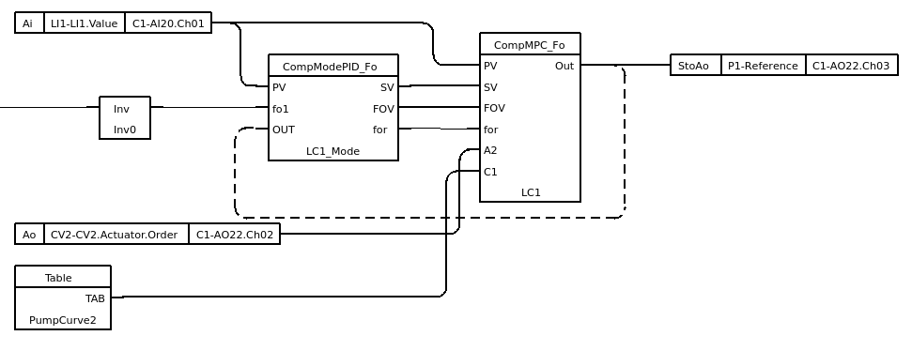
Fig 20 Plc program for CompMPC object
A step response from the controller is shown in Fig 8.

Linear regression attributes
Attribute | Description
NoOfAttr | Number of attributes used by the model.  The attributes are normally connected to the Attr1, Attr2, … input pins of the function object.
Coeff0 | Intercept coefficient in the linear regression model.
AttrCoeff | Coefficients for the attributes in the linear regression model.
BaseAttrRelation | Base type of relation for the attribute in the linear regression model.
TightAttrRelation | Tight relation for an attribute.

MLP model
MLP (multilayer perceptron) is a neural network with an input layer, a number of hidden layers and an out layer.
The MLP is implemented in the classes CompMPC_MLP and CompMPC_MLP_Fo.
The MLP can handle nonlinear relations, thus no conversion of the input parameters are required. One problem though is that the MLP can’t handle accumulative processes as there is no time relation involved in the MLP training. A solution to this is implemented where inputs that have integral relation are trained also with time shifted values. The time shifts should equal the time steps in the prediction.

Flow control example
In this example we will study a flow control, where the flow is measured with the flow sensor FI1, and controlled by the speed of the pump P1. As we have seen in the Level control example above, the pump characteristics are nonlinear, but the MLP will take care of this and no linearization is needed.

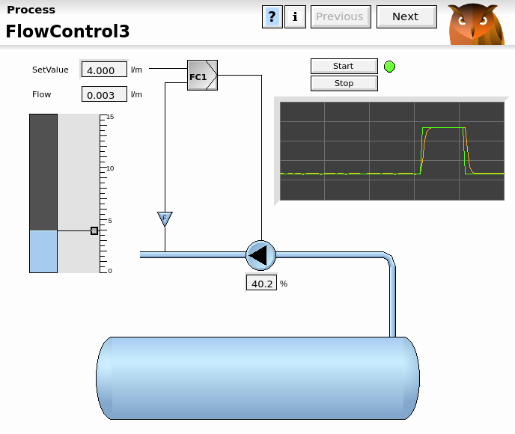
Fig 21 Flow control
In this example we will only regard the flow and the pump speed. We start by making an Xtt log with the signal from the flow sensor and the pump reference.
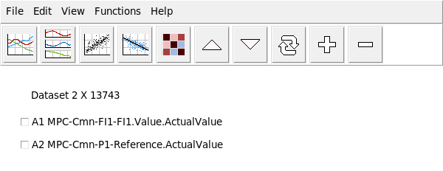
Fig 22 Dataset with flow and pump reference
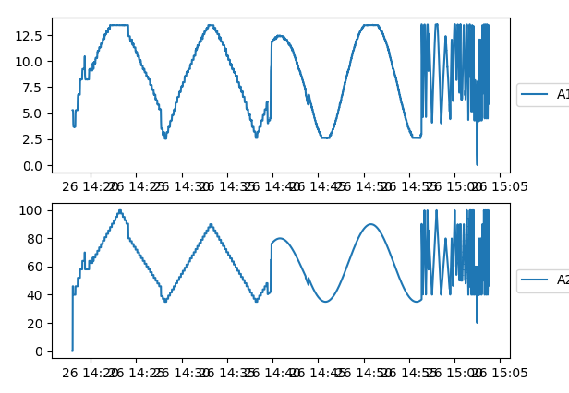
Fig 23 Curves for dataset
The MLP regressor is opened and scaler is set to Standard, solver to adam and Activation to relu. The default layer sizes are kept with three hidden layer and 20 nodes in each layer.
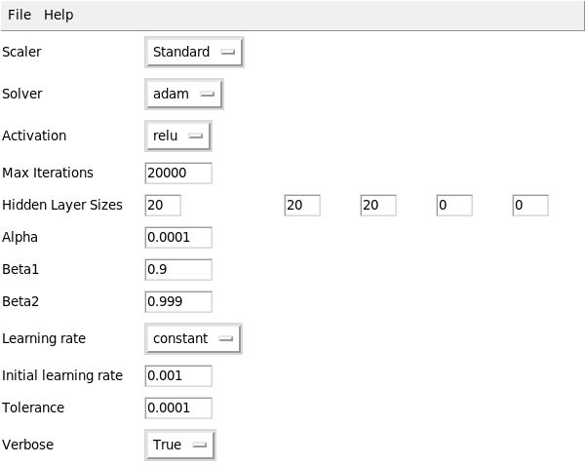
Fig 24 MLP model creation
By activating File/Create model in the menu the learning starts and after a while the result is displayed.
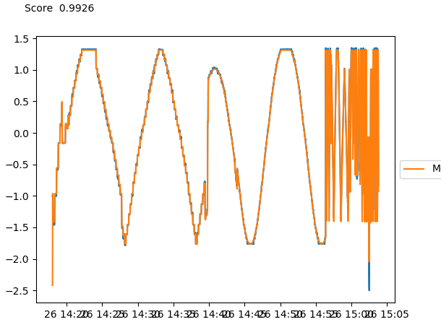
Fig 25 Model result
The model is saved and exported from File/Save model and File/Export model. The saved model will be applied to some test curves and the exported model will exported to the process node and read by the CompMPC_MLP controller.
We also made another Xtt logging of the same parameters that now will be used as a test set. The dataset is read into the analyzer, and by opening the MLP regressor and activating File/Apply model in the menu, the previously created model can be applied on our test data. The result is displayed below, and as you can see the result for low flows are quite poor. The reason is that there are hardly any samples in this area in the training set, and this shows the importance of covering the whole parameter range in the training set. Unlike the linear regressor, the MLP is quite bad at extrapolating and interpolating. Adding some samples for low flows to the training set finally give us an acceptable model.
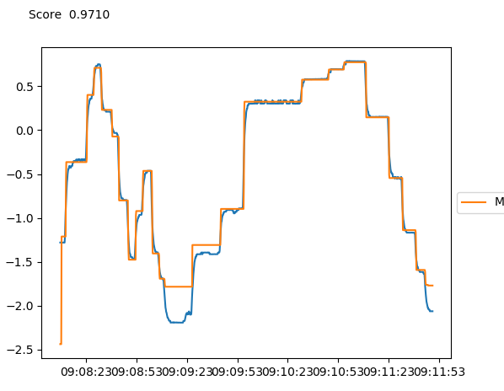
Fig 26 The model applied to the test dataset

The controller is configured with an CompMPC_MLP in the plant hierarchy, and the function object CompMPL_MLP_Fo in the plc code.
The exported model file, $pwrp_load/flow_model2.dat, is inserted into the attribute ModelFile of the CompMPC_MLP object. The file also has to be distributed to the process node. This is actually the only model specific configurations are required. The the predictive part is configured and the model correction.

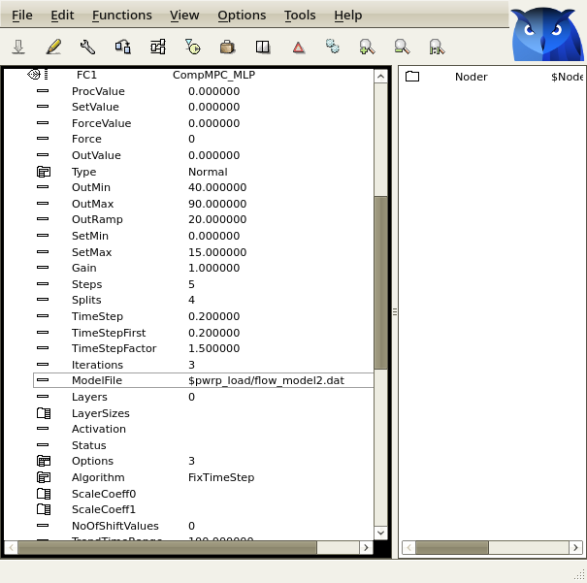
Fig 27 Plant configuration for CompMPC_MLP
The configuration is completed with a mode object of class CompModePID, and the plc programming.
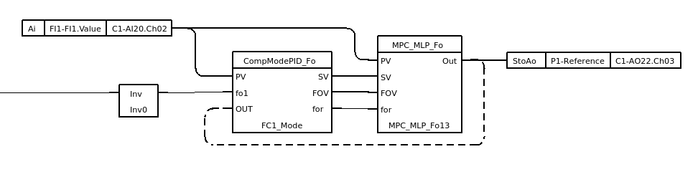
Fig 28 Plc program with CompMPC_MLP_Fo
After some tuning of the outvalue ramp and integration time, the resulting step response is displayed below.
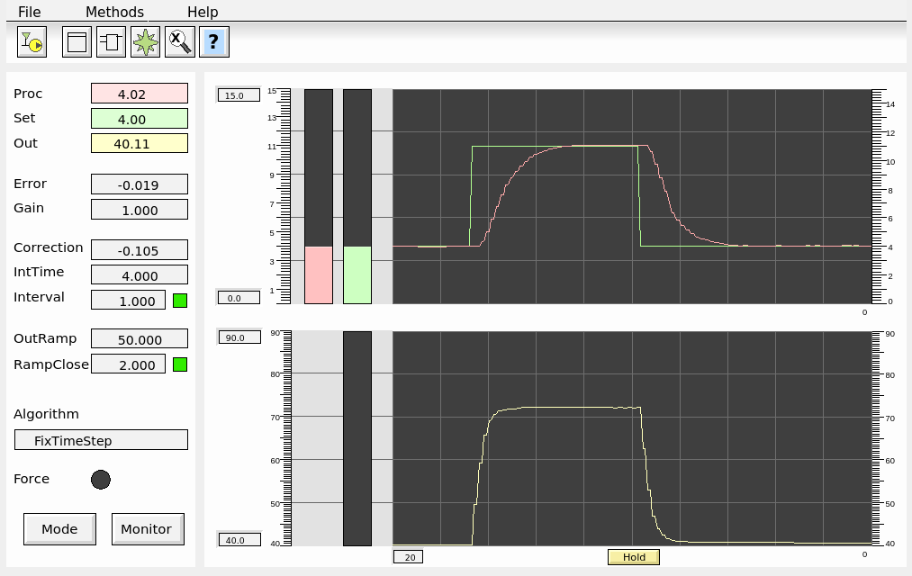
Fig 29 Step response

Monitor object
A monitor object, CompMPC_Monitor, that displays curves for the prediction and the model can be connected to the CompMPC and CompMPC_MLP objects.
In the upper graph, the set value (green) and the optimal predicted process value (orange) are displayed. In the lower graph the optimal out value (yellow) is displayed.
The current model value compared with the process value are displayed with two bars, MV (model value) and PV (process value)
The object also contains a trend curve for the model and the process value. The trend is opened from the Model Trend button.
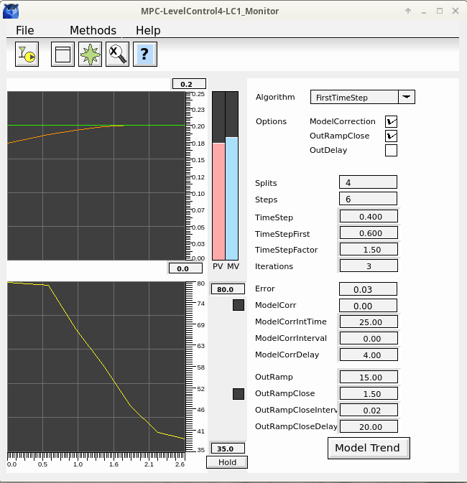
Fig 30 Object graph for monitor object

MLP model attributes
Attribute | Description
Type | Normal or accumulating.
ModelFile | Model file containing the parameter for the MLP.  This file is created by the export function of the MLP Regressor.
ScaleCoeff0 | Coefficient for scaling of attribute values.  If scaling is selected when the model is created, these values are fetched from the model file.  If other scaling should be performed, the scaling coefficients should be inserted manually.
ScaleCoeff1 | Coefficient for scaling of attribute values.
NoOfShiftValues | Used for type accumulating. Number of shifted columns.

