Proview Installation Guide Fedora
Release Fedora 11
System Requirements:
Platform: x86
Kernel >= 2.6.26.5

Package pwr47
Download the the pwr47 package and save to disk The package is downloaded to the Download directory by default. Click on the Home icon on the desktop or start the file browser from the menu(Applications/System Tools/File Browser).
Click on the Download map to view the download package.
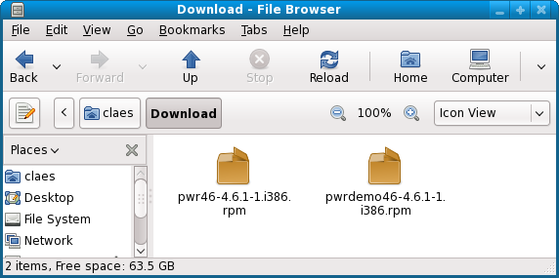
Doubleclick on the pwr47 icon to start the installation.
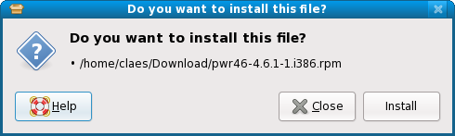
Click on install
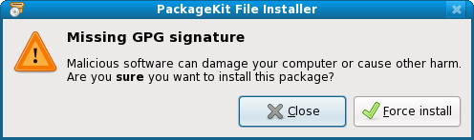
Click on Force install.
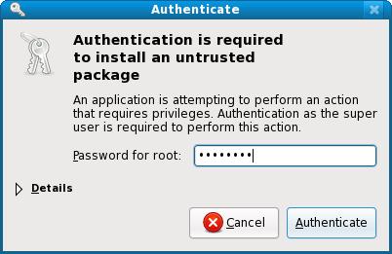
Enter the root password and press Authenticate.
The package is now installed.
Login as user pwrp and start the Project Administrator by clicking on the Proview desktop icon.
If you are new to Proview, read the Proview Getting Started Guide available at www.proview.se

Package pwrdemo
Download the pwrdemo package. Open a Terminal window and go to the catalog of the downloaded package. Install the package with rpm.
> cd Download
> rpm -i pwrdemo47_4.7.x-x.fedora.i386.rpm
Replace x.x with the actual version.
Note ! Doublelclicking on the package icon will not install the package correctly.
When the installation is finished, login as user pwrp and click on on the Pwrdemo icon on the desktop.
The runtime monitor for the demoproject is now started. Start the runtime environment by clicking on the 'Start Runtime' button.
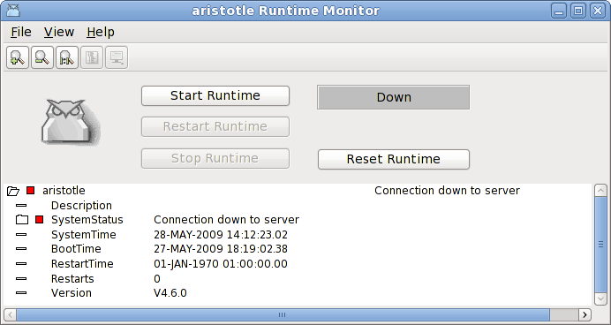
Fig Runtime monitor
When the label has switched from 'Down' to 'Running' activate File/Start Operator Environment in the menu. The operator window is now opened.
Fig Operator window
Acknowledge the alarms by clicking on the tick buttons to the left (this will remove the beep). Activate the PwrDemo, LevelControl and TemperatureControl buttons to view the demo project graphs.

Package pwrrt
Download the pwrrt package. Open a file browser viewing the Download catalog and doubleclick on the pwrrt packaged icon and repeat the procedure described for for pwr47 above.
The runtime package should be installed "stand-alone" without the pwr47-package.
A linux-system with the pwrrt-package is your control-system. Proview will be started automatically at boot-time.

Package pwrsev
Install mysql and mysql-server.
Download the pwrsev package. Open a file browser viewing the Download catalog and doubleclick on the pwrsev packaged icon and repeat the procedure described for for pwr47 above.
The storage environment package should be installed "stand-alone" without the pwr47 or pwrrt package.

