

Release Notes V5.0

2013 11 07

Copyright SSAB Oxelösund AB 2013

Permission is granted to copy, distribute and/or modify this document
under the terms of the GNU Free Documentation License, Version 1.2
or any later version published by the Free Software Foundation;
with no Invariant Sections, no Front-Cover Texts, and no Back-Cover Texts.

Table of Contents
Upgrading to Proview V5.0.0 4
New functions 4
Ethernet Powerlink 4
Proview as MN 4
Proview as CN 4
EplHandler 4
Multiview operator interface 4
Alarmview and multiple alarm and event lists 6
Android application 8
Graphs opened from pwg files in web interface 9
Object graphs in web interface 9
Building development environment in ARM 9
Wb history in html 9
Export of History curves from curve window 9
Show existence of MoreText in alarm and event list 10
Show backup file content 10
Eventlog statistics 10
Loadfile version check in build node 11
Component for frequency converter ABB ACS880 11
Ge graph always on top 11
Ge scale snap to grid 11
Ge support for SVG images 12
Ge insert of color tone 12
Ge graph list bar 12
Storage of events in sev server 13
sev_repair options for clean and optimize database 14
Objects for constant analog and integer values 14
New Classes 15
EplHandler 15
EplMN 15
EplCN 15
Epl_Module 15
Epl_CNServer 15
Epl_CNServerModule 15
BR_Di4_EplModule 15
BR_Do4_EplModule 15
BR_Ai4_EplModule 15
BR_Ao4_EplModule 15
XttMultiView 15
SevHistEvents 15
AppGraph 16
ConstAv 16
ConstIv 16
Modified Classes 16
Upgrade from V4.8.X to V5.0.0 16

Upgrading to Proview V5.0.0
This document describes new functions i Proview V5.0.0, and how to upgrade a project from V4.8 to V5.0.0.

New functions

Ethernet Powerlink
Powerlink, an ethernet fieldbus based on the CAN protocol, is now added to the Proview IO system. A Powerlink network consists of one Managing Node (MN) and a number of Controlled Nodes (CN). Both the MN and CN are implemented in Proview which thus can act as both master or device. The Powerlink network is configured in the openCONFIGURATOR, and a correponding configuration also has to be done in the Proview database, with Agent, Rack, Card and channel objects.

Proview as MN
When Proview act as a Managing Node, the MN is configured with a Epl_MN in the node hierarchy. Below this, one Epl_CN object is create for each device on the network. A CN contains modules, configured with CN_Module object. There are also a number of CN_Module object available for B&R modules and ACS880.
The openCONFIGURATOR is opened from the popup menu of a Epl_MN object.

Proview as CN
When Proview acs as a Controlled Node, it is configured with a Epl_CNServer object, and below this Epl_CNServerModule objects.

EplHandler
The Powerlink stack is executed in a separate server process configured with a EplHandler object. The Process attribute should be set to Powerlink for all Powerlink IO objects. For this reason the Powerlink IO will not be synchronized with the Plc program. The Powerlink stack will not function when it's started by a plc thread, but hopefully this problem can be solved in the future.
See also Guide to IO System for more information about the Powerlink configuration.

Multiview operator interface
Multiview is a window organized as table where each cell can contain a graph, a trend, a sev history curves, an alarm list, an event list or another multview window. The example below displays a multiview window with one column and two rows. The first cell contains another multiview with two columns the tree rows, and the second cell contain an alarm window. The different alarm windows shows alarms from different parts of the plant, specified by alarmviews.
An multiview window is configured by a XttMultView object. The Action array contains the specification for each cell.
It is also possible to exchange a graph or curve in a cell with the 'set subwindow' command.
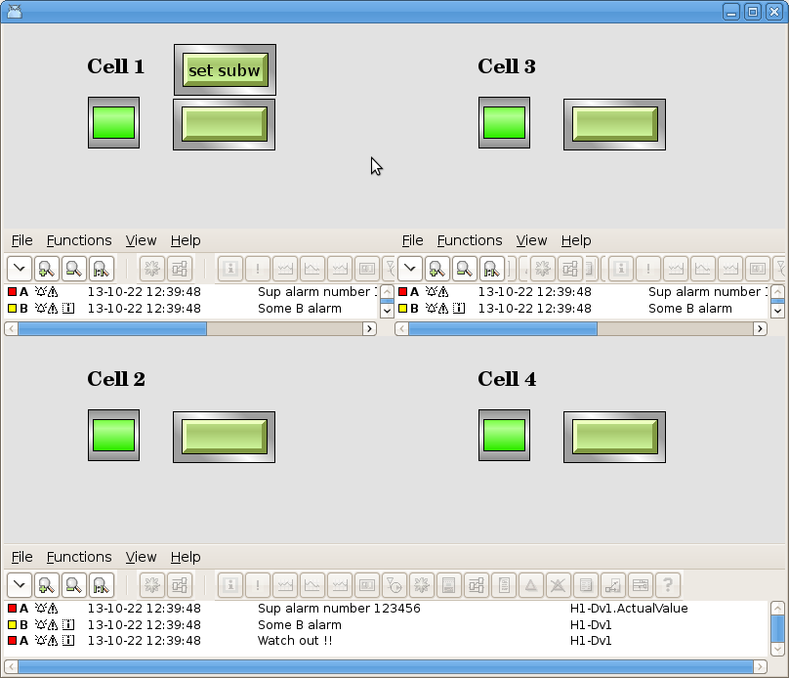
Fig Multiview window

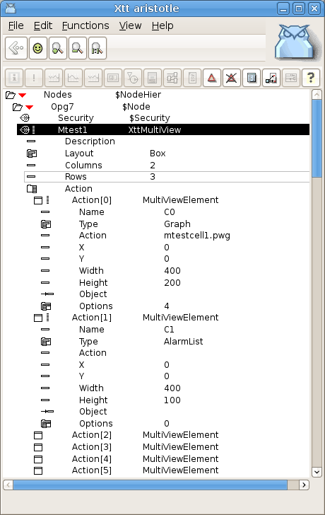
Fig Multiview configuration

Alarmview and multiple alarm and event lists
It is possible to open a number of different alarm and event lists called satellites. The alarms displayed in the differnt alarm lists are specifed in AlarmView objects. The alarms can be categorized and placed in to different maps.
An alarm view is configured with an AlarmView object. Every map in the alarm view is configured by an AlarmCategory object that contains an array of hierarhies. Alarms from these hierarchies will be displayed in this map.
The alarm and event lists can be opened with the xtt commands
xtt> show alarmlist satellite [/alarmview=]
xtt> show eventlist satellite [/alarmview=]
The satellite alarm and event lists can also be viewed in multiview windows.

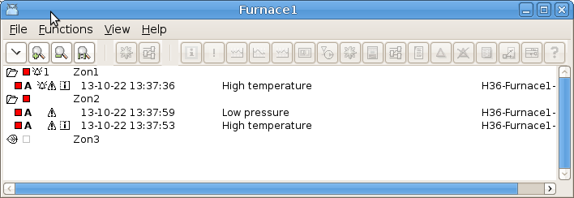
Fig AlarmView for funace 1
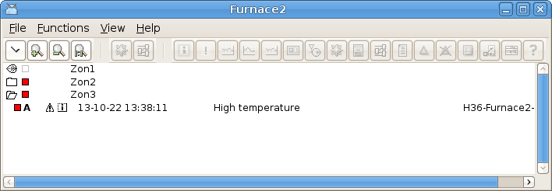
Fig AlarmView for furnace 2
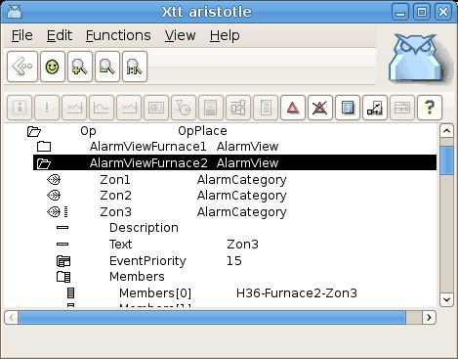
Fig configuration of alarm view

Android application
V5.0.0 contains a beta version of an android application. The application uses the same communication protocoll as the web interface in Proview and uses the same server processes. These are, as before, configured with the WebHandler object. A new object is the AppGraph object, that can be positioned below the WebHandler object to specify Ge graphs for the application.
The app contains the the following functionallity
- Access control with login and user privileges.
- Runtime navigator.
- Plc trace.
- Alarm list.
- Event list.
- Display of cross references for signals.
- Ge graphs.

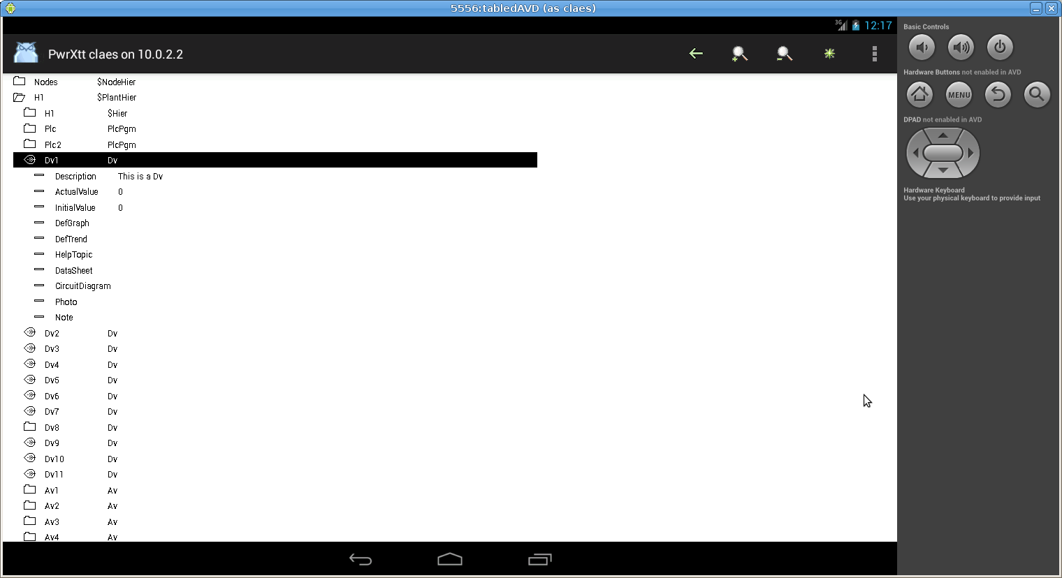
Fig Navigator in android application
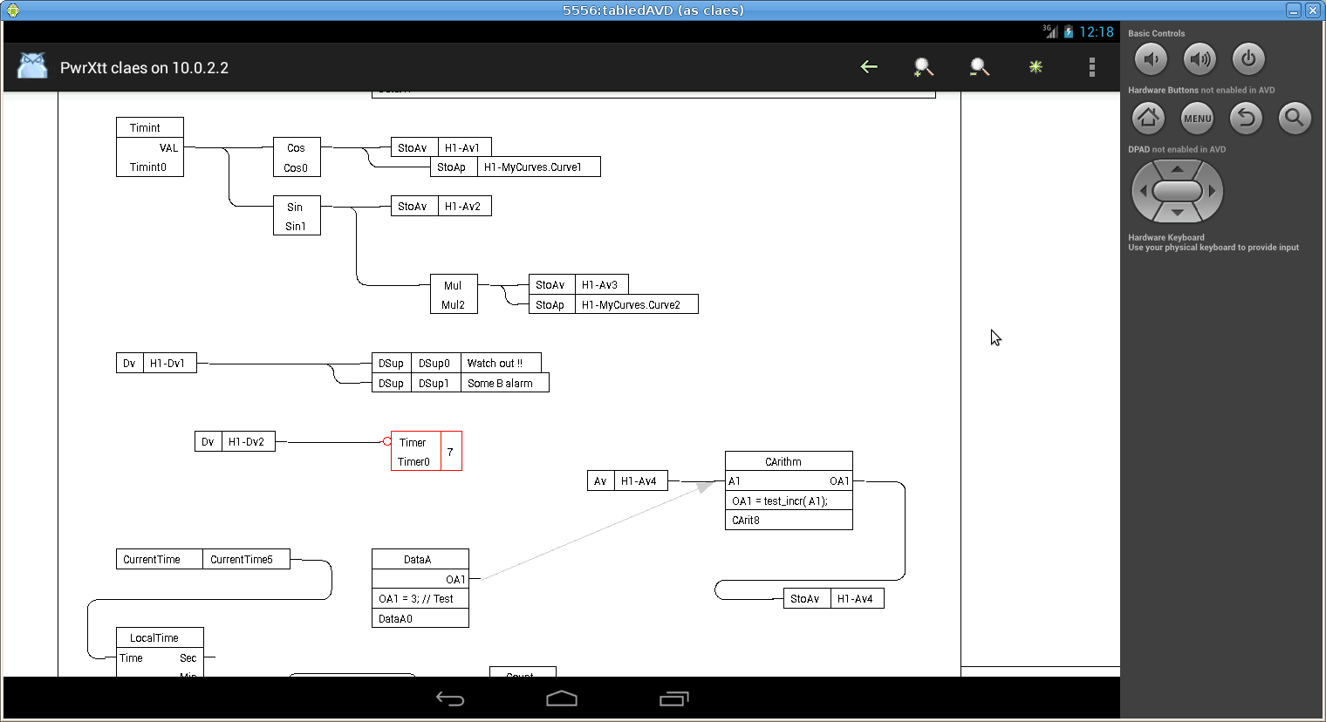
Fig Plc trace in android application

Graphs opened from pwg files in web interface
Previously when a graph was displayed int he web or java interface, it had to be exported as an java frame or a java applet. Exporting to java could be a problem for large graphs as there is a limitaion in size of java functions, and large jar-files could also result in slow performance. Now the .pwg file is read directly from the $pwrp_web catalog instead.

Object graphs in web interface
Object graphs for BaseComponent objects wasn't available in the web interface before, as the jar archive was to large to get acceptable performance. Now as the pwg-files are used instead, these object graphs are available.

Building development environment in ARM
It is now possilbe to build the develoment package on ARM.

Wb history in html
The wb history is converted to html on $pwrp_web and can be open with a link to wb_history.html. Note! If the comment is enabled in the configurator (Options/Settings/Hierarchy) this page will be more interesting.

Export of History curves from curve window
The export function in the history curve window, File/Export in the menu, has the additional choice ”All attributes”. All curves will be exported to text file, and this file can later be imported with the xtt command ”open history/file=”

Show existence of MoreText in alarm and event list
If there is a MoreText for an alarm or event, this is marked with an info icon in the alarm and event list. When the info icon is clicked, the MoreText is displayed.
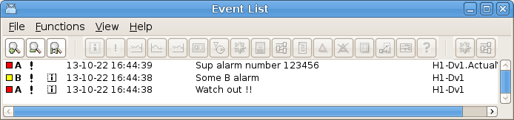

Show backup file content
The configurator command ”show backup” will open the backup utility, that can show the content of a backup file. It is also possible to compare two backup files, or to compare the values in the backup file with the values in the development database. Marked values can then be stored to the database.
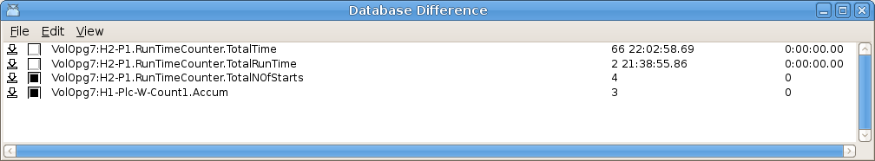
Fig Found differences between the values in the backup file and the development database

Eventlog statistics
Event statistics, ie the number of times and event is registred in the evenlog database, can be displayed from File/Statistics in the Eventlog dialog.
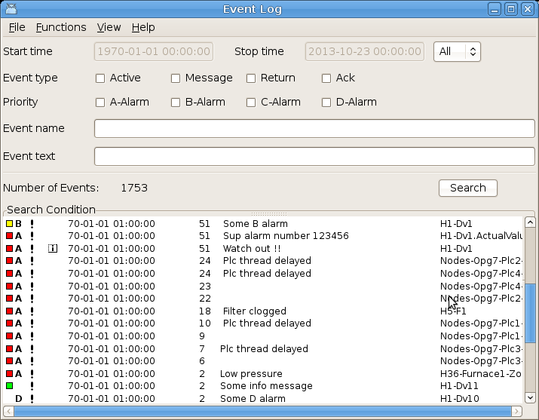
Fig event log statistics

Loadfile version check in build node
A version check of load-files is made when the node is built in addition to the check that is made when the distribution package is built.

Component for frequency converter ABB ACS880
New component objects for frequency converter ABB ACS800 with Profibus or Powerlink communication.

Ge graph always on top
It is possible to open a graph that is always on top of another graph. This is done with the /pwindow and /pinstance qualifiers to the 'open graph' command. /pwindow specifies the name of the parent graph, and /pinstance instance object for the parent graph, if parent graph is an object graph.

Ge scale snap to grid
Snap to grid for the Ge scale function implemented.

Ge support for SVG images
It is now possible to insert an SVG file as an image into the Ge editor. Use File/Import Image or just copy the svg-file to $pwrp_pop, and it will appear under Local/Images in the palette.

Ge insert of color tone
The currently selected tone in the Ge color palette is now displayed in the palette. When Tone dynamics is selected for a component, the tone can be inserted by selecting a tone in the palette, and the Ctrl+DoubleClick on the tone property in the object editor, eg DigLowTone.Tone. Previously Ctrl+DoubleClick worked to insert the current fill color into a color property.
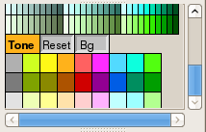
Fig Current tone displayed
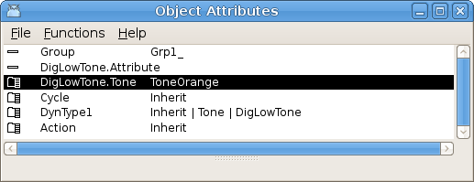
Fig Current tone inserted into DigLowTone.Tone with Ctrl+DoubleClick

Ge graph list bar
The graphs can be viewed in a list to the left in the Ge editor. By double clicking on the graph, the graph is opened. The graph list is viewed from View/View Graph List in the menu.
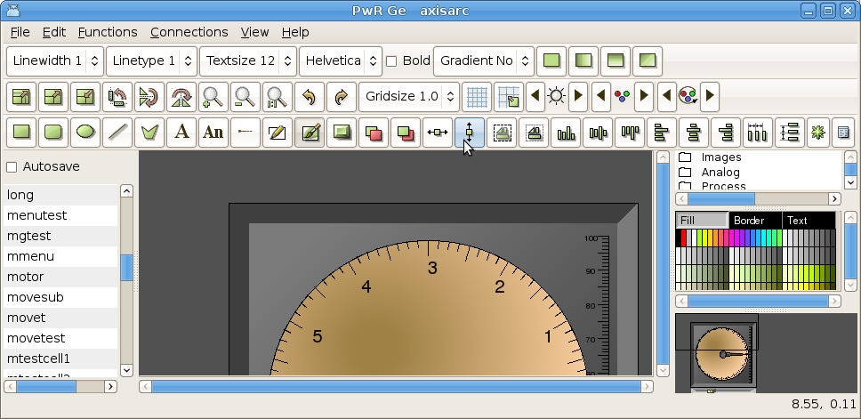
Fig New graph list to the left

Storage of events in sev server
Events can be store in a storage server with a SevHistEvents object. The SevHistEvents object has an EventSelectList attribute specifying the events that should be stored. All events for one SevHistEvents object is stored in one table described below.
+-------------------+------------------+------+-----+---------+-------+
| Field | Type | Null | Key | Default | Extra |
+-------------------+------------------+------+-----+---------+-------+
| time | datetime | NO | MUL | NULL | |
| ntime | int(10) unsigned | YES | | NULL | |
| eventtype | int(11) | YES | | NULL | |
| eventprio | int(11) | YES | | NULL | |
| eventid_nix | int(11) | YES | | NULL | |
| eventid_birthtime | int(11) | YES | | NULL | |
| eventid_idx | int(11) | YES | | NULL | |
| eventtext | varchar(80) | YES | | NULL | |
| eventname | varchar(80) | YES | | NULL | |
+-------------------+------------------+------+-----+---------+-------+
For the moment there is no Proview tool to examine the event table. Information about the events has to be retrieved trough sql commands.
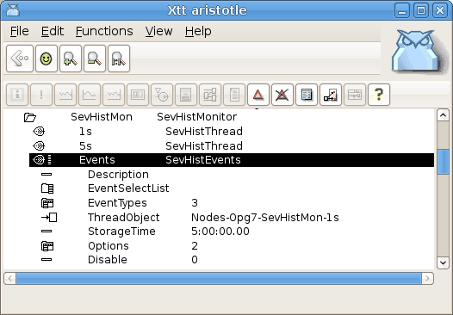
Fig SevHistEvents object configuring storage of events

sev_repair options for clean and optimize database
The storage server utility program sev_repair has new options for cleaning and optimizing the database.

sev_repair Maintain sev database

sev_repair [-e] [-r] [-c] [-o] [-l] [-t 'tablename'] [-h]

-r Repair database
-e Alter database engine to engine specified in /etc/proview.cnf,
eg "sevMysqlEngine innodb"
-c Clean tables
-o Optimize tables
-l List tables
-t Table name when a single table is to be repaired, cleaned or optimized.
Default is all tables.

Clean table can be used when the storage time has been reduced to remove superfluous rows. When tables are cleaned they can be optimized with the optimize option to retreive disk-space. The optimization is only implemented for mysql innodb tables, and disk-space will only be retreived if individual files for each table are configured with innodb_file_per_table.

Objects for constant analog and integer values
ConstAv and ConstIv are new objects for constant analog and integer values. The values can not be motified in runtime.

New Classes

EplHandler
Object to configure the Powerlink server.

EplMN
I/O Agent object configuring a Powerlink Managing Node.

EplCN
I/O Rack object configuring a Powerlink Controlled Node.

Epl_Module
I/O Card object configuring a Powerlink module.

Epl_CNServer
Object configuring the Proview node as a Powerlink Controlled Node.

Epl_CNServerModule
Object configuring a module in a Powerlink server.

BR_Di4_EplModule
Power link module object for a B&R device with 4 Di channels.

BR_Do4_EplModule
Power link module object for a B&R device with 4 Do channels.

BR_Ai4_EplModule
Power link module object for a B&R device with 4 Ai channels.

BR_Ao4_EplModule
Power link module object for a B&R device with 4 Ao channels.

XttMultiView
Configures a multiview window in a operator station.

SevHistEvents
Configures storage of events on a storage server.

AppGraph
Configures a Ge graph in an android app.

ConstAv
Constant analog value.

ConstIv
Constant integer value.

Modified Classes

Upgrade from V4.8.X to V5.0.0
Enter the administrator and change the version of the project to V5.0.0. Save and close the administrator.
I you have any class volumes, enter the class editor and build the volume.
Enter the configurator for each root volume and activate 'Function/Update Classes' and build.

