

Release Notes V5.3

2015 14 21

Copyright © 2005-2015 SSAB AB

Permission is granted to copy, distribute and/or modify this document
under the terms of the GNU Free Documentation License, Version 1.2
or any later version published by the Free Software Foundation;
with no Invariant Sections, no Front-Cover Texts, and no Back-Cover Texts.

Table of Contents
Upgrading to Proview V5.3.0 4
New functions 4
Softing Profinet stack in user space 4
Streaming video and camera control 4
Method toolbar and menu for object graphs 4
Toolbar in eventlog window 5
Conditional confirm action for toggle dig 5
Ge dynamics DigFourShift 5
Release attribute for Slider dynamics 5
Plc object IOSimulFlag 6
Components with embedded plc code 6
Editor for text and code attributes 7
Plc editing with script 7
Ge script update 8
Ge script example 8
Remove several objects with subwindows in plc editor 8
Sev database hdf5, beta release 8
Attribute flag DevHideValue 9
Hierachies in class volumes 9
Multiview pane and fix layout 9
System events 9
New Classes 10
XttMethodsMask 10
SystemSup 10
GetRefA, GetRefD, GetRefI, GetRefS 11
StoRefA, StoRefD, StoRefI, StoRefS 11
CStoRefA, CStoRefI, CStoRefS 11
SetRefD, ResRefD 11
IOSimulFlag 11
Eurotherm_EPower, Eurotherm_EPowerAggr 11
PlcEmbed 11
Modified Classes 11
Upgrade procedure 11

Upgrading to Proview V5.3.0
This document describes new functions i Proview V5.3.0, and how to upgrade a project from V5.2.0 to V5.3.0.

New functions

Softing Profinet stack in user space
The softing Profinet stack is now distributed as an archive. Previously in was distributed as a kernel module that had to be build with the current kernel by Softing. This vastly improves the usability of the Profinet stack for external users as the stack can be installed as an ordinary package.

Streaming video and camera control
A video stream from a network camera can be displayed with the XttCamera object.
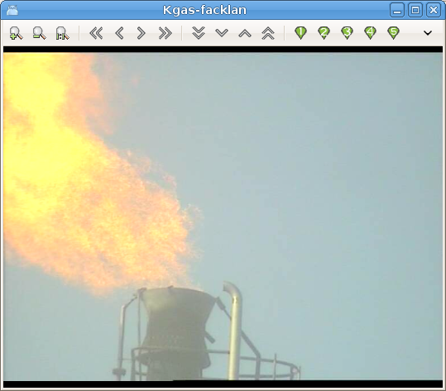
The video can be displayed in a separate window or in a MultiView window. It can not be embedded in a Ge graph.
The protocol VAPIX for control of Axis cameras are supported. With buttons in the control panel the camera can be paned, tilted and zoomed. It is also possible to store 10 camera positions.

Method toolbar and menu for object graphs
There is a new design for the method buttons, and they are also gathered in a new toolbar component that will only view the configured methods. Configured but not authorized method buttons are dimmed.
There is also a new Ge action for the method pulldown menu, MethodPulldownMenu. The menu only displays the configured methods. There is also a HelpMenu property to only display the help methods, Help and HelpClass, which makes it possibe to use it as the help menu of the object graph.
Signal and components contain a XttMethodMask attribute with information about which methods buttons should be displayed. This can configured in the configurator, or it will be calculated the first time the object graph is opened.
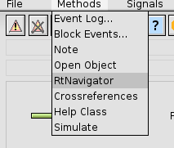

Toolbar in eventlog window
There is a new toolbar in the Eventlog window to zoom in and out and to activate methods for the selected event.

Conditional confirm action for toggle dig
The confirm action in Ge has two new properties, OnSet and OnReset. These can be combined with ToggleDig where OnSet is true, the confirm window will only be displayed when the toggled attribute is set, and if OnReset is true, the confirm window will only be displayed when the toggled attribute is reset.

Ge dynamics DigFourShift
The dynamic DigFourShift can used for subgraphs with several pages. Three boolean attributes are specified and the dynamics will shift between four pages. New subgraphs using the DigFourShift are TrafficLight2 and TrafficLight3.
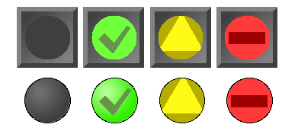
Fig TrafficLight2 and TrafficLight3 with DigFourShift dynamics

Release attribute for Slider dynamics
The property ReleaseAttr is added to Slider dynamics. A boolean attribute can be specified in ReleaseAttr that will be set when the slider is released.

Plc object IOSimulFlag
This is a new function object to fetch the IOSimulFlag attribute in the IOHandler object. It can be used in function objects to test if simulation is active.

Components with embedded plc code
Previously components with plc code had to be separated in a main object containing signals and data, and a function object containing the plc code. Now it is possible to create components containing plc code without creating a function object. The plc code is embedded in the component and you just create the component object and the plc code will automatically be generated under the component. The component should contain an PlcEmbed attribute with the plc thread, reset object and execute order. As there is no function object, references to other object has to be done with another mechanism. The component can contain attributes of type AttrRef that points to attributes in other object where values should be fetched or stored in the plc code. In the code, GetRef and StoRef objects are used to fetch and store these values via an attribute reference. This kind of components are suitable for components with a limited interaction with other objects.
Components with embedded plc can be inserted into other component or aggregate classes. In the example below the Burner attribute is an array with 20 component object with embedded plc.
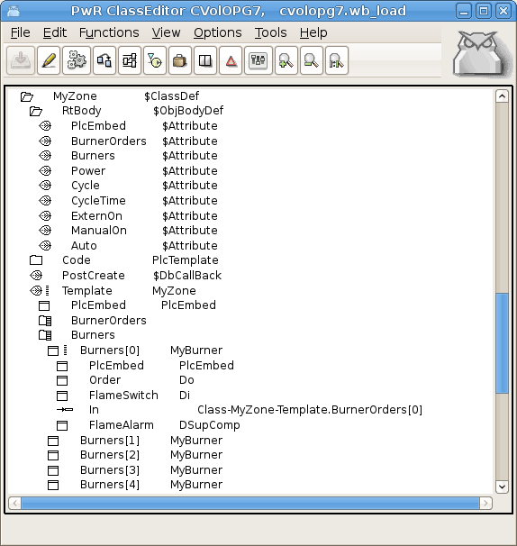
Fig Configuration of a component class with embedded plc

Editor for text and code attributes
A text editor can be opened from the plc editor to edit text and code attributes in BodyText, HelpText, Carithm and DataArithm objects. The editor is opened from EditText or EditCode in the plc editor popuop menu, thus making it easy to edit the text or code without opening the object editor first.
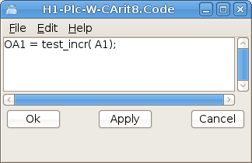
Fig Text and code editor

Plc editing with script
Some new script function has been added to be able create function objects and connections in a plc program with script. When editing a plc session is opened with OpenPlcPgm() and later closed with ClosePlcPgm(). In the plc session function objects are created with CreatePlcObject() and connections with CreatePlcConnection(). Attribute values can be set with SetPlcObectAttr() and function object can be connected with objects in the plant hierarchy with PlcConnect().
New functions
CreateObject() | Create an ordinary object in the planthier.
OpenPlcPgm() | Open a plc program and start an plc editing session.
CreatePlcObject() | Create a plc document or plc function object.
CreatePlcConnection() | Create a plc connection between two function objects.
SetPlcObjectAttr() | Set attribute values in a function object or plc document.
PlcConnect() | Activate the plc connect function.
ClosePlcPgm() | Close the plc editing session.

Script example

main()
int first_child = 1;
int after = 3;

#Create some plant object s
CreateObject("H2","$PlantHier","H1",after)
CreateObject("Plc2","PlcPgm","IO-MOT1",first_child);
CreateObject("ObjFan1","MCC2","H2-Plc",after)
save

# Open a plc session
OpenPlcPgm("IO-MOT1-Plc2");

# Create a document
CreatePlcObject("Doc01","Document",2.0,2.0);
SetPlcObjectAttr("Doc01.DocumentOrientation",1);
SetPlcObjectAttr("Doc01.DocumentSize",3);

CreatePlcObject("And1","And",1.0,1.0,"Doc01",7,1,5)
CreatePlcObject("Fan01","MCC_Fo",1.3,1.0,"Doc01")
CreatePlcObject("GetDi01","GetDi",0,4,1.0,"Doc01")
PlcConnect("GetDi01","IO-MOT)-INP-R0_C02_DI_A1");
CreatePlcConnection("GetDi01","Status","And1","In1");
ClosePlcPgm();
endmain

Ge script update
The Ge script function has been updated and improved. Enumeration names can be used for different kind of enumerations, eg dynamic and action types.

Ge script example
create object/x1=1/y1=1/x2=10/y2=10/subgraph=movesub
set current annotation "Close"
set current gradient VerticalTube1
set current attr HostObject.Object H1-Dv1
set current attr dyntype1 DigLowColor|Move|DigColor
set current attr DigLowColor.Color White
set current attr DigLowColor.Color White
set current attr DigColor.Instances 2|3
set current attr DigColor2.Color GreenGreenYellow
set current attr action ToolTip|SetDig|ValueInput
set current attr ToolTip.Text "Some tooltip text..."
set current attr Access Operator1|System

Remove several objects with subwindows in plc editor
It's now possible to remove several objects with subwindows at the same time. Previously they had to be removed one by one.

Sev database hdf5, beta release
The database hdf5 is added as an alternative to mysql and sqlite as database in sev. For the moment there is no journal file in hdf5, and the database can be corrupt after for example a power failure. Journaling will be added to hdf5 this year. The advantage of hdf5 is that it requires much less space the sql databases, and data can be fetched much faster.

Attribute flag DevHideValue
Flag DevHideValue for an attribute will hide the value in the configurator. Combined with RtHide it can be used for password attributes.

Hierachies in class volumes
It's now possible to insert one hierarchy level for $ClassDef objects in a class volume. The hierachy object should be of class $ClassHier.
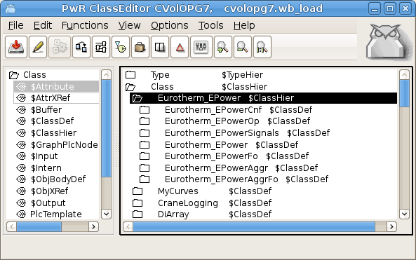
Fig Hierarchy in class volume

Multiview pane and fix layout
Pane and fix layout are added to the MultiView window.
Pane layout means that the border line between two windows can be moved to adjust the size of the two windows. Pane is only supported for MutliViews with two columns and one row.
With Fix layout the coordinates for each cell is specified and the cell positions will not be adjusted if the window size if changed.

System events
A number of events and alarms generated by the system is added. These are configured by SystemSup objects in the MessageHandler object. These alarms can be modified or disabled by editing the SystemEvent array in the MessageHandler object.The following events will cause an alarm or event message
- Link down
- Node up
- Node restart
- Outunit restart
- Emergency break with reboot
- Emergency break with fixed output values
- Emergency break with fixed I/O
- Simulate load
- System status error
- System status warning
- IO soft error limit reached
- IO hard error limit reached
- Application alarm quota exceeded
- System alarm quota exceeded
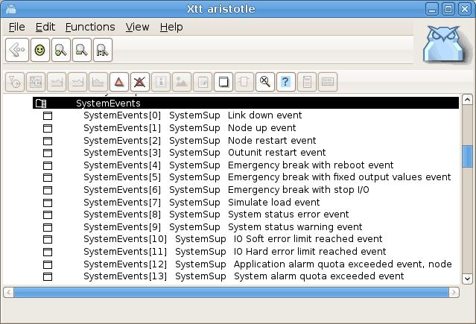
Fig System event array in the MessageHandler object

New Classes

XttMethodsMask
Contains bitmasks for Xtt methods. This class is inserted in all signal and component objects.

SystemSup
Supervision object for system events. Only present in the SystemEvent array in the MessageHandler object.

GetRefA, GetRefD, GetRefI, GetRefS
Get the value of an analog, digital, integer or string attribute by reference.

StoRefA, StoRefD, StoRefI, StoRefS
Store a value into an analog, digital, integer of string attribute by reference.

CStoRefA, CStoRefI, CStoRefS
Conditional storage of an analog, digital or string attribute by reference.

SetRefD, ResRefD
Set and reset of a digital attribute by reference.

IOSimulFlag
Plc object to fetch the value of IOSimulFlag in the IOHandler object.

Eurotherm_EPower, Eurotherm_EPowerAggr
A set of classes to control a Eurotherm Epower thyristor aggregate with Profinet communication.

PlcEmbed
Class for components with embedded plc code.

Modified Classes

Upgrade procedure
The upgrading has to be done from any version in the interval V4.7.0. If the project has a lower version, the upgrade has to be performed stepwise following the schema
V2.1 -> V2.7b -> V3.3 -> V3.4b -> V4.0.0 -> V4.1.3 ->V4.2.0->V4.5.0->V4.6.0->V4.7.0->V4.8.6->(V5.0.0)->V5.1.0->V5.2

Enter the administrator and change the version of the project to V5.2.0. Save and close the administrator.

Enter the directory volume and save.
I you have any class volumes, enter the class editor and build the volume.
Enter the configurator for each root volume and activate 'Function/Update Classes' and build.
Note ! The update procedure upgrade.sh doesn't have to be executed.
Modify OpPlace, PID and CompPID objects
- set the IsDefaultOp attribute in the OpDefault OpPlace object to 1.
- set PDAbsFlag = 1, WindupMask = BPID, MaxWindup = same vaue as MaxOut and MinWindup = same value as MinOut in PID and CompPID objects.

