

Release Notes V5.1

2014 02 04

Copyright SSAB Oxelösund AB 2014

Permission is granted to copy, distribute and/or modify this document
under the terms of the GNU Free Documentation License, Version 1.2
or any later version published by the Free Software Foundation;
with no Invariant Sections, no Front-Cover Texts, and no Back-Cover Texts.

Table of Contents
Upgrading to Proview V5.1.0 4
New functions 4
Supervision in component objects 4
ABB ACS880 with PPO7 Profinet communication 5
Ubuntu package for cross compilation of Raspberry projects 5
Export of Xtt fast curve 5
Xtt command to close the current graph and multiwindow 6
Xtt logging modifications 6
New Classes 6
DSupComp 6
DSupCompFo 6
ASupComp 6
ASupCompFo 6
Modified Classes 6
Upgrade procedure 6
Make a copy of the project 7
Dump the databases 7
Linux release upgrade 8
Change version 8
upgrade.sh 8
classvolumes 8
renamedb 8
cnvdump 9
loaddb 9
cnvobjects 9
compile 9
createload 9
createboot 9
List example 9

Upgrading to Proview V5.1.0
This document describes new functions i Proview V5.1.0, and how to upgrade a project from V5.0.0 to V5.1.0.

New functions

Supervision in component objects
DSupComp and ASupComp is a new type of supervision objects for components. The function is identical to DSup and Asup, but they are separated in a main object, containing the data for the object, and a function object used in the plc code. For DSupComp the function object is DSupCompFo and for ASupComp the function object is ASupCompFo.
Previously when ordinary DSup and ASup object where use in components, these objects were placed in the plc code and the only property that normally could be modified was the event text. With the new objects, all the supervision attributes are available for modification, such as MoreText, EventPriority, EventFlags, TimerTime etc.
All supervision objects in the base components are replaced by DSupComp and ASupComp objects. The figure below shows the DSupComp object for high high limit in a BaseSensor object.
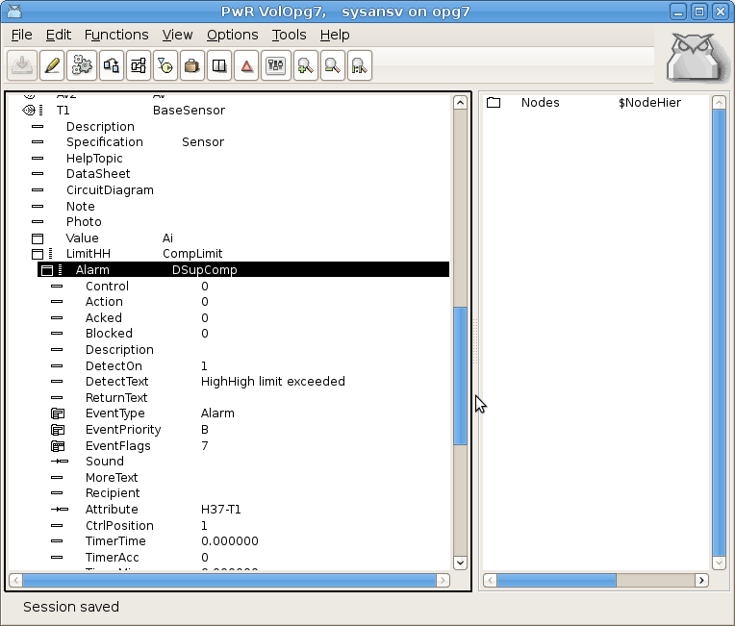

ABB ACS880 with PPO7 Profinet communication
A set of object for communication and control of frequency converter ABB ACS880 with Profinet communication is added. The set contains a profinet device object with predefined gsdm file, a profinet module with IO module fo r the PPO7 communication. Note that the PPO7 message for profinet differs from PPO7 for profibus, and a specific IO module is required. Also objects for the frequency converter, and aggregates for motor, pump and fan control are added.

Ubuntu package for cross compilation of Raspberry projects
The new package that can be installed on Ubuntu, contains cross compiled runtime actives for Rasberry PI, thus making it possible to develop RPI projects on Ubuntu, without having to build a cross compiled Proview release from sources. The name of the package is pwrrpi51 and it requires that the development package pwr51 first is installed.
Also the cross compiler rpi-tools for rasbian has to be installed on the developmen node.

Export of Xtt fast curve
An export function is added to the Xtt fast curve window to export the curve to text file. The text file can later be opened in a curve window with the xtt command ”open fast /file='filename'”.

Xtt command to close the current graph and multiwindow
These close commands are used for command buttons to close the current graph or multiwindow. When using multiwindows and window objects the name of the graph can be unknown when editing, and the name $current can be used to point out the current multiwindow or graph.
xtt> close graph $current
xtt> close multiwindow $current

Xtt logging modifications
Some changes are made in the xtt logging utility. The default filename is changed and is individual for the different entries. An entry is cleared before a restore is done.

New Classes

DSupComp
Digital supervision object for components. Basically a DSup object that is divided into a main object in the plant hierarchy, and a function object in the plc, DSupCompFo.

DSupCompFo
Function object to DSupComp.

ASupComp
Analog supervision object for components. Basically an ASup object that is divided into a main object in the plant hierarchy, and a function object in the plc, ASupCompFo.

ASupCompFo
Function object to ASupComp.

Modified Classes

Upgrade procedure
The upgrading has to be done from any version in the interval V4.7.0. If the project has a lower version, the upgrade has to be performed stepwise following the schema
V2.1 -> V2.7b -> V3.3 -> V3.4b -> V4.0.0 -> V4.1.3 ->V4.2.0->V4.5.0->V4.6.0->V4.7.0->V4.8.6->(V5.0.0)->V5.1.0
When upgradeing from lower versions than V5.0.0, upgradeing from V4.8.x can be done directly to V5.1.0.
The upgrade procedure is to dump the database with reload.sh, change the version of the project in the projectlist, and then execute the script upgrade.sh.
NOTE !!
Do not activate Update Classes.

If the previous version should be kept, first make a copy of the project.

Make a copy of the project
Do sdf to the project and start the administrator
> pwra
Now the Projectlist is opened. Enter edit mode, login as administrator if you lack access. Find the current project and select Copy Project from the popup menu of the ProjectReg object. Open the copy and assign a suitable project name and path. Save and close the administrator.

Dump the databases
Execute the first pass, dumpdb, in the script reload.sh.
> reload.sh

reload.sh Dump and reload of database.

Arguments Database or databases to reload.
I no arguments is supplied, all databases will be reloaded.

Pass

dumpdb Dump database to textfile $pwrp_db/'volume'.wb_dmp
classvolumes Create structfiles and loadfiles for classvolumes
renamedb Rename the old database
dirvolume Load directory volume
loaddb Load the dump into the new database
compile Compile all plcprograms in the database
createload Create new loadfiles.
createboot Create bootfiles for all nodes in the project.

-- Reloading volume directory volopg2

Pass: dumpdb classvolumes renamedb dirvolume loaddb compile createload createboot

Enter start pass [dumpdb] >

------------------------------------------------------------------------
Pass dump database
------------------------------------------------------------------------
Do you want to continue ? [y/n/go] y
ls: cannot access /data0/pwrp/opg2/common/db/*.wb_dmp: No such file or directory
Dumping volume directory in /data0/pwrp/opg2/common/db/directory.wb_dmp
...
I Database opened /data0/pwrp/opg2/common/db/volopg2.db
ls: cannot access /data0/pwrp/opg2/common/db/*.wb_load: No such file or directory

------------------------------------------------------------------------
Pass create structfiles and loadfiles for classvolumes
------------------------------------------------------------------------
Do you want to continue ? [y/n/go] n
setdb is obsolete
>

Check that the one dumpfile is created for every rootvolume

> cd $pwrp_db
> ls -l *.wb_dmp
-rw-rw-r-- 1 cs pwrp 7467 2010-03-26 16:32 volopg2.wb_dmp

Linux release upgrade
If you are using an older Ubuntu version to upgrade the linux release and install the pwr51 package.

Change version
Enter the administrator and change the version of the project to V5.1.0. Save and close the administrator.

upgrade.sh
Do sdf to the project.
upgrade.sh is a script that is divided into a number of passes. After each pass you you have to answere whether to continue with the next pass or not.
Start the script with

> upgrade.sh

Start from the classvolumes pass.

Enter start pass [classvolumes] >

classvolumes
Create loadfiles and structfiles for the class volumes.

renamedb
Store the old databases under the name $pwrp_db/'volumename'.db.1.

cnvdump
Converts DSup and ASup to DSupComp and ASupComp for base component objects.

loaddb
Create databases and load the dumpfiles into them.

cnvobjects
Convert objects in loaded database.

compile
Compile all the plc programs.

createload
Create loadfiles for the root volumes.

createboot
Create bootfiles for all nodes in the project.
If the project contains any application programs, these has to be built manually.
Delete files from the upgrading procedure:
$pwrp_db/*.wb_dmp.*
$pwrp_db/*.db.1 (old databases, directories which content also should be removed)

List example
>
> sdf opg2
Setting base /data0/x4-7-1/rls
bash: cd: /data0/pwrp/opg2/src/login: No such file or directory
>
> upgrade.sh

upgrade.sh Upgrade from V4.7.0 to V4.8.0

Pass

classvolumes Create loadfiles for classvolumes.
renamedb Rename old databases.
cnvdump Convert the dumpfiles.
loaddb Load dumpfiles.
cnvobjects Convert objects in loaded database.
compile Compile all plcprograms in the database
createload Create new loadfiles.
createboot Create bootfiles for all nodes in the project.

-- Upgrade opg2

Enter start pass [classvolumes] >

------------------------------------------------------------------------ Pass create structfiles and loadfiles for classvolumes
------------------------------------------------------------------------Do you want to continue ? [y/n/go] y
ls: cannot access /data0/pwrp/opg2/src/db/*.wb_load: No such file or directory

------------------------------------------------------------------------ Pass rename old databases
------------------------------------------------------------------------Do you want to continue ? [y/n/go] y
-- Saving file /data0/pwrp/opg2/src/db/volopg.db -> /data0/pwrp/opg2/src/db/volopg.db.1

------------------------------------------------------------------------Pass cnvdump
------------------------------------------------------------------------Do you want to continue ? [y/n/go] y
/data0/pwrp/opg4/src/db/volopg2.wb_dmp

------------------------------------------------------------------------Pass load database
------------------------------------------------------------------------Do you want to continue ? [y/n/go] y
-- Loading volume volopg
...
-- Processing line: 57
-- Building volume directory
I Volume directory loaded
I Database opened /data0/pwrp/opg2/src/db/directory.wb_load
-- Processing line: 200
-- Building volume VolOpg
I Volume VolOpg loaded
Berkeley DB 4.6.21: (September 27, 2007)
info put: 0
Berkeley DB 4.6.21: (September 27, 2007)
info get: 0
int rc = m_txn->abort(): 0

------------------------------------------------------------------------
Pass convert objects in loaded database
------------------------------------------------------------------------
Do you want to continue ? [y/n/go] y

Proview is free software; covered by the GNU General Public License.
You can redistribute it and/or modify it under the terms of this license.

Proview is distributed in the hope that it will be useful
but WITHOUT ANY WARRANTY; without even the implied warranty of
MERCHANTABILITY or FITNESS FOR A PARTICULAR PURPOSE. See the
GNU General Public License for more details.

-- Processing line: 21
-- Building volume localWb
I Volume localWb loaded
-- Set H5-V1.Actuator.Mode.AlarmLocalMode.Attribute = H5-V1.Actuator.Mode
-- Set H5-V1.Actuator.DiffAlarm.Attribute = H5-V1.Actuator
-- Set H5-V1.Actuator.SwitchAlarm.Attribute = H5-V1.Actuator
-- Set H19-M1.TempSwitch.Alarm.Attribute = H19-M1.TempSwitch
-- Set H19-M1.TempSensor.LimitHH.Alarm.Attribute = H19-M1.TempSensor
-- Set H19-M1.TempSensor.LimitH.Alarm.Attribute = H19-M1.TempSensor
-- Set H19-M1.TempSensor.LimitL.Alarm.Attribute = H19-M1.TempSensor
-- Set H19-M1.TempSensor.LimitLL.Alarm.Attribute = H19-M1.TempSensor %WNAV-E-MSG, Session saved

------------------------------------------------------------------------Pass compile plcprograms
------------------------------------------------------------------------Do you want to continue ? [y/n/go] y
...
Berkeley DB 4.6.21: (September 27, 2007)
info get: 0
I Database opened /data0/pwrp/opg2/src/db/volopg.db
-- Plc window generated F1-Z1-Plc-W
-- Plc window compiled for x86_linux optimized -O3 F1-Z1-Plc-W
-- Plc plcpgm compiled for x86_linux optimized -O3 F1-Z1-Plc
-- Plc window generated F1-Z2-Plc-W
-- Plc window compiled for x86_linux optimized -O3 F1-Z2-Plc-W
-- Plc plcpgm compiled for x86_linux optimized -O3 F1-Z2-Plc

------------------------------------------------------------------------Pass create loadfiles
------------------------------------------------------------------------Do you want to continue ? [y/n/go] y
-- Removing old loadfiles
rm: cannot remove `/data0/pwrp/opg2/bld/common/load/ld_vol*.dat': No such file or directory
...
Berkeley DB 4.6.21: (September 27, 2007)
info get: 0
I Database opened /data0/pwrp/opg2/src/db/volopg.db
-- Building archive for volume: 000_001_001_012
-- Archive built for volume: 000_001_001_012

-- Working with load file volume 'VolOpg'...
-- Open file...
-- Successfully created load file for volume 'VolOpg'
-- 26 objects with a total body size of 21976 bytes were written to new file.

Before this pass you should compile the modules included by ra_plc_user.

------------------------------------------------------------------------Pass create bootfiles
------------------------------------------------------------------------Do you want to continue ? [y/n/go] y
-- Creating bootfiles for all nodes

Proview is free software; covered by the GNU General Public License.
You can redistribute it and/or modify it under the terms of this license.

Proview is distributed in the hope that it will be useful
but WITHOUT ANY WARRANTY; without even the implied warranty of
MERCHANTABILITY or FITNESS FOR A PARTICULAR PURPOSE. See the
GNU General Public License for more details.

-- Creating bootfile for node opg
plc_opg_0507_00011
-- Plc thread generated priority 0, scantime 0.10000 s, 2 plcpgm's
-- Plc process compiled for x86_linux optimized -O3 Dummy
-- Plc program linked for x86_linux node plc_opg_0507
-- Creating bootfile for node aristotle
plc_aristotle_0517_00011
-- Plc thread generated priority 0, scantime 0.10000 s, 2 plcpgm's
-- Plc process compiled for x86_linux optimized -O3 Dummy
-- Plc program linked for x86_linux node plc_aristotle_0517

-- The upgrade procedure is now accomplished.

setdb is obsolete
>
>

