

Release Notes V4.8

2012 03 05

Copyright SSAB Oxelösund AB 2010

Permission is granted to copy, distribute and/or modify this document
under the terms of the GNU Free Documentation License, Version 1.2
or any later version published by the Free Software Foundation;
with no Invariant Sections, no Front-Cover Texts, and no Back-Cover Texts.

Table of Contents
Upgrading to Proview V4.8.0 6
New functions 6
Profinet 6
Web interface 7
Velleman K8055 experiment board 7
History curve window 7
Xtt logging condition 8
Operator log 8
Xtt commands 8
oplog 8
UTF-8 coded translation tables and help file texts 9
Embedded Linux 9
ARM architecture 9
Mac OS X 9
New Classes 9
PnControllerSoftingPNAK 9
PnDevice 9
PnModule 9
Siemens_ET200S_PnDevice 9
Siemens_ET200M_PnDevice 9
Sinamics_G120_PnDevice 9
ABB_ACS_PnDevice 10
BaseFcPPO5IoModule 10
BaseFcPPO3IoModule 10
BaseFcPPO3PnModule 10
Sinamics_Tgm1_PnModule 10
Siemens_Ai2_PnModule 10
Siemens_Ao2_PnModule 10
Siemens_Di4_PnModule 10
Siemens_Di2_PnModule 10
Siemens_Do4_PnModule 10
Siemens_Do2_PnModule 10
Siemens_Do32_PnModule 10
Siemens_D16_PnModule 11
Siemens_Do8_PnModule 11
Siemens_Di32_PnModule 11
Siemens_Di16_PnModule 11
Siemens_Di8_PnModule 11
Siemens_Dx16_PnModule 11
Siemens_Ai8_PnModule 11
Siemens_Ao8_PnModule 11
Siemens_Ai4_PnModule 11
Siemens_Ao4_PnModule 11
Sinamics_G120_Tgm1 11
Sinamics_G120_Tgm1Fo 11
GPIO 11
GPIO_Module 12
OneWire 12
Maxim_DS18B20 12
USB_Agent 12
Velleman_K8055 12
Velleman_K8055_Board 12
Modified Classes 12
BaseFcPPO5PbModule 12
BaseFcPPO3PbModule 12
BaseFcPPO3 12
V4.8.1 Additions 12
Remote support for WebSpheare Message Queue 12
I/O support for Arduino USB boards 13
PID controller derivative filter algorithm modified 13
Logging of events in process graphics 13
Upgrade from V4.8.0 to V4.8.1 13
V4.8.2 Additions 13
Miscellanous module and class volume 13
Hilscher cifX board 14
UDP IO 14
USB Joystick 14
NMps cells with size 60 and 120 14
Axis arc 14
Upgrade from V4.8.0 or V4.8.1 to V4.8.2 17
V4.8.3 Additions 17
Post server 17
Report server 19
Xtt Collect window 21
Show all signals in a Collect window 21
Ge multiline texts 21
Web site opened from other location 22
New Plc objects 22
Modbus RTU 22
V4.8.4 Additions 22
Buffer channels and signals 22
Buffer Inputs 23
Buffer Outputs 23
ChanBiBlob and ChanBoBlob 23
Sev database engine 23
Upgrade from V4.8.0, V4.8.1, V4.8.2 or V4.8.3 to V4.8.4 23
Upgrade procedure 24
Make a copy of the project 24
Dump the databases 24
Linux release upgrade 25
Change version 25
upgrade.sh 25
classvolumes 26
renamedb 26
cnvdump 26
loaddb 26
compile 26
createload 26
createboot 26
List example 26
Appendix A Embedded Linux 30
Project 31
Installing Proview 33
Proview runtime 33
Project 35
Settings 35
Distribute 35
Appendix B Mac OS X 36
Build from source on Mac OS X 10.6 x86_64 36

Upgrading to Proview V4.8.0
This document describes new functions i Proview V4.8.0, and how to upgrade a project from V4.7.0 to V4.8.0.

New functions

Profinet
An interface to the Softing profinet stack PNAK is implemented in V4.8. Also an Profinet configurator using the gsdml configuration files is added. Also, using the same Profinet stack, there exist a new tool for identifying devices on a Profinet network and function to set name and ip-address for the repective devices. Read more about how th use the Profinet interface in ”Guide to I/O system”.
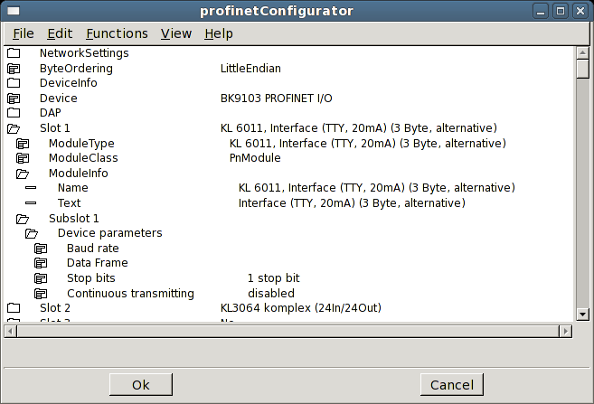
Fig The Profinet configurator

Web interface
- Language support is added to the Web interface.
- Method buttons in object graph added.
- Object graphs updated.

Velleman K8055 experiment board
Velleman K8055 is an USB experiment board with 2 Ai, 5 Di, 8 Do and 2 Ao. It is can be purchased as a kit, K8055, or as an assembled board, VM110. The card can be used to test Proview with some simple application.
The board is configured with the objects USB_Agent, Velleman_K8055 and K8055_Board. See Guide to I/O System for more info.

History curve window
The curve window for process history has a new toolbar to choose time interval.
It is also possible view curves for several stored attributes, either by configuring a PlotGroup object containing references to a number of SevHist objects, or by adding curves to a curve window.
You add a curve by selecting the signal, or SevHist object in the navigator and press the '+' button.
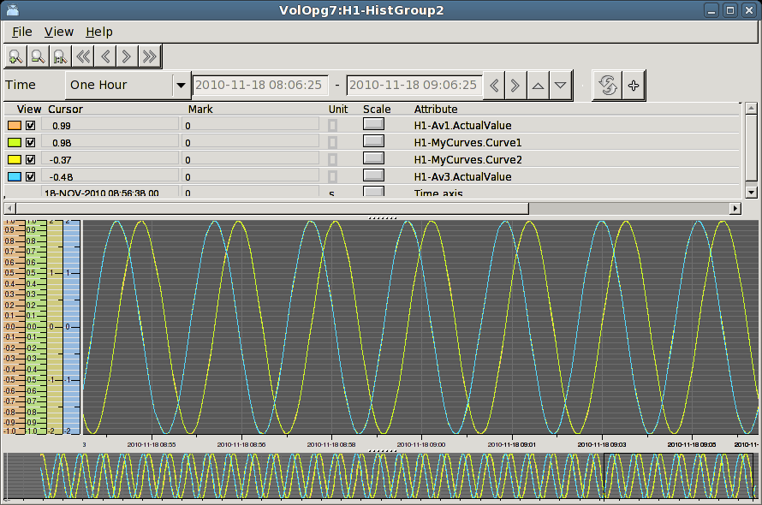
Fig History curve window with multiple curves

Xtt logging condition
The condition property of the Xtt logging function can contain an expression where values of database attributes are fetched by the GetD, GetA and GetI functions for digital, analog and integer attributes respectively, e.g
expr( GetD("H1-Dv1.ActualValue") && GetA("H1-Av3.ActualValue") > -0.8)

Operator log
Operator actions can be logged to file.
The logging is started with the xtt command 'oplog start' and the default log file is $pwrp_log/xtt.log. The logging is stopped with the command 'oplog stop' .
A log file can be played, i.e. all actions in the file are executed, with the command 'oplog play'.

Xtt commands

oplog
New command to handle operator log.
xtt> oplog start [/file=] Start the logging.
xtt> oplog stop Stop the logging.
xtt> oplog play [/file=] [/speed=] Execute logged actions.

UTF-8 coded translation tables and help file texts
It is possible to write UTF-8 coded translations tables and help file texts by adding the 'Coding:UTF-8' tag on the first line. This will make it possible to create translated versions of the operator environment to most languages. A translation to chinese (zh_cn) is planned to the next release.

Embedded Linux
Support to build Proview for embedded Linux with cross compilation is added to V4.8.0. See Appendix A.

ARM architecture
Build files for ARM are added to the runtime module. To build for ARM see Appendix A.

Mac OS X
Proview can be built on Mac OS X 10.6 on x86_64 by using fink. See Appendix B for more info.

New Classes

PnControllerSoftingPNAK
I/O Agent object configuring the Softing Profinet stack PNAC.

PnDevice
I/O Rack object configuring a Profinet device. The device is configured by the Profinet configurator opened from the ConfigureDevice method.

PnModule
I/O Card object configuring a Profinet module. The module objects are created by the Profinet configurator.

Siemens_ET200S_PnDevice
Device object for a Siemens ET200S.

Siemens_ET200M_PnDevice
Device object for a Siemens ET200M.

Sinamics_G120_PnDevice
Device object for a Sinamics G120 drive.

ABB_ACS_PnDevice
Device object for a ABB ACS800 drive with RETA-02 interface (profinet).

BaseFcPPO5IoModule
Generic I/O Bus module object for PPO5. Contains the Channels for the communication and should be an attribute object of the module object for the IO bus system.

BaseFcPPO3IoModule
Generic I/O Bus module object for PPO3 / Standard telegram 1. Contains the Channels for the communication and should be an attribute object of the module object for the IO bus system.

BaseFcPPO3PnModule
Module object for a drive using Standard Telegram 1 / PPO3. The Io-attribute of this object can be directly connected to a drive object of type BaseFcPPO3 in the $PlantHier. This one in turn can be connected to a function object in a plc-program of type BaseFcPPO3Fo.

Sinamics_Tgm1_PnModule
Module object for a drive using Standard Telegram 1. The Io-attribute of this object can be directly connected to a drive object of type Sinamics_G120_Tgm1 in the $PlantHier. This one in turn can be connected to a function object in a plc-program of type Sinamics_G120_Tgm1Fo.

Siemens_Ai2_PnModule
Module object for a Siemens ET200 module with 2 analog inputs.

Siemens_Ao2_PnModule
Module object for a Siemens ET200 module with 2 analog outputs.

Siemens_Di4_PnModule
Module object for a Siemens ET200 module with 4 digital inputs.

Siemens_Di2_PnModule
Module object for a Siemens ET200 module with 2 digital inputs.

Siemens_Do4_PnModule
Module object for a Siemens ET200M module with 4 digital outputs.

Siemens_Do2_PnModule
Module object for a Siemens ET200 module with 2 digital outputs.

Siemens_Do32_PnModule
Module object for a Siemens ET200 module with 32 digital outputs.

Siemens_D16_PnModule
Module object for a Siemens ET200 module with 16 digital outputs.

Siemens_Do8_PnModule
Module object for a Siemens ET200 module with 8 digital outputs.

Siemens_Di32_PnModule
Module object for a Siemens ET200 module with 32 digital inputs.

Siemens_Di16_PnModule
Module object for a Siemens ET200 module with 16 digital inputs.

Siemens_Di8_PnModule
Module object for a Siemens ET200 module with 8 digital outputs.

Siemens_Dx16_PnModule
Module object for a Siemens ET200 module with 16 digital outputs and 16 digital inputs.

Siemens_Ai8_PnModule
Module object for a Siemens ET200 module with 8 analog inputs.

Siemens_Ao8_PnModule
Module object for a Siemens ET200 module with 8 analog outputs.

Siemens_Ai4_PnModule
Module object for a Siemens ET200 module with 4 analog inputs.

Siemens_Ao4_PnModule
Module object for a Siemens ET200 module with 4 analog outputs.

Sinamics_G120_Tgm1
Class representing a G120 drive using Standard telegram 1. The I/O can be directly connected to a BaseFc PPO3IoModule.

Sinamics_G120_Tgm1Fo
Function object working on a Sinamics _G120_Tgm1 drive object. Connect drive to function object with the connect method.

GPIO
I/O Rack object configuring GPIO, General Purpos I/O.

GPIO_Module
I/O Card object configuring GPIO.

OneWire
I/O Rack object configuring the Maxim 1-wire bus.

Maxim_DS18B20
I/O object configuring the Maxim DS18B20 temperature sensor on the 1-wire bus.

USB_Agent
I/O Agent object initializing libusb for attachment of USB devices.

Velleman_K8055
I/O Rack object for Velleman K8055 experiment board.

Velleman_K8055_Board
I/O Card object for Velleman K8055 experiment board.

Modified Classes

BaseFcPPO5PbModule
The internal channels are moved to an internal BaseFcPPO5IoModule attribute object.

BaseFcPPO3PbModule
The internal channels are moved to an internal BaseFcPPO3IoModule attribute object.

BaseFcPPO3
Added attributes for Status Word and Control Word as bitmasks.

V4.8.1 Additions

Remote support for WebSpheare Message Queue
WebSpheare Message Queue is implementet as a remote communication protocol. Configure with a RemnodeWMQ object.

I/O support for Arduino USB boards
Arduino USB boards are configured with the rack object Ardunio_USB and the card object Arduino_UNO. See Guide to I/O Systems for more info.

PID controller derivative filter algorithm modified
The filter algorithm for the derivative part of the PID controller is modified.

Logging of events in process graphics
All events in the process graph, such as cursor motion, button clicks, keyboard actions, can be logged on file, and replayed to repeat the actions. This is a usable function for debugging the operator environment. It is started by the xtt command 'oplog start /event/file='.

Upgrade from V4.8.0 to V4.8.1
Enter the administrator and change the version of the project to V4.8.1. Save and close the administrator.
I you have any class volumes, enter the class editor and build the volume.
Enter the configurator for each root volume and activate 'Function/Update Classes' and build.

V4.8.2 Additions

Miscellanous module and class volume
A new module and classvolume is added for miscellanous function. It contains a pingping game and an object that sets patterns to Do boards for demo usage.
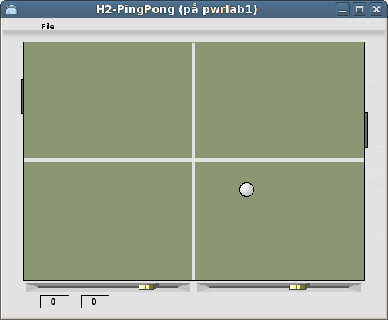
Fig Pingpong game Misc_PingPong

Hilscher cifX board
Hilscher cifX is a family of I/O cards handling a number of different I/O buses, CANopen, CC-Link, DeviceNet, EtherCAT, EtherNet/IP, Modbus TCP, Powerlink, Profibus, Profinet and Sercos III. The interface to Proview is the same for all the boards and buses.
The board and the devices/slaves on the bus are configured in the SYCON.net configurator on Windows. The configuration is exported to a configuration file, that is copied to the process station.
Read more in Guide to IO Systems.
A beta version of an cifX implementation of Profinet controller, using the Proivew configurator, is also present.

UDP IO
The UPD IO make is possible to send and recieive UDP messages with the IO interface, ie configure the message are with input and output channels, and use signal objects to set or get the content of the message. The UDP IO is configured with the UDP_IO card object and a generic rack object BaseIORack.

USB Joystick
USB Joysticks are configured with the USB_Joystick object, or with a subclass of this class as the CodeMerc_JoyWarrior that is configured for a Code Mercenarias JoyWarrior with 3 axes and 8 buttons.

NMps cells with size 60 and 120
Previously only NMps cells of size 30 existed. Cells with size 60 and 120 are added where the data references are implemented as arrays.

Axis arc
Ge component AxisArc for a circular scale.
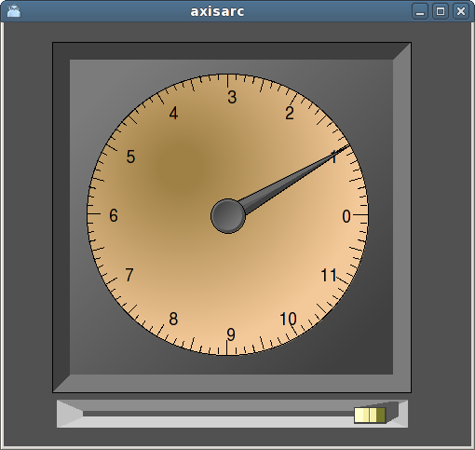

Upgrade from V4.8.0 or V4.8.1 to V4.8.2
Enter the administrator and change the version of the project to V4.8.2. Save and close the administrator.
I you have any class volumes, enter the class editor and build the volume.
Enter the configurator for each root volume and activate 'Function/Update Classes' and build.

V4.8.3 Additions

Post server
The post server sends events and alarms as epost or sms messages.
A messages is configured with a Dsup or Asup object with the bits Email or SMS in the EventFlags attribute filled in. Also a recepient has to be stated.

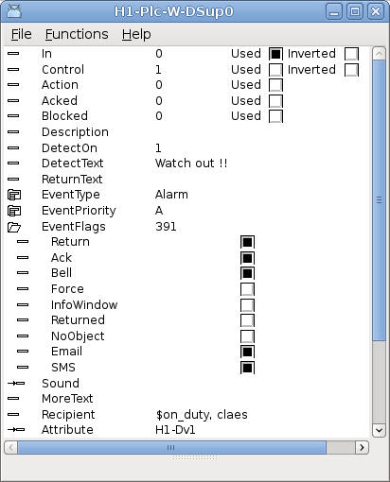
The recipient is a user, or a number of users, defined in the user database. The alarm text is sent to the epost adress or SMS number defnied for these users. It is also possible to define symbols that contains users, and specify the symbols with a $ sign before the symbol name. The symbols are defined in the Symbol array in the PostConfig object.
The post server is configured with a PostConfig object in the node hierarchy.
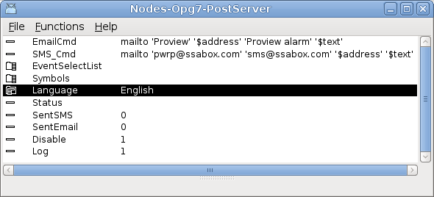
A shell command for sending the mail it inserted into the EmailCmd attribute, and also a shell command to send SMS messages is stated in SMS_Cmd attribute. The commands contatins the symbols $address and $text that will be replaced by the epost address/SMS number and the alarm text.

Report server
The Report server handles reports. A report contains a text that includes current values from attributes in the realtime database. The text is defined with a template of xtt help format. The value tag prints the value of the specified attribute with the specified format, eg <value attr=H1-Av1.ActualValue format=%7.2f> will print the current value of H1-Av1 with the format %7.2 which means with 7 characters and 2 decimals. Note also the date tag in the example below.

Temperature report
<hr>

image> pwr_logga.gif

Date <date format=%1t>, SSAB EMEA AB

<b>Current temperature

Temp1 = <value attr=H1-Av1.ActualValue format=%7.2f> <t>Temp2 = \ <value attr=H1-Av2.ActualValue format=%7.2f>
Temp2 = <value attr=H1-Av2.ActualValue format=%7.2f> <t>Temp1 = \ <value attr=H1-Av1.ActualValue format=%7.2f>

<hr>

This is the apperance of the above template file in pdf format.
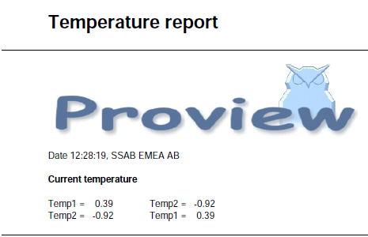
A report is configured by a Report object.
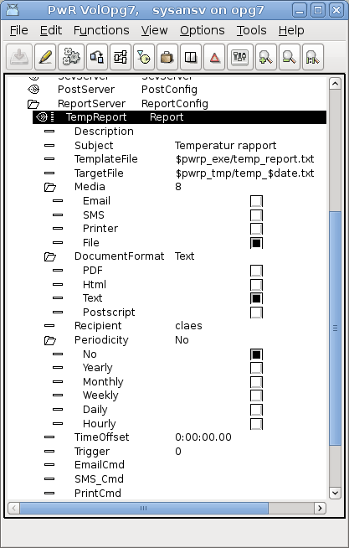
The report object is usually configured below the ReportConfig object, that configures the report server. The report can be triggered manually, or from the plc program, by setting the Trigger attribute. It can also be sent periodically by specifing how often and at what time the report should be sent or stored.
The report can be
- Sent as email, as an attached pdf-file, as an html or as plain text.
- Sent as sms as plain text.
- Sent to printer as postscript.
- Written to file as pdf-file, html-file or text-file.

The report server is configured by a ReportConfig object in the plant hiearchy.
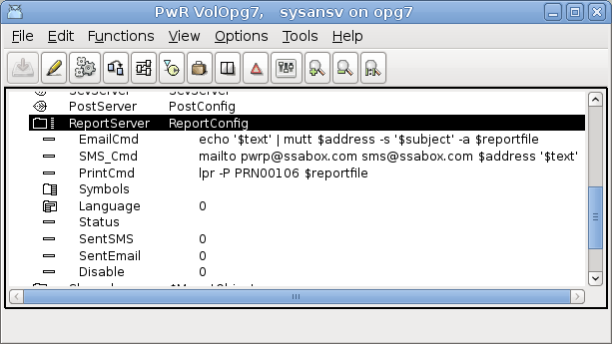

Xtt Collect window
Attributes collected with the collect function in xtt can be displayed in a separate window. Multiple collect window can be used concurrently.
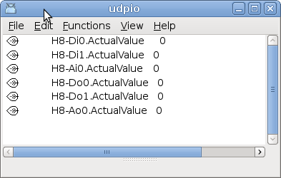
The collect window can be stored and opened again later.

Show all signals in a Collect window
A new function show all signals in a hierarchy in a collect window. Select the hierarchy and activate Functions / Collect / Signals (Shift+Ctrl+T) in the xtt menu.
It is also possible to display all IO signals, ie Di, Do, Ai, Ao, Ii, Io and Co, in a hierachy in a collect window by activating Functions / Collect /IOSignals (Ctrl + T) in the xtt menu.

Ge multiline texts
Multiline texts contatined in Text attributes can be displayed in Ge.

Web site opened from other location
It is now possible to place the website no another server than the operator or process station.
In the attribute PwrHost the Proview node to attach to is stated. To be able to open a socket to the Proview node, one has to

To be able to open the web interface from another site than the process or operator station, the host name of the process station has to be stated in PwrHost and a signature has to be applied to the jar-files of the web site. The signature is an alias created by keytool and is stated in AppletSignature.
In this example a signature with the alias pwrkey is created with a validity of 100 years
> keytool -genkey -alias pwrkey
> keytool -selfcert -alias pwrkey -validity 36500

The alias should be signed to all jarfiles in $pwrp_web, pwr_rt_client.jar, pwr_jop.jar, pwr_jopc.jar etc. This is done with jarsigner
> jarsigner $pwrp_web/pwr_rt_client.jar pwrkey

The project specific jarfile will automatically be signed if the alias is stated in AppletSignature. Note that the passphrase for the keystore has to be entered in the terminal window. It is possible to state the passphrase in the AppletSignature after the alias and a '/', eg 'pwrkey/mypassphrase'.

New Plc objects
PulseTrain – generates pulstrains with cycletimes from 1 ms to 30s.
True – true output.
False – false output.
EnumToStr – convert enum value to corresponding string.
StrToEnum – convert enum string to value.

Modbus RTU
V4.8.3 contains a beta release of Modbus RTU master and slave.

V4.8.4 Additions

Buffer channels and signals
The buffer channels, ChanBo and ChanBi, and corresponding signal objects, Bo and Bi, are used for tranferring IO data of type arrays, strings or binary data.
Also the channel objects ChanBoBlob and ChanBiBlob are implemented where the IO data is not stored in an Area object and IO-copied, but copied directly to the specified target attribute.
Buffer IO is implemetned for bus IO, eg Profibus, Profinet, Modbus, IO_UDP, Libnodave etc

Buffer Inputs
Buffer inptuts are configured by placing a ChanBi object under a card object. The size of the received data area is specified in the Size attribute. Also Representation shoud be stated.
The ChanBi is connected to a subclass of the Bi class. There are some predefined subclasses, BiIntArray20, BiIntArray100, BiFloatArray20, BiFloatArray100 and BiString80. Signal objects of other sizes can be defined as userclasses, and has to contain an ActualValue attribute and an InitValue attribute in that order. ActualValue should be and array of pointers to the desired data type, and InitValue an array of the desired datatype. For single strings though, ActualValue is a string pointer, and InitalValue a string.
To use the buffer input signal in the plc code, function object of type GetBiInt32, GetBiFloat32, GetBiString80, StoBiInt32, StoBiFloat32, StoBiString80, CStoBiInt32, CStoBiFloat32 and CStoBiString80 are used.

Buffer Outputs
Buffer outputs are configured in a similar way with ChanBo object below the card object. It is connected to a subclass of the Bo class, and the predefined Bo classes are BoIntArray20, BoIntArray100, BoFloatArray20, BoFloatArray100, BoString80.
To use the buffer input signal in the plc code, function object of type GetBoInt32, GetBoFloat32, GetBoString80, StoBoInt32, StoBoFloat32, StoBoString80, CStoBoInt32, CStoBoFloat32 and CstoBoString80 are used.

ChanBiBlob and ChanBoBlob
The normal buffer channels, ChanBi and ChanBo, are IO copied to ensure that the signal value is not changed during a plc scan. This means that the signal value is stored in area object in the System volume, and that each plc thread makes a copy of this area and reads all signal values from the copy. In cases where the IO copying are not important, and the overhead is unwanted, channels of type ChanBiBlob and ChanBoBlob can be used instead.
ChanBiBlob and ChanBoBlob does not have a corresponding signal type. Instead they are connected to an aribitrary attribute, and for inputs, the content of the IO area is copied to the attribute, while for outputs the content of the buffer attribute is copied to the IO area. There is no conversion of the content of the area content and no byte swapping for different byte ordering are performed.

Sev database engine
The database engine for the tables in the Sev mysql database can be set from the configration file /etc/proview.cnf with the sevMysqlEngine, eg
sevMysqlEngine innodb
This will only affect new created tables. To modify existing tables sev_repair has to be executed with the option -e
> sev_repair -e
This will set the engine of all existing tables to the engine specified in /etc/proview.cnf

V4.8.5 Additions

ConversionOn, InvertOn, TestOn displayed in rt_xtt
The ConversionOn, InvertOn and TestOn flags for IO channels are displayed with an icon for the channel and corresponding signal i rt_xtt.
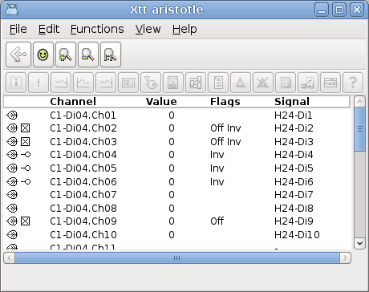

Ge pie chart
New Pie chart in Ge
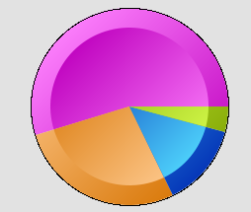

Ge bar chart
New Bar chart in Ge
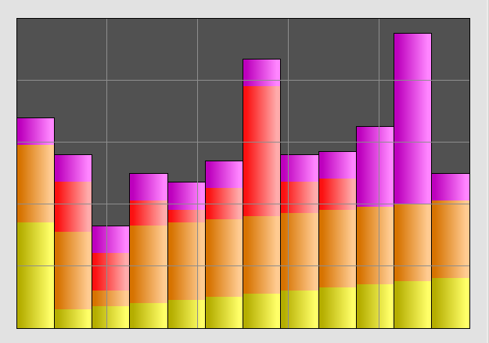

Custom logotype
The Proview icon it the operator window can be replace by a custom logotype by placing an png-image in $pwrp_exe/pwrp_logotype.png. See the SSAB logo below.
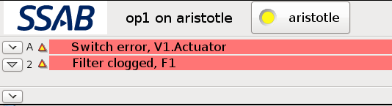

Upgrade from V4.8.0, V4.8.1, V4.8.2 or V4.8.3 to V4.8.4
Enter the administrator and change the version of the project to V4.8.4. Save and close the administrator.
I you have any class volumes, enter the class editor and build the volume.
Enter the configurator for each root volume and activate 'Function/Update Classes' and build.

Upgrade procedure
The upgrading has to be done from any version in the interval V4.7.0. If the project has a lower version, the upgrade has to be performed stepwise following the schema
V2.1 -> V2.7b -> V3.3 -> V3.4b -> V4.0.0 -> V4.1.3 ->V4.2.0->V4.5.0->V4.6.0->V4.7.0->V4.8.3
The upgrade procedure is to dump the database with reload.sh, change the version of the project in the projectlist, and then execute the script upgrade.sh.
NOTE !!
Do not activate Update Classes.

If the previous version should be kept, first make a copy of the project.

Make a copy of the project
Do sdf to the project and start the administrator
> pwra
Now the Projectlist is opened. Enter edit mode, login as administrator if you lack access. Find the current project and select Copy Project from the popup menu of the ProjectReg object. Open the copy and assign a suitable project name and path. Save and close the administrator.

Dump the databases
Execute the first pass, dumpdb, in the script reload.sh.
> reload.sh

reload.sh Dump and reload of database.

Arguments Database or databases to reload.
I no arguments is supplied, all databases will be reloaded.

Pass

dumpdb Dump database to textfile $pwrp_db/'volume'.wb_dmp
classvolumes Create structfiles and loadfiles for classvolumes
renamedb Rename the old database
dirvolume Load directory volume
loaddb Load the dump into the new database
compile Compile all plcprograms in the database
createload Create new loadfiles.
createboot Create bootfiles for all nodes in the project.

-- Reloading volume directory volopg2

Pass: dumpdb classvolumes renamedb dirvolume loaddb compile createload createboot

Enter start pass [dumpdb] >

------------------------------------------------------------------------
Pass dump database
------------------------------------------------------------------------
Do you want to continue ? [y/n/go] y
ls: cannot access /data0/pwrp/opg2/common/db/*.wb_dmp: No such file or directory
Dumping volume directory in /data0/pwrp/opg2/common/db/directory.wb_dmp
...
I Database opened /data0/pwrp/opg2/common/db/volopg2.db
ls: cannot access /data0/pwrp/opg2/common/db/*.wb_load: No such file or directory

------------------------------------------------------------------------
Pass create structfiles and loadfiles for classvolumes
------------------------------------------------------------------------
Do you want to continue ? [y/n/go] n
setdb is obsolete
>

Check that the one dumpfile is create for the directory volume and one for every other rootvolume

> cd $pwrp_db
> ls -l *.wb_dmp
-rw-rw-r-- 1 cs pwrp 1771 2010-03-26 16:32 directory.wb_dmp
-rw-rw-r-- 1 cs pwrp 7467 2010-03-26 16:32 volopg2.wb_dmp

Linux release upgrade
If you are using Ubuntu 9.4 or Fedora 10 you need to upgrade the linux release and install the pwr48 package.

Change version
Enter the administrator and change the version of the project to V4.8.0. Save and close the administrator.

upgrade.sh
Do sdf to the project.
upgrade.sh is a script that is divided into a number of passes. After each pass you you have to answere whether to continue with the next pass or not.
Start the script with

> upgrade.sh

Start from the classvolumes pass.

Enter start pass [classvolumes] >

classvolumes
Create loadfiles and structfiles for the class volumes.

renamedb
Store the old databases under the name $pwrp_db/'volumename'.db.1.

cnvdump
Converts values of Profibus module objects.

loaddb
Create databases and load the dumpfiles into them.

compile
Compile all the plc programs.

createload
Create loadfiles for the root volumes.

createboot
Create bootfiles for all nodes in the project.
If the project contains any application programs, these has to be built manually.
Delete files from the upgrading procedure:
$pwrp_db/*.wb_dmp.*
$pwrp_db/*.db.1 (old databases, directories which content also should be removed)

List example
>
> sdf opg2
Setting base /data0/x4-7-1/rls
bash: cd: /data0/pwrp/opg2/src/login: No such file or directory
>
> upgrade.sh

upgrade.sh Upgrade from V4.7.0 to V4.8.0

Pass

classvolumes Create loadfiles for classvolumes.
renamedb Rename old databases.
loaddb Load dumpfiles.
Cnvdump Convert the dumpfiles.
compile Compile all plcprograms in the database
createload Create new loadfiles.
createboot Create bootfiles for all nodes in the project.

-- Upgrade opg2

Enter start pass [classvolumes] >

------------------------------------------------------------------------ Pass create structfiles and loadfiles for classvolumes
------------------------------------------------------------------------Do you want to continue ? [y/n/go] y
ls: cannot access /data0/pwrp/opg2/src/db/*.wb_load: No such file or directory

------------------------------------------------------------------------ Pass rename old databases
------------------------------------------------------------------------Do you want to continue ? [y/n/go] y
-- Saving file /data0/pwrp/opg2/src/db/directory.db -> /data0/pwrp/opg2/src/db/directory.db.1
-- Saving file /data0/pwrp/opg2/src/db/volopg.db -> /data0/pwrp/opg2/src/db/volopg.db.1

------------------------------------------------------------------------Pass cnvdump
------------------------------------------------------------------------Do you want to continue ? [y/n/go] y
/data0/pwrp/opg4/src/db/volopg2.wb_dmp

------------------------------------------------------------------------Pass load database
------------------------------------------------------------------------Do you want to continue ? [y/n/go] y
-- Loading volume volopg
...
-- Processing line: 57
-- Building volume directory
I Volume directory loaded
I Database opened /data0/pwrp/opg2/src/db/directory.wb_load
-- Processing line: 200
-- Building volume VolOpg
I Volume VolOpg loaded
Berkeley DB 4.6.21: (September 27, 2007)
info put: 0
Berkeley DB 4.6.21: (September 27, 2007)
info get: 0
int rc = m_txn->abort(): 0

------------------------------------------------------------------------Pass compile plcprograms
------------------------------------------------------------------------Do you want to continue ? [y/n/go] y
...
Berkeley DB 4.6.21: (September 27, 2007)
info get: 0
I Database opened /data0/pwrp/opg2/src/db/volopg.db
-- Plc window generated F1-Z1-Plc-W
-- Plc window compiled for x86_linux optimized -O3 F1-Z1-Plc-W
-- Plc plcpgm compiled for x86_linux optimized -O3 F1-Z1-Plc
-- Plc window generated F1-Z2-Plc-W
-- Plc window compiled for x86_linux optimized -O3 F1-Z2-Plc-W
-- Plc plcpgm compiled for x86_linux optimized -O3 F1-Z2-Plc

------------------------------------------------------------------------Pass create loadfiles
------------------------------------------------------------------------Do you want to continue ? [y/n/go] y
-- Removing old loadfiles
rm: cannot remove `/data0/pwrp/opg2/bld/common/load/ld_vol*.dat': No such file or directory
...
Berkeley DB 4.6.21: (September 27, 2007)
info get: 0
I Database opened /data0/pwrp/opg2/src/db/volopg.db
-- Building archive for volume: 000_001_001_012
-- Archive built for volume: 000_001_001_012

-- Working with load file volume 'VolOpg'...
-- Open file...
-- Successfully created load file for volume 'VolOpg'
-- 26 objects with a total body size of 21976 bytes were written to new file.

Before this pass you should compile the modules included by ra_plc_user.

------------------------------------------------------------------------Pass create bootfiles
------------------------------------------------------------------------Do you want to continue ? [y/n/go] y
-- Creating bootfiles for all nodes

Proview is free software; covered by the GNU General Public License.
You can redistribute it and/or modify it under the terms of this license.

Proview is distributed in the hope that it will be useful
but WITHOUT ANY WARRANTY; without even the implied warranty of
MERCHANTABILITY or FITNESS FOR A PARTICULAR PURPOSE. See the
GNU General Public License for more details.

-- Creating bootfile for node opg
plc_opg_0507_00011
-- Plc thread generated priority 0, scantime 0.10000 s, 2 plcpgm's
-- Plc process compiled for x86_linux optimized -O3 Dummy
-- Plc program linked for x86_linux node plc_opg_0507
-- Creating bootfile for node aristotle
plc_aristotle_0517_00011
-- Plc thread generated priority 0, scantime 0.10000 s, 2 plcpgm's
-- Plc process compiled for x86_linux optimized -O3 Dummy
-- Plc program linked for x86_linux node plc_aristotle_0517

-- The upgrade procedure is now accomplished.

setdb is obsolete
>
>

Appendix A Embedded Linux
Proview is adapted to be built for embedded Linux systems with cross compilation in a Linux host environment.
First the Proview runtime module of the base system has to be built, and then a project is created where also the plc executable is built with cross compilation. The following example will describe a build for the ARM architecture with the cross compilation tools arm-linux-gnueabi-gcc, arm-linux-gnueabi-g++ and arm-linux-gnueabi-ar.

The runtime module build is dependent on an development installation or a complete build on the host system. Platform independent files as loadfiles and java archives are copied from the host release to the embedded build tree, also build tools in the host release are used to perform the build.

Environment variables defining the cross compilation tools, and the path to the exe directory of the host release has to be defined before starting the build.
export pwre_cc=arm-linux-gnueabi-gcc
export pwre_cxx=arm-linux-gnueabi-g++
export pwre_ar=arm-linux-gnueabi-ar
export pwre_host_exe=/usr/pwr47/os_linux/hw_x86/exp/exe

The tool to build Proview from sources, pwre, also has to be initialized
export pwre_env_db=~/pwre_env_db
export pwre_bin=~/pwrsrc_4.7.1/src/tools/pwre/src/os_linux
source $pwre_bin/pwre_function

Follow the Build from sources guide to build from the source code with the following modifications.
When adding the pwre environment, state the import root to the hw directory of the host release
Import root: /usr/pwr47/os_linux/hw_x86
and set hardware to arm.
Hardware: arm

> pwre add armx471
Source root []? /home/pwrd/pwrsrc_4.7.1/src
Import root []? /usr/pwr47/os_linux/hw_x86
Build root []? /home/pwrd/pwrrls_4.7.1
Build type [dbg]?
OS [linux]?
Hardware []? arm
Description []? X4.7.1 for ARM

Initialize the arm environment
> pwre init armx471
Create the build tree
> pwre create_all_modules
Import files from the import release
> pwre import rt
If the java archives are to be a part of the release these can be imported with the command
> pwre import java
Build the runtime module. If you want to customize the build you can choose what additional modules you want to build in the file $pwre_bin/ebuild.dat
> pwre ebuild rt

When the build is performed, create the /usr/pwrrt/exe, /usr/pwrrt/load directories in the embedded file system and copy the rt_ files to the exe directory, and .dbs -files to load directory.
Define the embedded release in the project list with a BaseReg object and insert to path to the release.
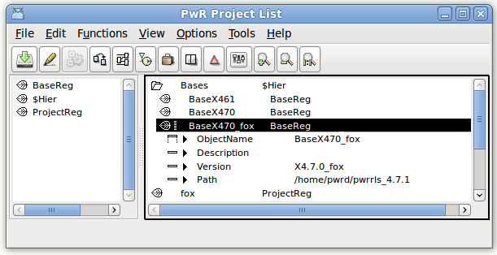

Project
The project is created and developed and simulated in the host release environment.
Set the OperatingSystem of the NodeConfig object for the embedded node in the directory volume to CustomBuild.
Create CustomBuild object below the NodeConfig object, that points out the embedded release and platform, and that defines the embedded toolchain.
The CustomBuild object will create a script, $pwp_exe/custom_build.sh that sets up the embedded build environment. If you need to make additional changes you can remove CustomBuild object and insert the changes in custom_build.sh.

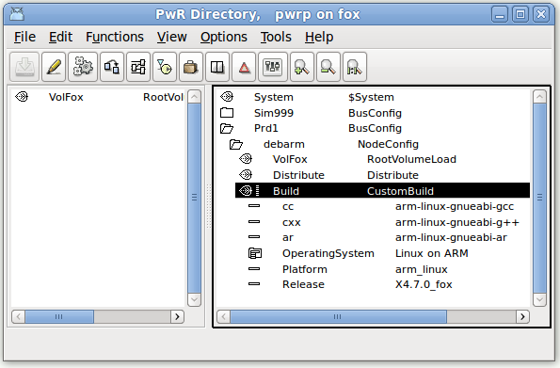

Installing Proview
The following directories should be created in the root files system and the following files should be copied to them.

Proview runtime
/etc
Copied from $pwre_croot/src/tools/bld/pkg/deb/pwrrt
pwrp_profile
proview.cnf

/usr/pwrp/adm/db/
Copied from $pwra_db
pwr_user2.dat

/usr/pwrrt/exe
Copied from $pwr_exe (/home/pwrd/pwrrls_4.7.1/os_linux/hw_arm/rt/exe)
pwr_pkg.sh
pwr_stop.sh
rs_remote_3964r
rs_remote_logg
rs_remote_modbus
rs_remote_serial
rs_remote_tcpip
rs_remotehandler
rt_alimserver
rt_bck
rt_emon
rt_fast
rt_ini
rt_neth
rt_neth_acp
rt_print.sh
rt_prio
rt_qmon
rt_rtt
rt_sevhistmon
rt_statussrv
rt_sysmon
rt_tmon
rt_trend
rt_webmon.sh
rt_webmonelog.sh
rt_webmonmh.sh

/usr/pwrrt/load
Copied from $pwr_load
abb.dbs
basecomponent.dbs
inor.dbs
klocknermoeller.dbs
nmps.dbs
opc.dbs
otherio.dbs
othermanufacturer.dbs
profibus.dbs
pwrb.dbs
pwrs.dbs
remote.dbs
rt.dbs
siemens.dbs
ssabox.dbs
telemecanique.dbs
tlog.dbs
wb.dbs

/usr/pwrrt/lib
Copied from $pwr_lib
pwr_beans.jar
pwr_jop.jar
pwr_jopc.jar
pwr_rt.jar
pwr_rt_client.jar

Project
/pwrp/common/load
Copy from $pwrp_load
Loadfile ('rootvolumename'.dbs)
ld_node file (ld_node_'nodename'_'busid'.dat)
ld_boot file (ld_boot_'nodename'_'busid'.dat)
ld_appl file (ld_appl_'nodename'_'busid'.txt)
flow-files (.flw)
crossreference files (rtt_crr*_'volumeid'.dat)

/pwrp/common/log
Create only this directory if you want a log-file for system messages. Note that this might wear out you flash memory.
/var/www
Copy from $pwrp_web
*.html
pwrp_'nodename'_web.jar

Copy from $pwr_lib
pwr_rt_client.jar
pwr_jop.jar
pwr_jopc.jar

/pwrp/arm_linux/exe
Copy from $pwrp_root/bld/arm_linux/exe
Plc executable (plc_'nodename'_'busid'_'version')
xtt_help.dat

Settings
Set the Qcom busid in /etc/proview.cnf, parameter qcomBusId.
Execute /etc/pwrp_profile in .bashrc for the root user
source /etc/pwrp_profile

Add startup-file for Proview in for example /etc/init.d. Copy from
$pwre_croot/src/tools/pkg/deb/pwrrt/pwr

Distribute
The distributor can be use to copy files to a running system. For single user system add the username to the bootnode in the NodeConfig object, e.g. root@mynode.

Appendix B Mac OS X

Build from source on Mac OS X 10.6 x86_64

Install Xcode from the installation CD, or download from http://developer.apple.com/technologiew/xcode.html

Download fink from http://www.fink.project.org. Follow the instructions to install. Install for 64 bit (question in ./bootstrap).

Install gtk

> fink install gtk+2
> fink install gtk+2-dev

Install doxygen
> fink install doxygen

Download BerkeleyDB 4.8 from http://www.oracle.com/technetwork/database/berkeleydb/download.
Build with
> cd ./build_unix
> ../dist/configure –enable-cxx
> make
> sudo make install

Download iconv from http://ftp.gnu.org/pub/gnu/libiconv/libiconv-1.13.1.tar.gz.
Build with ./configure, make, sudo make install.

Download Proview sourcecode and follow the Build from source guide.
To download with git, install git with
> fink install git

Before build:
> export PKG_CONFIG_PATH=/sw/fink/pkgconfig
> export PATH=$PATH:/sw/bin

Before you start Proview runtime:

Add to /etc/sysctl.conf

kern.sysv.shmmax=167772160
kern.sysv.shmseg=16
kern.sysv.shmall=65536

