

DEPARTMENT OF COMPUTER SCIENCE AND ENGINEERING

Course: CSE391
Name: Siam Khandaker
ID: 22299030
Email: siam.khandaker@g.bracu.ac.bd
Project Title: The Tenth Frame — Bowling Club Management Simulator
The Tenth Frame — Bowling Club Management Simulator
Project Features:
A. Core Website
- Interactive SVG Facility Map — hover cards, click-to-expand zones, lane deep-link into booking
- Dynamic Fixture & Results Dashboard — filter by league/team/date-range/status; animated next-match card
- Lane Availability Widget — 15 s colour-coded polling on homepage
- Touring Team Welcome Portal — form → DB record → mailable welcome pack + browser-print PDF
- Social Event Hub with Countdowns — live per-card countdowns, paid tickets via SSL Commerz (BDT), RSVP + capacity tracking
- Live Bar Status Display — OPEN/CLOSED + 1 s countdown from club hours
- Season Statistics Dashboard — W/D/L stacked bars + rotating Player Spotlight
- Announcement Ticker — scrolling marquee, urgent-priority styling, admin CRUD
- RSVP with Capacity Tracking — row-locked capacity check, remaining-spots, AJAX updates
- Animated Micro-interactions & Scroll Reveals — IntersectionObserver, keyframe animations, prefers-reduced-motion guards
B. Simulation Layer — Manager Mode
- Day Cycle engine — 14-step advance pipeline (queue promote → serve → expire → accidents → happiness/drift → inventory decay → complaints → matches → finance → reputation → schedule)
- Bad-Day toggle — forces 100 % accident chance for testing
- Staff management — hire (2–4 personalities, conflict map), edit, fire, reapply (new-identity reset)
- Staff happiness & quitting — drift by traits/relationships/salary-cut; quit at ≤19 happiness
- Shifts & schedule auto-generation — daily one shift per active staff, complete/cancel
- Waiting queue + auto-promotion — conflict → queue; promote on cancel or day-advance (reputation-first)
- Confrontation mechanic with DM-style interrogation — chip questions (where/log/witness/reporter), conclude narrative via InterrogationEngine; verdicts: upheld / dismissed / penalized / reporter_penalized
- Personality traits — 8 seeded traits with pivot map and conflict enforcement
- Inventory management — full CRUD + adjust + restock + daily decay + low-stock alerts; stock % capped at 100 %
- Inventory purchase-bill approval — caretaker restock → pending bill → manager Accept (pay via SSL Commerz) or Reject (revert stock + fine consumed portion); manager's own restocks auto-approve instantly
- Accident engine — per-role base chance × personality/happiness/oil; bad-day forces 1.0; injuries excluded
- Accidents → inventory damage — type-mapped damageInventory() calls InventoryService::adjust()
- Complaint resolution & compensation — auto-complaints + visitor/steward complaints; free_game + priority_queue working; refund/discount/apology deferred
- League match prep & standings — prep window, readiness, critical kits, resolveDue/Completed; penalties for unprepared teams
- Touring request management — confirm/decline pending touring requests from the public portal
- Revenue/expense finance — salaries/30 + accident costs; revenue from serve/league
- Reputation system — accidents, open complaints, league penalties, quits, low happiness, reviews
B2. Simulation Layer — Steward Mode
- Snitch inbox — view snitch reports escalated by crew chat NPC vents; escalate to confrontation or dismiss
- Ban request proposals — review visitor behaviour, propose ban requests routed to admin for approval/denial
- Complaint filing — file visitor complaints on behalf of guests, triggering the resolution pipeline
- Visitor management — view visitor list, review visitor reputation and ban status
- Staff review of visitors — submit steward reviews that apply +20 × avg reputation to visitor score
- Touring request review — assist manager in reviewing and processing incoming touring requests
B3. Simulation Layer — Caretaker Mode
- Inventory adjust & restock — adjust stock levels and submit restock requests that generate pending purchase bills for manager approval
- Crew chat — daily seeded threads with DM channels, NPC personality-driven chips and reactions, JSON poll
- League match prep — prepare kits, lane oil, and training within the 3-day prep window; readiness tracking with critical-kit blocks
- Shifts view — view assigned shifts with weekly progress tracking; mark shifts complete
- Lane maintenance — oil lanes, toggle maintenance status; cleaning and oiling logged to maintenance history
C. Simulation Layer — Visitor/Client Mode
- Lane booking — calendar + lane rack UI; duplicate guard; conflict → queue
- Visitor reviews & ratings — completed-booking only; helpful/not-helpful votes; reputation update on day-advance
- Visitor complaints — log + resolve with compensation
- Waiting queue display — queue position shown in real time
D. Virtual Bowling Mini-Game
- Top-down canvas lane — drawLane / PIN_SPOTS / drawPin
- Ball curve physics — aim angle, hook, power tiers, MAX burst, tank/no-tank
- Pin physics & scoring — velocity + collision + per-frame scoreboard
- Standard bowling scoring incl. 10th frame — ScoringEngine server-side + client mirror + total cross-check
- Leaderboard — top-10 + personal best, guest "Guest" rows, is_high_score logic
E. Role Dashboards & Navigation
- Role dashboards — manager/steward/caretaker/customer entry shells with live stats; End-of-Day report card
- Module Dock — per-role left rail with day chip, Next Day, Bad Day toggle, 33+ verified links
- Oil Alley design system — CSS-var token system, v4 controls (fold-select, stepper, pin-check, lane-range, lc calendar, br-wrap)
F. Cross-Cutting Infrastructure
- SSL Commerz payment integration — checkout, IPN webhook, dev-mode offline path, reconcile sweep
- Email mailables — RsvpConfirmation, RsvpReceipt, OrderReceipt, TouringWelcome
- Google OAuth — social login alongside Breeze auth
- Role middleware — EnsureRole (admin/steward/caretaker/customer) on every gated route

Screenshots:
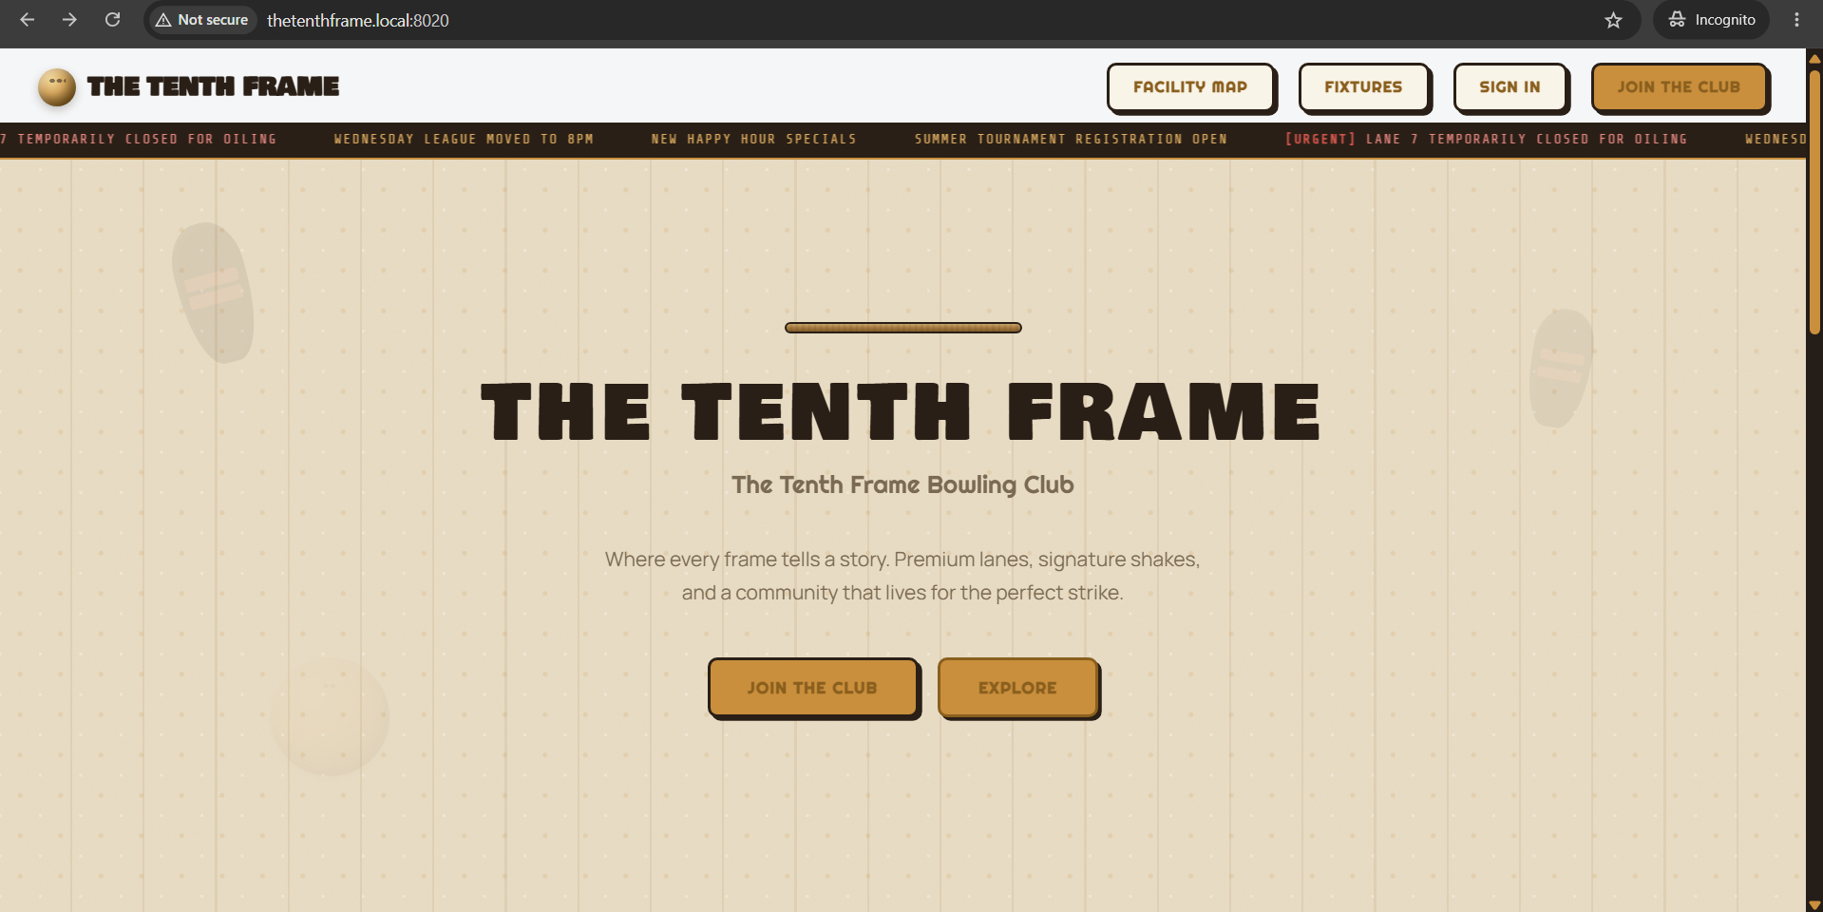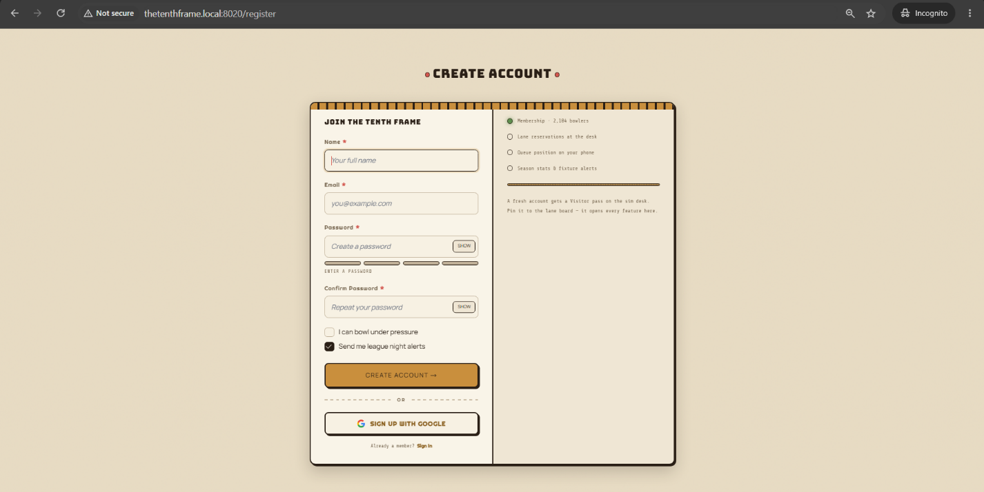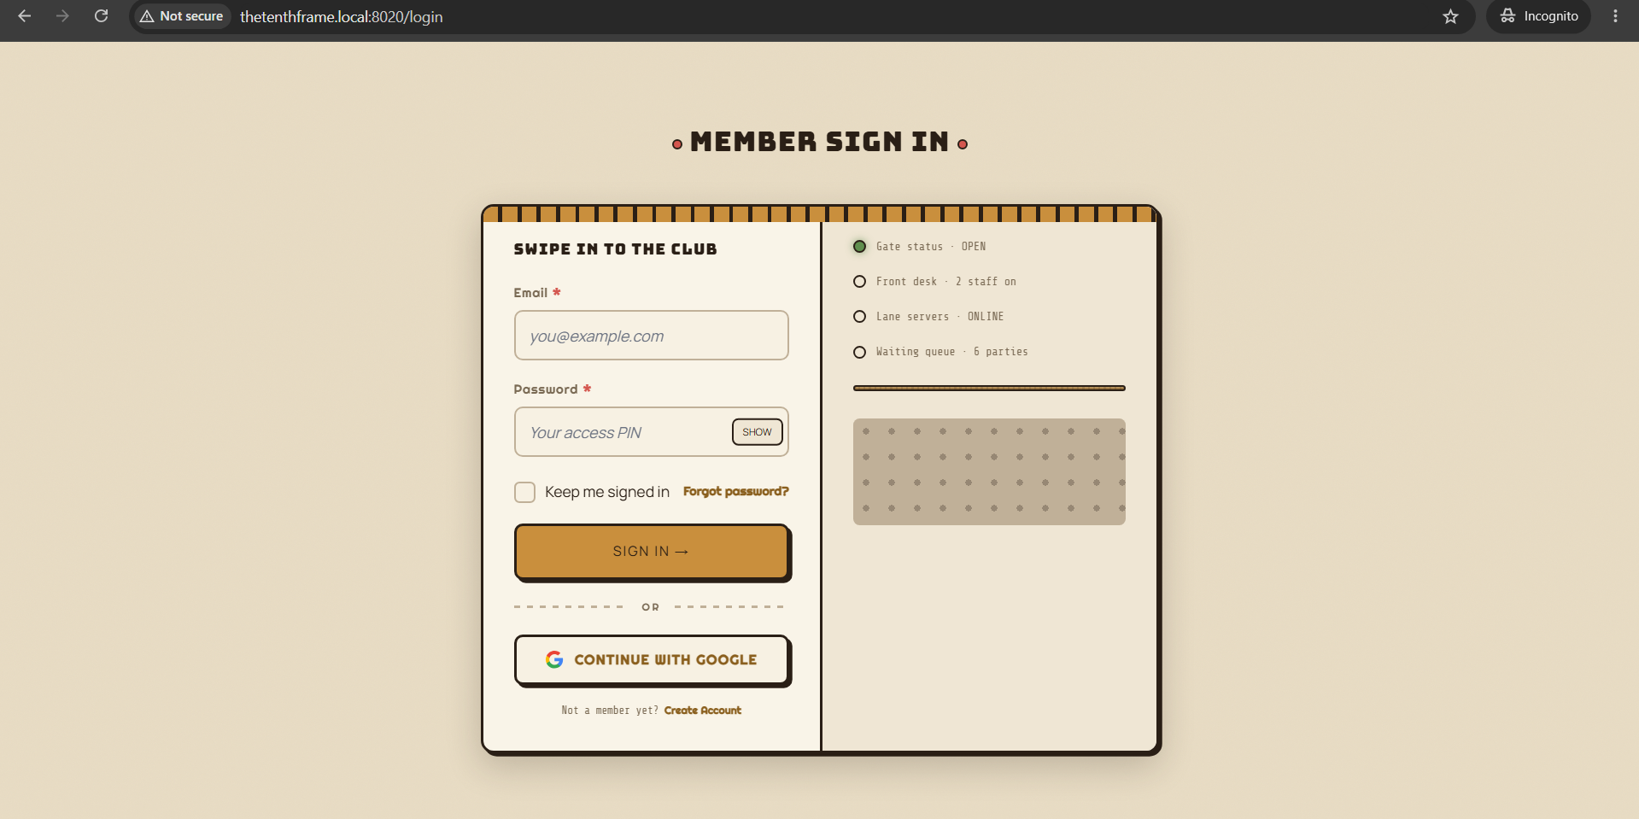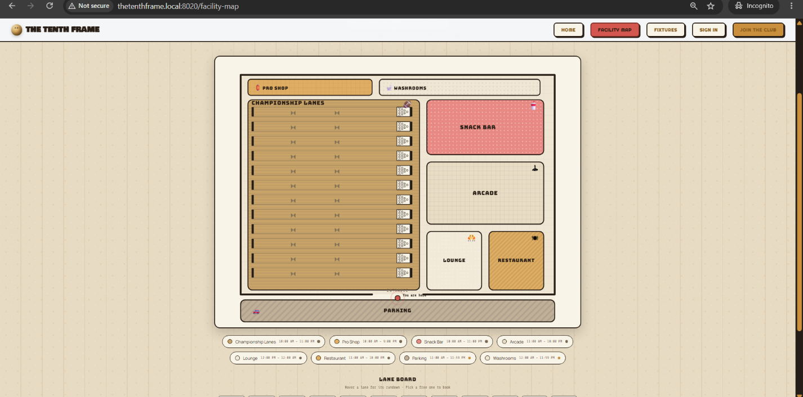
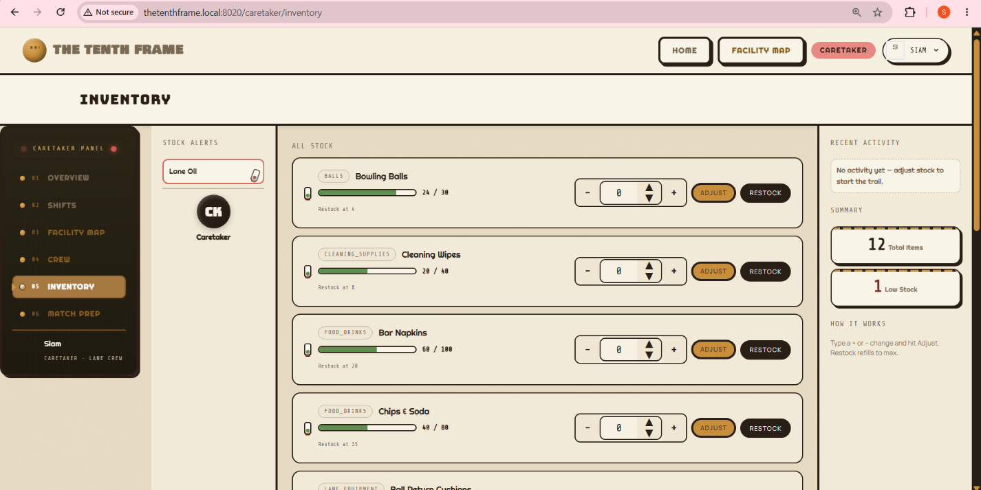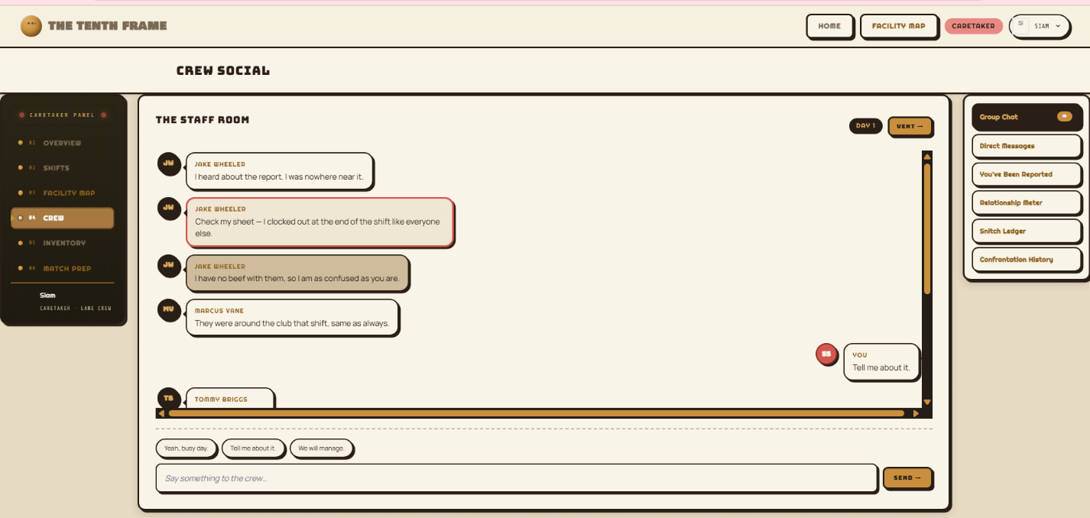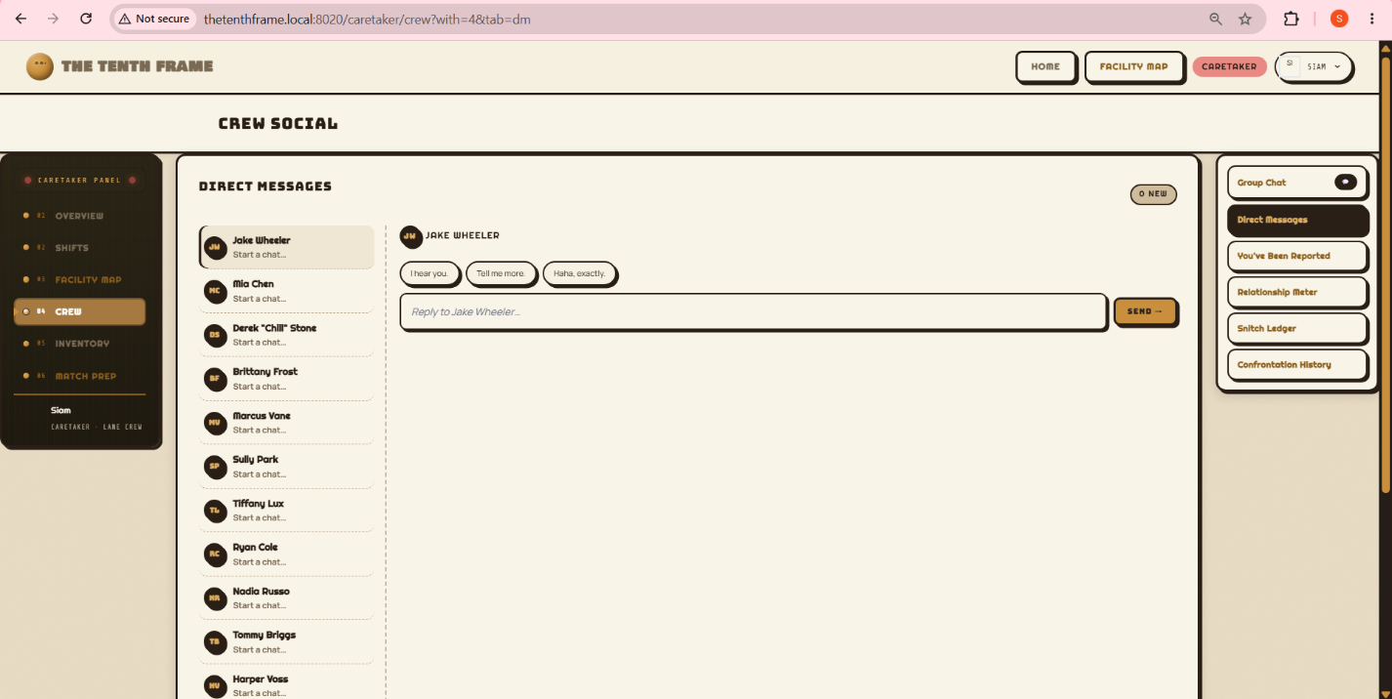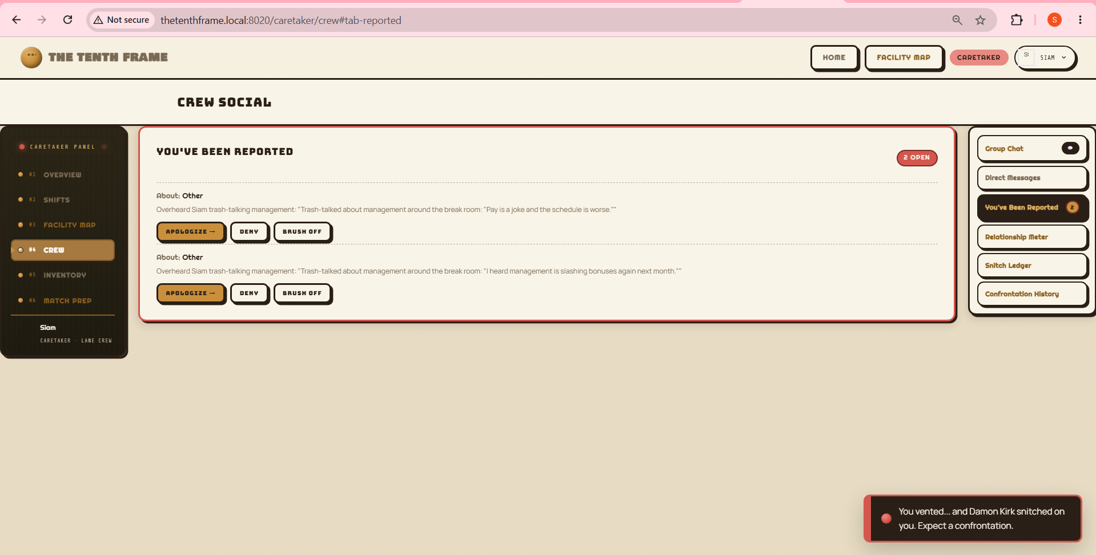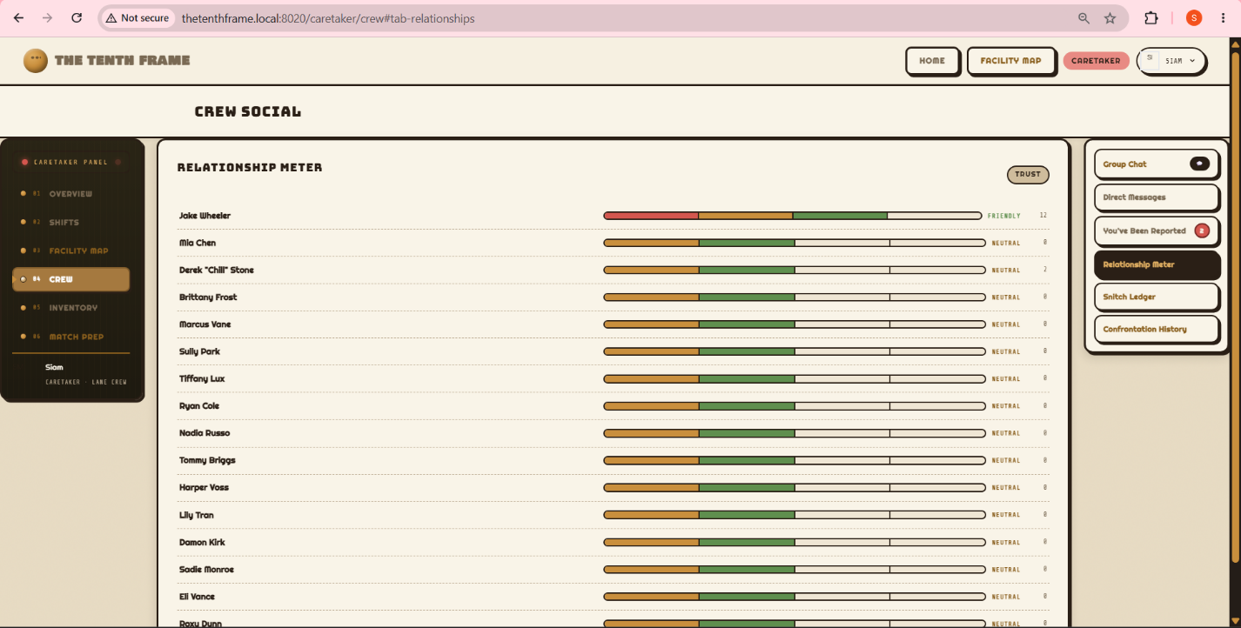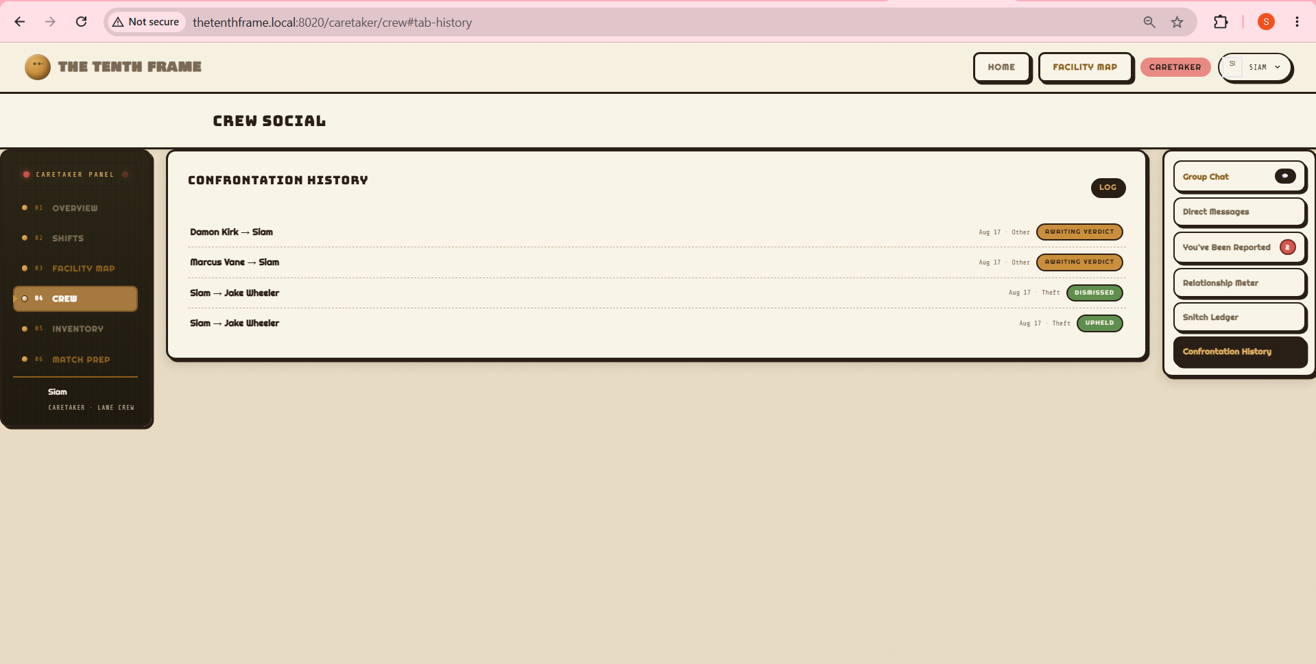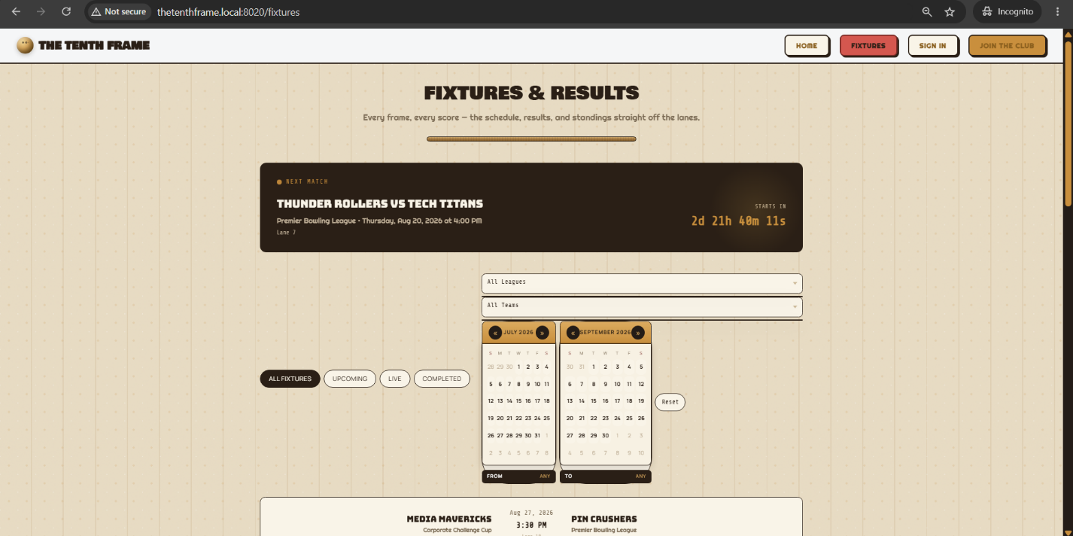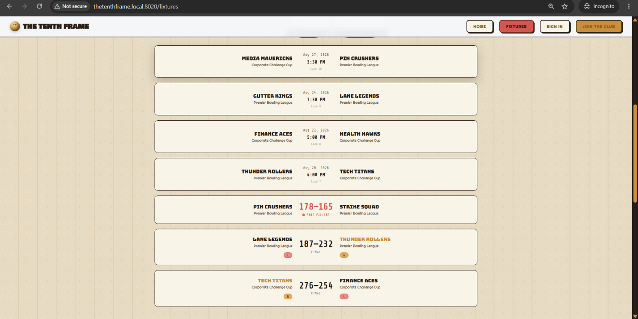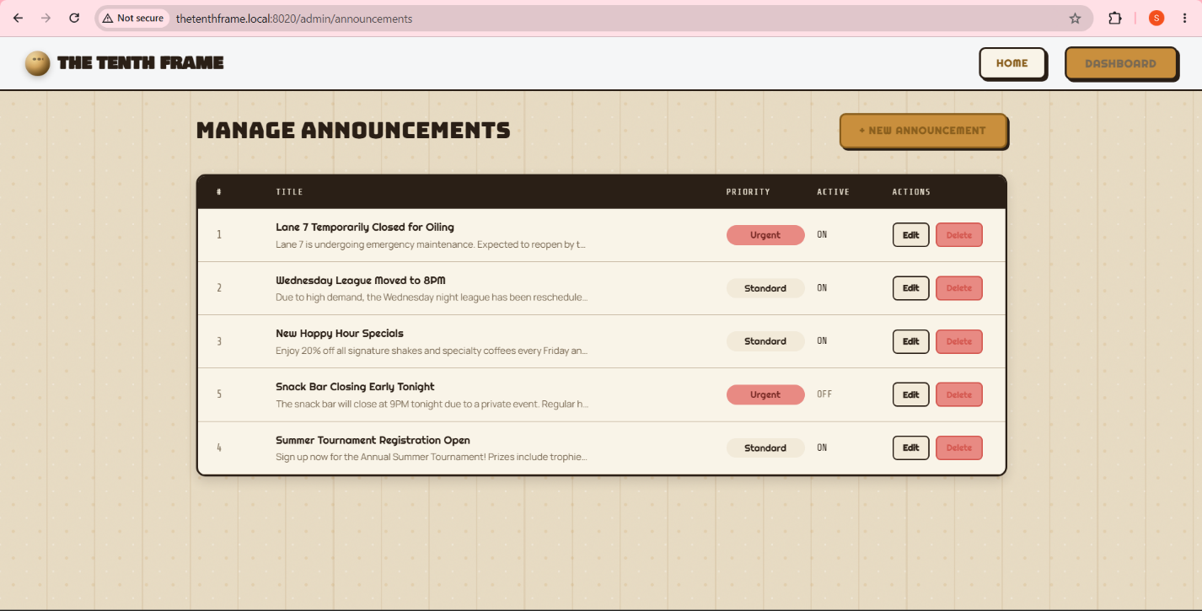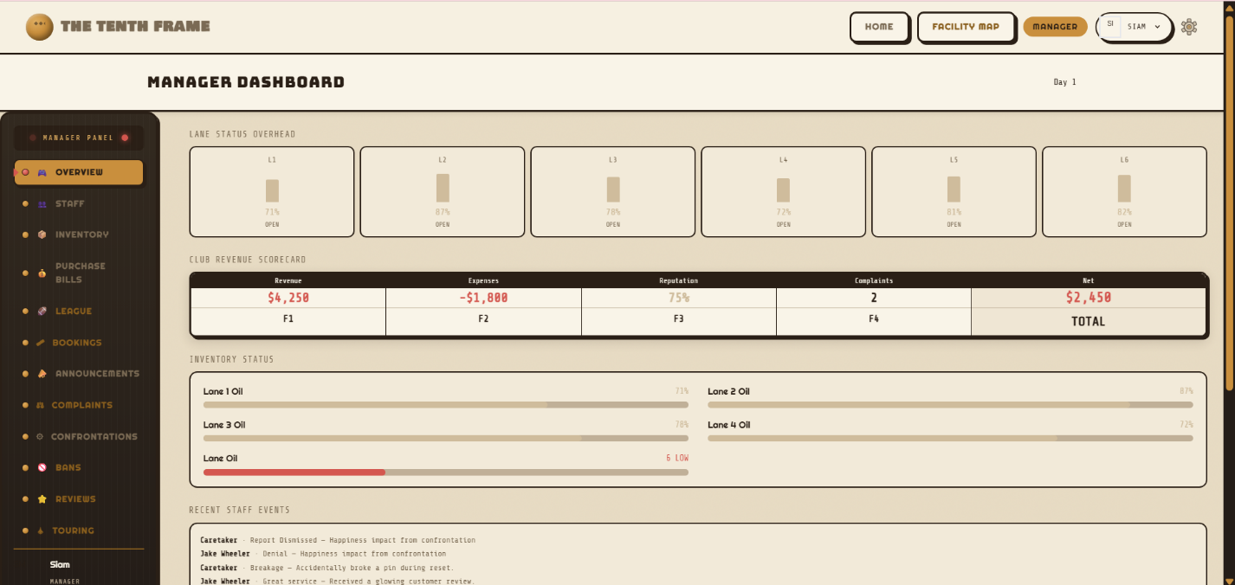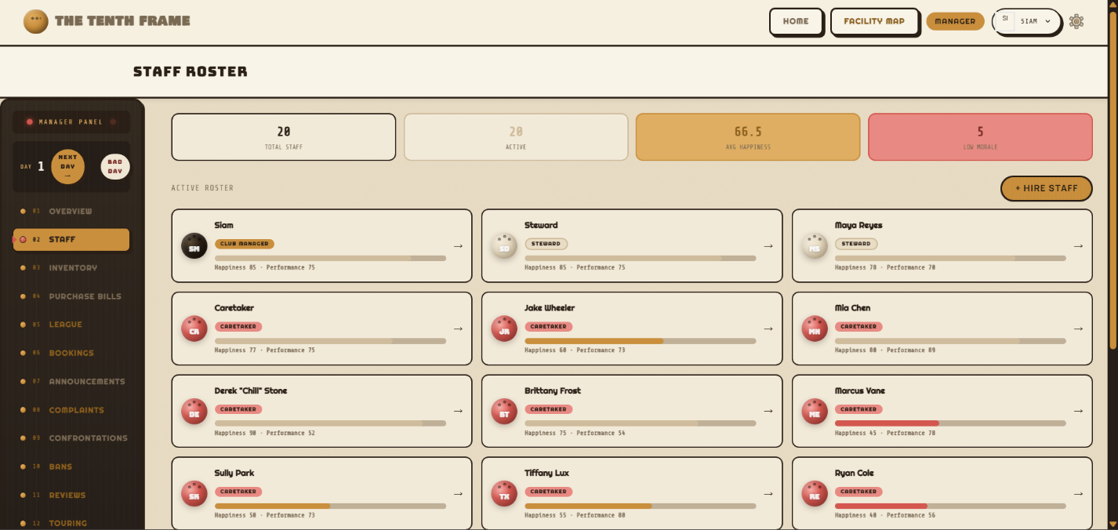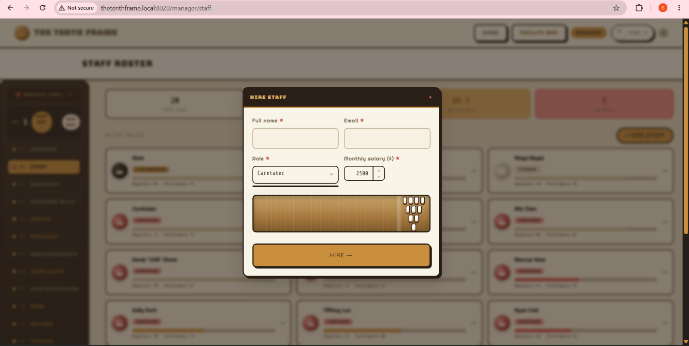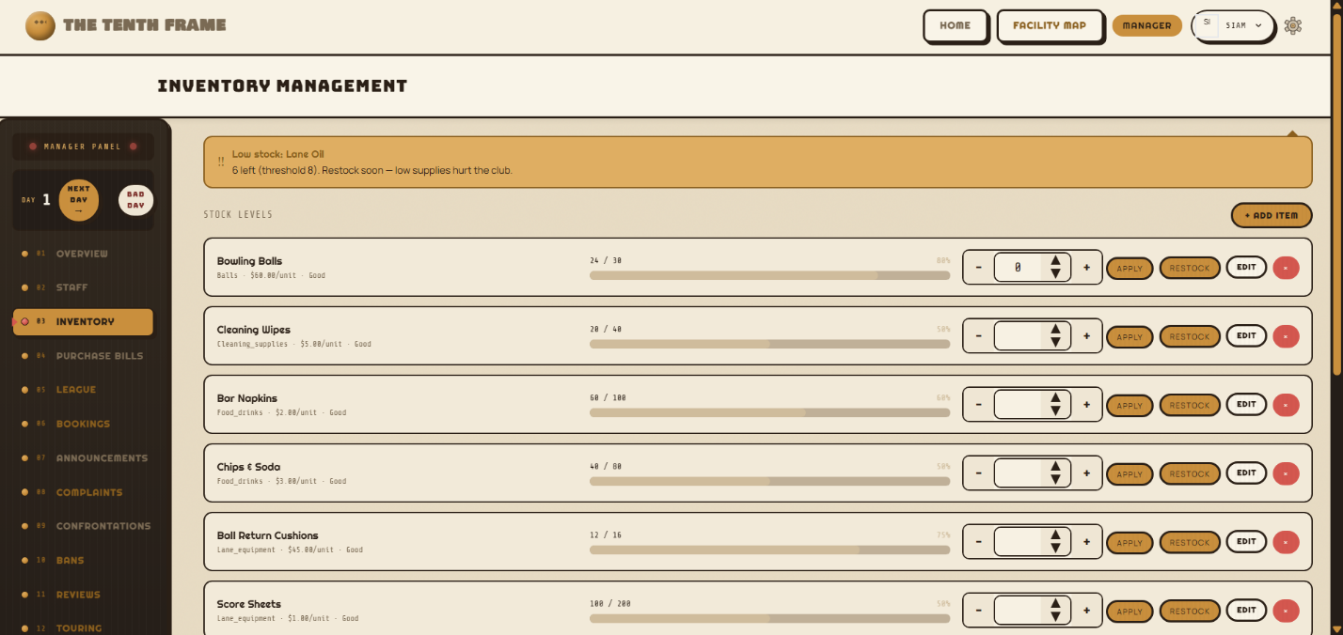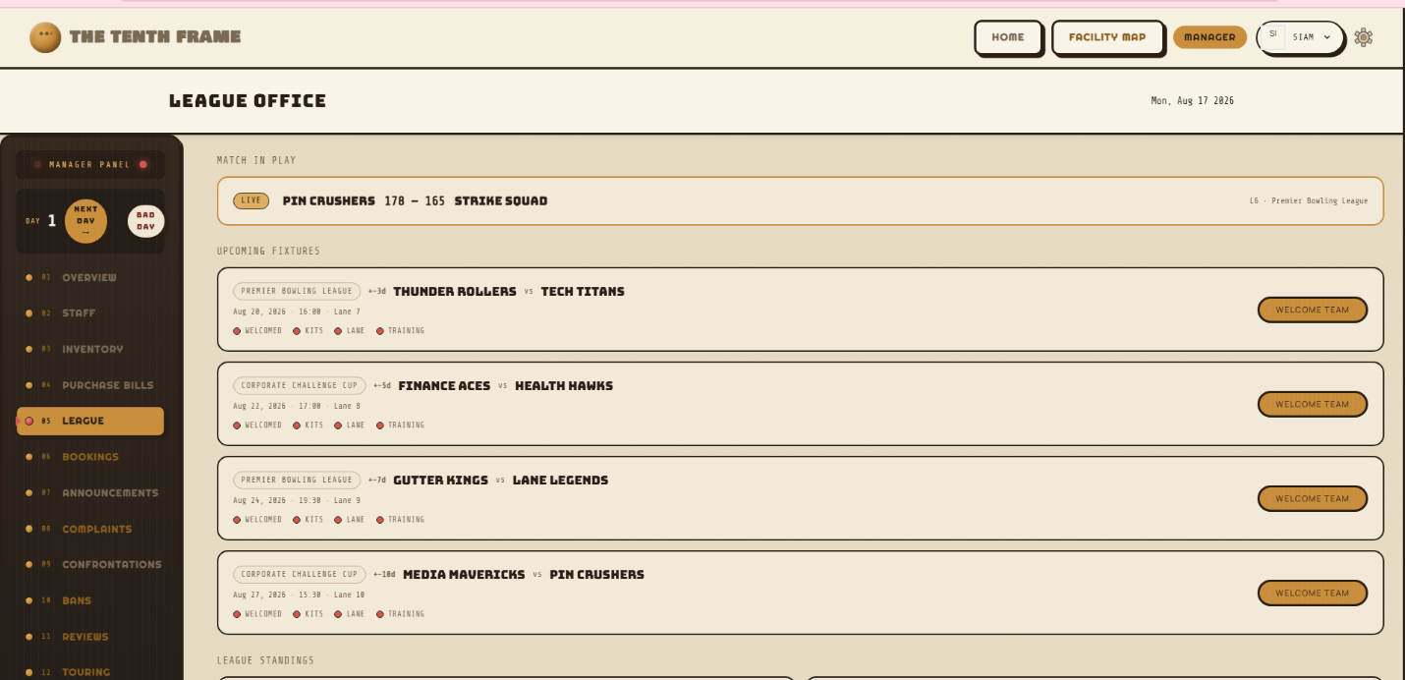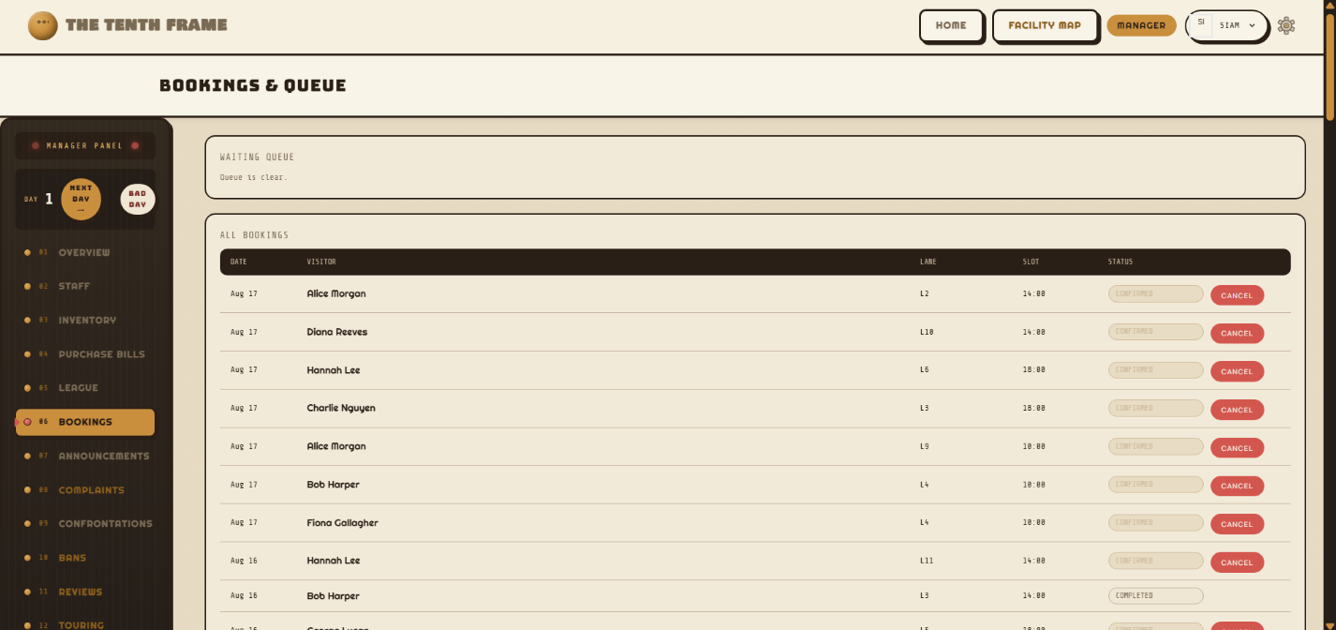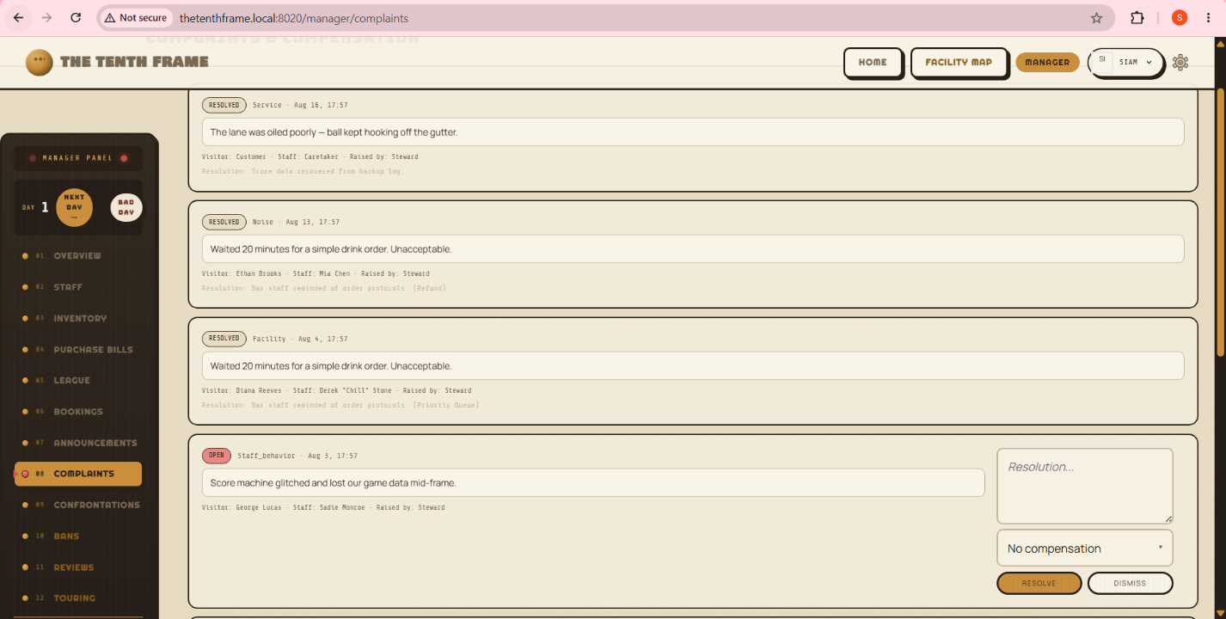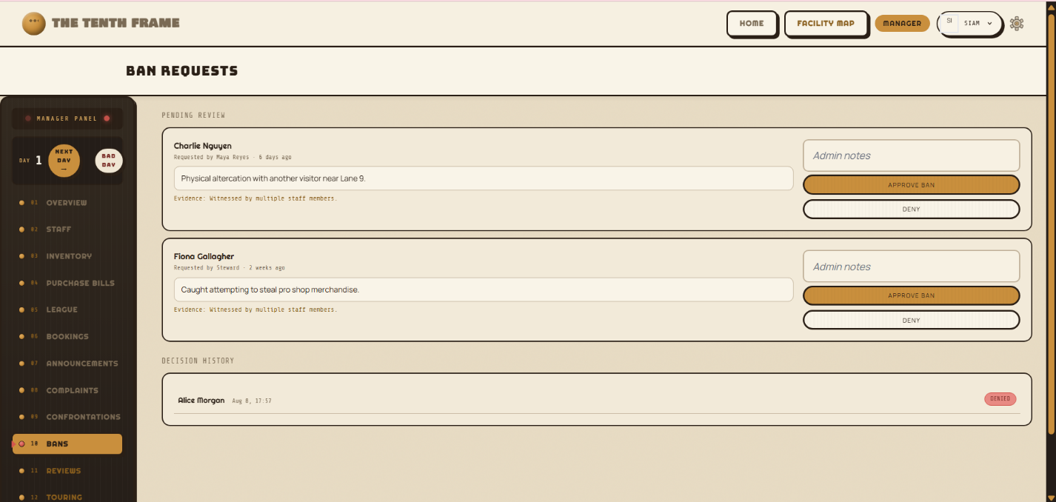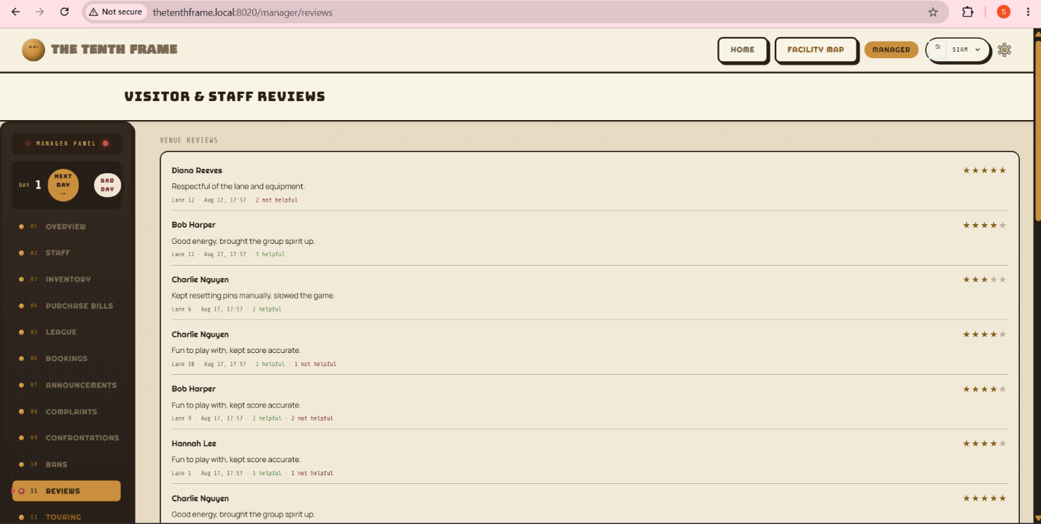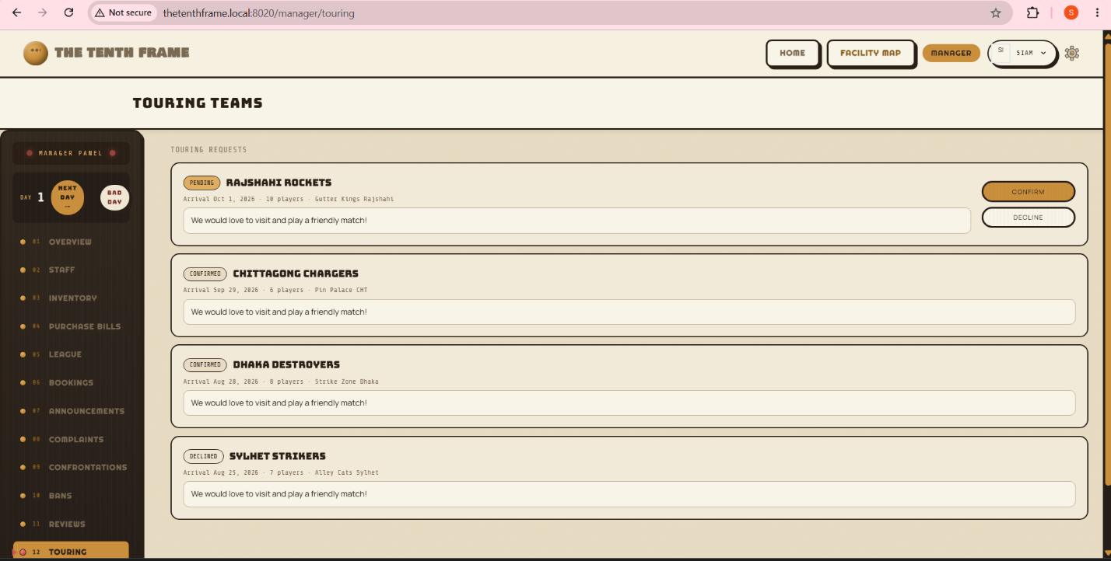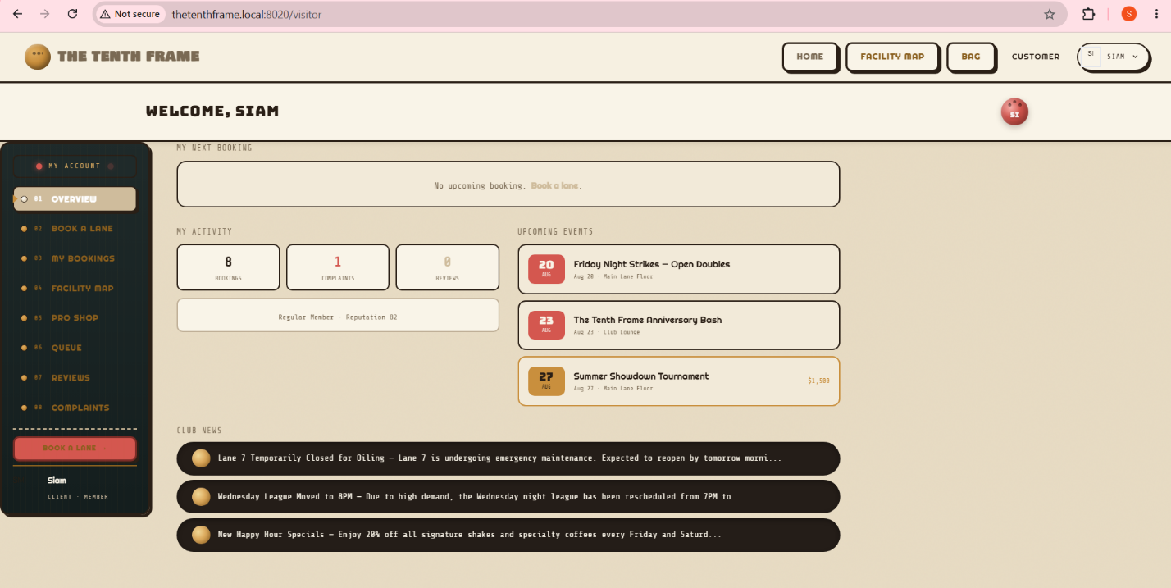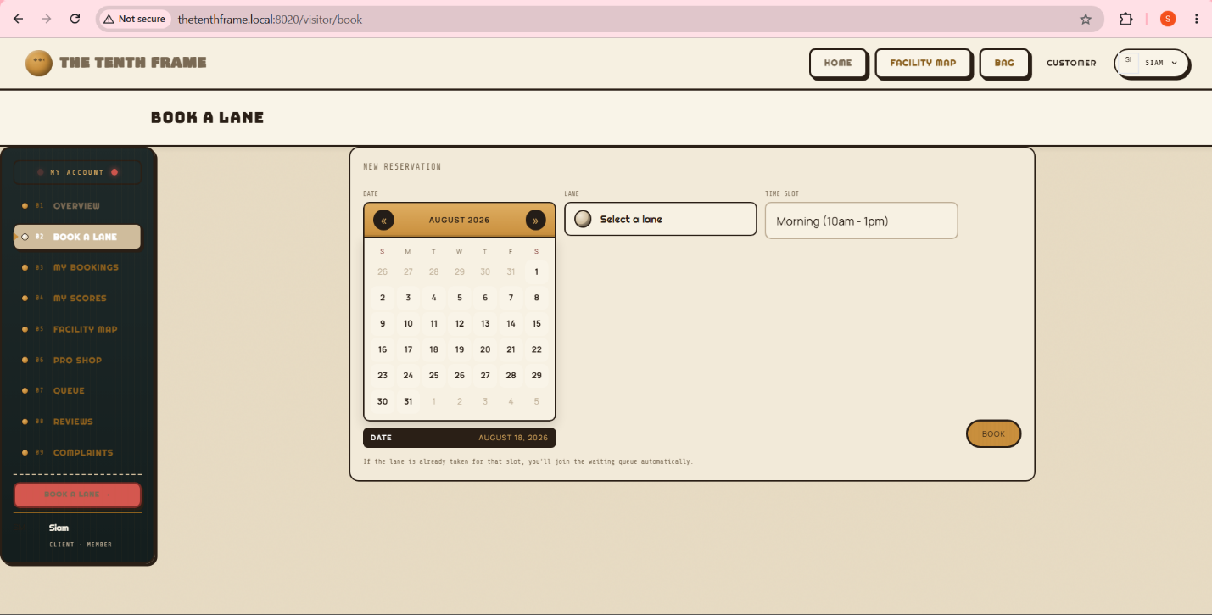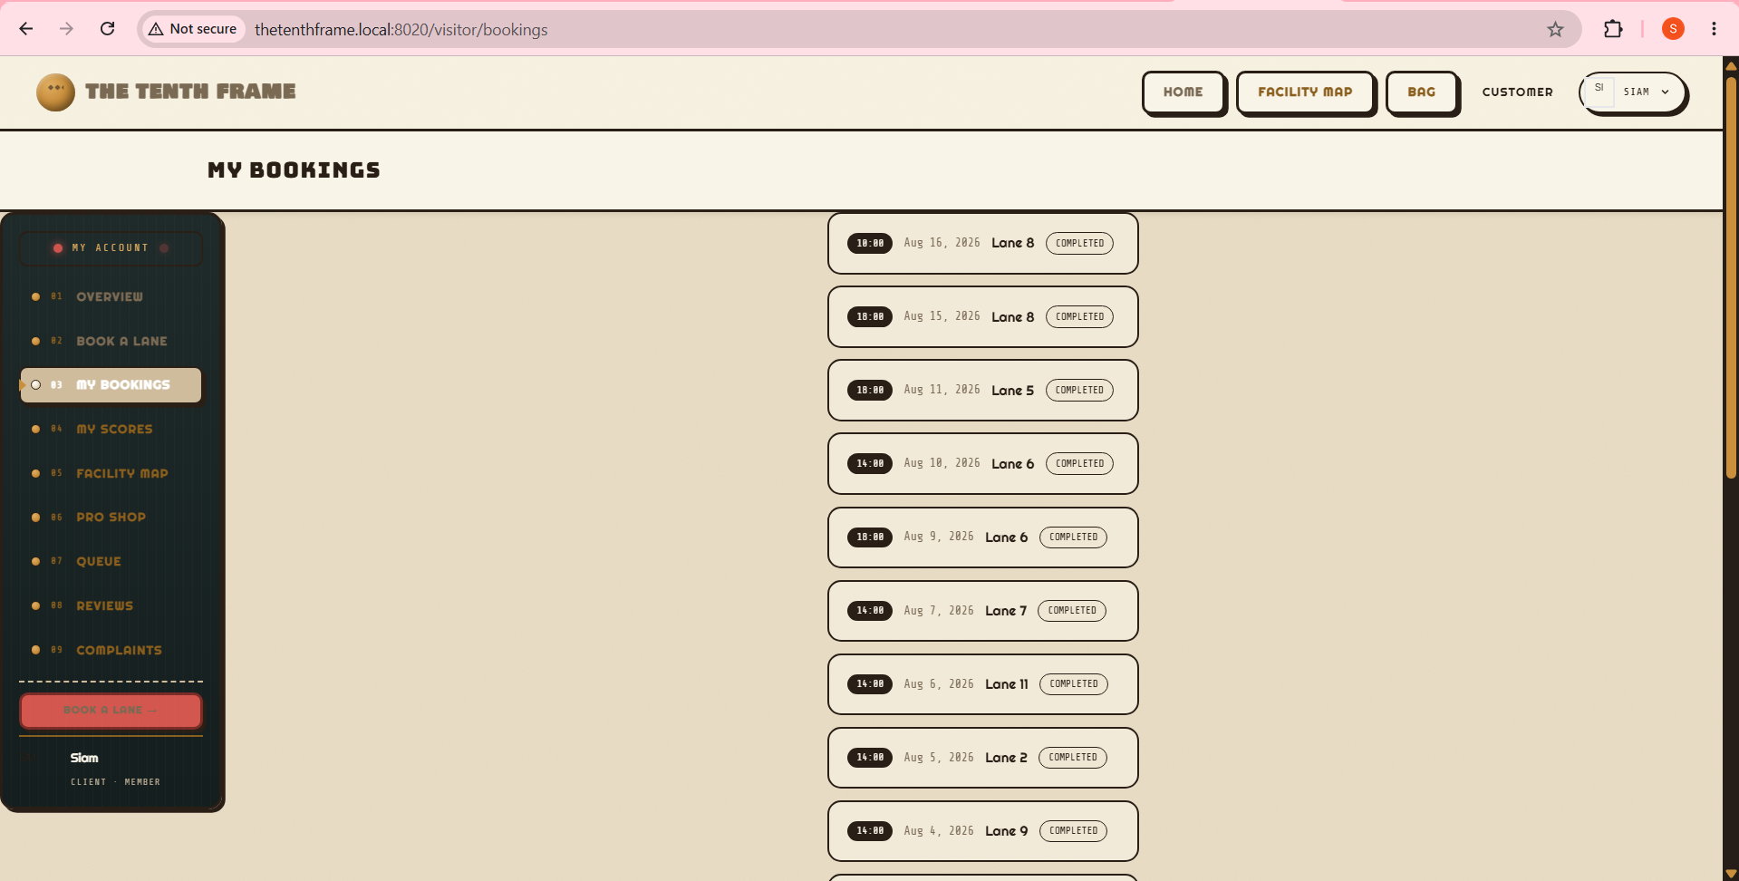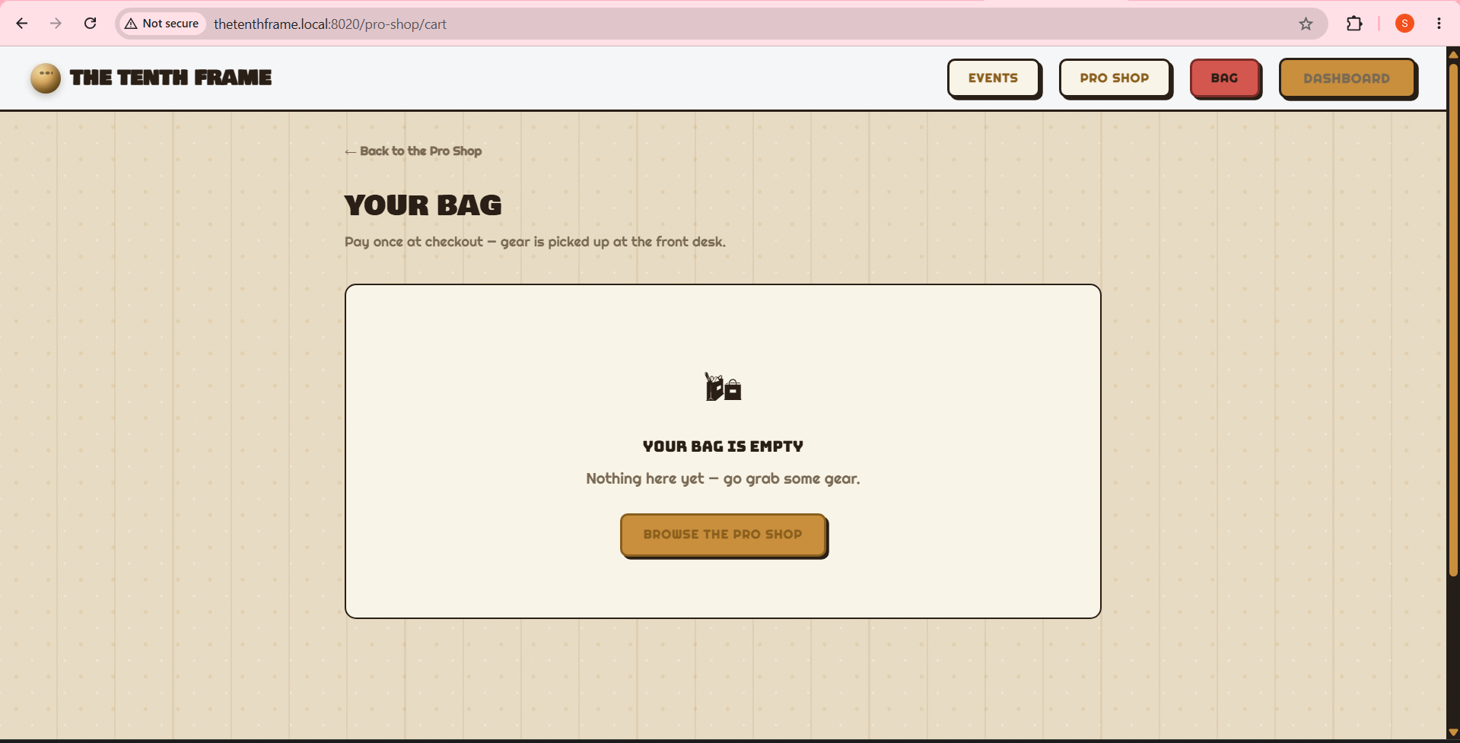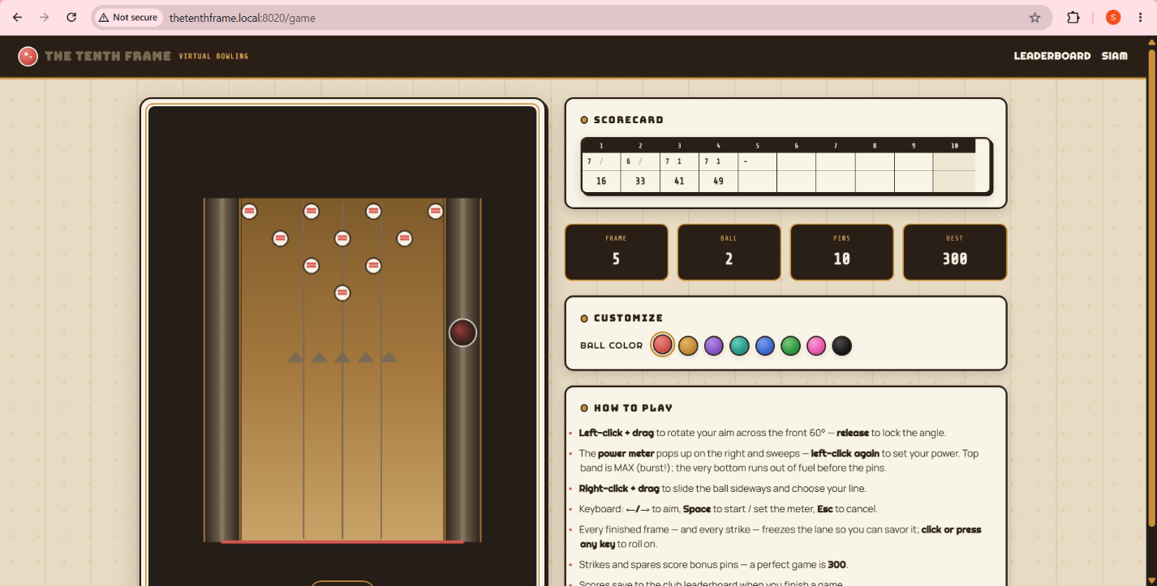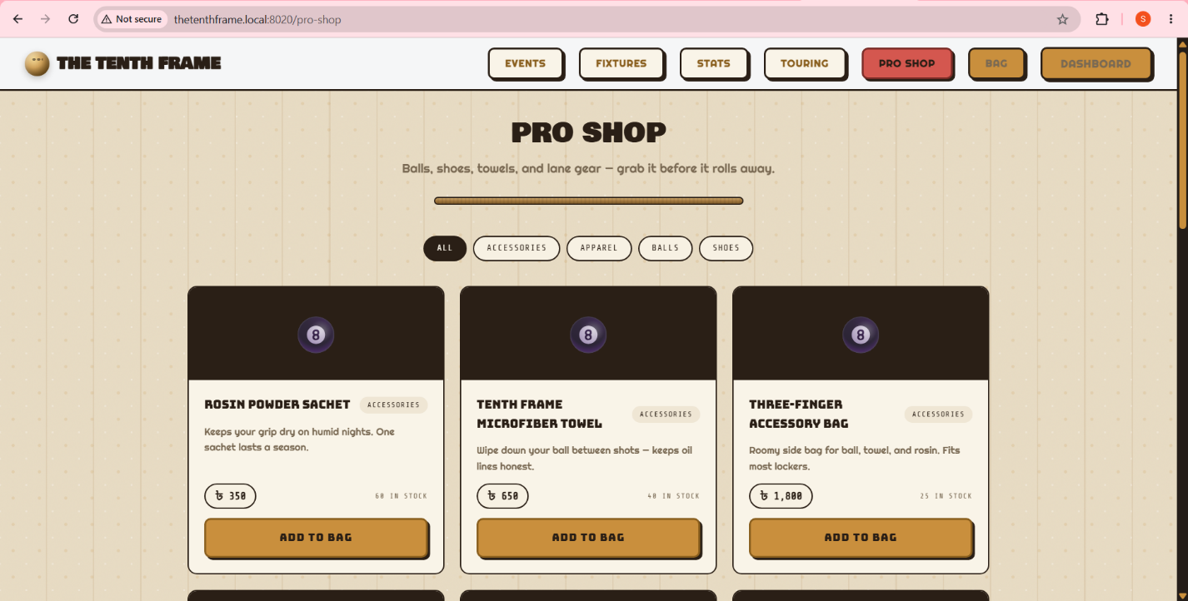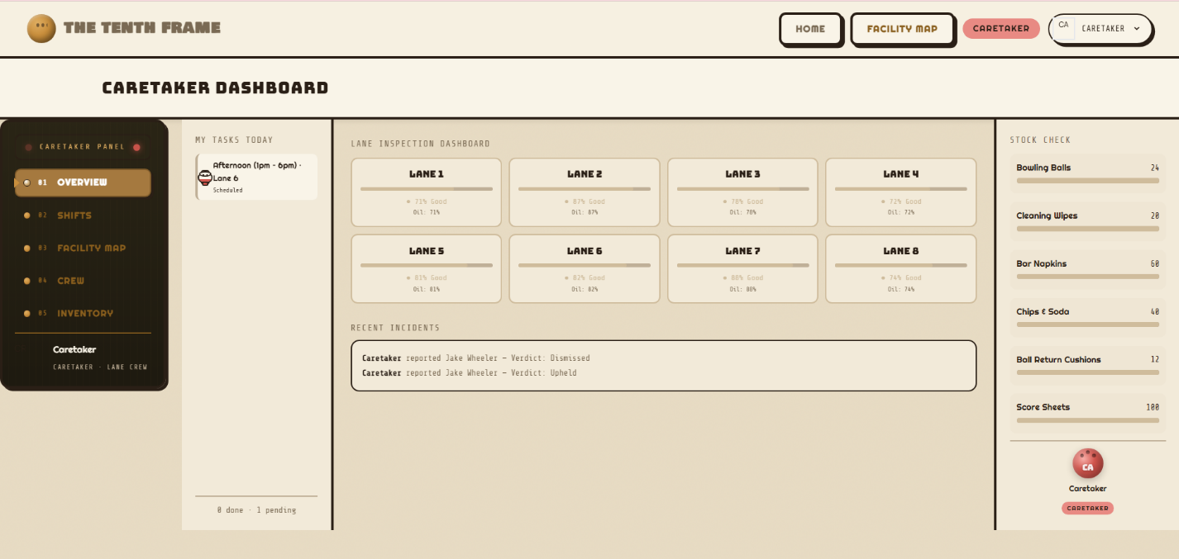
Online Resources used:
a) Reference:
- Laravel 12 documentation (laravel.com/docs)
- MySQL 8 reference manual
- MDN Web Docs (Canvas API, IntersectionObserver, CSS Custom Properties)
- SSL Commerz developer documentation (sandbox integration guide)
- Groq API documentation (LLM integration, rule-based fallback)
b) Stackoverflow or GitHub links:
- Laravel Breeze authentication scaffolding
- Socialite Google OAuth integration
- Blade component patterns and slot-based layouts
- Canvas animation best practices (requestAnimationFrame, physics loops)
Future Enhancements:
Following enhancements can be added to the current system:
- Wire the Groq LLM integration for real NPC dialogue (currently rule-based with fallback)
- Implement auto day-advance (scheduled command or real-time mode) so the simulation progresses without manual clicks
- Add runtime league/fixture generation so league play continues beyond the seeded fixtures
- Wire the remaining compensation options (refund, discount, apology) to actual effects
- Implement the penalized confrontation verdict to actually dock the staff member's salary
- Register SimulationDataSeeder + InventoryCategoriesSeeder in DatabaseSeeder so fresh installs populate the sim world automatically
- Add a server-side PDF generator for touring welcome packs (currently browser-print)
- Add prefers-reduced-motion guards to the facility map animations

