**4 Migrate database to AWS and give access to QuickSight – scenario tasks**

**Part 1 – backup the database**

1. You need to create the objects which will allow you to restore your superstore database from the earlier part of this course.
2. Using SSMS, script out your superstore database to the Documents of your PC using the advanced scripting options found in Tasks > Generate Scrips.
3. Script out as file called ‘createdb.sql’ the schema only (create tables)
4. Script out as file called ‘insertdata.sql’ the data only (insert into tables).

In both cases you want to script the entire database. This will result in two SEPARATE .sql query files. One small file will contain the table definition. The second larger file will contain the data values. Be careful to rename your files on saving so you do not overwrite the previous script.

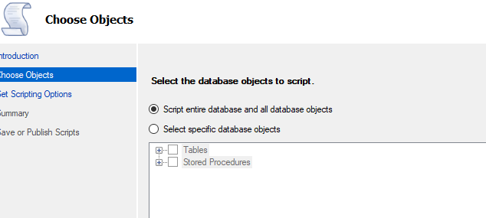

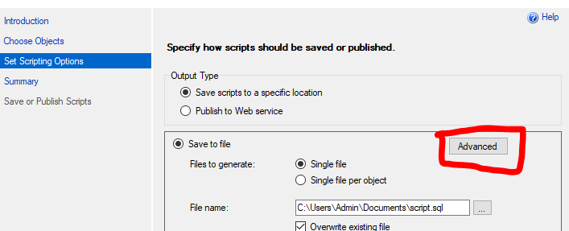

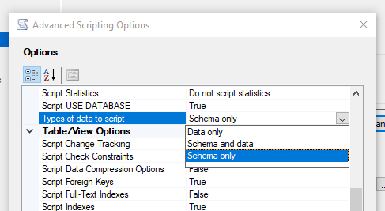

1. Open each query with SSMS locally in turn but DO NOT EXECUTE to preview and troubleshoot through any elements of the syntax which will not work for a cloud instance restore – for example references to local drive locations. These can be removed and a new copy of the .sql files saved.

**Part 2 – create RDS instance for SQL Server which is public**

1. Log into your AWS Management Console and navigate to RDS (Managed Relational Database Service) in your chosen AWS region
2. Create a new RDS instance with Microsoft SQL Server Express edition (Standard, not Enterprise instance) which includes the following configuration options:
   1. SQl server version which **matches** the server version you have been working with until now. See [how to check your SQL server version](https://www.mssqltips.com/sqlservertip/1140/how-to-tell-what-sql-server-version-you-are-running/) HINT: it doesn’t need to be the exact minor point release match, but take the latest available matching major release. For example if your SQL version is 15, you could use any 15.00.X version but the latest one is the smarter choice, it will have the most bug fixes.
   2. Database name set as <yourinitials>-migrate
   3. A small instance class with general purpose storage and minimum allocated storage (our database is small)
   4. Do not connect to EC2
   5. **Do** use IPv4 only
   6. Public access is allowed via assigned public IP
   7. For now, utilise the existing default security group allocation
   8. No need for SQL server windows authentication as no other users will access the DB instance than yourself
   9. Turn off performance insights and automated backups – these are not needed for a classroom setting
   10. Enable minor release updates

1. (optional) Before you choose Create, review the estimated monthly costs of the DB instance you are provisioning. Which configuration options do you think will reduce or increase those costs?
2. Autogenerate or reuse your master password while completing this task but **remember to take note of this password at the point of creating your database instance!** (I highly recommend using a simple password for this purpose)

**Part 3 – Configure outside connection to RDS from SSMS**

1. You will create a backdoor allowing management studio to connect IN to your RDS SQL Server in your virtual private cloud over the internet.
2. In your AWS management console, identify the security group settings by searching either for security groups or VPC – the configuration you are looking for is at the VPC (virtual private cloud) uppermost level of control
3. Create a new security group **in the same geography** as your RDS instance which includes an inbound rule, allowing IPv4 access in, for the type MSSQL, using protocol TCP and the matching port of your RDS instance (normally 1433).



1. After creating the security group, return to and modify the RDS instance to associate it with that security group. Make the alteration immediately to the RDS instance.

**Part 4 – test your connection from SSMS to your RDS instance**

1. Once the RDS instance is available (this may take a few minutes), you should be able to review the instance information including connectivity. Note the end point and port for the server name which will be entered separated by a comma. You will also need the RDS instance on AWS username and password for the SSMS connection.
2. Open SSMS locally and connect to the RDS instance using the above information and following this [helpful article on connecting from SSMS to RDS](https://docs.aws.amazon.com/AmazonRDS/latest/UserGuide/USER_ConnectToMicrosoftSQLServerInstance.html) for any troubleshooting issues. Remember to check that the database server on AWS is available, publicly accessible and the security group you created in the last step has been associated with the instance.
3. Once you have successfully connected to your AWS SQL server RDS instance from management studio, save and close any open SQL queries, disconnecting from any other SQL server instance so that the only connection shown is AWS. On the left hand side under schemas you should only see ‘rdsadmin’. This is where you will create your new cloud superstore schema.

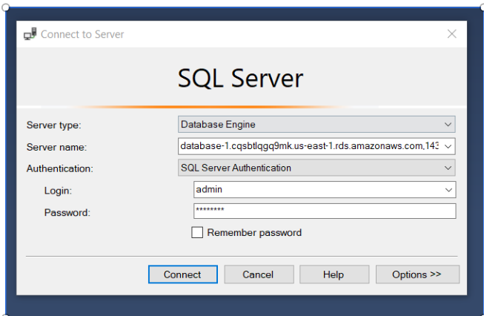

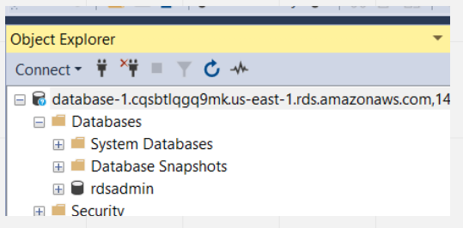

1. Right click on the database name (RDS instance) to create a new query and check the SQL server management studio is actually now connected to your AWS cloud.

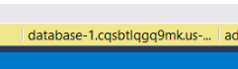

**Part 5 – restore your database backup to RDS**

1. You will restore the database using a) create and b) insert scripts in SSMS. Yesterday you connected to your RDS instance from SSMS so the credentials should be cached to connect again. You will need the end point, port, username, and password from the DB instance you created.
2. Open the Create and Insert data scripts you saved in the SSMS query editor. Review the scripts, checking there are no references to local directories, and remove any unnecessary additional configuration settings which are irrelevant to the migration (or that create errors when you try to execute). If you do not know how to troubleshoot, discuss with your instructor, or ask them for a backup script.

III. Running the queries in full will create and populate your migrated database on the RDS instance in AWS. The scripts include commands that

a. Create the database

b. Create the tables with PKs defined

c. Populate the tables with data

d. Supports creation of the date dimension (migrate stored proc or other method)

e. Add FK constraints to the Fact table

IV. Refresh the schema view to see the database, tables and stored procedure in the cloud RDS instance afterwards.

**Important : confirm the database is present and tables DO contain data before moving on.**

**Part 6– create QuickSight inbound role**

1. From your AWS Console navigate to your QuickSight account (or register for a QuickSight account that supports RDS connections) and check the AWS Region which you are hosted in. This information is visible if you select your QuickSight user profile in the top right in the browser. You will need this region information to set up the Inbound QuickSight connection, taking the IP address from this list : [Regions and IP Addresses](https://docs.aws.amazon.com/quicksight/latest/user/regions.html)

1. Next, navigate to your VPC (where you are hosting RDS) from your AWS Console
2. Once inside the VPC, locate the Security Group Settings and create the inbound QuickSight role which will be associated with your DB instance in RDS, following [this article about allowing Quicksight to access the database.](https://docs.aws.amazon.com/quicksight/latest/user/rds-vpc-access.html)
3. In the VPC security groups, add a new security group with an INBOUND rule for MMSQL, over the protocol TCP and port matching the RDS instance, with a source of the regional IP of where QuickSight is located. Note that if multiple QuickSight instances are to connect to the RDS database, then multiple inbound rules must be configured.

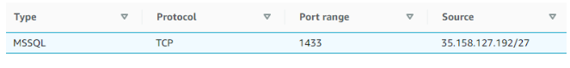

1. Returning to your RDS instance, modify the database instance to associate it with this new security group. Apply the change straightaway, it may take a few minutes for the update to take effect.
2. Once the instance is available again, you can test access to the database from your QuickSight account by creating a new data set from the fact table in your database (RDS or SQL Server connection type, the end point and port are defined, the database name is the schema name)

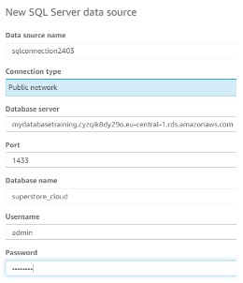

1. Publish and use in an analysis, visualising the data in the fact table by a scatter plot showing Profit and Quantity (hint: use the lightning bold Autograph feature).
2. If the analysis is successful, you are ready to move on to editing the data source and creating your dashboard. If you get an access error, check again that you have successfully added the security group to the instance and with the correct geographical IP. You may have to contact your network administrator for help if those steps have been correctly completed and permission is denied, because the restriction could exist between VPCs. If you are unable to progress beyond this point, you will use the alternative method of uploading the full superstore.csv file to SPICE on QuickSight as a data set directly.

