**EssexLash**

By Sian Dobrin

# Contents

**Contents**

**1 Introduction**

Document Overview

Client Description

Scope

**2 Content**

Structure

Layout

House Layout

Individual page layout

**3 Design**

Branding

Colour Scheme

Final Designs

# 1 Introduction

## Document Overview

The purpose of this document is to show how each page in the EssexLash website will be designed and why different elements for each page in the website have been chosen. This document also explains the content of the website, including the website's structure and layout accompanied by the use of wireframes.

## Client Description

The Client is an upcoming Lash Bar business based in Hornchurch Essex, called EssexLash. The business started in September 2015. and is made up of two well qualified eyelash technicians who offer a wide range of eyelash treatments to the general public. The business also offers small cosmetic treatments once a month. These treatments are given by other qualified beauty therapists. The business mainly deals with eyelash treatments as this is offered every day the Lash Bar is open.

The client has a wide range of clientele ranging from loyal customers to celebrities. The business prides itself on the area that the Lash Bar is situated (Essex) and uses the area to promote themselves. The area has recently become more popular in the public eye as there are a lot of television programmes based in Essex and celebrities from the casts of the television programmes use this business also to receive eyelash treatments.

The client aims to promote the business even further, allowing them to become a more recognised business and in the future, expand the business and employ more eyelash technicians.

## Scope

The purpose of this website is to promote EssexLash and to provide all of the information a user may need to know about the business. Thus the website needs to attract new customers and at the same time be informative and clear and answer any queries that users may have about the business and the treatments that it offers. The website needs to explain to users what the EssexLash business is, what treatments they offer, what different eyelash treatments look like and how much the different eyelash treatments cost. The website must answer any questions that the user has clearly and informatively. The website must be usable and intuitive so that all different users of different technological skills are able to use the website and navigate throughout the website to find what information they intend to view.

# 2 Content

## Structure

* **Homepage-** The homepage will be the first page that users will view when they enter the EssexLash website URL. The homepage will serve the purpose of drawing users in so that they want to find out more about the business and start to then navigate to other pages of the website. On the homepage, the logo will be displayed as well as a navigation bar and a welcome message. A small explanation of what the business can do for its customers will be shown -this is to impress users so that they carry on navigating through the website. A footer containing contact and social media information as well as last updated information will also be displayed. Also, photos of celebrity clientele will be shown to entice users in who are fans of the celebrities with the intention that they will then want an eyelash treatment similar to the celebrity in which they admire.
* **About Us-** The About Us page will be used to explain to users what the EssexLash business actually is. This page will also describe the staff that work at EssexLash and what qualifications they have, in the aim of showing users that EssexLash have well qualified staff working there, allowing the business to achieve a trustworthy relationship with the users. On the About Us page, the logo will be displayed as well as a navigation bar and a welcome message. An explanation about what EssexLash does as a business will be shown, as well as information about the staff that work there. Also, a footer containing contact and social media information as well as last updated information will be shown.
* **Price List-** The purpose of the Price List page is to clearly show the prices of every single treatment available at Essex Lash. On the Price List page, the logo will be displayed as well as a navigation bar and a welcome message. A small introduction will be given inviting the users to read the price list. A list of prices for each treatment will be displayed as well as the amount of time each treatment takes. The amount of time will be shown so that users can easily understand the pricing of the treatments, as a lot of the treatments are priced relative to the amount of time the treatment takes. Also, a footer containing contact and social media information as well as last updated information will be shown.
* **Gallery-** The purpose of the Gallery page is to clearly show images of different customers' results from having different eyelash treatments. By doing so, potential customers will be able to view what look they would like to achieve and will then be able to pick which treatment would be most suitable for them to have. Also, images will be shown of customers from all different age groups and ethnicities to make it clear to users that the EssexLash business has good results on all different customers. The logo will be displayed as well as a navigation bar and a welcome message. A small introduction will be given explaining the gallery. There will be lots of images shown for each different treatment offered by EssexLash. Also, a footer containing contact and social media information as well as last updated information will be shown.
* **Testimonials-** The purpose of the Testimonials page is to show the users reviews that previous customers have given so that they feel more confident in choosing to have a treatment from EssexLash. This is intended to show that EssexLash regularly gives its customers good results and keeps up a high standard of customer satisfaction. The logo will be displayed as well as a navigation bar and a welcome message. There will also be a small introduction explaining how EssexLash values customer feedback and customer satisfaction. Also, a footer containing contact and social media information as well as last updated information will be shown.
* **FAQ's-** The purpose of the FAQ's page (frequently asked questions) is to provide users with answers to any questions that they might have. The most common questions that customers ask at EssexLash will be shown including extremely informative answers. The logo will be displayed as well as a navigation bar and a welcome message. There will also be a small introduction explaining that the page is about frequently answered questions and encouraging the users to contact EssexLash if their questions still are not answered. Also, a footer containing contact and social media information as well as last updated information will be shown.
* **Contact Us-**The purpose of the Contact Us page is to provide all the information that a user may need to be able to contact EssexLash and even visit the EssexLash Lash bar. The business's opening hours, address and telephone number will be displayed, as well as parking information. The logo will be displayed as well as a navigation bar and a welcome message. There will also be a small introduction explaining that users are welcome to contact EssexLash. Also, a footer containing contact and social media information as well as last updated information will be shown.

## Layout **House Layout:** This is the layout which each page in the website will follow.

# 

# **Homepage:**

**About Us:**

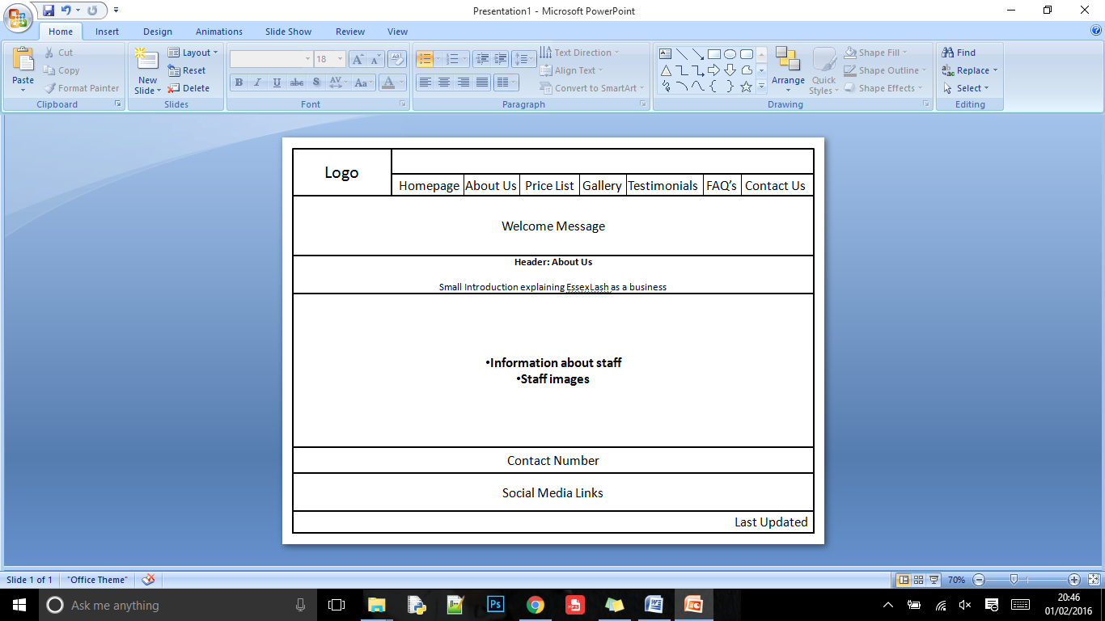

**Price List:**

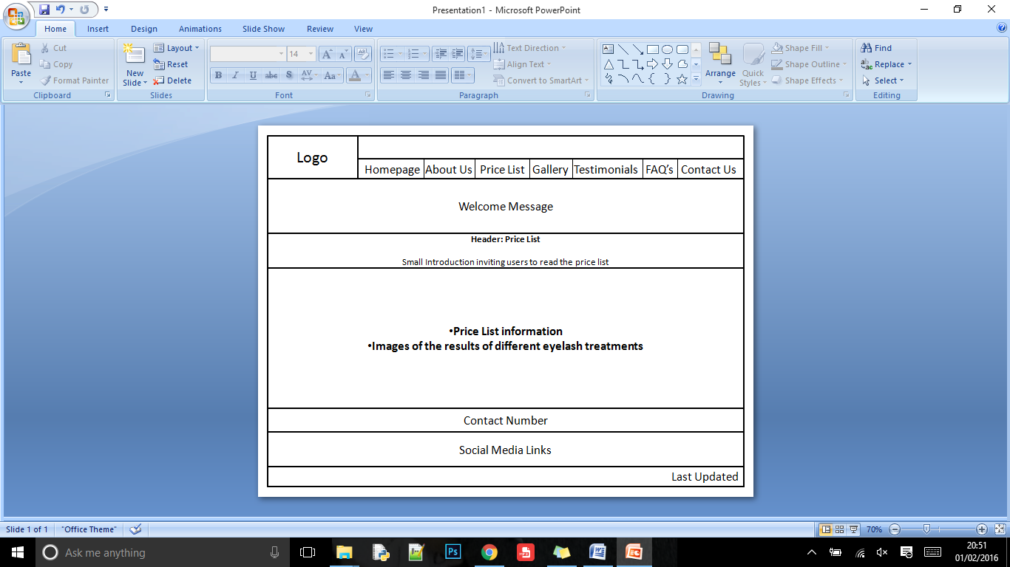

# **Gallery:**

**Testimonials:**

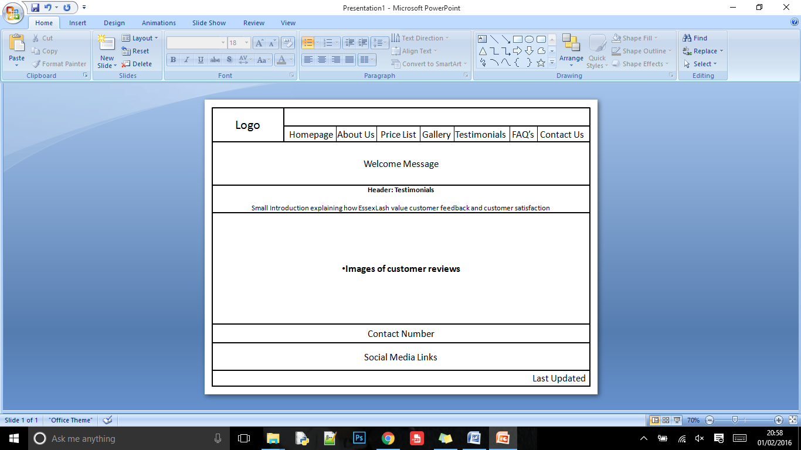

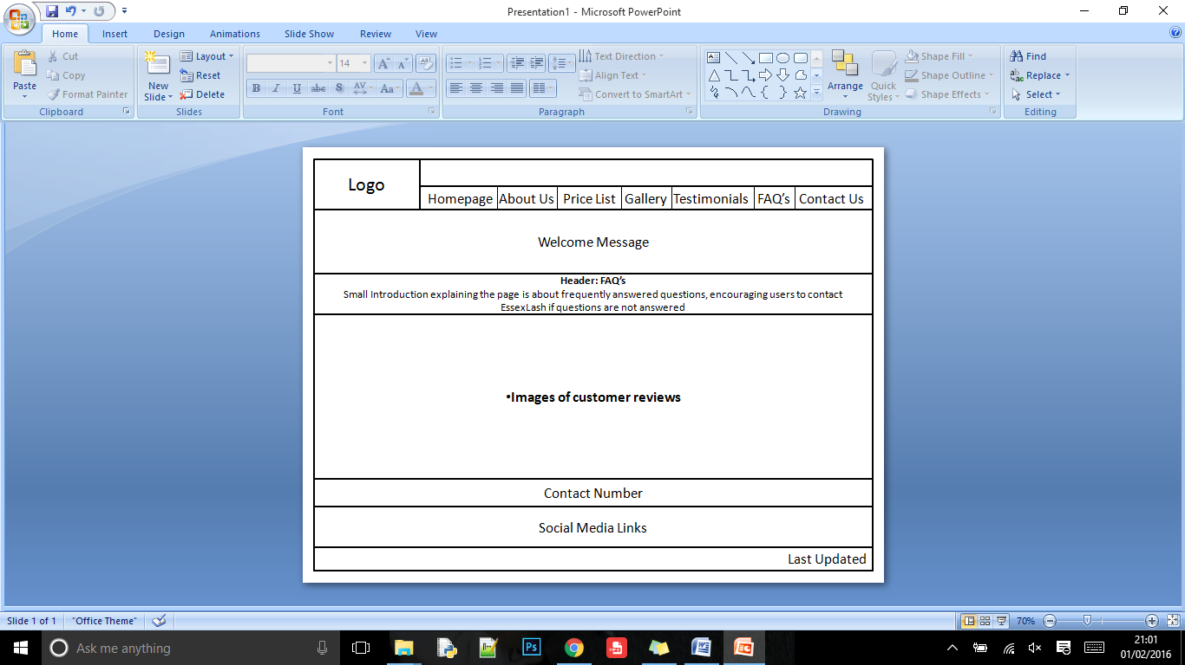**FAQ's:**

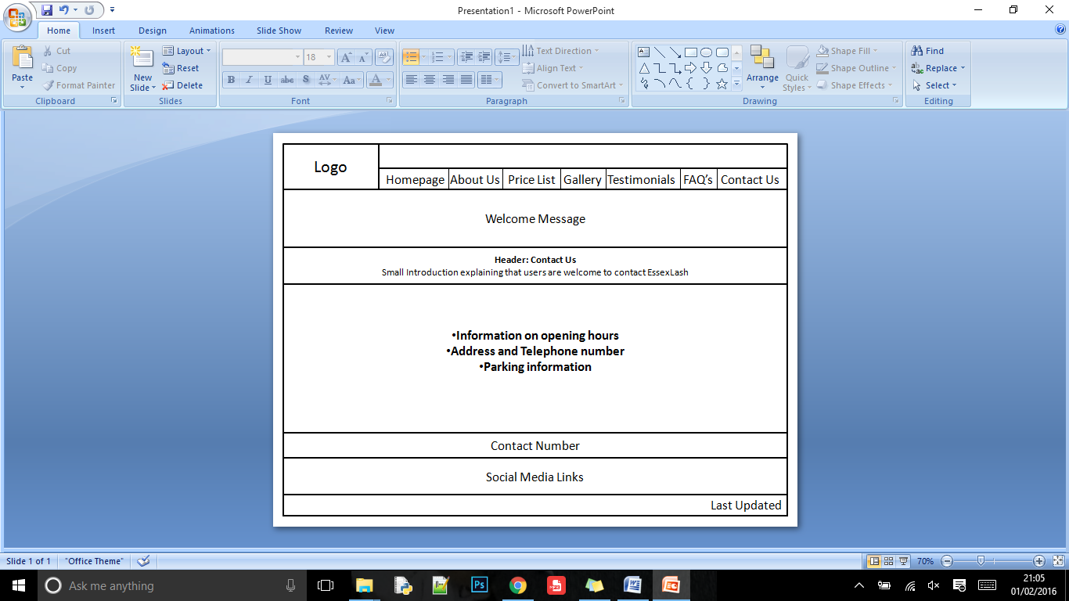**Contact Us:**

# 3 Design

## Branding



**Current Logo:**

**Images of Lash Bar:**

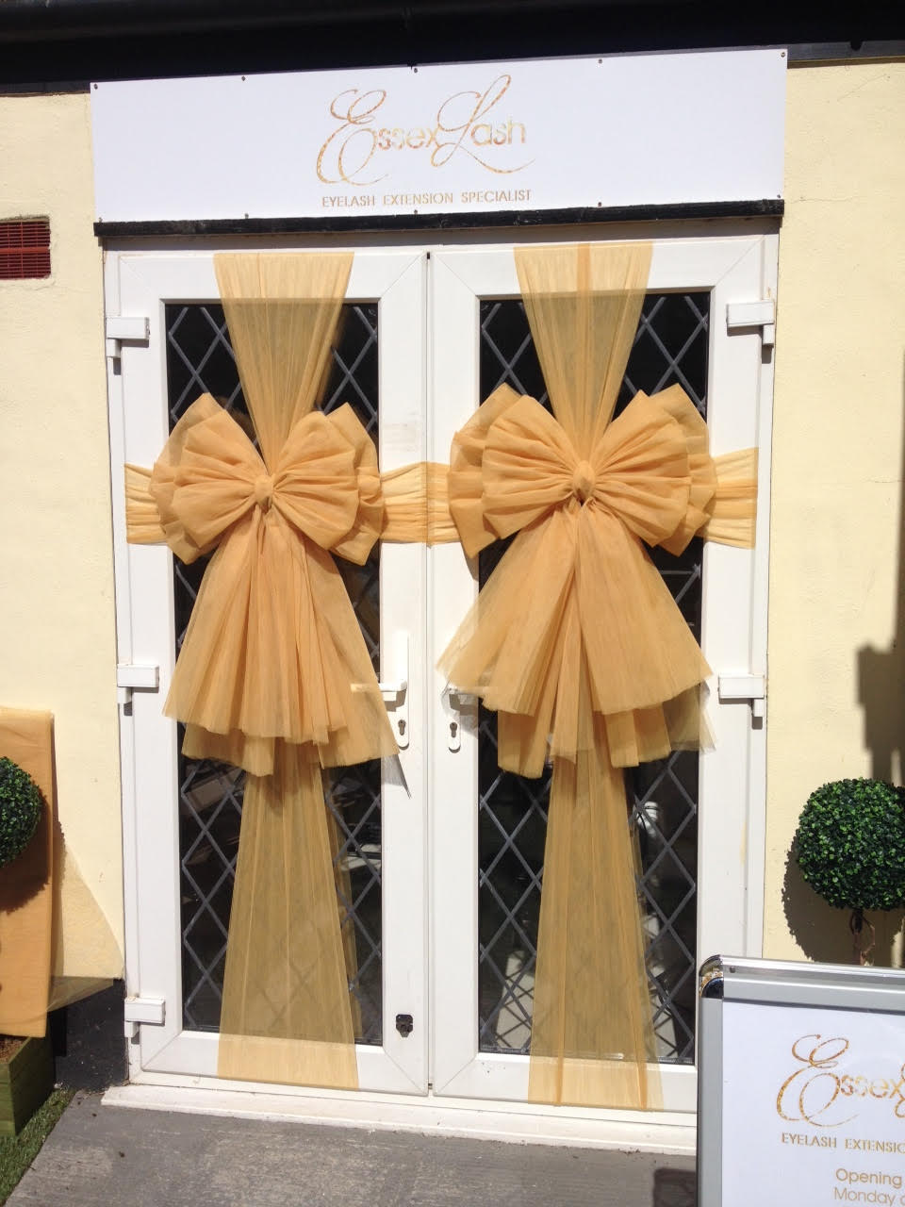

## room3.jpg

**Image of current price list handout:**

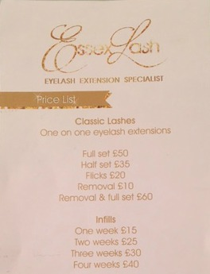

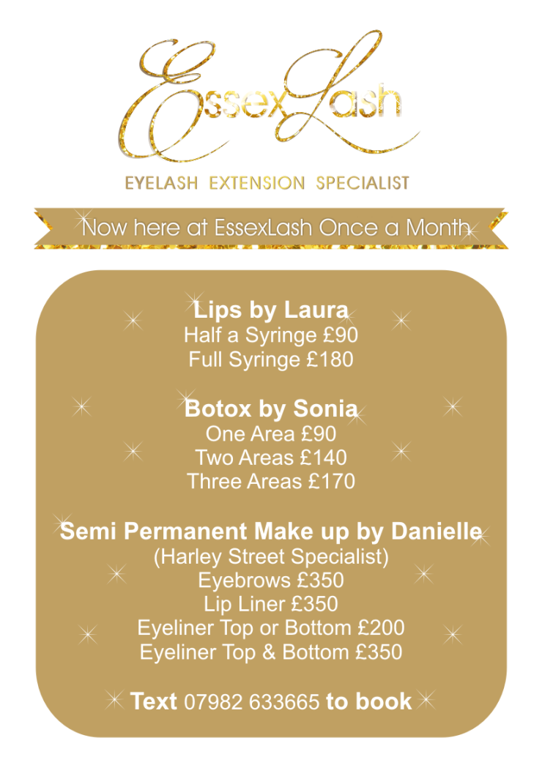**Image of flyer:**

EssexLash aims to make their customers look glamorous, therefore the brand has a very glamorous and luxurious feel. There are a lot of gold colours and glitter throughout the brand which their current customers find very appealing. As you can see from the logo, the logo itself is glittery and gold and uses calligraphy and this logo reflects the brand well as the writing is made to seem luxurious in a way. Also, as you can see from the lash bar photos, the actual outside doors of the lash bar are covered in gold bows, EssexLash aim to be welcoming and friendly and I feel this attribute shows off this part of the brand. The inside of the lash bar has a wall which is coated in gold glitter. The gold theme is quite consistent throughout the branding. This colour scheme choice gives a feel of opulence and is designed to make customers feel as if they are having a very luxurious and superior experience. The EssexLash brand want their business to be recognised as well established and sophisticated and this is shown by the decor and the deluxe colour scheme.

## Colour Scheme

The colour scheme that I will be using for the website will consist of white and gold. This will then make the website consistent with the colour scheme that the business has already adopted. The hex code for the white colour is #FFFFFF which is obviously widely recognised. The hex code for the metallic gold colour that will be used is #D4AF37 . The text on the website will be white when the background behind it is gold and the text will be gold when the background behind it is white. This reversible look is shown on the business's price list and flyer shown above. All images will be surrounded by gold borders due to the fact that the lash bar has lots of gold frames inside it and this will again be continuing the EssexLash branding style onto the website.

**Wireframe showing colour scheme to be used throughout the website:**

Navigation links will use gold text and have white backgrounds. When the navigation links are each hovered over, these colours will reverse and the text will become white and the background colours will become gold.

The introduction for each page will use white text and will have a gold background.

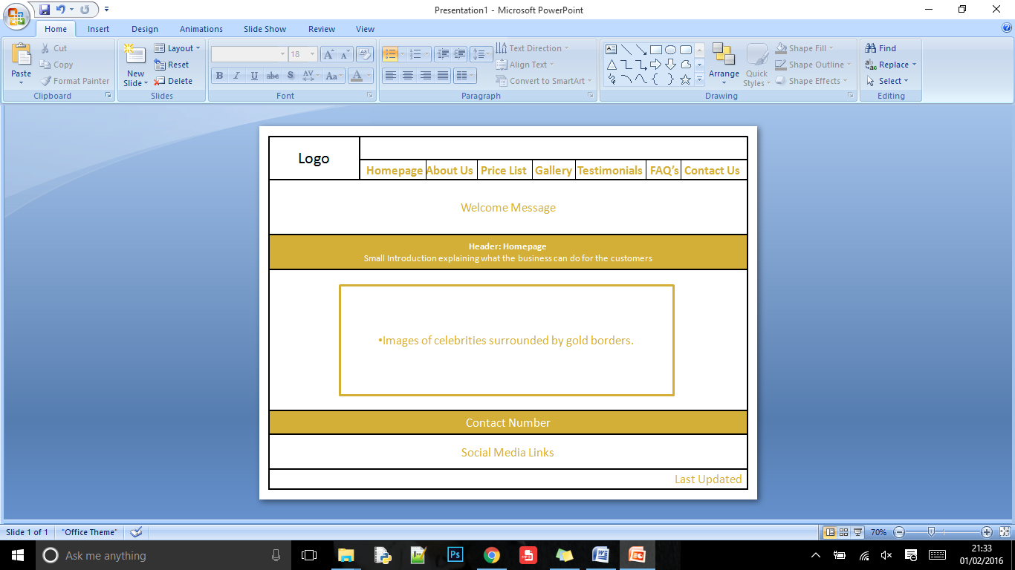

## 

All content information will be shown using gold text with a white background.

Last updated information will be shown using gold text with a white background.

Contact number details will be shown using white text with a gold background.

Images will be surrounded by gold borders.

## Final Designs

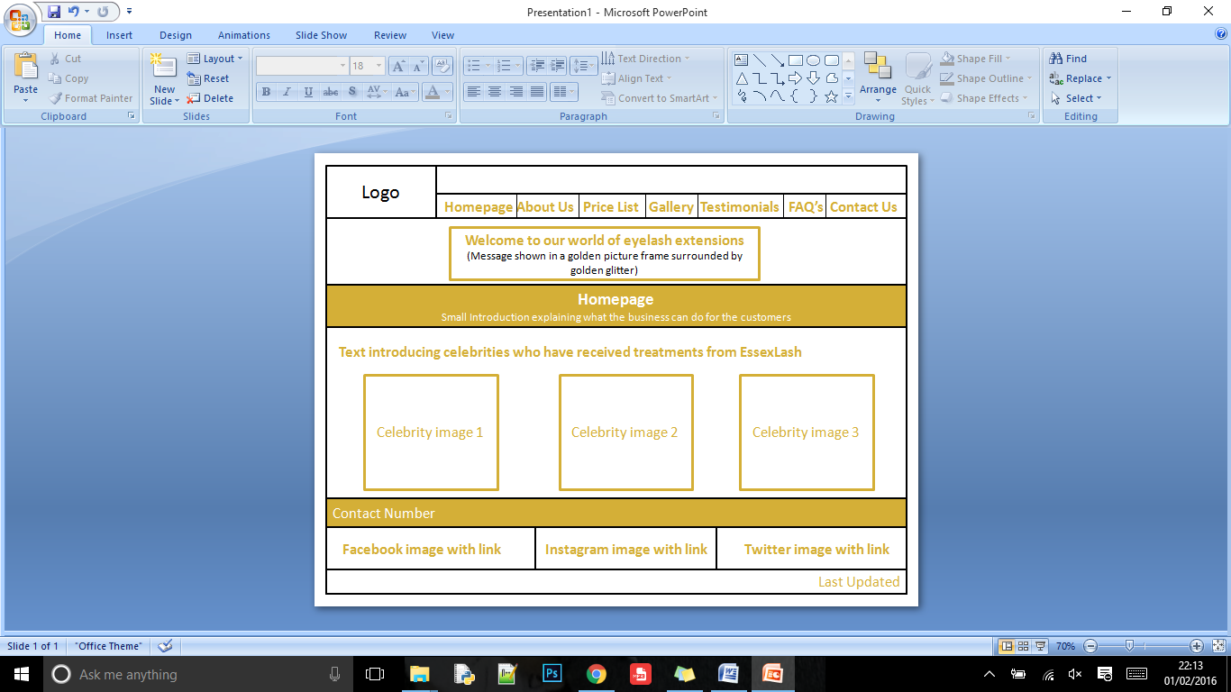**Homepage:**

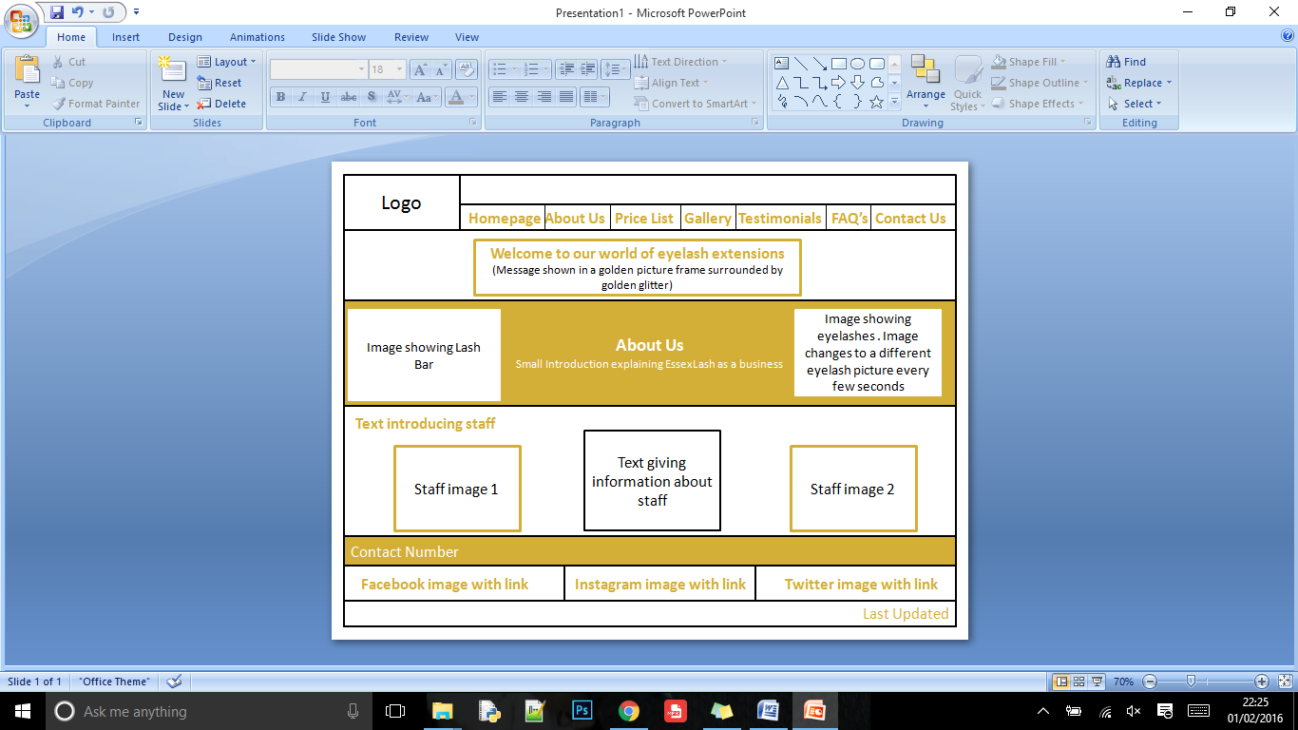 **About Us:**

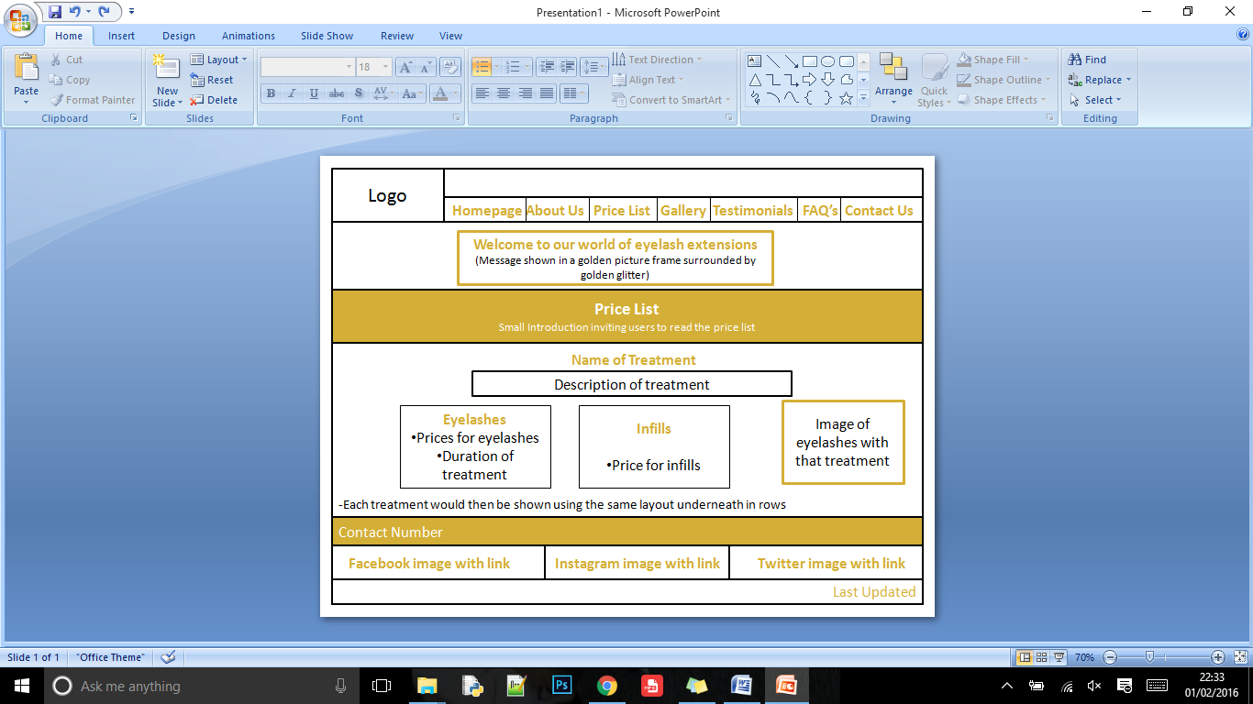**Price List:**

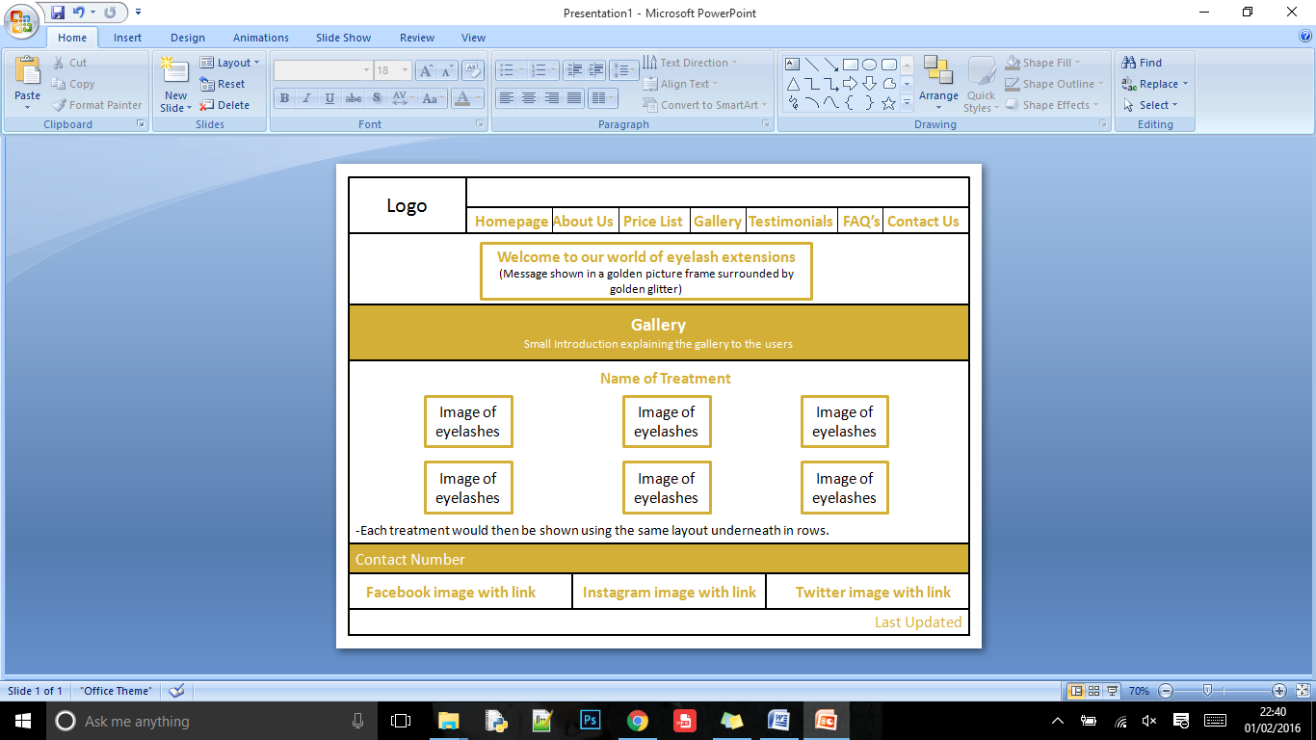**Gallery:**

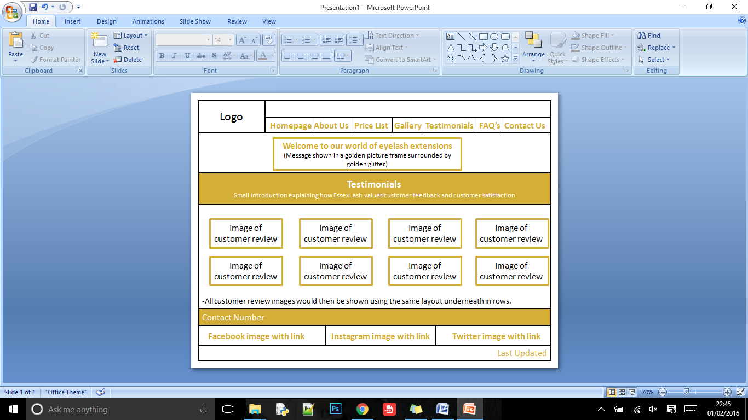**Testimonials:**

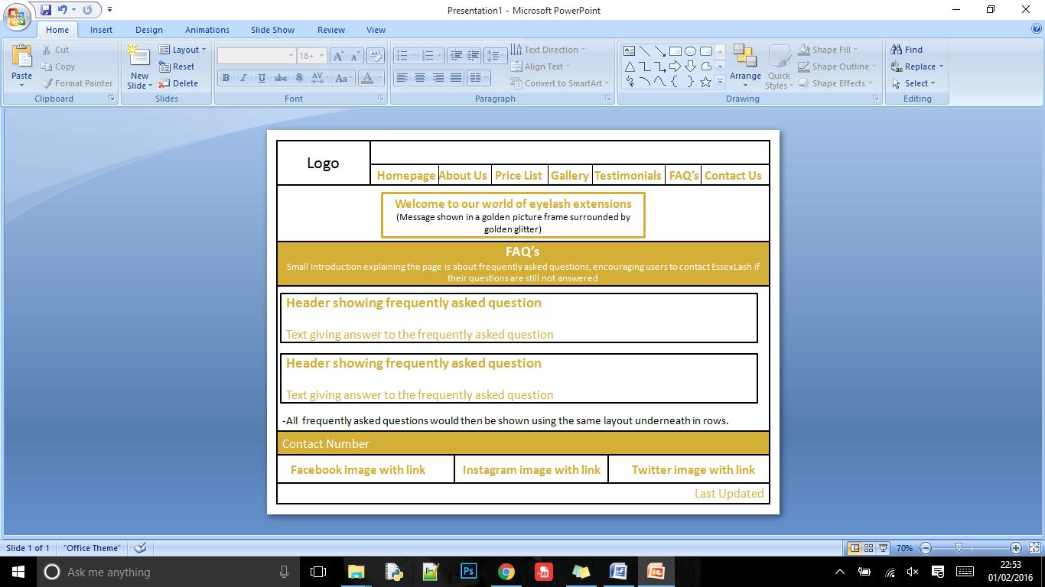**FAQ's:**

**Contact Us:**

