
ASDP DIMS Frontend — Deployment Script Setup & Pipra Operational User Manual
Step-by-Step Operator Guide for Zero-Downtime Blue-Green Deployment, Target Host Script Setup, Real-Time Pipeline Telemetry, and Pipra Control Plane Usage
Document ID | Target Application | Security Level | Release Engine
2026-10-31-v1.0 | asdp-dims-fe | RBAC Enforced (Admin/Op) | Blue-Green 10-Stage Machine

1. Executive Overview & Architecture Bridge
This operational manual provides a complete, step-by-step procedure for deploying the ASDP DIMS Frontend (asdp-dims-fe) application. It establishes the bridge between the target server's standalone shell script (deploy_asdp-dims-fe.sh) and the modern Pipra Control Plane, which orchestrates, automates, and secures this deployment with real-time SSE streaming logs, centralized audit ledgers, role-based access control (RBAC), and automated sub-second rollback recovery.
The core architectural pattern implemented by both systems is an isolated Blue-Green staging barrier: candidate releases are compiled into immutable container artifacts, booted on an isolated staging port (:4001), and subjected to real HTTP synthetic health probes. Live customer traffic on port :4000 is never touched until the candidate proves 100% operational.
[ZERO-DOWNTIME GUARANTEE] Core Safety Principle: Pipra never stops or interrupts an active production container during build or staging. If a build fails or staging health checks time out, the candidate container is cleanly terminated with zero impact on serving traffic.

2. Parameter Mapping Matrix: Shell Script vs. Pipra
Every parameter accepted by the deploy_asdp-dims-fe.sh bash script maps 1:1 to a first-class configuration attribute in Pipra. This eliminates command-line syntax errors and guarantees consistency across all team members.
Shell Flag | Default Value | Pipra UI Mapping | Purpose & Architectural Role
--branch <branch> | devel | Wizard Step 2: Target Branch | Git branch to synchronize and deploy (e.g. devel, main).
--tag <image_tag> | v1.0.10-b3112 | Wizard Step 2: Release Tag | Docker image tag suffix (asdp-dims-fe:<tag>).
--name <name> | asdp-dims-fe | App Catalog: Project Slug | Production Docker container name identifier.
--env-file <file> | .env.development | App Catalog: Environment File | Environment file mounted at build/run time.
--port <port> | 4000 | App Catalog: Production Port | Live customer-facing host port serving traffic.
--staging-port <p> | 4001 | App Catalog: Staging Port | Ephemeral port used for pre-cutover health probes.
--dockerfile <f> | Dockerfile.jenkins | App Catalog: Dockerfile Path | Docker build recipe within repository root.
--app-dir <dir> | /home/devel/asdp-dims-fe | App Catalog: Host Directory | Absolute remote server worktree directory.
--skip-pull | false | Wizard Step 3: Skip Git Pull | Skips git fetch/pull if deploying local worktree.
--verify-local | false | Target Host Settings: Verify | Runs host npm ci && npm run build verification.
Health Retries | 15 attempts | Target Host Settings: Retries | Max attempts to probe staging before declaring failure.
Health Interval | 2 seconds | Target Host Settings: Interval | Interval between HTTP synthetic probes on port :4001.

3. Target Server Script Setup (Manual Baseline)
Before deploying via Pipra or running manual commands, set up the worktree, permissions, and script on the target Linux host.

Step 3.1: Connect to Target Server via SSH
ssh devel@192.168.10.12

Step 3.2: Verify Git Repository Clone
Ensure the repository is cloned to the configured application directory:
# Verify directory existence
ls -ld /home/devel/asdp-dims-fe
# If not yet cloned:
git clone git@gitlab.asyst.co.id:asdp/asdp-dims-fe.git /home/devel/asdp-dims-fe
cd /home/devel/asdp-dims-fe

Step 3.3: Verify Environment Files
Ensure your target environment files are placed in the application root:
cd /home/devel/asdp-dims-fe
ls -la .env.development .env.production
# If missing, copy from your secure credential template
cp .env.example .env.development

Step 3.4: Save & Make deploy_asdp-dims-fe.sh Executable
Save the zero-downtime deployment script and grant execute permissions:
cd /home/devel/asdp-dims-fe
chmod +x deploy_asdp-dims-fe.sh

Step 3.5: Smoke-Test Script via Terminal (Optional)
Execute a dry-run or fast test deployment manually to verify host Docker privileges:
./deploy_asdp-dims-fe.sh \
--branch devel \
--tag test-manual-$(date +%s) \
--name asdp-dims-fe \
--port 4000 \
--staging-port 4001 \
--env-file .env.development \
--skip-pull

4. Step-by-Step Guide to Deploying via Pipra
Pipra allows you to control, inspect, and trigger this exact deployment from a centralized web cockpit with zero manual terminal commands.

Step 4.1: Access & Sign In to Pipra
Open your browser and navigate to http://localhost:4200 (or your shared team control plane IP):
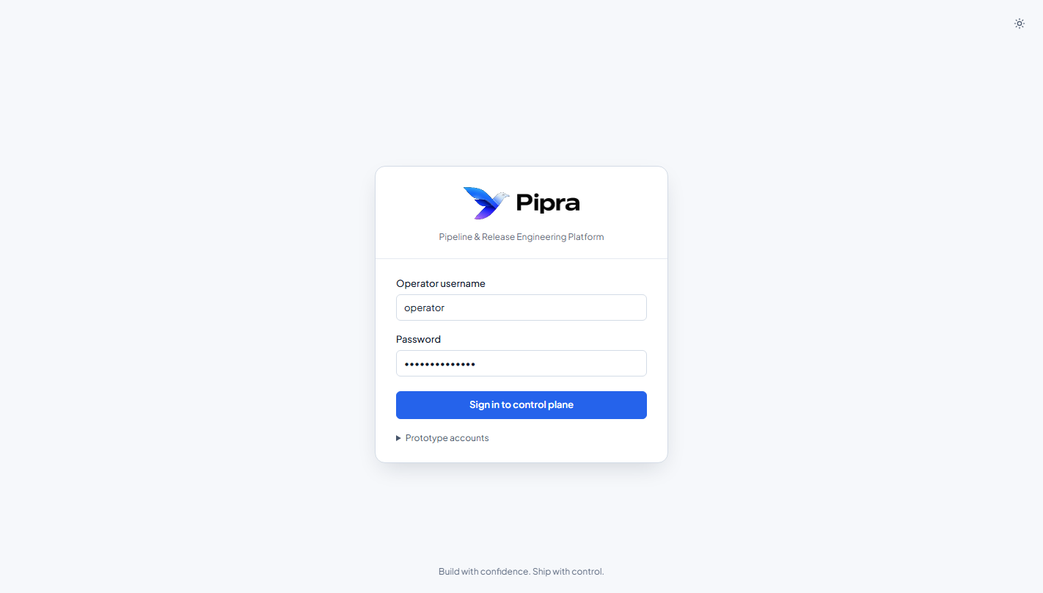
Figure 1: Pipra Secure Sign-In Portal with Role-Based Access Control
Username | Default Password | Permission Scope
admin | pipra-admin-2026 | Administrator: Full project registration, target host setup, purge, and deployment access.
operator | pipra-ops-2026 | Operator: Launch deployment wizard, trigger atomic cutovers, initiate rollbacks.
viewer | pipra-viewer-2026 | Viewer: Read-only observation of pipelines, live log streams, and audit history.

Step 4.2: Register the asdp-dims-fe Project in Applications Catalog
1. In the sidebar, navigate to Applications & Projects (#/apps).
2. Click the 'Register new project' button.
3. Enter the project configuration parameters:
- Project Slug: asdp-dims-fe
- Display Name: ASDP DIMS Frontend
- Git Repository URL: git@gitlab.asyst.co.id:asdp/asdp-dims-fe.git
- Default Branch: devel
- Dockerfile: Dockerfile.jenkins
- Host App Directory: /home/devel/asdp-dims-fe
- Production Port: 4000
- Staging Port: 4001
4. Click Confirm.
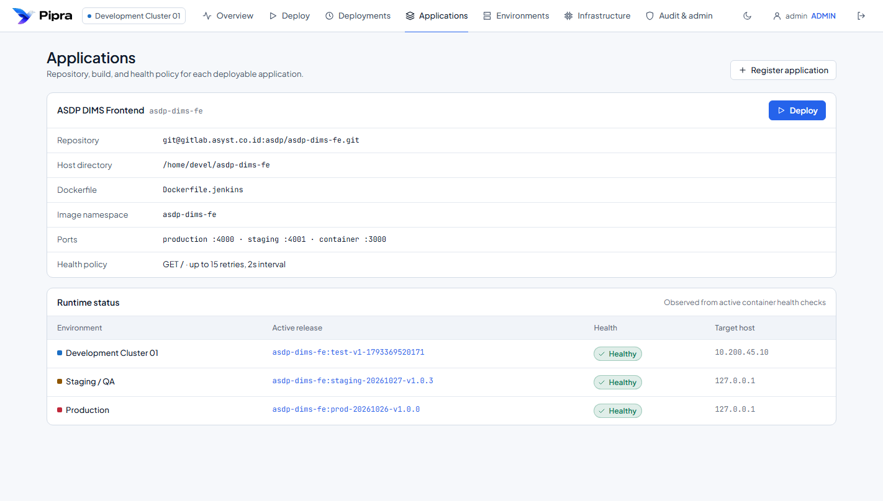
Figure 2: Pipra Applications & Multi-Project Catalog View

Step 4.3: Attach Target Environments to asdp-dims-fe
1. In the Applications catalog, locate the ASDP DIMS Frontend project card.
2. Click 'Add environment'.
3. Configure target host parameters:
- For Local/Loopback: Host 127.0.0.1, User devel, Port 22, Auth: None.
- For Remote Production: Host 192.168.10.12, User devel, Auth: SSH Password / Key (stored in AES-256 Vault).
- Production Safeguard: Check 'Production Critical' for production environments to enforce operator confirmation barriers.
4. Click Confirm.
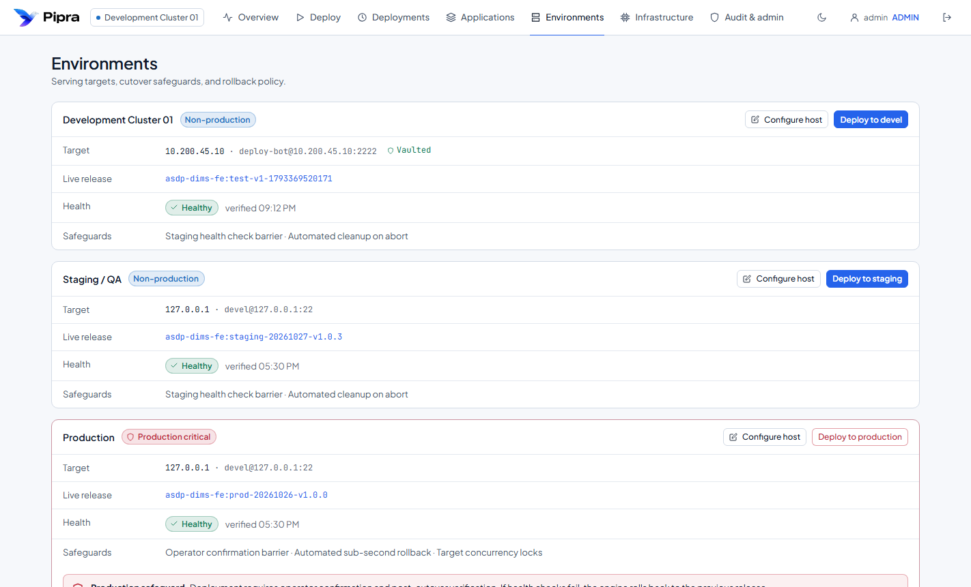
Figure 3: Target Environments & Host Safeguard Management

Step 4.4: Test Target Host SSH Connectivity
Click the 'Test SSH' button next to the environment. Pipra performs an active diagnostic over SSH, querying the remote Docker daemon and verifying BuildKit availability. A green toast notification confirms active connectivity.

Step 4.5: Launching a Zero-Downtime Deployment via the Wizard
1. Click 'Launch wizard' or navigate to Deploy Application (#/deploy).
2. Complete the 3-Step Wizard:
- Step 1 (Target): Select ASDP DIMS Frontend and your target environment (e.g., Development Host or Production Cluster).
- Step 2 (Revision): Choose the branch to deploy (devel, main, release/*), review auto-generated tag (v1.0.10-b3112).
- Step 3 (Cutover): Review ports (:4000 & :4001), check the production cutover confirmation barrier, and click 'Deploy Release'.
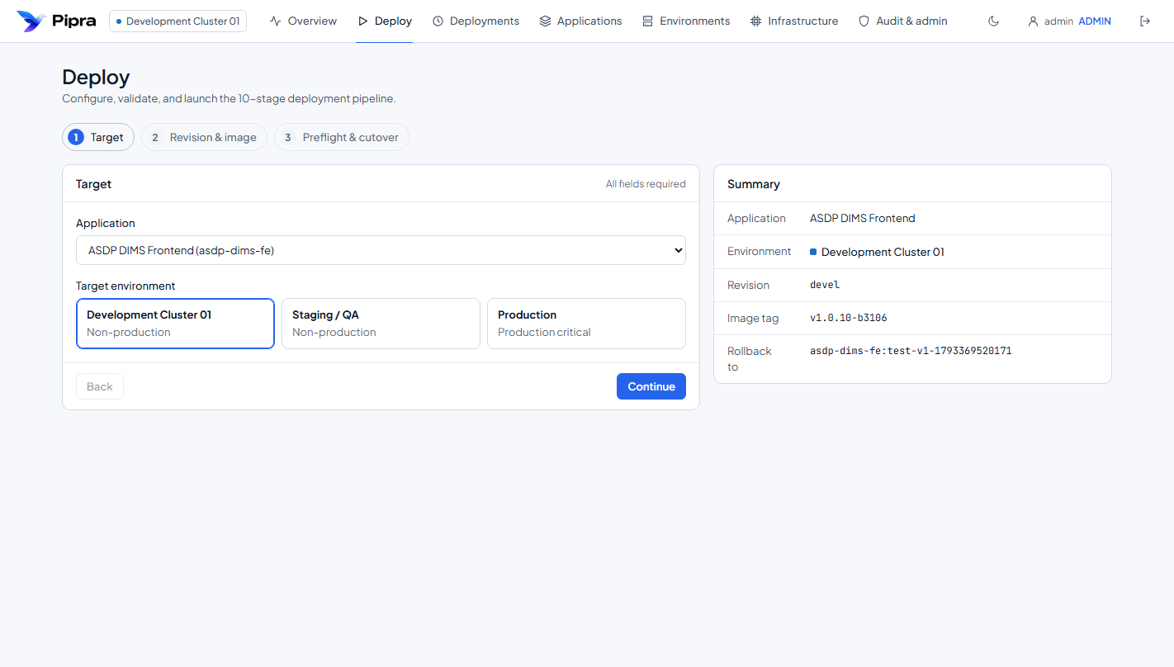
Figure 4: 3-Step Zero-Downtime Deployment Wizard

Step 4.6: Real-Time Pipeline Monitoring & SSE Streaming Logs
Pipra redirects you to the live Deployment Detail cockpit (#/deployments/:id). Execution runs asynchronously in the background. The interactive 10-stage timeline tracks each phase in real time:
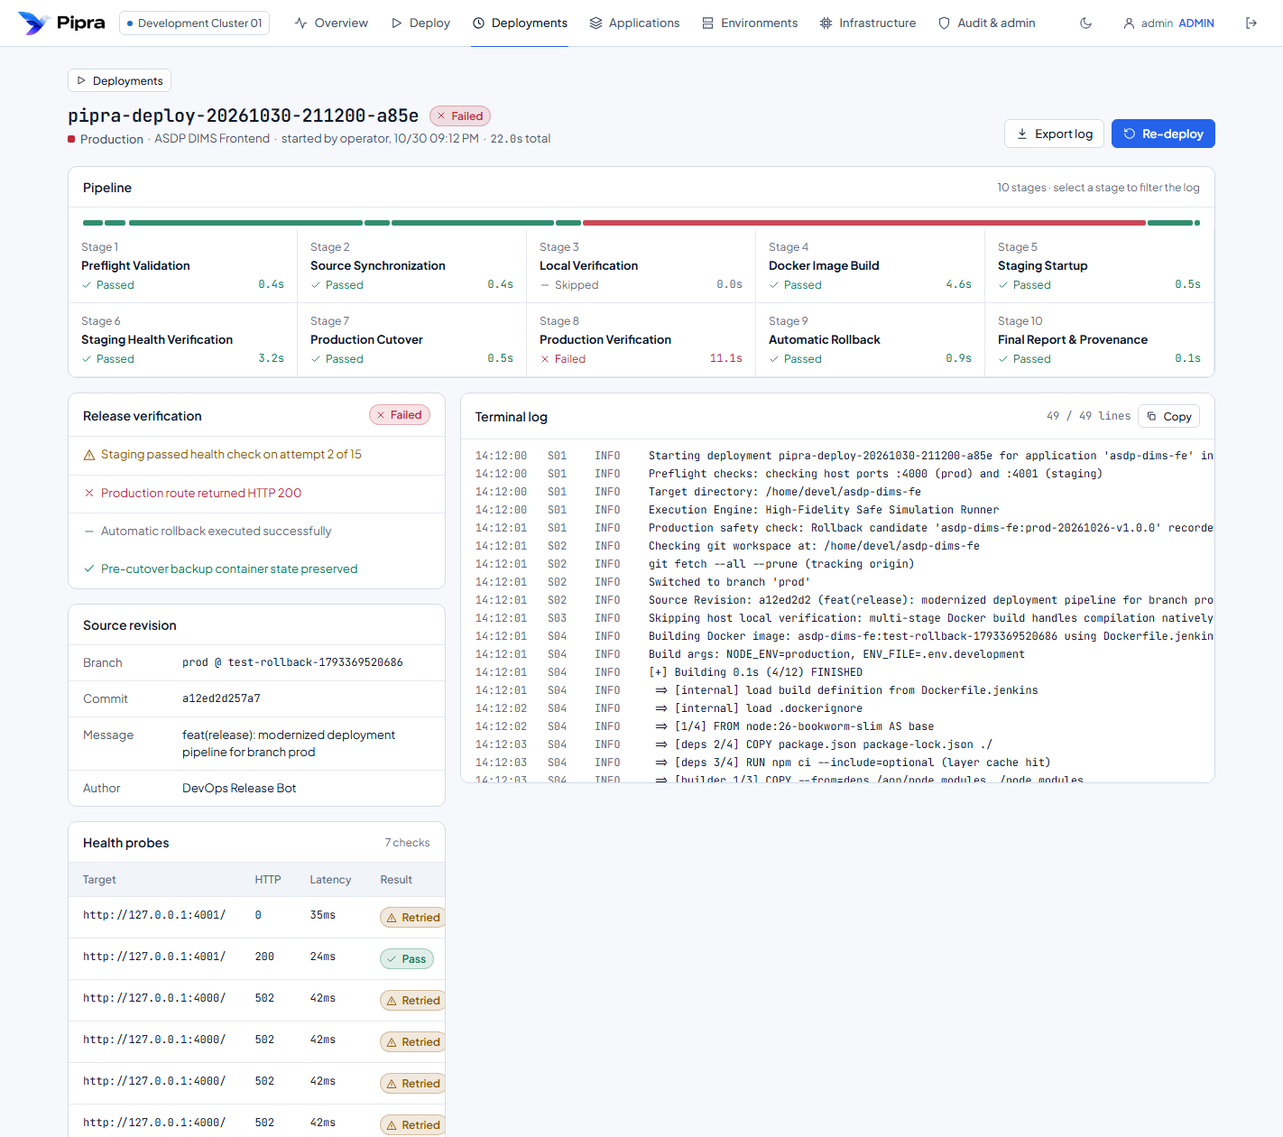
Figure 5: Live 10-Stage Pipeline Cockpit with Real-Time Log Streaming
Stage | Execution Details | Safety Assurance
Stage 1: Preflight | Checks host port conflicts (:4000/:4001) and snapshots rollback container. | Pass required to proceed.
Stage 2: Source Sync | Fetches latest commits, checks out branch, records SHA & commit author. | Guarantees exact provenance.
Stage 4: Docker Build | Compiles Docker image using BuildKit caching; captures build duration. | Streams stdout/stderr in real time.
Stage 5 & 6: Staging Probes | Launches container on :4001; sends 15 HTTP probes at 2s intervals. | Zero customer impact on probe failure.
Stage 7 & 8: Atomic Cutover | Performs atomic swap to port :4000; verifies live traffic stability. | Sub-second transition (< 800ms).
Stage 9 & 10: Finalization | Retires pre-cutover backup, updates fleet registry, logs audit record. | Release marked SUCCEEDED.

Step 4.7: Automated Sub-Second Rollback (Failure Safeguard)
If a candidate release fails staging health probes on port :4001, Pipra automatically terminates the candidate container. The live container on port :4000 is never touched. If a failure occurs post-cutover, Pipra restores the pre-cutover backup container within < 800ms, completely preserving live customer traffic.

5. Project Maintenance & Lifecycle Operations
- Editing Metadata: Click 'Edit' on the project card to update repository URLs, branch rules, or ports.
- Dual-Stage Archival: Click 'Archive' to temporarily hide a project from active catalogs and the Deployment Wizard. Historical audit logs remain 100% intact.
- Restoring Projects: Switch to the 'Archived Projects' tab and click 'Restore' to reactivate.
- Permanent Purge: To permanently remove a project, click 'Permanently Delete' in the Archived tab and type the project slug into the typed confirmation barrier.

6. Troubleshooting & Diagnostics FAQ
[OPERATIONAL FAQ & DIAGNOSTICS] Q: SSH check returns 'Permission denied'?
A: Verify the remote user (devel) belongs to the docker group ('sudo usermod -aG docker devel') and check SSH vaulted credentials in Pipra.
Q: Staging health check fails on attempt 15?
A: Inspect container stdout in Pipra's log viewer. Verify environment variables in .env.development. Fix in git, push, and click Re-deploy.
Q: Can I run Pipra on my laptop to manage remote servers?
A: Yes. Run 'node server.js' on your laptop. Configure the target server IP in the environment modal. Pipra dispatches commands securely over SSH.

