
Pipra — Target Server Deployment Guide
Step-by-Step Operator Runbook for Zero-Downtime Blue-Green Releases, Live Fleet Telemetry, and Automated Rollback Recovery
Document ID | Target System | Security Level | Release Engine
DOC-PIPRA-DEPLOY-v1.0 | Linux x86_64 / Docker | RBAC Enforced (Op/Admin) | 10-Stage State Machine

1. Executive Overview & Deployment Architecture
Pipra is a high-reliability, self-hosted deployment orchestration platform designed for release engineering and production operations. It replaces fragile manual shell deployments (such as legacy deploy_asdp-dims-fe.sh scripts) with a deterministic, auditable 10-stage execution state machine featuring automated staging verification and sub-second atomic cutover.
The core architectural pattern implemented by Pipra is an isolated Blue-Green staging barrier: candidate releases are compiled into immutable container artifacts, booted on an isolated staging port (:4001), and subjected to real HTTP synthetic health probes. Live production traffic on port :4000 is never touched until the candidate proves 100% operational.
[CORE SAFETY PRINCIPLE] Zero-Downtime Guarantee: Pipra never stops or interrupts an active production container during build or staging. If a build fails or staging health checks time out, the candidate container is cleanly terminated with zero impact on serving traffic.

Stage & Identifier | Automated Execution Routine | Safety Gate / Guarantee
Stage 1: Preflight | Validates RBAC permissions, git ref, Docker daemon status, target ports, and concurrency locks. | Zero external side-effects; rejects invalid requests immediately.
Stage 2: Source Sync | Executes git fetch and checkouts the immutable revision; records SHA, commit message, and author. | Ensures exact git provenance and reproducibility.
Stage 3: Local Verify | Optional pre-build verification (npm ci / npm run build). Skipped by default. | Prevents redundant compilation when multi-stage Docker is active.
Stage 4: Docker Build | Compiles production container image with BuildKit caching; captures size & duration. | Masks sensitive build arguments and redacts credentials from logs.
Stage 5: Staging Startup | Launches candidate container on isolated host port (:4001). | Existing live container on :4000 continues serving without interruption.
Stage 6: Health Verify | Executes automated HTTP synthetic probes (GET /) against :4001 with retry loop. | Barrier gate: Deployment will NOT proceed if staging fails verification.
Stage 7: Atomic Cutover | Performs atomic container swap: renames live to backup, binds candidate to :4000. | Sub-second transition with state preservation.
Stage 8: Prod Verify | Probes live route at http://127.0.0.1:4000/ to confirm live traffic service. | If probes fail, triggers automated sub-second rollback (Stage 9).
Stage 9: Auto Rollback | Restores pre-cutover backup container and rebinds live production traffic. | Automated fail-safe that restores previous known-good release.
Stage 10: Finalization | Cleans up staging artifacts/backups, updates SQLite registry, emits audit log. | Marks deployment as SUCCEEDED and updates fleet status.

2. Prerequisites & Target Server Topology
Before triggering releases, operators must verify that target environments and agent host daemons are online. Pipra segregates environments by risk tier, enforcing strict confirmation barriers and rollback mandates on production.
Environment | Host IP / Target | Port Mapping | Risk Tier & Safeguard Policy
Development | 10.200.45.10 / local | :4000 (app) | Non-production cluster. Rapid iteration, hotfix testing.
Staging / QA | 127.0.0.1 / host | :4001 (isolated) | Staging validation barrier. Mandatory pre-cutover health check.
Production | 172.25.207.222 | :4000 (live) | Production critical. Requires Operator confirmation & automated rollback.

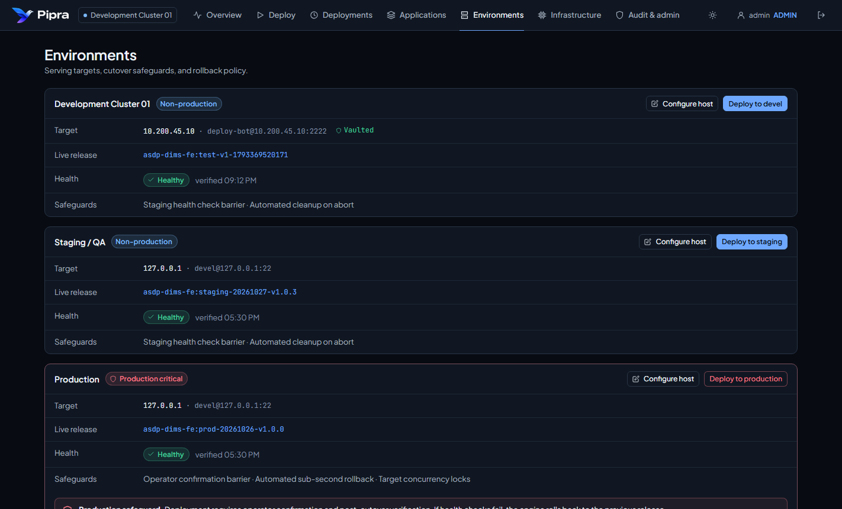
Figure 1: Target Environments Configuration & Production Critical Safeguards
Each target environment maintains explicit safeguards: operator confirmation barriers, target concurrency locks (preventing overlapping deployments), and automated sub-second rollbacks. If an environment reports disconnected or stale, inspect the Execution Agents console.
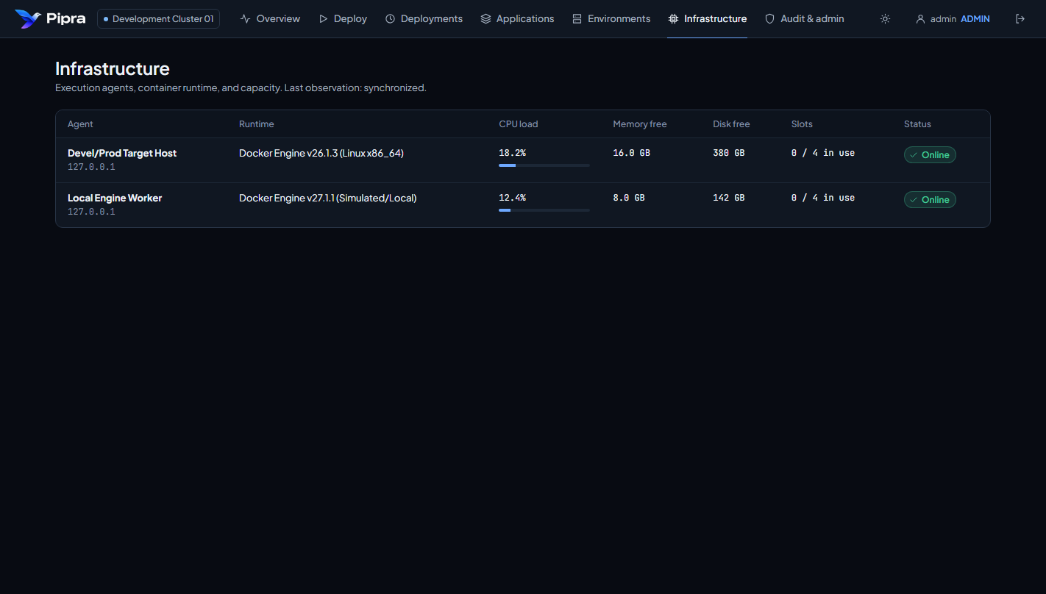
Figure 2: Execution Agents Telemetry & Docker Host Capacity

3. Step-by-Step Deployment Walkthrough

Step 3.1: Sign In to Pipra Control Plane
1. Open your web browser and navigate to the Pipra Control Plane at http://<pipra-host>:4200 (or http://localhost:4200).
2. In the Operator username field, enter your authorized account username (e.g. operator or admin).
3. Enter your account password. For sandbox and prototype sessions, the prototype account chips at the bottom can be clicked to automatically populate verified test credentials (admin / pipra-admin-2026, operator / pipra-ops-2026).
4. Click 'Sign in to control plane'.
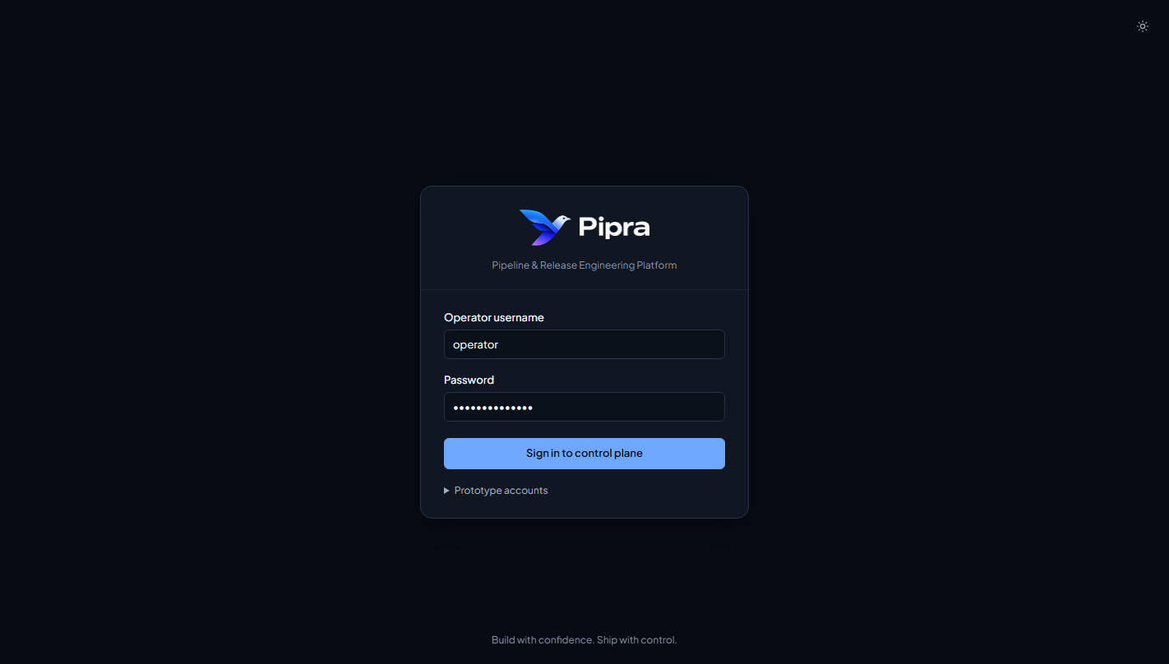
Figure 3: Pipra Control Plane Sign-in Screen & Prototype Accounts Picker
[PERMISSION REQUIREMENT] Role-Based Access Control (RBAC): The 'viewer' account has read-only access and cannot launch deployments. Triggering pipeline releases requires 'operator' or 'admin' privileges. Production host settings require 'admin'.

Step 3.2: Inspect Fleet Health on the Operations Cockpit
Upon authentication, Pipra opens the Release Operations cockpit. Before launching any new deployment:
1. Check the 4-cell metric strip: Verify active pipeline count (engine idle vs busy) and historical verified rate.
2. Review the 'Needs attention' alert panel: If previous production runs failed, inspect diagnostics to understand whether a rollback is currently serving.
3. Inspect the 'Serving now' promotion rail: Ensure that upstream environments (Development, Staging) report Healthy status before deploying to Production.
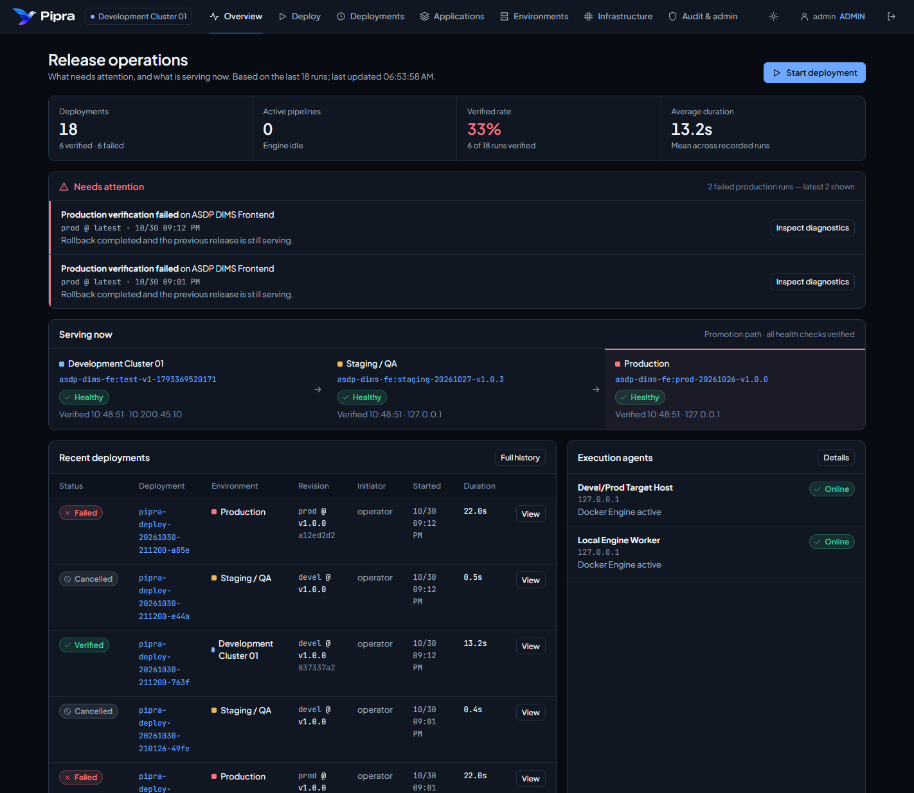
Figure 4: Release Operations Cockpit, Promotion Rail & Live Health States
4. To inspect the application repository configuration, Dockerfile source, or health probe policies, open the Applications tab from the primary navigation bar.
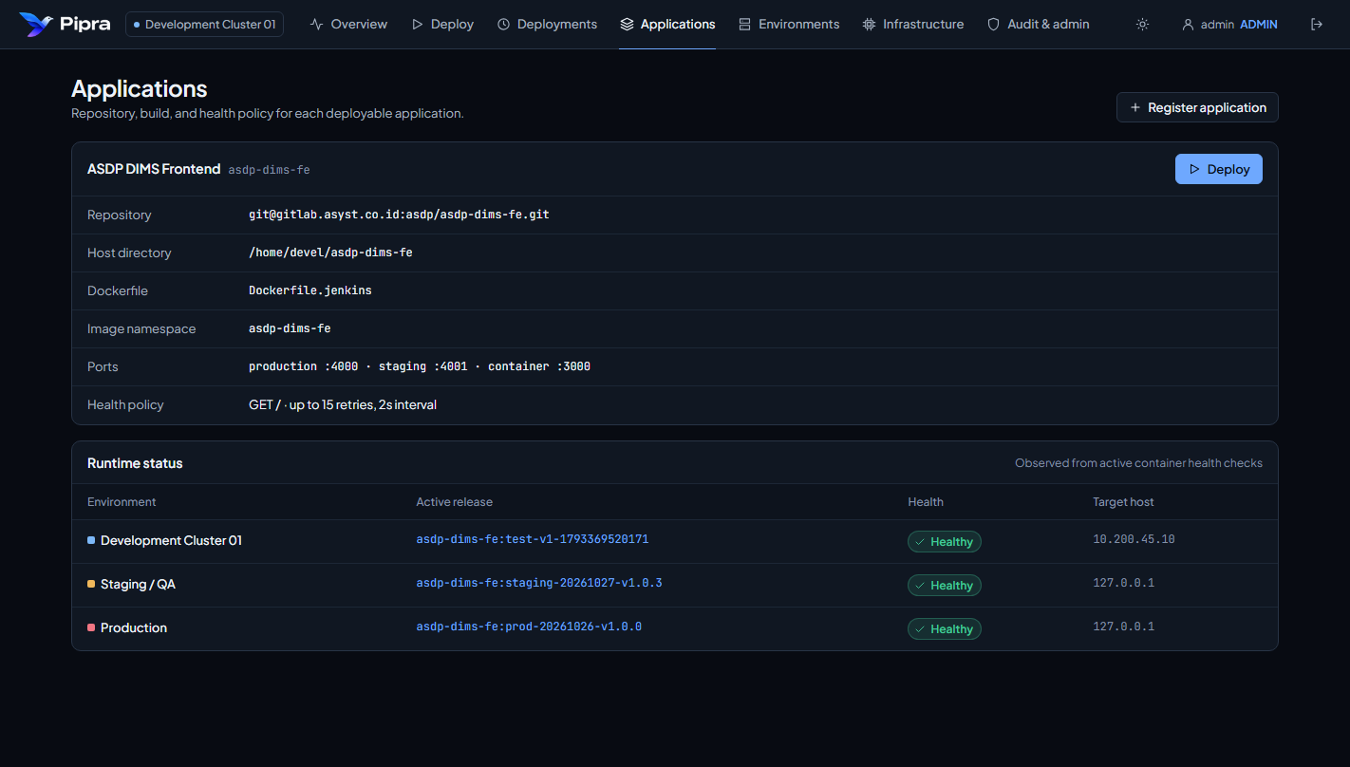
Figure 5: Applications Registry & Health Policy Configuration

Step 3.3: Configure & Launch the Deployment Wizard
To initiate a deployment, click the 'Deploy' tab in the top navigation or click 'Start deployment' from the Cockpit. The Deployment Wizard guides the operator through a safe 3-stage validation workflow:
• Stage 1 (Target): Select the deployable application (e.g. ASDP DIMS Frontend) and choose the Target Environment (Development, Staging, or Production). Non-production targets allow immediate progression, while Production activates high-risk indicators.
• Stage 2 (Revision & Image): Enter the Branch / tag / ref (permitted refs: devel, main, prod, staging, release/*, hotfix/*). Provide an immutable Image tag (e.g. v1.0.10-b3021) and confirm container name.
• Stage 3 (Preflight & Cutover): Pipra runs automated preflight checks on target host ports (:4000, :4001) and records the current rollback candidate release. When deploying to Production, the operator MUST check the explicit confirmation box: 'I confirm deploying <tag> to Production'.
[CRITICAL PRODUCTION SAFEGUARD] Production Safeguard Barrier: When Production is selected, the submit button is styled in high-visibility danger crimson. The button remains strictly disabled until the operator acknowledges the cutover impact checkbox.

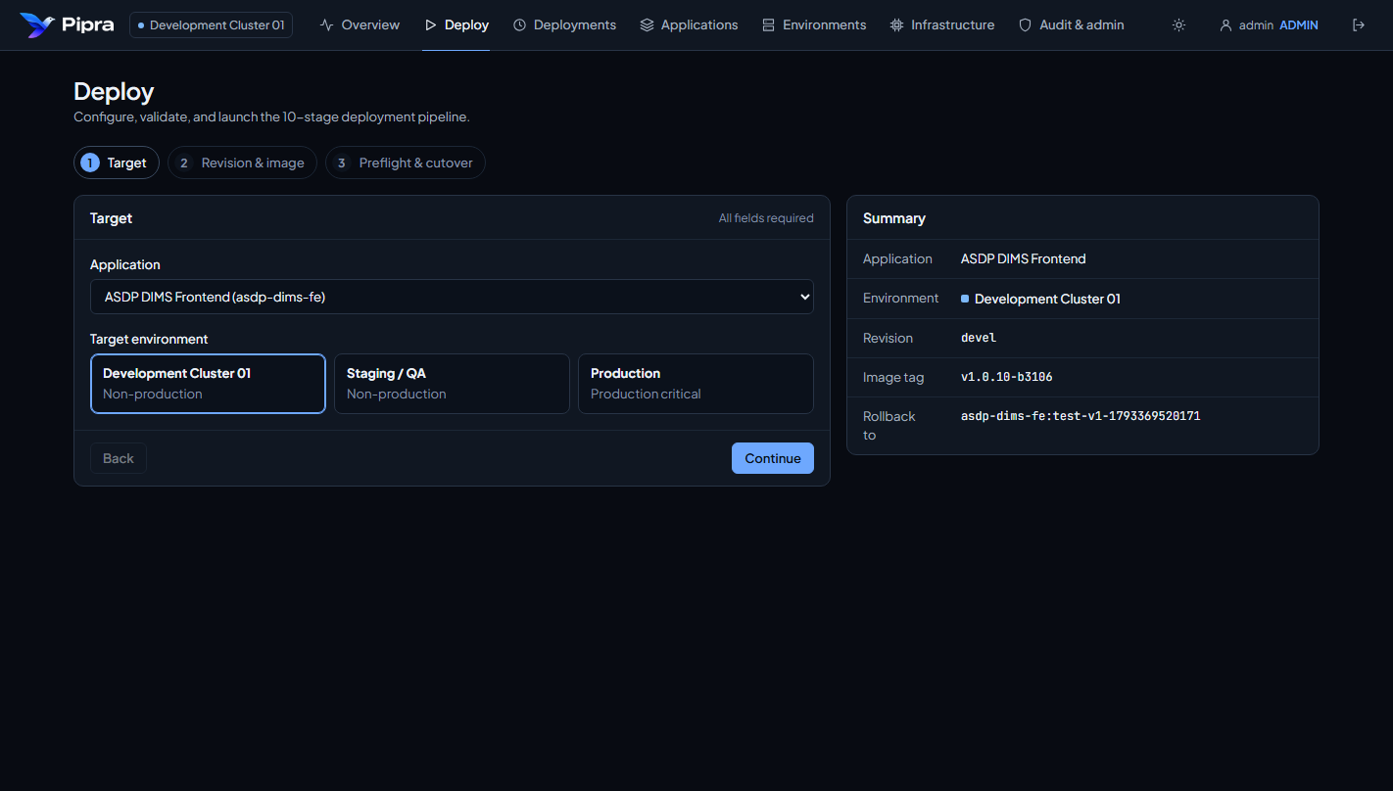
Figure 6: 3-Stage Deployment Wizard & Live Preflight Summary
Click 'Start deployment to <environment>' to submit the job. Pipra enqueues the release and immediately routes to the live execution view.

Step 3.4: Real-Time Observability & Stage Monitoring
The Live Deployment Detail view provides comprehensive, real-time observability as the release executes through the 10-stage engine:
1. Pipeline Progress Bar & Stage Pills: Visual bar reflects duration and status of each stage (Passed = Green, Skipped = Gray, Failed = Red).
2. Stage Selection: Clicking any stage button filters the Terminal Log specifically to that stage's diagnostic output.
3. Live Terminal Log: Monospace output displaying real container build output, probe retries, container IDs, and cutover timestamps. Sensitive credentials and secret environment variables are automatically masked.
4. Health Probes Table: Displays each HTTP probe attempt, latency in milliseconds, and pass/retry/fail outcomes.
5. Release Verification Card: Confirms whether staging passed, production route returned HTTP 200, and backup container state is preserved.
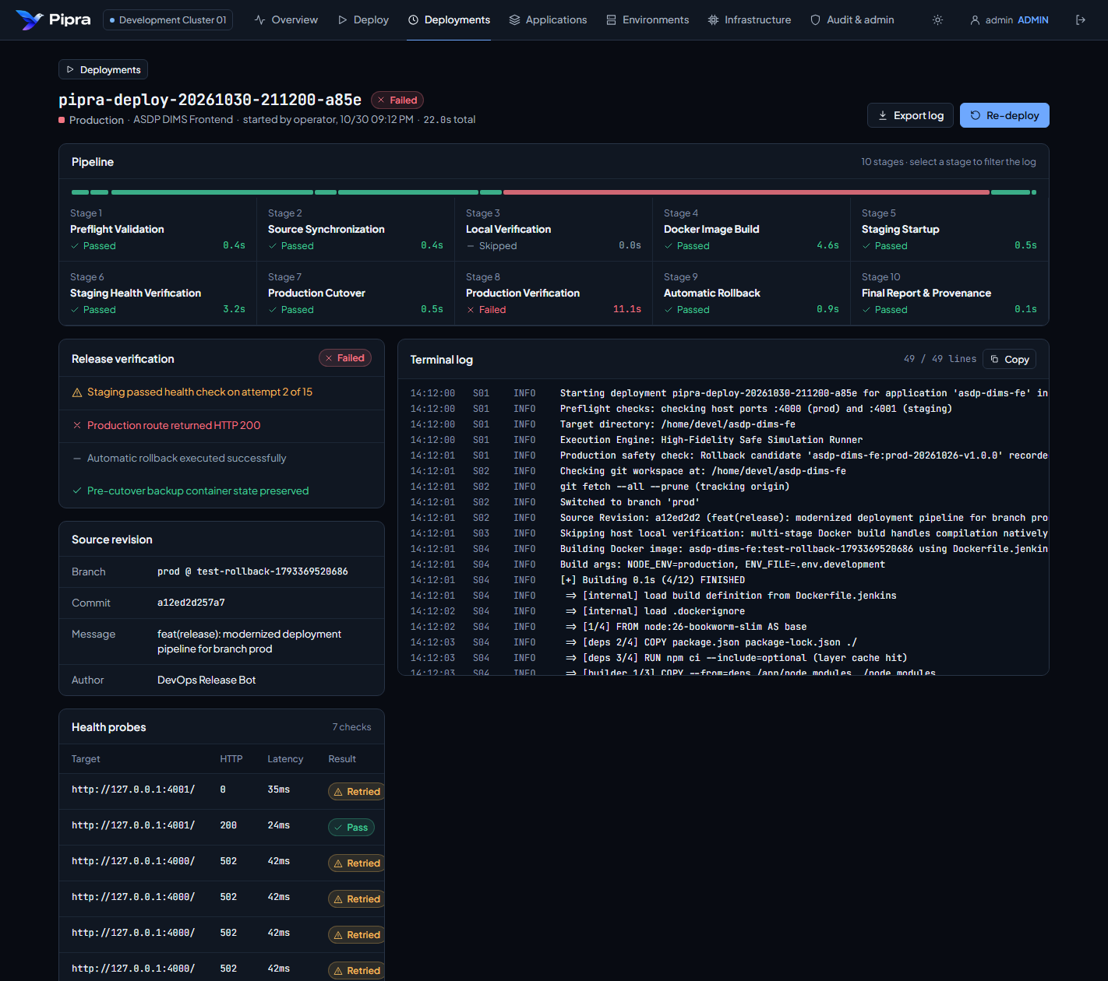
Figure 7: Live Pipeline Execution Detail, Interactive Timeline & Health Probes Table

Step 3.5: Post-Deployment Verification, History & Audit Logs
Once a deployment reaches a terminal status (Verified or Failed):
1. Deployment History: Open the Deployments tab to search past executions by deployment ID, commit SHA, branch, or environment. Filter by environment (Development, Staging, Production) or outcome status.
2. Audit & Administration Trail: All consequential operations—including user logins, deployment submissions, cancellations, and host changes—are immutably logged in the Audit & Admin log with operator username, client IP, timestamp, and target environment.
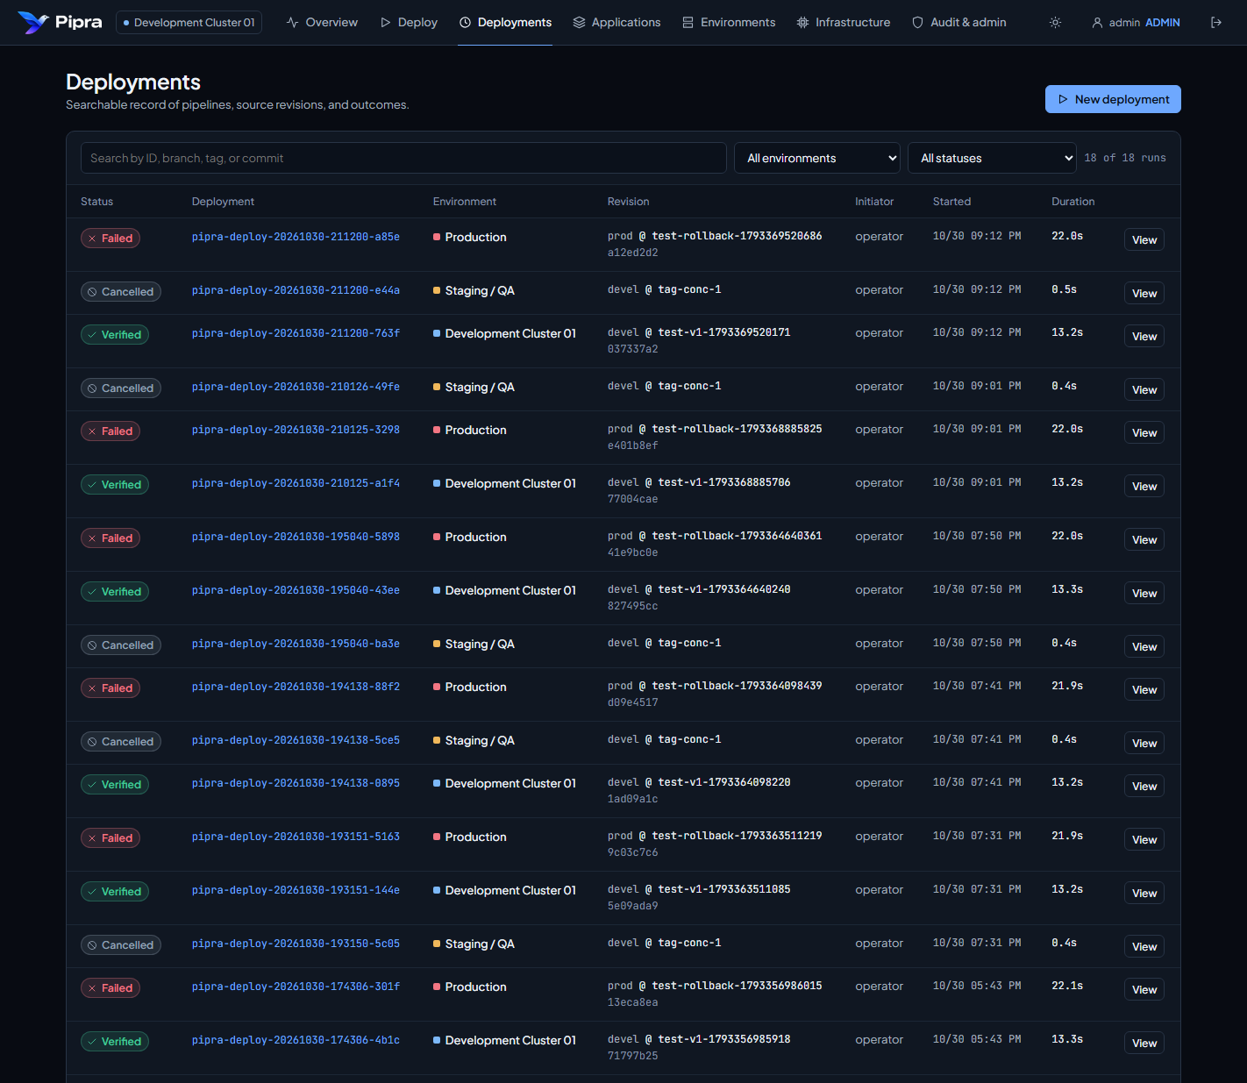
Figure 8: Deployments History with Multi-Attribute Search & Environment Filters
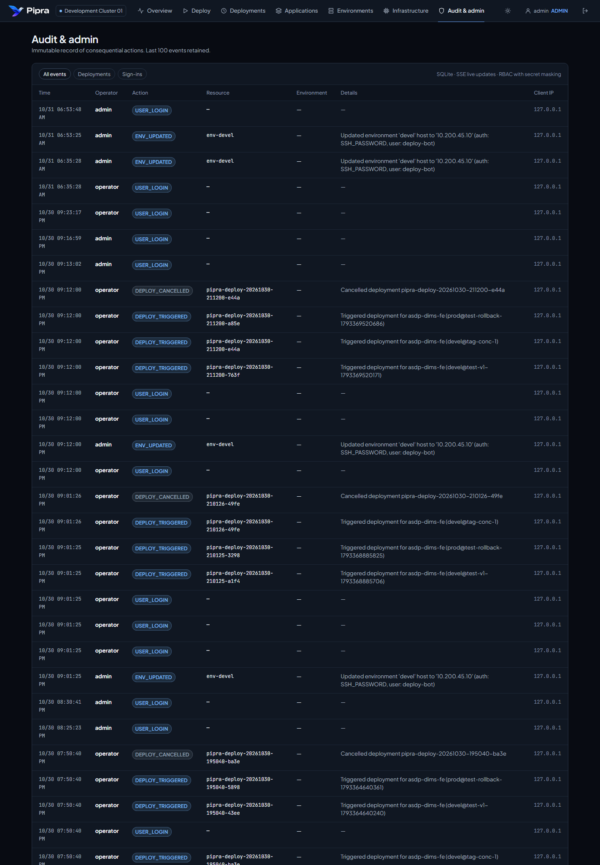
Figure 9: Immutable Audit Trail & Administrative Activity Log

4. Operational Failure Modes & Automated Recovery
Pipra is designed around the principle of deterministic recovery: systems will experience software bugs, bad builds, and failed runtime probes, but the control plane must prevent user-facing downtime automatically.
Failure Scenario | Detection Trigger | Automated Pipra Action | Operator Procedure
Staging Health Timeout (HTTP 000 / 502) | Stage 6 probes fail after 15 retries. | Staging container is killed & pruned. Production traffic is NEVER touched. | Zero user impact. Review Stage 4/5 logs to fix application startup error.
Production Verification Failure | Cutover succeeded, but Stage 8 live probes return error. | Stage 9 (Auto Rollback) executes instantly: stops faulty container, restores backup container. | Previous release is restored within ~1 second. Production remains operational.
Target Concurrency Lock (HTTP 409) | Two operators click deploy to same target simultaneously. | Second request is rejected immediately with HTTP 409 conflict error. | Prevents Docker port collisions and corrupt state.
Process Crash / Host Reboot | Pipra daemon terminates mid-deployment. | Startup reconciliation marks orphan run as INTERRUPTED. | Operator clicks 'Re-deploy' or restores previous known-good release.

[AUTOMATED RECOVERY GUARANTEE] Rollback Assurance: When a production release fails post-cutover verification, Pipra automatically preserves and restores the pre-cutover container. The deployment record clearly indicates 'Rollback completed and the previous release is still serving', preventing false-positive panic.

5. Operator Pre-Flight & Post-Flight Checklists
Follow this checklist for every production deployment cycle:
Check | Phase / Action | Operational Verification Standard
[ ] Step 1 | Verify Agent Status | Open Infrastructure tab; confirm target host reports 'Online' with < 80% CPU load.
[ ] Step 2 | Verify Upstream Health | Confirm the candidate build was verified in Staging before promoting to Production.
[ ] Step 3 | Check Permitted Ref | Ensure branch ref is standard (devel, main, release/*, hotfix/*).
[ ] Step 4 | Unique Tagging | Confirm image tag follows semantic versioning or build ID (e.g. v1.0.10-b3021).
[ ] Step 5 | Acknowledge Safeguard | Review rollback candidate in Stage 3 preflight before clicking confirmation checkbox.
[ ] Step 6 | Monitor Probes | Observe Stage 6 and Stage 8 health probe latencies in real time.
[ ] Step 7 | Verify Serving Release | Return to Cockpit; verify new tag is active in the 'Serving now' Promotion Rail.
[ ] Step 8 | Audit Confirmation | Check Audit & Admin tab to verify operator action was recorded with timestamp.

Pipra Control Plane | ASYST Platform Engineering | Confidential & Proprietary
For emergency platform support or on-call incident escalation, contact DevOps Release Engineering.

