

Data Technician
Louis Parsons

Name: Louis Parsons
Course Date: 16/12/24
Table of contents
Day 1: Task 1 2
Day 2: Task 1 2
Day 2: Task 2 3
Day 2: Task 3 4
Day 3: Task 1 4
Day 3: Task 2 5
Dataset: 5
Step 1: Create a Pivot Table 5
Step 2: Use the SWITCH Function 5
Submission: 6
Day 3: Task 3 6
Day 4: Task 1 7
Course Notes 9
Additional Information 10

Day 1: Task 1

Please complete the below boxes on commons laws and regulations that must be followed when working with customers data, use the below bulleted list to support your answers.

- What is it
- Why is it important
- Provide a real-world example of how you can follow it
- How does it impact working with data
- What could happen if you breached it

Data Protection Act | a law that controls how personal information is collected, stored, and used. It protects your privacy and gives you rights over your data. E.g A shop takes your name for an order; must keep it safe, use it only for that order, and delete it if you ask.  Impact: Requires secure, fair handling of personal data with clear purpose and user rights.  Breach: Fines, legal action, loss of trust, and mandatory investigations.
GDPR | GDPR: A European law that protects personal data by controlling how it’s collected, used, and stored. Example: A website must ask permission before using cookies and let you request deletion of your info.  Impact: Demands strict consent, transparency, and strong data protection measures.  Breach: Severe fines, reporting obligations, reputational damage, and legal consequences.
Freedom of Information Act | The Freedom of Information Act lets people request recorded information from public bodies. Example: you can ask a council for reports on how local funds were spent.  Impact: Requires organisations to store information clearly and provide it upon valid request.  Breach: Complaints, investigations, and penalties for withholding or mishandling information.
Computer Misuse Act | The Computer Misuse Act makes hacking, spreading malware, and accessing data without permission illegal. Example: opening someone’s email account without consent is a criminal offence under this law.  Impact: Requires secure systems and prevents unauthorised access or data manipulation.  Breach: Criminal charges, fines, imprisonment, and organisational security audits.

Day 2: Task 1

Please research and complete the following tasks within the retail-sales_dataset.xlsx document, paste a print screen into the provided boxes below:

- In the sheet ‘retail_sales_dataset’ add all available data between columns A –J into a ‘table’
- Using the ‘sort’ function, sort ‘Age’ to ‘largest to smallest’
- Using the ‘SUM’ function, show me the commission total in cell ‘L10’
- Using the ‘AVERAGE’ function, show me the average commission in cell ‘L11’

Print screen 1 | 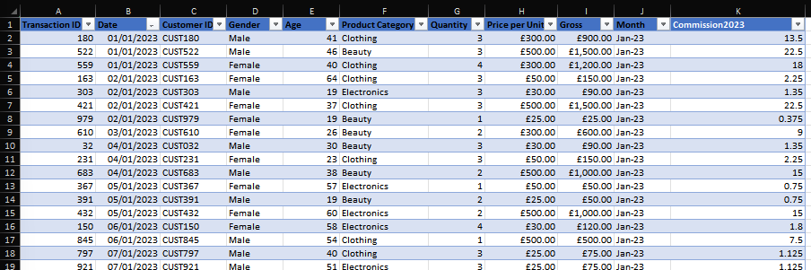
Print screen 2 | 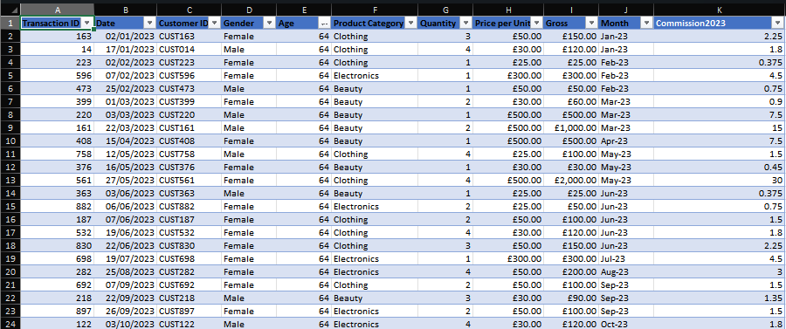
Print screen 3 | 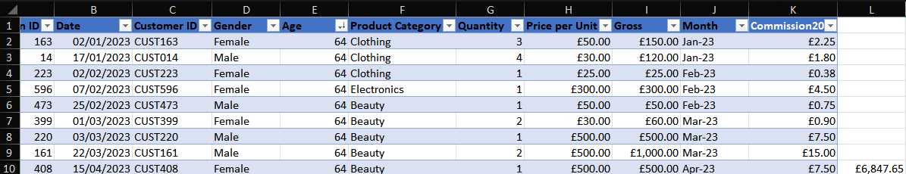
Print screen 4 | 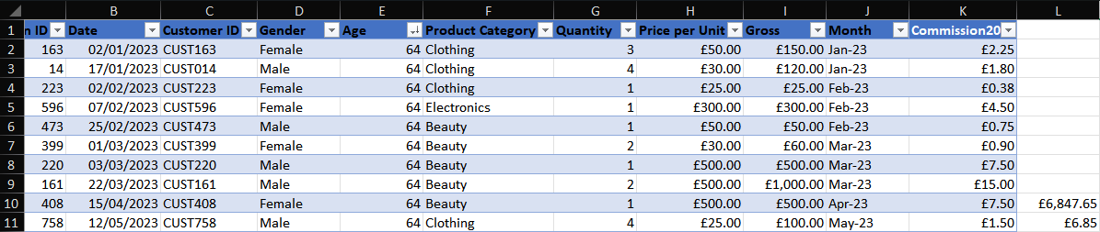

Day 2: Task 2

Please research and complete the following tasks within the retail-sales_dataset.xlsx document, paste print screens into the provided box below:



Print screen 1 | 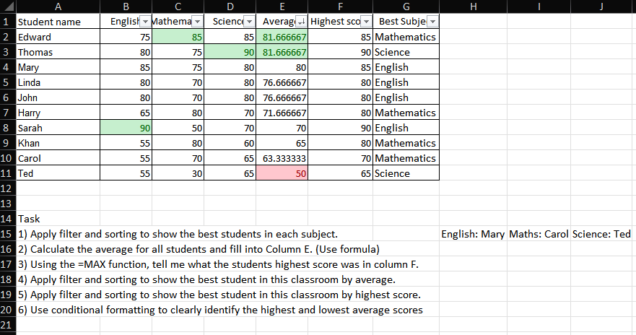

Day 2: Task 3

Using the skills developed today, have some fun with the data set you have imported. Paste your work below and enjoy!

Print screen 1 | 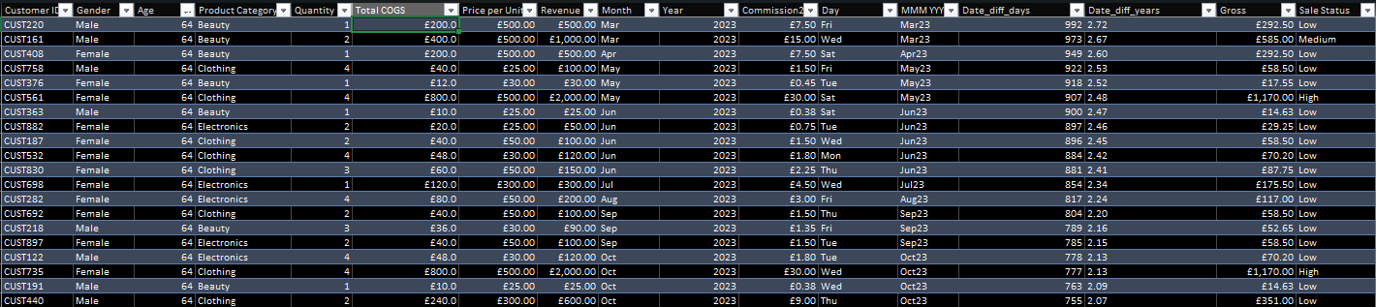
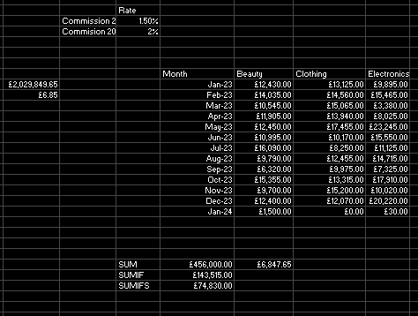
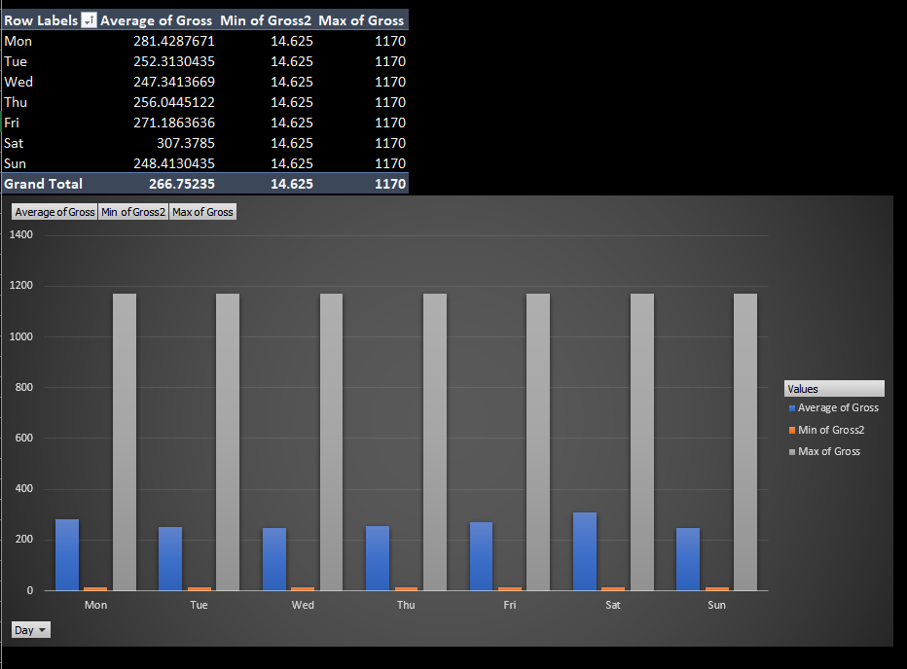
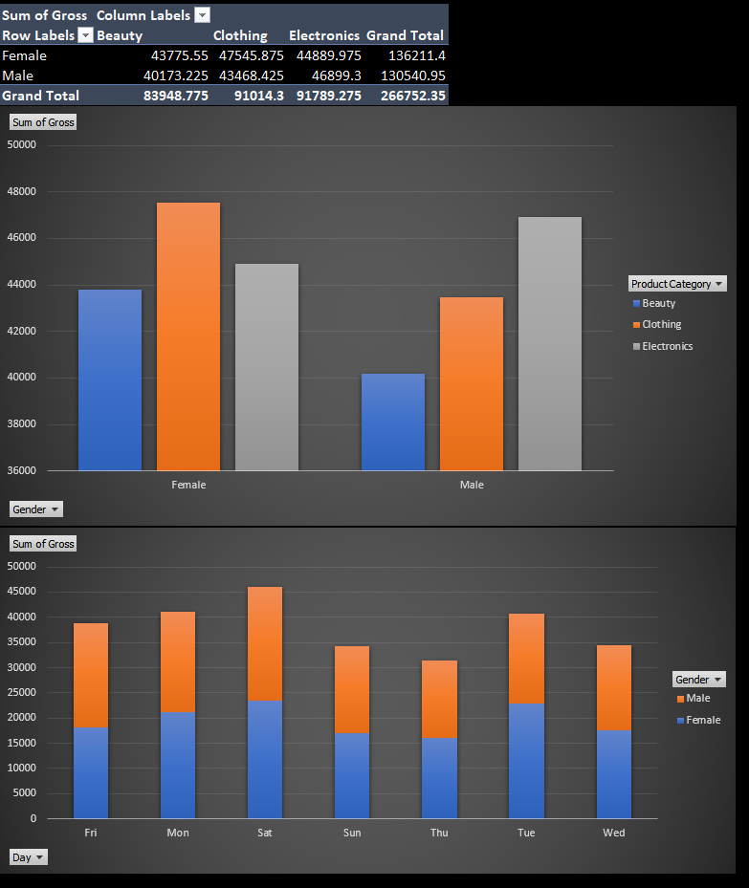
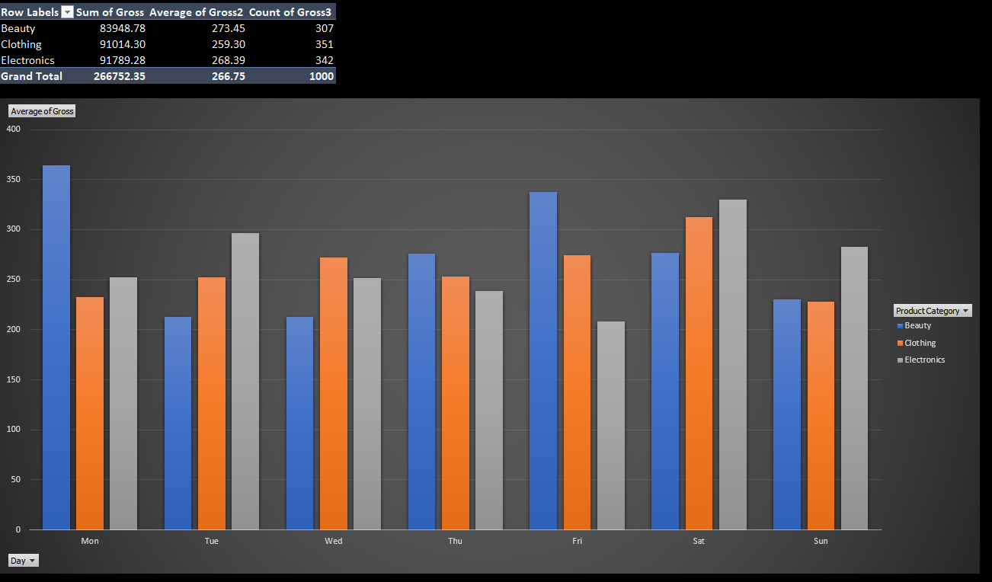
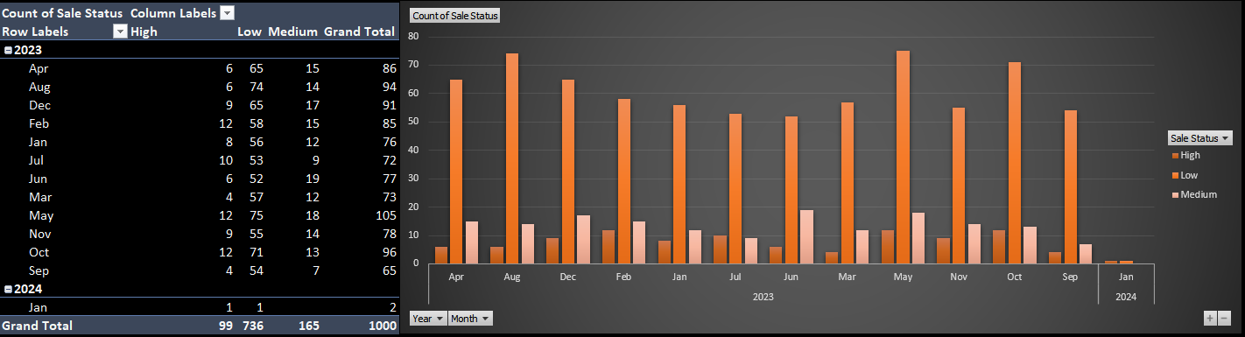
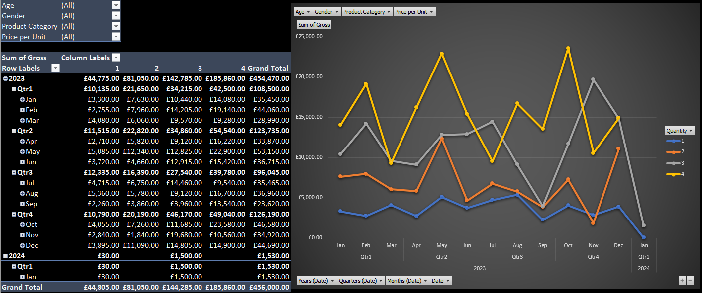
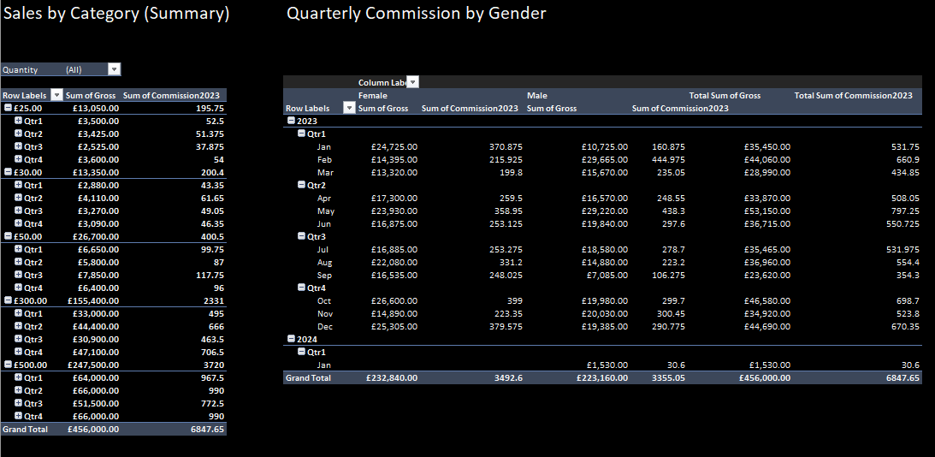
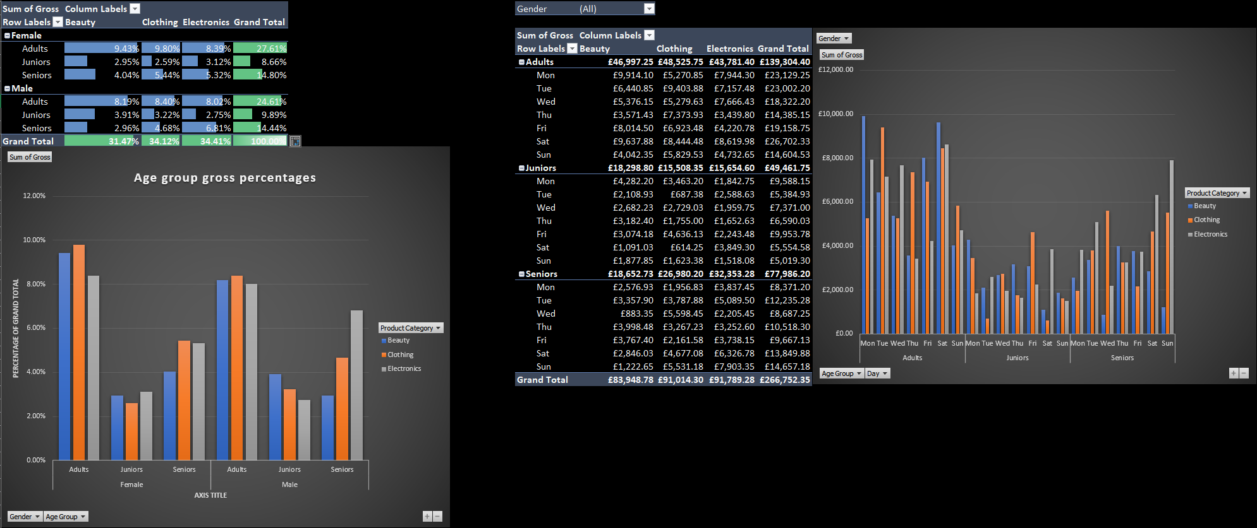

Day 3: Task 1

Please download the dataset ‘Day_3_Task_1_Bike_Sales_Pivot_Lab.xlsx’ and the lab instructions.

Do not worry if you do not complete the lab, just working with data and playing with the pivot table will be good experience.

Please paste your final pivot table below and complete the reflection questions:

Print screen 1 | 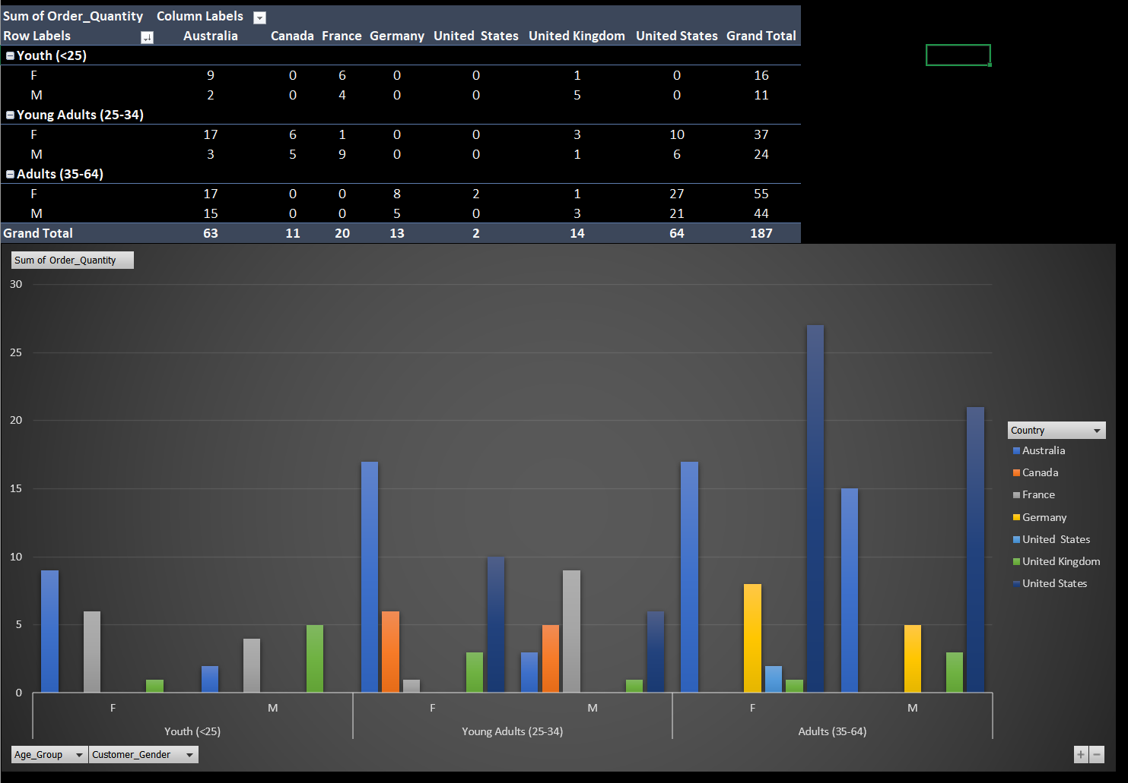
In which markets does Germany have customers? | Germany’s sales activity appears limited to the Adult (35–64) segment and spans three state-level markets: Hamburg, Hessen, and Nordrhein-Westfalen.  In Hamburg, a single female customer placed an order with a quantity of 1. In Hessen, female customers placed orders with a quantity of 2, while male customers placed orders with a quantity of 1, giving the state a balanced but modest level of activity. Nordrhein-Westfalen shows the strongest demand within Germany: female customers placed orders with a quantity of 4, and male customers placed orders with a quantity of 1, making it the highest-volume German market. Overall, Germany’s sales are exclusively adult-driven, with Nordrhein-Westfalen emerging as the most active region by total order quantity. The choice mountain bike models for these markets appear to be the Mountain-200 Silver and the Mountain-200 Black.
What country has sales in all markets? | The only Country with sales in all markets (both Men and Women in age groups: <25, 25-34 and 35-64) is the United Kingdom.
What are the most profitable markets by country, age group, and gender? | California (USA) is the most profitable market overall. It is the most profitable region overall for the Female and Male demographic. California is also the overall most profitable for the 35-64 age group for both men and women.  Victoria (Australia) is the most profitable market for Women in the 25-34 age range.  British Columbia (Canada) has a narrow lead in profit for Men in the 25-34 age range, it is very closely followed for this demographic by the Seine market in Paris (France).  For the <25’s, Nord (France) is the most profitable for Males. France also holds the highest profit for Women in this age range in Seine Saint Denis, closely followed by another French market, Seine (Paris).
Any other findings? | The market of South Australia (Australia) has the lowest overall total profit, and only to the Male demographic.  Australia overall is the second most profitable country, making up profit in it’s other regions.  The United Kingdom is narrowly the least profitable country overall, followed closely by Canada.  Despite having higher profit by a narrow margin, Canada has the lowest quantity of goods sold compared to the other countries in the data set.

Day 3: Task 2

The dataset below tracks the sales performance of different products in various counties in England. Please paste the dataset into a blank Excel workbook. Your task is to:
- Create a Pivot Table to summarise the data by county and product.
- Use the SWITCH function to categorise products based on their sales volume.

Dataset:
County | Product | Sales Volume
Yorkshire | Laptops | 500
Yorkshire | Smartphones | 200
Cornwall | Laptops | 700
Cornwall | Printers | 400
Lancashire | Smartphones | 150
Lancashire | Laptops | 600
Essex | Printers | 800
Essex | Smartphones | 300
Durham | Laptops | 250
Durham | Printers | 300
Greater Manchester | Smartphones | 600
Greater Manchester | Laptops | 400

Step 1: Create a Pivot Table
- Select the dataset (columns A to C).
- Insert a Pivot Table to summarise the data by County in the rows and Products in the columns. Use Sales Volume as the value to be summarised.

Step 2: Use the SWITCH Function
In a new column next to your data, use the SWITCH function to categorise products based on Sales Volume as follows:
  - For sales greater than 600: "High"
  - For sales between 300 and 600: "Medium"
  - For sales less than 300: "Low"
SWITCH Function Example:
=SWITCH(TRUE, C2 > 600, "High", C2 >= 300, "Medium", "Low")
- Apply this formula to each row, and check if the products are categorised correctly.

Submission:
- A completed Pivot Table summarising sales by county and product.
- A new column in the dataset categorising products by sales volume using the SWITCH function.
  - Please paste your completed work below

Print screen 1 | =SWITCH(TRUE,[@[Sales Volume]]>600,"High",[@[Sales Volume]]>=300,"Medium","Low")  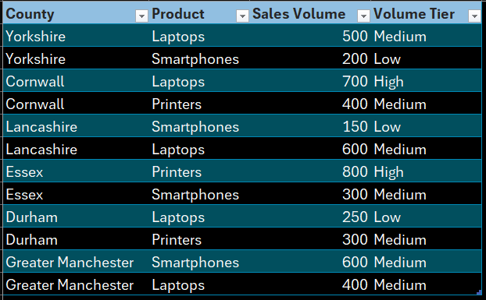

Day 3: Task 3

Please download the dataset ‘Day_3_Task_3_Bike_Sales_Visualisations_Lab.xlsx’ and the the lab instructions. Do not worry if you do not complete the lab, just working with data and playing with the charts will be good experience.

Please paste your results below:

Print screen 1 | 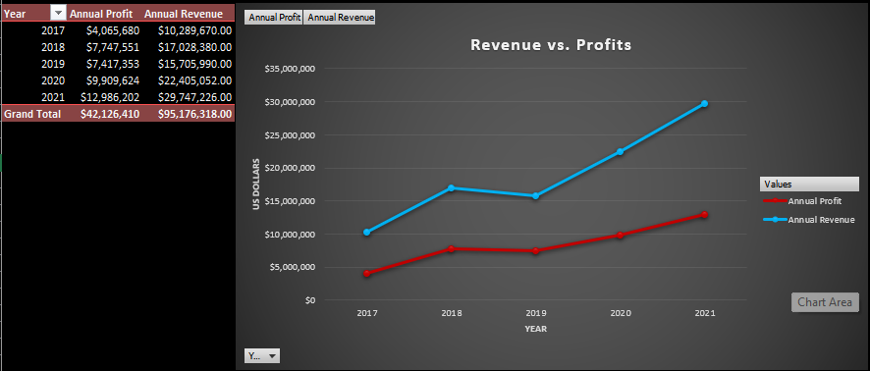  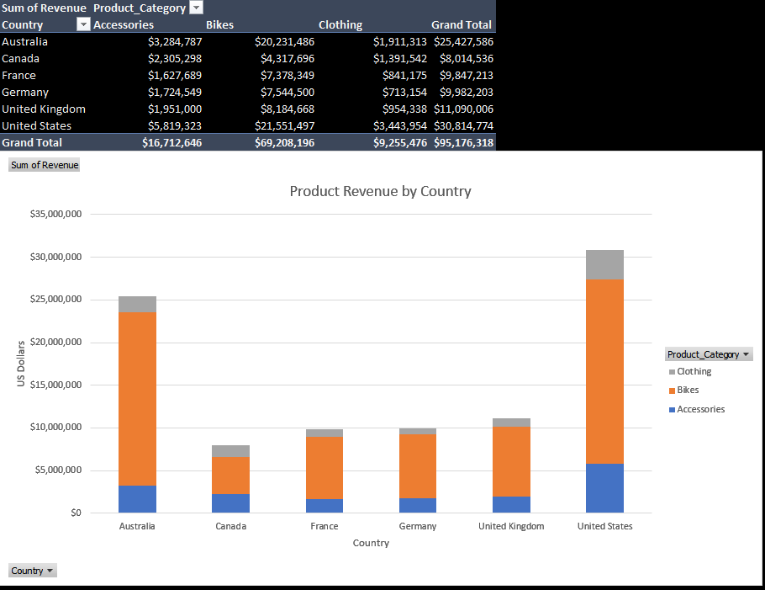  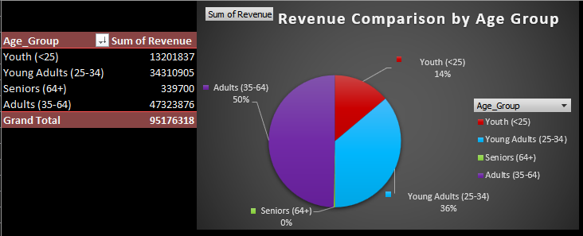

Day 4: Task 1

You have been asked to deliver your analysis findings to the board of directors, with your analysis you have identified that customers are leaving your company at the 12-month point, this is typically when they receive their renewal price.

Conduct research and complete the below questions:

How would you prepare for the delivery? | After processing the data into charts and findings…  I would review to ensure I fully understand the trends and can explain them clearly. I would practise delivering the key messages out loud, refine my slides so they are simple and easy to follow, and prepare supporting notes. I would also rehearse the order of the presentation and anticipate possible questions from the board so I can respond confidently.
What tools would you use for the delivery? | I may use PowerPoint to structure the presentation and visualise insights with charts. Excel would support my underlying analysis and allow me to reference the original data if needed. For delivery, I might use a laptop, a projector or large screen, and presenter tools such as slide clickers or speaker notes as well as printed PDFs for board members to review in order to keep the session smooth and professional.
What is prospecting and why would you complete this before your delivery? | Prospecting means researching and understanding your audience before you present. Before delivering to the board, I would use prospecting to identify what matters most to them — for example, revenue impact, customer retention, and business risks. This ensures that my presentation focuses on their priorities, uses the right level of detail, and highlights the insights they care about most.
Tell me best practices for public speaking and providing updates to senior leaders | Keep messages clear, concise, and focused on outcomes.  Maintain confident body language and steady pacing.  Use simple visuals rather than text-heavy slides.  Support statements with evidence and data.  Anticipate questions and prepare short, direct answers.  Stay calm, avoid jargon, and speak with clarity.  Highlight risks and recommendations explicitly so leaders can make decisions.
What will you show the board in your delivery? | I might show the board the key data trends from the analysis, including the rise in churn at Month 12, how the renewal price increase affects customer behaviour, and how revenue growth is slowing as a result. I will also show scenario modelling that outlines what happens if nothing changes and what improvements look like under new strategies. Finally, I will present recommended actions to reduce churn and improve long-term customer value.
How will you articulate the changes that are needed? | I will explain the changes clearly, focusing on cause and effect. For example, I will outline factors that may lead directly to increased churn at month 12, and then provide suggestions such as how smoothing the renewal process or introducing loyalty rates can reduce cancellations. The explanations will be simple, data-backed, and connected to business outcomes, so the board understands both the issue and the proposed solution.
Provide a list of online resources and videos that will support your preparation for public speaking | TED Talks on public speaking (e.g., Amy Cuddy, Julian Treasure)  Toastmasters International resources  YouTube: “How to Speak So People Want to Listen” – Julian Treasure  YouTube: “The Art of Public Speaking” – Dale Carnegie summaries  Coursera: “Successful Presentation” course  LinkedIn Learning: “Executive Presence on Video Calls
Evaluate tools that provide visualisation.  Tell me what they are.  Tell me what you would choose when delivering your presentation and why | Visualisation tools help turn data into charts, dashboards, and visuals that are easier to understand. Examples include Excel Charts, Power BI, Tableau, Google Data Studio, and PowerPoint. These tools allow you to present information quickly and clearly so decision-makers can interpret trends without needing to read raw data.  For this delivery, I would probably choose PowerPoint because it integrates well with Excel, allows clean visual layouts, and supports a structured narrative. It is the most suitable tool for presenting to senior leaders because it allows the use of speaker notes and works effectively in in-person or online settings.

Course Notes

It is recommended to take notes from the course, use the space below to do so, or use the revision guide shared with the class:
Projects – (Week 7 Portfolio)
https://www.youtube.com/watch?v=MTlQvyNQ3PM
- Excel
- Data analysis
- Project presentation

Additional Information

We have included a range of additional links to further resources and information that you may find useful, these can be found within your revision guide.

END OF WORKBOOK

Please check through your work thoroughly before submitting and update the table of contents if required.

Please send your completed work booklet to your trainer.

