

Data Technician
Louis Parsons

Name:
Course Date:
Table of contents
Day 1: Task 1 3
Day 1: Task 2 3
Day 3: Task 1 4
Day 4: Task 1: Written 6
Day 4: Task 2: SQL Practical 9
Course Notes 19
Additional Information 19

Day 1: Task 1

Please research and complete the below questions relating to key concepts of databases.

What is a primary key? | A primary key is a field (or combination of fields) that uniquely identifies each record in a table.  It cannot be duplicated and cannot contain NULL values.  Examples: customer_id, order_id, book_id.
How does this differ from a secondary key? | A secondary key is a field that is indexed for faster searching, but does not uniquely identify a record.  It can have duplicates and can contain NULL values.  Example: searching products by title or customers by email.
How are primary and foreign keys related? | A foreign key is a field in one table that references the primary key of another table.  This creates relationships between tables and enforces referential integrity.  Example:  orders.customer_id (FK) → customer.customer_id (PK)
Provide a real-world example of a one-to-one relationship | A person and their passport.  Each person has only one passport, and each passport belongs to one person.
Provide a real-world example of a one-to-many relationship | A customer can place many orders, but each order belongs to only one customer.  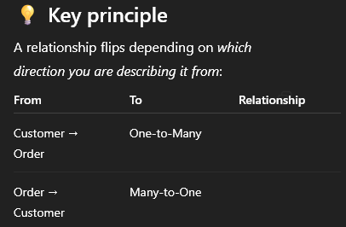
Provide a real-world example of a many-to-many relationship | Students and courses:  A student can enrol in many courses, and each course can contain many students.  e.g. Student_roll; student_courses, course_roll

Day 1: Task 2

Please research and complete the below questions relating to key concepts of databases.

What is the difference between a relational and non-relational database? | A relational database stores data in structured tables with rows and columns and uses relationships (PK/FK).  Examples: MySQL, SQL Server, PostgreSQL.  A non-relational database (NoSQL) stores data in more flexible formats such as documents, key-value pairs, graphs, or wide-column stores.  Examples: MongoDB, Redis, Neo4j, Cassandra.
What type of data would benefit off the non-relational model?  Why? | - Unstructured data (text, logs, JSON, multimedia)  - Rapidly changing data  - Large-scale distributed datasets  - Flexible schemas that may change over time  Why?  Because non-relational databases:  - Allow schema flexibility  - Scale horizontally across multiple servers  - Handle high-volume, high-velocity data  - Perform better for use cases like real-time analytics and big data

Day 3: Task 1

Please research the below ‘JOIN’ types, explain what they are and provide an example of the types of data it would be used on.

Self-join | A self-join is when a table is joined to itself.  The table is given two different aliases so SQL can compare rows within the same table.  It is useful when rows in the same dataset have a relationship.  Example Use Case:  Finding employees and their managers when both employees and managers are stored in the same Employee table.  Example Scenario:  - Employee table contains: employee_id, name, manager_id  - Join the table to itself to match each employee with their manager.
Right join | A RIGHT JOIN returns all rows from the right table, and only matching rows from the left table.  If no match exists, the left side shows NULL.  Example Use Case:  Listing all suppliers, including those that haven’t supplied any products yet.  Example Scenario:  - RIGHT JOIN Supplier (right table) to Book (left table)  - Ensures all suppliers are shown even if they have zero books.
Full join | A FULL (OUTER) JOIN returns all rows from both tables, matching them where possible.  If no match exists on either side, NULLs fill the missing values.  Example Use Case:  Comparing two datasets that should align but may have gaps — such as merging two customer lists from different systems.  Example Scenario:  - Merge Customer_2023 and Customer_2024 lists  - Show customers present in either year.
Inner join | An INNER JOIN returns only rows where both tables have matching values.  Non-matching rows from either table are excluded.  Example Use Case:  Showing all valid orders where the customer actually exists.  Example Scenario:  - INNER JOIN Order with Customer  - Only customers who made an order appear.
Cross join | A CROSS JOIN returns the Cartesian product of two tables — every row of table A is combined with every row of table B.  Example Use Case:  Creating combinations, such as generating all product × store combinations for forecasting.  Example Scenario:  - 5 stores × 20 products = 100 possible combinations.
Left join | A LEFT JOIN returns all rows from the left table, and only matching rows from the right table.  If there is no match, the right side shows NULL.  Example Use Case:  Showing all customers, including those with no orders.  Example Scenario:  - LEFT JOIN Customer (left) to Order (right)  - All customers are displayed even if they have never purchased.

Day 4: Task 1: Written

In your groups, discuss and complete the below activity. You can either nominate one writer or split the elements between you. Everyone however must have the completed work below:

Imagine you have been hired by a small retail business that wants to streamline its operations by creating a new database system. This database will be used to manage inventory, sales, and customer information. The business is a small corner shop that sells a range of groceries and domestic products. It might help to picture your local convenience store and think of what they sell. They also have a loyalty program, which you will need to consider when deciding what tables to create.

Write a 500-word essay explaining the steps you would take to set up and create this database. Your essay should cover the following points:
- Understanding the Business Requirements:
  - What kind of data will the database need to store?
  - Who will be the users of the database, and what will they need to accomplish?
- Designing the Database Schema:
  - How would you structure the database tables to efficiently store inventory, sales, and customer information?
  - What relationships between tables are necessary (e.g., how sales relate to inventory and customers)?
- Implementing the Database:
  - What SQL commands would you use to create the database and its tables?
  - Provide examples of SQL statements for creating tables and defining relationships between them.
- Populating the Database:
  - How would you input initial data into the database? Give examples of SQL INSERT statements.
- Maintaining the Database:
  - What measures would you take to ensure the database remains accurate and up to date?
  - How would you handle backups and data security?

Your essay should include specific examples of SQL commands and explain why each step is necessary for creating a functional and efficient database for the retail business.

Please write your 500-word essay here | 1. Understanding the Business Requirements  To design an effective database for a small retail business, we first identified what information the shop needs to manage each day. The business must track customers, the products it sells, stock levels, suppliers, and customer orders. It also benefits from monitoring a loyalty points system to support customer retention. These requirements established the core data categories: customer contact information, product descriptions and pricing, supplier cost data, order dates, and loyalty points earned per transaction. The main users of this system would be shop staff recording sales, managers overseeing stock and suppliers, and the business owner reviewing customer activity and business performance. Understanding these needs ensured the database would support both daily operations and longer-term decision-making, confirming data fields such as names, dates, and price values were essential.  2. Designing the Database Schema  We translated the requirements into an Entity Relationship Diagram (ERD) containing five tables: Customers, Products, Suppliers, Orders, and Loyalty. Each table was assigned a primary key, such as Cust_ID, Product_ID, or Orders_ID. Foreign keys captured the relationships: Customer_ID and Product_ID link Orders to Customers and Products, respectively, while Suppliers connect to Products through Product_ID. A one-to-one optional relationship between Orders and Loyalty records allows each order to generate a single loyalty entry. These structures reflect the real-world flow of retail operations—a customer places an order, the order contains a product, and the customer earns loyalty points based on that transaction. Normalisation principles ensured each table contained only one type of information, reducing data duplication and improving long-term maintainability.  3. Implementing the Database  Once the ERD was complete, we implemented the database using MySQL. The schema was created with:  CREATE DATABASE d4t1_retail;  USE d4t1_retail;  Tables were then created following the planned structure. For example, the real SQL used for Products was:  CREATE TABLE products (  Product_ID INT,  Product_name TEXT,  Status TEXT,  Sales_price DOUBLE  );  Orders and Loyalty included foreign keys to enforce referential integrity, such as:  FOREIGN KEY (Customer_ID) REFERENCES customers(Cust_ID)  These definitions are shown in the exported SQL schema.  This ensured that the live database structure matched the ERD exactly.  4. Populating the Database  The tables were populated using CSV imports to ensure realistic and consistent data across all entities. The final database contains 20 customers, 15 products, 10 suppliers, 40 orders, and 40 matching loyalty entries, reflecting a small but realistic retail dataset. For example, real values imported include orders such as:  INSERT INTO orders VALUES (1,'2024-06-20',7,14,'2024-06-21');  and loyalty entries such as:  INSERT INTO loyalty VALUES (1,1,26,'Silver');  This demonstrates complete, working data that aligns with the schema and provides material for analysis and SQL testing.  5. Maintaining the Database  To maintain accuracy over time, the database requires regular updates—for example, adjusting stock levels as orders are placed, updating customer information, or redefining loyalty tiers. Primary keys and foreign key constraints help prevent invalid data from being entered. Backups should be scheduled regularly to prevent data loss, and access should be restricted to protect customer information. With the schema implemented and populated, the business now has a reliable relational database supporting operations such as analysing popular products, checking supplier costs, or reviewing customer loyalty performance. Following the full design and implementation process—from requirements to ERD to SQL build—ensures the system is structured, scalable, and ready for practical use.  550 words Extras below:  SQL Queries proof of concept:  - All orders joined with customers  SELECT o.Orders_ID, c.Name, o.Date_of_order  FROM orders o  JOIN customers c ON o.Customer_ID = c.Cust_ID;  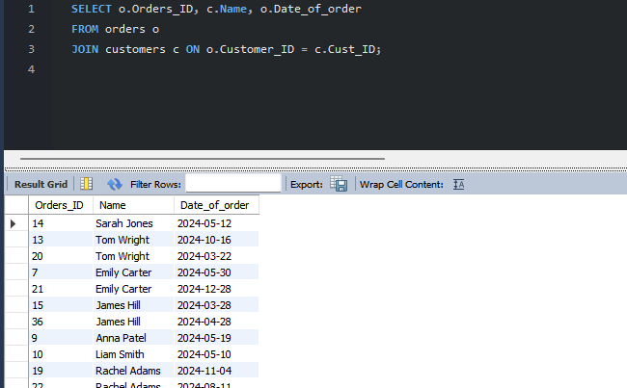  - Total loyalty points earned per customer  SELECT c.Name, SUM(l.points_balance) AS TotalPoints  FROM loyalty l  JOIN orders o ON l.order_id = o.Orders_ID  JOIN customers c ON o.Customer_ID = c.Cust_ID  GROUP BY c.Name  ORDER BY TotalPoints DESC;  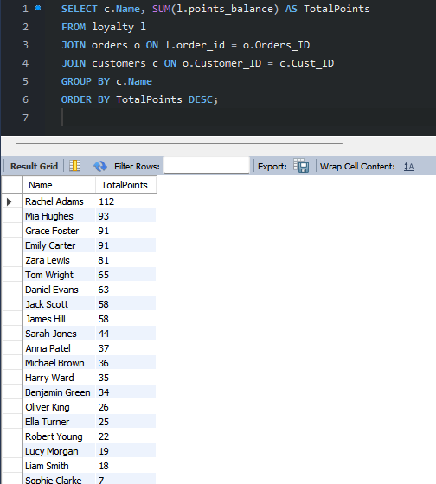  - Most popular product  SELECT  p.Product_name,  COUNT(*) AS TimesOrdered  FROM orders o  JOIN products p ON o.Product_ID = p.Product_ID  GROUP BY p.Product_ID, p.Product_name  ORDER BY TimesOrdered DESC;  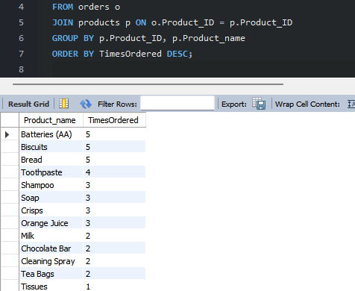  - Supplier cost compared to selling price  SELECT p.Product_name, s.Sup_name, s.Cost_price, p.Sales_price  FROM suppliers s  JOIN products p ON s.Product_ID = p.Product_ID;  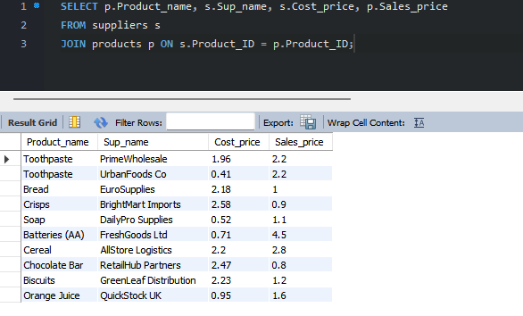

Day 4: Task 2: SQL Practical

In your groups, work together to answer the below questions. It may be of benefit if one of you shares your screen with the group and as a team answer / take screen shots from there.

Setting up the database:

- Download world_db(1)
- Follow each step to create your database

For each question I would like to see both the syntax used and the output.

- Count Cities in USA: Scenario: You've been tasked with conducting a demographic analysis of cities in the United States. Your first step is to determine the total number of cities within the country to provide a baseline for further analysis.

SELECT COUNT(*) AS total_cities_in_usa
FROM city
WHERE CountryCode = 'USA';
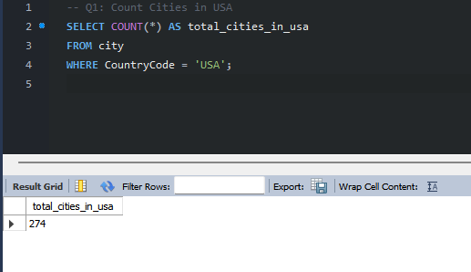

- Country with Highest Life Expectancy: Scenario: As part of a global health initiative, you've been assigned to identify the country with the highest life expectancy. This information will be crucial for prioritising healthcare resources and interventions.

SELECT Name, LifeExpectancy
FROM country
ORDER BY LifeExpectancy DESC
LIMIT 1;
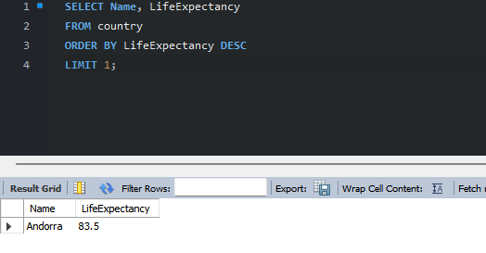

Alternative using max and subquery:
SELECT name, LifeExpectancy
FROM country
WHERE LifeExpectancy = (
SELECT MAX(LifeExpectancy)
FROM country);
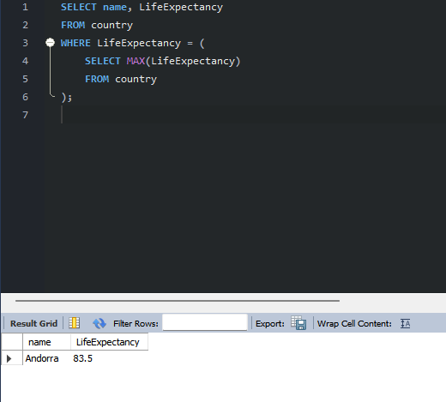

- "New Year Promotion: Featuring Cities with 'New : Scenario: In anticipation of the upcoming New Year, your travel agency is gearing up for a special promotion featuring cities with names including the word 'New'. You're tasked with swiftly compiling a list of all cities from around the world. This curated selection will be essential in creating promotional materials and enticing travellers with exciting destinations to kick off the New Year in style.

SELECT Name, CountryCode
FROM city
WHERE Name LIKE '%New%';
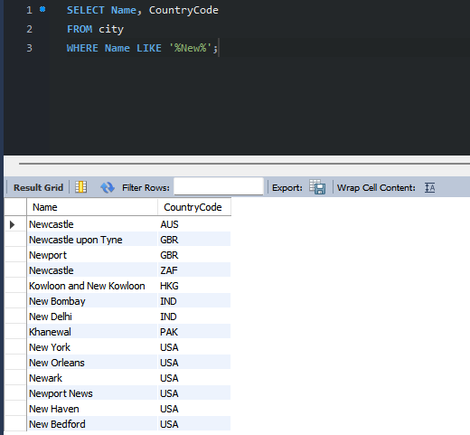

- Display Columns with Limit (First 10 Rows): Scenario: You're tasked with providing a brief overview of the most populous cities in the world. To keep the report concise, you're instructed to list only the first 10 cities by population from the database.

SELECT Name, Population
FROM city
ORDER BY Population DESC
LIMIT 10;
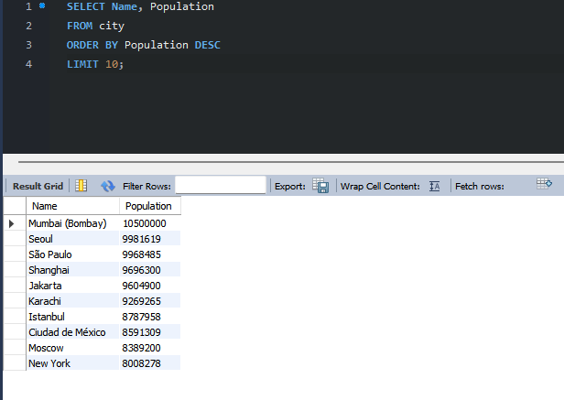

- Cities with Population Larger than 2,000,000: Scenario: A real estate developer is interested in cities with substantial population sizes for potential investment opportunities. You're tasked with identifying cities from the database with populations exceeding 2 million to focus their research efforts.

SELECT Name, Population
FROM city
WHERE Population > 2000000
ORDER BY Population DESC;
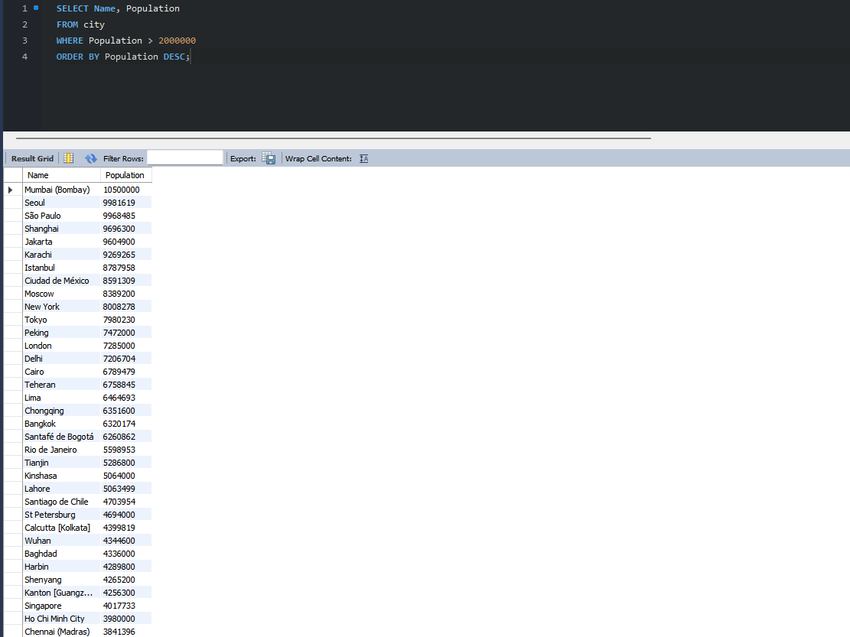

- Cities Beginning with 'Be' Prefix: Scenario: A travel blogger is planning a series of articles featuring cities with unique names. You're tasked with compiling a list of cities from the database that start with the prefix 'Be' to assist in the blogger's content creation process.

SELECT Name, CountryCode
FROM city
WHERE Name LIKE 'Be%';
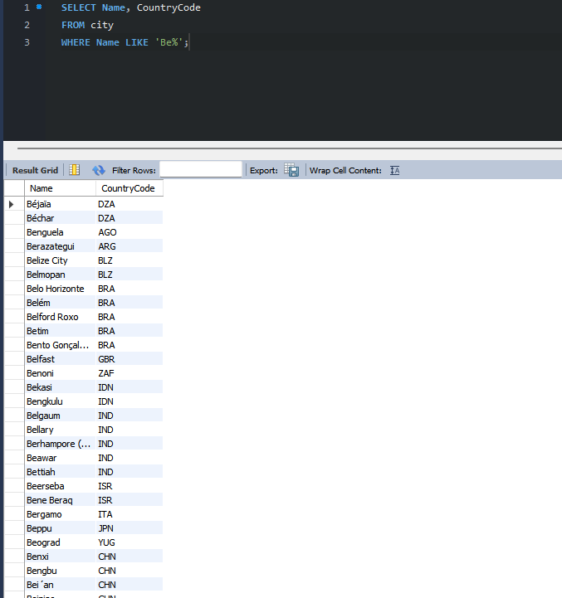

- Cities with Population Between 500,000-1,000,000: Scenario: An urban planning committee needs to identify mid-sized cities suitable for infrastructure development projects. You're tasked with identifying cities with populations ranging between 500,000 and 1 million to inform their decision-making process.

SELECT Name, Population
FROM city
WHERE Population BETWEEN 500000 AND 1000000
ORDER BY Population DESC;

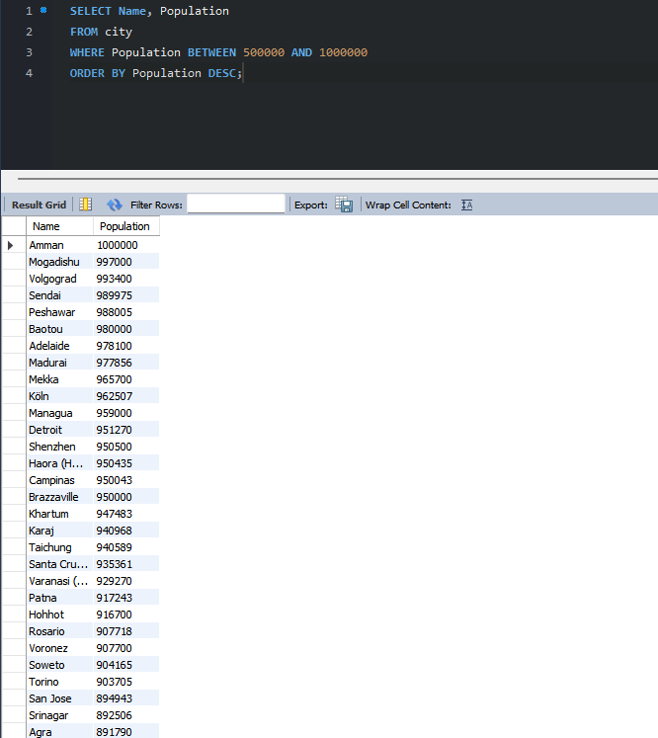

- Display Cities Sorted by Name in Ascending Order: Scenario: A geography teacher is preparing a lesson on alphabetical order using city names. You're tasked with providing a sorted list of cities from the database in ascending order by name to support the lesson plan.

SELECT Name
FROM city
ORDER BY Name ASC;
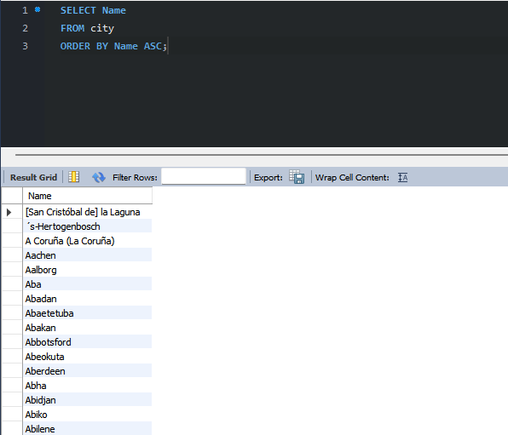

- Most Populated City: Scenario: A real estate investment firm is interested in cities with significant population densities for potential development projects. You're tasked with identifying the most populated city from the database to guide their investment decisions and strategic planning.

SELECT Name, Population
FROM city
ORDER BY Population DESC
LIMIT 1;
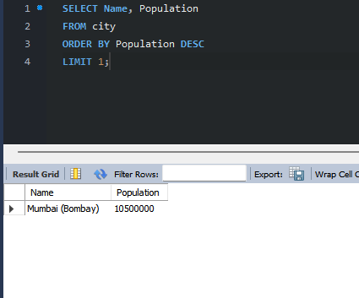

- - Alternative formula using MAX:
SELECT Name, Population
FROM city
WHERE Population = (
SELECT MAX(Population)
FROM city
);
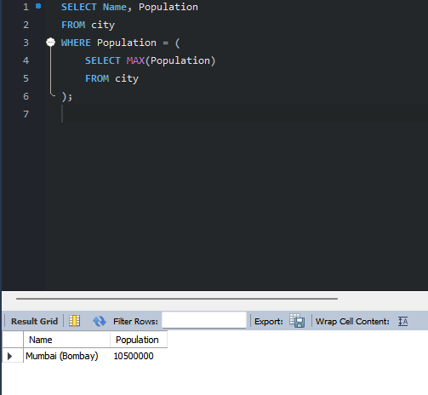

- City Name Frequency Analysis: Supporting Geography Education Scenario: In a geography class, students are learning about the distribution of city names around the world. The teacher, in preparation for a lesson on city name frequencies, wants to provide students with a list of unique city names sorted alphabetically, along with their respective counts of occurrences in the database. You're tasked with this sorted list to support the geography teacher.

SELECT Name, COUNT(*) AS occurrences
FROM city
GROUP BY Name
ORDER BY Name ASC;
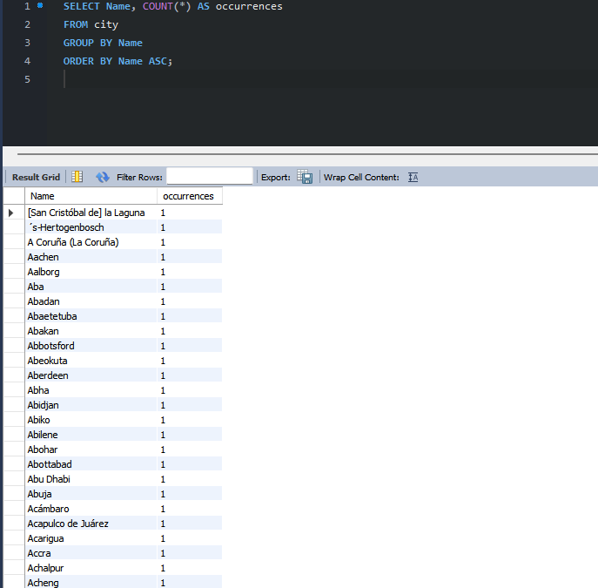

- City with the Lowest Population: Scenario: A census bureau is conducting an analysis of urban population distribution. You're tasked with identifying the city with the lowest population from the database to provide a comprehensive overview of demographic trends.

SELECT Name, Population
FROM city
ORDER BY Population ASC
LIMIT 1;
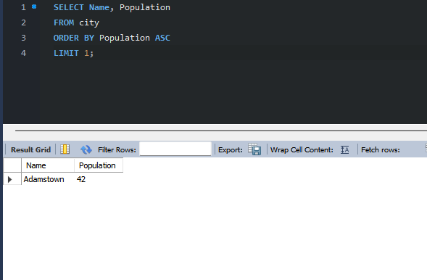

- Country with Largest Population: Scenario: A global economic research institute requires data on countries with the largest populations for a comprehensive analysis. You're tasked with identifying the country with the highest population from the database to provide valuable insights into demographic trends.

SELECT Name, Population
FROM country
ORDER BY Population DESC
LIMIT 1;
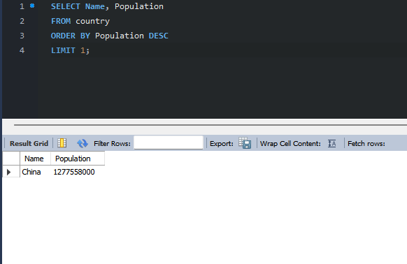

- Capital of Spain: Scenario: A travel agency is organising tours across Europe and needs accurate information on capital cities. You're tasked with identifying the capital of Spain from the database to ensure itinerary accuracy and provide travellers with essential destination information.

SELECT country.Name AS Country,
city.Name AS Capital
FROM country
JOIN city ON country.Capital = city.ID
WHERE country.Name = 'Spain';
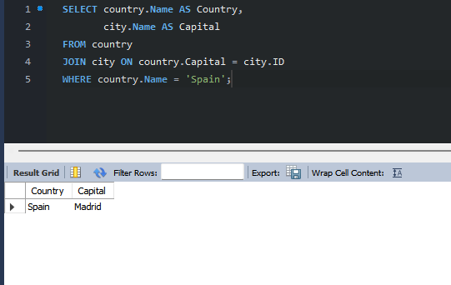
Alternative formula using sub query
SELECT
(SELECT Name FROM country WHERE Name = 'Spain') AS Country,
(SELECT Name FROM city WHERE ID = (SELECT Capital FROM country WHERE Name = 'Spain')) AS Capital;
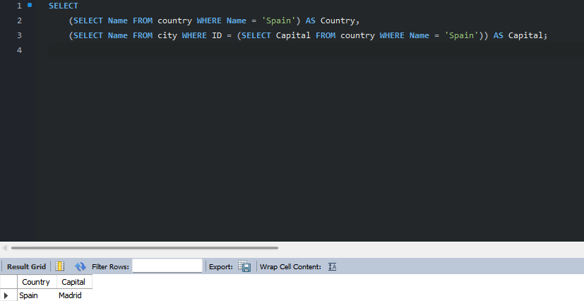

- Country with Shortest Life Expectancy: Scenario: A healthcare foundation is conducting research on global health indicators. You're tasked with identifying the country with the highest life expectancy from the database to inform their efforts in improving healthcare systems and policies.

SELECT Name, LifeExpectancy
FROM country
WHERE LifeExpectancy IS NOT NULL
ORDER BY LifeExpectancy ASC
LIMIT 1;
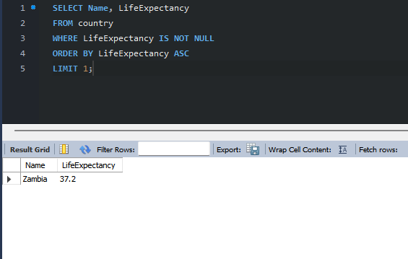

- Cities in Europe: Scenario: A European cultural exchange program is seeking to connect students with cities across the continent. You're tasked with compiling a list of cities located in Europe from the database to facilitate program planning and student engagement.
SELECT city.Name AS City, country.Name AS Country
FROM city
JOIN country ON city.CountryCode = country.Code
WHERE country.Continent = 'Europe';
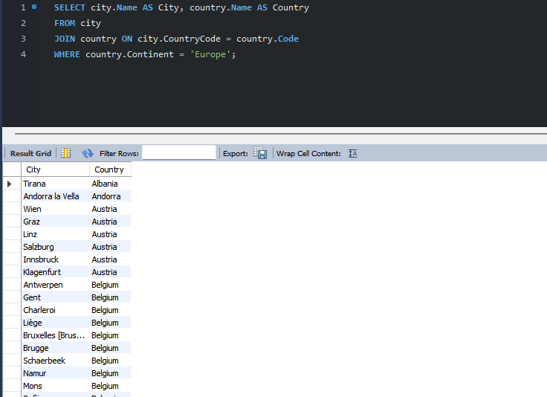
Alternative using subquery
SELECT c.Name AS City, (SELECT Name FROM country WHERE Code = c.CountryCode) AS Country
FROM city c
WHERE c.CountryCode IN (SELECT Code FROM country WHERE Continent = 'Europe');
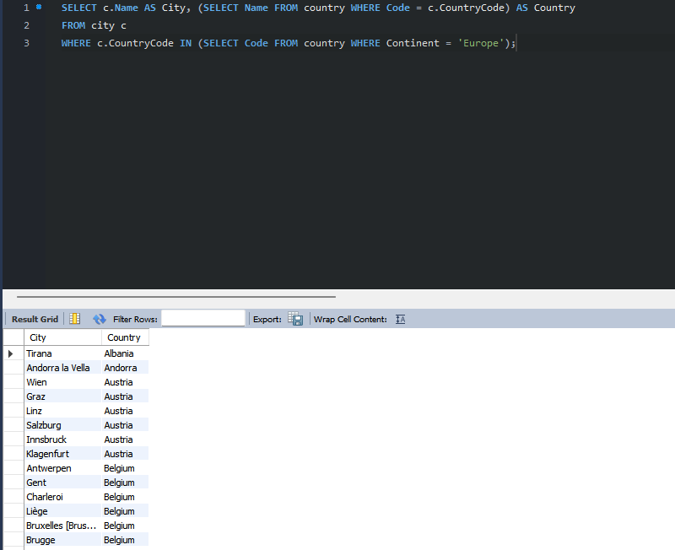

- Average Population by Country: Scenario: A demographic research team is conducting a comparative analysis of population distributions across countries. You're tasked with calculating the average population for each country from the database to provide valuable insights into global population trends.

SELECT Name AS Country,
AVG(Population) AS AvgPopulation
FROM country
GROUP BY Name
ORDER BY AvgPopulation DESC;
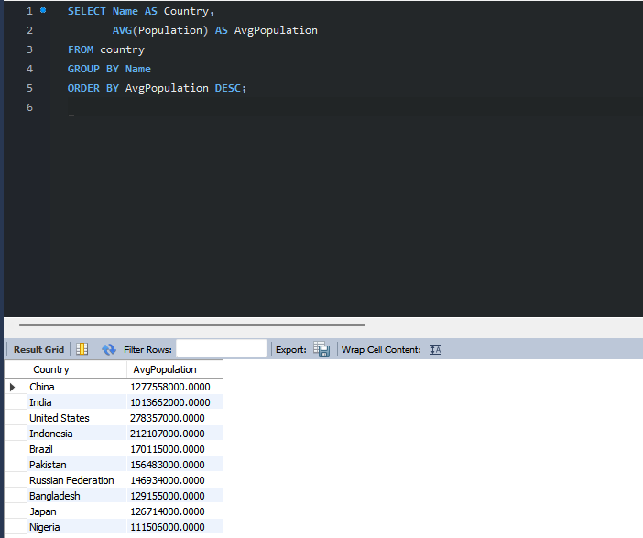

- Capital Cities Population Comparison: Scenario: A statistical analysis firm is examining population distributions between capital cities worldwide. You're tasked with comparing the populations of capital cities from different countries to identify trends and patterns in urban demographics.

SELECT country.Name AS Country,
city.Name AS Capital,
city.Population AS CapitalPopulation
FROM country
JOIN city ON city.ID = country.Capital
ORDER BY city.Population DESC;
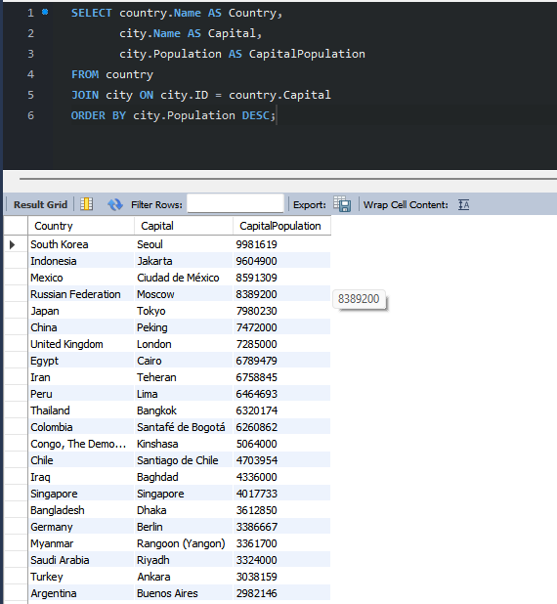

- Countries with Low Population Density: Scenario: An agricultural research institute is studying countries with low population densities for potential agricultural development projects. You're tasked with identifying countries with sparse populations from the database to support the institute's research efforts.

SELECT Name,
Population,
SurfaceArea,
(Population / SurfaceArea) AS Density
FROM country
ORDER BY Density ASC;
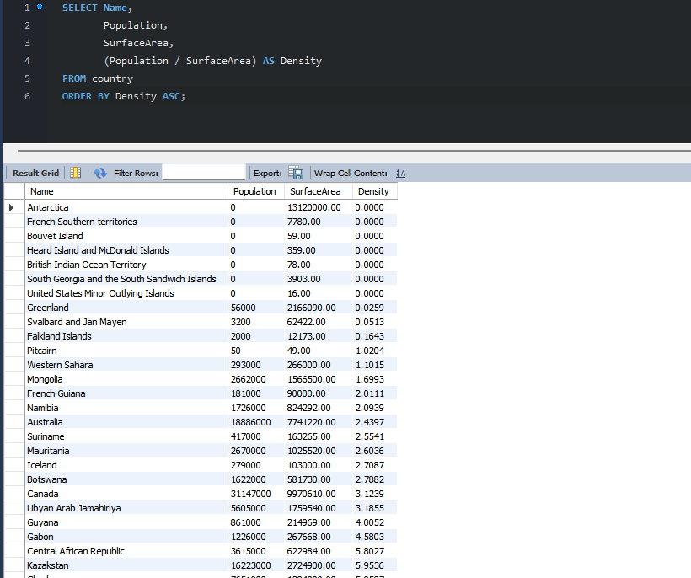

- Cities with High GDP per Capita: Scenario: An economic consulting firm is analysing cities with high GDP per capita for investment opportunities. You're tasked with identifying cities with above-average GDP per capita from the database to assist the firm in identifying potential investment destinations.

SELECT
ci.Name AS City,
co.Name AS Country,
(co.GNP / co.Population) AS GDP_per_capita
FROM city ci
JOIN country co ON ci.CountryCode = co.Code
WHERE co.GNP IS NOT NULL
AND co.Population > 0
AND (co.GNP / co.Population) >
(SELECT AVG(GNP / Population)
FROM country
WHERE GNP IS NOT NULL AND Population > 0)
ORDER BY GDP_per_capita DESC;
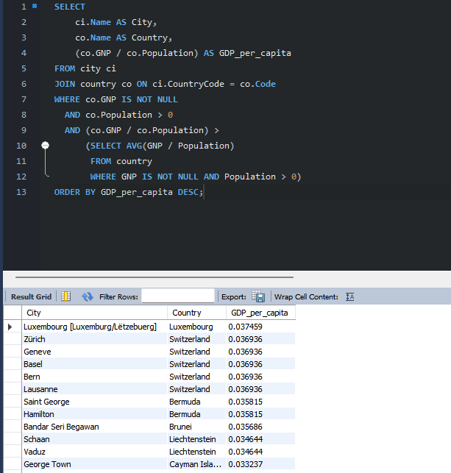
--
This answers the question, but kind of shows the question is flawed because it assumes that each city would be responsible for the entire GNP of a country, despite each city only holding a portion of the total population, so:

Instead, we used the only realistic option available in this dataset:
- First calculate GDP per capita at country level: country.GNP / country.Population
- Then attach that per-capita value to each city in that country and filter for cities in countries with above-average GDP per capita.
--
Second query to show GDP per capita with the global average to filter out below average GDP per capita cities/countries:
We keep the GNP IS NOT NULL and Population > 0 conditions because both the GDP-per-capita calculation and the above-average comparison require valid numeric values. Without these filters, MySQL would hit division-by-zero errors or produce NULLs that cannot be compared, which would break the query and distort the results.

City_GNP_Share calculates a city’s proportional share of national GNP by comparing its population to the total population of the country — effectively allocating GNP based on population share, the only realistic method possible with the World database.
--
SELECT
ci.Name AS City,
co.Name AS Country,
co.GNP AS TotalCountryGNP,
ci.Population AS CityPopulation,
co.Population AS CountryPopulation,
(co.GNP / co.Population) AS GDP_per_capita,
(co.GNP * (ci.Population / co.Population)) AS City_GNP_Share
FROM city ci
JOIN country co ON ci.CountryCode = co.Code
WHERE co.GNP IS NOT NULL
AND co.Population > 0
AND (co.GNP / co.Population) >
(SELECT AVG(GNP / Population)
FROM country
WHERE GNP IS NOT NULL AND Population > 0)
ORDER BY GDP_per_capita DESC;
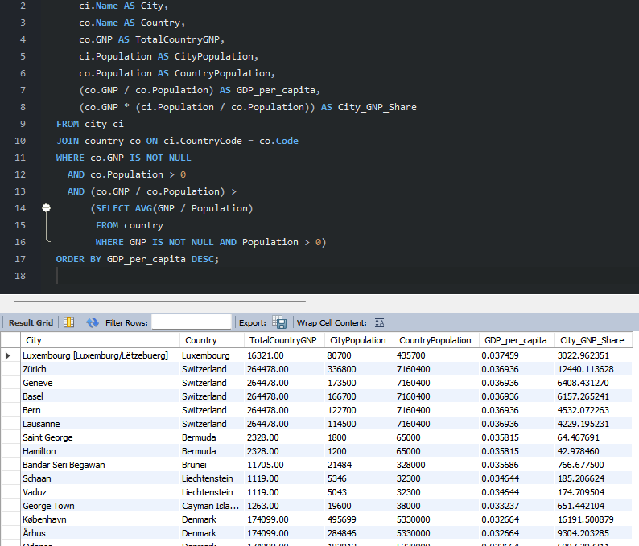

- Display Columns with Limit (Rows 31-40): Scenario: A market research firm requires detailed information on cities beyond the top rankings for a comprehensive analysis. You're tasked with providing data on cities ranked between 31st and 40th by population to ensure a thorough understanding of urban demographics.

SELECT Name, Population
FROM city
ORDER BY Population DESC
LIMIT 10 OFFSET 30;
LIMIT 30, 10;
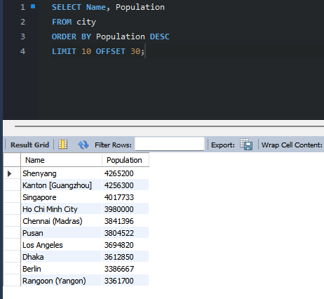

Course Notes

It is recommended to take notes from the course, use the space below to do so, or use the revision guide shared with the class:

Additional Information

We have included a range of additional links to further resources and information that you may find useful, these can be found within your revision guide.

END OF WORKBOOK

Please check through your work thoroughly before submitting and update the table of contents if required.

Please send your completed work booklet to your trainer.

