

Data Technician
Louis

Week 2

Name:
Course Date:
Table of contents
Day 1: Task 1 2
Day 1: Task 2 2
Day 2: Task 1 3
Day 2: Task 2 3
Day 3: Task 1 4
Day 3: Task 2 5
Day 4: Task 1 6
Day 4: Task 2 7
Course Notes 7
Additional Information 8

Day 1: Task 1

Please research the different versions of Tableau, compare and contrast them below and explain the limited functionality on ‘Tableau Public’.

Different Tableau versions | 1. Tableau Desktop  - Full professional tool  - Build dashboards, connect to large datasets, publish to Server/Cloud  - Paid licence  - Enterprise-grade features  2. Tableau Prep  - Data cleaning & transformation  - Joins, splits, pivots, shaping workflows  - Works alongside Tableau Desktop  - Paid licence  3. Tableau Server  - On-premise sharing environment  - Secure, organisation-wide  - Users view, interact, refresh dashboards  4. Tableau Cloud (formerly Tableau Online)  - Fully cloud-based  - No installation needed  - Same sharing/permissions as Server  - Subscription licence  5. Tableau Public  - Free version  - Cloud-based gallery of dashboards  - Major limitations:  - You cannot save locally → Everything is public on the internet  - No connection to private databases/files except CSV/Excel  - No row-level security  - No private dashboards  - Limited refresh options, limited automation

Day 1: Task 2

Using the EMSI_JobChange_UK dataset, create your own dashboard, I want to see a bar chart showing percentage change and a UK based map showing the key city locations impacted.

Paste your print screen here | 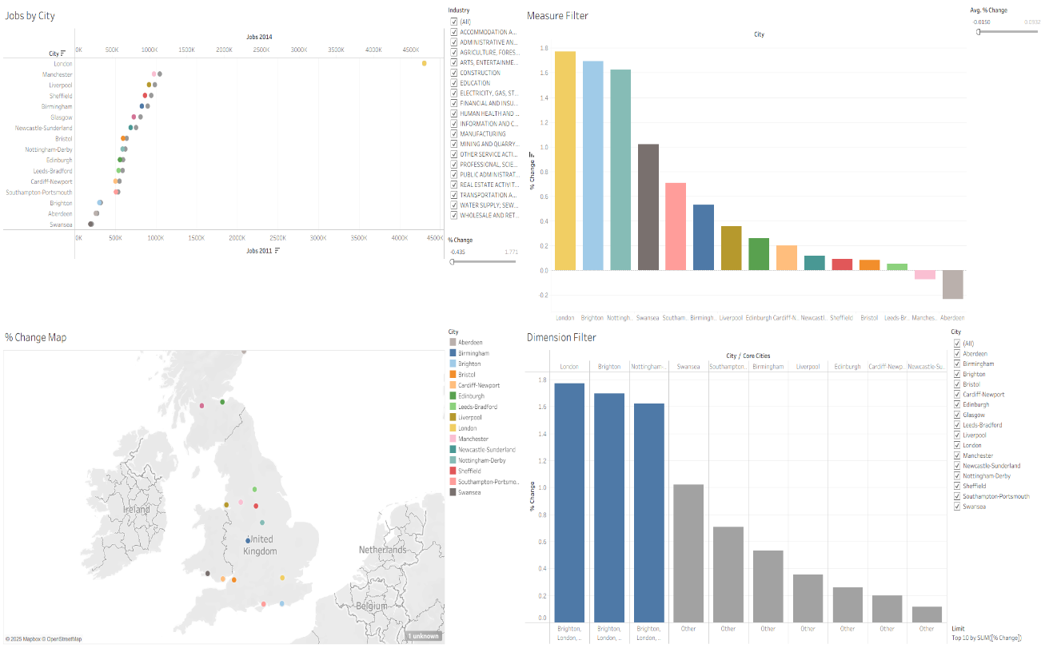  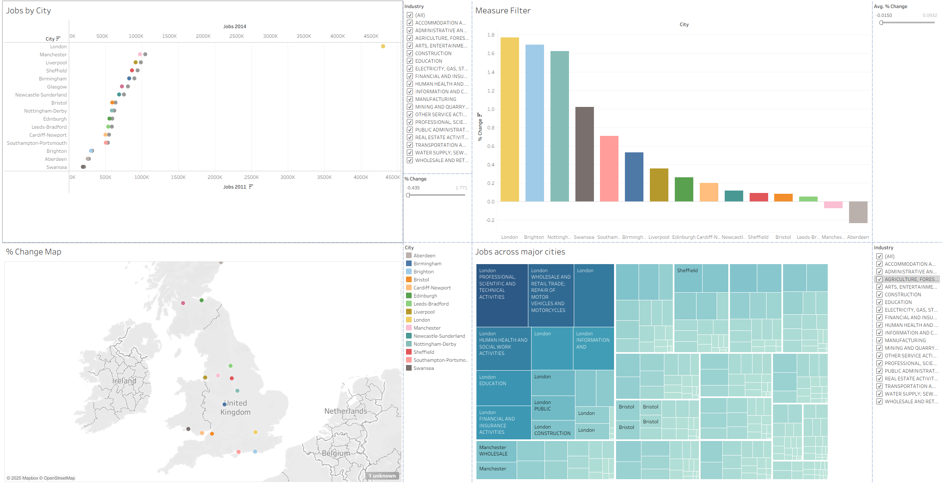

Day 2: Task 1

Using the Spotify data set, conduct an analysis to find trends and key information that could be used by an organisation for future projects.

There is no set scope for the analysis, simply to find trends and document them below:

Paste your print screens here | 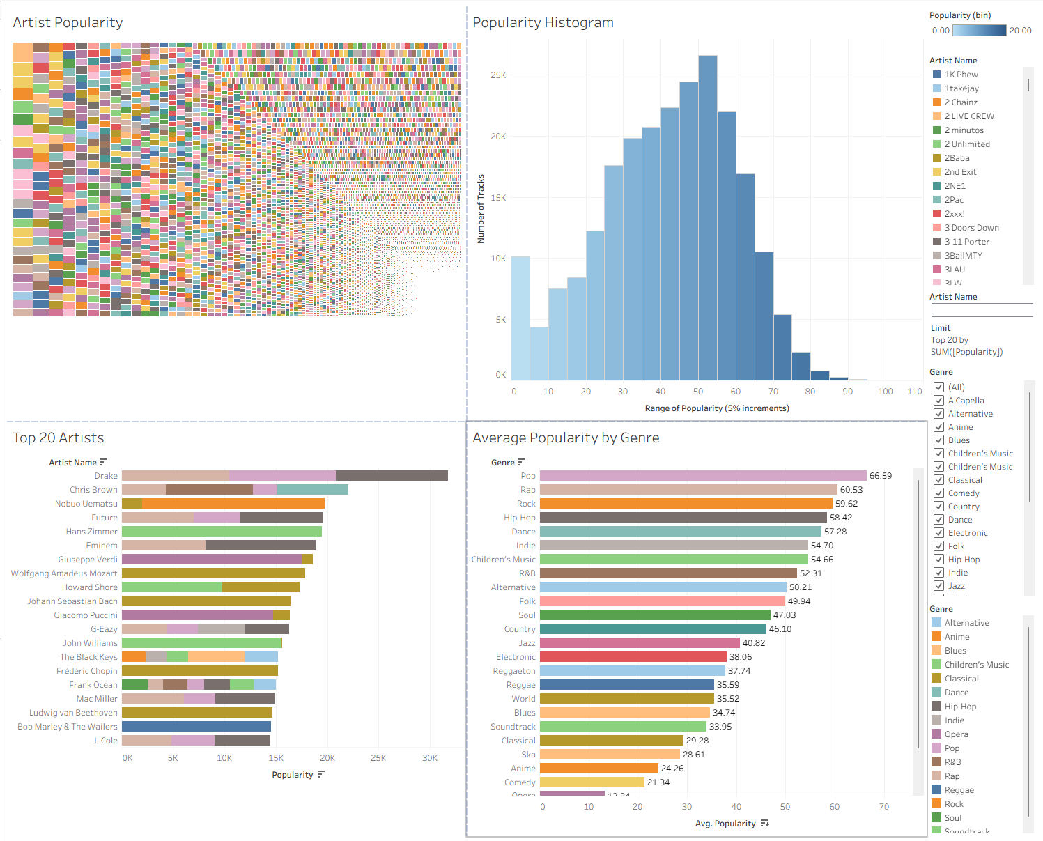  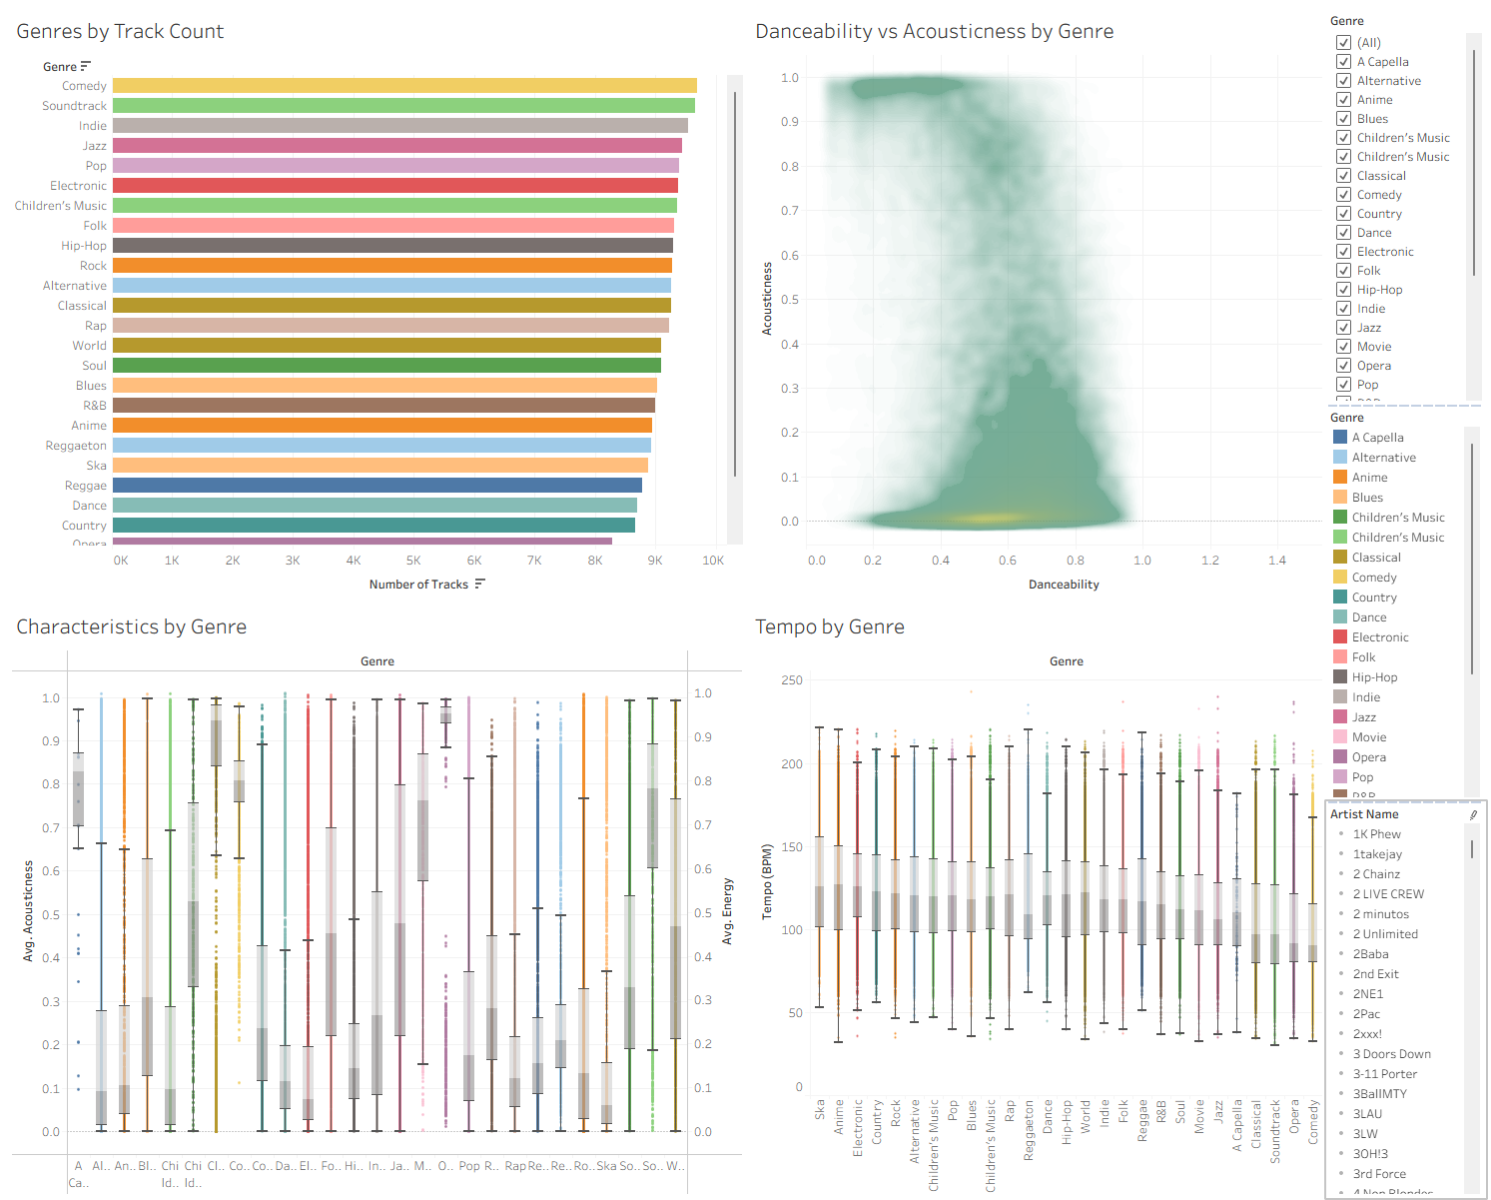  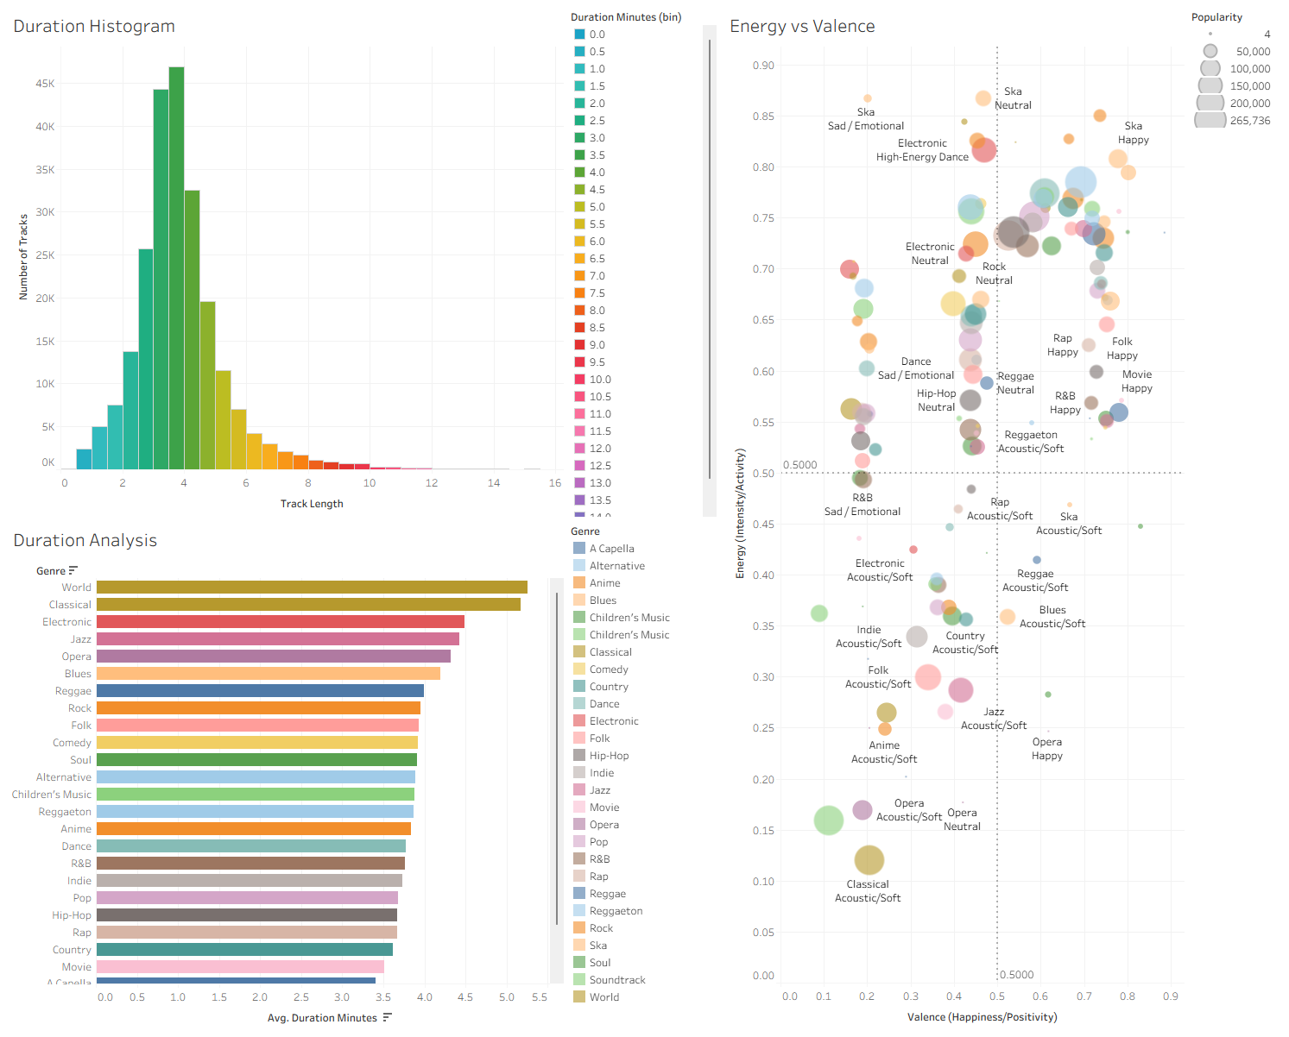

What did you find? | DASHBOARD 1 — Popularity Metrics (Which music and artists are most popular?)  The popularity chart shows that most songs sit around the middle — not “super famous,” but not unknown either. Only a small number reach very high popularity. When looking at genres, Pop, Hip-Hop, R&B, Rock, and Electronic stand out as the ones listeners stream the most. These styles make up much of the popular music in the dataset.  The artist charts show that a small group of big-name artists gather most of the attention. Artists like Drake, Taylor Swift, Post Malone, The Weeknd, Dua Lipa, Ed Sheeran, Billie Eilish, and Ariana Grande tend to dominate because they consistently release music that suits mainstream tastes. Meanwhile, genres like Classical, Jazz, Opera, and Folk appear with much lower popularity totals; these genres have loyal audiences but aren’t streamed as widely.  Overall, the first dashboard shows that popularity is heavily influenced by genre and star power. A few top genres and well-known artists carry a large share of total streams, while most other artists and genres stay at mid or low popularity levels.  DASHBOARD 2 — Genre & Audio Profile (How different genres “sound”)  This dashboard focuses on how songs from different genres feel and sound. The genre count chart shows that some genres (like Pop, Hip-Hop, Rock, and Electronic) appear much more often in the dataset, while others (like Folk, Classical, and Jazz) appear less, which helps explain why some genres naturally seem more popular.  The danceability vs acousticness chart shows very clear differences:  - Electronic, Dance, and House songs are very danceable and not acoustic at all — they use lots of production and electronic sounds.  - Folk, Classical, Jazz, and Singer-Songwriter songs are much more acoustic and less aimed at dancing.  - Pop and R&B sit in the middle, mixing both digital and acoustic elements.  The box plots (or feature comparisons) show each genre has its own “sound pattern.”  - EDM, Dance, and Hip-Hop tend to be loud, energetic, and rhythmic.  - Classical and Ambient are quiet, calm, and slow.  - Jazz and Blues vary a lot because they include both upbeat and chilled styles.  The tempo chart confirms this: fast genres like Drum & Bass, EDM, and Techno have high BPM, while slow genres like Classical, Jazz Ballads, and Ambient stay on the lower end. This dashboard makes it easy to see how genres differ in energy, speed, and mood.  DASHBOARD 3 — Track Behaviour & Mood (How long songs are and what moods they create)  Most songs in the dataset last around 3 to 4.5 minutes, which is the usual length for modern music on streaming platforms. Very long songs — like those found in Progressive Rock, Classical, or Ambient — appear much less often.  The duration vs popularity chart shows that song length does not strongly affect popularity. Short, medium, and long tracks can be equally liked, although extremely long songs usually don’t reach high popularity.  The Energy vs Valence (mood) chart shows the types of moods different genres create:  - EDM, Pop, K-Pop, and Dance often land in the “happy and energetic” area.  - Hip-Hop and Trap often stay energetic but more serious or moody.  - Classical, Acoustic, Ambient, and Folk songs sit in the calm and gentle area.  - Indie, R&B, Soul, and Jazz spread across the middle — warm, emotional, and balanced.  This dashboard shows that listeners overall prefer energetic and upbeat music but enjoy a wide range of moods depending on genre.

Day 2: Task 2

Using the Health, conduct an analysis to find trends and key information that could be used by an organisation for future support.

There is no set scope for the analysis, simply to find trends and document them below.

- Data can be lifesaving and is being used more within the NHS, reflect on how this data could support decision making for the NHS.

Paste your print screens here | 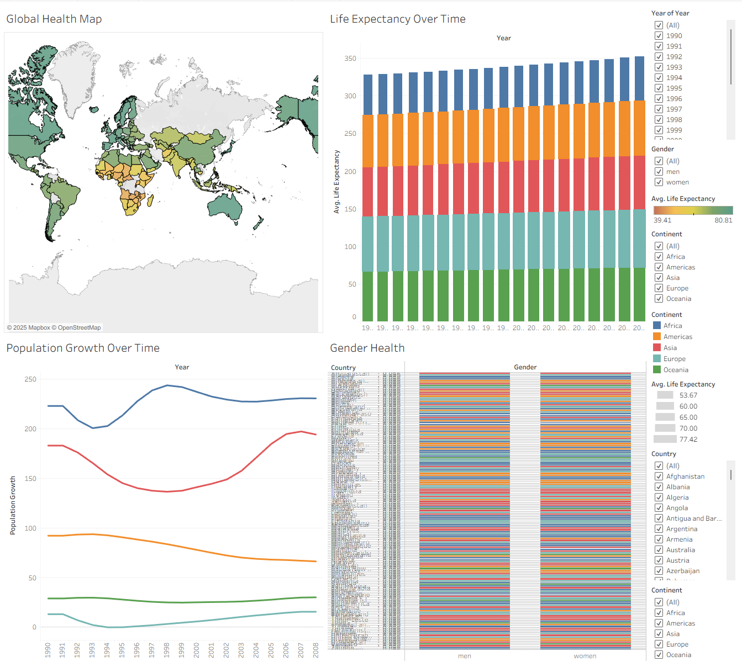  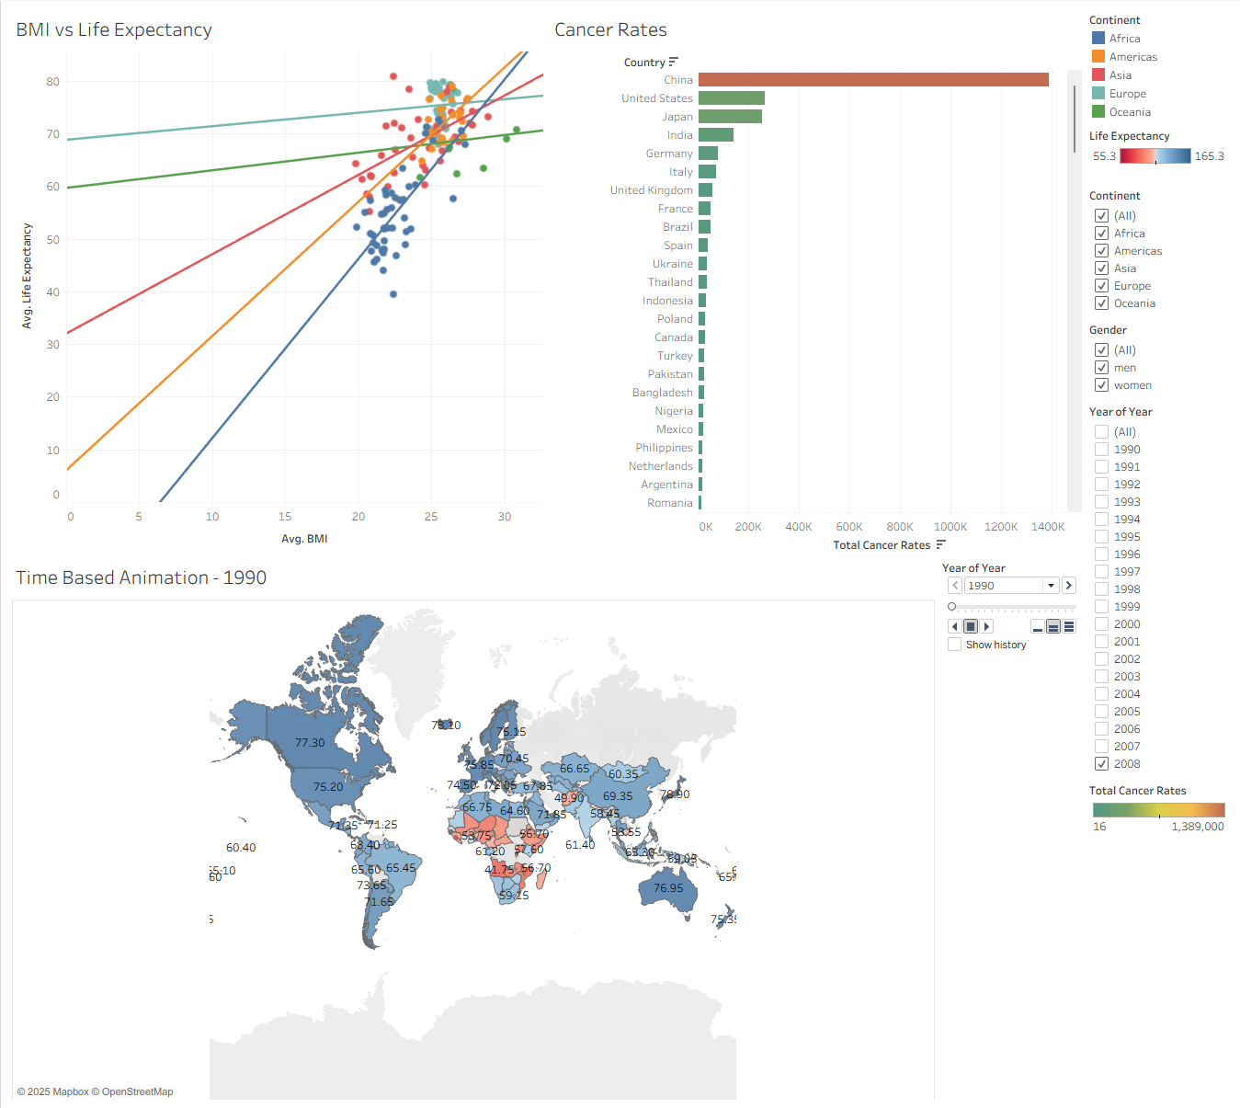
What did you find and any reflections on how the NHS could use this? | Health Data Analysis – Findings & Reflections  This dataset highlights several major global health patterns across life expectancy, population change, cancer rates, and gender differences. These insights are highly relevant for organisations like the NHS, as they help explain current and future pressures on healthcare systems.  1. Global Health Trends  Across 1990–2008, almost every region showed steady growth in life expectancy.  - Europe and Oceania consistently ranked highest, often reaching 78–82 years by the mid-2000s.  - Asia and the Americas increased from the mid-60s to low-70s.  - Africa showed the lowest values, sometimes dropping below 40 years for countries hit by HIV/AIDS, conflict, or economic instability.  A visual example: in 2008, Japan averaged around 82 years, while Sierra Leone averaged roughly 39 years — a stark contrast.  Population Changes  The population data shows that growth has been extremely uneven:  - Asia reached over 3 billion.  - Africa demonstrates the fastest growth rate.  - Slower growth appears in Europe and parts of the Americas.  These shifts matter because rapidly growing regions require more medical staff, hospital capacity, and vaccination programmes. For the NHS, this is relevant because migration patterns influence UK demographics, meaning demand for maternity services, chronic disease management, and health screening may rise based on where new populations originate.  2. Cancer Trends  Cancer conditions showed huge variations between countries, especially when comparing total cases versus cases per 1000 people.  Total Cases  Countries with very large populations naturally had the highest totals:  - China: ~1.39 million cases  - United States: ~4.14 million  - India: ~2.3 million  Population-Adjusted Rates  When measuring per 1000 people, the results showed:  - Wealthier nations often had higher cancer incidence, likely due to lifestyle factors, older populations, and better detection.  - Lung cancer peaked in countries with strong smoking histories (e.g., Eastern Europe, parts of Asia).  - Liver cancer appeared more often in countries affected by hepatitis or alcohol misuse.  - Stomach cancer was more common in East Asia.  These patterns highlight the importance of public health prevention. For the NHS, this supports ongoing investment in:  - Smoking cessation  - Hepatitis vaccinations  - Screening programmes (e.g., bowel, breast, cervical)  - Early diagnosis pathways (e.g., Faster Diagnostic Standard)  As the UK population ages, similar cancer patterns will likely increase pressure on oncology services.  3. Gender Health Trends  Across all continents, women consistently live longer than men.  The gap can range from 3–7 years, depending on region.  This difference has several explanations — biological factors, risk-taking behaviour, cardiovascular disease rates, and men’s lower engagement with healthcare services.  For the NHS, this suggests:  - Men may need targeted outreach campaigns.  - Earlier interventions for heart disease, obesity, alcohol use, and mental health could address the gap.  - Encouraging more preventive check-ups for men could reduce avoidable deaths.  How the NHS Could Use This Data  Overall, these global patterns can help the NHS:  - Plan long-term services based on demographic shifts.  - Strengthen prevention, focusing on high-risk groups (men, smokers, older populations).  - Prepare for rising chronic disease rates, especially cancer.  - Improve resource planning by understanding which populations might require more intensive care.

Day 3: Task 1

Please complete Lab 1 ‘Get Data in Power Bi Desktop’. Once complete, paste a print screen below and in the collaboration board.

“Teaching is the best way to learn, so please listen out for support requests from the class and we’ll work through the challenges together”

Paste your completed lab here | 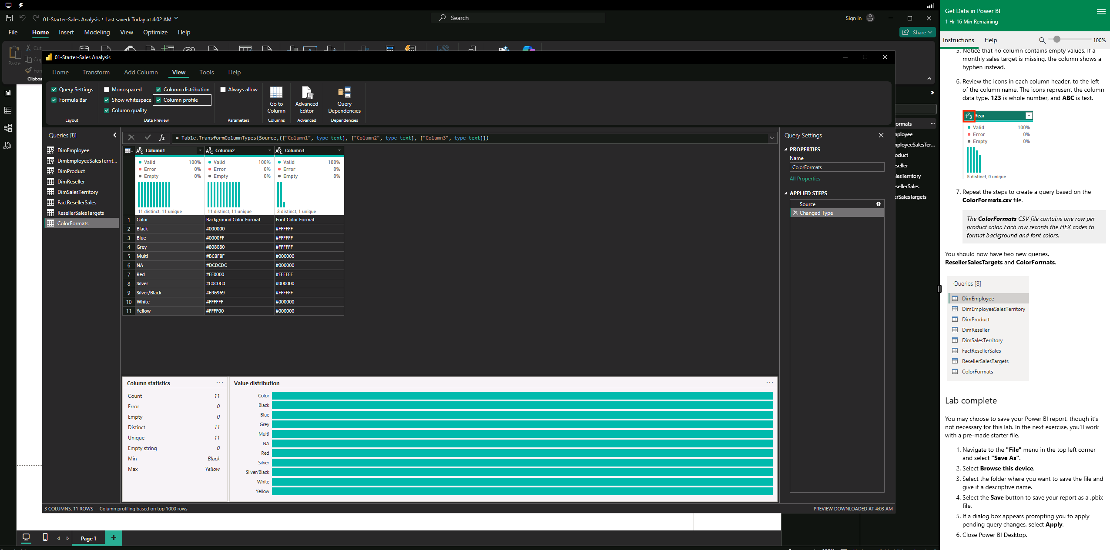

Day 3: Task 2

Please complete Lab 2 ‘Load Transformed Data in Power BI Desktop’. Once complete, paste a print screen below and in the collaboration board.

“Teaching is the best way to learn, so please listen out for support requests from the class and we’ll work through the challenges together”

Paste your completed lab here | 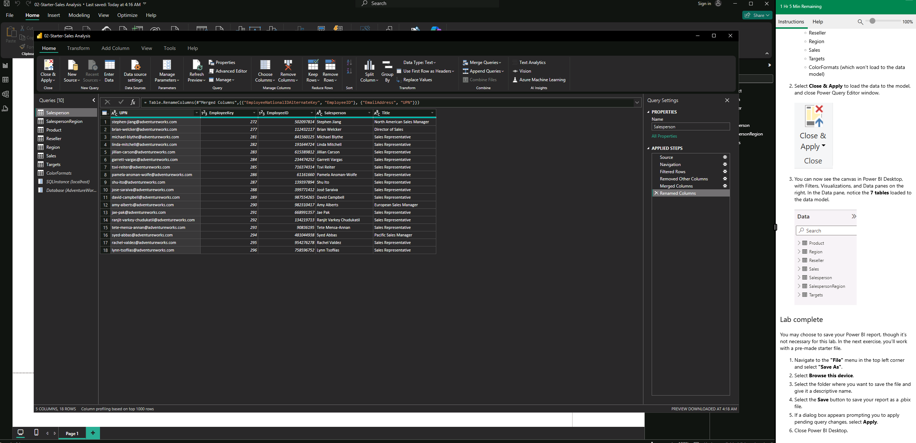  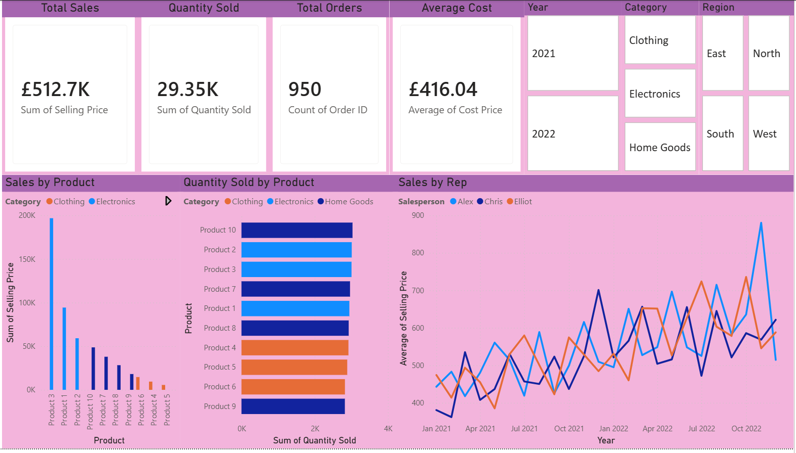  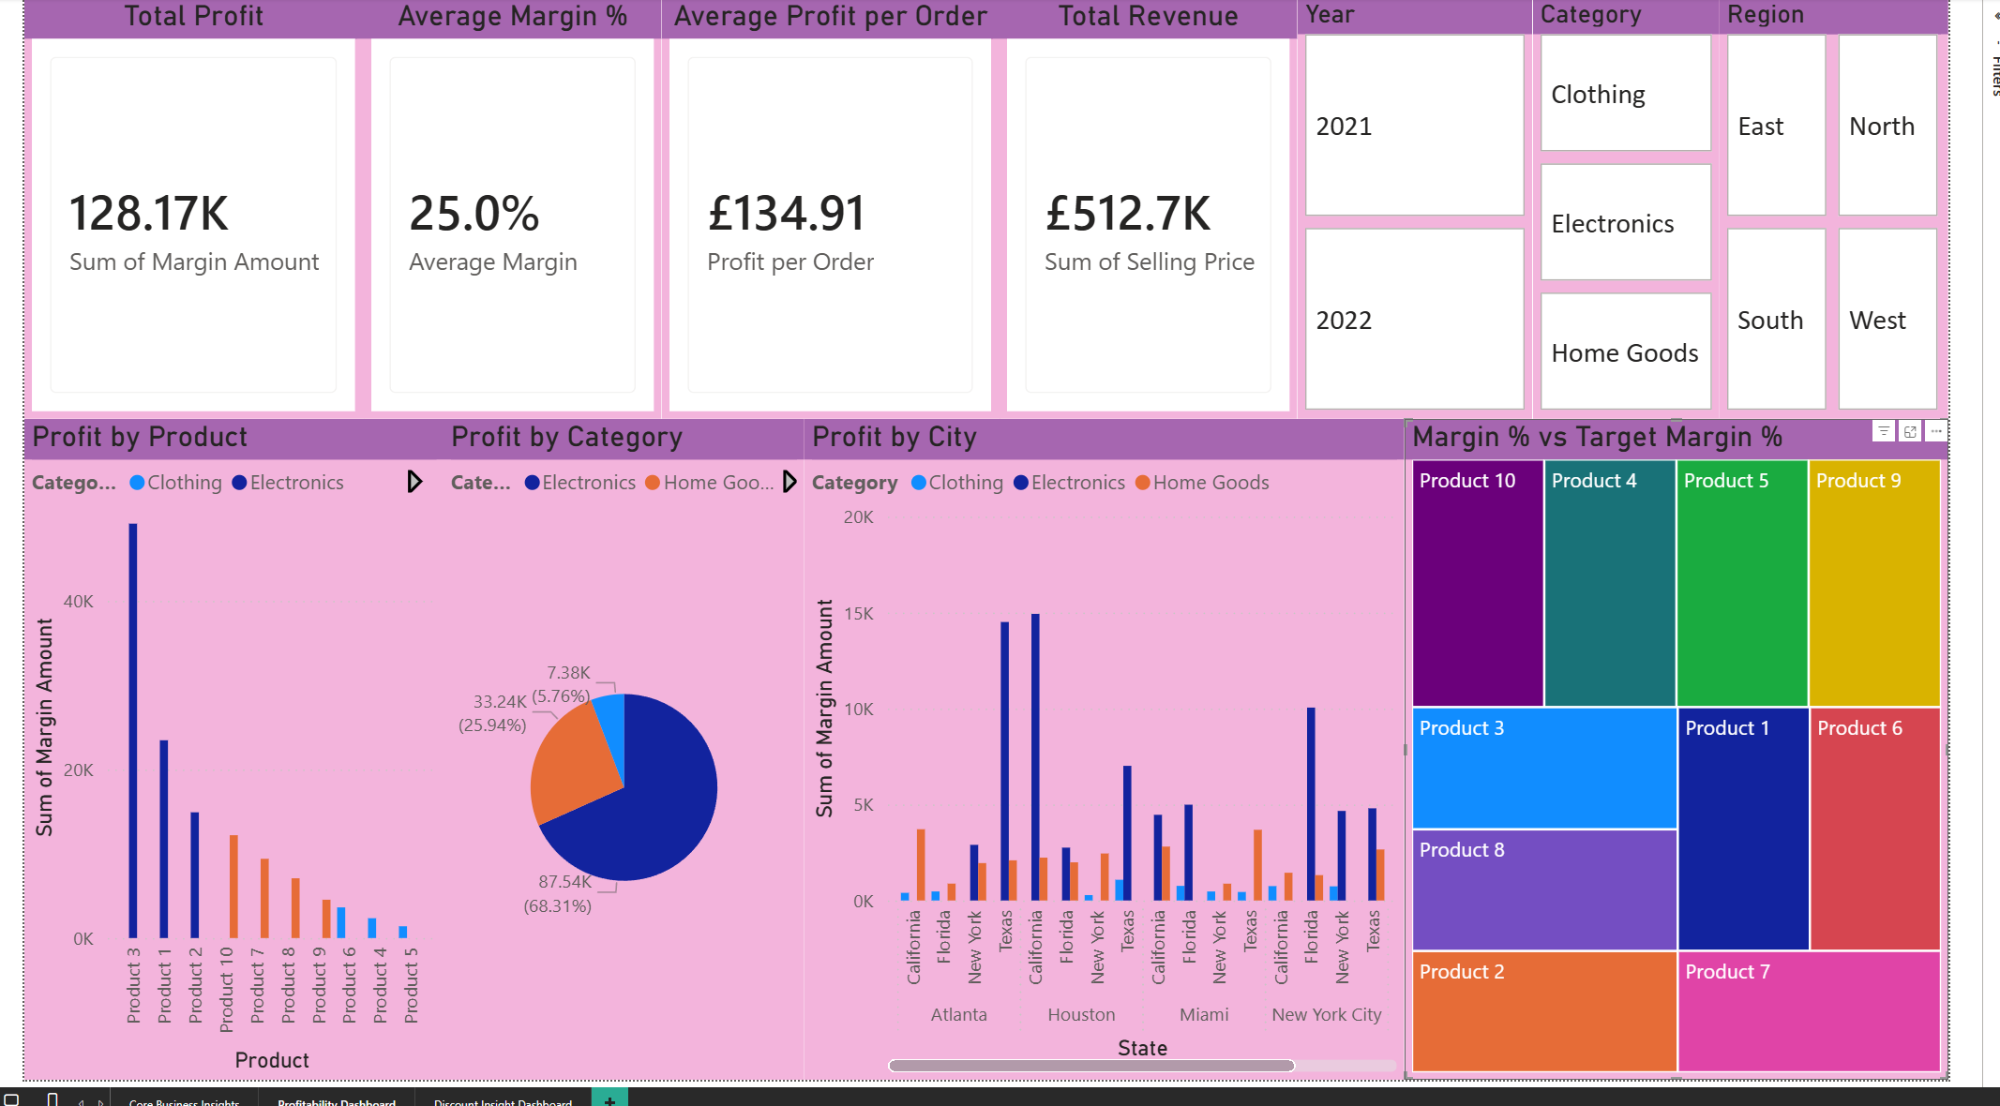

Day 4: Task 1

Please complete Lab 8 ‘Design a Report in Power BI Desktop’. Once complete, paste a print screen below and in the collaboration board.

“Teaching is the best way to learn, so please listen out for support requests from the class and we’ll work through the challenges together”

Paste your completed lab here | 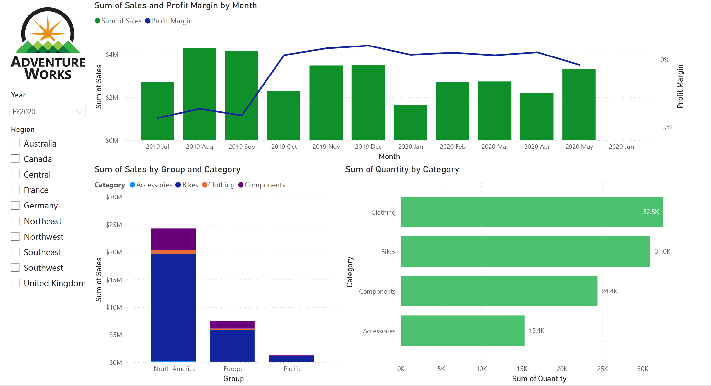  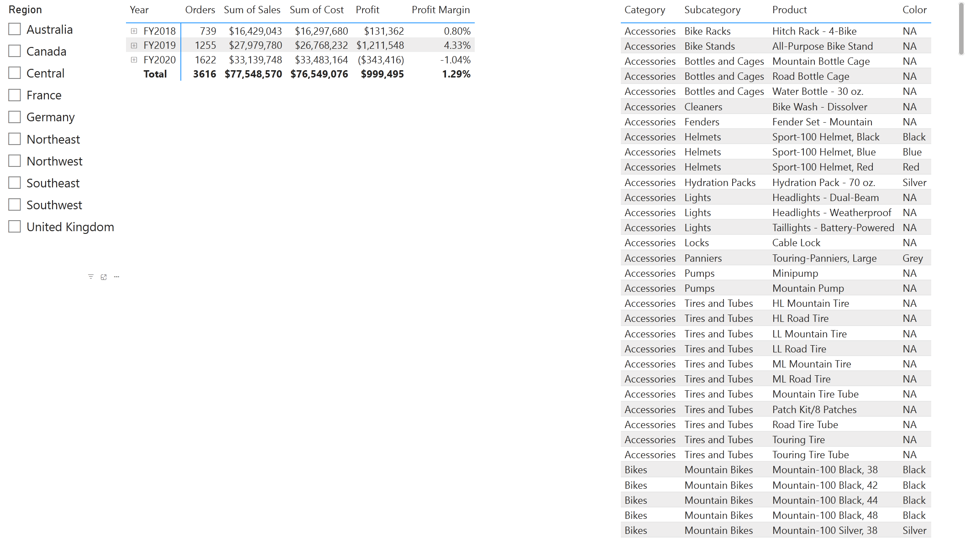  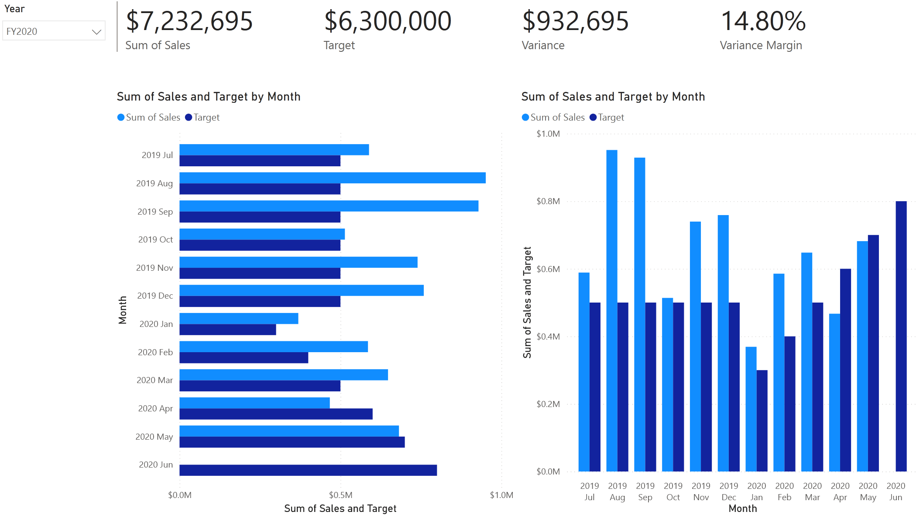

Day 4: Task 2

Please complete Lab 12 ‘Create a Power BI Dashboard’. Once complete, paste a print screen below and in the collaboration board.

“Teaching is the best way to learn, so please listen out for support requests from the class and we’ll work through the challenges together”

Paste your completed lab here | 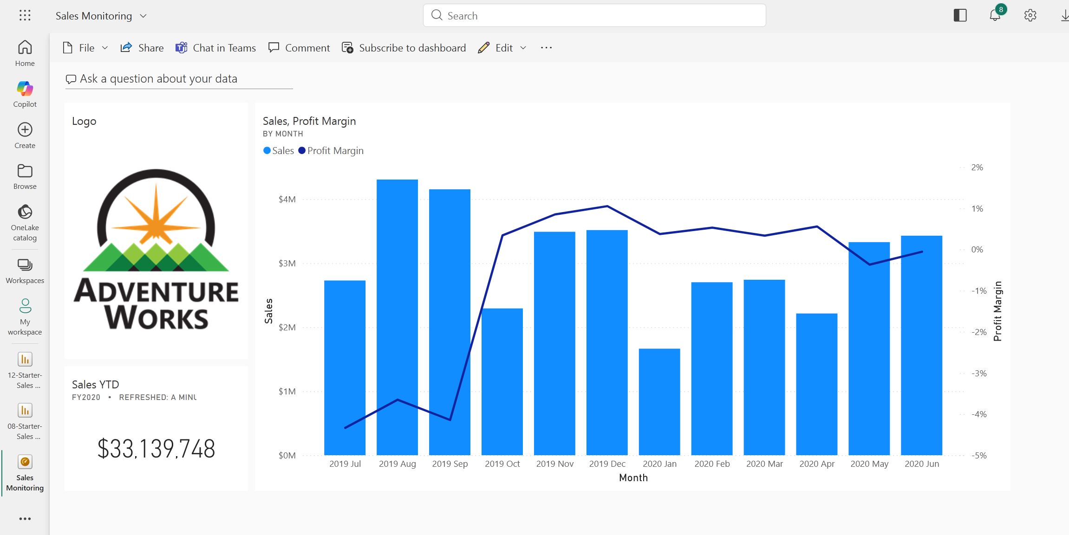

Course Notes

It is recommended to take notes from the course, use the space below to do so, or use the revision guide shared with the class.

We have included a range of additional links to further resources and information that you may find useful, these can be found within your revision guide.

END OF WORKBOOK

Please check through your work thoroughly before submitting and update the table of contents if required.

Please send your completed work booklet to your trainer.

Information

