

Data Technician
Louis

Week 5

Name:
Course Date:
Table of contents
Day 1: Task 1 3
Day 1: Task 2 3
Day 1: Task 3 4
Day 2: Task 1 5
Day 3: Task 1 9
Day 3: Task 2 10
Day 3: Task 3 11
Day 4: Task 1 12
Day 4: Task 2 13
1. Scenario Background 13
2. Data Laws and Regulations 14
3. Azure Service Recommendations 14
4. Data Types and Data Modelling 14
5. Data Storage Formats and Structures in Azure 14
6. Additional Considerations 15
Submission Guidelines: 15
Course Notes 17
Additional Information 17

Day 1: Task 1

Please research and complete the below questions relating to key concepts of cloud.

Be prepared to discuss the below in the group following this task.

What can cloud computing do for us in the real-world? | Cloud computing allows people and organisations to store data, run software, and access computing power over the internet instead of relying on a single physical computer or local server.  In the real world, this means:  - Accessing files and applications from anywhere (e.g. Google Drive, OneDrive)  - Streaming services (Netflix, Spotify) running reliably at scale  - Supporting remote work, online learning, and collaboration  - Powering apps, websites, AI tools, and data analysis without needing powerful personal hardware  - Automatically backing up data and protecting it against hardware failure
How can it benefit a business? | Cloud computing benefits businesses by improving efficiency, scalability, and cost control.  Key benefits include:  - Lower upfront costs (no need to buy and maintain physical servers)  - Scalability – resources can grow or shrink based on demand  - Improved collaboration across teams and locations  - High availability and disaster recovery, reducing downtime risk  - Faster innovation, as new tools and services can be deployed quickly  - Security and compliance features managed by specialist providers  For businesses, cloud computing supports growth while reducing operational complexity.
What’s the alternative to cloud computing? | The main alternative is on-premises (on-prem) computing.  This involves:  - Owning and maintaining physical servers on-site  - Managing hardware, software, security, backups, and updates internally  - Higher upfront and ongoing maintenance costs  - Limited scalability and slower deployment  Some organisations use a hybrid approach, combining on-prem systems with cloud services, often for security, regulatory, or legacy reasons.
What cloud providers can we use, what are their features and functions?
  Features | AWS | Azure | GCP
  Strength | Largest and most mature cloud platform | Strong integration with Microsoft tools | Data, analytics and AI expertise
  Compute | EC2 (virtual servers). Lambda (serverless) | VMs, Azure functions | Compute Engine, Cloud functions
  Storage | S3, EBS, Glacier | Blob storage, File Storage | Cloud storage
  Databases | RDS, DynamoDB, Redshift | Azure SQL, Cosmos DB | BigQuery, CloudSQL
  Analytics/AI | Athena, Sagemaker | Synapse Analytics, AI studio | BigQuery, Vertex AI
  Best use | Startups, large enterprises, wide service choice | Windows based businesses, Office/365, SQL server | Data-heavy workloads and machine learning

Day 1: Task 2

Please research the below cloud offerings, explain what they are and examples of use cases.
IaaS gives you control, PaaS gives you a development platform, and SaaS gives you finished software you can use straight away.
Cloud Offerings | Explain what it is | When / how might you use this service in the real-world?
IaaS (Infrastructure as a service) | IaaS provides virtualised computing resources over the internet, such as servers, storage, and networking. The cloud provider manages the physical hardware, but you control the operating system, applications, and configurations. | You would use IaaS when you need full control over your environment. Examples include hosting websites, running databases, creating virtual machines for testing, or replacing on-premise servers without buying hardware.
PaaS (Platform as a service) | PaaS provides a ready-to-use platform for developing, running, and managing applications. The provider manages the infrastructure, OS, and runtime, allowing developers to focus only on writing and deploying code. | You would use PaaS when building or deploying applications quickly. Examples include developing web or mobile apps, APIs, or data services without worrying about server setup, updates, or scaling.
SaaS (Software as a service) | SaaS delivers fully functional software over the internet. Everything is managed by the provider, and users simply access the software through a browser or app. No installation or maintenance is required. | You would use SaaS for everyday business or personal tools. Examples include email (Outlook, Gmail), file storage (Google Drive), CRM systems (Salesforce), collaboration tools (Teams), and accounting software.

Day 1: Task 3

Please research the below terms and explain what they are, when they would be appropriate and a real-world example of where it could be implemented (i.e. what type of organisation).

Public Cloud | A cloud environment where computing resources are owned and managed by a third-party provider and shared across multiple customers. Services are delivered over the internet.  When it’s appropriate:  • When cost efficiency and scalability are important  • When security requirements are standard rather than highly specialised  • When rapid deployment is needed Startups, small–to–medium businesses, e-commerce companies, streaming services.  Example: A retail company hosting its website and databases on AWS or Azure.
Private Cloud | A cloud environment dedicated to a single organisation. It may be hosted on-premises or by a third-party provider but is not shared with others.  When it’s appropriate:  • When strict security, privacy, or regulatory compliance is required  • When an organisation needs full control over infrastructure  • When handling sensitive or confidential data Banks, healthcare providers, government departments.  Example: A hospital running patient records in a private cloud to meet data-protection laws.
Hybrid Cloud | A combination of public and private cloud environments that share data and applications, allowing workloads to move between them.  When it’s appropriate:  • When some data must remain private but other workloads can scale publicly  • When migrating from on-premises systems to the cloud gradually  • When flexibility and cost optimisation are needed Large enterprises, financial institutions, public sector organisations.  Example: A bank keeping customer data in a private cloud while using public cloud resources for analytics and testing.
Community Cloud

Day 2: Task 1

Describe, with examples, the three major areas that the Computer Misuse Act deals with.
The Computer Misuse Act covers illegal access, illegal access with criminal intent, and illegal damage or disruption to computer systems.

Area | Description | Example
Unauthorised access to computer material | Gaining access to a computer system, network, or data without permission, even if no damage is caused. | Logging into someone else’s email or work account without their permission.
Unauthorised access with intent to commit further offences | Accessing a computer system with the intention of committing another crime, such as fraud, theft, or identity misuse. | Hacking into a company database to steal customer credit card details.
Unauthorised modification of computer material | Changing, deleting, damaging, or disrupting data or systems without permission, including spreading malware or launching attacks. | Deploying a virus or ransomware that deletes or encrypts files, or carrying out a denial-of-service attack.

The computer misuse act 1990 is an act where an individual can be criminalised because of computer related offense. Describe three extra powers that the Police and Justice Act 2006 (Computer Misuse) has added.

Description
1. Increased penalties for computer misuse offences
Description:
The Act significantly increased the maximum penalties for offences under the Computer Misuse Act. Serious computer misuse offences can now result in up to 10 years’ imprisonment and/or unlimited fines.
Why this matters:
This reflects the greater harm caused by cybercrime, such as large-scale hacking, fraud, and attacks on critical systems.
2. New offence: Making, supplying, or obtaining tools for computer misuse
Description:
It became illegal to create, supply, or obtain software or tools intended to be used for computer misuse (e.g. hacking tools, malware, password crackers), even if the offence has not yet taken place.
Why this matters:
This allows police to act before an attack happens, targeting people who enable cybercrime rather than only those who carry it out.
3. Expanded offence of unauthorised access with intent
Description:
The Act broadened offences to include unauthorised access to a computer with intent to commit further crimes, such as fraud, identity theft, or causing serious damage to systems.
Why this matters:
It ensures that hackers can be prosecuted not just for access, but also for what they intended to do next, even if further damage was not completed.
The 2006 Act increased penalties, criminalised hacking tools, and widened offences to cover intent and preparation for cybercrime.

Look at the below website to answer the questions:
https://www.gov.uk/personal-data-my-employer-can-keep-about-me

Write down three items of data which a company can store about an employee.
Personal details
Such as name, address, date of birth, National Insurance number, and contact details
Employment records
Including job title, employment contract, salary, working hours, performance reviews, and training records
Attendance and absence records
Such as sickness records, holiday entitlement and usage, and disciplinary records (where relevant and lawful)
Employers can store basic personal details, information about your job and pay, and records about attendance or performance, if it’s necessary and handled properly.

Give three more examples of data that an employer can only store if they first get the employee’s permission.
Medical or health information
For example medical conditions, doctors’ notes, disability details, or health assessments (unless strictly required for legal obligations like health & safety).
Biometric data
Such as fingerprints, facial recognition data, or retina scans used for building access or clock-in systems.
Religious or belief information
Including religion, beliefs, or philosophical views, for example collected for diversity monitoring (must be voluntary).

Conduct further research to answer the below questions.

Question | Answer
Provide one example of: Copyright infringement | Downloading or sharing movies, music, or software without paying for it or having permission from the copyright holder (e.g. torrenting a paid film).
Provide one example of: Plagiarism | Copying text from a website or another person’s work and submitting it as your own without crediting the original author.
What are two consequences of copyright infringement and software piracy? | Legal action, such as fines or court prosecution  Financial loss to creators and companies, reducing income and investment in new products
Give three possible consequences for individuals when using pirated software | Legal penalties, including fines or criminal charges  Security risks, such as malware, viruses, or data theft  Loss of support and updates, leading to unstable or unsafe systems

Listed below are some laws which we have covered today:

1. Computer Misuse Act 1990
2. Police and Justice Act 2006 (Computer Misuse)
3. Copyright, Designs and Patents Act 1988
4. Copyright (Computer Programs) Regulations 1992
5. The Health and Safety (Display Screen Equipment) Regulations 1992
6. Data Protection Act 2018
7. Consumer Rights Act 2015

- Insert a number in the first column of each row to match each of the statements with one of the above Acts.

- One of statements is incorrect and not illegal. For this statement, write ‘Not illegal’.

Act number | Clause
4 | With some exceptions, it is illegal to use unlicensed software
7 | Any product, digital or otherwise, must be fit for the purpose it is supplied for
3 | Unauthorised modification of computer material is illegal
Not illegal | It is illegal to create or use a hacking tool for penetration testing
6 | Personal data may only be used for specified, explicit purposes
5 | Employers must provide their computer users with adequate health and safety training for any workstation they work at
2 | It is illegal to distribute hacking tools for criminal purposes
3 | It is illegal to distribute an illicit recording
6 | Personal data may not be kept longer than necessary
1 | Gaining unauthorised access to a computer system is illegal
5 | Employers must ensure that employees take regular and adequate breaks from looking at their screens
1 | It is illegal to prevent or hinder access (e.g. by a denial-of-service attack) to any program or data held in any computer
6 | Personal data must be accurate and where necessary kept up to date

Day 3: Task 1

Please complete the below lab (3) ‘Explore relational data in Azure’ and paste evidence of the completed lab in the box provided.



Completed lab | 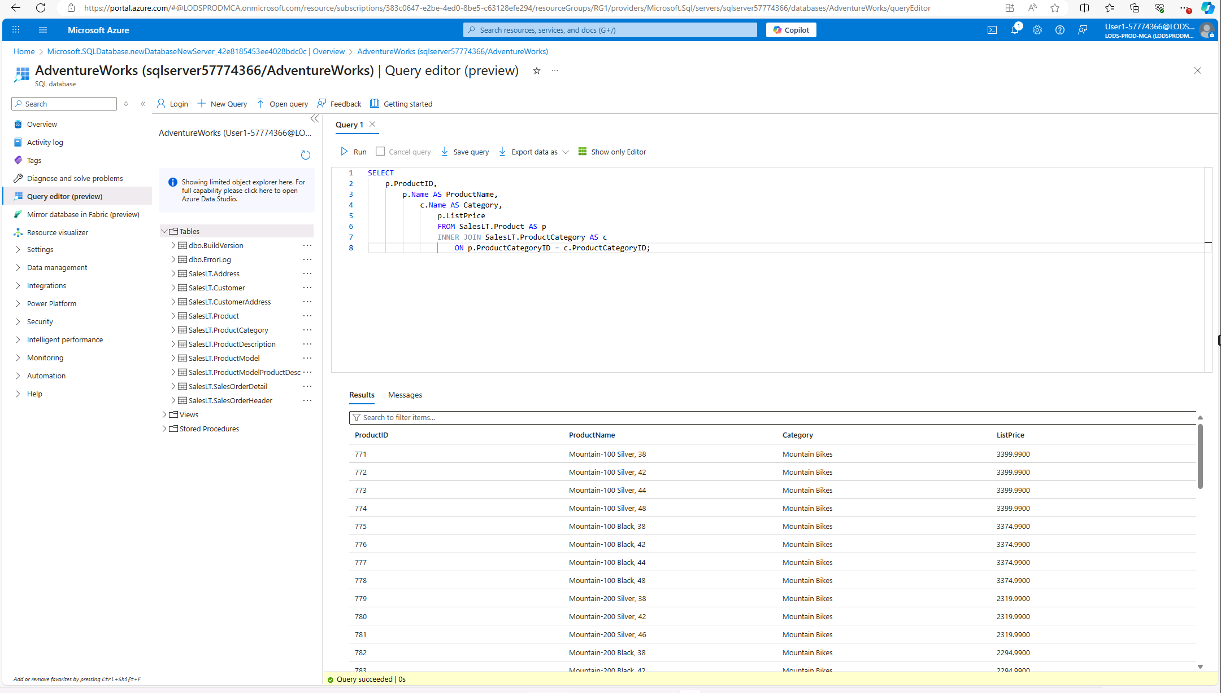

Day 3: Task 2

Please complete the below lab (4) ‘Explore non-relational data in Azure’ and paste evidence of the completed lab in the box provided.



Completed lab | 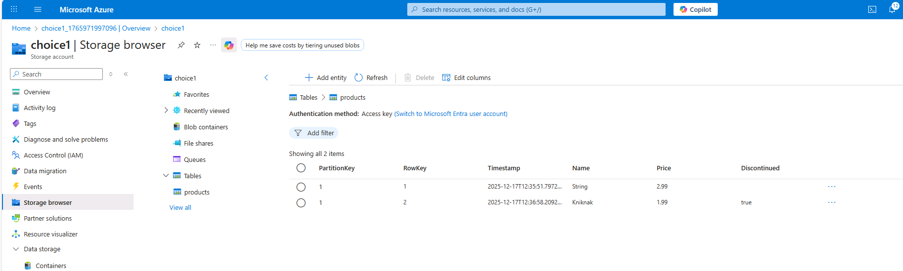  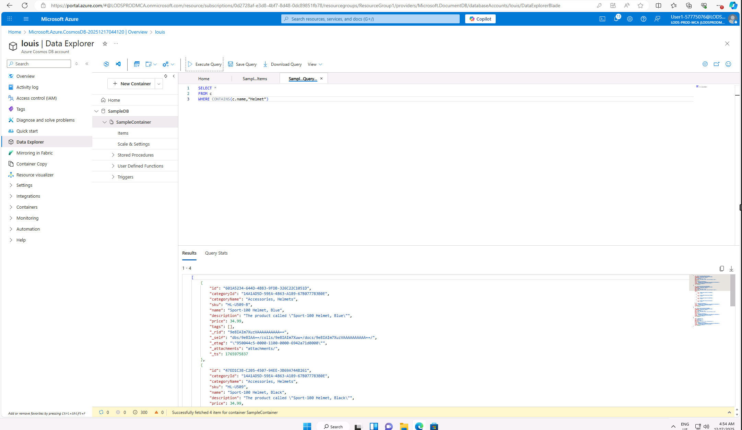

Day 3: Task 3

Please complete the below lab (5) ‘Explore data analytics in Azure’ and paste evidence of the completed lab in the box provided.

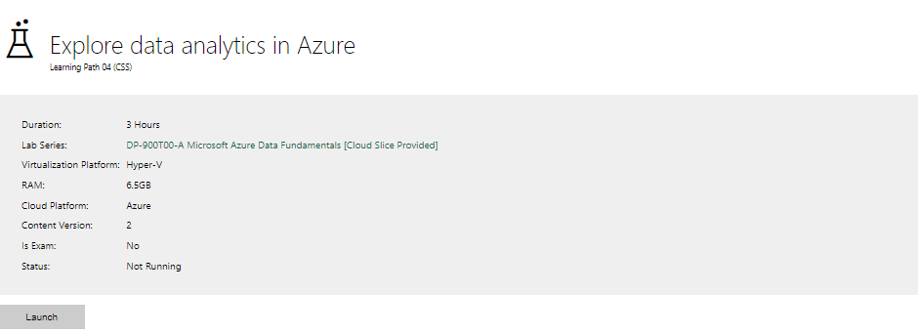

Completed lab | 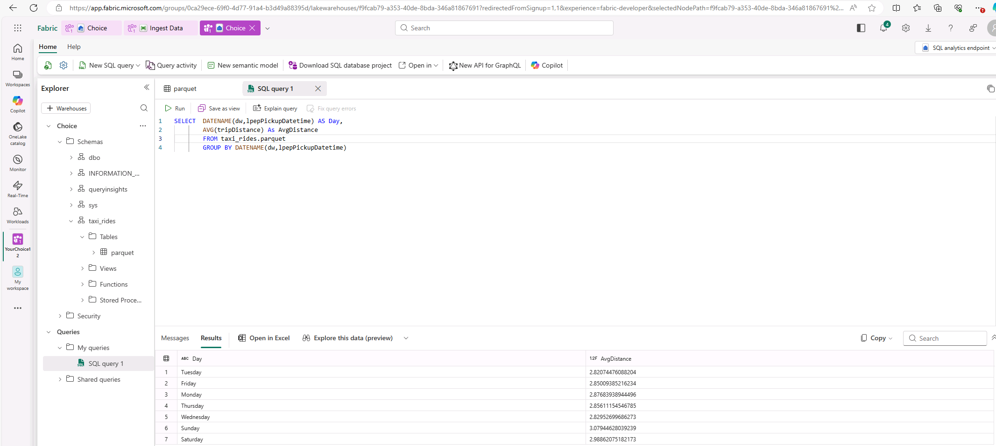  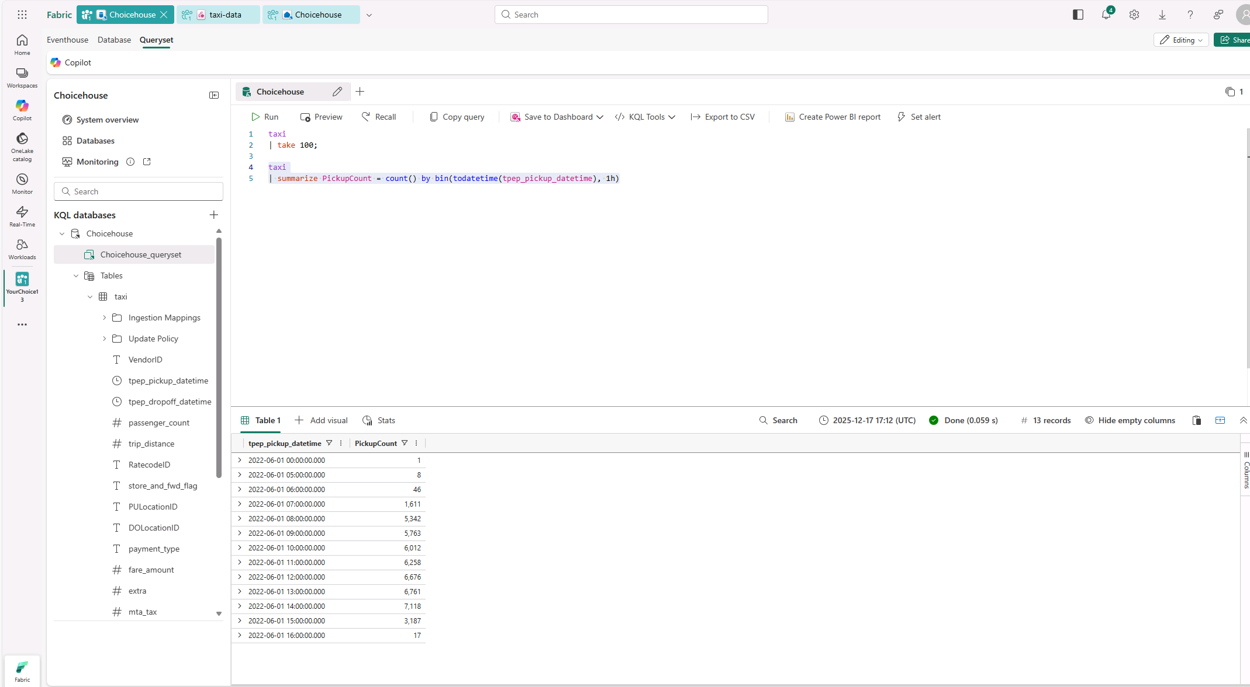  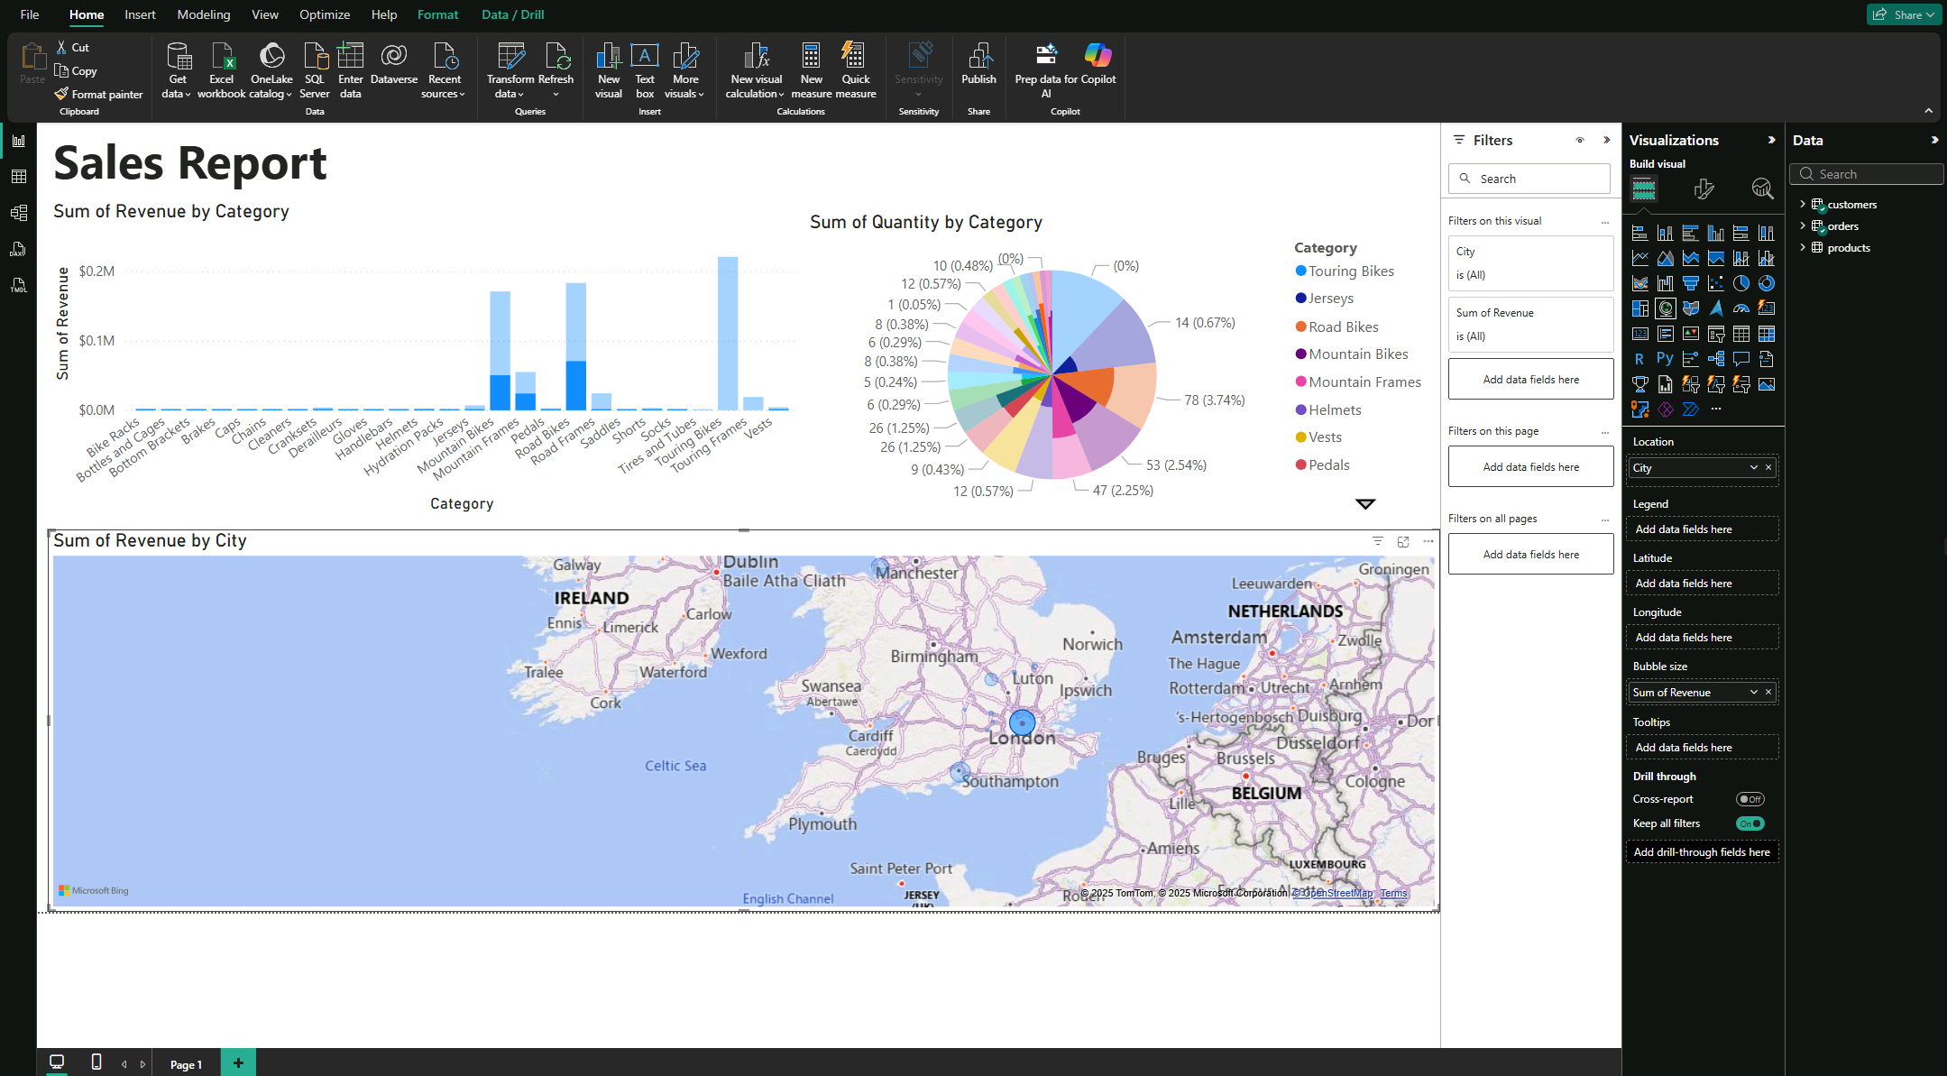

Day 4: Task 1

In your teams, complete the Azure DP-900 practice exam and paste your result below – this is open book and please research and discuss your answers as a team.


Result | 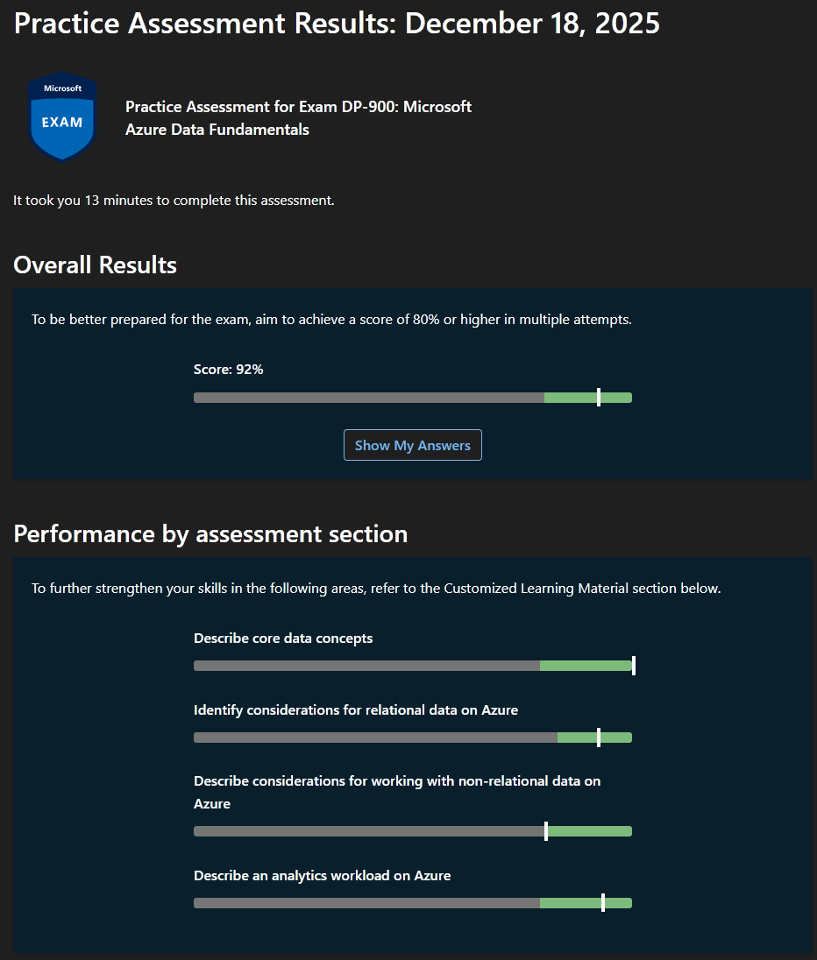

Day 4: Task 2

1. Scenario Background
"Paws & Whiskers" is a growing pet shop that aims to improve its business by analysing sales, customer information, and inventory data. Currently, the data is collected manually or stored in spreadsheets. Management is interested in transitioning to Microsoft Azure to streamline data storage, analysis, and reporting, enabling them to make data-driven decisions.

2. Data Laws and Regulations
Identify and explain the data laws and regulations relevant to handling customer data within the proposal. Ensure you cover the following points:
- GDPR Compliance: Highlight the importance of adhering to the General Data Protection Regulation (GDPR), particularly as it relates to storing and processing customer information.
- Data Protection Act (DPA) 2018: Outline how the DPA 2018 may affect the way "Paws & Whiskers" collects and stores data, ensuring compliance with UK laws on data privacy.
- Other Industry Standards: Research any additional data protection standards or regulations that may apply to pet shop data, particularly if they involve sensitive or payment information.

3. Azure Service Recommendations
Recommend Microsoft Azure services that would suit the company’s data analysis needs and explain why these services are suitable. Your recommendations should include:
- Data Storage: Identify suitable storage options, such as Azure Blob Storage or Azure SQL Database, and discuss the benefits of each for storing large datasets, including inventory, sales transactions, and customer details.
- Data Analysis Tools: Recommend tools such as Azure Machine Learning for customer behaviour analysis or Azure Synapse Analytics for analysing sales trends.
- Data Integration and Automation: Explain how services like Azure Data Factory could automate data collection and integration processes, improving efficiency.

4. Data Types and Data Modelling
Define the types of data "Paws & Whiskers" will need to work with and describe your approach to data modelling:
- Data Categories: Identify key data types, such as customer demographics, transaction history, pet inventory, and product categories.
- Data Modelling Approach: Outline how you would structure this data using a relational model or a data warehouse approach, considering factors like tables, entities, relationships, and primary keys.

5. Data Storage Formats and Structures in Azure
Discuss how you would store data within Azure and the formats you would recommend:
- Data Formats: Specify recommended formats (e.g., CSV for raw data imports, JSON for structured data, Parquet for analytics) and explain why these formats are suitable for specific data types.
- Data Security and Encryption: Include recommendations for securing data using Azure’s built-in encryption features and access controls to ensure compliance with data privacy regulations.

6. Additional Considerations
Provide any other considerations that might enhance data handling and efficiency in Azure, such as:
- Backup and Disaster Recovery: Outline a backup plan using Azure Backup or Azure Site Recovery to safeguard against data loss.
- Data Visualisation: Discuss potential use of Power BI within Azure for creating dashboards that provide management with real-time insights into sales and customer trends.
- Future Scalability: Comment on how Azure services can scale as the business grows, accommodating larger datasets and more complex analyses.

Submission Guidelines:
- Structure: Ensure your report is well-organised, with sections for each task (e.g., Data Laws, Azure Services, Data Types, etc.).
- Formatting: Include headings, bullet points where appropriate, and any visuals or diagrams that support your explanations.
- References: Cite any resources or regulations referenced in the report.
- Length: Aim for 1500-2000 words.

Azure Data Platform Proposal for Paws & Whiskers
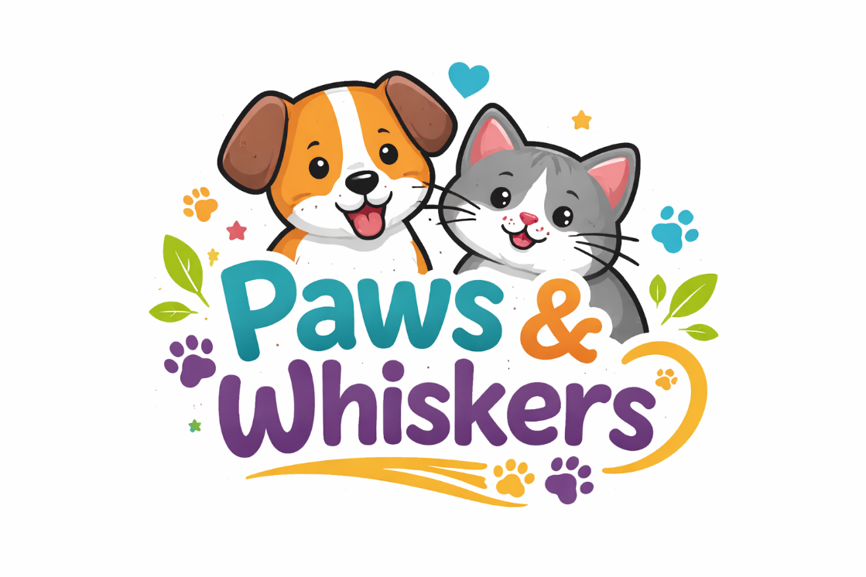
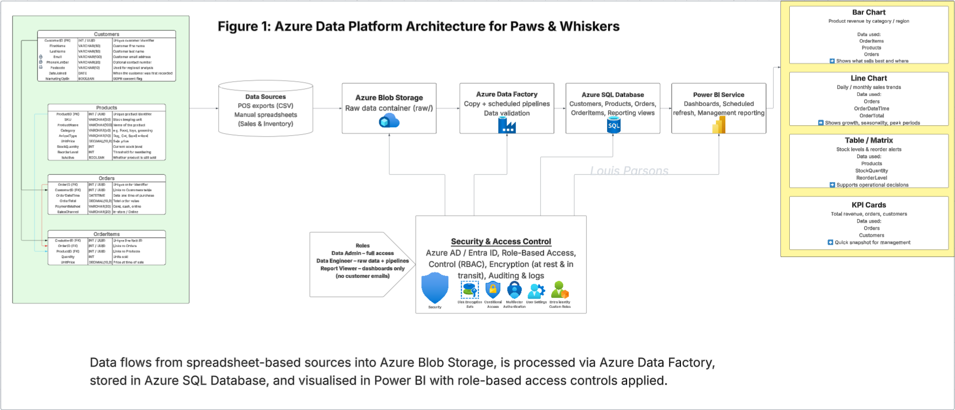

Contents
  - Scenario Background
1.1 Business Context
1.2 Current Challenges and Objectives
  - Data Laws and Regulations
2.1 GDPR Compliance
2.2 Data Protection Act (DPA) 2018
2.3 Other Industry Standards
  - Azure Service Recommendations
3.1 Data Storage Services
3.2 Data Analysis Tools
3.3 Data Integration and Automation
  - Data Types and Data Modelling
4.1 Data Categories
4.2 Relational Data Model
4.3 Analytical / Warehouse-Style Reporting Layer
  - Data Storage Formats and Structures in Azure
5.1 Data Formats
5.2 Data Security and Encryption
  - Additional Considerations
6.1 Backup and Disaster Recovery
6.2 Data Visualisation
6.3 Future Scalability
  - Security and Access Control
7.1 Role Definitions
7.2 Access Restrictions by Service
7.3 Auditing and Compliance Support
  - Example SQL Queries and Formulas
8.1 Data Quality Queries
8.2 Revenue and Performance Calculations
8.3 Operational Queries
  - References

1. Scenario Background
“Paws & Whiskers” is a growing pet shop that wants to improve business performance by analysing sales, customer information, and inventory data. At the moment, this information is collected manually or stored in spreadsheets. That approach works when there are only a few products and a small number of daily sales, but it breaks down quickly as the business expands. Common issues include duplicated customer records, inconsistent product naming, accidental formula errors, and slow reporting (because someone has to manually combine sheets and “clean” the data before management can see anything useful).
Management’s goal is to transition to Microsoft Azure to streamline data storage, analysis, and reporting. The core value of Azure for this scenario is that it provides a secure, central environment where raw data can be stored safely, cleaned in a repeatable way, loaded into structured tables for reporting, and then visualised in dashboards. Instead of spending time rebuilding the same report every week, Paws & Whiskers can build a pipeline once and then let it run on a schedule.
This proposal covers the legal and regulatory responsibilities around customer data, recommends Azure services that match the business needs, describes the data types and modelling approach, explains storage formats and structures, and outlines additional considerations such as security, backup, reporting, and scalability.

2. Data Laws and Regulations
When Paws & Whiskers stores customer data in Azure, the business remains legally responsible for how that data is used and protected. Cloud storage does not reduce accountability; it just changes where the data lives and how it is managed.
GDPR Compliance
The General Data Protection Regulation (GDPR) applies to organisations processing personal data of individuals in the UK/EU. For Paws & Whiskers, personal data includes customer names, email addresses, phone numbers, addresses/postcodes, loyalty scheme identifiers, and potentially purchase history (because it can be linked back to an identifiable person).
In practice, GDPR affects the platform design in the following ways:
- Lawful basis and transparency: The business must be clear about why it collects customer data (e.g., fulfilling orders, loyalty rewards, marketing with consent). This means a privacy notice and clear customer communication, not just a “hidden” spreadsheet.
- Data minimisation: Only collect what is actually needed. For example, if phone numbers are optional, don’t make them mandatory fields.
- Access control: Not every staff member should be able to open a customer list with emails. Azure access needs to be role-based.
- Security: Data must be protected against unauthorised access, loss, or leakage. Azure supports encryption and access auditing, but the business still has to configure permissions properly.
- Retention: Customer data shouldn’t be kept forever “just in case”. A retention policy should exist (e.g., remove marketing contacts after a defined period of inactivity, retain invoices for a legally required period).
Data Protection Act (DPA) 2018
The Data Protection Act 2018 is the UK’s implementation of GDPR. For Paws & Whiskers, the impact is mostly practical: the business must handle personal data in a way that respects data subject rights (access requests, correction requests, deletion where appropriate), and must apply security that matches the sensitivity of the data.
This shapes the Azure implementation in terms of:
- Clear ownership: who is responsible for approving access to customer data (e.g., manager / data admin role).
- Auditability: the ability to show who accessed the database, when, and what they did (e.g., read/export activity).
- Secure processing: using encryption, identity management, and limited access pathways rather than shared logins.
Other Industry Standards
While GDPR/DPA focus on privacy, there are additional standards that can be relevant depending on what data is handled:
- PCI DSS (Payment Card Industry Data Security Standard): If the shop takes card payments, PCI DSS applies to the handling of card data. The safest approach is not to store card details at all in the Paws & Whiskers database; instead, use a third-party payment provider and only store non-sensitive references (e.g., transaction ID, payment status, payment method type).
- ISO/IEC 27001 (information security management): This is not a law, but it’s a widely recognised security standard. Azure’s compliance posture can help, and the proposal can align with ISO thinking by applying least privilege, logging, and documented controls.

3. Azure Service Recommendations
This section recommends Azure services based on what the business needs: storage for raw and structured data, automation for ingestion/cleaning, analytics capability, and reporting.
Data Storage
Azure Blob Storage (in an Azure Storage Account)
Blob Storage is ideal for storing raw files such as CSV exports from spreadsheets or POS systems. It’s low-cost, scalable, and doesn’t require strict structure. For Paws & Whiskers, Blob Storage can act as the “landing zone” where daily/weekly uploads arrive unchanged. That matters because it provides an audit trail: if numbers look wrong later, you can check what was uploaded and re-run processing.
Recommended structure (containers/folders):
- raw/ (original uploads, never edited)
- staged/ (cleaned outputs or intermediate extracts)
- curated/ (report-ready data, optionally parquet if using analytics services later)
Azure SQL Database
Azure SQL Database is suitable for the cleaned, structured dataset used for reporting. It supports tables, relationships, constraints, and indexing. For Paws & Whiskers, it would store core operational entities like Customers, Products, Orders, and OrderItems. This matches relational modelling skills already covered (tables, keys, joins) and supports Power BI integration cleanly.
Why both? Blob is best for raw files and history; SQL is best for structured queries and reporting. Together they form a simple but effective platform.
Data Analysis Tools
Azure Synapse Analytics (optional early, stronger later)
Synapse is useful when the business accumulates larger volumes of historical data and wants faster trend analysis over multiple years, or wants to query files directly from data lake-style storage. For the initial version, Paws & Whiskers can focus on Azure SQL + Power BI, but Synapse is a sensible “phase 2” service once reporting needs grow.
Azure Machine Learning (future-focused)
Azure ML could support customer behaviour analysis or forecasting (e.g., predicting stock demand for seasonal products). This is not essential for day one, but it’s worth identifying as a future option because management may eventually want predictions rather than just dashboards.
Data Integration and Automation
Azure Data Factory (ADF)
ADF automates ingestion from Blob Storage to Azure SQL Database. It provides repeatable pipelines, scheduling, and a visual interface that fits a learner-level build. For Paws & Whiskers, ADF can:
- Copy raw CSV files into SQL staging tables
- Trigger cleaning steps (SQL scripts/stored procedures)
- Load final reporting tables and views on a schedule
This removes the need for manual “copy-paste and tidy” work each week.

4. Data Types and Data Modelling
Data Categories
Paws & Whiskers will work with several main data categories:
- Customer demographics: Name, email, phone, postcode, loyalty ID, date joined, marketing consent flag.
- Transaction history: Order date/time, items bought, quantities, prices, total order value, payment method type, store/online flag.
- Inventory data: Product IDs/SKUs, stock quantity, reorder threshold, supplier name, cost price (if tracked), expiry date (for relevant items).
- Product categories: Category (food/toys/grooming), animal type (dog/cat/etc), brand, product size/variant.
Data Modelling Approach
Relational model (operational reporting core)
A relational model is the most realistic approach for a small business starting in Azure SQL. Suggested tables:
- Customers(CustomerID PK, FirstName, LastName, Email, Phone, Postcode, DateJoined, MarketingOptIn)
- Products(ProductID PK, SKU, ProductName, Category, AnimalType, UnitPrice, StockQuantity, ReorderLevel, SupplierName, IsActive)
- Orders(OrderID PK, CustomerID FK, OrderDateTime, PaymentMethod, OrderTotal)
- OrderItems(OrderItemID PK, OrderID FK, ProductID FK, Quantity, UnitPrice)
This structure supports integrity (keys/relationships), and it makes reporting easier because tables join predictably.
Warehouse-style reporting layer (lightweight)
Instead of building a full warehouse immediately, Paws & Whiskers can use:
- SQL views that flatten joins for Power BI
- Later, a simple star schema (SalesFact + dimensions) if performance demands increase
This keeps the first implementation achievable while still following good practice.

5. Data Storage Formats and Structures in Azure
Data Formats
Different formats make sense at different stages:
- CSV for raw imports: Most spreadsheet exports are already CSV-friendly, and ADF can ingest them easily. CSV is best for “raw landing” because it is transparent and easy to inspect.
- JSON for structured/semi-structured data: If Paws & Whiskers later uses an API (e.g., online store, loyalty app), JSON becomes common for event-style data.
- Parquet for analytics: If Synapse or Fabric-style analytics is introduced, Parquet is more efficient for large-scale querying due to columnar storage and compression.
Data Security and Encryption
Azure supports security controls that help meet GDPR/DPA expectations:
- Encryption at rest (Storage + SQL) and encryption in transit (TLS).
- Identity-based access using Microsoft Entra ID (Azure AD).
- Role-Based Access Control (RBAC) to limit who can access Blob containers, SQL servers, and ADF pipelines.
- Auditing/logging (SQL auditing and storage diagnostics) to track access and changes.
The key design decision is to restrict access by role, not trust.

6. Additional Considerations
Backup and Disaster Recovery
- Azure Backup can protect Azure SQL Database and storage accounts through scheduled backups and retention policies.
- Azure Site Recovery can be considered if the business later depends on high availability and requires recovery workflows. For a small shop, standard SQL automated backups plus storage redundancy is often a realistic baseline.
Data Visualisation
Power BI is the best fit for management dashboards. It can connect directly to Azure SQL Database and refresh on a schedule. Typical dashboards could include:
- Weekly revenue and sales volume
- Top-selling categories/products
- Low-stock and stock-out risk list
- Repeat customers vs new customers
- Sales by day/time (peak trading periods)
Future Scalability
Azure services can scale as the business grows:
- Blob storage grows cheaply with data volume
- Azure SQL can be scaled up (compute tier) as usage increases
- ADF pipelines can be extended to support more sources
- Synapse/ML can be added later without replacing the base platform

7. Security and Access Control
A realistic security model for a small business needs to be simple but strict around personal data. The platform should separate access into roles:
Data Admin (Manager/IT): full access to Storage, SQL, and ADF. Responsible for permissions and compliance.
Data Engineer (Analyst/Tech): can access raw containers and staging tables, build pipelines, run loads; should not export customer lists unless explicitly required.
Report Viewer (Staff/Management): read-only access to reporting views and Power BI dashboards; should not see raw files or staging tables.
How this is applied in Azure:
Blob Storage:
raw/ container: Data Admin + Data Engineer only
curated/ container (if used for reporting extracts): Data Admin + Report Viewer (read-only)
Azure SQL Database:
Create a reporting schema or views that exclude email/phone where possible.
Report Viewer gets SELECT permissions only on views, not base tables.
Only Admin/Engineer can read Customers.Email / Customers.Phone.
Power BI:
Dashboards show aggregated results.
If customer-level reporting is needed, use row-level security or limit dataset fields.
This setup supports GDPR/DPA principles by limiting exposure of personal data and creating clear accountability.

8. Example SQL Queries and Formulas
(Included because the platform needs actual logic, not just description)
1) Duplicate customer detection (data quality)
SELECT Email, COUNT(*) AS RecordCount
FROM dbo.Customers
WHERE Email IS NOT NULL
GROUP BY Email
HAVING COUNT(*) > 1;
Purpose: identify duplicate customer rows created by spreadsheet imports or inconsistent entry.
2) Revenue calculation (core business metric)
SELECT SUM(Quantity * UnitPrice) AS TotalRevenue
FROM dbo.OrderItems;
Purpose: calculate revenue directly from transactions so totals are consistent.
3) Category performance (what to stock more of)
SELECT p.Category,
SUM(oi.Quantity * oi.UnitPrice) AS CategoryRevenue
FROM dbo.OrderItems oi
JOIN dbo.Products p ON oi.ProductID = p.ProductID
GROUP BY p.Category
ORDER BY CategoryRevenue DESC;
Purpose: show which product categories drive sales.
4) Low stock list (operational action)
SELECT ProductName, StockQuantity, ReorderLevel
FROM dbo.Products
WHERE StockQuantity <= ReorderLevel
ORDER BY StockQuantity ASC;
Purpose: generate an automated reorder shortlist for staff.
5) Daily sales trend (Power BI line chart feed)
SELECT CAST(o.OrderDateTime AS date) AS SalesDate,
SUM(o.OrderTotal) AS DailySales
FROM dbo.Orders o
GROUP BY CAST(o.OrderDateTime AS date)
ORDER BY SalesDate;
Purpose: trend analysis and seasonality.

9. References
UK Government. Data Protection Act 2018.
European Union. General Data Protection Regulation (GDPR).
Microsoft. Azure SQL Database Documentation.
Microsoft. Azure Blob Storage Documentation.
Microsoft. Azure Data Factory Documentation.
Microsoft. Power BI Documentation.
Microsoft. Azure Well-Architected Framework – Security and Reliability.
Microsoft Learn. Introduction to Core Data Concepts in Azure (DP-900).
PCI Security Standards Council. PCI DSS Quick Guide.
IBM. Relational Databases vs Non-Relational Databases.
Amazon Web Services (AWS). Data Warehousing Concepts and Best Practices.

Course Notes

It is recommended to take notes from the course, use the space below to do so, or use the revision guide shared with the class:

We have included a range of additional links to further resources and information that you may find useful, these can be found within your revision guide.

END OF WORKBOOK

Please check through your work thoroughly before submitting and update the table of contents if required.

Please send your completed work booklet to your trainer.

