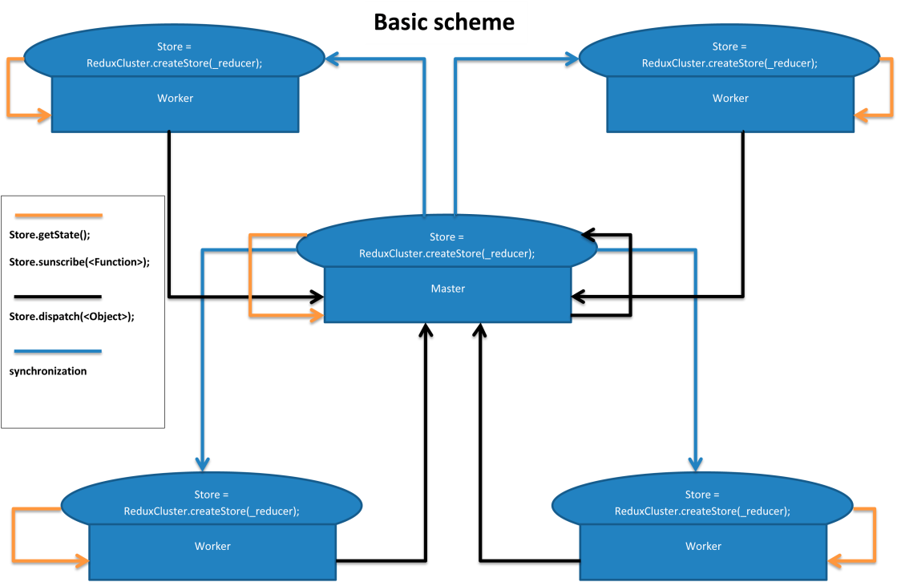 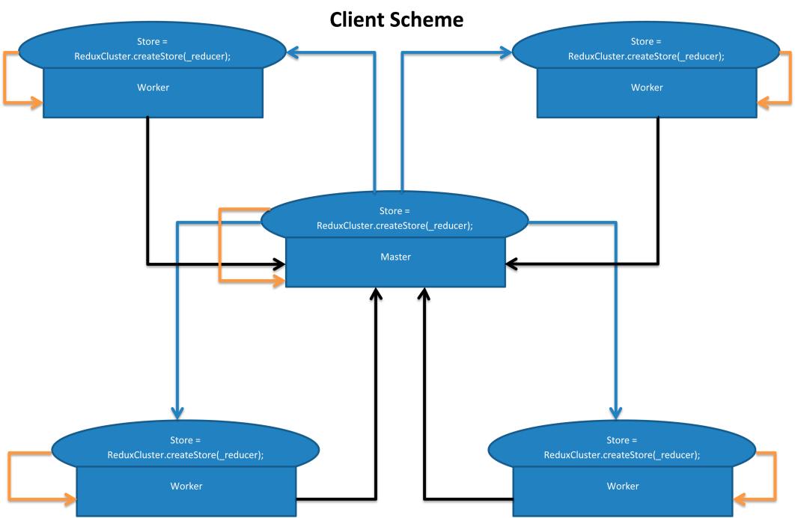

**Cluster Scheme**

Store.createClient(<Object>);

Store.createServer(<Object>);

TCP

TCP

Store.createClient(<Object>);

Store.createClient(<Object>);

IPC

LINUX (FILE SOCKET)

WINDOWS (NAMMED CHANNEL)

IPC

LINUX (FILE SOCKET)

IPC

WINDOWS (NAMMED CHANNEL)

IPC

Store.createServer(<Object>);

Store.createServer(<Object>);

 