CREATE DATABASE IF NOT EXISTS `concretepage`

USE `concretepage`;

CREATE TABLE IF NOT EXISTS `person` (

`pid` int(5) NOT NULL AUTO_INCREMENT,

`name` varchar(100) NOT NULL,

`location` varchar(100) NOT NULL,

PRIMARY KEY (`pid`)

) ENGINE=InnoDB AUTO_INCREMENT=14 DEFAULT CHARSET=latin1;

INSERT INTO `person` (`pid`, `name`, `location`) VALUES

(1, 'Mahesh', 'Varanasi'),

(2, 'Ram', 'Ayodhya');

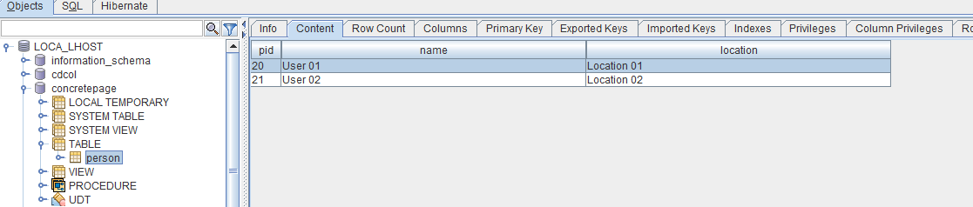

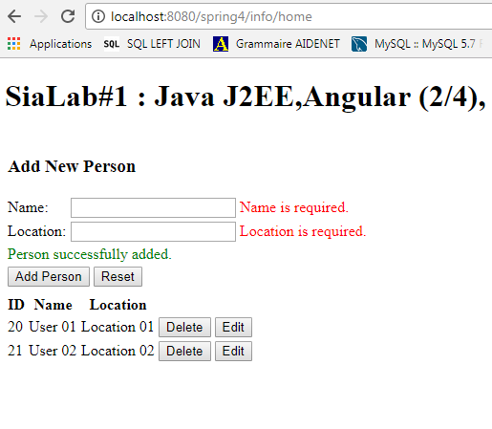http://localhost:8080/spring4/info/home