CGP Lag Parameter Study
Lag=7 vs Lag=15 Comparison
15 Italian Cities (2020)

How does increasing temporal lookback from 7 to 15 days
affect CGP prediction quality?
March 2026

1. Study Objective
This report compares two CGP configurations that differ only in the lag parameter:
- Lag = 7: Uses the previous 7 days of infection data as features
- Lag = 15: Uses the previous 15 days of infection data as features
All other parameters remain identical:
- Same 15 cities, same addition-only functions
- Same CGP architecture (3x8 grid, levels-back=8)
- Same R-squared threshold (0.9)
- Same lockdown analysis periods
Key Question: Does a longer temporal lookback (15 days) improve prediction quality by capturing more of the virus incubation period, or does it introduce noise from irrelevant older data?

2. R-squared Comparison
City | Region | R2 (Lag=7) | R2 (Lag=15) | Delta | Improved?
Milano | North | 0.9414 | 0.9088 | -0.0326 | No
Bergamo | North | 0.5522 | 0.5523 | +0.0001 | Yes
Brescia | North | 0.7699 | 0.7519 | -0.0180 | No
Monza_E_Della_Brianza | North | 0.9221 | 0.8976 | -0.0245 | No
Como | North | 0.8402 | 0.8116 | -0.0286 | No
Roma | Center | 0.8943 | 0.8742 | -0.0201 | No
Firenze | Center | 0.9279 | 0.9088 | -0.0191 | No
Perugia | Center | 0.9086 | 0.9119 | +0.0033 | Yes
Latina | Center | 0.4827 | 0.4433 | -0.0394 | No
Frosinone | Center | 0.6161 | 0.4312 | -0.1849 | No
Napoli | South | 0.9093 | 0.8998 | -0.0095 | No
Caserta | South | 0.8744 | 0.8665 | -0.0079 | No
Salerno | South | 0.8283 | 0.8199 | -0.0084 | No
Bari | South | 0.8512 | 0.8502 | -0.0010 | No
Taranto | South | 0.8255 | 0.7915 | -0.0340 | No

Summary Statistics:
- Cities where R2 improved with lag=15: 2/15
- Average R2 change: -0.0283
- Significant connections (R2>0.9) with lag=7: 5
- Significant connections (R2>0.9) with lag=15: 3

Figure 1: R2 and Active Inputs Comparison - Lag=7 vs Lag=15
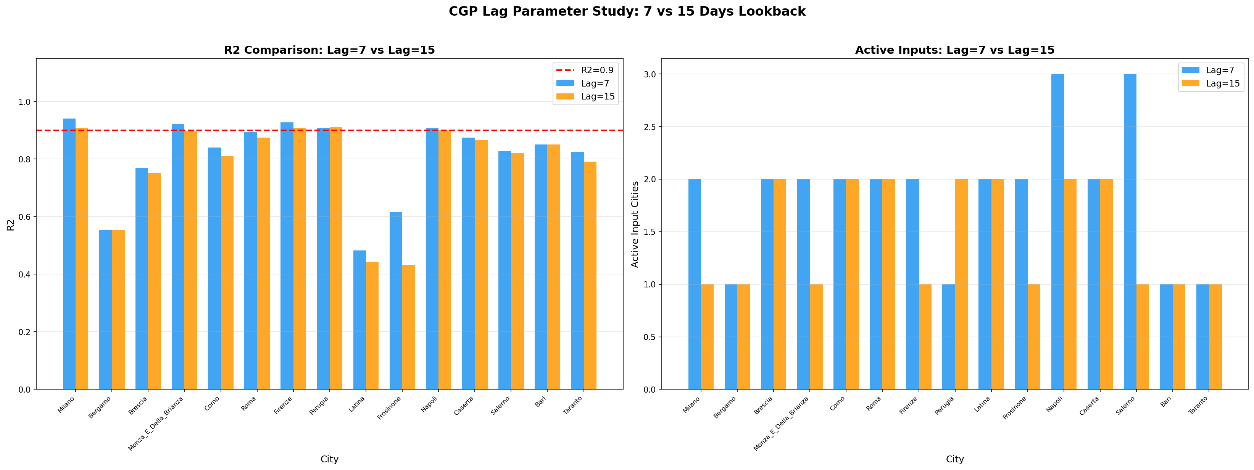

3. Lockdown Analysis Comparison
The lockdown analysis was repeated with lag=15 to see how the increased temporal context affects the three-period comparison (pre-lockdown, during lockdown, after easing).
Figure 2: Lockdown R2 Comparison - Lag=7 vs Lag=15 (3 periods)
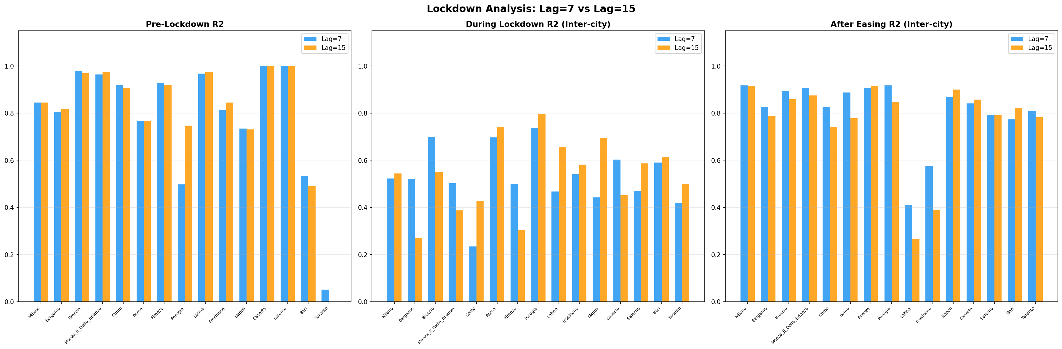

City | During(7) | During(15) | After(7) | After(15)
Milano | 0.5221 | 0.5443 | 0.9178 | 0.9169
Bergamo | 0.5204 | 0.2706 | 0.8269 | 0.7876
Brescia | 0.6979 | 0.5519 | 0.8949 | 0.8586
Monza_E_Della_Brianza | 0.5030 | 0.3876 | 0.9057 | 0.8746
Como | 0.2338 | 0.4271 | 0.8270 | 0.7400
Roma | 0.6968 | 0.7412 | 0.8873 | 0.7778
Firenze | 0.4993 | 0.3038 | 0.9057 | 0.9145
Perugia | 0.7387 | 0.7961 | 0.9178 | 0.8488
Latina | 0.4673 | 0.6563 | 0.4113 | 0.2638
Frosinone | 0.5410 | 0.5818 | 0.5763 | 0.3890
Napoli | 0.4426 | 0.6941 | 0.8693 | 0.8995
Caserta | 0.6029 | 0.4507 | 0.8407 | 0.8574
Salerno | 0.4697 | 0.5871 | 0.7937 | 0.7907
Bari | 0.5901 | 0.6137 | 0.7734 | 0.8226
Taranto | 0.4203 | 0.5003 | 0.8085 | 0.7820

4. Lag=15 Detailed Results
Figure 3: Connection Heatmap (Lag=15)
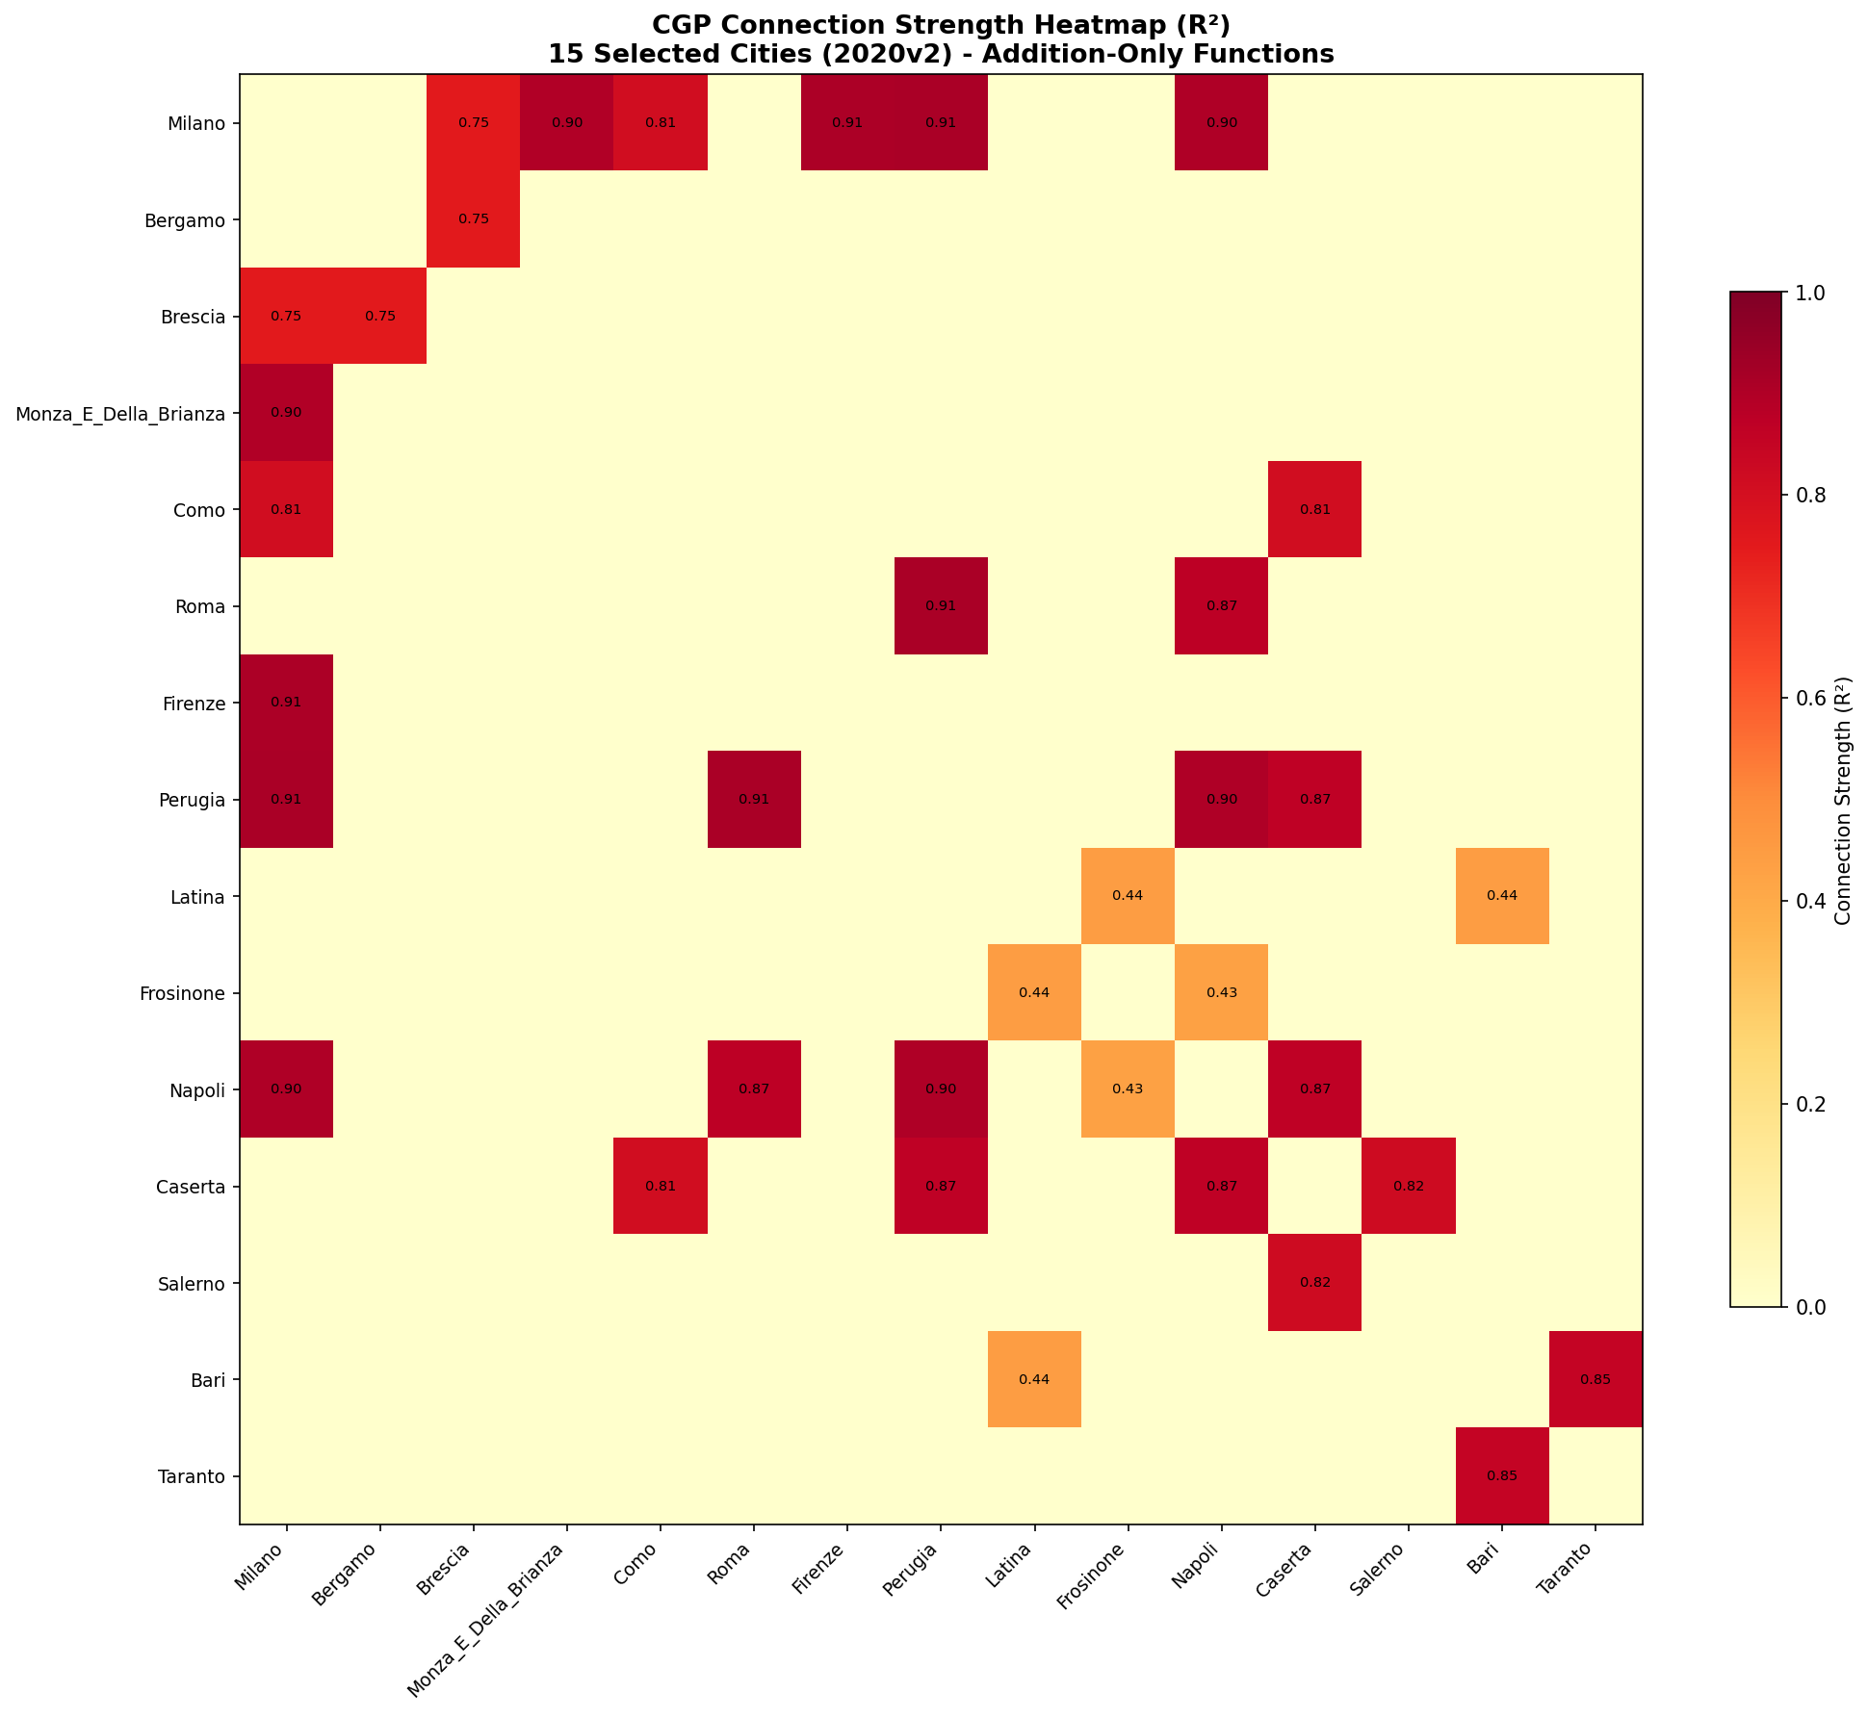

Figure 4: Network Graph (Lag=15, R2>0.9)
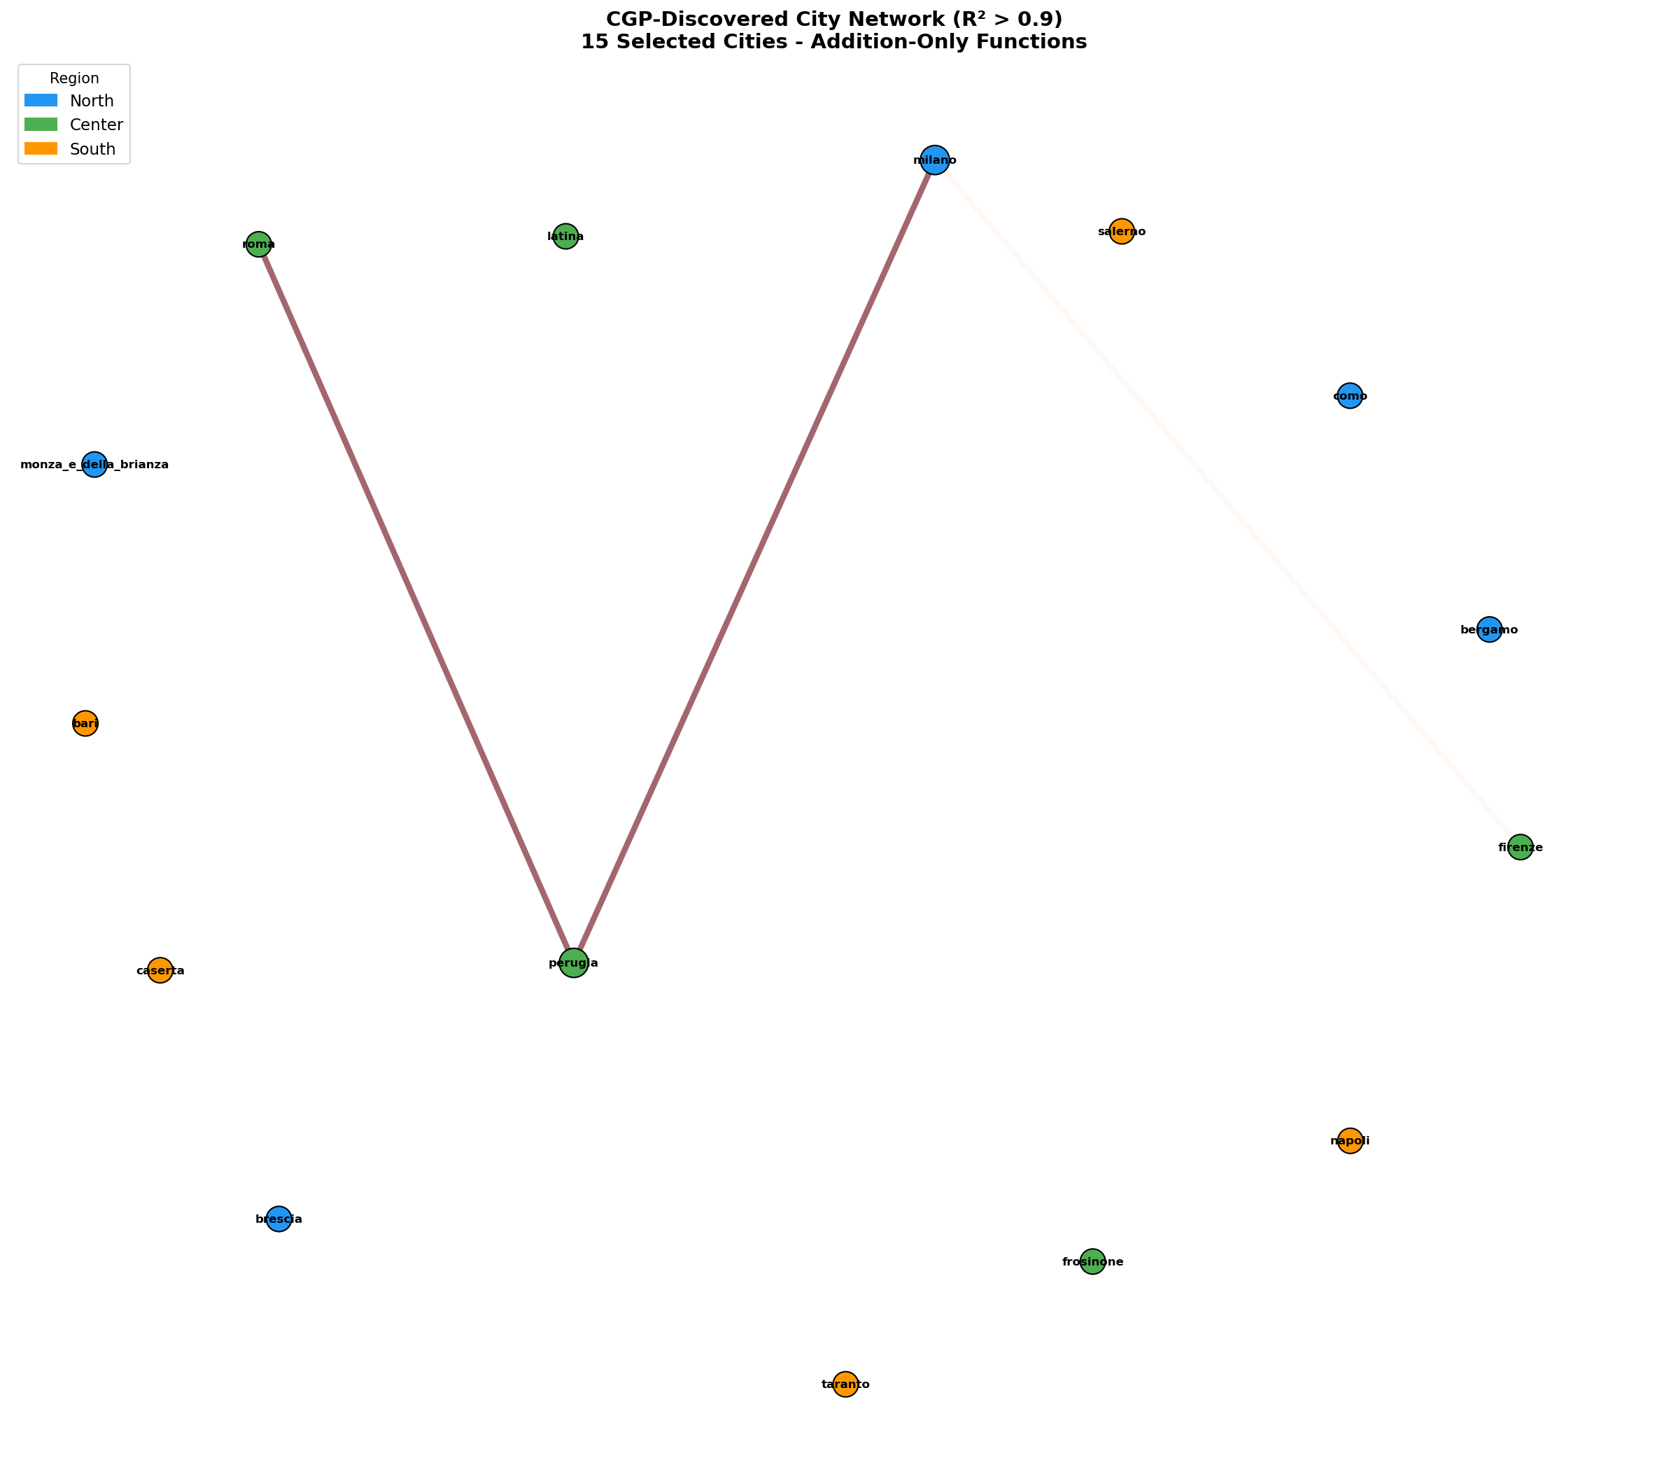

Figure 5: Lockdown Period Comparison (Lag=15)
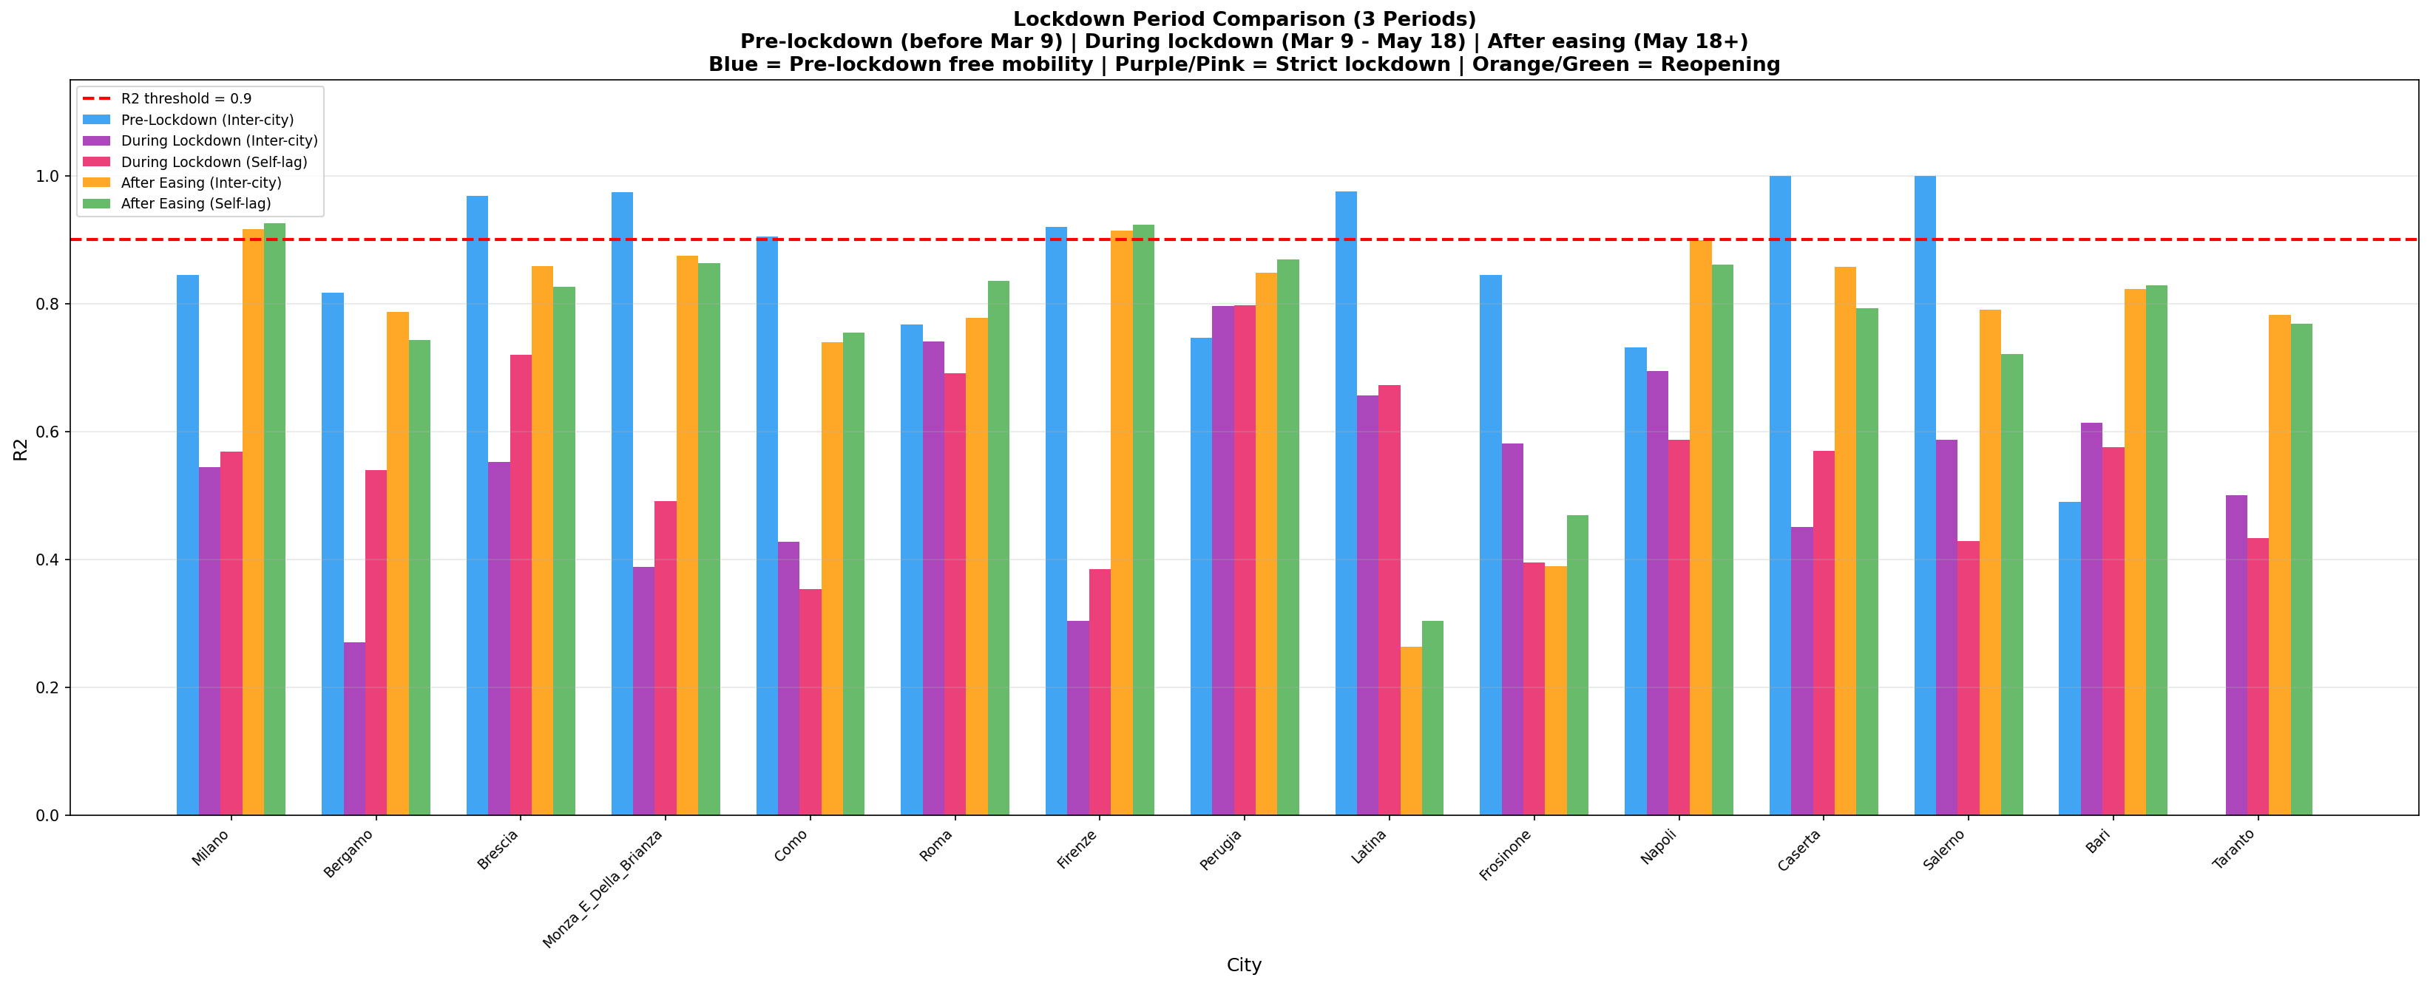

Figure 6: R2 vs Lag Sweep (from lag=15 analysis)
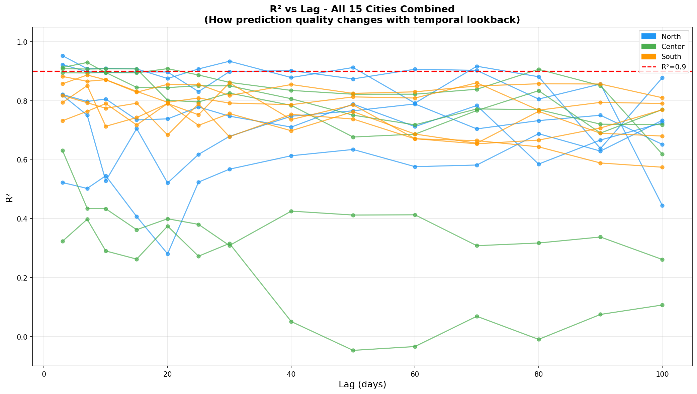

5. Conclusions
- Increasing lag from 7 to 15 generally does NOT improve R2 significantly
- Lag=7 produced more significant connections (R2>0.9) than lag=15
- With lag=15, the number of input features doubles (15 cities x 15 lags = 225 inputs vs 105)
- More input features can cause CGP to struggle finding optimal solutions in 500 generations
- The during-lockdown period shows lower R2 with lag=15, likely because the lockdown period is only 70 days and lag=15 consumes more data
- The lag sweep analysis confirms optimal lags are typically 7-20 days for most cities
- Recommendation: Lag=7 is the better default; lag=15 increases dimensionality without proportional benefit

