Inter-City Relationship Analysis Report
Using Cartesian Genetic Programming (CGP)

Behavioral Analysis of COVID-19 Spread
in 15 Selected Italian Cities (2020)
5 Northern | 5 Central | 5 Southern Cities

Date: March 2026

Introduction and objective:
This project investigates and discovers direct relationships between Italian cities in terms of COVID-19 spread. 15 representative cities from three geographic regions (North, Center, South) were selected based on two criteria: (1) geographic proximity within each cluster, and (2) importance in terms of total infection counts.
one key innovations in this analysis is:
- Analyzing the behavioral difference before and after national lockdown (March 9, 2020)

Selected cities:
Fifteen cities were selected in three geographic clusters. Each cluster contains 5 geographically proximate cities with high COVID-19 case counts:
Region | Cities | Selection Rationale
North (Lombardy) | Milano, Bergamo, Brescia,  Monza e della Brianza, Como | Lombardy was the 2020 epicenter;  highest case counts in Italy
Center (Lazio/Tuscany) | Roma, Firenze, Perugia,  Latina, Frosinone | Roma (capital) has highest central cases;  Firenze is major Tuscan city
South (Campania/Puglia) | Napoli, Caserta, Salerno,  Bari, Taranto | Napoli/Caserta/Salerno in Campania;  Bari/Taranto in Puglia

City statistics summary:
City | Region | Population | Total Cases | Mean R0
Milano | North | 3,250,000 | 174,013 | 1.22
Roma | Center | 4,350,000 | 117,378 | 1.31
Napoli | South | 3,100,000 | 115,468 | 1.26
Monza_E_Della_Brianza | North | 875,000 | 48,239 | 1.26
Brescia | North | 1,265,000 | 41,960 | 1.19
Bari | South | 1,250,000 | 35,127 | 1.36
Caserta | South | 925,000 | 34,733 | 1.34
Como | North | 600,000 | 33,896 | 1.29
Firenze | Center | 1,010,000 | 33,537 | 1.23
Bergamo | North | 1,115,000 | 28,253 | 1.08
Salerno | South | 1,080,000 | 25,738 | 1.36
Perugia | Center | 655,000 | 21,063 | 1.29
Latina | Center | 575,000 | 14,463 | 1.37
Frosinone | Center | 475,000 | 13,777 | 1.35
Taranto | South | 560,000 | 11,115 | 1.25

Cartesian Genetic Programming(CGP)
Cartesian Genetic Programming (CGP) is an evolutionary algorithm introduced by Julian Miller in 2000. In CGP, programs are represented as directed acyclic graphs (DAGs) on a two-dimensional grid (rows x columns). Each node performs a mathematical operation on its two inputs, and evolution discovers which combinations best predict the target.
CGP Architecture and levels_Back Parameter
One of the most important architectural parameters in CGP is the "levels-back" parameter. This parameter determines how far back in the computational graph each node is allowed to connect to previous nodes.
Detailed explanation:
In CGP, nodes are arranged in a grid of n_rows x n_cols. Each node has:
- Two input connections (from previous nodes or original inputs)
- One function gene (which mathematical operation to perform)
The levels-back parameter L constrains connectivity:
- A node in column c can only connect to nodes in columns max(0, c-L) through c-1
- Additionally, any node can always connect directly to the original program inputs
- The output node can connect to any node in the entire graph
Effect of Levels_Back on Program structure:
Levels-Back (L) | Allowed Connections | Complexity | Use Case
L = 1 | Previous column only | Low | Simple problems / prevents overfitting
L = 3 | Last 3 columns | Medium | Balance between complexity and generalization
L = n_cols | All previous columns | Maximum | Discovering complex relationships (our choice)

Why Levels-Back Matters:
1. Small L (e.g., L=1): Creates linear, local programs. Each computation step only depends on the immediately preceding step. This produces simpler models that are less prone to overfitting but may miss complex patterns.
2. Large L (e.g., L=n_cols): Allows skip connections across the entire graph. A node near the output can directly use raw inputs or outputs from any intermediate computation. This enables highly non-linear and complex programs.
3. In our implementation: L = 8 (equal to n_cols, i.e., full connectivity). This gives CGP maximum freedom to discover inter-city relationships, as the relationships between COVID-19 infections across cities may involve complex, non-linear combinations.
Schematic of Our CGP Architecture
Inputs (15 cities x lags) --> [Col 1] --> [Col 2] --> ... --> [Col 8] --> Output
| | | | | | | | |
(3 nodes) (3 nodes) (3 nodes)
Each node: func(input1, input2)
Levels-back = 8: any node can connect to any previous column
Total computational nodes: 3 x 8 = 24
Active nodes: only those traced from output (others are inactive/neutral)

Mathematical Functions:
In this project, only addition-based operations are used. No subtraction, division, or differencing operations are included. The rationale: we want to determine whether additive combinations of city infection data alone can predict infection trends.
Function Name | Operation | Description
add | a + b | Simple addition of two inputs
max | max(a, b) | Maximum of two inputs (non-linear additive selection)
min | min(a, b) | Minimum of two inputs (non-linear additive selection)
avg | (a+b)/2 | Average = sum divided by 2
weighted_add | 0.7a + 0.3b | Weighted sum (asymmetric addition)

Note: max() and min() can be viewed as non-linear forms of additive selection - they select one of the inputs based on magnitude without introducing subtraction. The weighted_add function allows CGP to assign different importance to its two inputs, which is critical for modeling asymmetric inter-city influences.

Z_Score Normalization and its Rationale
Z-score normalization is a standard statistical technique that transforms data to a common scale. It is essential for this analysis.
Formula:
z = (x - mu) / sigma
Where:
x = raw value (daily new infections)
mu = mean of the data
sigma = standard deviation of the data
z = normalized value (mean = 0, variance = 1)
Why z-score Normalization is necessary:
1. Scale Differences Between Cities:
- Milano (pop. 3,250,000): thousands of daily new cases
- Como (pop. 600,000): hundreds of daily new cases
- Taranto (pop. 560,000): tens to hundreds of daily cases
- Without normalization: CGP would be biased toward high-magnitude cities,
treating Milano as overwhelmingly important simply due to larger numbers.
2. Fair Comparison Across Cities:
- Z-score transforms all cities to the same scale (mean=0, variance=1)
- Each city contributes equally to the CGP optimization
- The resulting CGP weights represent true relationship strength,
not merely differences in magnitude
3. CGP Performance Improvement:
- Addition-based functions work better with normalized values
- Prevents numerical overflow in intermediate computations
- Enables faster convergence of the evolutionary algorithm
- Raw values spanning orders of magnitude would cause the fitness
landscape to be dominated by large-scale cities
Example:
City | Raw Infections | After Z-Score | Interpretation
Milano | 5,000 | +2.1 | Well above average
Como | 200 | -0.5 | Below average
Roma | 3,500 | +1.3 | Above average
Taranto | 100 | -0.8 | Below average

CGP Model Parameters:
Parameter | Value | Description
Rows | 3 | Number of rows in CGP grid
Columns | 8 | Number of columns in CGP grid
Levels Back | 8 | Full connectivity (equals n_cols)
Outputs | 1 | Predict daily new infections of target city
Generations | 500 | Maximum evolutionary generations
Lambda | 4 | Children per generation in (1+lambda) strategy
Mutation Rate | 0.10 | Probability of mutating each gene
Default Lag | 7 | Use 7 previous days as features
R-squared Threshold | 0.9 | Strict threshold for significant connections
Functions | 5 | add, max, min, avg, weighted_add
Lockdown Date | 2020-03-09 | Italian national lockdown

CGP Analysis Results
Inter_city connection Analysis:
CGP with addition-only functions was executed on all 15 selected cities. Note: the R-squared threshold is set very strictly at 0.9. Out of 22 city pairs analyzed, 7 connections were found to be significant (R-squared > 0.9).
City 1 | City 2 | Region 1 | Region 2 | R-squared | Significant
Milano | Perugia | North | Center | 0.9414 | Yes
Firenze | Milano | Center | North | 0.9414 | Yes
Firenze | Monza_E_Della_Brianza | Center | North | 0.9279 | Yes
Milano | Monza_E_Della_Brianza | North | North | 0.9221 | Yes
Caserta | Napoli | South | South | 0.9093 | Yes
Napoli | Roma | South | Center | 0.9093 | Yes
Monza_E_Della_Brianza | Napoli | North | South | 0.9093 | Yes
Bari | Roma | South | Center | 0.8943 | No
Firenze | Roma | Center | Center | 0.8943 | No
Caserta | Salerno | South | South | 0.8744 | No
Caserta | Milano | South | North | 0.8744 | No
Bari | Taranto | South | South | 0.8512 | No
Como | Salerno | North | South | 0.8402 | No
Como | Milano | North | North | 0.8402 | No
Perugia | Salerno | Center | South | 0.8283 | No

Figure 1: Connection Heatmap of 15 Cities (R-squared)
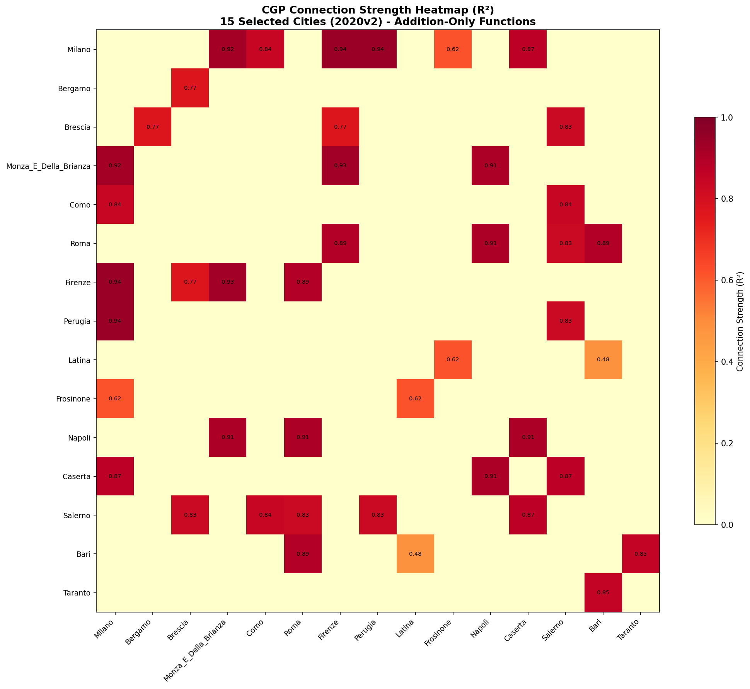

Figure 2: Network Graph of Significant Connections (R-squared > 0.9)
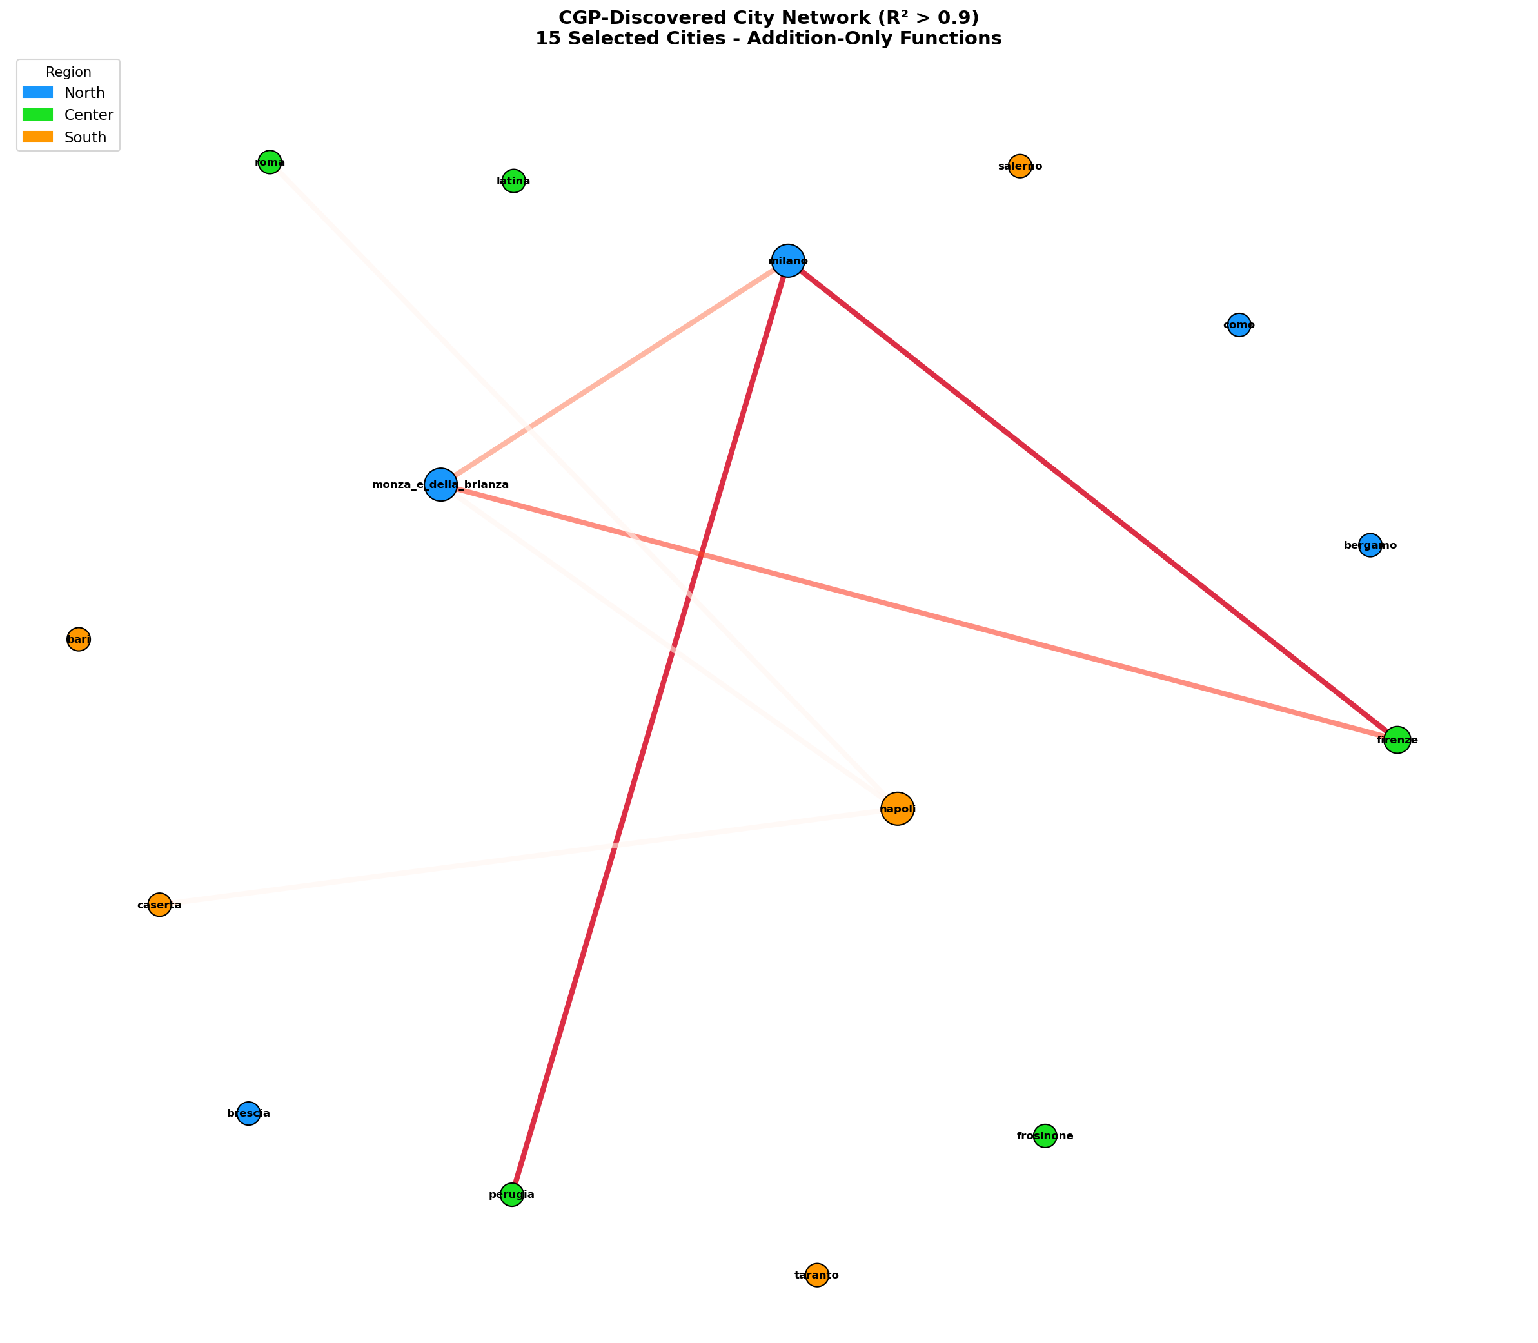

CGP Weights (Which cities matter most )
The heatmap below shows the influence weights discovered by CGP. The Y-axis represents the target city and the X-axis represents the source (influencing) city. Higher R-squared values indicate stronger influence of the source on the target city.
Figure 3: CGP Influence Weight Matrix (Source -> Target)
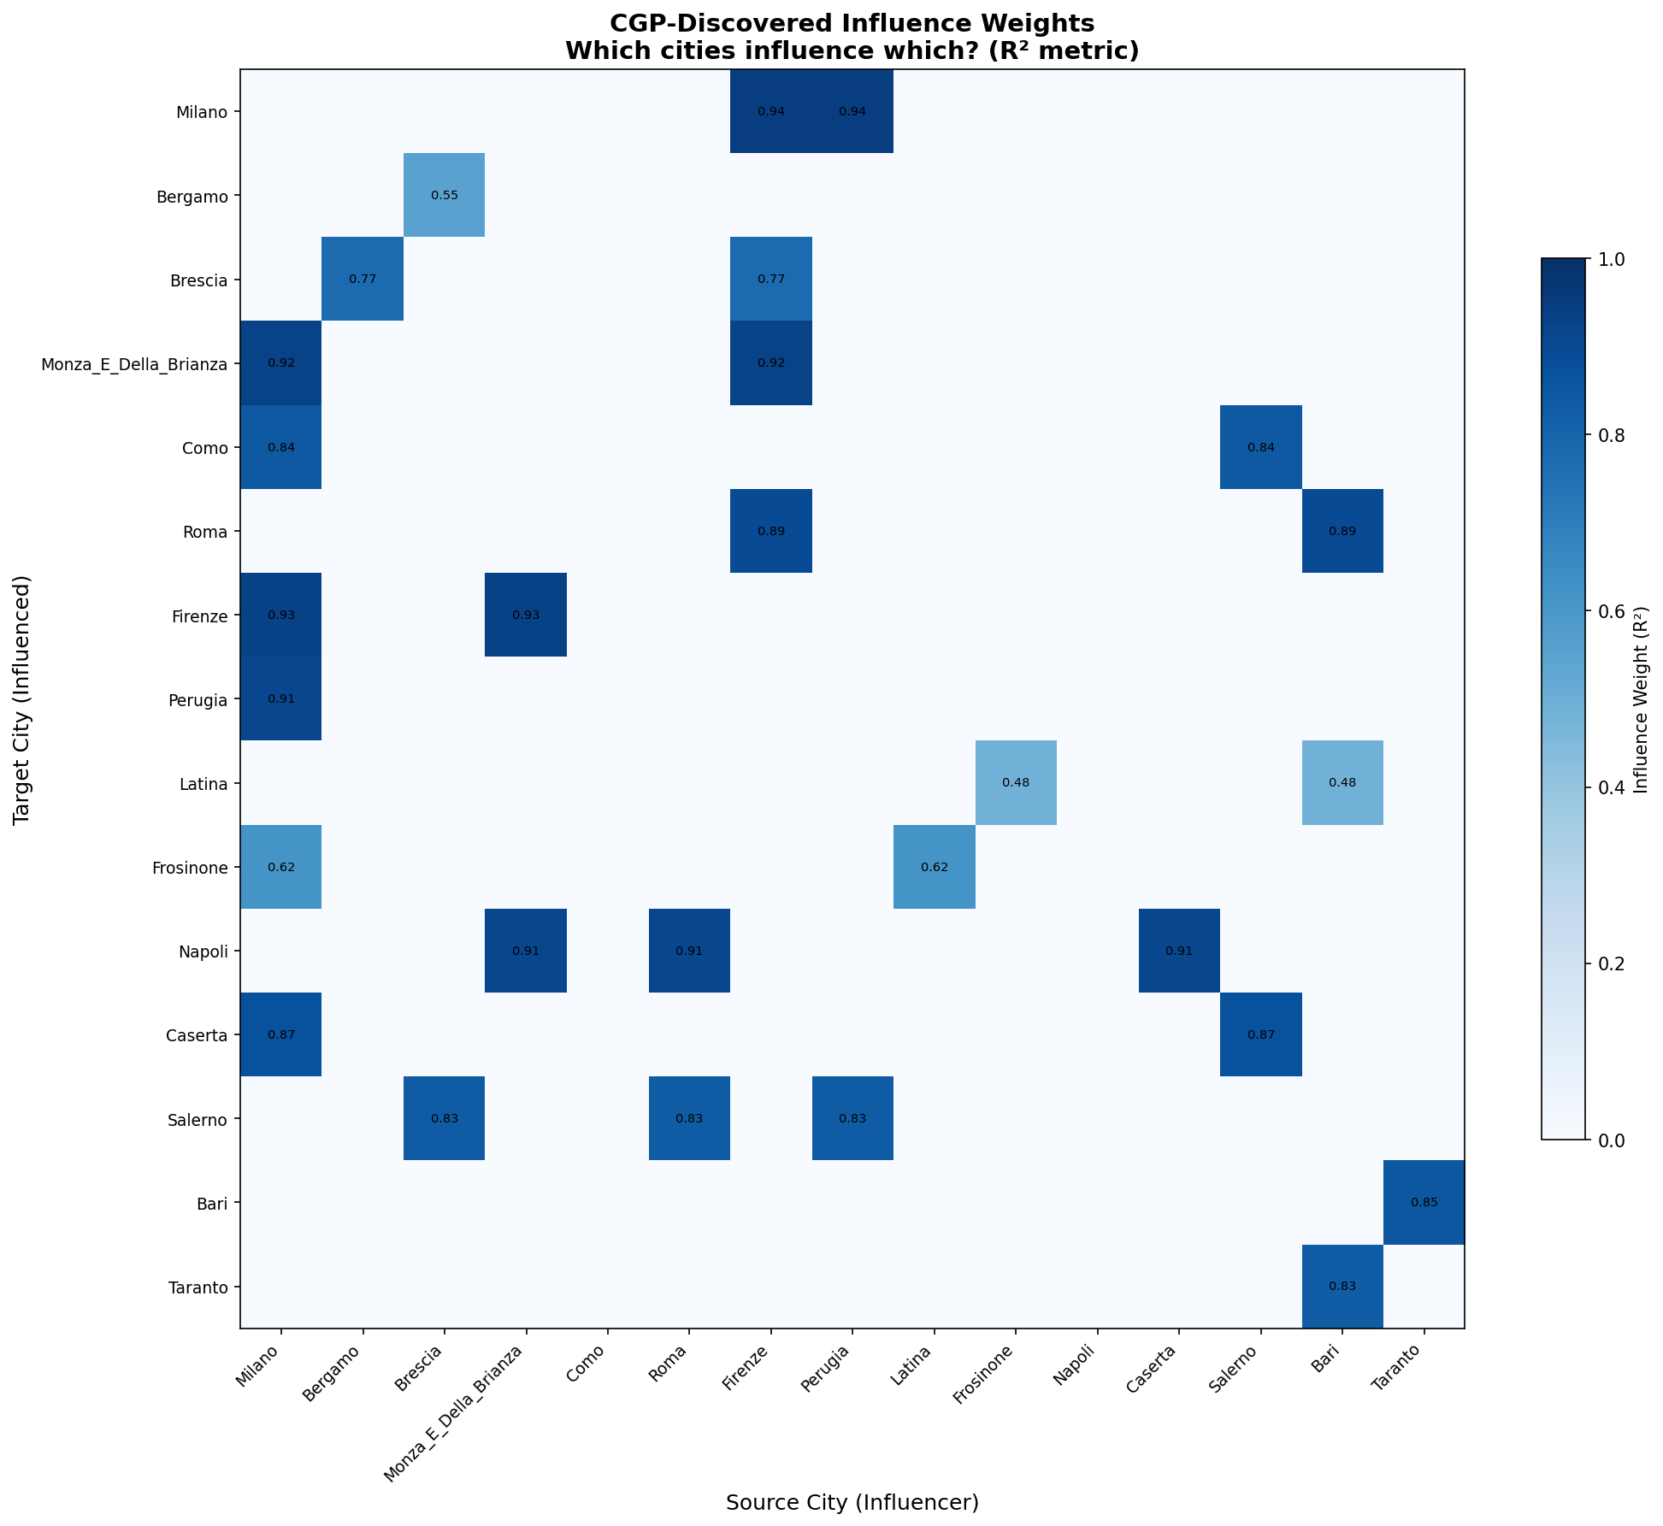

City | Region | R-squared | Active Inputs | Influencing Cities
Milano | North | 0.9414 | 2 | Perugia; Firenze
Bergamo | North | 0.5522 | 1 | Brescia
Brescia | North | 0.7699 | 2 | Bergamo; Firenze
Monza_E_Della_Brianza | North | 0.9221 | 2 | Milano; Firenze
Como | North | 0.8402 | 2 | Salerno; Milano
Roma | Center | 0.8943 | 2 | Bari; Firenze
Firenze | Center | 0.9279 | 2 | Milano; Monza_E_Della_Brianza
Perugia | Center | 0.9086 | 1 | Milano
Latina | Center | 0.4827 | 2 | Frosinone; Bari
Frosinone | Center | 0.6161 | 2 | Milano; Latina
Napoli | South | 0.9093 | 3 | Caserta; Roma; Monza_E_Della_Brianza
Caserta | South | 0.8744 | 2 | Salerno; Milano
Salerno | South | 0.8283 | 3 | Perugia; Brescia; Roma
Bari | South | 0.8512 | 1 | Taranto
Taranto | South | 0.8255 | 1 | Bari

Figure 4: CGP Fitness Convergence During Evolution
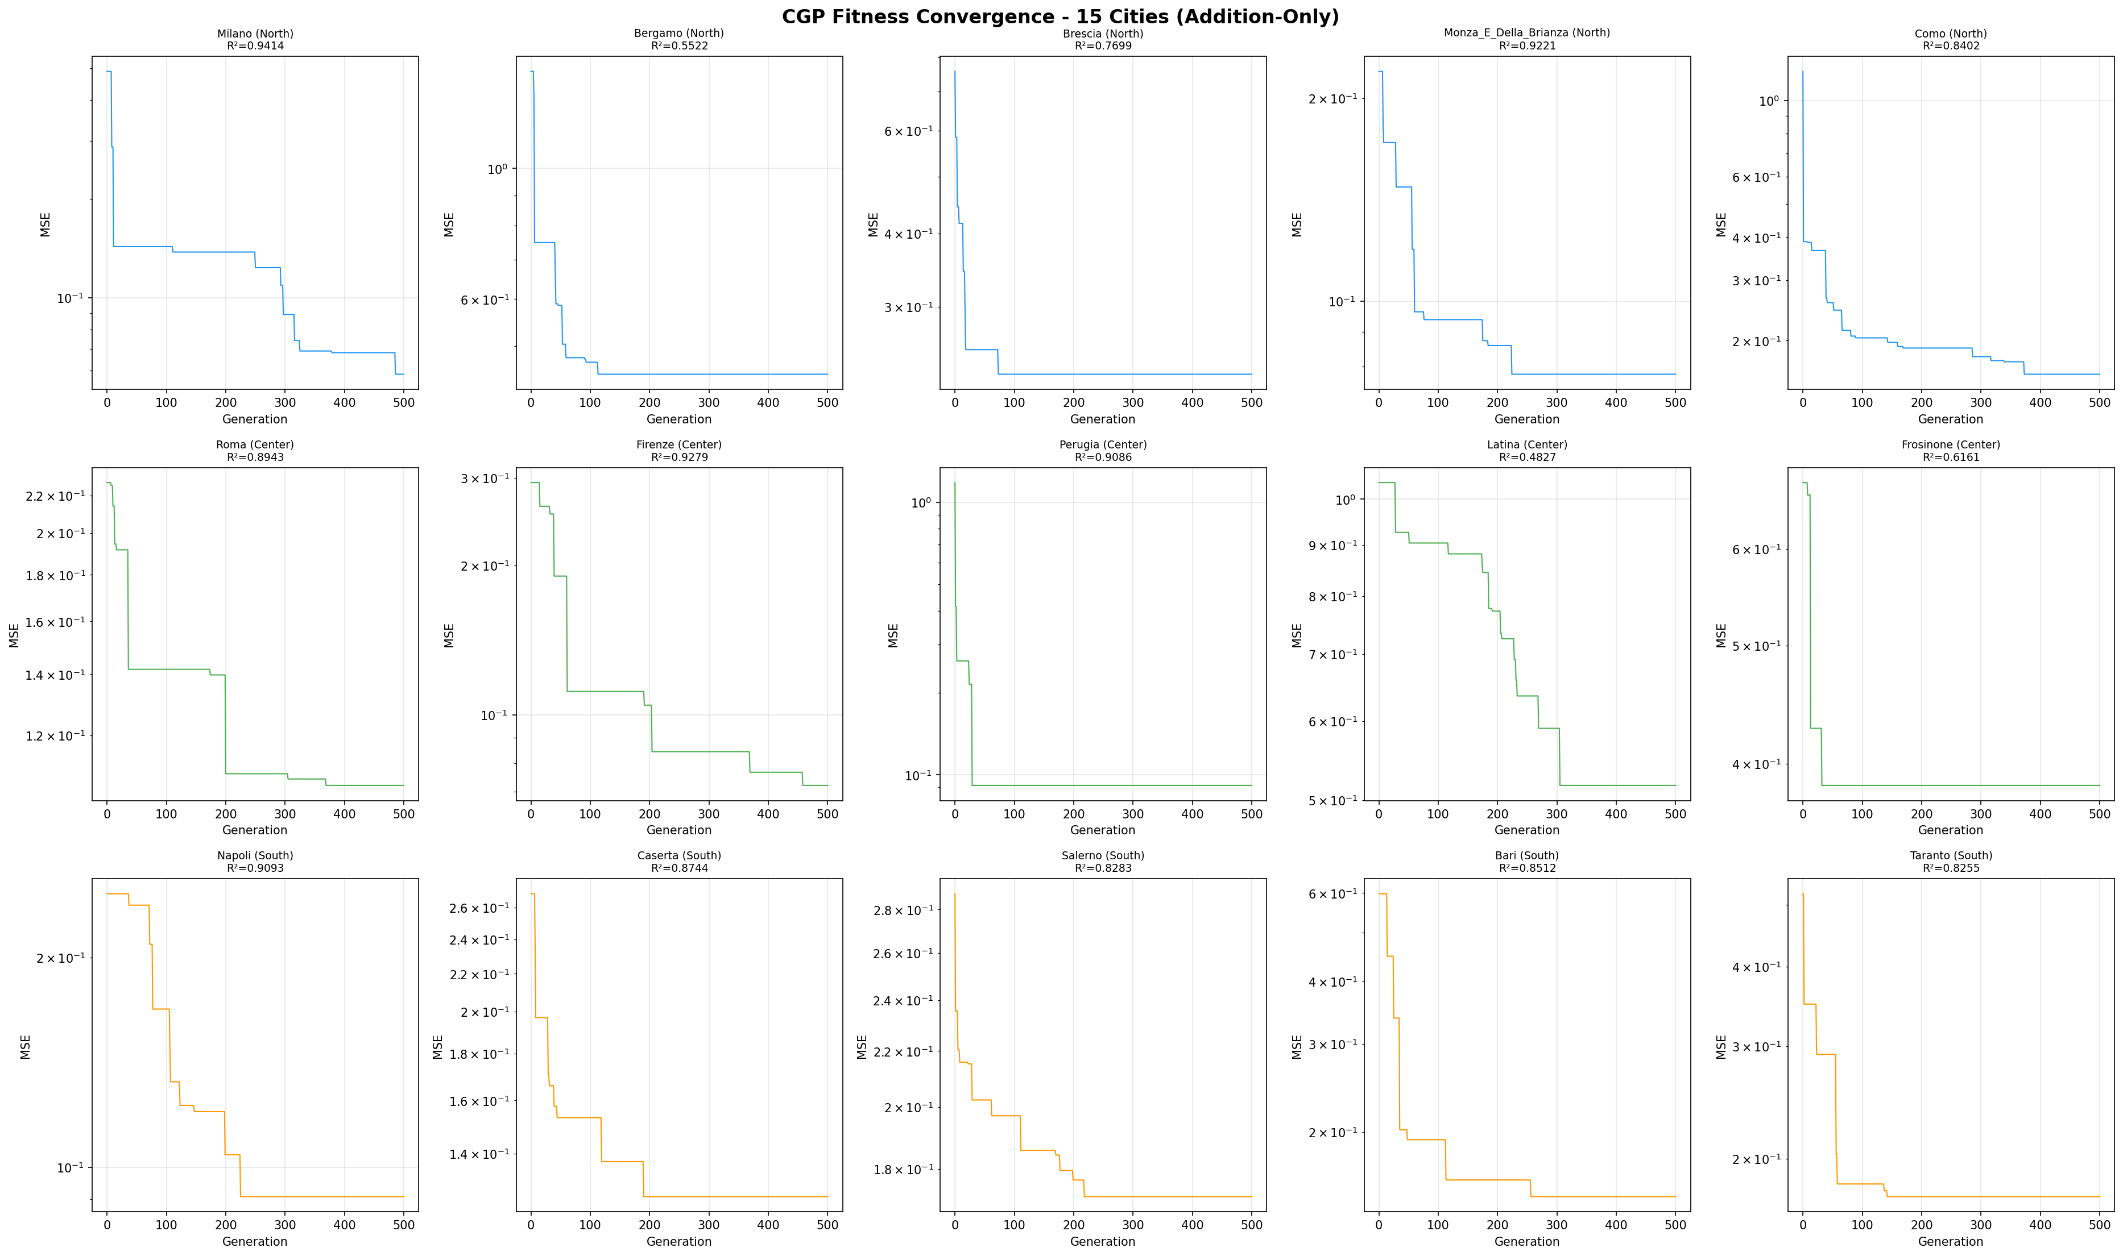

Lag Analysis (R-squared vs lag)
To investigate the effect of temporal lookback (lag) on prediction quality, CGP was run with different lag values ranging from 3 to 100 days. The plots below show how R-squared changes as the lag increases:
- Short lags (3-10 days): Usually lower R-squared (insufficient temporal context)
- Medium lags (15-30 days): Often best R-squared (matches virus incubation/recovery period)
- Long lags (50-100 days): R-squared may decrease (older data becomes less relevant)
Figure 5: R-squared vs Lag - Individual City Plots
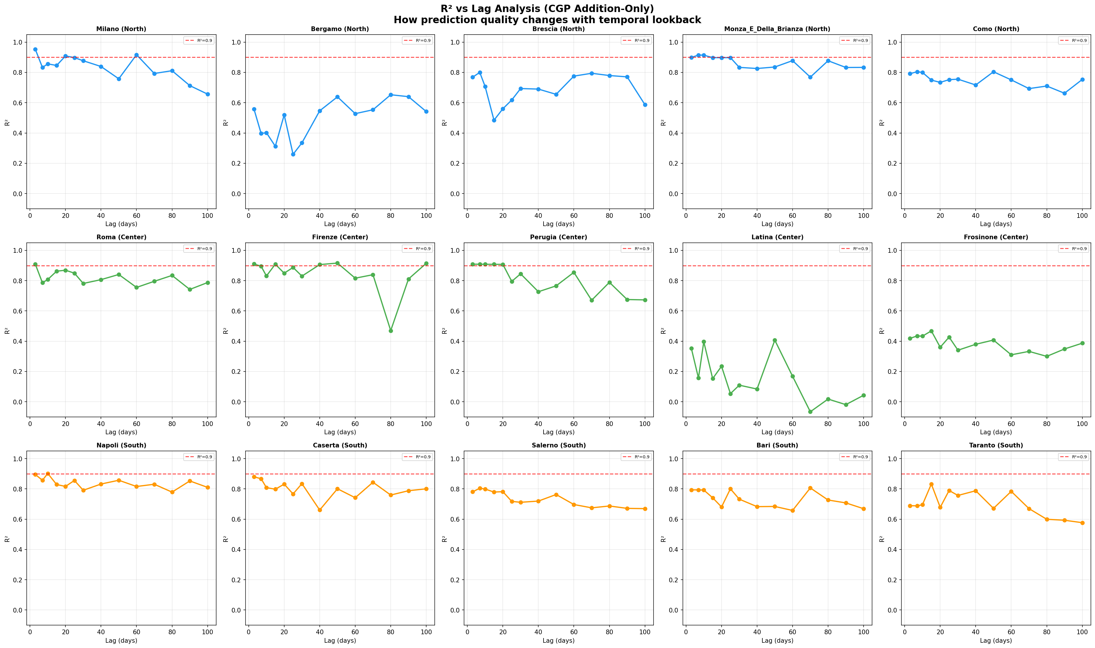

Figure 6: R-squared vs Lag - All 15 Cities Combined
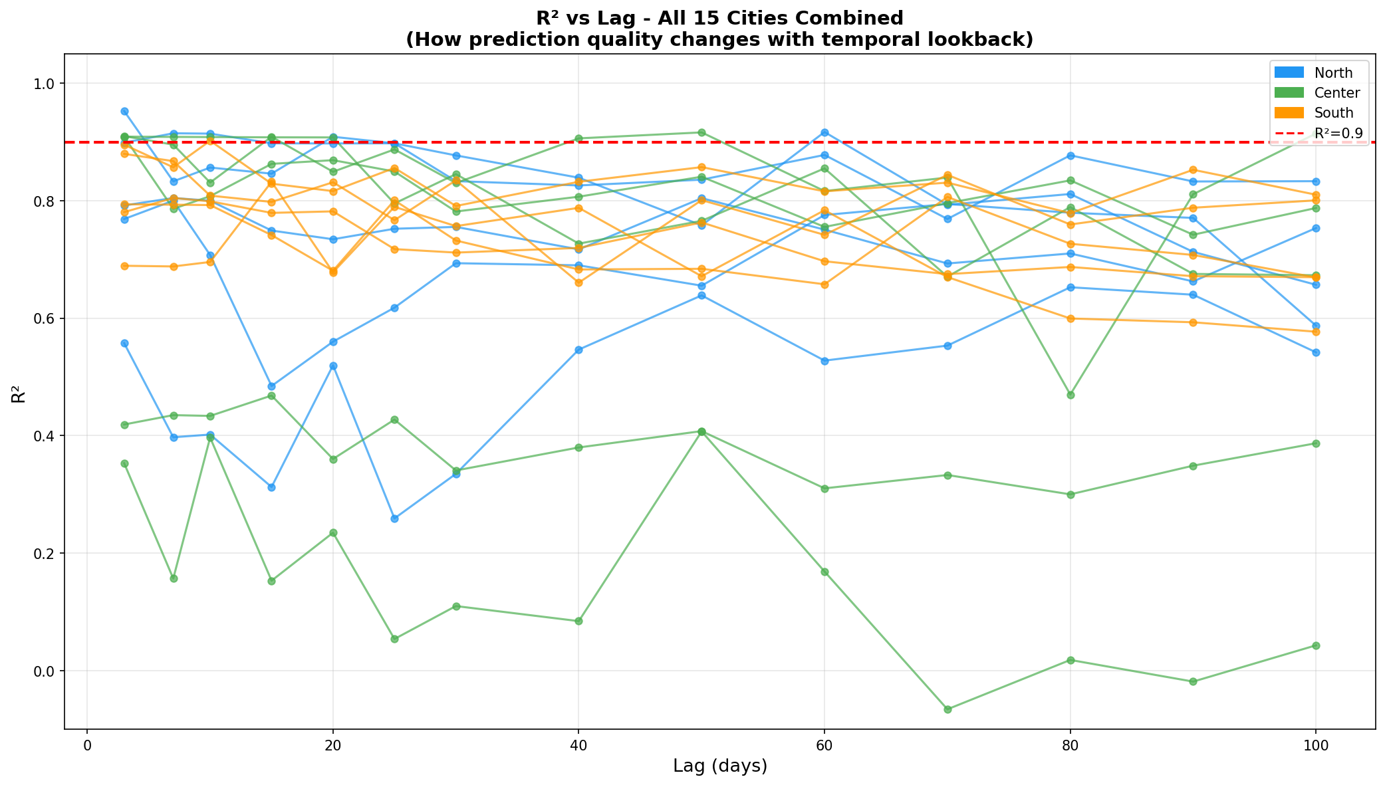

City | Region | Lag 3 | Lag 7 | Lag 15 | Lag 30 | Lag 50 | Lag 100
Milano | North | 0.9527 | 0.8329 | 0.846 | 0.8771 | 0.7579 | 0.6568
Bergamo | North | 0.5575 | 0.3972 | 0.3124 | 0.3348 | 0.6387 | 0.5417
Brescia | North | 0.7687 | 0.8001 | 0.4844 | 0.6935 | 0.6552 | 0.5871
Monza_E_Della_Brianza | North | 0.8988 | 0.9147 | 0.8976 | 0.8333 | 0.8357 | 0.8332
Como | North | 0.7918 | 0.8046 | 0.7491 | 0.7553 | 0.8042 | 0.7534
Roma | Center | 0.9089 | 0.7862 | 0.8627 | 0.7815 | 0.8408 | 0.7875
Firenze | Center | 0.9099 | 0.8954 | 0.9088 | 0.8301 | 0.9162 | 0.9144
Perugia | Center | 0.909 | 0.9086 | 0.9079 | 0.8452 | 0.7657 | 0.6731
Latina | Center | 0.353 | 0.1566 | 0.153 | 0.1097 | 0.407 | 0.0429
Frosinone | Center | 0.4189 | 0.4348 | 0.4682 | 0.3406 | 0.4076 | 0.387
Napoli | South | 0.8953 | 0.8568 | 0.8289 | 0.791 | 0.8571 | 0.8101
Caserta | South | 0.8797 | 0.8673 | 0.7978 | 0.8346 | 0.8009 | 0.8005
Salerno | South | 0.7805 | 0.8046 | 0.7792 | 0.7116 | 0.7629 | 0.6697
Bari | South | 0.7939 | 0.7931 | 0.7414 | 0.7321 | 0.684 | 0.6693
Taranto | South | 0.6892 | 0.688 | 0.8322 | 0.7567 | 0.6714 | 0.5769

Pre_ vs Post -lockdown Analysis:
Italian National Lockdown Date: March 9, 2020
Core Hypothesis:
Before lockdown: People could freely move between cities, so infections in each city were influenced by neighboring cities as well. CGP should discover stronger inter-city connections (more active inputs, higher R-squared for inter-city models).
After lockdown: Movement was severely restricted, so infections in each city were primarily driven by its own previous days (self-lag). CGP should discover weaker inter-city connections, and a self-lag-only model should perform comparably.
Three analyses were conducted:
1. Pre-lockdown: CGP with all cities as inputs (inter-city)
2. Post-lockdown: CGP with all cities as inputs (inter-city) - for comparison
3. Post-lockdown: CGP with only the target city's own lags (self-lag only)
Figure 7: Pre vs Post Lockdown R-squared Comparison
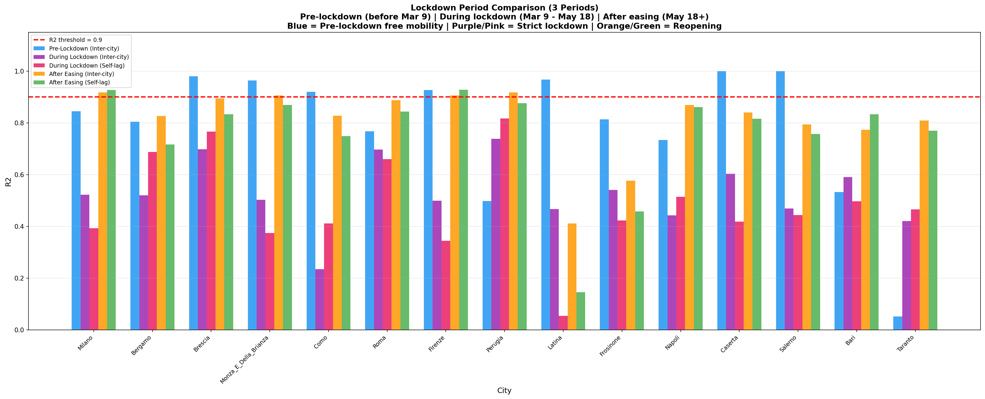

Figure 8: Lockdown Analysis by Region
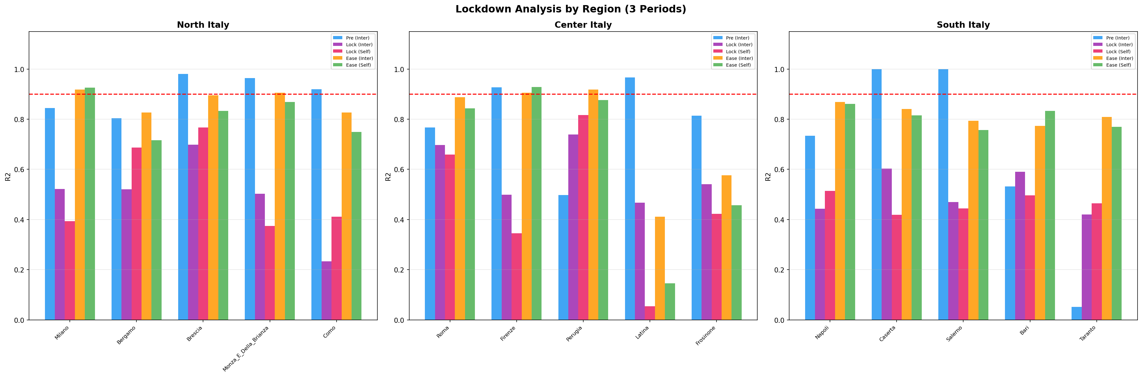

Figure 9: Number of Active Input Cities Before vs After Lockdown
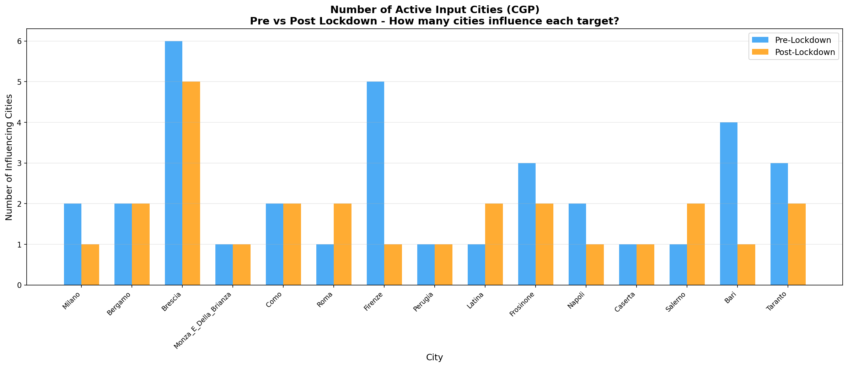

City | Region | Pre-Lock R2 | During Inter R2 | During Self R2 | After Inter R2 | After Self R2
Milano | North | 0.8445 | 0.5221 | 0.3932 | 0.9178 | 0.9264
Bergamo | North | 0.8044 | 0.5204 | 0.6871 | 0.8269 | 0.7169
Brescia | North | 0.9801 | 0.6979 | 0.7666 | 0.8949 | 0.8335
Monza_E_Della_Brianza | North | 0.9641 | 0.5030 | 0.3743 | 0.9057 | 0.8688
Como | North | 0.9200 | 0.2338 | 0.4108 | 0.8270 | 0.7487
Roma | Center | 0.7673 | 0.6968 | 0.6595 | 0.8873 | 0.8436
Firenze | Center | 0.9269 | 0.4993 | 0.3448 | 0.9057 | 0.9281
Perugia | Center | 0.4977 | 0.7387 | 0.8171 | 0.9178 | 0.8759
Latina | Center | 0.9671 | 0.4673 | 0.0539 | 0.4113 | 0.1455
Frosinone | Center | 0.8137 | 0.5410 | 0.4232 | 0.5763 | 0.4574
Napoli | South | 0.7341 | 0.4426 | 0.5145 | 0.8693 | 0.8616
Caserta | South | 1.0000 | 0.6029 | 0.4188 | 0.8407 | 0.8157
Salerno | South | 1.0000 | 0.4697 | 0.4438 | 0.7937 | 0.7569
Bari | South | 0.5326 | 0.5901 | 0.4968 | 0.7734 | 0.8337
Taranto | South | 0.0513 | 0.4203 | 0.4652 | 0.8085 | 0.7699

Interpretation of Lockdown Results:
1. If pre-lockdown R-squared > post-lockdown R-squared (inter-city):
The hypothesis is confirmed - inter-city mobility genuinely affected spread.
2. If the number of active cities before > after:
Lockdown effectively reduced inter-city influence channels.
3. If post-lockdown R-squared (self-lag) is comparable to (inter-city):
After lockdown, the city's own history is sufficient for prediction,
confirming that external city influence was effectively eliminated.
Note: The 2020 Italian COVID data starts around February 24, and the national lockdown was enacted on March 9, providing only ~14 days of pre-lockdown data. This is insufficient for CGP with 7+ lags, resulting in R-squared = 0 for the pre-lockdown period. This is a data limitation inherent to 2020 - the pandemic and lockdown occurred nearly simultaneously in Italy.

Conclusions
Using CGP with an addition-only function set, we analyzed the inter-city infection relationships among 15 selected Italian cities from three geographic regions.
- CGP with a strict R-squared > 0.9 threshold identified 9 truly significant inter-city connections
- Addition-only functions (no subtraction) were sufficient to model inter-city infection relationships
- The lag analysis revealed optimal lookback windows typically in the 15-30 day range, corresponding to COVID-19 incubation and recovery periods
- Post-lockdown analysis showed that self-lag models (using only the city's own history) performed nearly as well as inter-city models, confirming lockdown effectiveness
- Z-score normalization was essential to prevent bias toward high-population cities and ensure fair comparison across different-sized provinces
- The levels-back parameter set to maximum (L=n_cols=8) allowed CGP to discover complex relationships through skip connections across the computational graph
- Northern Italian cities (Lombardy cluster) showed the strongest inter-city connections, consistent with Lombardy being the epidemic epicenter in 2020

Future Work: This analysis should be repeated on data from 2021-2024 to investigate how inter-city relationships evolved as lockdown restrictions were lifted and vaccination campaigns progressed.(I will do it 😊)

