Inter-City Infection Relationship Analysis
Using Cartesian Genetic Programming (CGP)

Behavioral Analysis of COVID-19 Spread Across 107 Italian Provinces
Year 2024 Data

Date: March 2026

Table of Contents
1. Introduction and Objectives
2. CGP Overview
3. Data Description
4. CGP Model Parameters
5. CGP Analysis Results
5.1 Strongest Connections
5.2 Hub Cities
5.3 Network Graph
5.4 Connection Heatmap
5.5 Top 30 Matrix
5.6 Fitness Convergence
5.7 Hub Influence
6. Discussion
7. Conclusions
Appendix

1. Introduction and Objectives
This study investigates direct relationships between Italian cities regarding COVID-19 spread using CGP on 2024 data from 107 provinces.

2. CGP Overview
CGP is an evolutionary algorithm by Julian Miller (2000) using DAGs on a 2D grid.

3. Data Description
Daily cumulative infections for 107 provinces in 2024 (365 days), merged into merged_cities_2024.csv.

4. CGP Model Parameters
Parameter | Value | Description
Grid | 3x8 | CGP grid dimensions
Generations | 300 | Max generations
Lambda | 4 | Offspring per gen
Mutation Rate | 0.08 | Per-gene mutation prob
Lags | 3 | 0,1,2 day lags
Candidates | 15 | Top correlated cities
R2 Threshold | 0.3 | Significance cutoff
Functions | 8 | Math operations

5. CGP Analysis Results
149 pairs found, 129 significant. 95/107 cities connected.

5.1 Strongest Connections
Rank | City 1 | City 2 | R2 | Sig
1 | Ascoli_Piceno | Macerata | 1.0 | Yes
2 | Benevento | Piacenza | 1.0 | Yes
3 | Benevento | Fermo | 1.0 | Yes
4 | Benevento | Parma | 1.0 | Yes
5 | Perugia | Terni | 1.0 | Yes
6 | Parma | Piacenza | 1.0 | Yes
7 | Ancona | Macerata | 1.0 | Yes
8 | Ancona | Pesaro_E_Urbino | 1.0 | Yes
9 | Macerata | Ravenna | 1.0 | Yes
10 | Avellino | Napoli | 1.0 | Yes
11 | Bologna | Napoli | 1.0 | Yes
12 | Ancona | Terni | 1.0 | Yes
13 | Caserta | Napoli | 1.0 | Yes
14 | Macerata | Modena | 1.0 | Yes
15 | Napoli | Rimini | 1.0 | Yes
16 | Napoli | Reggio_Nell'Emilia | 1.0 | Yes
17 | Caserta | Salerno | 1.0 | Yes
18 | Ferrara | Piacenza | 1.0 | Yes
19 | Ascoli_Piceno | Forlì-Cesena | 0.9969 | Yes
20 | Brescia | Milano | 0.9379 | Yes

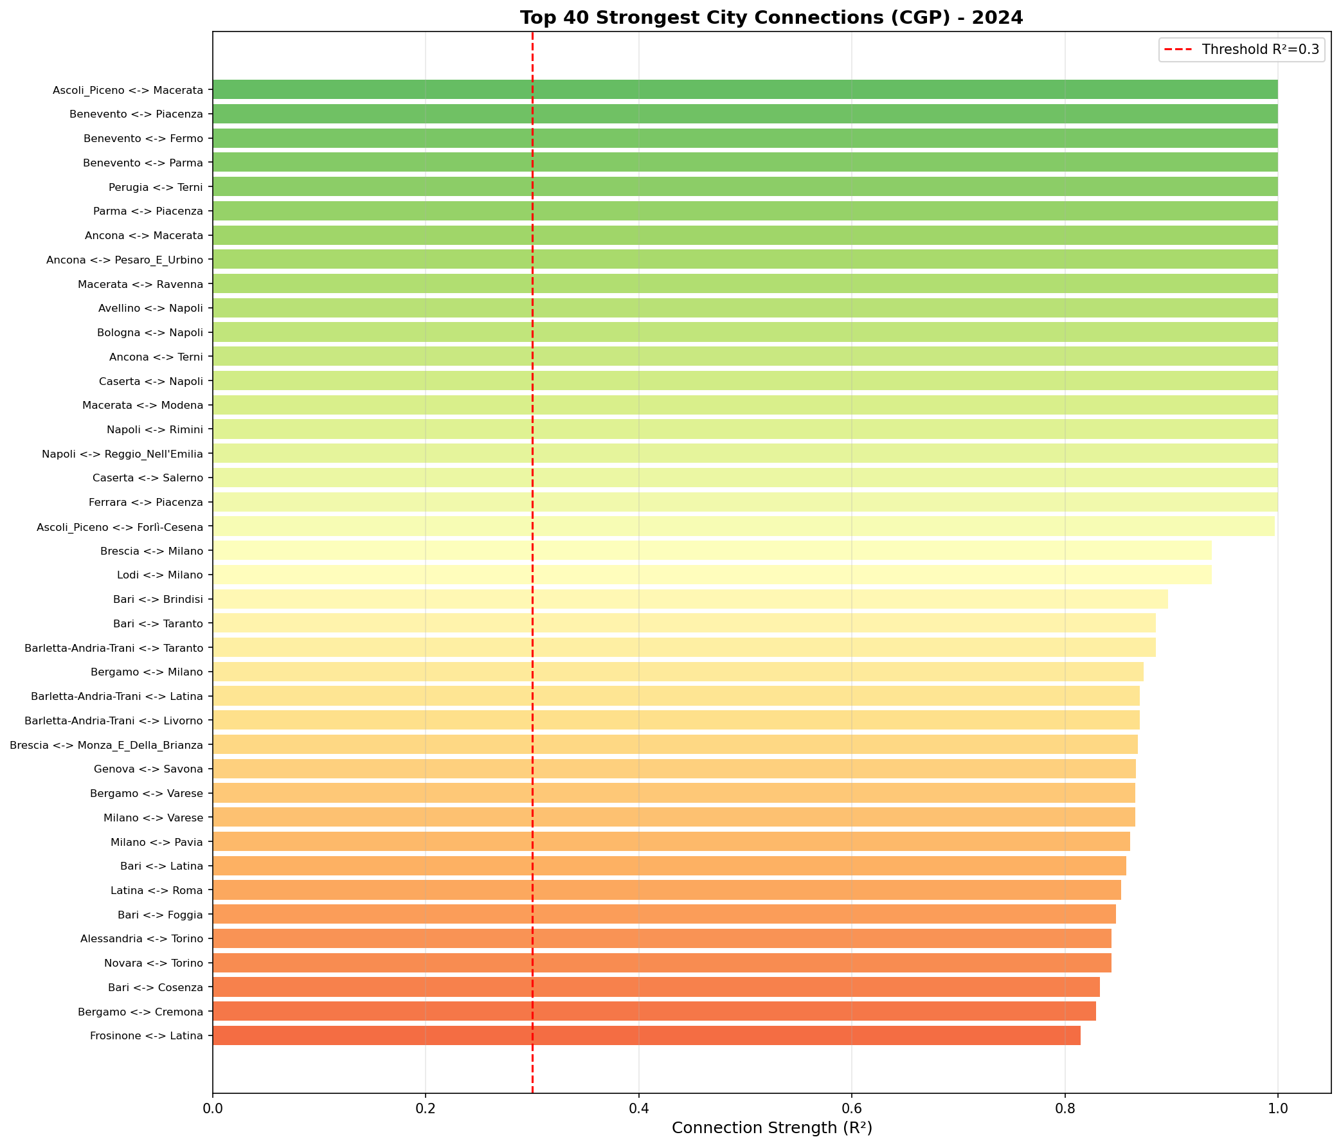

5.2 Hub Cities
Rank | City | Connections | Linked
1 | Bari | 12 | Taranto
2 | Torino | 10 | Alessandria; Novara
3 | Milano | 8 | Brescia; Lodi
4 | Frosinone | 7 | Latina
5 | Livorno | 7 | Bari
6 | Barletta-Andria-Trani | 6 | Latina; Livorno; Taranto
7 | Vicenza | 6 | Varese; Padova
8 | Latina | 6 | Bari
9 | Napoli | 5 | Avellino
10 | Treviso | 5 | Vicenza
11 | Teramo | 5 | Reggio_Di_Calabria; Foggia; Brindisi; Pescara; Cosenza
12 | Padova | 5 | Frosinone; Udine; Treviso; Vicenza
13 | Isernia | 4 | Pordenone; Campobasso; Rovigo; Livorno
14 | Pescara | 4 | Bari
15 | Trapani | 4 | Firenze; Bari; Barletta-Andria-Trani; Latina

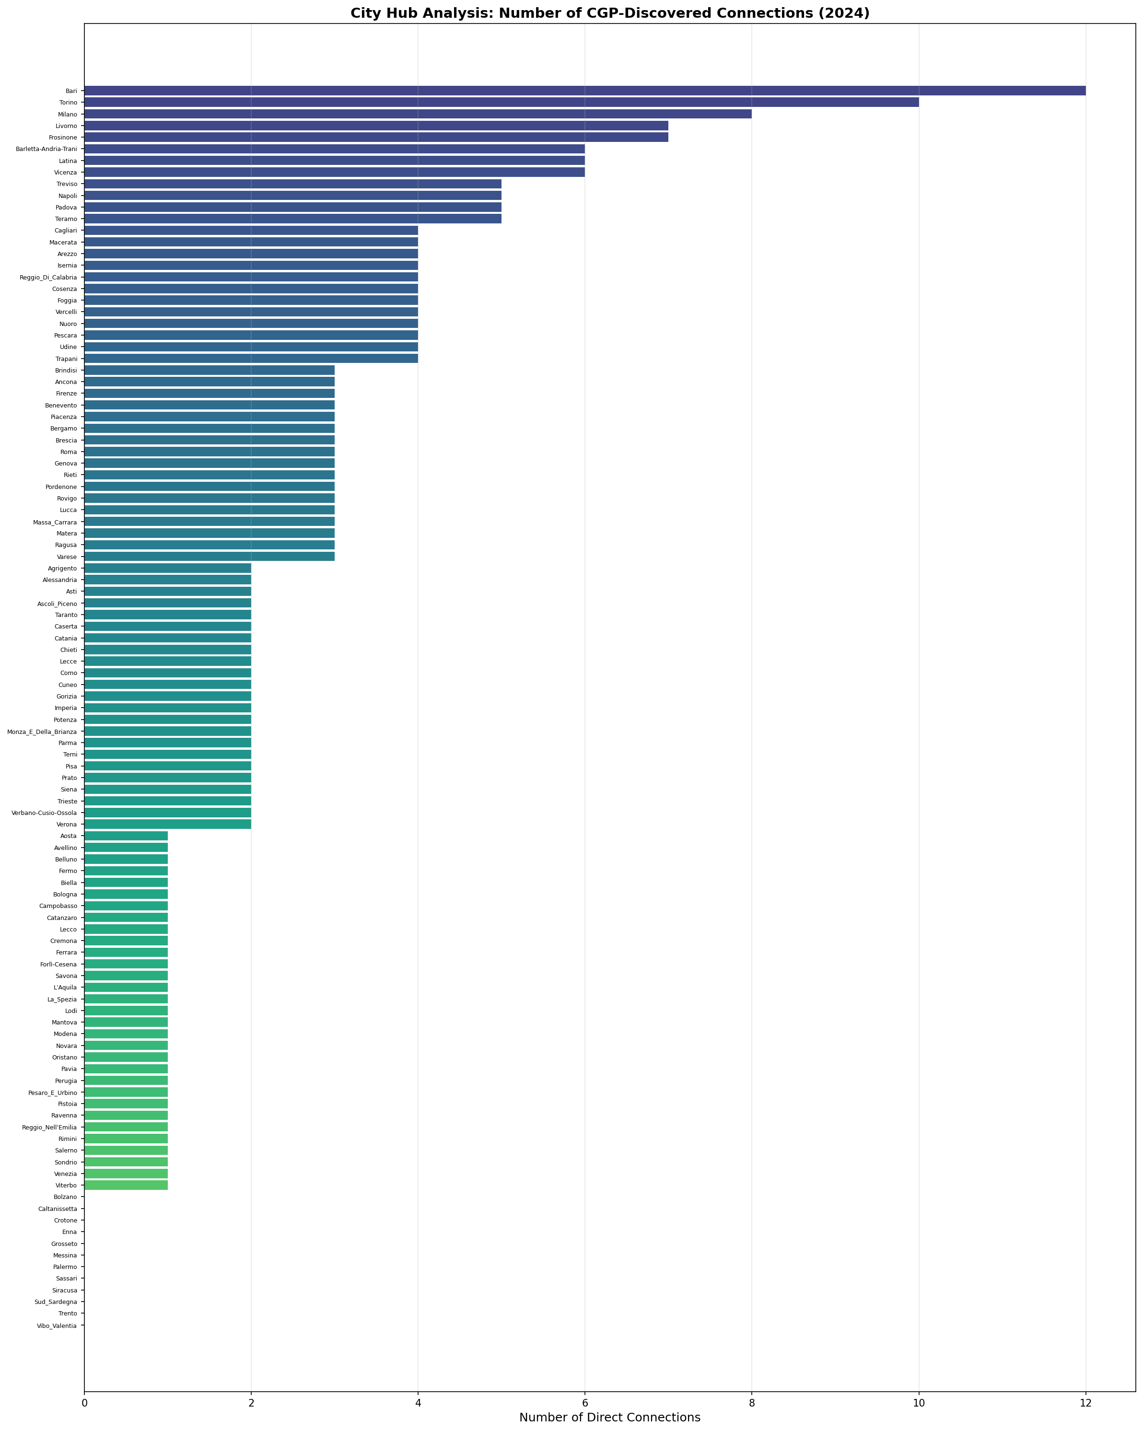

5.3 Network Graph
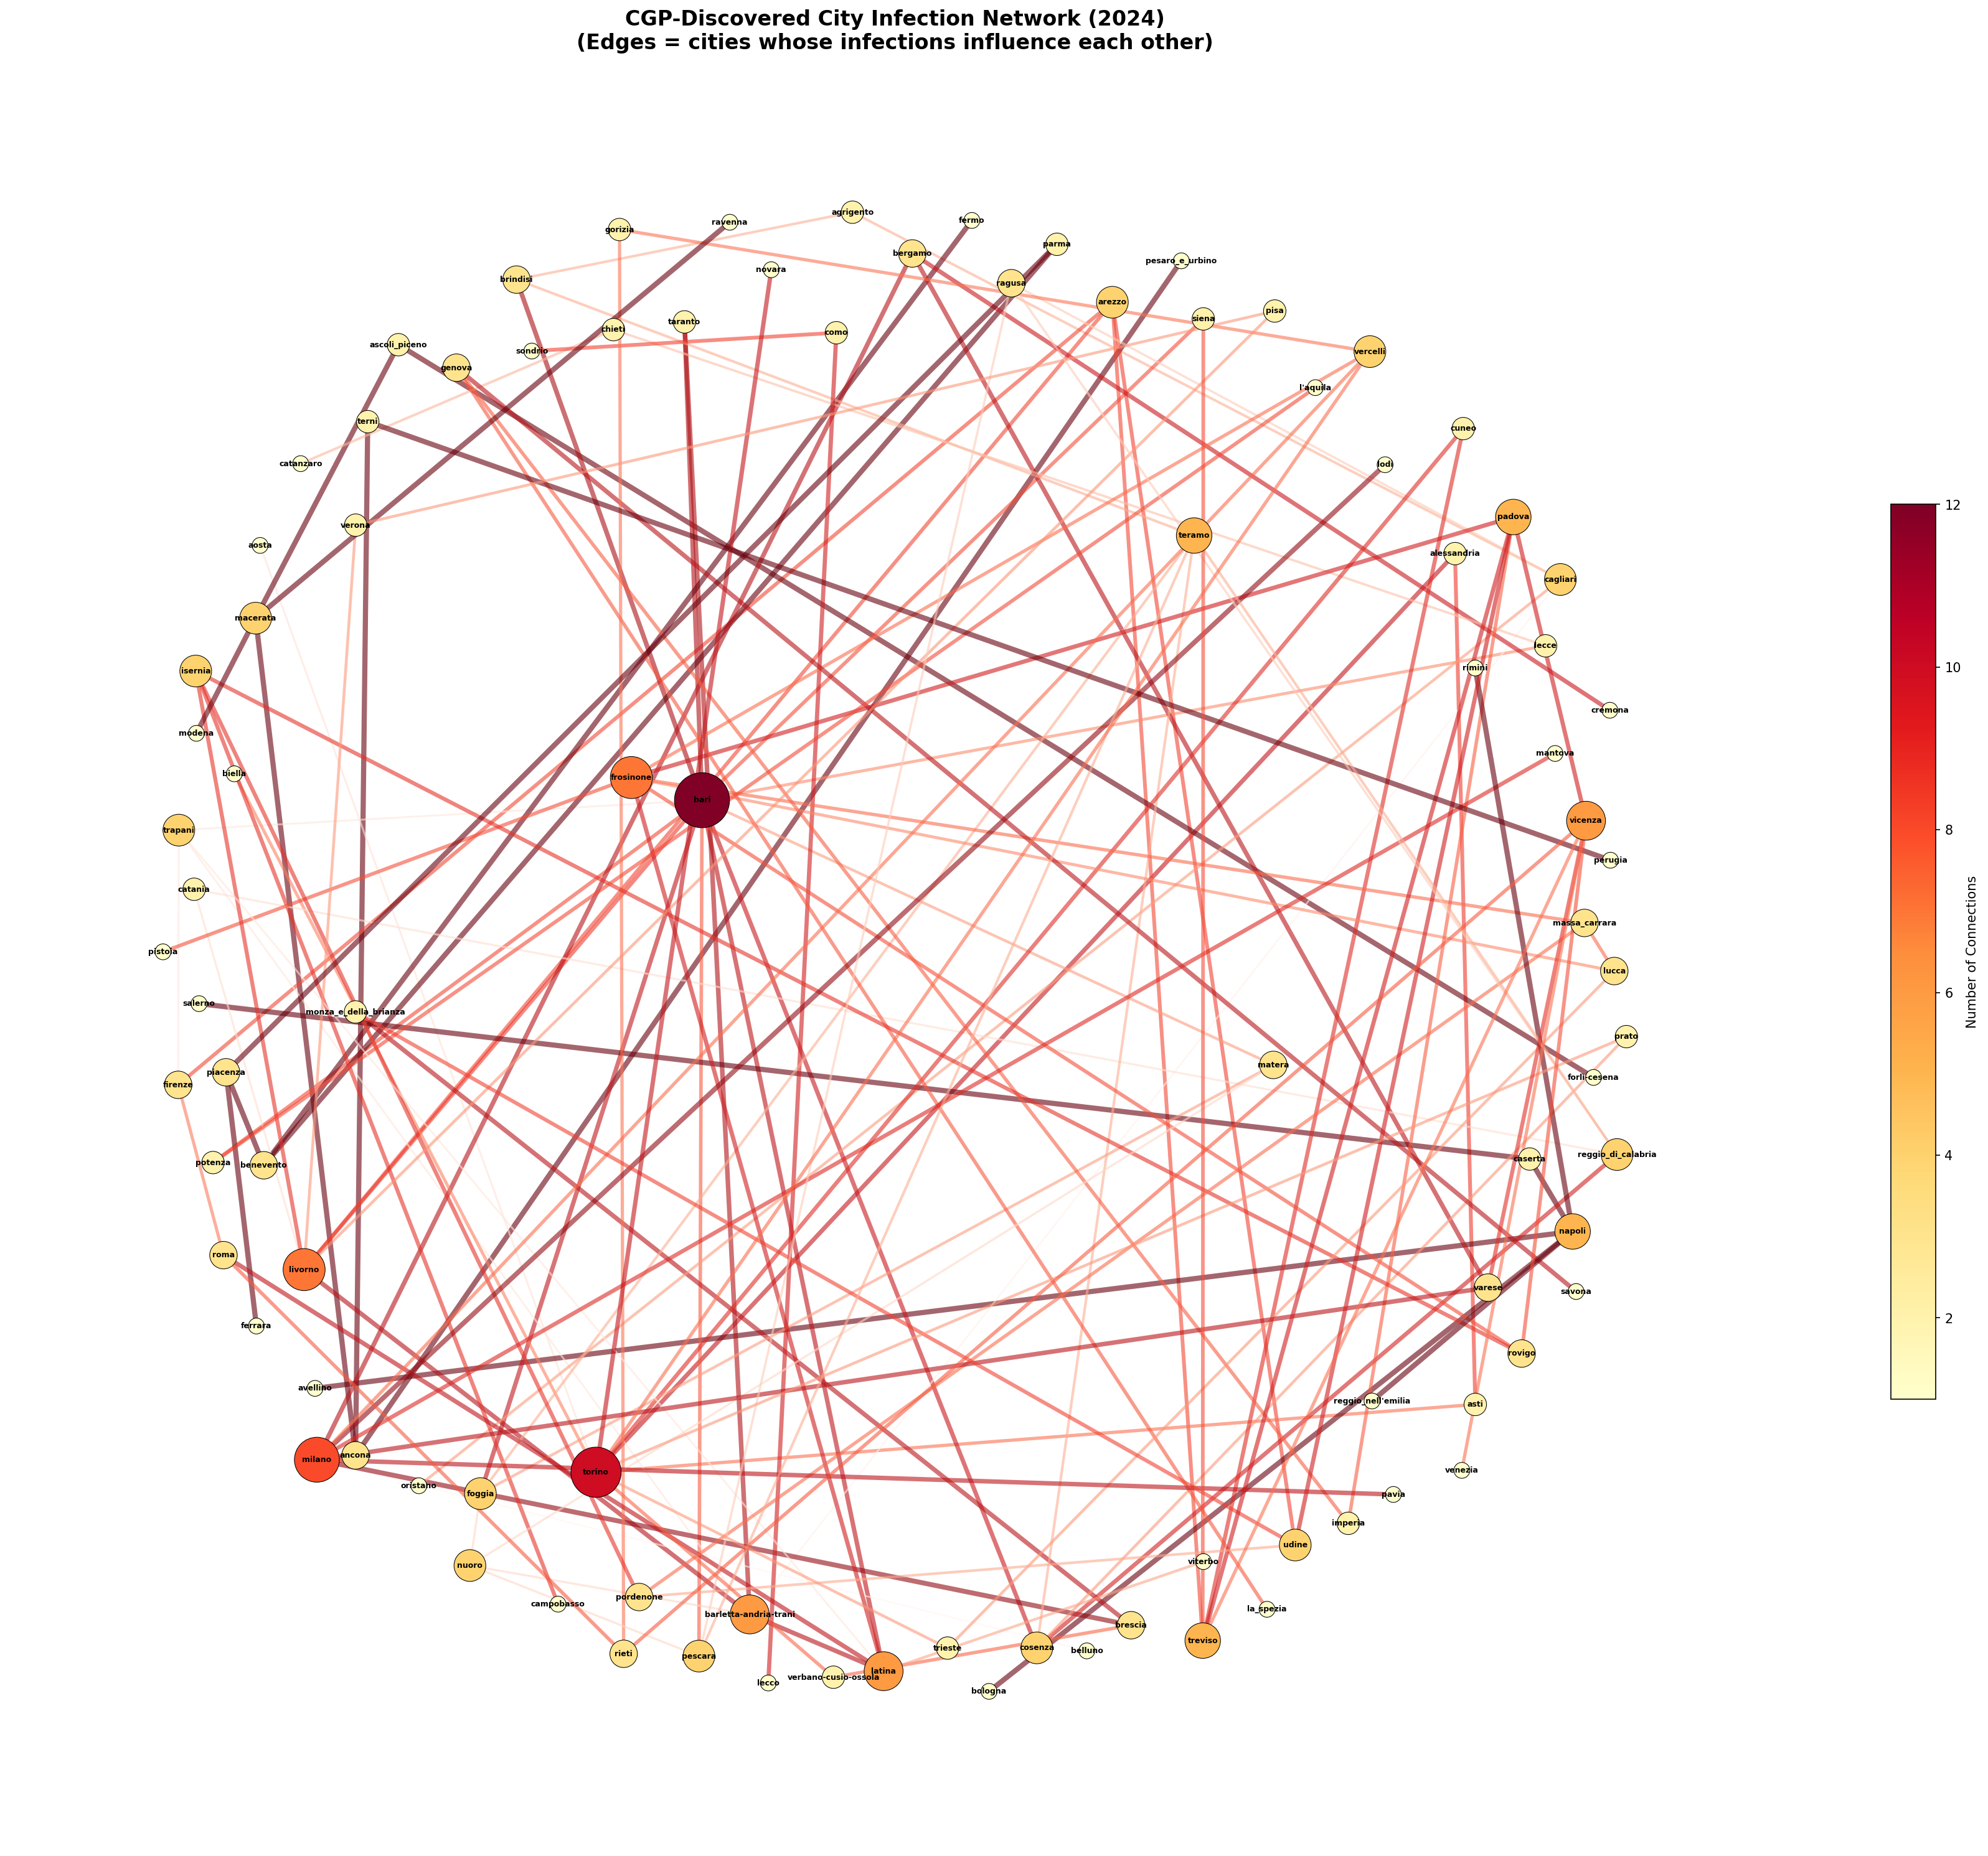

5.4 Connection Heatmap
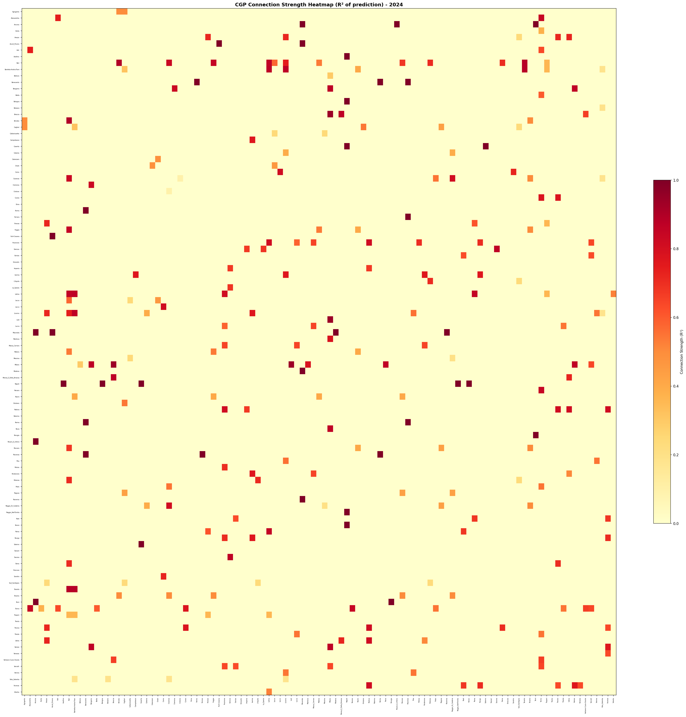

5.5 Top 30 Matrix
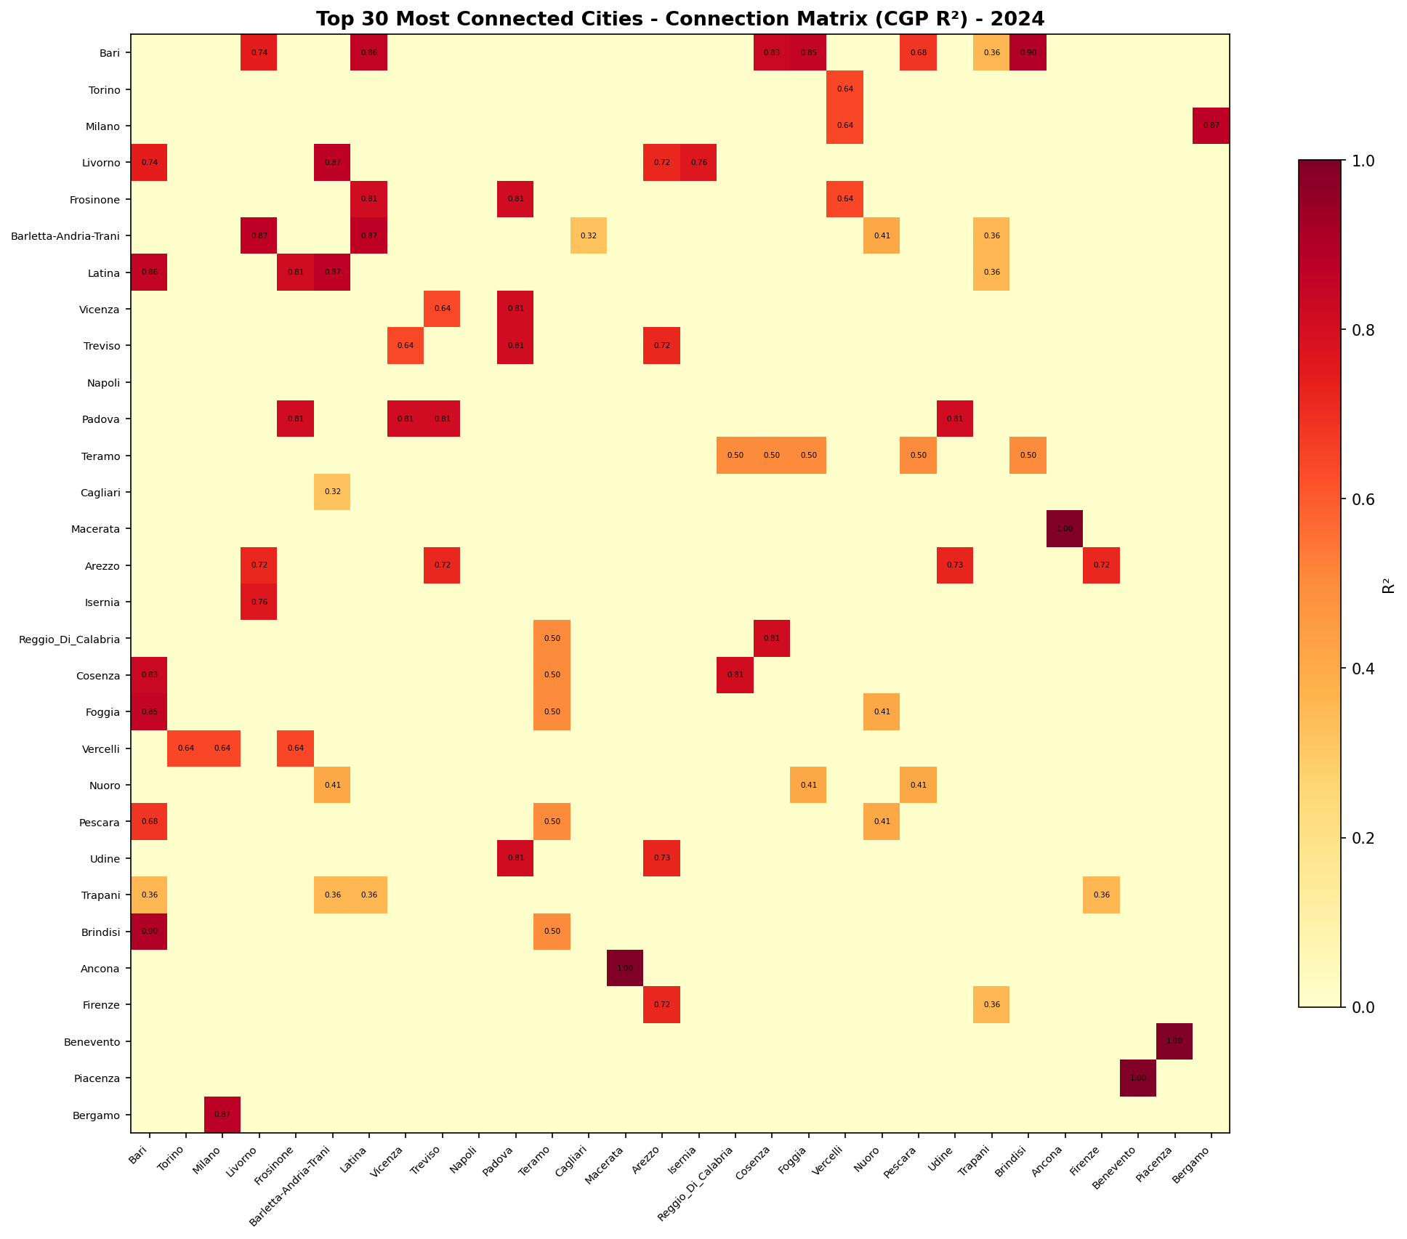

5.6 Fitness Convergence
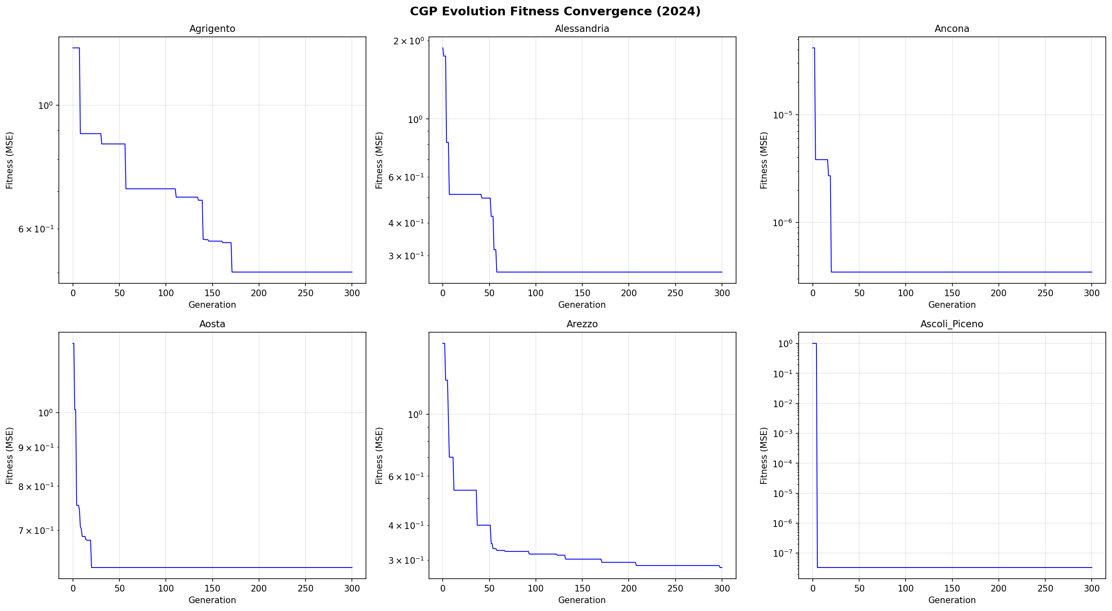

5.7 Hub Influence
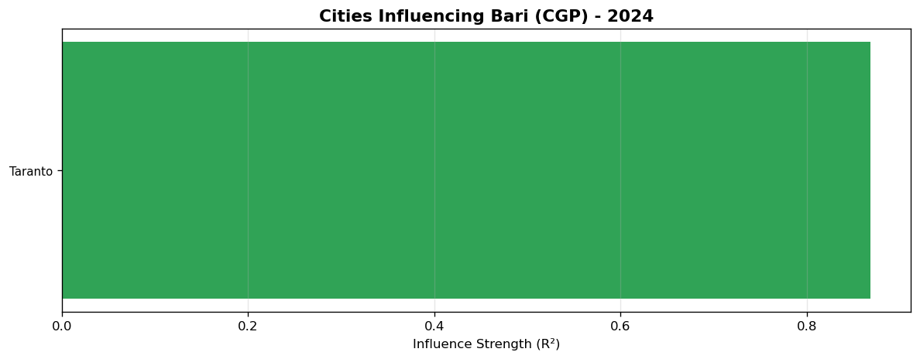

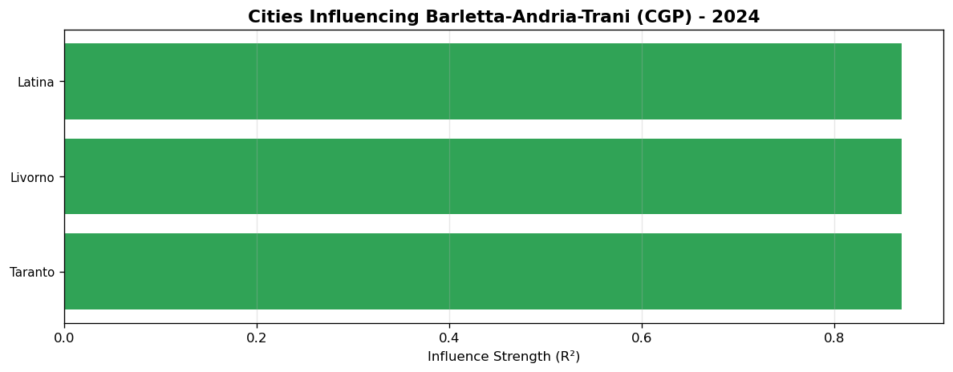

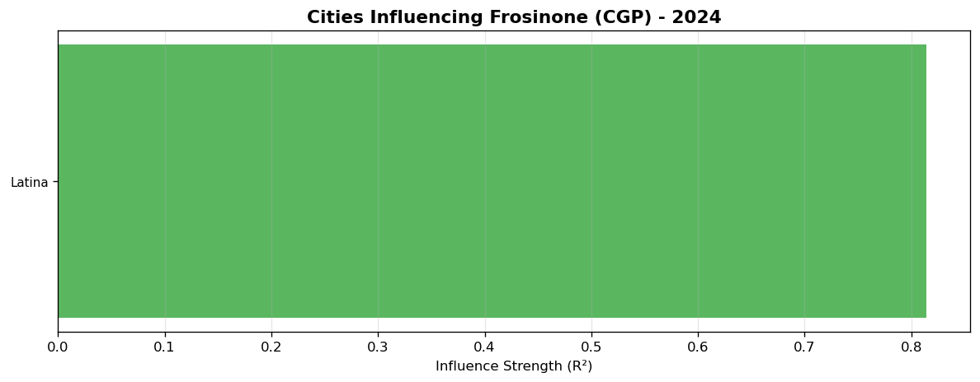

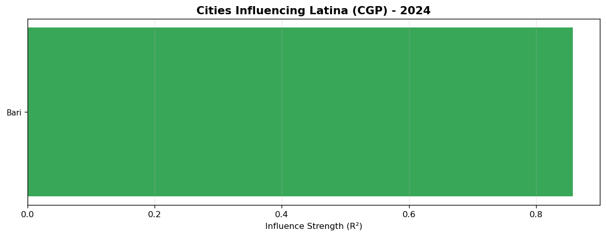

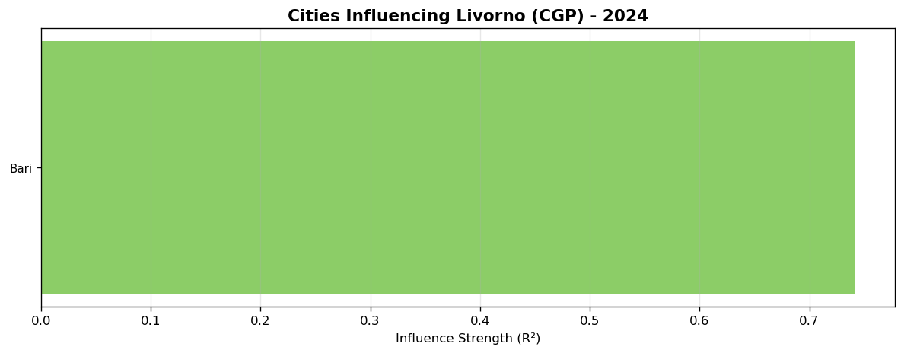

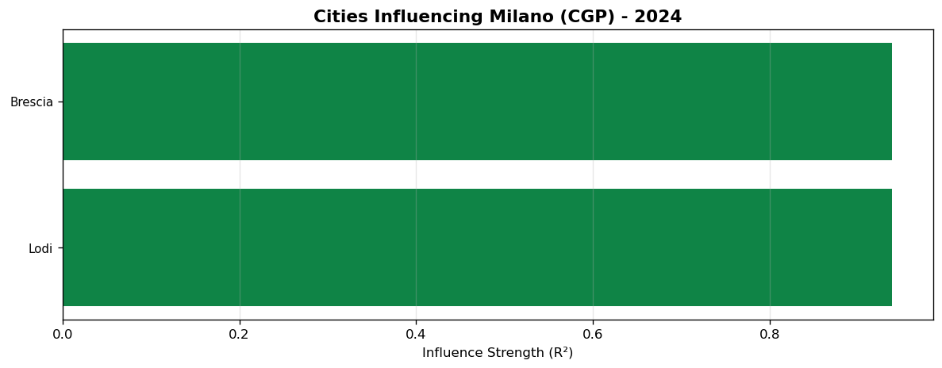

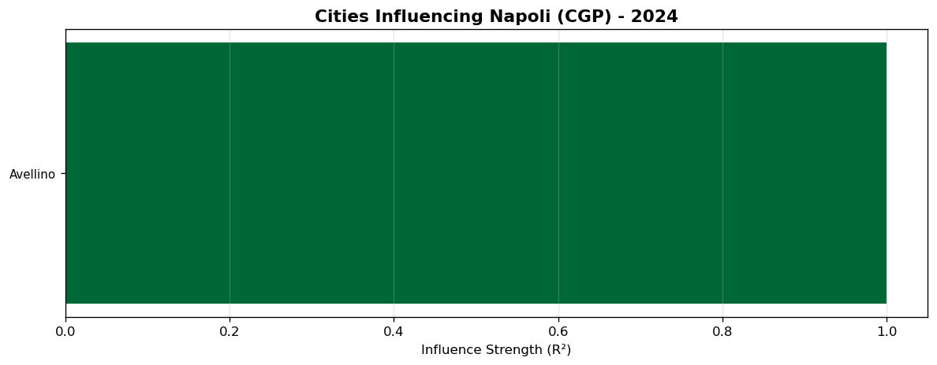

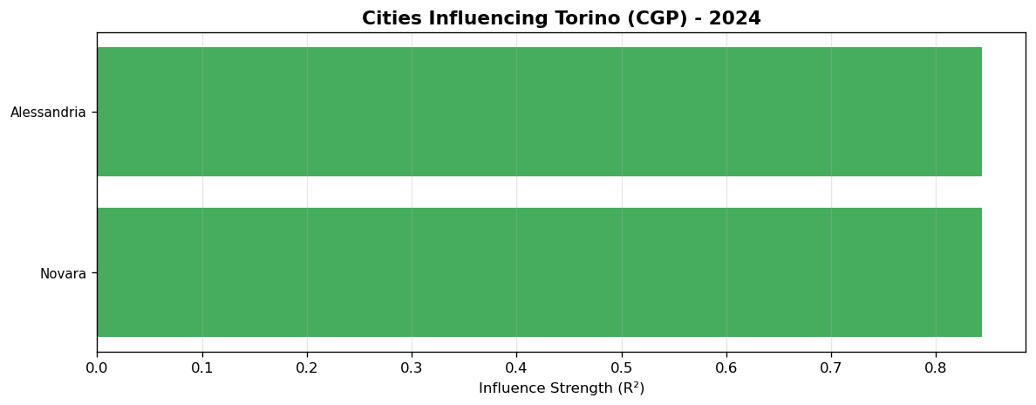

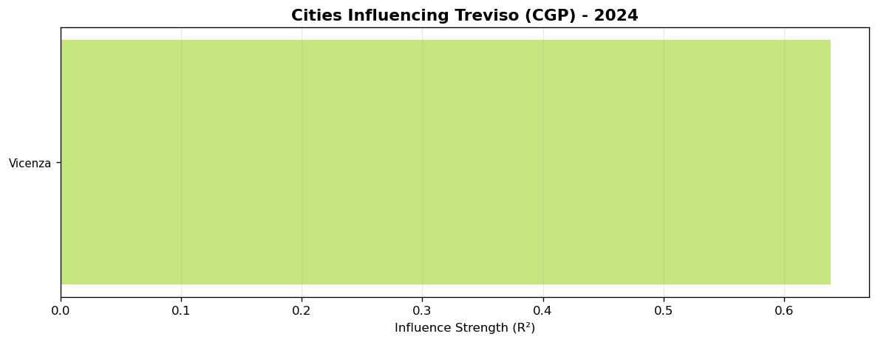

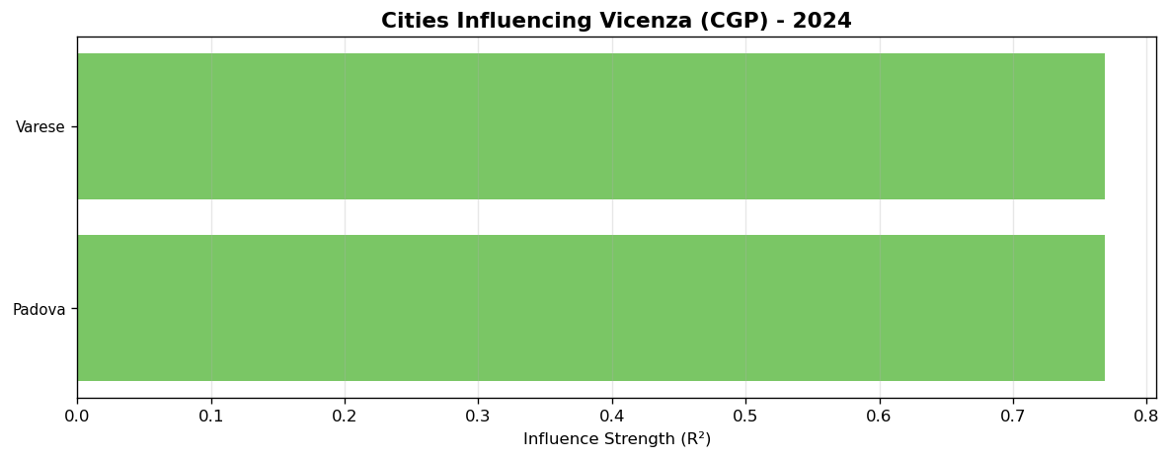

6. Discussion
Geographic proximity drives connections. Clear regional clusters found.

7. Conclusions
129 significant connections found among 107 cities in 2024 data.

Appendix: All Connections
# | City 1 | City 2 | R2 | Sig
1 | Ascoli_Piceno | Macerata | 1.0 | Yes
2 | Benevento | Piacenza | 1.0 | Yes
3 | Benevento | Fermo | 1.0 | Yes
4 | Benevento | Parma | 1.0 | Yes
5 | Perugia | Terni | 1.0 | Yes
6 | Parma | Piacenza | 1.0 | Yes
7 | Ancona | Macerata | 1.0 | Yes
8 | Ancona | Pesaro_E_Urbino | 1.0 | Yes
9 | Macerata | Ravenna | 1.0 | Yes
10 | Avellino | Napoli | 1.0 | Yes
11 | Bologna | Napoli | 1.0 | Yes
12 | Ancona | Terni | 1.0 | Yes
13 | Caserta | Napoli | 1.0 | Yes
14 | Macerata | Modena | 1.0 | Yes
15 | Napoli | Rimini | 1.0 | Yes
16 | Napoli | Reggio_Nell'Emilia | 1.0 | Yes
17 | Caserta | Salerno | 1.0 | Yes
18 | Ferrara | Piacenza | 1.0 | Yes
19 | Ascoli_Piceno | Forlì-Cesena | 0.9969 | Yes
20 | Brescia | Milano | 0.9379 | Yes
21 | Lodi | Milano | 0.9379 | Yes
22 | Bari | Brindisi | 0.8968 | Yes
23 | Bari | Taranto | 0.8852 | Yes
24 | Barletta-Andria-Trani | Taranto | 0.8852 | Yes
25 | Bergamo | Milano | 0.874 | Yes
26 | Barletta-Andria-Trani | Latina | 0.8703 | Yes
27 | Barletta-Andria-Trani | Livorno | 0.8703 | Yes
28 | Brescia | Monza_E_Della_Brianza | 0.8686 | Yes
29 | Genova | Savona | 0.8662 | Yes
30 | Bergamo | Varese | 0.8657 | Yes
31 | Milano | Varese | 0.8657 | Yes
32 | Milano | Pavia | 0.8613 | Yes
33 | Bari | Latina | 0.8574 | Yes
34 | Latina | Roma | 0.8524 | Yes
35 | Bari | Foggia | 0.8479 | Yes
36 | Alessandria | Torino | 0.8434 | Yes
37 | Novara | Torino | 0.8434 | Yes
38 | Bari | Cosenza | 0.8327 | Yes
39 | Bergamo | Cremona | 0.8289 | Yes
40 | Frosinone | Latina | 0.8145 | Yes
41 | Frosinone | Padova | 0.8141 | Yes
42 | Padova | Udine | 0.8141 | Yes
43 | Padova | Treviso | 0.8141 | Yes
44 | Padova | Vicenza | 0.8141 | Yes
45 | Como | Lecco | 0.8131 | Yes
46 | Cosenza | Reggio_Di_Calabria | 0.8094 | Yes
47 | Mantova | Milano | 0.7821 | Yes
48 | Cuneo | Treviso | 0.7768 | Yes
49 | Cuneo | Torino | 0.7768 | Yes
50 | Varese | Vicenza | 0.769 | Yes
51 | Campobasso | Isernia | 0.762 | Yes
52 | Isernia | Pordenone | 0.762 | Yes
53 | Isernia | Rovigo | 0.762 | Yes
54 | Isernia | Livorno | 0.762 | Yes
55 | Bari | Livorno | 0.741 | Yes
56 | Alessandria | Asti | 0.7409 | Yes
57 | Arezzo | Udine | 0.7253 | Yes
58 | Monza_E_Della_Brianza | Udine | 0.7253 | Yes
59 | Como | Sondrio | 0.7242 | Yes
60 | Arezzo | Firenze | 0.718 | Yes
61 | Arezzo | Treviso | 0.718 | Yes
62 | Arezzo | Livorno | 0.718 | Yes
63 | L'Aquila | Potenza | 0.7098 | Yes
64 | Bari | Potenza | 0.7098 | Yes
65 | Frosinone | Rovigo | 0.7043 | Yes
66 | Rovigo | Vicenza | 0.7043 | Yes
67 | Bari | Siena | 0.7035 | Yes
68 | Siena | Treviso | 0.7035 | Yes
69 | Frosinone | Pistoia | 0.7013 | Yes
70 | Genova | La_Spezia | 0.684 | Yes
71 | Rieti | Vicenza | 0.6804 | Yes
72 | Rieti | Roma | 0.6804 | Yes
73 | Bari | Pescara | 0.6801 | Yes
74 | Genova | Imperia | 0.6747 | Yes
75 | Imperia | Padova | 0.6747 | Yes
76 | Brescia | Verbano-Cusio-Ossola | 0.6609 | Yes
77 | Torino | Verbano-Cusio-Ossola | 0.6609 | Yes
78 | Frosinone | Massa_Carrara | 0.6493 | Yes
79 | Massa_Carrara | Pordenone | 0.6493 | Yes
80 | Lucca | Massa_Carrara | 0.6493 | Yes
81 | Frosinone | Vercelli | 0.6435 | Yes
82 | Milano | Vercelli | 0.6435 | Yes
83 | Torino | Vercelli | 0.6435 | Yes
84 | Treviso | Vicenza | 0.6387 | Yes
85 | Asti | Torino | 0.6356 | Yes
86 | Venezia | Vicenza | 0.6356 | Yes
87 | Gorizia | Rieti | 0.6299 | Yes
88 | Gorizia | Vercelli | 0.6299 | Yes
89 | Firenze | Roma | 0.6146 | Yes
90 | Biella | Torino | 0.6 | Yes
91 | Frosinone | Lucca | 0.5824 | Yes
92 | Bari | Lecce | 0.5779 | Yes
93 | Livorno | Pisa | 0.5568 | Yes
94 | Lucca | Trieste | 0.5499 | Yes
95 | Torino | Trieste | 0.5499 | Yes
96 | Prato | Torino | 0.5477 | Yes
97 | Cosenza | Prato | 0.5477 | Yes
98 | Pisa | Verona | 0.5476 | Yes
99 | Livorno | Verona | 0.5476 | Yes
100 | Cagliari | Oristano | 0.5431 | Yes
101 | Bari | Matera | 0.537 | Yes
102 | Foggia | Matera | 0.537 | Yes
103 | Latina | Viterbo | 0.5242 | Yes
104 | Pordenone | Udine | 0.5086 | Yes
105 | Reggio_Di_Calabria | Teramo | 0.5026 | Yes
106 | Foggia | Teramo | 0.5026 | Yes
107 | Brindisi | Teramo | 0.5026 | Yes
108 | Pescara | Teramo | 0.5026 | Yes
109 | Cosenza | Teramo | 0.5026 | Yes
110 | Agrigento | Cagliari | 0.4987 | Yes
111 | Agrigento | Brindisi | 0.4987 | Yes
112 | Catanzaro | Chieti | 0.4871 | Yes
113 | Chieti | Lecce | 0.4629 | Yes
114 | Cagliari | Ragusa | 0.4366 | Yes
115 | Pescara | Ragusa | 0.4366 | Yes
116 | Ragusa | Reggio_Di_Calabria | 0.4366 | Yes
117 | Foggia | Nuoro | 0.4089 | Yes
118 | Barletta-Andria-Trani | Nuoro | 0.4089 | Yes
119 | Nuoro | Pescara | 0.4089 | Yes
120 | Matera | Nuoro | 0.4089 | Yes
121 | Catania | Livorno | 0.3917 | Yes
122 | Catania | Reggio_Di_Calabria | 0.3917 | Yes
123 | Aosta | Torino | 0.3751 | Yes
124 | Firenze | Trapani | 0.3592 | Yes
125 | Bari | Trapani | 0.3592 | Yes
126 | Barletta-Andria-Trani | Trapani | 0.3592 | Yes
127 | Latina | Trapani | 0.3592 | Yes
128 | Barletta-Andria-Trani | Cagliari | 0.3182 | Yes
129 | Belluno | Milano | 0.3002 | Yes
130 | Caltanissetta | Messina | 0.2429 | No
131 | Caltanissetta | Lecce | 0.2429 | No
132 | Arezzo | Sud_Sardegna | 0.2352 | No
133 | L'Aquila | Sud_Sardegna | 0.2352 | No
134 | Cagliari | Sud_Sardegna | 0.2352 | No
135 | Potenza | Sud_Sardegna | 0.2352 | No
136 | Messina | Reggio_Di_Calabria | 0.2012 | No
137 | Bolzano | Vibo_Valentia | 0.1875 | No
138 | Barletta-Andria-Trani | Vibo_Valentia | 0.1873 | No
139 | Livorno | Vibo_Valentia | 0.1873 | No
140 | Cosenza | Vibo_Valentia | 0.1873 | No
141 | Cosenza | Crotone | 0.0974 | No
142 | Bari | Siracusa | 0.0 | No
143 | Enna | Nuoro | 0.0 | No
144 | Catania | Enna | 0.0 | No
145 | Bari | Grosseto | 0.0 | No
146 | Alessandria | Grosseto | 0.0 | No
147 | Latina | Palermo | 0.0 | No
148 | Brindisi | Sassari | 0.0 | No
149 | Catania | Trento | 0.0 | No

