SIR Model Report
Synthetic Data for 10 Italian Cities

SIR Modeling with γ=0.14 and β=0.35
Synthetic Data with Known Inter-City Connections

Date: April 2026

Table of Contents
1. Introduction
2. The SIR Model
3. Synthetic Data Description
4. Model Parameters
5. Ground Truth Connections
6. Results
7. Conclusions

1. Introduction
This project uses the SIR (Susceptible-Infected-Recovered) compartmental model to generate synthetic COVID-19 infection data for 10 Italian cities. The primary goal is to create a dataset with KNOWN inter-city connections (ground truth) so that the CGP algorithm can be validated by recovering these connections.
The advantage of synthetic data is that we know the "ground truth" and can precisely evaluate CGP's ability to discover the correct connections.

2. The SIR Model
The SIR model divides the population into three compartments:
Compartment | Symbol | Description
Susceptible | S | Individuals not yet infected
Infected | I | Currently infectious individuals
Recovered | R | Recovered or deceased individuals

Differential equations:
dS/dt = -β × S × I / N
dI/dt = β × S × I / N - γ × I
dR/dt = γ × I
R₀ = β/γ is the basic reproduction number. When R₀ > 1, the disease spreads.

3. Synthetic Data Description
Synthetic data was generated for 10 Italian cities using the SIR model with city-specific initial conditions and population sizes. Inter-city spillover effects were applied at three levels (1%, 5%, 10%) to simulate disease transmission between connected cities.
# | City | Region | Population | Total Cases | Rate(%) | R₀
1 | Roma | Lazio | 4,350,000 | 4,263,710 | 98.0 | 2.5
2 | Napoli | Campania | 3,100,000 | 3,240,921 | 104.5 | 2.51
3 | Milano | Lombardia | 3,250,000 | 3,205,766 | 98.6 | 2.5
4 | Torino | Piemonte | 2,250,000 | 2,338,093 | 103.9 | 2.5
5 | Bari | Puglia | 1,260,000 | 1,378,433 | 109.4 | 2.5
6 | Palermo | Sicilia | 1,270,000 | 1,374,277 | 108.2 | 2.5
7 | Firenze | Toscana | 1,010,000 | 1,154,824 | 114.3 | 2.51
8 | Catania | Sicilia | 1,115,000 | 1,132,950 | 101.6 | 2.5
9 | Bologna | Emilia-Romagna | 1,015,000 | 1,091,910 | 107.6 | 2.5
10 | Genova | Liguria | 850,000 | 980,549 | 115.4 | 2.5

4. Model Parameters
Parameter | Value | Description
γ (gamma) | 0.14 | Recovery rate: ~7 day recovery period
β (beta) | 0.35 | Infection rate
R₀ | 2.5 | Basic reproduction number (β/γ)
Duration | 365 days | Full year simulation
Cities | 10 | Major Italian cities
Spillover | 1%, 5%, 10% | Three levels tested

5. Ground Truth Connections
The following connections are defined as ground truth. The goal of CGP is to recover these connections from the synthetic data:
# | Source | Target | Strength | Lag (days)
1 | Milano | Torino | Strong | 3
2 | Milano | Genova | Strong | 4
3 | Milano | Bologna | Medium | 5
4 | Roma | Napoli | Strong | 3
5 | Roma | Firenze | Medium | 4
6 | Napoli | Bari | Strong | 4
7 | Napoli | Palermo | Medium | 5
8 | Bologna | Firenze | Strong | 3
9 | Catania | Palermo | Strong | 2
10 | Bari | Catania | Medium | 5

Figure 1: Ground Truth Network of City Connections
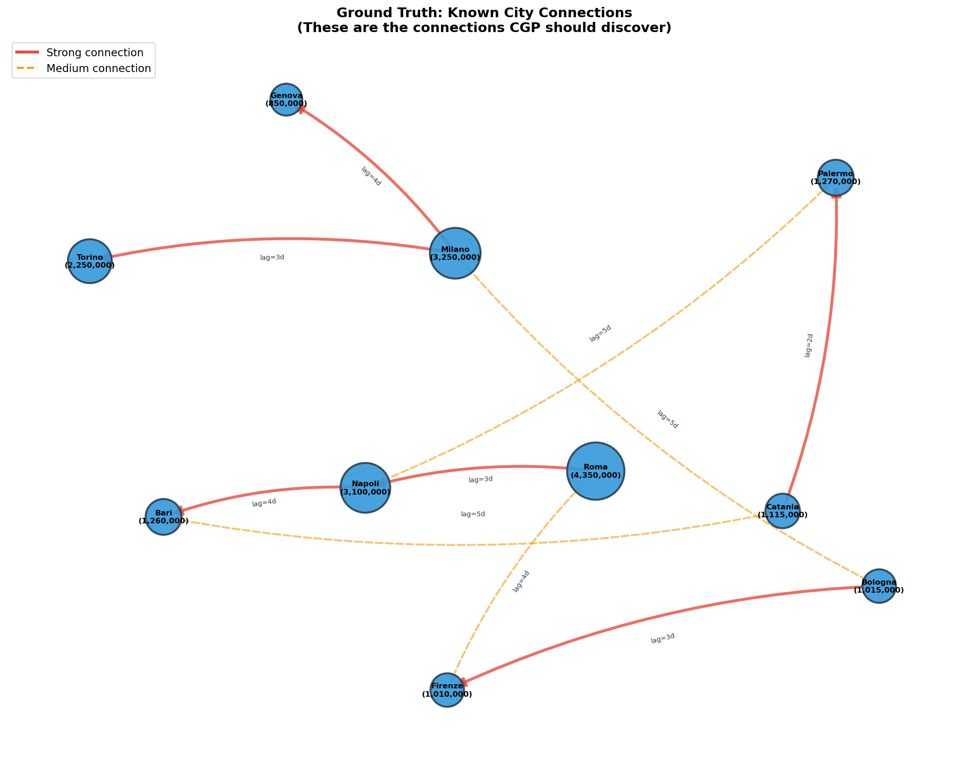

6. Results

6.1 All Cities Comparison
Figure 2: Comparison of All 10 Cities - Synthetic SIR
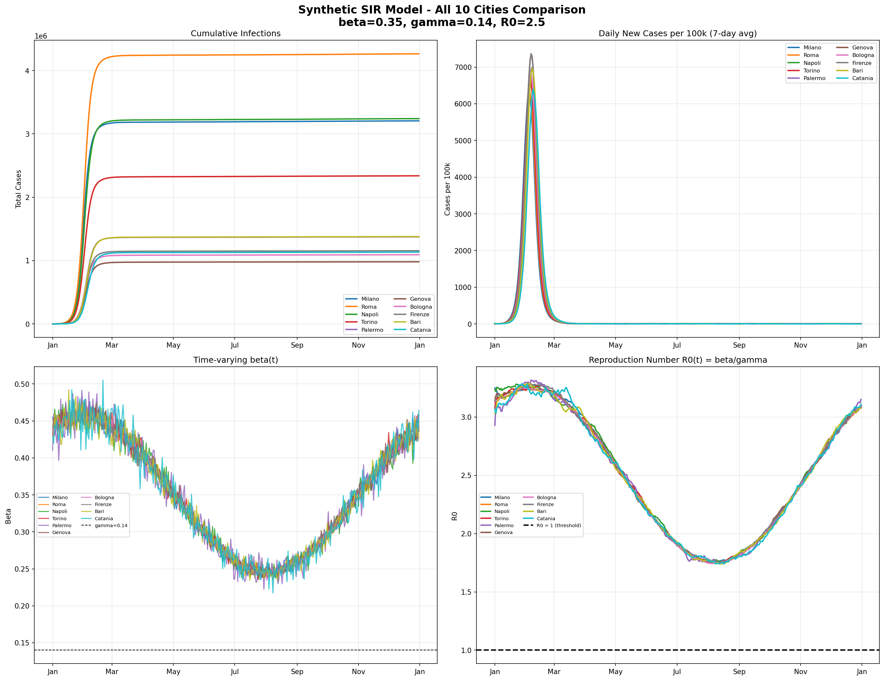

6.2 Spillover Effect
Figure 3: Comparing 1%, 5%, and 10% Spillover Effects
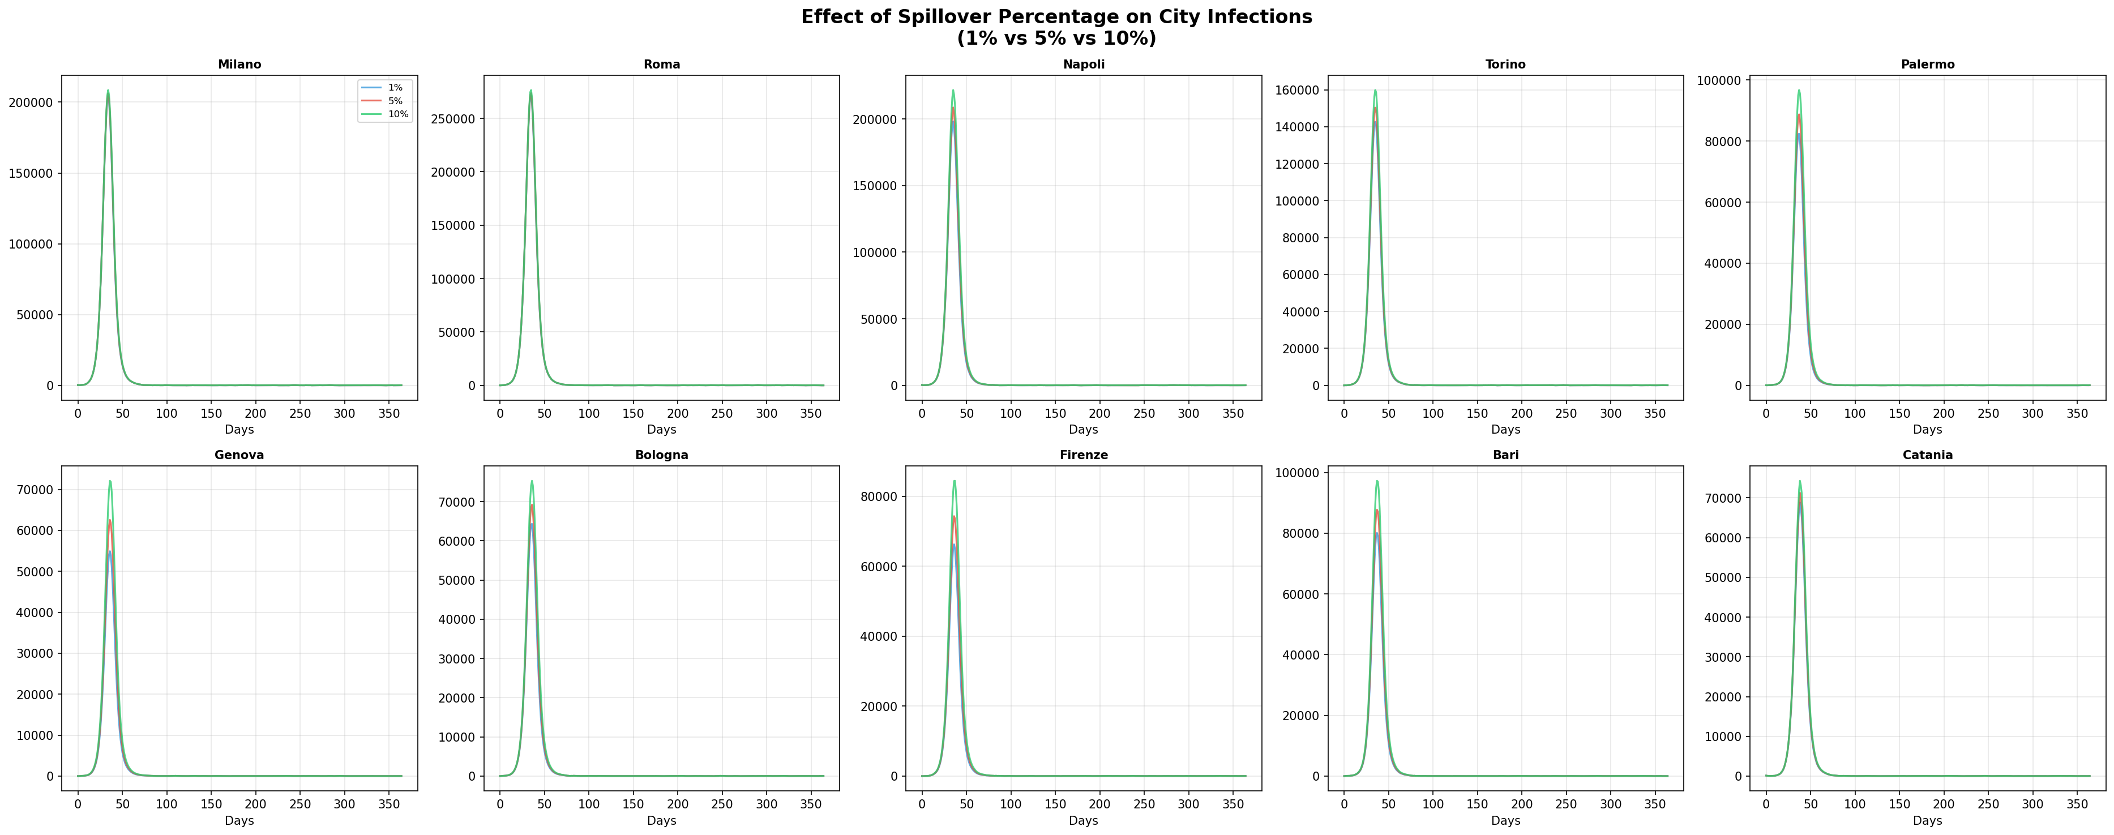

6.3 Sample City Results
Figure 4: SIR Results - Milano
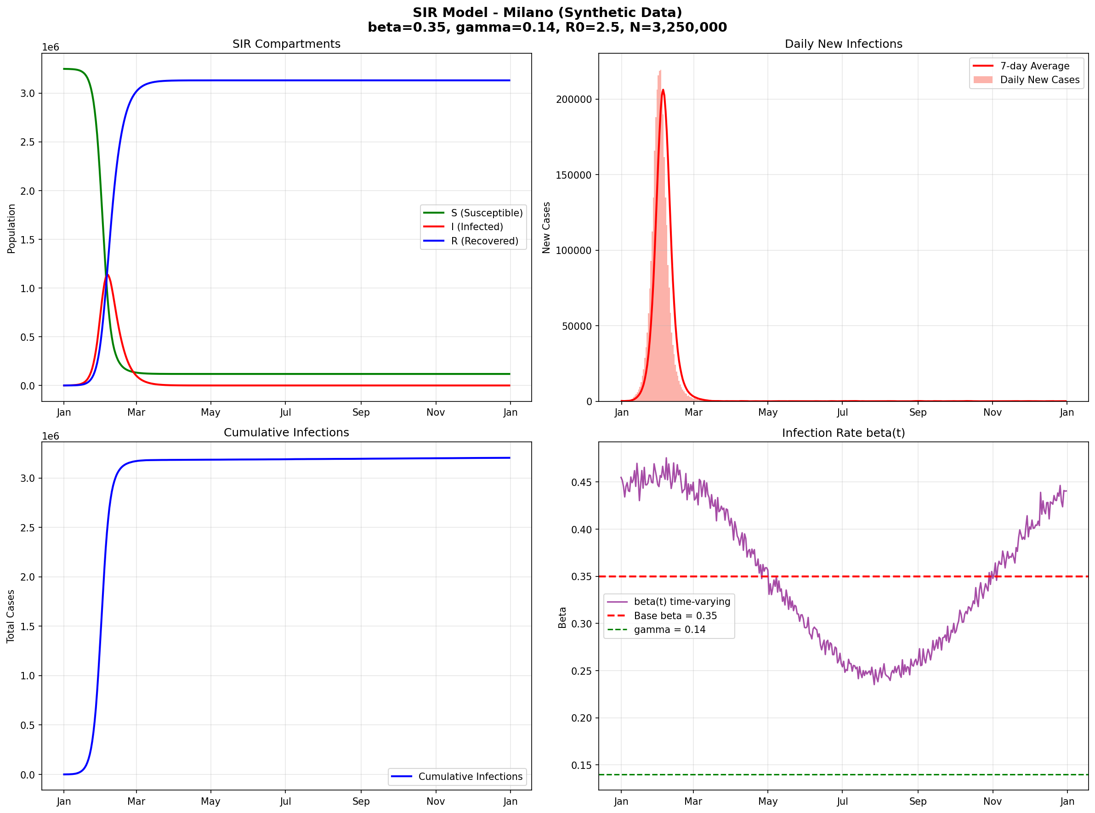

Figure 5: SIR Results - Roma
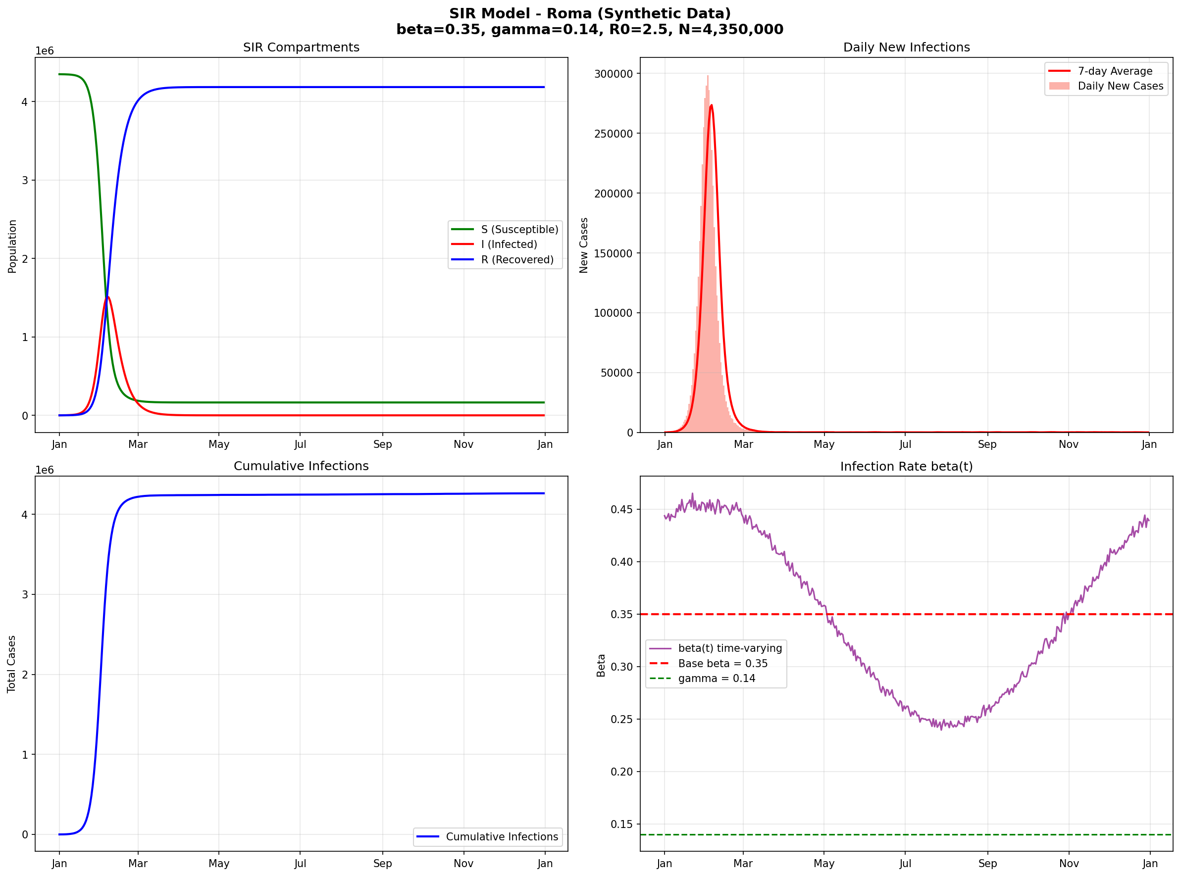

Figure 6: SIR Results - Napoli
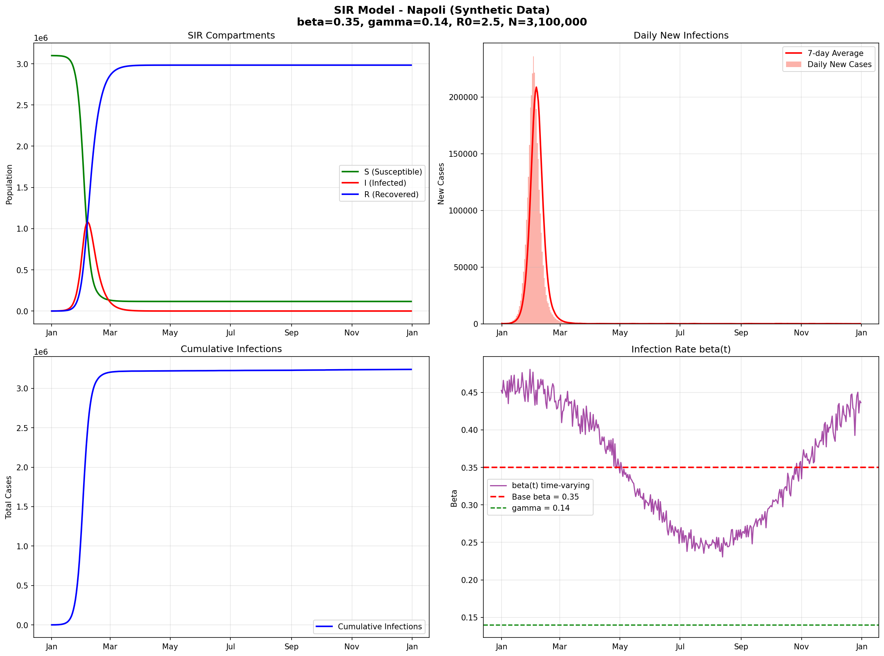

Figure 7: SIR Results - Torino
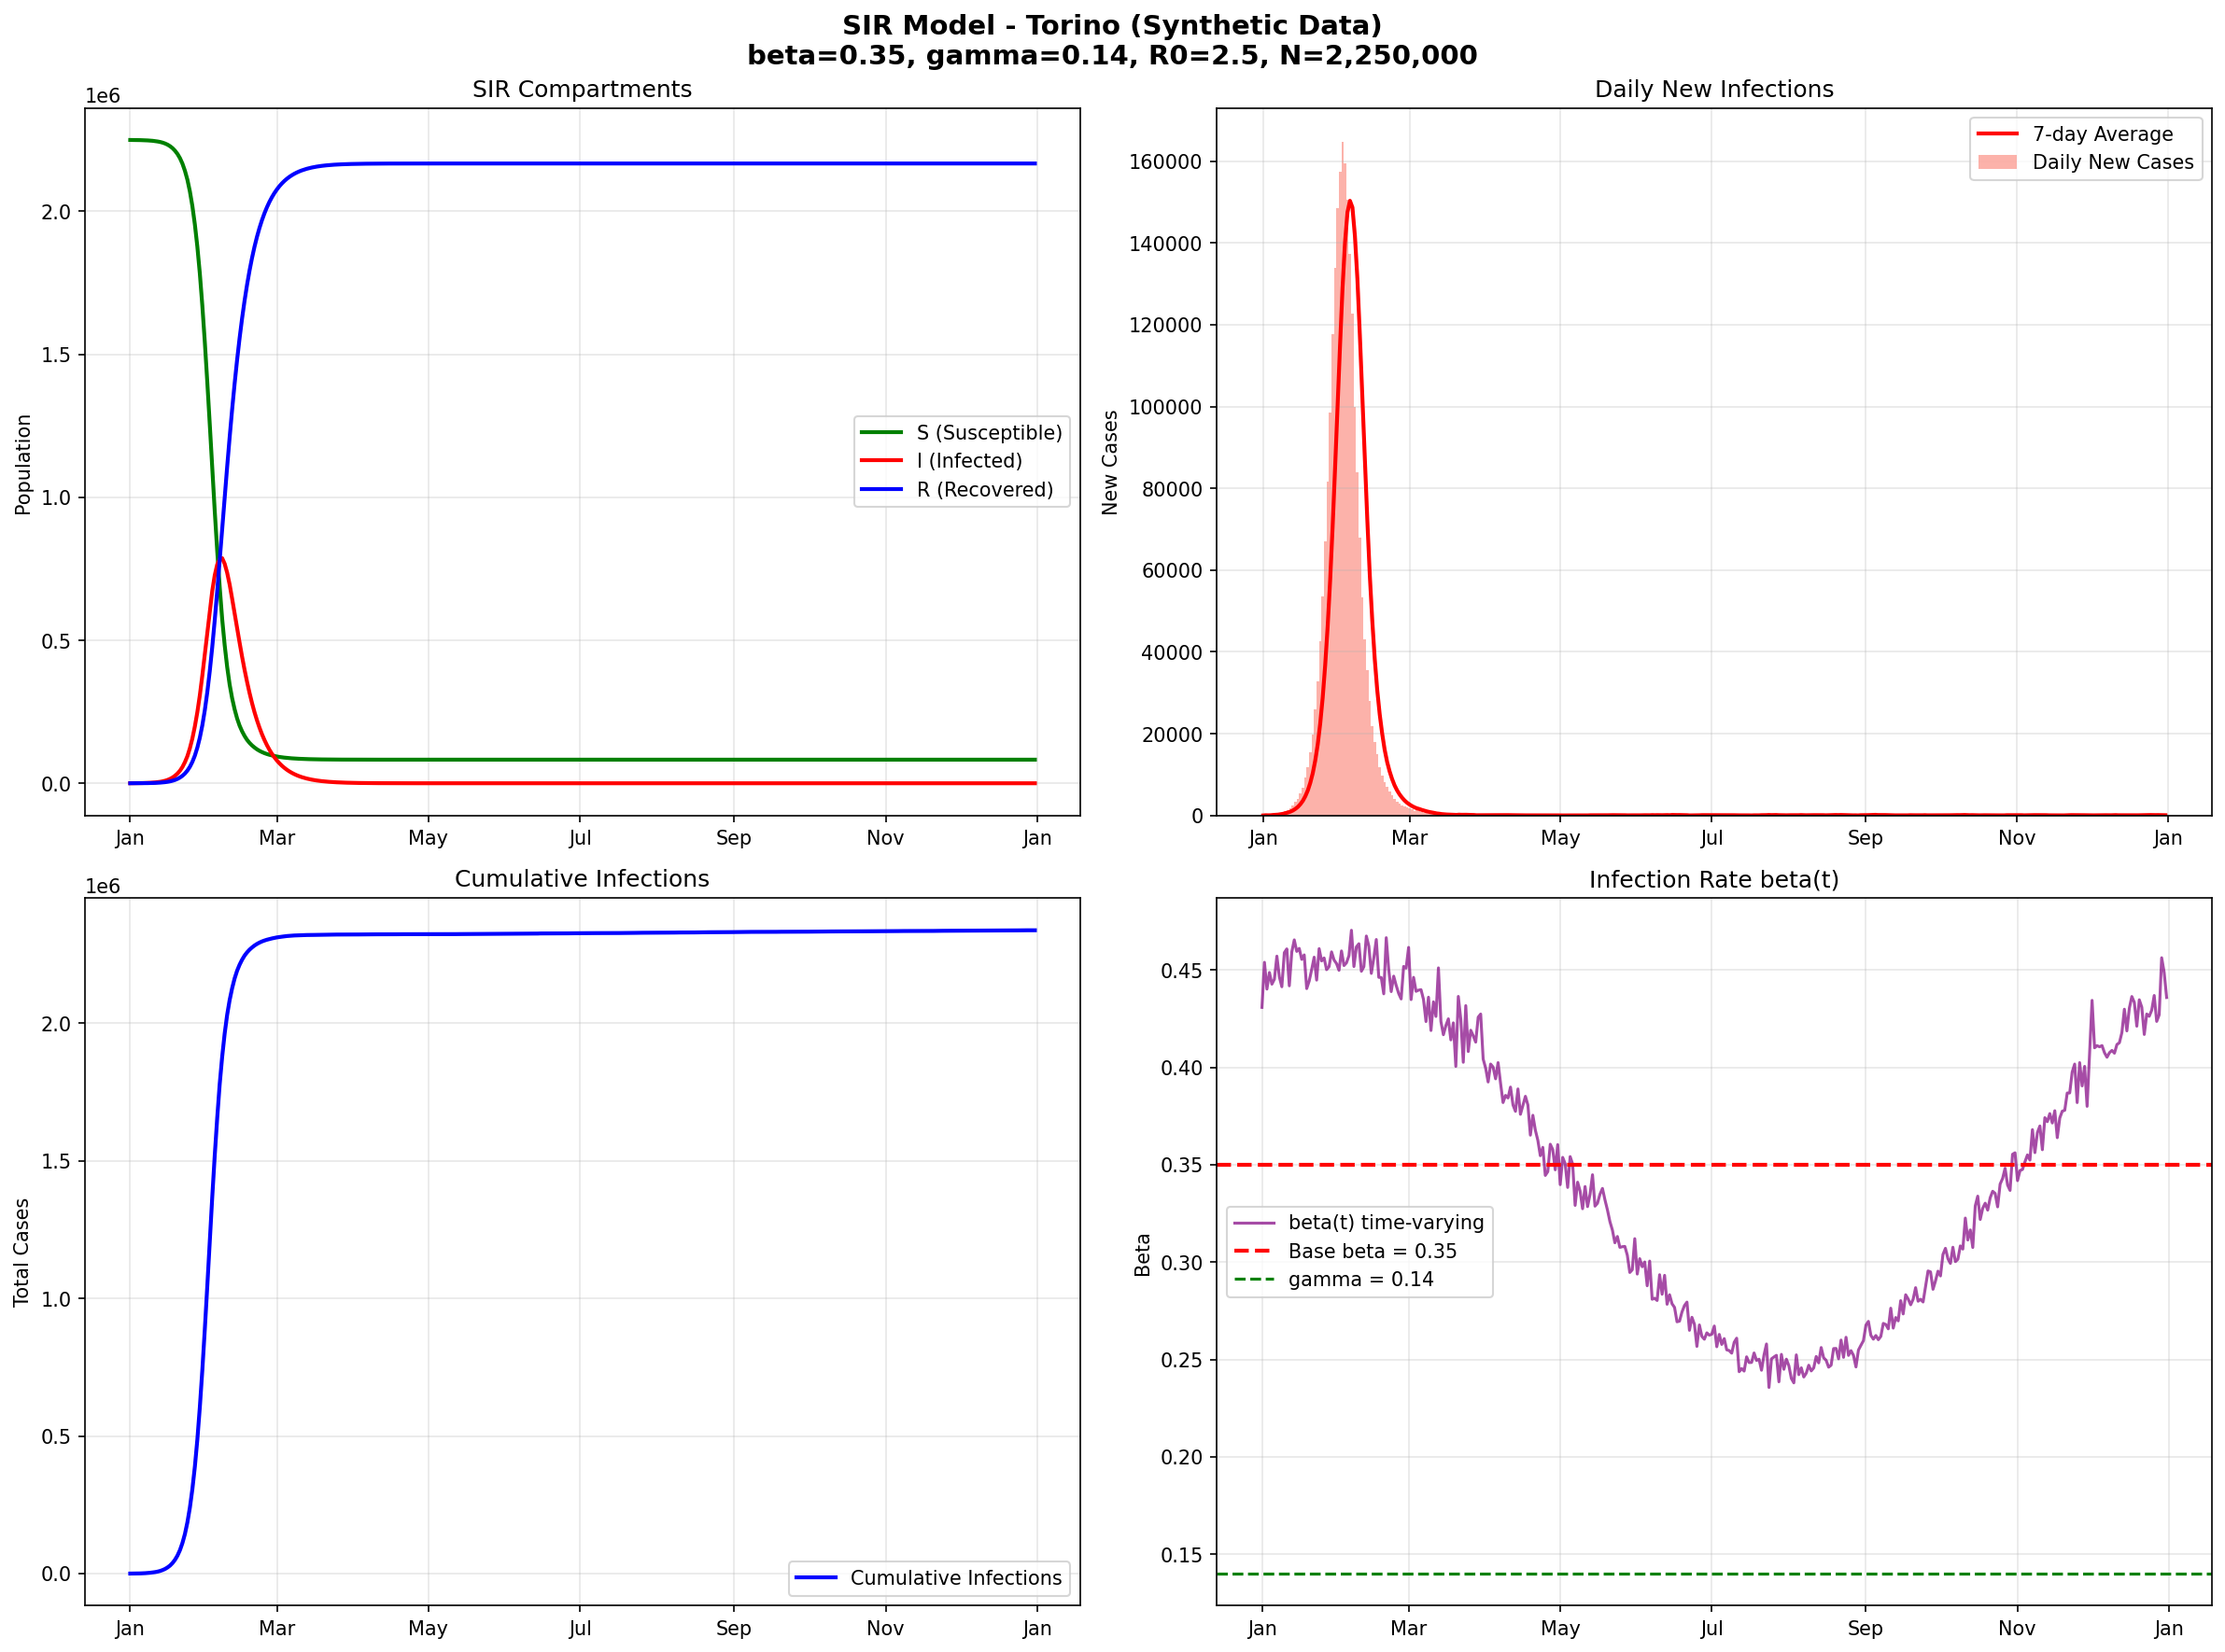

Figure 8: SIR Results - Bologna
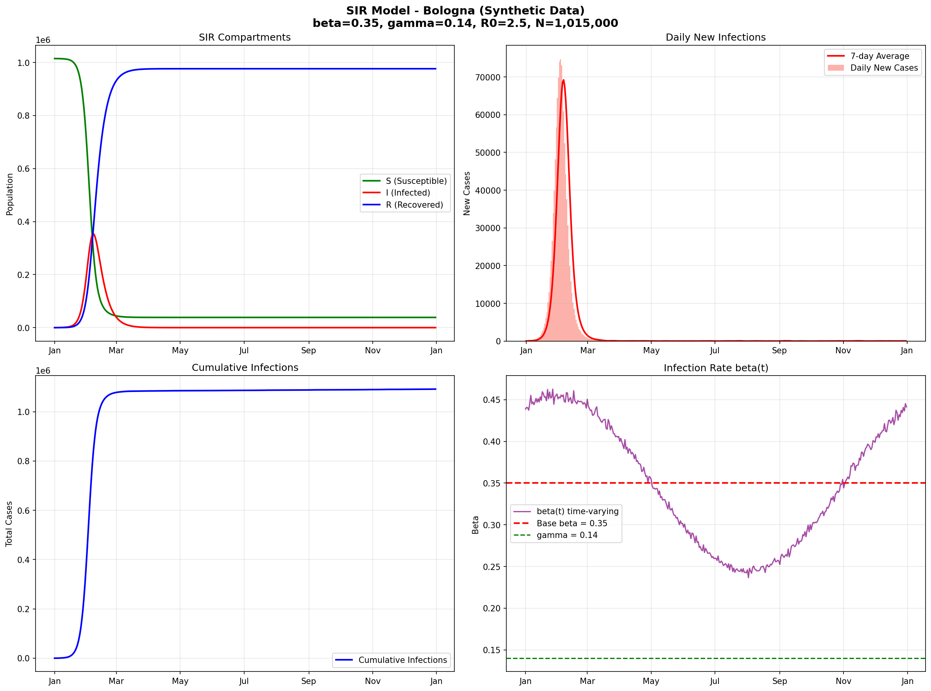

7. Conclusions
- 10 Italian cities simulated with real population data
- SIR model with β=0.35, γ=0.14 (R₀=2.5) produced realistic curves
- Inter-city spillover applied at three levels (1%, 5%, 10%)
- Data is ready for CGP analysis to validate connection discovery
- Ground truth defines 10 specific city-to-city connections

