SIR Compartmental Model Report
for 107 Italian Provinces

COVID-19 Spread Modeling Using the SIR Model
Year 2021 Data

Date: March 2026

Table of Contents
1. Introduction
2. The SIR Model
3. Data Description
4. Model Parameters
5. Results
5.1 Summary Table
5.2 Top 10 Comparison
5.3 Beta Heatmap
5.4 R0 Distribution
5.5 City Results
6. Discussion
7. Conclusions
Appendix

1. Introduction
SIR model applied to COVID-19 data from 107 Italian provinces for 2021.

2. The SIR Model
Compartmental model: S (Susceptible), I (Infected), R (Recovered).
dS/dt = -beta*S*I/N, dI/dt = beta*S*I/N - gamma*I, dR/dt = gamma*I
R0 = beta/gamma. Piecewise fitting with 30-day segments using Differential Evolution.

3. Data Description
Metric | Value
Cities | 107
Period | 2021-01-01 to 2021-12-31
Days | 365
Data Type | Cumulative cases (totale_casi)
Source | Protezione Civile Italiana

4. Model Parameters
Parameter | Value | Description
Gamma | 0.07 | Recovery ~14 days
Segment | 30 days | Piecewise constant beta
Optimizer | Diff. Evolution | Robust evolutionary
Max Iter | 300 | Max generations
Beta Range | [0.01, 2.0] | Allowed range
Objective | Norm. MSE | Normalized MSE

5. Results
Total 2021 infections: 6,016,349. Average R0: 1.31.

5.1 Summary Table (Top 20)
# | City | Pop. | Cases | Rate(%) | Beta | R0
1 | Milano | 3,250,000 | 413,691 | 12.7 | 0.1011 | 1.44
2 | Roma | 4,350,000 | 369,335 | 8.5 | 0.0772 | 1.1
3 | Napoli | 3,100,000 | 345,490 | 11.1 | 0.0949 | 1.36
4 | Torino | 2,250,000 | 259,888 | 11.6 | 0.0937 | 1.34
5 | Brescia | 1,265,000 | 142,649 | 11.3 | 0.0911 | 1.3
6 | Padova | 940,000 | 127,182 | 13.5 | 0.0825 | 1.18
7 | Bologna | 1,020,000 | 125,206 | 12.3 | 0.0783 | 1.12
8 | Treviso | 890,000 | 121,901 | 13.7 | 0.0829 | 1.18
9 | Varese | 890,000 | 120,876 | 13.6 | 0.0928 | 1.33
10 | Verona | 930,000 | 119,250 | 12.8 | 0.0813 | 1.16
11 | Monza_E_Della_Brianza | 875,000 | 115,545 | 13.2 | 0.1058 | 1.51
12 | Bari | 1,250,000 | 110,259 | 8.8 | 0.1119 | 1.6
13 | Vicenza | 860,000 | 108,870 | 12.7 | 0.0842 | 1.2
14 | Firenze | 1,010,000 | 108,458 | 10.7 | 0.1021 | 1.46
15 | Venezia | 855,000 | 107,940 | 12.6 | 0.081 | 1.16
16 | Bolzano | 535,000 | 100,897 | 18.9 | 0.0864 | 1.23
17 | Palermo | 1,250,000 | 96,898 | 7.8 | 0.1031 | 1.47
18 | Catania | 1,080,000 | 95,510 | 8.8 | 0.0865 | 1.24
19 | Salerno | 1,080,000 | 92,752 | 8.6 | 0.0933 | 1.33
20 | Caserta | 925,000 | 89,196 | 9.6 | 0.0975 | 1.39

5.2 Top 10 Cities Comparison
Figure 1: Top 10 Comparison
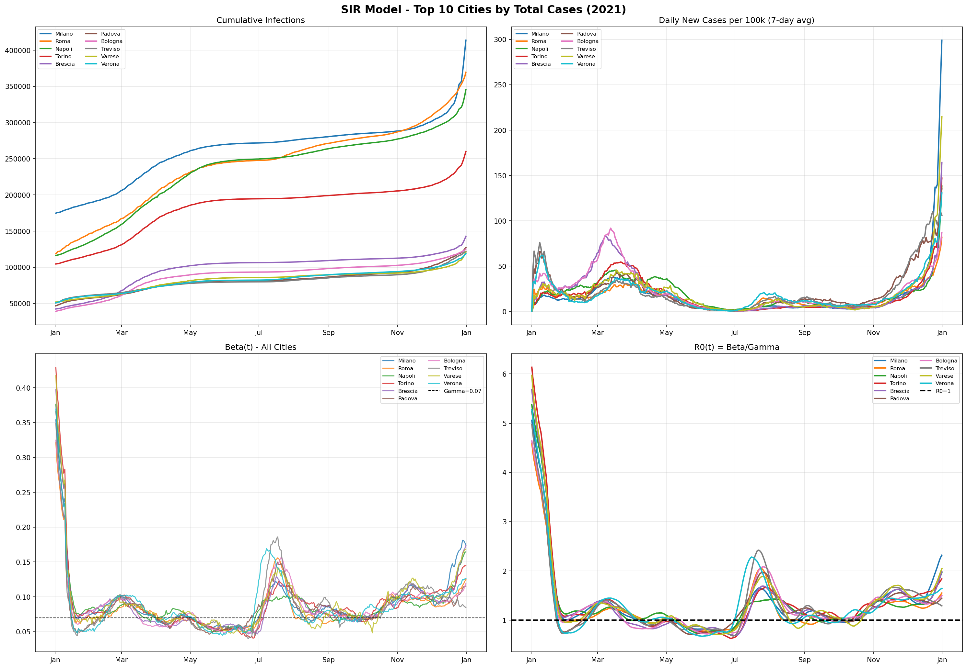

5.3 Beta Heatmap
Figure 2: Beta Heatmap
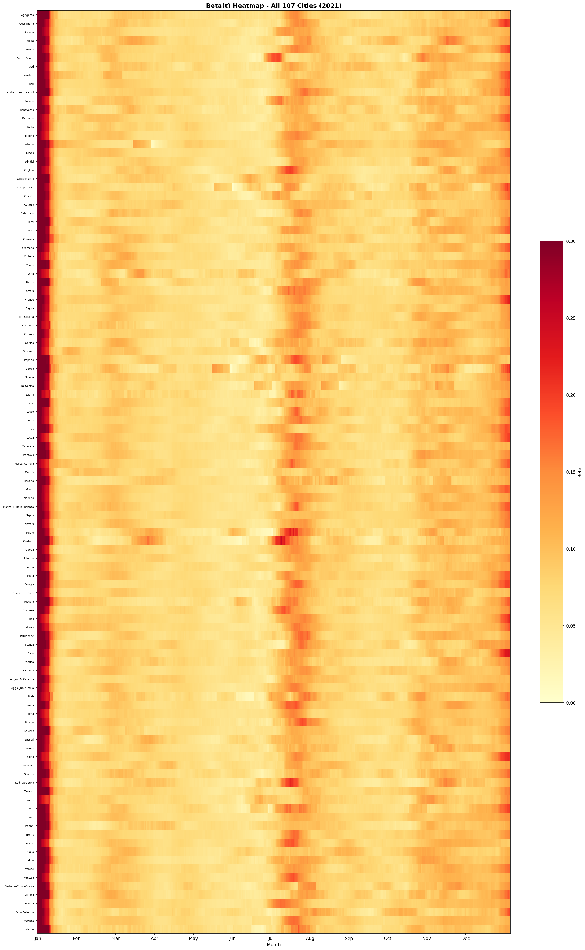

5.4 R0 Distribution
Figure 3: R0 Distribution
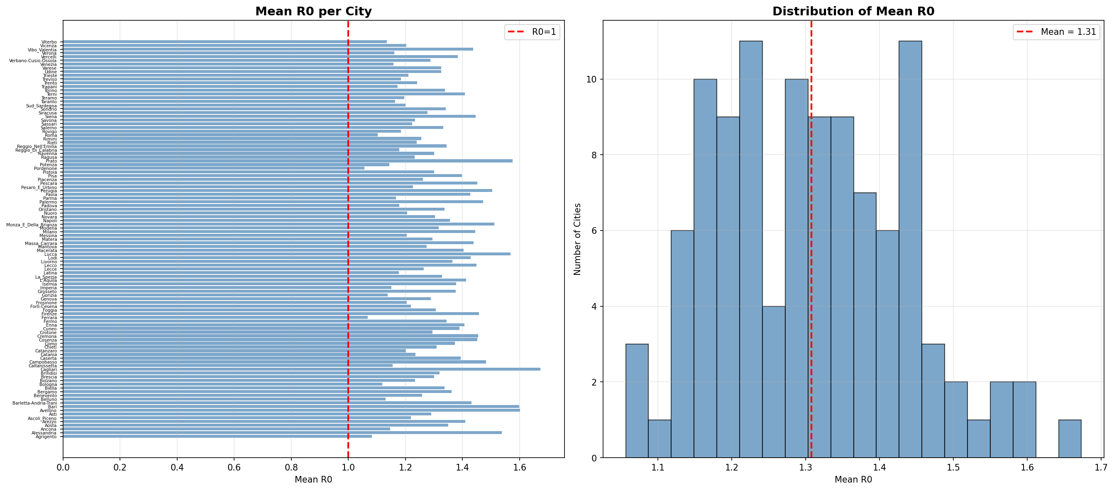

5.5 Individual City Results
Figure 4: Roma
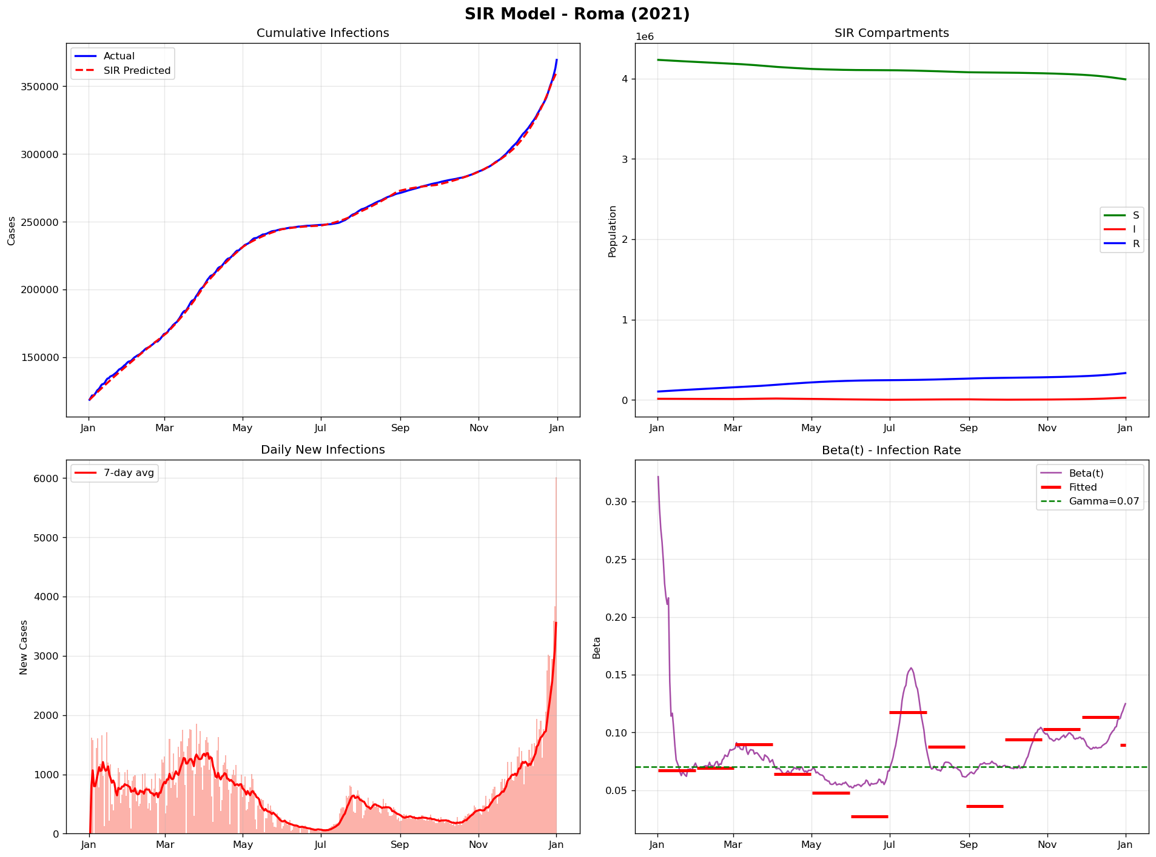

Figure 5: Milano
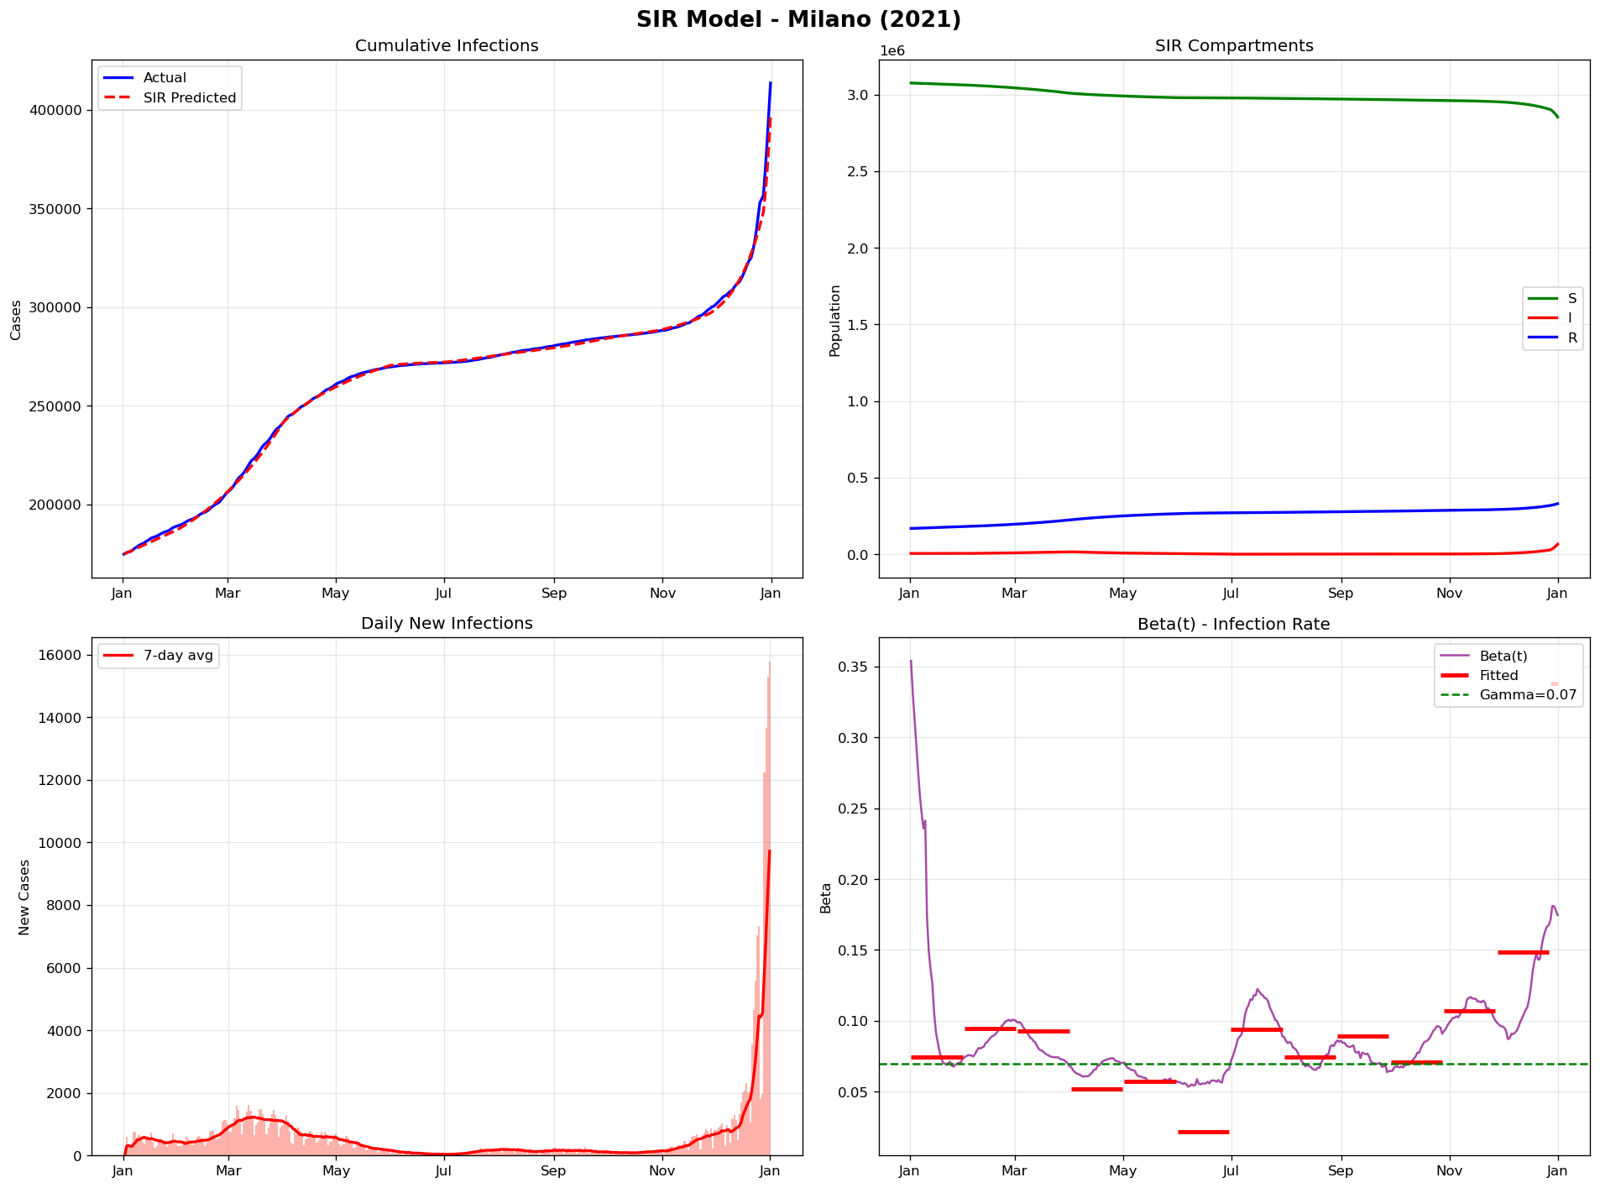

Figure 6: Napoli
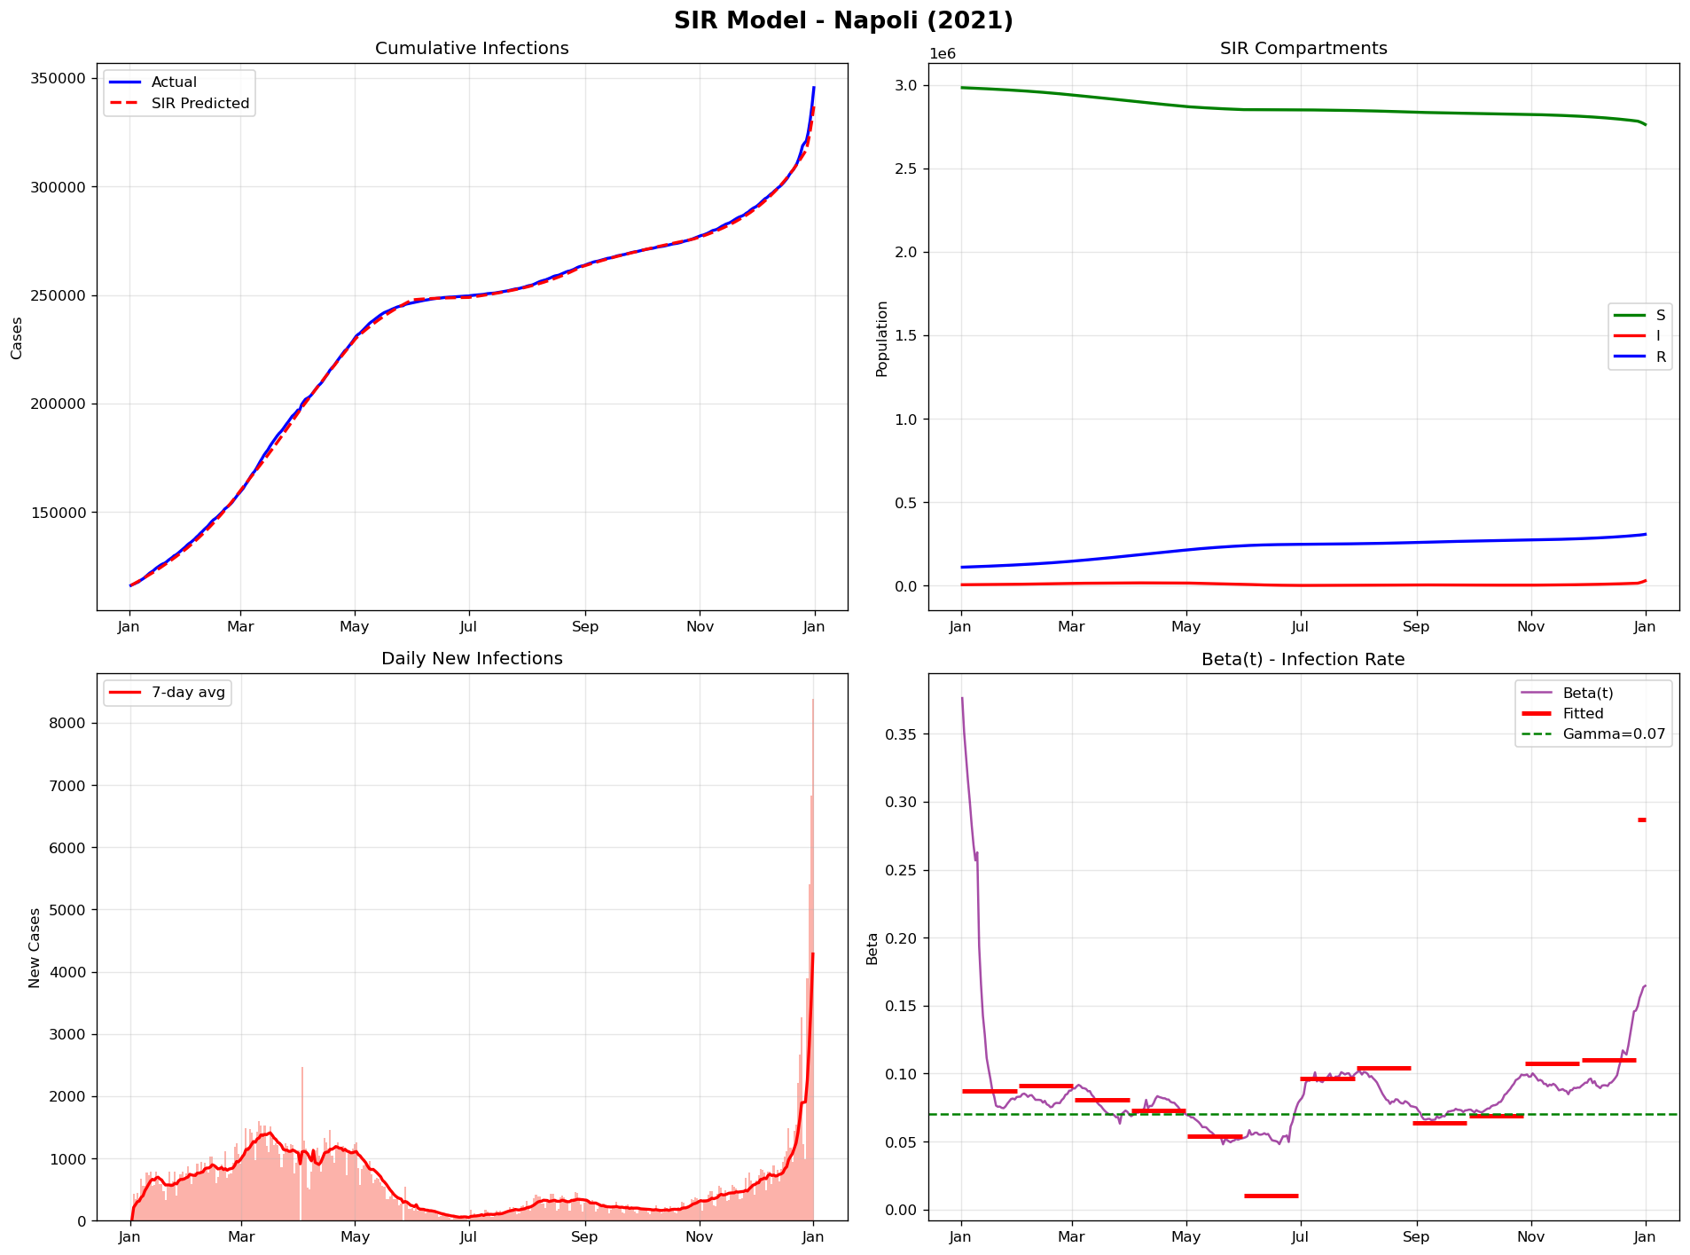

Figure 7: Brescia
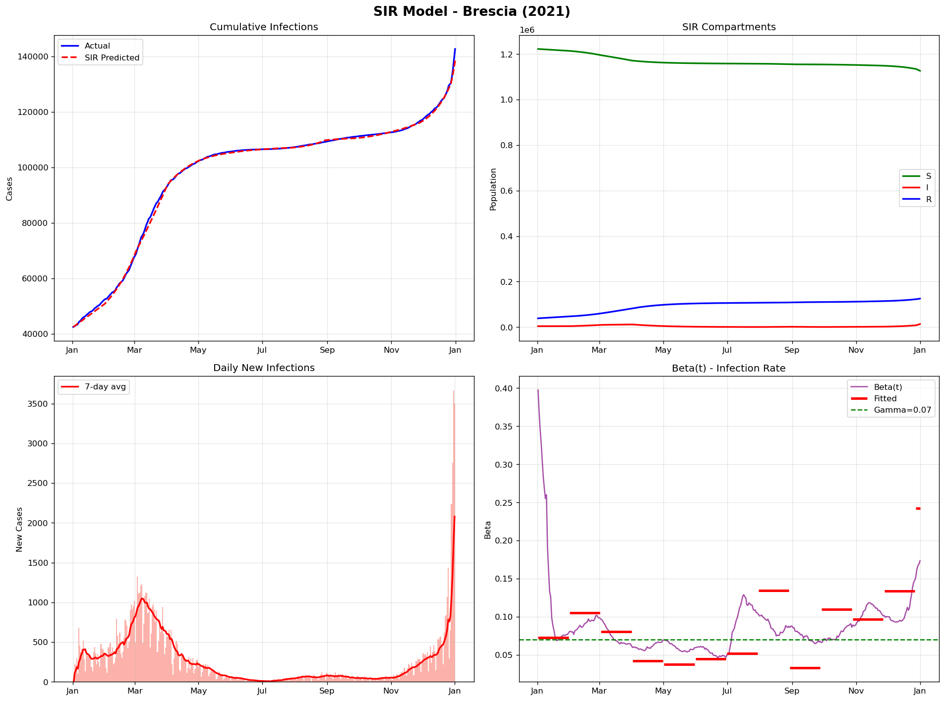

Figure 8: Bologna
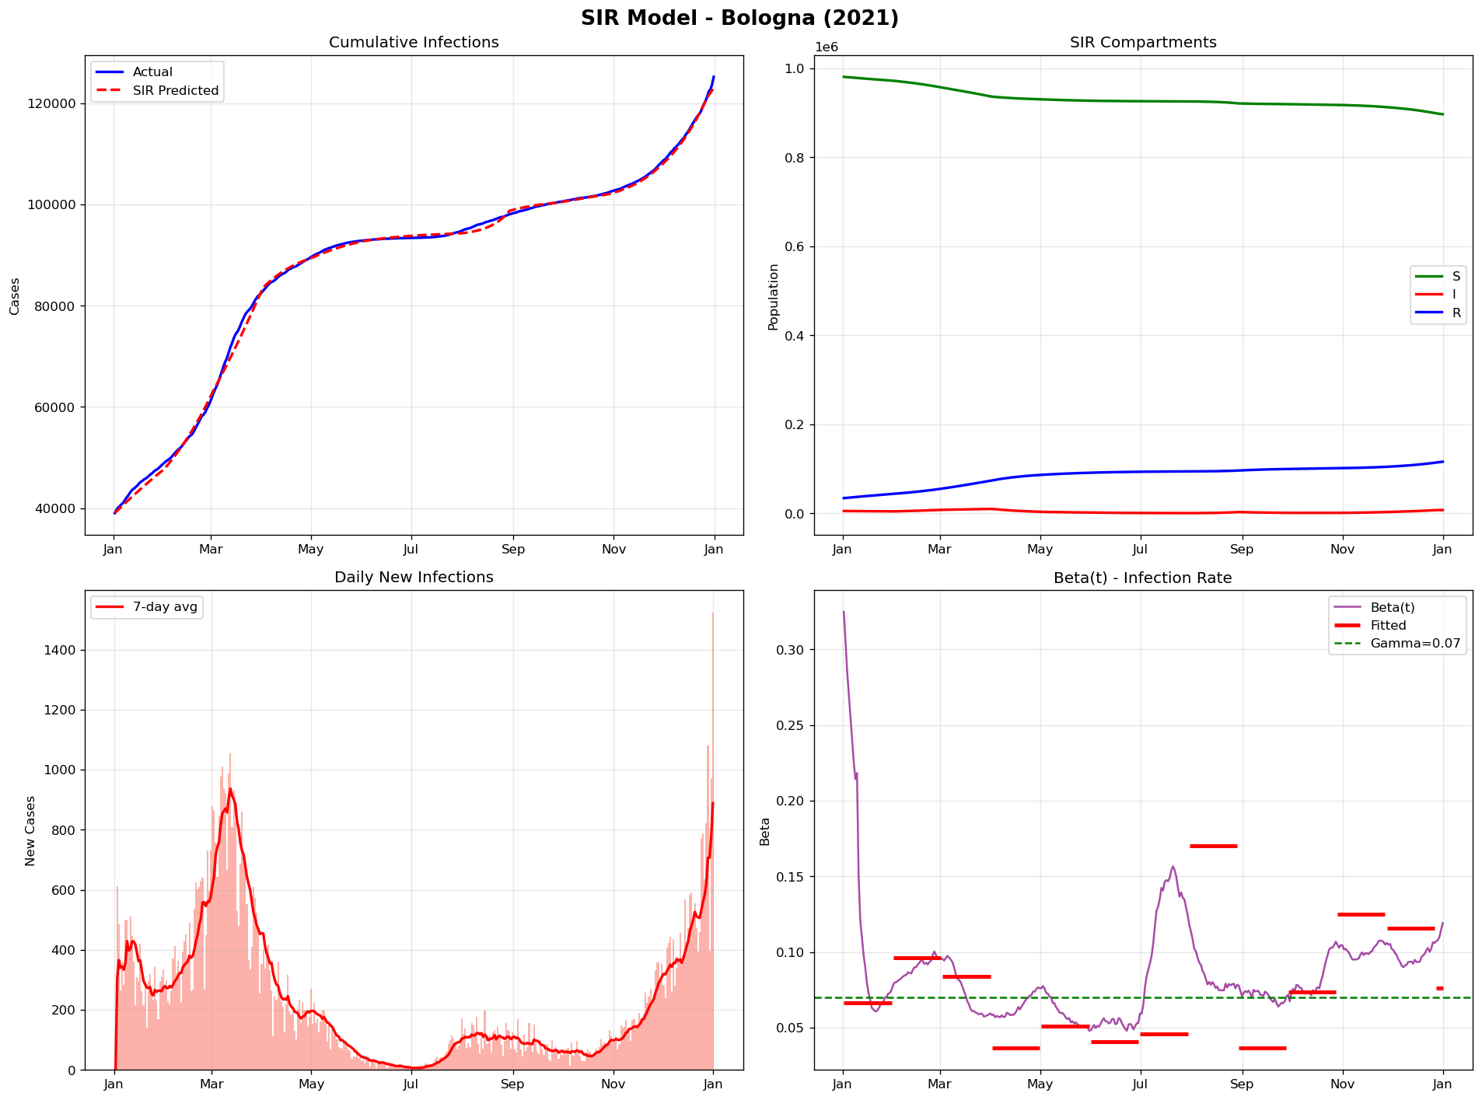

6. Discussion
Beta varied significantly throughout 2021 reflecting pandemic waves and interventions.

7. Conclusions
- Total 2021 infections: 6,016,349
- Average R0: 1.31
- SIR fitted successfully to all 107 cities
- Piecewise fitting with DE produced optimal results

Appendix: Full Results (107 Cities)
# | City | Pop. | Cases | Rate(%) | Beta | R0
1 | Milano | 3,250,000 | 413,691 | 12.7 | 0.1011 | 1.44
2 | Roma | 4,350,000 | 369,335 | 8.5 | 0.0772 | 1.1
3 | Napoli | 3,100,000 | 345,490 | 11.1 | 0.0949 | 1.36
4 | Torino | 2,250,000 | 259,888 | 11.6 | 0.0937 | 1.34
5 | Brescia | 1,265,000 | 142,649 | 11.3 | 0.0911 | 1.3
6 | Padova | 940,000 | 127,182 | 13.5 | 0.0825 | 1.18
7 | Bologna | 1,020,000 | 125,206 | 12.3 | 0.0783 | 1.12
8 | Treviso | 890,000 | 121,901 | 13.7 | 0.0829 | 1.18
9 | Varese | 890,000 | 120,876 | 13.6 | 0.0928 | 1.33
10 | Verona | 930,000 | 119,250 | 12.8 | 0.0813 | 1.16
11 | Monza_E_Della_Brianza | 875,000 | 115,545 | 13.2 | 0.1058 | 1.51
12 | Bari | 1,250,000 | 110,259 | 8.8 | 0.1119 | 1.6
13 | Vicenza | 860,000 | 108,870 | 12.7 | 0.0842 | 1.2
14 | Firenze | 1,010,000 | 108,458 | 10.7 | 0.1021 | 1.46
15 | Venezia | 855,000 | 107,940 | 12.6 | 0.081 | 1.16
16 | Bolzano | 535,000 | 100,897 | 18.9 | 0.0864 | 1.23
17 | Palermo | 1,250,000 | 96,898 | 7.8 | 0.1031 | 1.47
18 | Catania | 1,080,000 | 95,510 | 8.8 | 0.0865 | 1.24
19 | Salerno | 1,080,000 | 92,752 | 8.6 | 0.0933 | 1.33
20 | Caserta | 925,000 | 89,196 | 9.6 | 0.0975 | 1.39
21 | Modena | 710,000 | 85,608 | 12.1 | 0.0922 | 1.32
22 | Como | 600,000 | 79,601 | 13.3 | 0.0961 | 1.37
23 | Bergamo | 1,115,000 | 78,749 | 7.1 | 0.0953 | 1.36
24 | Genova | 830,000 | 73,129 | 8.8 | 0.0903 | 1.29
25 | Cuneo | 585,000 | 70,170 | 12.0 | 0.0972 | 1.39
26 | Perugia | 655,000 | 66,396 | 10.1 | 0.1053 | 1.5
27 | Udine | 530,000 | 65,050 | 12.3 | 0.0928 | 1.33
28 | Reggio_Nell'Emilia | 530,000 | 63,203 | 11.9 | 0.0941 | 1.34
29 | Trento | 545,000 | 62,935 | 11.5 | 0.0868 | 1.24
30 | Pavia | 545,000 | 62,487 | 11.5 | 0.0999 | 1.43
31 | Foggia | 610,000 | 54,482 | 8.9 | 0.0915 | 1.31
32 | Forlì-Cesena | 395,000 | 54,029 | 13.7 | 0.0853 | 1.22
33 | Rimini | 340,000 | 53,310 | 15.7 | 0.0879 | 1.26
34 | Latina | 575,000 | 49,725 | 8.6 | 0.0824 | 1.18
35 | Mantova | 410,000 | 47,652 | 11.6 | 0.0892 | 1.27
36 | Messina | 620,000 | 46,172 | 7.4 | 0.0843 | 1.2
37 | Ravenna | 390,000 | 46,089 | 11.8 | 0.091 | 1.3
38 | Ancona | 470,000 | 45,494 | 9.7 | 0.0803 | 1.15
39 | Taranto | 560,000 | 45,490 | 8.1 | 0.0814 | 1.16
40 | Pisa | 420,000 | 43,839 | 10.4 | 0.0978 | 1.4
41 | Frosinone | 475,000 | 42,052 | 8.9 | 0.0843 | 1.2
42 | Alessandria | 410,000 | 41,034 | 10.0 | 0.1076 | 1.54
43 | Reggio_Di_Calabria | 530,000 | 40,519 | 7.6 | 0.0825 | 1.18
44 | Lecce | 790,000 | 39,334 | 5.0 | 0.0885 | 1.26
45 | Novara | 365,000 | 38,628 | 10.6 | 0.0912 | 1.3
46 | Parma | 455,000 | 38,260 | 8.4 | 0.0817 | 1.17
47 | Lucca | 390,000 | 38,227 | 9.8 | 0.1098 | 1.57
48 | Cremona | 355,000 | 38,037 | 10.7 | 0.1018 | 1.45
49 | Trieste | 235,000 | 37,749 | 16.1 | 0.0848 | 1.21
50 | Arezzo | 340,000 | 34,871 | 10.3 | 0.0987 | 1.41
51 | Pistoia | 295,000 | 34,609 | 11.7 | 0.0911 | 1.3
52 | Cosenza | 700,000 | 33,664 | 4.8 | 0.1016 | 1.45
53 | Lecco | 340,000 | 33,657 | 9.9 | 0.1014 | 1.45
54 | Ferrara | 345,000 | 33,546 | 9.7 | 0.0748 | 1.07
55 | Prato | 260,000 | 32,806 | 12.6 | 0.1103 | 1.58
56 | Pordenone | 310,000 | 32,112 | 10.4 | 0.074 | 1.06
57 | Pesaro_E_Urbino | 360,000 | 31,456 | 8.7 | 0.0859 | 1.23
58 | Barletta-Andria-Trani | 390,000 | 31,387 | 8.0 | 0.1002 | 1.43
59 | Piacenza | 285,000 | 30,413 | 10.7 | 0.0883 | 1.26
60 | Siracusa | 390,000 | 30,157 | 7.7 | 0.0894 | 1.28
61 | Macerata | 310,000 | 29,141 | 9.4 | 0.0983 | 1.4
62 | Livorno | 335,000 | 28,386 | 8.5 | 0.0956 | 1.37
63 | Avellino | 400,000 | 28,040 | 7.0 | 0.1121 | 1.6
64 | Belluno | 200,000 | 27,686 | 13.8 | 0.0791 | 1.13
65 | Cagliari | 430,000 | 27,251 | 6.3 | 0.1171 | 1.67
66 | Chieti | 380,000 | 27,063 | 7.1 | 0.0917 | 1.31
67 | Lodi | 230,000 | 26,724 | 11.6 | 0.1 | 1.43
68 | Teramo | 305,000 | 26,554 | 8.7 | 0.0837 | 1.2
69 | Brindisi | 385,000 | 25,974 | 6.7 | 0.0924 | 1.32
70 | L'Aquila | 295,000 | 25,754 | 8.7 | 0.0989 | 1.41
71 | Pescara | 320,000 | 25,713 | 8.0 | 0.1016 | 1.45
72 | Trapani | 425,000 | 25,288 | 6.0 | 0.0821 | 1.17
73 | Siena | 265,000 | 24,739 | 9.3 | 0.1012 | 1.45
74 | Sassari | 490,000 | 24,437 | 5.0 | 0.0857 | 1.22
75 | Imperia | 210,000 | 24,123 | 11.5 | 0.0805 | 1.15
76 | Savona | 275,000 | 23,944 | 8.7 | 0.0864 | 1.23
77 | Asti | 210,000 | 23,571 | 11.2 | 0.0904 | 1.29
78 | Viterbo | 310,000 | 23,553 | 7.6 | 0.0794 | 1.13
79 | Potenza | 360,000 | 23,206 | 6.4 | 0.08 | 1.14
80 | Ragusa | 320,000 | 22,619 | 7.1 | 0.0863 | 1.23
81 | Rovigo | 235,000 | 22,248 | 9.5 | 0.0829 | 1.18
82 | Caltanissetta | 255,000 | 22,051 | 8.6 | 0.0809 | 1.16
83 | Agrigento | 415,000 | 21,867 | 5.3 | 0.0757 | 1.08
84 | La_Spezia | 218,000 | 20,667 | 9.5 | 0.093 | 1.33
85 | Sondrio | 180,000 | 20,138 | 11.2 | 0.0938 | 1.34
86 | Massa_Carrara | 195,000 | 19,295 | 9.9 | 0.1007 | 1.44
87 | Gorizia | 140,000 | 18,939 | 13.5 | 0.0797 | 1.14
88 | Terni | 225,000 | 18,618 | 8.3 | 0.0985 | 1.41
89 | Benevento | 270,000 | 17,973 | 6.7 | 0.0881 | 1.26
90 | Verbano-Cusio-Ossola | 155,000 | 17,961 | 11.6 | 0.0902 | 1.29
91 | Vercelli | 170,000 | 17,172 | 10.1 | 0.0969 | 1.38
92 | Ascoli_Piceno | 205,000 | 16,702 | 8.1 | 0.0854 | 1.22
93 | Biella | 175,000 | 16,382 | 9.4 | 0.0936 | 1.34
94 | Fermo | 170,000 | 16,057 | 9.4 | 0.0941 | 1.34
95 | Grosseto | 220,000 | 15,814 | 7.2 | 0.0963 | 1.38
96 | Aosta | 124,000 | 15,075 | 12.2 | 0.0945 | 1.35
97 | Sud_Sardegna | 340,000 | 14,957 | 4.4 | 0.084 | 1.2
98 | Catanzaro | 350,000 | 14,905 | 4.3 | 0.0841 | 1.2
99 | Rieti | 155,000 | 14,543 | 9.4 | 0.0867 | 1.24
100 | Nuoro | 205,000 | 14,068 | 6.9 | 0.0844 | 1.21
101 | Matera | 195,000 | 12,088 | 6.2 | 0.0907 | 1.3
102 | Enna | 160,000 | 12,042 | 7.5 | 0.0985 | 1.41
103 | Campobasso | 215,000 | 11,985 | 5.6 | 0.1038 | 1.48
104 | Vibo_Valentia | 155,000 | 10,588 | 6.8 | 0.1006 | 1.44
105 | Crotone | 170,000 | 10,405 | 6.1 | 0.0906 | 1.29
106 | Oristano | 155,000 | 7,507 | 4.8 | 0.0936 | 1.34
107 | Isernia | 83,000 | 4,615 | 5.6 | 0.0965 | 1.38

