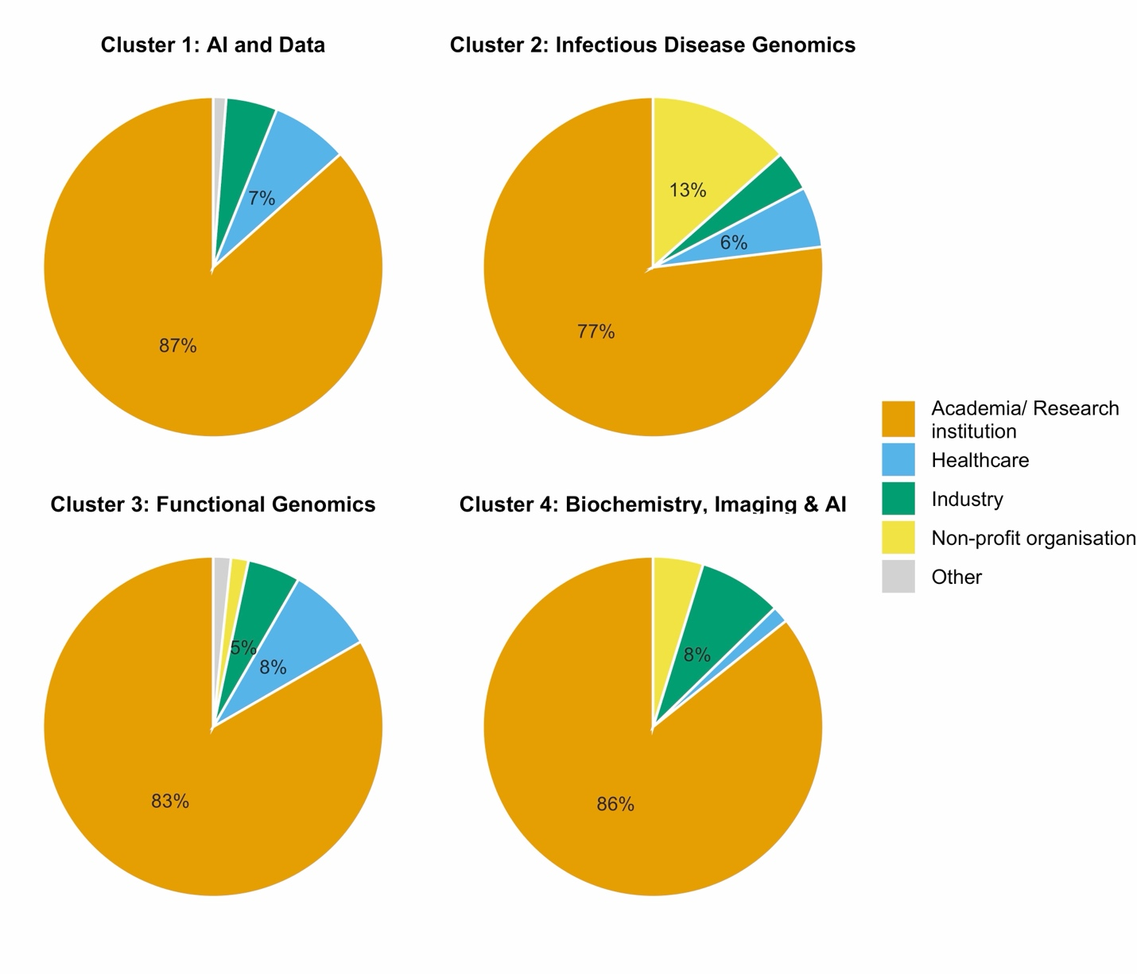
Supplementary Figure 1. Profile composition per sector
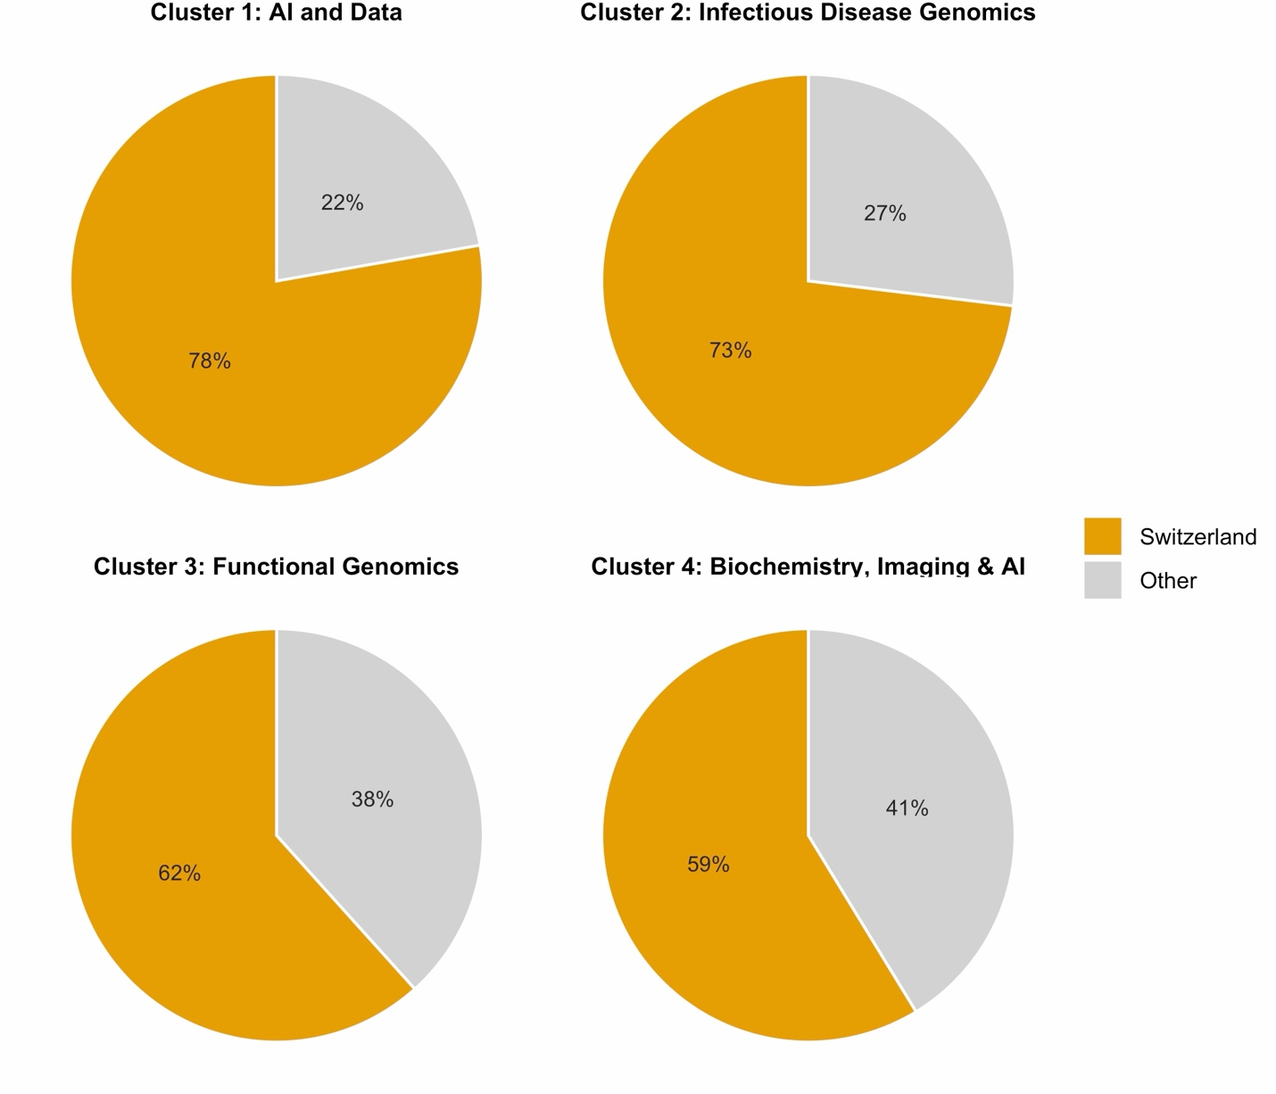
Supplementary Figure 2. Profile composition Switzerland versus other countries.
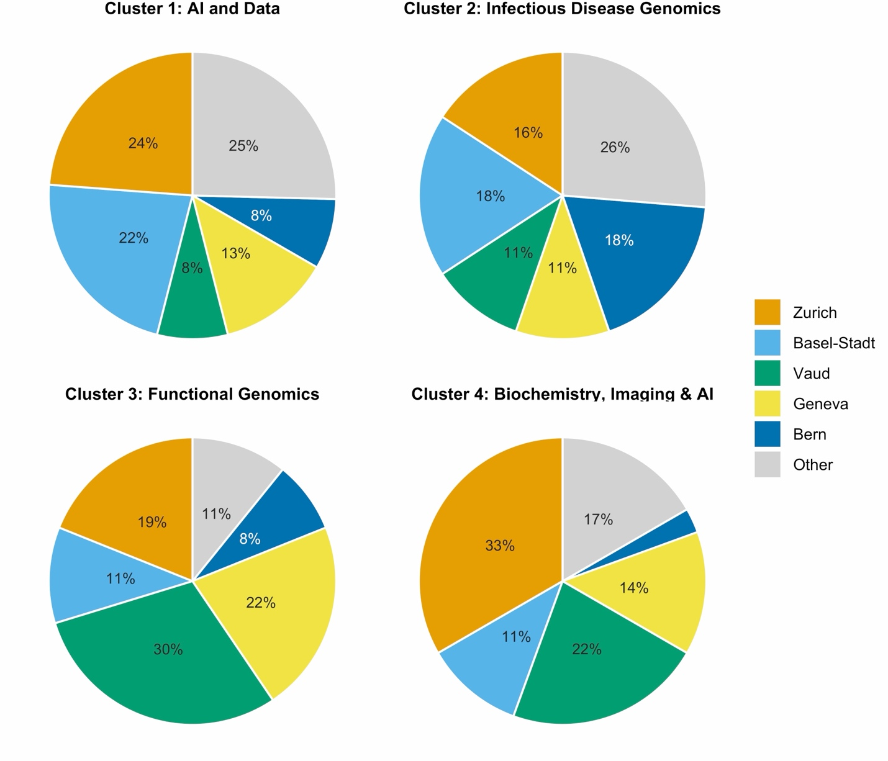
Supplementary Figure 3. Profile composition per canton. Only respondents who indicated to work in Switzerland are represented.
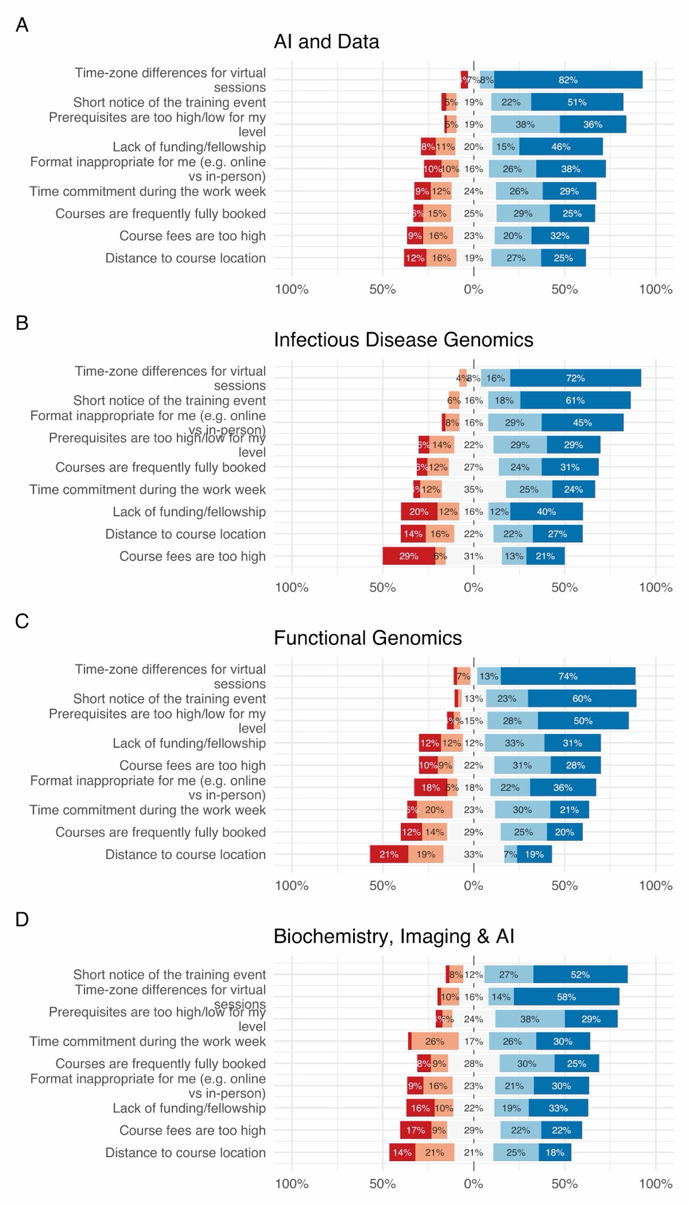
Supplementary Figure 4. Barriers per profile. Colors as in figure 4.
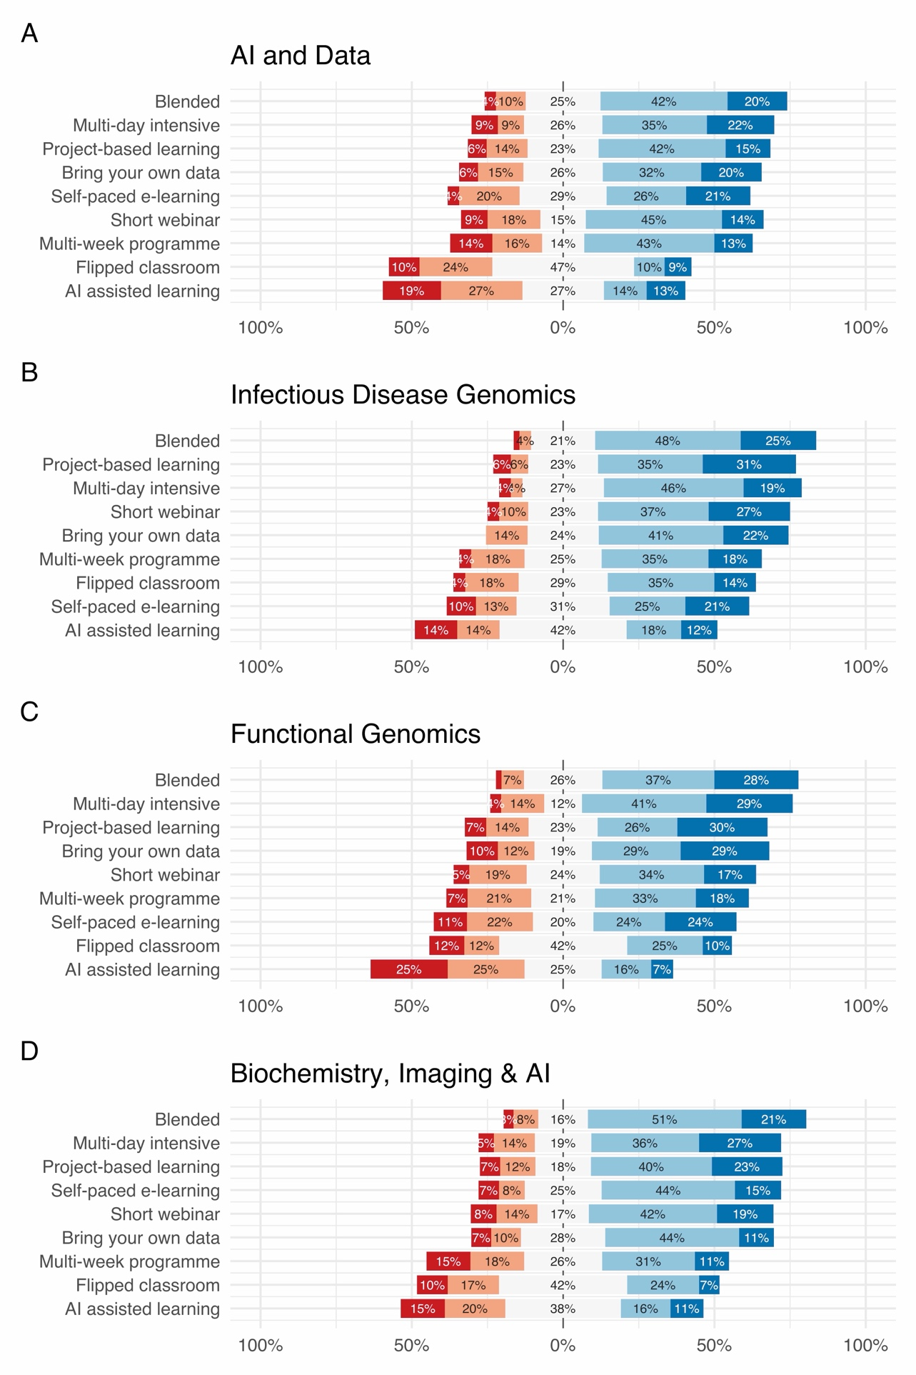
Supplementary Figure 5. Preferred learning formats per profile. Colors as in figure 5.

