Characterization of heterogeneous bioinformatics training needs in the AI era

Geert van Geest, Valeria Di Cola, Monique Zahn, Diana Marek, Gregoire Rossier, Wandrille Duchemin, Tania Wyss, Joana Carlevaro-Fita, Deepak Tanwar, Marion Vaucher, Patricia M. Palagi
Abstract
Bioinformatics training providers serve highly heterogeneous audiences, an ongoing challenge sharpened by fast-evolving technologies like generative AI. Surveys can help understanding training needs, but analyzing responses in aggregate can mask within-group heterogeneity and obscure conclusions. We present a network-based clustering protocol that instead groups respondents by the similarity of their survey responses: respondents are represented as nodes in a correlation network built from Likert-type topic ratings, and community detection groups them into learner profiles that share training needs, independent of demographic labels. We demonstrate the protocol on the 2026 SIB Swiss Institute of Bioinformatics (SIB) training needs survey (n=260, March–April 2026), covering course topics, participation barriers, and format preferences.
We identified four thematically distinct, interpretable learner profiles — AI and data, infectious disease genomics, functional genomics, and biochemistry, imaging & AI — each with topic priorities, barriers, and format preferences that remain hidden in an aggregate analysis: one topic ranked among the top overall training needs dropped far down the list within one profile, while a topic of only moderate overall priority was the single most-needed topic within another. Across all profiles, AI/LLM skills and reproducible data practices were in high demand, whereas AI-assisted learning was, unexpectedly, the least preferred format, pointing to a preference for human-led instruction. Because the protocol depends only on a shared Likert scale rather than any specific topic set, it is directly reusable for other training-needs assessments, and we provide the full, tested implementation to support this reuse. Integrating these profiles into curriculum design lets training providers target topic selection, format, and barrier mitigation to each group rather than a single aggregate curriculum.
Biographical note: the authors are members of the SIB Training group, that provides training to ensure that life scientists make the best of the latest advances in computational biology.
Key points:
- We present a validated, openly available network-clustering method for identifying learner profiles from training-needs survey data.
- Applied to the 2026 SIB training needs survey, the method identified four thematically distinct, reproducible learner profiles, capturing training-need heterogeneity that demographics miss.
- AI/LLM skills are the top training gap across all profiles, alongside strong demand for FAIR/reproducible data practices — yet respondents prefer human-led formats over AI-assisted learning.
- Curricula should be tailored to learner profiles rather than demographics or aggregate topic rankings, which each hide profile-specific needs.
Keywords: network analysis; community detection; training needs assessment; bioinformatics education; survey methodology; generative AI

1 Introduction
The rapid and continuous evolution of high-throughput experimental technologies, large-scale data infrastructures, and artificial intelligence (AI) makes bioinformatics training a necessity for life science researchers [1]. National and international training providers, such as the SIB Swiss Institute of Bioinformatics (SIB), aim to provide high-quality, effective short-format courses [2] to a heterogeneous audience at point of need. This audience ranges from academic PhD candidates requiring upskilling in specific analytical competences to corporate senior scientists or clinical personnel seeking broad overviews of emerging resources in computational biology.
It is a continuous challenge to match the training needs of such a diverse audience. A frequently used method to understand such needs are training needs surveys [e.g. 3,4–8]. These previous training needs surveys have analyzed various dimensions such as course topics, format, and logistics independently or sliced responses using classical demographic categories like career stage or geographic region. While informative, such an approach assumes that individuals within a demographic sub-group are homogeneous. However, demographic characteristics like career stage, region or sector do not necessarily explain common training needs; a post-doctoral researcher likely shares more training needs with a research technician in industry who works with similar data, than with a post-doctoral researcher working in a different domain.
Clustering of survey responses can be highly valuable for understanding such respondent heterogeneity. The approach was already introduced in the eighties for market segmentation [9], and currently finds a wide range of applications [10–14]. For our case of bioinformatics training needs, identifying clusters can identify survey respondents with similar needs. Therefore, it can help training providers design curricula that are tailored to the specific needs of these sub-groups, rather than relying on broad demographic categories.
In recent years, the fast growth of Artificial Intelligence (AI) and Large Language Models (LLMs) has transformed both the bioinformatics landscape and the nature of computational training itself [15,16]. Various generative AI tools have shifted how researchers write code [17], automate workflows and retrieve data [18]. LLM and generative AI are heavily used by scientists [19], and they are frequently used for education [20,21], both in the classroom and for self-directed learning [22,23]. To understand the impact of AI on training needs, it is therefore important to identify what kind of AI-related topics are required by scientists. This can help training providers design courses that address the specific needs, and to ensure that AI-related topics are integrated into the curriculum in a way that is relevant and useful for all learners.
This paper describes a data-driven framework for understanding training needs based on the SIB training needs survey in terms of course topics, formats, and barriers. By converting individual responses into a correlation graph, we identify clusters of respondents who share common training needs, regardless of their institutional or regional backgrounds, and characterize each cluster as a learner profile. We detail the underlying data preprocessing pipeline, a conceptual overview of graph construction, and the subsequent characterization of these learner profiles, with an emphasis on how AI can be incorporated in training programs.

2 Methods

2.1 Survey design and distribution
The SIB training needs survey was designed to collect information using mostly multiple-choice and Likert-type questions. All survey questions, and anonymized responses, can be found in Supplementary Data 1. At its core, the questionnaire evaluated course topics, barriers and formats using 5-point Likert-type scales:
- Training needs: Respondents evaluated their training needs for detailed sub-topics nested within five global computational domains: Omics analysis, Computational methods and AI, Data management and knowledge representation, Biomedicine and pathogens, and Biodiversity and Ecology, which were quantified using an ordinal scale ranging from ‘Not needed’ to ‘Absolutely essential’.
- Perceived participation barriers: Participation barriers like course fees, travel distance, timing constraints, and prerequisite alignment were quantified using an ordinal scale ranging from ‘No barrier’ to ‘Critical barrier’.
- Preferred learning formats: Delivery formats like webinars, bring your own data, problem-based learning, multi-day intensive courses, self-paced e-learning, and AI-assisted learning were quantified using an ordinal scale ranging from ‘Strongly dislike’ to ‘Strongly like’.
Demographic data were also collected through multiple-choice questions to characterize the respondent pool: career stage, geographic demographics (working country and Swiss canton), organization type (Academia, Healthcare, Industry, Non-profit), and historical interaction (time elapsed since attending their last SIB training course).
The survey was distributed through the SIB training mailing list, the SIB network, various international communities (among which ELIXIR (https://elixir-europe.org/) and Life Science Trainers (https://lifescitrainers.org/)) and social media. The survey was open for responses for a period of 6 weeks, between March 17th and April 30th 2026, and participation was voluntary and anonymous.

2.2 Data preprocessing and missing value handling
For the questions on training needs, respondents were explicitly permitted to skip topics that were not relevant to their work. Consequently, non-responses within the training needs questions were treated as meaningful omissions, i.e. ‘not relevant’. To preserve the complete respondent pool and avoid the biases, missing values were therefore imputed with the minimum ordinal score of 1, corresponding to a “Not needed” response. All data analysis steps were implemented in R ([24]; version 4.3.1) using the packages dplyr [25] for data manipulation and ggplot2 [26] for visualization. All code can be found on GitHub (https://github.com/sib-swiss/analyze-training-needs-survey/) and Zenodo (https://zenodo.org/records/20446763).

2.3 Graph-based network and community detection
To define clusters of participants without relying on pre-existing demographic labels, we modeled the survey respondents using network analysis (Figure 1). In this network, each individual respondent is represented as a single node. For every possible pair of respondents, we calculated the Pearson correlation coefficient based on their responses across all training sub-topics. This score reflects the similarity in their training needs. These similarity scores form the connections (edges) between nodes, where the weight of the connection represents the strength of the positive correlation between those two responses. To eliminate weak background noise and prevent the network from becoming too dense, we filtered based on a threshold of the Pearson correlation coefficient, pruning any connection falling below it. Unsupervised clustering of the filtered respondent network was then performed using the Leiden community detection algorithm [27]. The network analysis and community detection was conducted using the igraph package in R [28].
We evaluated stability by resampling 80% of respondents over 100 iterations, reran the full network-construction and clustering procedure on each subsample, and compared the resulting partition to the full-data clustering (restricted to the subsampled respondents) using the Adjusted Rand Index (ARI), which ranges from 0 (chance-level agreement) to 1 (identical partitions). We swept this stability score over a grid of edge-threshold percentiles (50th–90th) and resolutions (0.5–2), restricting the comparison to configurations yielding a comparable number of interpretable clusters (excluding clusters of 5 or fewer respondents).
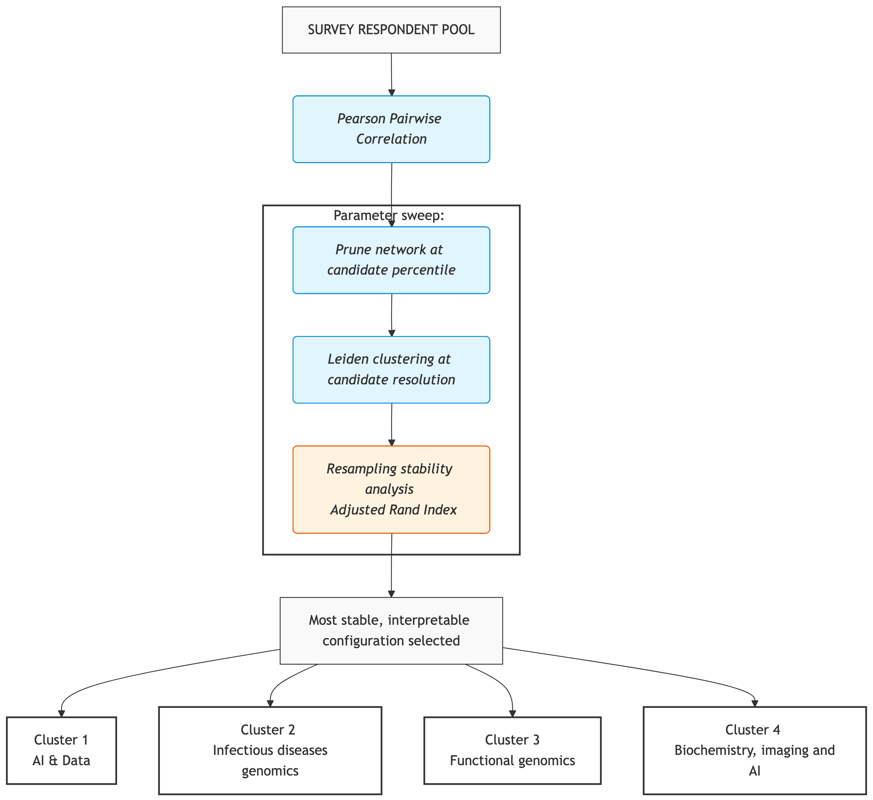
Figure 1: Graph-based clustering workflow for identifying learner profiles. Respondents are modeled as nodes in a network, with edges representing pairwise correlation of training needs. The edge-threshold percentile and resolution were identified using a parameter sweep. For each candidate combination, the network was pruned and clustered with Leiden community detection, and the resulting partition’s resampling stability (Adjusted Rand Index) was evaluated. The most stable, interpretable configuration from this sweep was then used to build the final pruned network and cluster respondents into the learner profiles reported here.

3 Results

3.1 Survey data
A total of 260 responses were gathered, of which 175 (67.3%) were from Switzerland (Figure 2 A). Most respondents from Switzerland were spread across six cantons that all have a large university (Figure 2 B). Most respondents were working in academia (n = 215, 82.7%; Figure 2 C). The career stage was distributed across academic professions (Figure 2 D), with a majority of PhD candidates (n = 77, 26.6%) and senior scientists/PIs (n = 67, 25.7%).
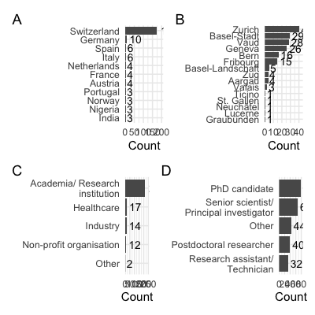
Figure 2: Respondent demographics. (A) Country of work. (B) Canton (if working in Switzerland). (C) Organisation type. (D) Career stage.
For a wide range of pre-defined course topics, the respondents were asked to indicate their training needs on a 5-point Likert scale. The overall distribution of responses is shown in Figure 3 A, which indicates that the majority of respondents expressed a need for training in AI-related topics, FAIR data and computational methods, as well as in integrating imaging with omics data. In contrast, topics related to e.g. transposable elements analysis and 16S sequencing data analysis were generally considered as less needed.
Barriers to participate in SIB courses were also assessed using a 5-point Likert scale. The overall distribution of responses is shown in Figure 3 B, which indicates that the majority of respondents did not perceive any of the listed factors as a significant barrier to their participation in SIB courses. However, some respondents indicated that distance and course fees could be potential barriers.
When asked about their preferred learning formats, respondents expressed a preference for blended modes (a combination of synchronous and asynchronous learning), multi-day intensive courses (2-5 days of live course activities) and interactive and problem-based learning approaches, such as bring your own data (participants utilize their own datasets to learn) and project-based learning (participants work in groups to investigate real-world problems). Remarkably, AI-assisted formats (integrates AI technologies into education to personalize learning) were generally less favored. The overall distribution of responses is shown in Figure 3 C.
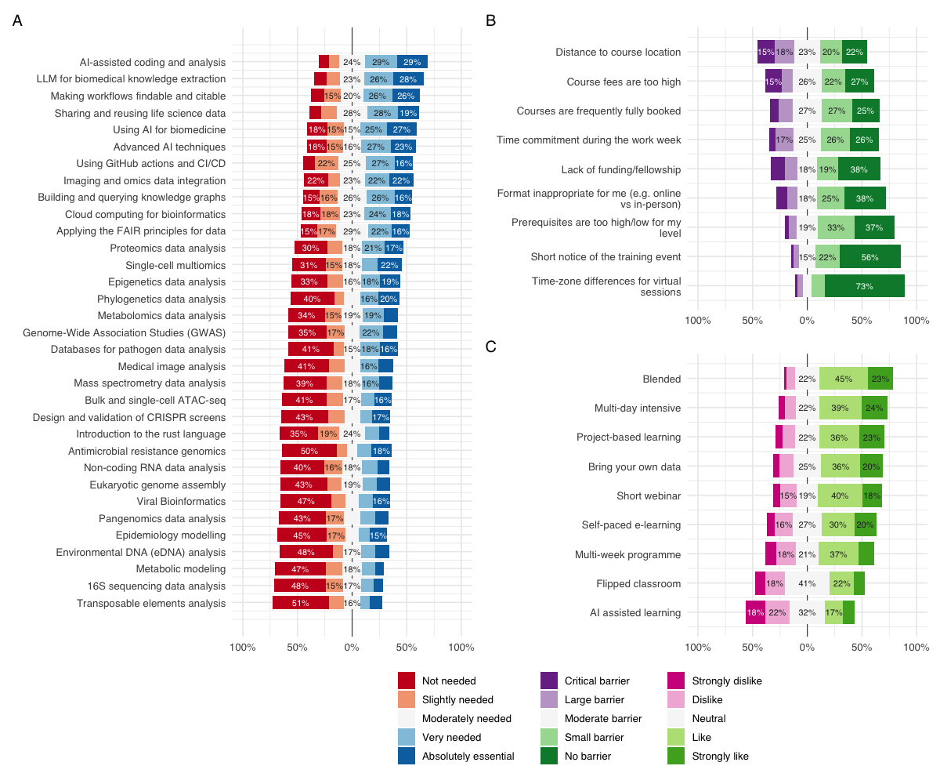
Figure 3: Overall responses of training needs, barriers and format preferences. (A) Training needs. (B) Barriers to participation in SIB courses. (C) Preferred learning formats. The topics, barriers and formats are ordered by the proportion of respondents who indicated that they needed the topic, that the factor was not a barrier, or that they liked the format, respectively. Only percentages over 15% are shown. Some original answers were abbreviated for visualization purposes. For the full answers, please refer to Supplementary Data 1 & 2.

3.2 Graph-based clustering of course preference responses
To group respondents based on their training needs, we constructed a network where nodes represent respondents and edges represent the similarity of their training preferences. We chose the clustering configuration by sweeping edge-threshold percentile (50th–90th) and resolution (0.5–2). To assess how sensitive this partition is to which respondents happen to be surveyed, we repeated the clustering procedure on 100 random 80% subsamples of respondents and compared each resulting partition to the full-data clustering using the Adjusted Rand Index (ARI; Figure 4). The highest agreement was found for the combination 60th percentile / resolution 1 (median ARI = 0.93, range 0.92–0.93), close to what would indicate a fully reproducible partition. Recovery was similarly high and consistent across learner profiles (Table 1).
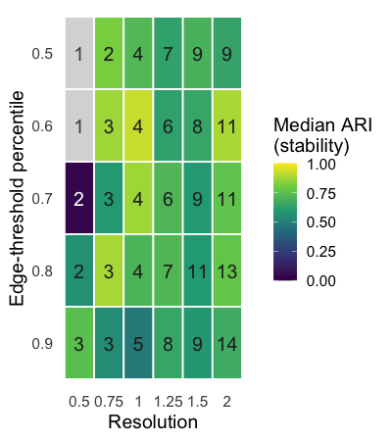
Figure 4: Resampling stability (median Adjusted Rand Index across 100 80%-subsample iterations) across a grid of edge-threshold percentiles and resolutions, using Leiden community detection. Numbers show the count of clusters retaining more than 5 respondents at each setting; grey tiles indicate settings where the partition collapsed to a single cluster in some resampling iterations, making the Adjusted Rand Index undefined.
Table 1: Per-cluster recovery under resampling: for each learner-profile cluster, the fraction of its (sampled) members assigned to a single most-common cluster across 100 80%-subsample iterations.
cluster | median recovery | min recovery | max recovery
Cluster 1 | 1.000 | 0.941 | 1.000
Cluster 2 | 1.000 | 1.000 | 1.000
Cluster 3 | 0.938 | 0.938 | 0.978
Cluster 4 | 0.942 | 0.942 | 0.979

3.3 Clusters and learner profiles
The four resulting clusters were characterized by distinct training needs, shown by their top 10 of most liked topics (Figure 5). This clearly shows that responses within each cluster have distinct preferences that are not visible when analyzing the entire respondent pool (Figure 3 A). Based on these distinct needs, we defined four learner profiles: Cluster 1 (Figure 5 A) is characterized by an interest in using AI and best practices for data, including application of LLMs and reproducible and FAIR data, and is hereafter referred to as the ‘AI and data’ profile. Cluster 2 (Figure 5 B) is characterized by infectious disease topics and possibly ecology, indicating an interest in phylogenetics, pathogen genomics and epidemiology, and is referred to as the ‘Infectious disease genomics’ profile. Cluster 3 (Figure 5 C) is characterized by an interest in functional genomics topics, indicating an interest in transcriptomics and epigenetics, and is referred to as the ‘Functional genomics’ profile. Cluster 4 (Figure 5 D) is characterized by training needs on biochemistry, imaging and AI, indicating an interest in proteomics, mass spectrometry and imaging and omics data integration, and is referred to as the ‘Biochemistry, imaging & AI’ profile. All clusters have topics related to AI in their top 10, indicating that AI is a cross-cutting theme across all learner profiles.
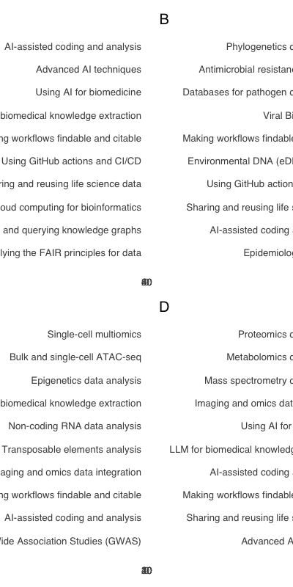
Figure 5: The top 10 most liked topics are shown for each cluster, indicating that each cluster has distinct training needs. Only the answers “Very needed” (light blue) and “Absolutely essential” (dark blue) are shown. The numbers in the bars represent the count of respondents within the respective cluster selecting the answer. (A) Cluster 1: AI and data. (B) Cluster 2: Infectious disease genomics. (C) Cluster 3: Functional genomics. (D) Cluster 4: Biochemistry, imaging & AI. Some topics have been abbreviated for clarity; the full topic names presented to the respondents can be found in Supplementary Data 2.
These learner profiles can be further characterized based on demographic characteristics (Figure 6; Supplementary Figure 1-3), barriers to participation (Supplementary Figure 4), and preferred learning formats (Supplementary Figure 5). Such analyses can help training providers design targeted curricula that address the specific needs of each profile. For example, the ‘AI and data’ profile (Cluster 1) has the highest proportion of early-career scientists (PhD candidates and postdoctoral researchers; Figure 6; 51%) and the highest proportion of respondents from Switzerland (Supplementary Figure 2; 78%), while the ‘Functional genomics’ profile (Cluster 3) has the highest proportion of senior scientists (32%; Figure 6) and respondents from outside of Switzerland (38%). These differences in demographics can inform the design of training programs that are tailored to the specific needs and preferences of each learner profile.
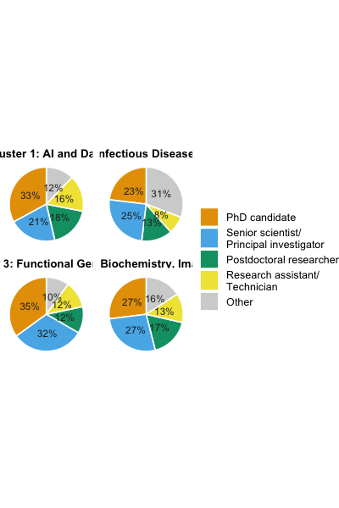
Figure 6: Career stage composition per cluster.

4 Discussion
This paper serves two purposes: it demonstrates a network-based clustering protocol for characterizing heterogeneous training needs from survey data, and it reports a snapshot of bioinformatics training needs in spring 2026, a period in which generative AI and large language models (LLMs) became increasingly relevant. In this section, we first discuss the methodological implications of our approach, and then discuss the survey outcomes in the context of bioinformatics training.

4.1 Cluster-based analysis for survey data
The problems that can be solved with bioinformatics are very diverse, and professionals solving these problems are highly heterogeneous. Therefore, analyzing the survey as a homogeneous group, or slicing the group by demographic indicators only partly captures the diversity of training needs. This issue is not specific to bioinformatics training, creating clusters of respondents is an overall valuable approach for understanding survey data, for example in citizenship norms [10], health literacy [11,12], bullying [14] or company training [13].
Several of these applications rely on latent class analysis [10,13,14] (LCA), a model-based alternative that assumes respondents are drawn from a mixture of latent groups, each characterized by its own probability of endorsing every item [29]. Unlike LCA, our approach does not require responses to different items to be conditionally independent once class membership is known. This assumption is difficult to justify for surveys on training needs, since it can be relevant to survey topic preferences in various domains, and topics in the same domain are expected to correlate. For example in our data, all four learner profiles we identified had AI-related topics among their top 10 most-needed, a pattern consistent with a general interest in AI that cuts across profiles rather than being fully explained by profile membership, which is the kind of residual item correlation that the assumption of local independence rules out. Our approach also avoids the chance of overfitting by using LCA. As a rule of thumb, 300 responses or more are desirable for LCA to prevent overfitting [30], a number that can be quite difficult to reach for local surveys on training needs. In our case we had four classes and 33 topics with five levels each. Estimating a full response-probability profile per item and class would require an estimated 531 free parameters (4 classes/clusters × 33 topics × 4 free category probabilities, plus 3 class-proportion parameters), exceeding our sample of 260 respondents and risking unstable or non-identifiable class solutions. Network-based clustering avoids this altogether by reducing each respondent’s profile to a single pairwise similarity score, so the number of parameters needed to define the clustering does not grow with the number of topics.
Our presented combination of survey with Likert-type questions and multiple-choice demographic questions with network-based clustering analysis provides an effective method to understand heterogeneous training needs. Similarly designed future training-needs surveys could run in similar limitations on the assumptions of LCA, making network-based clustering a broadly appropriate method for analysis. The clustering approach itself does not depend on the specific topics, wording, or number of domains used in our survey data — it only requires a set of Likert-type items sharing a common scale, asked of every respondent. This makes it directly reusable for other training-needs assessments. The accompanying implementation (https://github.com/sib-swiss/analyze-training-needs-survey) includes the survey design, preprocessing, and clustering steps as parameterized, reusable functions, so the protocol can be applied to a new dataset simply by supplying a new response export and question metadata file.

4.2 Survey outcomes
The majority of respondents were working in Switzerland as an academic researcher, likely because the survey was primarily advertised through the SIB training mailing list and other academic channels and networks within Switzerland. This outcome aligns well with the aims of the survey, as SIB training is primarily intended for academic researchers working in Switzerland. Nevertheless, we think that the survey results can be used for similar training curricula in other countries. Here, we discuss the overall survey outcomes along the three dimensions of training needs, participation barriers and learning formats.

4.2.1 A clear need for skills in AI and reproducible research
From the complete pool of survey results, it becomes clear that there is a demand for training on using (generative) AI and LLMs. Four of the possible topics related to AI/LLM skills and all four of them were in the top six of most needed topics. The two courses that were indicated as most needed were on how to use AI effectively: “AI-assisted coding and analysis”, and “Using large language models (LLM) for biomedical knowledge extraction”. A little bit less needed was the topic “Advanced AI techniques (agentic AI, MCP and RAGs)”, which is more related to developing AI tools. This shows that most respondents are aware of the potential of the use AI and LLMs in their daily work in bioinformatics, but there is a need for training on it. This perceived skill gap in AI and LLMs is a known barrier for the adoption and responsible use of AI in general [15,31], and it is reassuring to see that the respondents are aware of this gap and are interested in learning more about it, particularly in the ‘AI and data’ profile (Cluster 1).
The survey also revealed that there is a demand for training on FAIR data management and reproducible research, with “Making bioinformatics workflows findable and citable” and “Sharing and reusing life science data” as 3rd and 4th most needed respectively. This shows awareness of a need for learning about open and reproducible research practices amongst most respondents, which corresponds with earlier findings regarding perceptions on FAIR data practices [32], and its challenges [33].
While applying such outcomes to actual curriculum design, it is important to note that there can be a gap between intention - indicating a desire or need for training - and action - actually participating in a training course on the topic, known as the intention-behavior gap [34]. Although the questions on training needs were phrased in a way that the answer should relate to the respondents’ own training needs (“.. specify your training needs ..”), some answers might represent what the respondents think their communities or colleagues need. This is also reflected in the relatively high proportion of senior scientists and PIs in the survey (25.7%), who might be more likely to answer on behalf of their group or lab rather than their own personal training needs. Therefore, the translation of these answers from intention to action, i.e. actually participating in a training course on the topic, might not be straightforward.

4.2.2 Participation barriers
For most barriers, the majority of respondents did not perceive them as a barrier, or only a small one, to participation. Overall, the largest barriers were distance and course fees, reported as a large or critical barrier by 33% and 25% of respondents respectively, whereas barriers related to time-zone differences were perceived as minimal. Identifying which factors are limiting, and for which learner profile, is exactly the kind of actionable, curriculum-relevant signal the clustering protocol is intended to surface, rather than a single aggregate statement that “distance is a barrier” for the respondent pool as a whole. Any resulting mitigation nevertheless has to weigh trade-offs the survey itself does not capture: shifting more courses online, for instance, reduces a distance barrier but can come at some cost to student satisfaction [35] and learning effectiveness [36].

4.2.3 The need for human interaction
Respondents particularly liked short interactive live course formats, and combinations of both live and self-paced learning (blended). This shows the need of the human aspect in courses, such as the interaction between trainers and learners, and between learners themselves. Despite it being suggested to improve educational outcomes [37], there was a tendency towards dislike of AI-assisted learning formats, which is interesting given the high demand for training on AI and LLMs. This indicates that while respondents are interested in learning about AI, they prefer to learn in a more traditional format, with human interaction and guidance. This could be explained by overall trust issues regarding AI usage in education [38]. We do not know how respondents interpreted what ‘AI-assisted learning formats’ means. It is therefore important in next steps to understand how learners would appreciate this format, and what their expectations are.

4.2.4 Learner profiles characterize heterogeneous training bioinformatics needs
By using graph-based clustering of the answers on training topics, we got a much more granular view, revealing insights that would otherwise remain hidden. For example, the topic “Using large language models (LLM) for biomedical knowledge extraction” was ranked 2nd most needed by the complete pool of respondents. Within the clusters, though, it ranked well inside the top 10 for three of the four learner profiles, but not for the ‘Infectious disease genomics’ profile (Cluster 2). This shows that organising a course on this topic would serve the primary needs of most learner profiles, but only partly those of Cluster 2’s respondents. The reverse also occurs. The topic “Phylogenetics data analysis” ranked 15th among the complete pool of respondents, suggesting a moderate to low priority. Within the ‘Infectious disease genomics’ profile (Cluster 2), however, it was the single most needed topic. Since the number of respondents was fairly evenly distributed across clusters, each learner profile deserves similar attention when designing a curriculum that matches these heterogeneous training needs. Organising courses around profile-specific topics, rather than relying on the aggregate ranking alone, would therefore better serve substantial groups of respondents.
The learner profiles also enable a more targeted approach to address barriers to participation, learning formats and demographics. For example, a large proportion of respondents in the ‘Functional genomics’ profile (Cluster 3) indicated that distance to the course location is a barrier, and only a small proportion indicated that course fees are a barrier. On the contrary, a large proportion of respondents in the ‘Infectious disease genomics’ profile (Cluster 2) indicated that course fees are a barrier, and distance was the second most frequently indicated barrier. For curriculum design, this could suggest to focus on paid online multi-day courses for the ‘Functional genomics’ profile, and free webinars for the ‘Infectious disease genomics’ profile. This shows that these differences in barriers, preferred formats and demographics can inform the design of training programs that are tailored to the specific needs and preferences of each learner profile.

5 Conclusion
This study presents a network-based clustering protocol for characterizing heterogeneous training needs using Likert-type survey questions in combination with multiple-choice demographic questions, and demonstrates its use on the 2026 SIB training needs survey. By clustering respondents based on their shared needs rather than demographics, we identified four meaningful learner profiles, each with distinct topic priorities, participation barriers, and format preferences. Applied to this dataset, the analysis indicated a clear need for training on AI-related topics alongside a preference for human-led, interactive formats over AI-assisted learning, raising questions about trust and the role of human interaction in AI-era training. Because the protocol depends only on a shared Likert scale across survey items rather than on the specific topics or wording used here, we expect it to generalize to other training-needs assessments. The full pipeline is openly available to support such reuse, alongside the parameter-sensitivity and algorithm-choice considerations discussed above.
1. Via A, Rivas JDL, Attwood TK, et al. Ten Simple Rules for Developing a Short Bioinformatics Training Course. PLOS Computational Biology 2011; 7:e1002245
2. Williams JJ, Tractenberg RE, Batut B, et al. An international consensus on effective, inclusive, and career-spanning short-format training in the life sciences and beyond. PLOS ONE 2023; 18:e0293879
3. Attwood TK, Blackford S, Brazas MD, et al. A global perspective on evolving bioinformatics and data science training needs. Briefings in Bioinformatics 2019; 20:398–404
4. Sangeda RZ, Mwakilili AD, Masamu U, et al. A Baseline Evaluation of Bioinformatics Capacity in Tanzania Reveals Areas for Training. Frontiers in Education 2021; 6:665313
5. Rocha M, Massarani L, Souza SJD, et al. The past, present and future of genomics and bioinformatics: A survey of Brazilian scientists. Genetics and Molecular Biology 2022; 45:e20210354
6. Drew J, Morgan W, Galindo S, et al. Revisiting barriers to implementation of bioinformatics into life sciences education. Frontiers in Education 2023; 8:
7. Velozo B, Carvalho C, Feitosa R, et al. Mapping educational needs in bioinformatics in Brazil: Adapting ISCB 3.0 competencies to a regional context. Bioinformatics Advances 2024; 5:vbaf311
8. Geest G van, Thomas-Lopez D, Feitzinger AA, et al. Community needs for FAIR pathogen data. 2026;
9. Punj G, Stewart DW. Cluster Analysis in Marketing Research: Review and Suggestions for Application. Journal of Marketing Research 1983; 20:134–148
10. Hooghe M, Oser J, Marien S. A comparative analysis of ‘good citizenship’: A latent class analysis of adolescents’ citizenship norms in 38 countries. International Political Science Review 2016; 37:115–129
11. Cheng C, Elmer S, Batterham R, et al. Measuring health literacy to inform actions to address health inequities: A cluster analysis approach based on the Australian national health literacy survey. Journal of Public Health 2024; 46:e663–e674
12. Hyde LL, Boyes AW, Mackenzie LJ, et al. Electronic Health Literacy Among Magnetic Resonance Imaging and Computed Tomography Medical Imaging Outpatients: Cluster Analysis. Journal of Medical Internet Research 2019; 21:e13423
13. Wenger M, Lamamra N. Analysing the continuing education needs of Swiss in-company trainers: An approach based on the latent class analysis. Journal of Vocational, Adult and Continuing Education and Training 2024; 7:28
14. Chung JY, Lee S. Are bully-victims homogeneous? Latent class analysis on school bullying. Children and Youth Services Review 2020; 112:104922
15. Wen Bin Goh W, Polster A, Wong L, et al. Rethinking bioinformatics expertise in the era of artificial intelligence. npj Digital Medicine 2026; 9:398
16. Ruan W, Lyu Y, Zhang J, et al. Large language models for bioinformatics. Quantitative Biology 2026; 14:e70014
17. Jiang J, Wang F, Shen J, et al. A Survey on Large Language Models for Code Generation. ACM Transactions on Software Engineering and Methodology 2026; 35:58:1–58:72
18. Sima A-C, Farias TM de. On the Potential of Artificial Intelligence Chatbots for Data Exploration of Federated Bioinformatics Knowledge Graphs. 2023;
19. Daepp MIG, Tomlinson K, Counts S, et al. AI and the democratization of knowledge work. Nature Computational Science 2026; 6:558–564
20. Bewersdorff A, Hartmann C, Hornberger M, et al. Taking the next step with generative artificial intelligence: The transformative role of multimodal large language models in science education. Learning and Individual Differences 2025; 118:102601
21. Wang Z, Mingzhuo L, Islam AYMA. Reimagining teacher-AI co-design in learning task design: Trends and perspectives. Humanities and Social Sciences Communications 2026; 13:757
22. Esiyok E, Gokcearslan S, Kucukergin KG. Acceptance of Educational Use of AI Chatbots in the Context of Self-Directed Learning with Technology and ICT Self-Efficacy of Undergraduate Students. International Journal of Human–Computer Interaction 2025; 41:641–650
23. Wu D, Zhang S, Ma Z, et al. Unlocking Potential: Key Factors Shaping Undergraduate Self-Directed Learning in AI-Enhanced Educational Environments. Systems 2024; 12:332
24. R Core Team. R: A language and environment for statistical computing. 2026;
25. Wickham H, François R, Henry L, et al. Dplyr: A grammar of data manipulation. 2026;
26. Wickham H. ggplot2: Elegant graphics for data analysis. 2016;
27. Traag VA, Waltman L, Eck NJ van. From Louvain to Leiden: Guaranteeing well-connected communities. Scientific Reports 2019; 9:5233
28. Csárdi G, Nepusz T, Traag V, et al. igraph: Network analysis and visualization in r. 2026;
29. Weller BE, Bowen NK, Faubert SJ. Latent Class Analysis: A Guide to Best Practice. Journal of Black Psychology 2020; 46:287–311
30. Nylund-Gibson K, Choi AY. Ten frequently asked questions about latent class analysis. Translational Issues in Psychological Science 2018; 4:440–461
31. Sidhu GS, Sayem MA, Taslima N, et al. AI AND WORKFORCE DEVELOPMENT: A COMPARATIVE ANALYSIS OF SKILL GAPS AND TRAINING NEEDS IN EMERGING ECONOMIES. International journal of business and management sciences 2024; 4:12–28
32. Kersloot MG, Abu-Hanna A, Cornet R, et al. Perceptions and behavior of clinical researchers and research support staff regarding data FAIRification. Scientific Data 2022; 9:241
33. Martínez-García A, Alvarez-Romero C, Román-Villarán E, et al. FAIR principles to improve the impact on health research management outcomes. Heliyon 2023; 9:
34. Sheeran P, Webb TL. The Intention–Behavior Gap. Social and Personality Psychology Compass 2016; 10:503–518
35. Ebner C, Gegenfurtner A. Learning and Satisfaction in Webinar, Online, and Face-to-Face Instruction: A Meta-Analysis. Frontiers in Education 2019; 4:
36. Meng W, Yu L, Liu C, et al. A systematic review of the effectiveness of online learning in higher education during the COVID-19 pandemic period. Frontiers in Education 2024; 8:
37. Dong Y. Generative AI technologies and educational outcomes: A comprehensive meta-analysis comparing traditional and AI-driven approaches. Humanities and Social Sciences Communications 2026; 13:559
38. Lelescu A, Sava S, Grosseck G, et al. Exploring trust in generative AI for higher education institutions: A systematic literature review focused on educators. Humanities and Social Sciences Communications 2025; 12:1961

