Integration

Material
https://youtu.be/2TsW5A53hTg?si=Bas__YskLl21-YjF

Exercises
Let’s have a look at the UMAP again. Although cells of different samples are shared amongst ‘clusters’, you can still see seperation within the clusters:
Code starts here:
Seurat::DimPlot(seu, reduction = "umap")
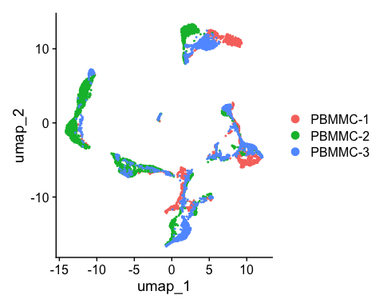
To perform the integration, we split our object by sample, resulting into a set of layers within the RNA assay. The layers are integrated and stored in the reduction slot - in our case we call it integrated.cca. Then, we re-join the layers
Code starts here:
seu[["RNA"]] <- split(seu[["RNA"]], f = seu$orig.ident)
seu <- Seurat::IntegrateLayers(object = seu, method = CCAIntegration,
orig.reduction = "pca",
new.reduction = "integrated.cca",
verbose = FALSE)
# re-join layers after integration
seu[["RNA"]] <- JoinLayers(seu[["RNA"]])
We can then use this new integrated matrix for clustering and visualization. Now, we can re-run and visualize the results with UMAP.
 Exercise
Create the UMAP again on the integrated.cca reduction (using the function RunUMAP - set the option reduction accordingly). After that, generate the UMAP plot. Did the integration perform well?

 Answer
Performing the scaling, PCA and UMAP:
Code starts here:
seu <- RunUMAP(seu, dims = 1:30, reduction = "integrated.cca")
Plotting the UMAP:
Code starts here:
Seurat::DimPlot(seu, reduction = "umap")
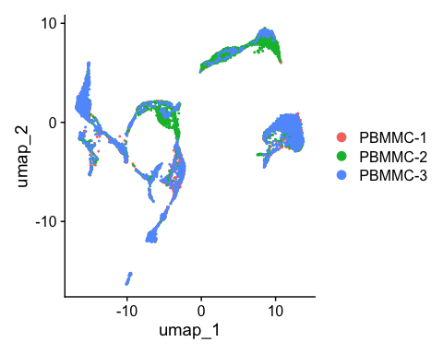

Save the dataset and clear environment
Code starts here:
saveRDS(seu, "day2/seu_day2-3.rds")
Clear your environment:
Code starts here:
rm(list = ls())
gc()
.rs.restartR()

