Cell annotation

Material
https://youtu.be/dNO7W7qkKBM?si=xkLBHjT8V25AEzIx
- Review on automated cell annotation

Exercises
Code starts here:
seu <- readRDS("day2/seu_day2-4.rds")
library(Seurat)
Loading required package: SeuratObject
Warning: package 'SeuratObject' was built under R version 4.3.3
Loading required package: sp
Attaching package: 'SeuratObject'
The following objects are masked from 'package:base':
intersect, t
Load the following packages:
Code starts here:
library(celldex)
Loading required package: SummarizedExperiment
Loading required package: MatrixGenerics
Loading required package: matrixStats
Warning: package 'matrixStats' was built under R version 4.3.3
Attaching package: 'MatrixGenerics'
The following objects are masked from 'package:matrixStats':
colAlls, colAnyNAs, colAnys, colAvgsPerRowSet, colCollapse,
colCounts, colCummaxs, colCummins, colCumprods, colCumsums,
colDiffs, colIQRDiffs, colIQRs, colLogSumExps, colMadDiffs,
colMads, colMaxs, colMeans2, colMedians, colMins, colOrderStats,
colProds, colQuantiles, colRanges, colRanks, colSdDiffs, colSds,
colSums2, colTabulates, colVarDiffs, colVars, colWeightedMads,
colWeightedMeans, colWeightedMedians, colWeightedSds,
colWeightedVars, rowAlls, rowAnyNAs, rowAnys, rowAvgsPerColSet,
rowCollapse, rowCounts, rowCummaxs, rowCummins, rowCumprods,
rowCumsums, rowDiffs, rowIQRDiffs, rowIQRs, rowLogSumExps,
rowMadDiffs, rowMads, rowMaxs, rowMeans2, rowMedians, rowMins,
rowOrderStats, rowProds, rowQuantiles, rowRanges, rowRanks,
rowSdDiffs, rowSds, rowSums2, rowTabulates, rowVarDiffs, rowVars,
rowWeightedMads, rowWeightedMeans, rowWeightedMedians,
rowWeightedSds, rowWeightedVars
Loading required package: GenomicRanges
Loading required package: stats4
Loading required package: BiocGenerics
Attaching package: 'BiocGenerics'
The following object is masked from 'package:SeuratObject':
intersect
The following objects are masked from 'package:stats':
IQR, mad, sd, var, xtabs
The following objects are masked from 'package:base':
anyDuplicated, aperm, append, as.data.frame, basename, cbind,
colnames, dirname, do.call, duplicated, eval, evalq, Filter, Find,
get, grep, grepl, intersect, is.unsorted, lapply, Map, mapply,
match, mget, order, paste, pmax, pmax.int, pmin, pmin.int,
Position, rank, rbind, Reduce, rownames, sapply, setdiff, sort,
table, tapply, union, unique, unsplit, which.max, which.min
Loading required package: S4Vectors
Attaching package: 'S4Vectors'
The following object is masked from 'package:utils':
findMatches
The following objects are masked from 'package:base':
expand.grid, I, unname
Loading required package: IRanges
Attaching package: 'IRanges'
The following object is masked from 'package:sp':
%over%
Loading required package: GenomeInfoDb
Warning: package 'GenomeInfoDb' was built under R version 4.3.3
Loading required package: Biobase
Welcome to Bioconductor
Vignettes contain introductory material; view with
'browseVignettes()'. To cite Bioconductor, see
'citation("Biobase")', and for packages 'citation("pkgname")'.
Attaching package: 'Biobase'
The following object is masked from 'package:MatrixGenerics':
rowMedians
The following objects are masked from 'package:matrixStats':
anyMissing, rowMedians
Attaching package: 'SummarizedExperiment'
The following object is masked from 'package:Seurat':
Assays
The following object is masked from 'package:SeuratObject':
Assays
library(SingleR)
Attaching package: 'SingleR'
The following objects are masked from 'package:celldex':
BlueprintEncodeData, DatabaseImmuneCellExpressionData,
HumanPrimaryCellAtlasData, ImmGenData, MonacoImmuneData,
MouseRNAseqData, NovershternHematopoieticData
In the last exercise we saw that probably clustering at a resolution of 0.3 gave the most sensible results. Let’s therefore set the default identity of each cell based on this clustering:
Code starts here:
seu <- Seurat::SetIdent(seu, value = seu$RNA_snn_res.0.3)
 Note
From now on, grouping (e.g. for plotting) is done by the active identity (set at @active.ident) by default.
During cell annotation we will use the original count data (not the integrated data):
Code starts here:
DefaultAssay(seu) <- "RNA"
Based on the UMAP we have generated, we can visualize expression for a gene in each cluster:
Code starts here:
Seurat::FeaturePlot(seu, "HBA1")
Warning: The `slot` argument of `FetchData()` is deprecated as of SeuratObject 5.0.0.
ℹ Please use the `layer` argument instead.
ℹ The deprecated feature was likely used in the Seurat package.
Please report the issue at <https://github.com/satijalab/seurat/issues>.
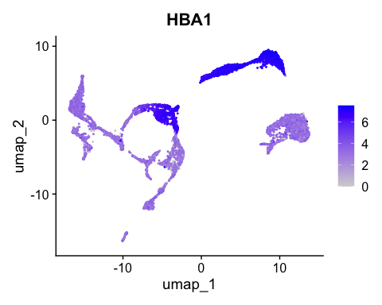
Based on expression of sets of genes you can do a manual cell type annotation. If you know the marker genes for some cell types, you can check whether they are up-regulated in one or the other cluster. Here we have some marker genes for two different cell types:
Code starts here:
tcell_genes <- c("IL7R", "LTB", "TRAC", "CD3D")
monocyte_genes <- c("CD14", "CST3", "CD68", "CTSS")
Let’s have a look at the expression of the four T cell genes:
Code starts here:
Seurat::FeaturePlot(seu, tcell_genes, ncol=2)
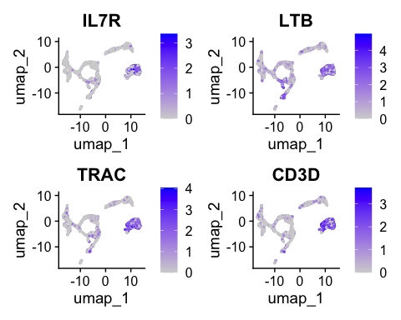
These cells are almost all in cluster 0 and 8. Which becomes clearer when looking at the violin plot:
Code starts here:
Seurat::VlnPlot(seu,
features = tcell_genes,
ncol = 2)
Warning: `PackageCheck()` was deprecated in SeuratObject 5.0.0.
ℹ Please use `rlang::check_installed()` instead.
ℹ The deprecated feature was likely used in the Seurat package.
Please report the issue at <https://github.com/satijalab/seurat/issues>.
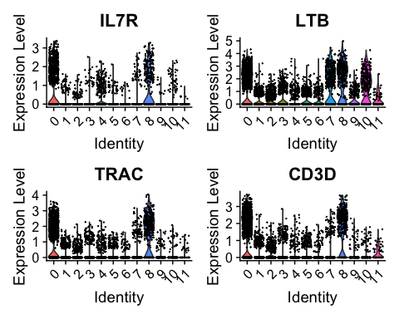
 Exercise
Have a look at the monocyte genes as well. Which clusters contain probably monocytes?

 Answer
Seurat::FeaturePlot(seu, monocyte_genes, ncol=2)
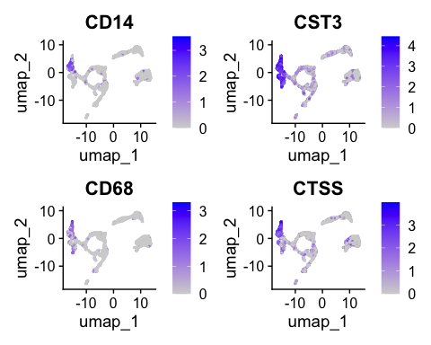
Seurat::VlnPlot(seu,
features = monocyte_genes,
ncol = 2)
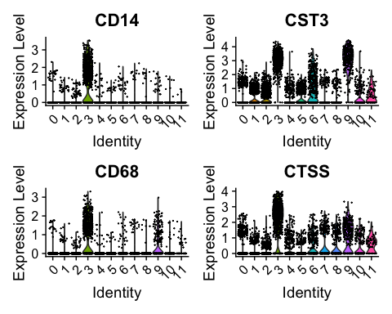
We can also automate this with the function AddModuleScore. For each cell, an expression score for a group of genes is calculated:
Code starts here:
seu <- Seurat::AddModuleScore(seu,
features = list(tcell_genes),
name = "tcell_genes")
 Exercise
After running AddModuleScore, a column was added to seu@meta.data.
A. What is the name of that column? What kind of data is in there?
B. Generate a UMAP with color accoding to this column and a violinplot grouped by cluster. Is this according to what we saw in the previous exercise?

 Answer
A. The new column is called tcell_genes1. It contains the module score for each cell (which is basically the average expression of the set of genes).
B. You can plot the UMAP with
Code starts here:
Seurat::FeaturePlot(seu, "tcell_genes1")
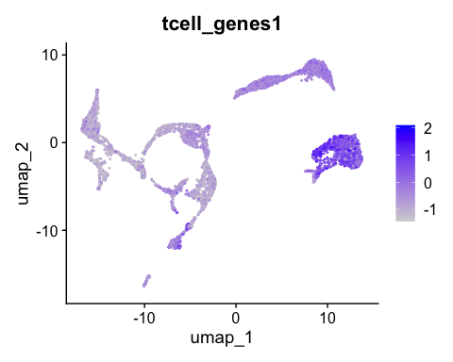
Which indeed shows these genes are mainly expressed in clusters 0 and 8:
Seurat::VlnPlot(seu,
"tcell_genes1")
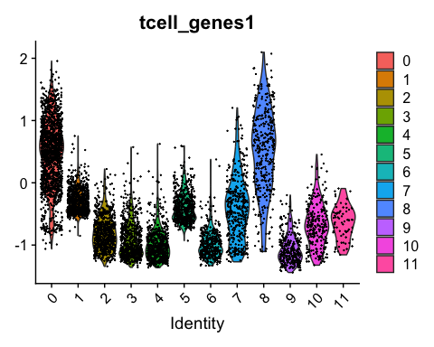

Annotating cells according to cycling phase
Based on the same principle, we can also annotate cell cycling state. The function CellCycleScore uses AddModuleScore to get a score for the G2/M and S phase (the mitotic phases in which cell is cycling). In addition, CellCycleScore assigns each cell to either the G2/M, S or G1 phase.
First we extract the built-in genes for cell cycling:
Code starts here:
s.genes <- Seurat::cc.genes.updated.2019$s.genes
g2m.genes <- Seurat::cc.genes.updated.2019$g2m.genes
Now we run the function:
Code starts here:
seu <- Seurat::CellCycleScoring(seu,
s.features = s.genes,
g2m.features = g2m.genes)
And we can visualize the annotations:
Code starts here:
Seurat::DimPlot(seu, group.by = "Phase")
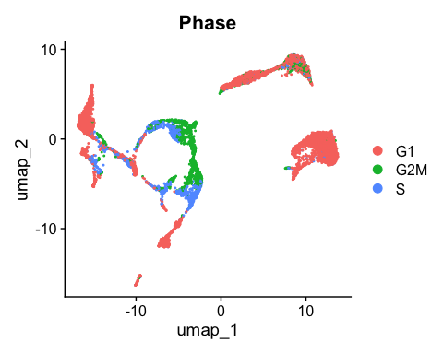
Based on your application, you can try to regress out the cell cycling scores at the step of scaling. Reasons for doing that could be:
- Merging cycling and non-cycling cells of the same type in one cluster
- Merging G2/M and S phase in one cluster
 Note
Note that correcting for cell cycling is performed at the scaling step. It will therefore only influence analyses that use scaled data, like dimensionality reduction and clustering. For e.g. differential gene expression testing, we use the raw original counts (not scaled).
Here, we choose not to regress out either of them. Because we are looking at developing cells, we might be interested to keep cycling cells seperated. In addition, the G2/M and S phases seem to be in the same clusters. More info on correcting for cell cycling here.

Cell type annotation using SingleR
To do a fully automated annoation, we need a reference dataset of primary cells. Any reference could be used. The package scRNAseq in Bioconductor includes several scRNAseq datasets that can be used as reference to SingleR. One could also use a reference made of bulk RNA seq data. Here we are using the a hematopoietic reference dataset from celldex. Check out what’s in there:
Code starts here:
ref <- celldex::NovershternHematopoieticData()
class(ref)
table(ref$label.main)
 Note
You will be asked whether to create the directory /home/rstudio/.cache/R/ExperimentHub. Type yes as a response.

 Note
You can find more information on different reference datasets at the celldex documentation
Now SingleR compares our normalized count data to a reference set, and finds the most probable annation:
Code starts here:
seu_SingleR <- SingleR::SingleR(test = Seurat::GetAssayData(seu),
ref = ref,
labels = ref$label.main)
See what’s in there by using head:
Code starts here:
head(seu_SingleR)
DataFrame with 6 rows and 4 columns
scores labels
<matrix> <character>
PBMMC-1_AAACCTGCAGACGCAA-1 0.216202:0.197296:0.086435:... B cells
PBMMC-1_AAACCTGTCATCACCC-1 0.143005:0.129582:0.170521:... CD8+ T cells
PBMMC-1_AAAGATGCATAAAGGT-1 0.113423:0.196264:0.111341:... Monocytes
PBMMC-1_AAAGCAAAGCAGCGTA-1 0.166749:0.168504:0.239303:... CD4+ T cells
PBMMC-1_AAAGCAACAATAACGA-1 0.102549:0.103979:0.178762:... CD8+ T cells
PBMMC-1_AAAGCAACATCAGTCA-1 0.181526:0.147693:0.115841:... Erythroid cells
delta.next pruned.labels
<numeric> <character>
PBMMC-1_AAACCTGCAGACGCAA-1 0.1471065 B cells
PBMMC-1_AAACCTGTCATCACCC-1 0.0753696 CD8+ T cells
PBMMC-1_AAAGATGCATAAAGGT-1 0.1274524 Monocytes
PBMMC-1_AAAGCAAAGCAGCGTA-1 0.0845267 CD4+ T cells
PBMMC-1_AAAGCAACAATAACGA-1 0.0607683 CD8+ T cells
PBMMC-1_AAAGCAACATCAGTCA-1 0.1057135 Erythroid cells
Visualize singleR score quality scores:
Code starts here:
SingleR::plotScoreHeatmap(seu_SingleR)
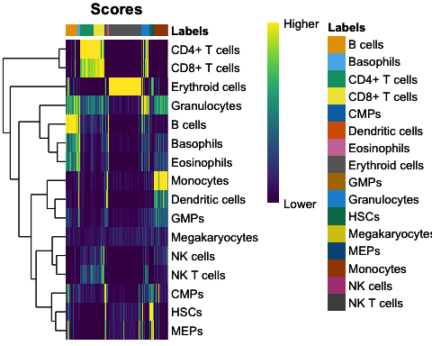
Code starts here:
SingleR::plotDeltaDistribution(seu_SingleR)
Warning: Groups with fewer than two datapoints have been dropped.
ℹ Set `drop = FALSE` to consider such groups for position adjustment purposes.
Warning in max(data$density, na.rm = TRUE): no non-missing arguments to max;
returning -Inf
Warning: Computation failed in `stat_ydensity()`.
Caused by error in `$<-.data.frame`:
! replacement has 1 row, data has 0
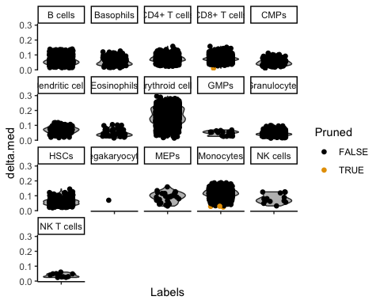
There are some annotations that contain only a few cells. They are usually not of interest, and they clogg our plots. Therefore we remove them from the annotation:
Code starts here:
singleR_labels <- seu_SingleR$labels
t <- table(singleR_labels)
other <- names(t)[t < 10]
singleR_labels[singleR_labels %in% other] <- "none"
In order to visualize it in our UMAP, we have to add the annotation to seu@meta.data:
Code starts here:
seu$SingleR_annot <- singleR_labels
We can plot the annotations in the UMAP. Here, we use a different package for plotting (dittoSeq) as it has a bit better default coloring, and some other plotting functionality we will use later on.
Code starts here:
dittoSeq::dittoDimPlot(seu, "SingleR_annot", size = 0.7)
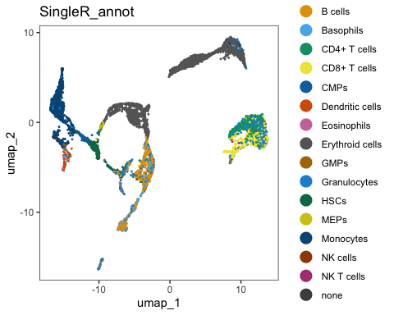
We can check out how many cells per sample we have for each annotated cell type:
Code starts here:
dittoSeq::dittoBarPlot(seu, var = "SingleR_annot", group.by = "orig.ident")
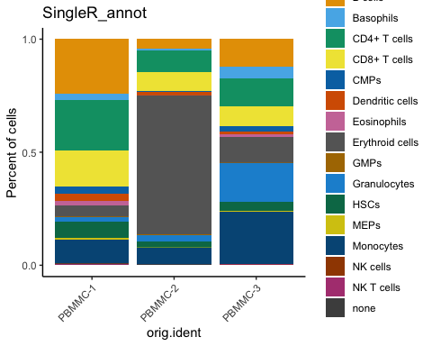
 Exercise
Compare our manual annotation (based on the set of T cell genes) to the annotation with SingleR. Do they correspond?
You can for example use the plotting function dittoBarPlot to visualize the cell types according to cluster (use RNA_snn_res.0.3 in stead of orig.ident))
 Answer
We can have a look at the mean module score for each SingleR annotation like this:
Code starts here:
dittoSeq::dittoBarPlot(seu,
var = "SingleR_annot",
group.by = "RNA_snn_res.0.3")
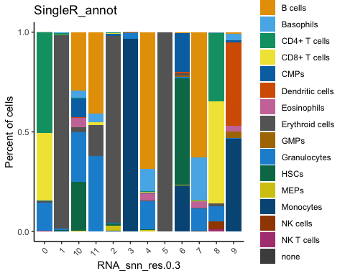
Here, you can see that cluster 0 and 8 contain cells annotated as T cells (CD4+ and CD8+).

Save the dataset and clear environment
Now, save the dataset so you can use it tomorrow:
Code starts here:
saveRDS(seu, "day3/seu_day3-1.rds")
Clear your environment:
Code starts here:
rm(list = ls())
gc()
.rs.restartR()

