Differential gene expression

Material
https://youtu.be/6Y5uCQWRRbg?si=mcV9qJUap1qvFjy3
- More information on pseudobulk analysis
- Muscat for pseudobulk DGE.
- Paper on the robustness of different differential expression analysis methods

Exercises

Find all markers for each cluster
Load the seu dataset you have created yesterday:
And load the following packages (install them if they are missing):
Code starts here:
library(Seurat)
library(edgeR) # BiocManager::install("edgeR")
library(limma)
library(dplyr)
library(scuttle)
The function FindAllMarkers performs a Wilcoxon plot to determine the genes differentially expressed between each cluster and the rest of the cells. Other types of tests than the Wilcoxon test are available. Check it out by running ?Seurat::FindAllMarkers.
Now run analysis:
Code starts here:
de_genes <- Seurat::FindAllMarkers(seu, min.pct = 0.25,
only.pos = TRUE)
Subset the table to only keep the significant genes, and you can save it as a csv file if you wish to explore it further. Then extract the top 3 markers per cluster:
Code starts here:
de_genes <- subset(de_genes, de_genes$p_val_adj < 0.05)
write.csv(de_genes,
"day3/de_genes_FindAllMarkers.csv",
row.names = F, quote = F)
top_specific_markers <- de_genes %>%
group_by(cluster) %>%
top_n(3, avg_log2FC)
And generate e.g. a dotplot:
Code starts here:
dittoSeq::dittoDotPlot(seu,
vars = unique(top_specific_markers$gene),
group.by = "RNA_snn_res.0.3")
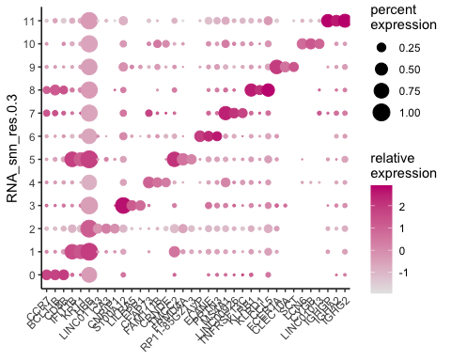
 Exercise
What are significant marker genes in cluster 0 and 8? Are the T cell genes in there?
You can re-load the vector with immune genes with:
Code starts here:
tcell_genes <- c("IL7R", "LTB", "TRAC", "CD3D")
 Answer
Code starts here:
de_genes[de_genes$gene %in% tcell_genes,] |> knitr::kable()
 | p_val | avg_log2FC | pct.1 | pct.2 | p_val_adj | cluster | gene
CD3D | 0 | 2.9119600 | 0.772 | 0.226 | 0 | 0 | CD3D
TRAC | 0 | 2.5821466 | 0.628 | 0.202 | 0 | 0 | TRAC
LTB | 0 | 1.8792775 | 0.761 | 0.394 | 0 | 0 | LTB
IL7R | 0 | 2.8925743 | 0.437 | 0.114 | 0 | 0 | IL7R
LTB1 | 0 | 1.3839002 | 0.676 | 0.465 | 0 | 7 | LTB
TRAC1 | 0 | 2.3960975 | 0.749 | 0.274 | 0 | 8 | TRAC
CD3D1 | 0 | 2.1124053 | 0.795 | 0.326 | 0 | 8 | CD3D
LTB2 | 0 | 1.8691213 | 0.757 | 0.462 | 0 | 8 | LTB
IL7R1 | 0 | 1.9115516 | 0.468 | 0.172 | 0 | 8 | IL7R
LTB3 | 0 | 0.9057526 | 0.743 | 0.466 | 0 | 10 | LTB
So, yes, the T-cell genes are highly significant markers for cluster 0 and 8.

Differential expression between groups of cells
The FindMarkers function allows to test for differential gene expression analysis specifically between 2 groups of cells, i.e. perform pairwise comparisons, eg between cells of cluster 0 vs cluster 2, or between cells annotated as T-cells and B-cells.
First we can set the default cell identity to the cell types defined by SingleR:
Code starts here:
seu <- Seurat::SetIdent(seu, value = "SingleR_annot")
Run the differential gene expression analysis and subset the table to keep the significant genes:
Code starts here:
deg_cd8_cd4 <- Seurat::FindMarkers(seu,
ident.1 = "CD8+ T cells",
ident.2 = "CD4+ T cells",
group.by = seu$SingleR_annot,
test.use = "wilcox")
deg_cd8_cd4 <- subset(deg_cd8_cd4, deg_cd8_cd4$p_val_adj<0.05)
 Exercise
Are CD8A, CD8B and CD4 in there? What does the sign (i.e. positive or negative) mean in the log fold change values? Are they according to the CD8+ and CD4+ annotations? Check your answer by generating a violin plot of a top differentially expressed gene.

 Answer
You can check out the results with:
Code starts here:
View(deg_cd8_cd4)
 | p_val | avg_log2FC | pct.1 | pct.2 | p_val_adj
CD8A | 0.0e+00 | 5.8036617 | 0.336 | 0.008 | 0.0000000
CTSW | 0.0e+00 | 3.4118773 | 0.276 | 0.030 | 0.0000000
CCL5 | 0.0e+00 | 4.2922622 | 0.285 | 0.062 | 0.0000000
CD8B | 0.0e+00 | 1.3123538 | 0.470 | 0.178 | 0.0000000
NKG7 | 0.0e+00 | 4.5376500 | 0.225 | 0.037 | 0.0000000
CST7 | 0.0e+00 | 4.4123574 | 0.143 | 0.012 | 0.0000000
GZMA | 0.0e+00 | 3.8501654 | 0.169 | 0.025 | 0.0000000
TRGC2 | 0.0e+00 | 3.4931638 | 0.144 | 0.018 | 0.0000000
RPS27 | 0.0e+00 | -0.1820605 | 1.000 | 1.000 | 0.0000000
KLRD1 | 0.0e+00 | 4.3589947 | 0.108 | 0.008 | 0.0000000
ID2 | 0.0e+00 | 0.8632969 | 0.565 | 0.353 | 0.0000000
GZMK | 0.0e+00 | 3.0113231 | 0.130 | 0.022 | 0.0000000
HCST | 0.0e+00 | 0.7949700 | 0.681 | 0.495 | 0.0000000
MT-CO1 | 0.0e+00 | 0.3243268 | 0.989 | 0.979 | 0.0000000
TRGC1 | 0.0e+00 | 3.6853476 | 0.110 | 0.013 | 0.0000000
FHIT | 0.0e+00 | -1.6706990 | 0.110 | 0.273 | 0.0000000
RP11-291B21.2 | 0.0e+00 | 1.3507107 | 0.222 | 0.077 | 0.0000000
MT-ND4 | 0.0e+00 | 0.3226206 | 0.963 | 0.932 | 0.0000000
CD4 | 0.0e+00 | -3.3247772 | 0.011 | 0.105 | 0.0000000
MT-CO2 | 0.0e+00 | 0.2401784 | 0.993 | 0.995 | 0.0000000
TRDC | 0.0e+00 | 2.6894608 | 0.105 | 0.019 | 0.0000000
CRTAM | 0.0e+00 | 3.7124154 | 0.068 | 0.003 | 0.0000000
PECAM1 | 0.0e+00 | 2.6701767 | 0.096 | 0.015 | 0.0000000
LYAR | 0.0e+00 | 1.6580580 | 0.198 | 0.076 | 0.0000000
GZMH | 0.0e+00 | 4.8543018 | 0.067 | 0.003 | 0.0000000
PRF1 | 0.0e+00 | 2.8596139 | 0.099 | 0.018 | 0.0000000
ACTB | 0.0e+00 | 0.3093718 | 0.965 | 0.925 | 0.0000000
AC092580.4 | 0.0e+00 | 1.3359936 | 0.173 | 0.061 | 0.0000000
CCL4 | 0.0e+00 | 3.7724347 | 0.118 | 0.031 | 0.0000001
RPS27A | 0.0e+00 | -0.1605123 | 1.000 | 1.000 | 0.0000001
RPL11 | 0.0e+00 | -0.1685948 | 1.000 | 1.000 | 0.0000002
KLRC1 | 0.0e+00 | 8.3089065 | 0.048 | 0.000 | 0.0000004
MT-CO3 | 0.0e+00 | 0.2753652 | 0.966 | 0.954 | 0.0000005
TPST2 | 0.0e+00 | 1.8352805 | 0.137 | 0.045 | 0.0000009
RUNX3 | 0.0e+00 | 1.0535174 | 0.180 | 0.071 | 0.0000009
HLA-B | 0.0e+00 | 0.3203112 | 0.970 | 0.934 | 0.0000012
RPL21 | 0.0e+00 | -0.1713527 | 1.000 | 1.000 | 0.0000012
MT-ND2 | 0.0e+00 | 0.2971960 | 0.958 | 0.918 | 0.0000013
RPS29 | 0.0e+00 | -0.1172011 | 1.000 | 1.000 | 0.0000032
GNLY | 0.0e+00 | 3.8610459 | 0.132 | 0.046 | 0.0000038
IL32 | 0.0e+00 | 0.5401192 | 0.739 | 0.624 | 0.0000060
FAM173A | 0.0e+00 | 1.1506784 | 0.194 | 0.087 | 0.0000076
NR4A2 | 0.0e+00 | 0.8415276 | 0.341 | 0.203 | 0.0000094
IL2RB | 0.0e+00 | 2.2000968 | 0.078 | 0.015 | 0.0000148
HOPX | 0.0e+00 | 2.3701004 | 0.089 | 0.022 | 0.0000197
CXCR3 | 0.0e+00 | 2.4269612 | 0.072 | 0.013 | 0.0000234
RPL30 | 0.0e+00 | -0.1749260 | 0.992 | 0.998 | 0.0000259
PLEK | 0.0e+00 | 2.7963063 | 0.059 | 0.008 | 0.0000327
CBLB | 0.0e+00 | 1.2237121 | 0.127 | 0.045 | 0.0000494
RPS25 | 0.0e+00 | -0.1727553 | 1.000 | 1.000 | 0.0000532
BZW1 | 0.0e+00 | 0.7778875 | 0.354 | 0.223 | 0.0000597
RPL34 | 0.0e+00 | -0.1552375 | 1.000 | 1.000 | 0.0000684
MT-ND3 | 0.0e+00 | 0.2539291 | 0.955 | 0.930 | 0.0000920
ACTG1 | 0.0e+00 | 0.4120757 | 0.744 | 0.622 | 0.0001017
RPL31 | 0.0e+00 | -0.1426997 | 1.000 | 0.998 | 0.0001340
CD160 | 0.0e+00 | 4.6296720 | 0.042 | 0.002 | 0.0001448
NT5E | 0.0e+00 | 4.1692640 | 0.042 | 0.002 | 0.0001452
TRAT1 | 0.0e+00 | -1.2378085 | 0.135 | 0.242 | 0.0001694
RPL35A | 0.0e+00 | -0.1498209 | 0.999 | 0.999 | 0.0001911
RPL32 | 0.0e+00 | -0.1349986 | 1.000 | 1.000 | 0.0001959
MAL | 0.0e+00 | -1.0983742 | 0.149 | 0.257 | 0.0001977
MATK | 0.0e+00 | 1.5714195 | 0.092 | 0.026 | 0.0002149
CD40LG | 0.0e+00 | -1.9356543 | 0.020 | 0.087 | 0.0002240
TGFBR3 | 0.0e+00 | 3.2149127 | 0.047 | 0.004 | 0.0003054
CLIC3 | 0.0e+00 | 2.7202513 | 0.054 | 0.008 | 0.0004215
JUN | 0.0e+00 | 0.5742398 | 0.681 | 0.588 | 0.0004373
KLRC4 | 0.0e+00 | 3.3549690 | 0.048 | 0.005 | 0.0005192
RPS23 | 0.0e+00 | -0.1485187 | 1.000 | 1.000 | 0.0005639
TMSB10 | 0.0e+00 | -0.1783588 | 0.996 | 0.999 | 0.0006274
IFRD1 | 0.0e+00 | 0.7876254 | 0.303 | 0.182 | 0.0006301
ICOS | 1.0e-07 | -1.8295856 | 0.035 | 0.107 | 0.0009510
MT-ATP6 | 1.0e-07 | 0.2791020 | 0.932 | 0.902 | 0.0009630
XCL2 | 1.0e-07 | 5.1473347 | 0.035 | 0.001 | 0.0009734
LITAF | 1.0e-07 | 0.6455639 | 0.407 | 0.277 | 0.0010564
KLRC2 | 1.0e-07 | 4.5769235 | 0.038 | 0.002 | 0.0011382
LAG3 | 1.0e-07 | 2.6152771 | 0.054 | 0.009 | 0.0012129
KLRG1 | 1.0e-07 | 1.8532056 | 0.103 | 0.037 | 0.0013752
IFNG | 1.0e-07 | 3.4727589 | 0.051 | 0.008 | 0.0013816
RPS15A | 1.0e-07 | -0.1390132 | 1.000 | 1.000 | 0.0014859
MT1F | 1.0e-07 | 1.8145433 | 0.086 | 0.026 | 0.0015767
S100B | 1.0e-07 | 2.0010809 | 0.105 | 0.038 | 0.0018264
LCP1 | 1.0e-07 | 0.7192442 | 0.312 | 0.198 | 0.0021165
MT-CYB | 1.0e-07 | 0.2155921 | 0.959 | 0.958 | 0.0021248
GZMB | 1.0e-07 | 4.7551476 | 0.037 | 0.002 | 0.0021433
HLA-DPB1 | 2.0e-07 | 0.9458630 | 0.210 | 0.113 | 0.0028339
MAP3K8 | 2.0e-07 | 2.3308513 | 0.058 | 0.012 | 0.0037843
STK17A | 3.0e-07 | 0.6044699 | 0.426 | 0.306 | 0.0049752
ZFP36 | 3.0e-07 | 0.6981065 | 0.394 | 0.276 | 0.0052431
A1BG | 3.0e-07 | 0.9879067 | 0.147 | 0.068 | 0.0052530
ACTN4 | 3.0e-07 | 1.6884121 | 0.074 | 0.021 | 0.0057168
GZMM | 3.0e-07 | 0.5590226 | 0.354 | 0.231 | 0.0057598
RPL13A | 3.0e-07 | -0.1027637 | 1.000 | 1.000 | 0.0062383
ABCB1 | 4.0e-07 | 2.0901339 | 0.057 | 0.012 | 0.0067877
DUSP2 | 4.0e-07 | 1.0251535 | 0.319 | 0.213 | 0.0069206
ARPC5L | 4.0e-07 | 0.8444989 | 0.173 | 0.087 | 0.0071525
CORO1B | 4.0e-07 | -1.2457970 | 0.122 | 0.209 | 0.0072482
C12orf75 | 5.0e-07 | 0.9457620 | 0.200 | 0.111 | 0.0086192
RPL18 | 5.0e-07 | -0.1498451 | 0.982 | 0.988 | 0.0088652
RPS8 | 5.0e-07 | -0.1596945 | 1.000 | 0.999 | 0.0091967
B2M | 5.0e-07 | 0.1532571 | 1.000 | 1.000 | 0.0095932
MT-ND1 | 5.0e-07 | 0.2998300 | 0.843 | 0.791 | 0.0098249
RPL37 | 6.0e-07 | -0.1315823 | 0.999 | 0.999 | 0.0103264
TSPAN32 | 6.0e-07 | 1.2568587 | 0.123 | 0.054 | 0.0103422
GPR183 | 6.0e-07 | -0.9248264 | 0.116 | 0.209 | 0.0103973
CCR7 | 6.0e-07 | -0.8769143 | 0.244 | 0.343 | 0.0113471
SRGN | 6.0e-07 | 0.7042011 | 0.467 | 0.360 | 0.0117323
RPL5 | 7.0e-07 | -0.1568235 | 0.983 | 0.989 | 0.0121481
RPL38 | 7.0e-07 | -0.1604085 | 0.989 | 0.993 | 0.0123553
CYBA | 7.0e-07 | 0.4154226 | 0.680 | 0.582 | 0.0136535
DUSP1 | 8.0e-07 | 0.5137168 | 0.688 | 0.582 | 0.0155765
TBX21 | 9.0e-07 | 3.9258636 | 0.033 | 0.002 | 0.0168414
XCL1 | 9.0e-07 | 4.2021279 | 0.033 | 0.002 | 0.0169279
LINC00152 | 1.1e-06 | 1.4174424 | 0.102 | 0.041 | 0.0197132
HLA-A | 1.1e-06 | 0.3019478 | 0.891 | 0.845 | 0.0198546
NSMAF | 1.1e-06 | 1.5192786 | 0.067 | 0.019 | 0.0207285
SCCPDH | 1.2e-06 | 1.6248603 | 0.068 | 0.020 | 0.0218906
RPS17 | 1.2e-06 | -0.1449256 | 0.999 | 0.999 | 0.0226365
NCR3 | 1.4e-06 | 1.5189519 | 0.074 | 0.023 | 0.0254304
HLA-C | 1.8e-06 | 0.2515121 | 0.907 | 0.859 | 0.0341751
TSPYL2 | 1.9e-06 | 0.5852828 | 0.269 | 0.168 | 0.0349308
AP3M2 | 2.0e-06 | -1.6253908 | 0.071 | 0.143 | 0.0370676
PRR5 | 2.1e-06 | 1.9492113 | 0.075 | 0.025 | 0.0399115
RPL36A | 2.3e-06 | -0.2223425 | 0.989 | 0.990 | 0.0436935
FCRL6 | 2.5e-06 | 6.1868906 | 0.024 | 0.000 | 0.0464487
ADTRP | 2.5e-06 | -2.8470196 | 0.010 | 0.053 | 0.0466904
BIRC3 | 2.6e-06 | -1.4864265 | 0.071 | 0.143 | 0.0489079
For an explanation of the log fold change have a look at ?Seurat::FindMarkers. At Value it says:
avg_logFC: log fold-chage of the average expression between the two groups. Positive values indicate that the gene is more highly expressed in the first group
To view CD8A, CD8B and CD4:
deg_cd8_cd4[c("CD4", "CD8A", "CD8B"),]
p_val avg_log2FC pct.1 pct.2 p_val_adj
CD4 2.290800e-14 -3.324777 0.011 0.105 4.277611e-10
CD8A 2.889582e-74 5.803662 0.336 0.008 5.395717e-70
CD8B 3.756143e-34 1.312354 0.470 0.178 7.013846e-30
Indeed, because we compared ident.1 = “CD8+ T cells” to ident.2 = “CD4+ T cells”, a negative log2FC for the CD4 gene indicates a lower expression in CD8+ T-cells than in CD4+ T-cells, while a positive log2FC for the CD8A and CD8B genes indicates a higher expression in CD8+ T-cells.
Plotting the genes in these two T-cell groups only:
Seurat::VlnPlot(seu,
features = c("CD4", "CD8A", "CD8B"),
idents = c("CD8+ T cells", "CD4+ T cells"))
Warning: The `slot` argument of `FetchData()` is deprecated as of SeuratObject 5.0.0.
ℹ Please use the `layer` argument instead.
ℹ The deprecated feature was likely used in the Seurat package.
Please report the issue at <https://github.com/satijalab/seurat/issues>.
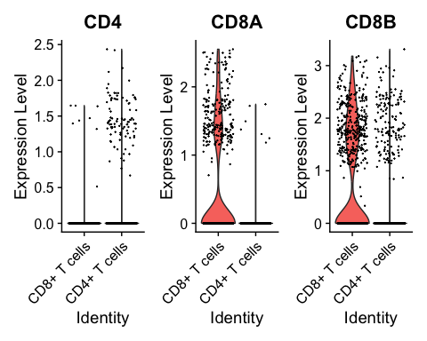

Differential expression using limma
The Wilcoxon test implemented in FindMarkers does not allow you to test for complex design (eg factorial experiments) or to include batch as a covariate. It doesn’t allow you to run paired-sample T tests for example.
For more complex designs, we can use edgeR or limma which are designed for microarray or bulk RNA seq data and provide a design matrix that includes covariates for example, or sample IDs for paired analyses.
We will load an object containing only pro B cells, both from healthy tissues (PBMMC), and malignant tissues (ETV6-RUNX1).
 Warning
Please NOTE that in the original design of this data set, the healthy and malignant tissues were not patient-matched, i.e. the real design was not the one of paired healthy and malignant tissues. However, for demonstration purposes, we will show you how to run a paired analysis, and do as if the PBMMC-1 and ETV6-RUNX1-1 samples both came from the same patient 1, the PBMMC-2 and ETV6-RUNX1-2 samples both came from the same patient 2, etc…
We can load the object and explore its UMAP and meta.data like this:
Code starts here:
proB <- readRDS("course_data/proB.rds")
Seurat::DimPlot(proB, group.by = "orig.ident")
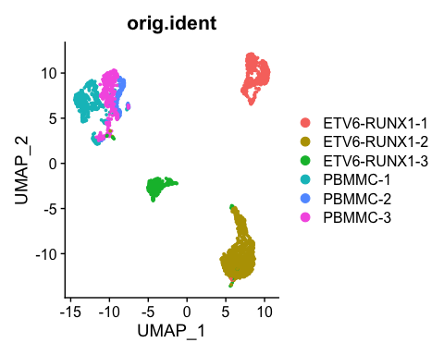
Code starts here:
table(proB@meta.data$type)
ETV6-RUNX1 PBMMC
2000 1021
head(proB@meta.data)
orig.ident nCount_RNA nFeature_RNA SingleR_annot
PBMMC-1_AAATGCCAGACTGGGT-1 PBMMC-1 4886 1727 Pro-B_cell_CD34+
PBMMC-1_AAATGCCTCCACTGGG-1 PBMMC-1 8397 2291 Pro-B_cell_CD34+
PBMMC-1_AACACGTTCTTGACGA-1 PBMMC-1 3444 1204 Pro-B_cell_CD34+
PBMMC-1_AACCATGAGAAGGTGA-1 PBMMC-1 8981 2437 Pro-B_cell_CD34+
PBMMC-1_AACCGCGCATGGTCAT-1 PBMMC-1 3719 1368 Pro-B_cell_CD34+
PBMMC-1_AAGCCGCCAGACGTAG-1 PBMMC-1 4573 1464 Pro-B_cell_CD34+
type
PBMMC-1_AAATGCCAGACTGGGT-1 PBMMC
PBMMC-1_AAATGCCTCCACTGGG-1 PBMMC
PBMMC-1_AACACGTTCTTGACGA-1 PBMMC
PBMMC-1_AACCATGAGAAGGTGA-1 PBMMC
PBMMC-1_AACCGCGCATGGTCAT-1 PBMMC
PBMMC-1_AAGCCGCCAGACGTAG-1 PBMMC
 Note
If you want to know how this pro-B cell subset is generated, have a look at the script here.
Let’s have a look at the UMAP (again), coloured by celltype:
Code starts here:
Seurat::DimPlot(proB, group.by = "type")
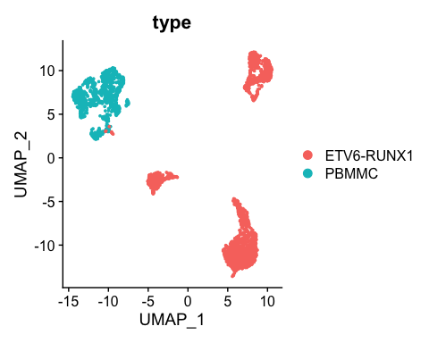
Let’s say we are specifically interested to test for differential gene expression between the tumor and normal samples.
 Note
Here we could also test for e.g. healthy versus diseased within a celltype/cluster.
Now we will run differential expression analysis between tumor and healthy cells using the patient ID as a covariate by using limma.
Prepare the pseudobulk count matrix:
Code starts here:
#taking the proB data
Seurat::DefaultAssay(proB) <- "RNA"
Seurat::Idents(proB) <- proB$orig.ident
## add the patient id also for paired DGE
proB$patient.id<-gsub("ETV6-RUNX1", "ETV6_RUNX1", proB$orig.ident)
proB$patient.id<-sapply(strsplit(proB$patient.id, "-"), '[', 2)
## Here we do perform pseudo-bulk:
##first a mandatory column of sample needs to be added to the meta data that is the grouping factor, should be the samples
proB$sample <- factor(proB$orig.ident)
# aggergate the cells per sampple
bulk <- Seurat::AggregateExpression(proB, group.by = "sample",
return.seurat = TRUE,
assay = "RNA")
# create a metadata data frame based on the aggregated cells
meta_data <- unique(proB@meta.data[, c("orig.ident",
"sample", "type",
"patient.id")])
rownames(meta_data) <- meta_data$orig.ident
bulk@meta.data <- meta_data[colnames(bulk), ]
##have a look at the counts
counts <- Seurat::GetAssayData(bulk, layer = "counts") |> as.matrix()
head(counts)
ETV6-RUNX1-1 ETV6-RUNX1-2 ETV6-RUNX1-3 PBMMC-1 PBMMC-2 PBMMC-3
RP11-34P13.7 0 0 0 2 0 0
FO538757.3 0 0 0 0 0 0
FO538757.2 138 275 74 129 40 112
AP006222.2 63 43 17 38 19 26
RP4-669L17.10 5 10 3 0 1 1
RP5-857K21.4 0 0 0 0 0 2
#have a look at the colData of our new object summed, can you see type and
#patient.id are there
head(bulk@meta.data)
orig.ident sample type patient.id
ETV6-RUNX1-1 ETV6-RUNX1-1 ETV6-RUNX1-1 ETV6-RUNX1 1
ETV6-RUNX1-2 ETV6-RUNX1-2 ETV6-RUNX1-2 ETV6-RUNX1 2
ETV6-RUNX1-3 ETV6-RUNX1-3 ETV6-RUNX1-3 ETV6-RUNX1 3
PBMMC-1 PBMMC-1 PBMMC-1 PBMMC 1
PBMMC-2 PBMMC-2 PBMMC-2 PBMMC 2
PBMMC-3 PBMMC-3 PBMMC-3 PBMMC 3
Generate a DGEList object to use as input for limma and filter the genes to remove lowly expressed genes. How many are left?
Code starts here:
#As in the standard limma analysis generate a DGE object
y <- edgeR::DGEList(counts, samples = bulk@meta.data)
##filter lowly expressed (recommanded for limma)
keep <- edgeR::filterByExpr(y, group = bulk$type)
y <- y[keep,]
##see how many genes were kept
summary(keep)
Mode FALSE TRUE
logical 11086 10017
Generate a design matrix, including patient ID to model for a paired analysis. If you need help to generate a design matrix, check out the very nice edgeR User Guide, sections 3.3 and 3.4. Extract the sample ID from the meta.data, then create the design matrix:
Code starts here:
## Create the design matrix and include the technology as a covariate:
design <- model.matrix(~0 + y$samples$type + y$samples$patient.id)
# Have a look
design
y$samples$typeETV6-RUNX1 y$samples$typePBMMC y$samples$patient.id2
1 1 0 0
2 1 0 1
3 1 0 0
4 0 1 0
5 0 1 1
6 0 1 0
y$samples$patient.id3
1 0
2 0
3 1
4 0
5 0
6 1
attr(,"assign")
[1] 1 1 2 2
attr(,"contrasts")
attr(,"contrasts")$`y$samples$type`
[1] "contr.treatment"
attr(,"contrasts")$`y$samples$patient.id`
[1] "contr.treatment"
# change column/rownames names to more simple group names:
colnames(design) <- make.names(c("ETV6-RUNX1", "PBMMC","patient2","patient3"))
rownames(design) <- rownames(y$samples)
Specify which contrast to analyse:
Code starts here:
contrast.mat <- limma::makeContrasts(ETV6.RUNX1 - PBMMC,
levels = design)
Firt, we perform TMM normalization using edgeR, and then limma can perform the transformation with voom, fit the model, compute the contrasts and compute test statistics with eBayes:
Code starts here:
dge <- edgeR::calcNormFactors(y)
#Do limma
vm <- limma::voom(dge, design = design, plot = TRUE)
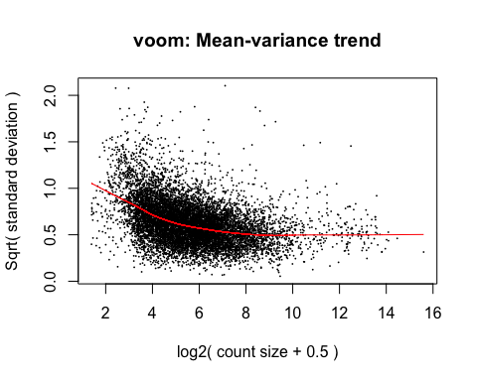
Code starts here:
fit <- limma::lmFit(vm, design = design)
fit.contrasts <- limma::contrasts.fit(fit, contrast.mat)
fit.contrasts <- limma::eBayes(fit.contrasts)
We can use topTable to get the most significantly differentially expressed genes, and save the full DE results to an object. How many genes are significant? Are you suprised by this number?
Code starts here:
# Show the top differentially expressed genes:
limma::topTable(fit.contrasts, number = 10, sort.by = "P")
logFC AveExpr t P.Value adj.P.Val B
RPS4Y2 5.346800 6.347826 15.39674 3.361453e-08 0.0001152727 9.477129
SDC2 9.070465 2.708711 15.33434 3.493119e-08 0.0001152727 7.681010
IGLL1 -3.788160 9.287148 -15.19483 3.808426e-08 0.0001152727 9.465422
CTGF 4.368363 6.029640 14.89301 4.603081e-08 0.0001152727 9.141505
AP005530.2 8.770808 2.560369 14.27130 6.879238e-08 0.0001335825 7.294079
GNG11 3.500250 6.457777 13.70183 1.008304e-07 0.0001335825 8.495288
HLA-DQA1 2.982748 7.410939 13.39202 1.249067e-07 0.0001335825 8.287394
PTP4A3 3.734865 5.449894 13.23439 1.395246e-07 0.0001335825 8.126807
CD27 4.115561 5.843582 13.23011 1.399471e-07 0.0001335825 8.147433
ALOX5 4.142010 5.682900 13.16658 1.463814e-07 0.0001335825 8.098199
limma_de <- limma::topTable(fit.contrasts, number = Inf, sort.by = "P")
length(which(limma_de$adj.P.Val<0.05))
[1] 2738
And we can check whether this corresponds to the counts by generating a violin plot, or a gene downregulated in tumor, or a gene upregulated in tumor:
Code starts here:
Seurat::VlnPlot(proB, "S100A9", split.by = "type")
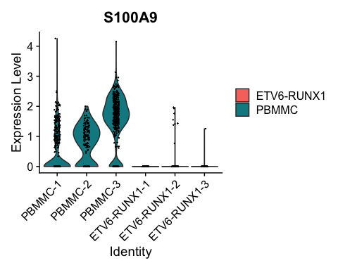
Code starts here:
Seurat::VlnPlot(proB, "SOCS2", split.by = "type")
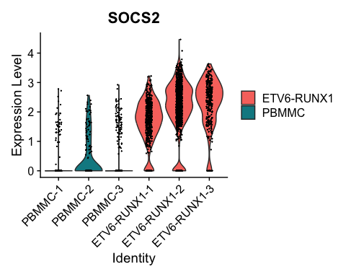
We can run a similar analysis with Seurat, but this will not take into account the paired design. Run the code below.
Code starts here:
tum_vs_norm <- Seurat::FindMarkers(proB,
ident.1 = "ETV6-RUNX1",
ident.2 = "PBMMC",
group.by = "type")
tum_vs_norm <- subset(tum_vs_norm, tum_vs_norm$p_val_adj<0.05)
 Exercise (extra)
How many genes are significant? How does the fold change of these genes compare to the fold change of the top genes found by limma?

 Answer
Code starts here:
dim(tum_vs_norm)
[1] 3820 5
We find 3820 significant genes. If we merge the FindMarkers and the limma results, keep limma’s most significant genes and plot:
Code starts here:
merge_limma_FindMarkers <- merge(tum_vs_norm, limma_de, by="row.names",
all.x=T)
par(mar=c(4,4,4,4))
plot(merge_limma_FindMarkers$avg_log2FC,
merge_limma_FindMarkers$logFC,
xlab="log2FC Wilcoxon", ylab="log2FC limma",
pch=15, cex=0.5)
abline(a=0, b=1, col="red")
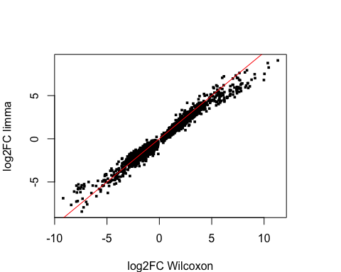

 Keep the object
Keep the tum_vs_norm and limma_de objects because we will use this output later for the enrichment analysis in the next section.

