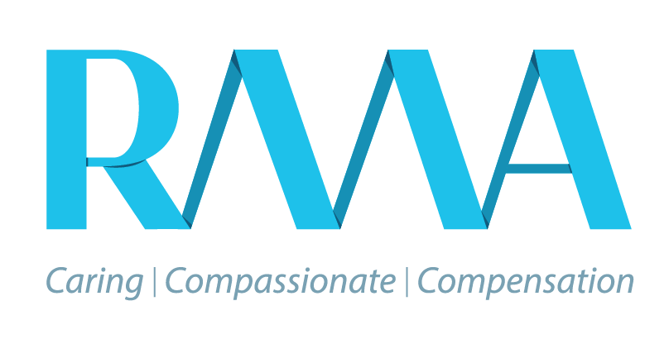

Date: DocumentDate

Our Reference Number: DocumentReferenceNumber

DocumentClientFullName

DocumentAddress

Dear Sir/Madam

Our Client: DocumentClientFullName

Account Number: DocumentReferenceNumber

Balance Due: R DocumentBalanceDue

Notification of handover

You are hereby advised that as a result of your failure to keep to the payment terms as agreed to with Rand Mutual Assurance (RMA) for premiums due, you are in breach of the assessment in terms of section 83 of the Compensation for Occupational Injuries and Diseases Act (COIDA), and the full outstanding balance is now due, owing and payable.

Take note your interest will also be back dated from the date you have not paid your term agreed amount. You are hereby notified that your account is been handed over to our Legal Department, a representative from which will be in touch with you shortly. Should you have any enquiries regarding the above, you may contact us on 0860 222 132 or [collections1@randmutual.co.za](mailto:collections1@randmutual.co.za).

Yours sincerely,

RMA Finance Department

