E – LEARNING PLATFORM
A PROJECT REPORT
Submitted by

Roll Number | Registration Number | Student Code | Student Name
22010301105 | 22013002490 Of 2022-  2023 | BWU/BCA/22/111 | LABANI BISWAS
22010301088 | 22013002473 of 2022-  2023 | BWU/BCA/22/094 | SIBAM CHOWDHURY
22010301104 | 22013002489 of 2022-  2023 | BWU/BCA/22/110 | AKASH PATRA
22010301086 | 22013002471 of 2022-  2023 | BWU/BCA/22/092 | SUBHADIP MAITI
22010301087 | 22013002472 of 2022-  2023 | BWU/BCA/22/093 | SUBHOJIT ROUTH
22010301071 | 22013002455 of 2022-  2023 | BWU/BCA/22/076 | KUSHAL CHAKRABORTY

in partial fulfillment for the award of the degree of

BACHELOR OF COMPUTER APPLICATION

In

Department of Computational Sciences BRAINWARE UNIVERSITY
398, Ramkrishnapur Road, Barasat, North 24 Parganas, Kolkata - 700 125



June, 2025

E – LEARNING PLATFORM
Roll Number | Registration Number | Student Code | Student Name
22010301105 | 22013002490 Of 2022-  2023 | BWU/BCA/22/111 | LABANI BISWAS
22010301088 | 22013002473 of 2022-  2023 | BWU/BCA/22/094 | SIBAM CHOWDHURY
22010301104 | 22013002489 of 2022-  2023 | BWU/BCA/22/110 | AKASH PATRA
22010301086 | 22013002471 of 2022-  2023 | BWU/BCA/22/092 | SUBHADIP MAITI
22010301087 | 22013002472 of 2022-  2023 | BWU/BCA/22/093 | SUBHOJIT ROUTH
22010301071 | 22013002455 of 2022-  2023 | BWU/BCA/22/076 | KUSHAL CHAKRABORTY
Submitted by

in partial fulfillment for the award of the degree of

BACHELOR OF COMPUTER APPLICATION
in

Computational Sciences

BRAINWARE UNIVERSITY
398, Ramkrishnapur Road, Barasat, North 24 Parganas, Kolkata - 700 125

BRAINWARE UNIVERSITY
398, Ramkrishnapur Road, Barasat, North 24 Parganas, Kolkata - 700 125

[COMPUTATIONAL SCIENCES]

BONAFIDE CERTIFICATE

Certified that this project report “E – LEARNING PLATFORM” is the bonafide work of “LABANI BISWAS, SIBAM CHOWDHURY, AKASH PATRA, SUBHADIP MAITI, SUBHOJIT ROUTH, KUSHAL CHAKRABORTY” who carried out the project work under my supervision.

SIGNATURE SIGNATURE
DR. JAYANTA AICH DOLAN GHOSH
HEAD OF THE DEPARTMENT SUPERVISOR
Computational Sciences Assistant Professor
Barasat, North 24 Parganas, Kolkata – 700125 Computational Sciences

ACKNOWLEDGEMENT
Project Title: E – Learning Platform
Project Group ID: BCA22B003
We, the undersigned project members, would like to express our sincere gratitude to Ms. Dolan Ghosh, Assistant Professor, Department of Computational Sciences, Brainware University, for their invaluable guidance, support, and encouragement throughout the course of this project. Their expert advice and constructive feedback were crucial in the successful completion of this work.

We also extend our heartfelt thanks to Dr. Jayanta Aich, Head of the Department of Computational Sciences ,for providing the necessary resources and support throughout this project.

We acknowledge with gratitude the support and cooperation of all faculty members and staff of the Department of Computational Sciences. Their insights and suggestions helped us stay on course and improve the quality of our work.

We especially thank our families, friends, and peers for their encouragement and support throughout this journey and for motivating us to achieve our goals.

Finally, we express our deepest gratitude to Brainware University for providing us with the opportunity to undertake this project as part of our academic curriculum.

Project Members:

1.
2.
3.
4.
5.
6.

Date:
Department of Computational Sciences
Brainware University
i

ABSTRACT

The E-learning platform is a user-friendly, web-based solution designed to deliver quality education and training to learners of all ages. It offers a wide range of courses, including academic subjects, professional skills, and personal development programs. The platform is accessible anytime, anywhere, and provides interactive features such as video lectures, quizzes, discussion forums, and live sessions to enhance engagement. It has integrated adaptive learning technologies, which help to personalize the content based on user needs, track progress through performance analytics, and ensures a secure, scalable website with multilingual access to reach more users and is compatible across all devices like smartphones, tablets, and desktops. It will connect the teachers with the learners, making the communication and collaboration processes more efficient. The E-learning platform has a user-friendly interface, empowering the individual to learn and grow both in life and professionally, by acquiring knowledge and skills for a lifetime.
ii

TABLE OF CONTENT

Chapter | Title | Page No
 | Abstract | ii
 | List Of Figures | iv
1 | Introduction | 1
2 | Objective | 2
3 | Planning | 3
4 | Requirement Analysis | 4
5 | System Flow | 5
5 | 5.1 Context Level Diagram | 5
5 | 5.2 Data Flow Diagram | 6
5 | 5.3 Activity Diagram | 7
 | 5.4 Sequence Diagram | 8
 | 5.5 Flow Chart | 9
6 | Proposed Design | 10
8 | Experiment Result | 12
9 | Future Scope | 15
10 | Conclusion | 16
 | References | 17

iii
LISTS OF FIGURES

SL NO | Figure Name | Page No
1 | Context Level Diagram (CLD) | 5
2 | Level 0 DFD | 6
3 | Level 1 DFD | 6
4 | Activity Diagram | 7
5 | Sequence Diagram | 8
6 | Flow Chart | 9
7 | Index Page | 10
8 | Admin Panel page | 11
9 | Database page | 11
10 | Register Page | 12
11 | Sign In Page | 12
12 | Subscription plan | 13
13 | Course List | 14
iv

CHAPTER 1

INTRODUCTION :
A E-learning Platform system is a software package that enables enterprises to deliver learning content and resources to their employees or students. A learning management system is often web-based to facilitate 24/7 access to e-learning courses and relevant education. Moreover, a learning management system is also called "Course management system", "Pedagogical platform" Or "E-learning platform". A learning management system is considered to be the missing bridge between current education improvements and effective uses of technology. Typically, e- learning management systems encourage instructors to guide and manage employee achievement more effectively by contextualizing the learning experience itself in a consistent and creative way.

1.1 Welcome to Edification :
Your Gateway to Learning, Growth, and Success!
At Edification, we believe that education is the key to unlocking limitless potential. Our platform is designed to make learning accessible, engaging, and effective for everyone, whether you're a student, professional, or lifelong learner.

1.2 Why Choose Us?
- Diverse Courses: Explore a wide range of topics, from professional development to personal growth, tailored to meet the needs of every learner.
- Free eBooks: Enrich your learning journey with our collection of free eBooks, designed to complement your courses and provide deeper insights.
- Flexible Learning: Learn at your own pace, anytime and anywhere, with our user-friendly platform.
CHAPTER 2

Objective:

The main objective of an e-learning platform project is to create an accessible, user-friendly, and efficient digital environment that allows learners to gain knowledge and skills at their own pace, anytime and anywhere, through the internet. This project aims to bridge the gap between students and quality education by providing interactive and computational Sciences -based content such as videos, PDF, and discussion forums that enhance understanding and engagement. It is designed to support learners from various educational backgrounds and age groups, offering personalized learning experiences that cater to individual needs, learning styles, and goals. The platform also seeks to support educators by enabling them to create, manage, and deliver courses with ease, track student progress, and provide timely feedback through integrated tools. So basically everyone can use it who has passion for learning something new or mastering any other skill to upgrade themselves, Some people might not find the traditional classroom as an option so this really huge for them. It promotes lifelong learning and skill development, empowering users to stay updated with current knowledge in a fast-changing world. This project documentation outlines the goals, technical requirements, system architecture, features, user roles, development process, and deployment strategy, ensuring a clear understanding for all stakeholders involved, including developers, educators, administrators, and learners. The e-learning platform ultimately aims to create a smarter, more inclusive, and collaborative learning ecosystem by integrating modern technologies like cloud computing, mobile compatibility, real-time communication, and artificial intelligence, thereby contributing to the broader mission of digital education and knowledge democratization.
CHAPTER 3

Planning:
The planning phase of an e-learning platform project is a crucial step that lays the foundation for the entire development process, ensuring that all team members are aligned on the goals, expectations, resources, and timelines. This phase starts with identifying the purpose of the platform, such as providing online education, training, or skill development to a specific target audience like students, professionals, or organizations. Next, the scope of the project is defined, which includes determining the types of content to be delivered (such as video lectures, PDFs, and live classes), the subjects or courses to be offered, and the features required like user registration, login system, discussion forums, chat support, certification, and admin control panels. After that, market research is conducted to understand user needs, study competitors, and gather feedback that can help design a more effective and user-friendly system. Based on this research, user personas are created and key requirements are written down in simple terms, ensuring that both technical and non-technical members can understand what needs to be built. Then comes the preparation of a project roadmap or timeline, which breaks down the project into phases such as planning, designing, development, testing, deployment, and maintenance, and assigns tasks to developers, designers, testers with specific deadlines to manage time effectively. Budget estimation is also done at this stage, including costs for development tools, hosting services, domain registration, software licenses, and marketing. Security, scalability, and mobile responsiveness are considered from the start to ensure the platform can handle growth and provide a safe environment for users. Risk assessment is also part of planning, where possible problems are identified early, such as delays, technical issues, or budget overruns, and backup plans are created to minimize their impact. Documentation is created at every step to clearly record all decisions, technical choices, and user requirements, so future team members can easily understand the project. Finally, the planning phase ends with a well-structured project proposal or documentation that includes objectives, features, technology stack, timelines, team roles, and estimated cost, which serves as a guide throughout the project. Overall, the planning stage ensures that the e-learning platform project begins with a clear vision, realistic expectations, and a detailed strategy for successful completion, while staying flexible enough to adapt to any changes or feedback during development.

CHAPTER 4

Requirement Analysis:

4.1 Software Requirements:
    - Operating System - Windows, MacOS, or Linux
    - IDE - Eclipse IDE or IntelliJ IDEA for Java development
    - JDK - Java Development Kit (JDK 17 or later)
    - Database - MySQL Workbench 8.0 CE
    - Web Server - Apache Tomcat 10.1
    - Fronted Framework - HTML, CSS, JAVASCRIPT
    - Styling Library – Bootstrap
    - Backend Frameworks - JSP (Java Server pages), Servlets
    - Browser - Google Chrome, Mozilla Firefox, or Microsoft Edge
    - Other Tools - Gson (for JSON handling)

4.2 Hardware Requirements:
4.2.1. Processor - Intel Core i3 or equivalent, or higher
4.2.2. RAM - 4 GB or Higher
    - Storage - Minimum 128 GB SSD
    - Operating System - Windows 10/11, MacOS, or HDD

CHAPTER 5

System Flow:

5.1 Context Level Diagram (CLD) :

This presents a context-level Data Flow Diagram (DFD) of an E-Learning Platform, illustrating its primary interactions with external entities. At the core is the "E-Learning Platform," represented by a central black circle. Three main external entities interact with this system: Student, Admin, and two functional modules—"Student Registration" and "Add Modules." Students begin by registering through the "Student Registration" module, which sends data into the system. Once registered, students can access video tutorials and participate in online examinations. These activities flow from and to the E-Learning Platform. Admins contribute by uploading video tutorials via the "Add Modules" function and receive student performance reports from the system. Thus, the Admin supports content management and monitoring. The diagram clearly shows bidirectional flows between the E-Learning Platform and its users, highlighting a structured process for content delivery, examination, and reporting. This context DFD effectively maps out the foundational components and data exchanges of an E-Learning platform at a high level.
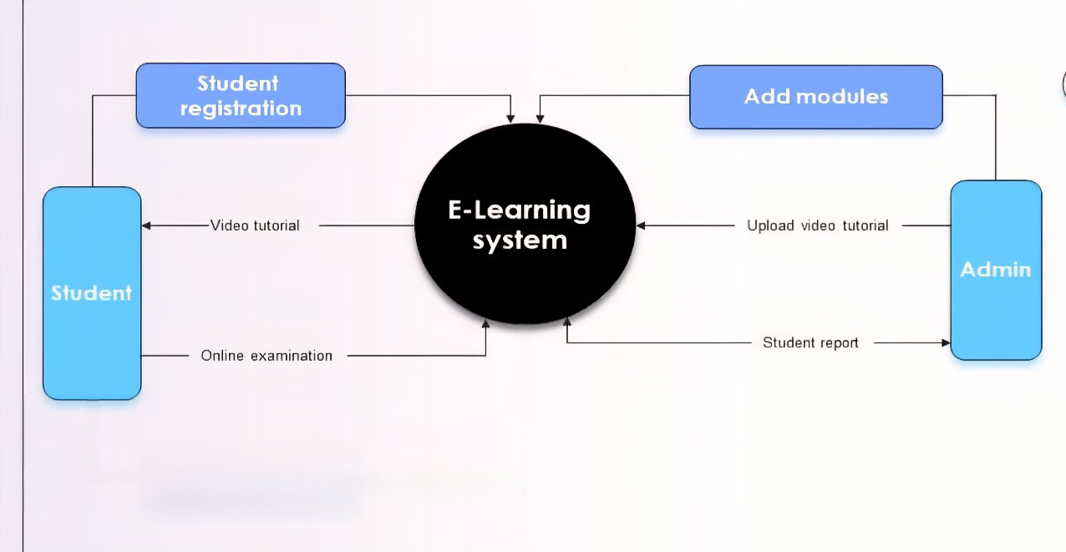

Figure 1: Context Level Diagram (CLD)

5.2 Data Flow Diagram (DFD) :
5.2.1 Level 0 DFD:
This diagram illustrates a Level 0 Data Flow Diagram (DFD) for a registration process within a system named "Edification." A user sends a registration request to the system, which then forwards an "add details request" to the admin. Upon approval, the admin sends a "request accepted" response back to Edification, which then instructs the user to "register yourself," completing the interaction loop between the user, system, and admin.

Figure 2: Level 0 DFD

5.2.2 Level 1 DFD:

Figure 3: Level 1 DFD

This Level 1 Data Flow Diagram (DFD) illustrates the internal processes of a course management system. It begins with user registration (Process 0.1), which stores details in the USER_TBL and allows users to view content via Process 0.2. Admins log in through Process 0.3 and initiate data entry for category and course sections. Categories are managed through updating (Process 0.4) and viewing (Process 0.5), interacting with the CAT_TBL for data storage. Similarly, courses are handled through Processes 0.6 and 0.7 for updating and viewing respectively, with information stored in the COURSE_TBL. Each process flows logically to reflect tasks like user interaction, admin control, and dynamic course or category updates within the system, ensuring smooth data flow and access management.
5.3 Activity Diagram :
This activity diagram represents the workflow of a course management system. It begins with the login process, where user credentials are validated. If the login is invalid, the user is redirected to retry; if valid, access is granted to the "Course Manage" section. From there, the user can perform one of three parallel actions: Add Course, Update Course, or Delete Course. Once any of these tasks are completed, the system proceeds to generate a report. The final step is logging off, which concludes the user’s session. This diagram effectively outlines the logical flow of activities for managing course content, emphasizing control decisions and parallel functionalities within the system’s operational structure.
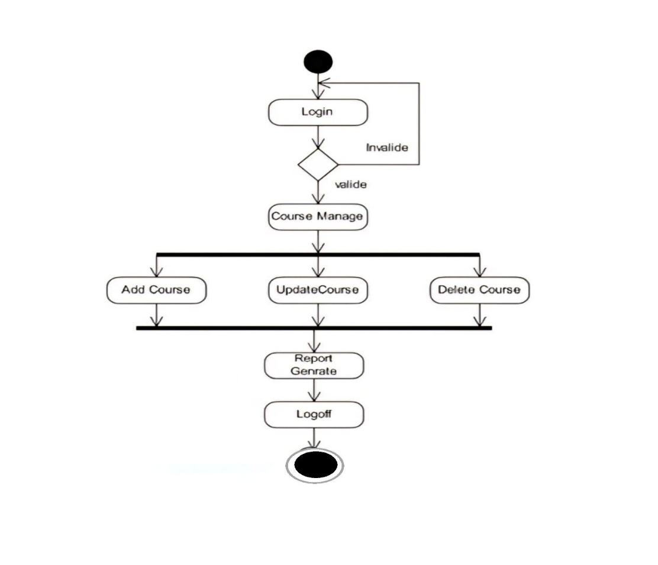

Figure 4: Activity Diagram
5.4 Sequence Diagram:
This sequence diagram illustrates the interactions among four entities—Interface, Admin, Student, and Professor in an E – Learning System. The process begins with the Interface managing accounts and course materials. The Admin handles tasks such as creating accounts, login authentication, class enrollment, and responding to student inquiries. Students perform actions like logging in, uploading course materials, and clarifying doubts. Professors interact by conducting live sessions, clarifying student queries, and uploading availability schedules. The diagram shows a clear flow of messages between components, representing how system functionalities are executed in real-time across different user roles. It provides a detailed view of system behavior and user interaction patterns in a structured and time-ordered manner.
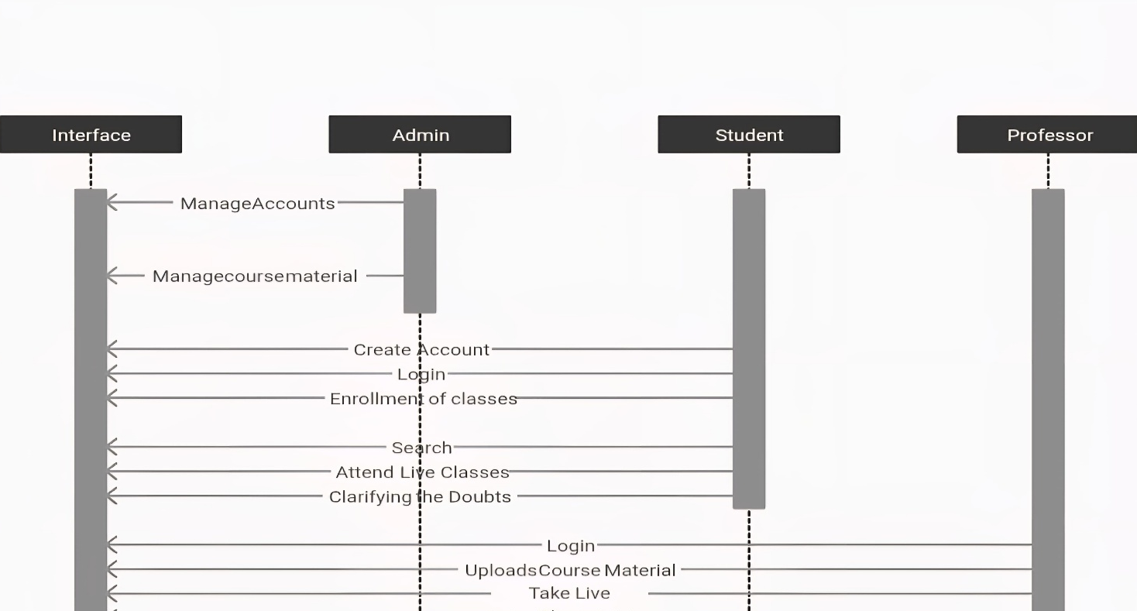

Figure 5: Sequence Diagram
5.5 Flow Chart:
This flowchart represents the user navigation process on an e-learning website. It begins with the user starting the session and logging into the system. Once logged in, the user enters the main interface of the e-learning platform. The next step involves selecting a course from the available options. Upon course selection, the user is given access to video lectures and can optionally view a corresponding PDF document. After engaging with the video lecture, the system confirms that the video has been viewed. The user then proceeds to log out, completing the learning session. The flowchart effectively outlines a straightforward and logical sequence of actions, ensuring a smooth learning experience from login to logout.

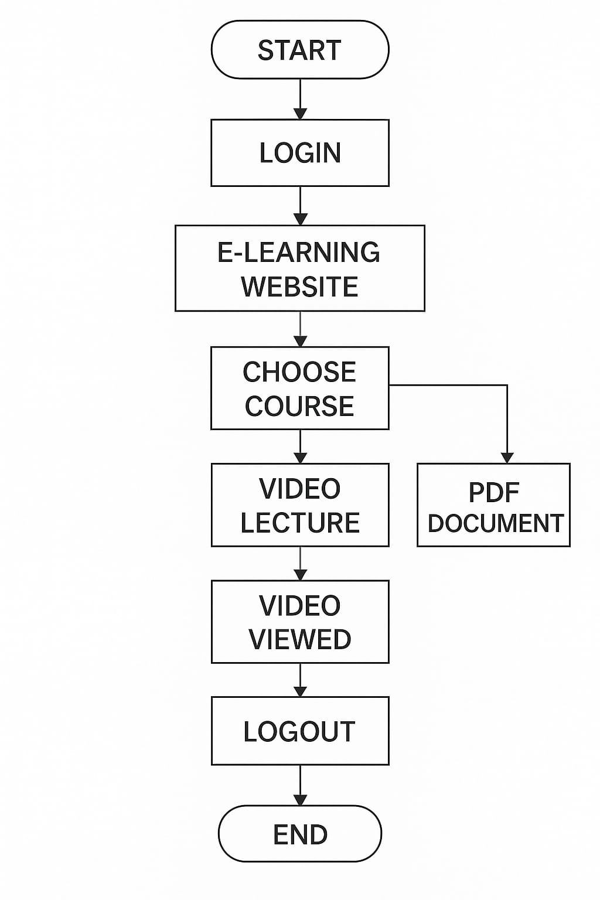

Figure 6: Flow Chart

CHAPTER 6

Proposed Design:

6.1 Index Page:

Figure 7: Index Page

This is the index page of our website.This image depicts the index page of an educational website named "Edification. Below, the section titled “Featured Courses” highlights three programs: UI/UX Design, Data Structure & Algorithm, and Web Development, each with course duration details. The interface is clean and modern, aiming to encourage users to explore and enroll in skill-enhancing educational opportunities
6.2 Admin Panel:
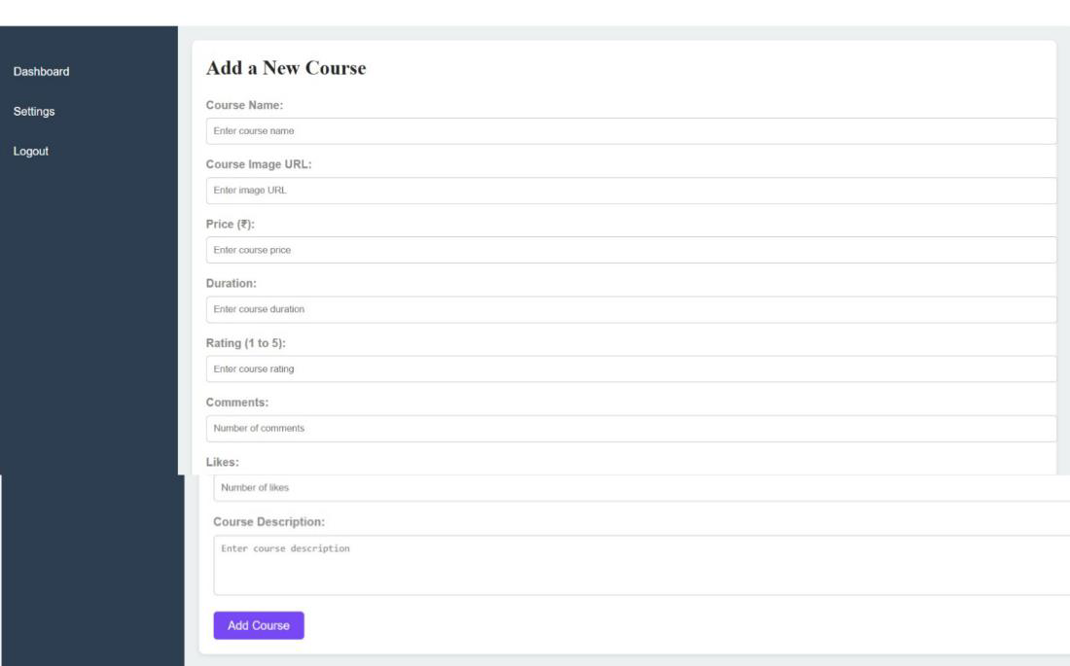

Figure 8: Admin Panel Page

The admin uses this panel to add new courses easily. They fill in the course name, image URL, Price, and duration in the provided input fields .They can also enter a rating(1 to 5), the number of comments and likes. There is a text box to write a course description. Once all the details entered, the admin clicks the “Add Course” button to save the course. The sidebar on the left allows navigation to the dashboard, settings, or logout. This panel helps admins manage courses efficiently in a simple and organized way.

6.3 Database Page :

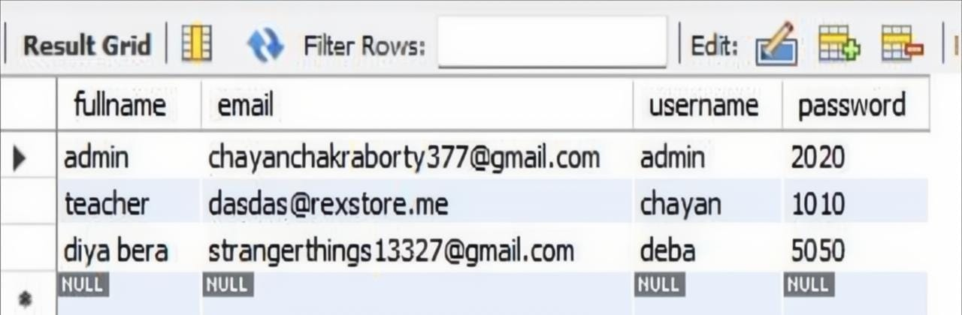

Figure 9: Database Page

This is the entire database of the Edification where the database contains four credentials such as fullname, email, username, password. Which it helps in authentication for login purpose.

CHAPTER 7

7. Experiment Result:

7.1 Register Page:

Figure 10: Register Page

This image shows a clean and modern user registration form with fields for full name, email, username, and password. A message confirms “Registration successful!” with a login link for existing users.

7.2 Sign Now Page :

Figure 11: Sign in Page

This image describe the sign in page. When the user enter the email and password then the page show this login is successful. After login then it is going to the homepage.

7.3 Subscription Plan :


Figure 12: Subscription Plan

We offer both paid and unpaid courses to cater to diverse learning needs. For our unpaid courses, you will have access to free YouTube videos and course notes for a duration of three months. For those opting for the paid version, you will benefit from live classes, along with weekly mock tests, ensuring a comprehensive and interactive learning experience.

7.4 Course List :

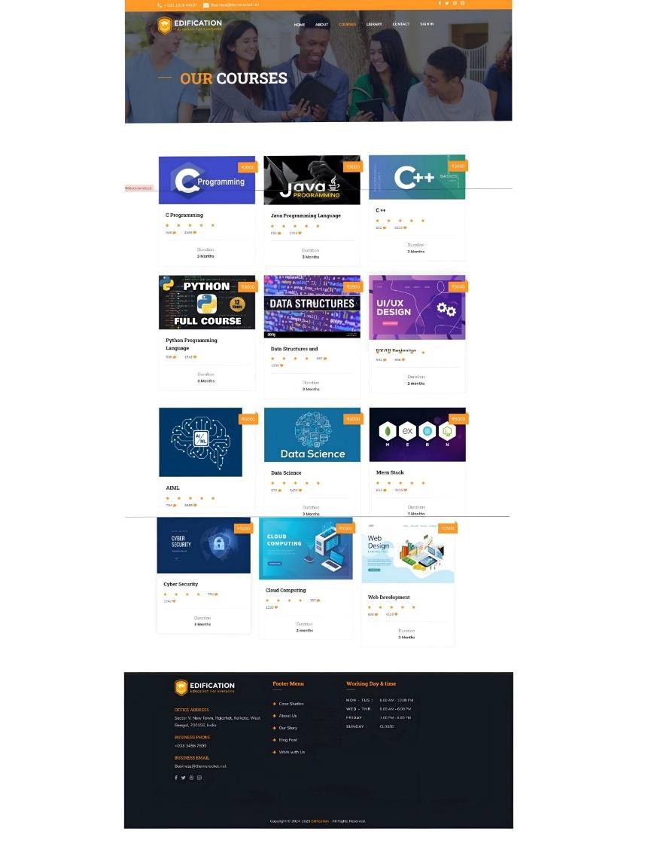

Figure 13: Course List

This is the Courses list page of our website. Here we provide the various type of courses such as C programming, C++, Python, Data Science, Data Structure, UI/UX Design, Cyber Security etc. Suppose at first the user can click the one course then he saw the pdf document and video link of this course things we have provided.

CHAPTER 8

Future Scope:
The future scope of e-learning platforms is vast and continually expanding, driven by rapid technological advancements and evolving educational needs. These platforms are transforming traditional learning by offering greater accessibility, flexibility, and personalization. With the integration of artificial intelligence (AI) and machine learning, e-learning systems are becoming more adaptive, tailoring content to individual learning styles and progress. Technologies like virtual reality (VR) and augmented reality (AR) are enhancing experiential learning, particularly in fields requiring hands-on practice such as healthcare, engineering, and vocational training. The increasing adoption of gamification and microlearning is also improving learner engagement and knowledge retention. Furthermore, mobile learning (m-learning) is enabling users to access educational content anytime and anywhere, expanding reach to remote and underserved populations. In the corporate sector, e-learning platforms are supporting continuous learning, upskilling, and compliance training, aligning with the growing demand for lifelong learning. The shift toward hybrid education models in schools and universities further solidifies the role of e-learning in mainstream education. These platforms are also becoming more inclusive by offering multilingual content and accessibility features for differently-abled learners. As cloud computing and 5G technology continue to evolve, the scalability and performance of e-learning platforms are expected to improve significantly. In the future, these platforms will not only serve as tools for academic learning but also as essential infrastructure for global knowledge sharing, career development, and personal growth. Overall, the e-learning ecosystem is poised to become more intelligent, immersive, and inclusive, playing a critical role in shaping the future of education and professional training worldwide.

CHAPTER 9

Conclusion:

Transformative Impact: E-learning platforms have the potential to revolutionize education by making it more accessible, flexible, and engaging.
Empowering Learners: They empower individuals with the knowledge and skills necessary to succeed in a rapidly changing world.
Continuous Innovation: Ongoing advancements in technology will further enhance the capabilities and effectiveness of e-learning platforms.
Key to Lifelong Learning: E-learning platforms facilitate lifelong learning by providing accessible and conveni0ent access to educational resources.

REFERENCES

- CSS grid layout - CSS: Cascading Style Sheets | MDN. (2025, February 7). MDN Web Docs. https://developer.mozilla.org/en-US/docs/Web/CSS/CSS_grid_layout
- GeeksforGeeks. (2024, October 16). HTML login form. GeeksforGeeks. https://www.geeksforgeeks.org/html-login-form/
- Mimo: The coding platform you need to learn Web Development, Python, and more. (n.d.). https://mimo.org/glossary/html/including-javascript
- Mullor, M. (2024, February 14). 21 best anime movies of all time you should watch. Digital Spy. https://www.digitalspy.com/movies/g44947765/best-anime-movies/
- Rathee, K. (2021, August 24). 7 tips for a good ER Diagram Layout. Vertabelo Data Modeler. https://vertabelo.com/blog/vertabelo-tips-good-er-diagram-layout/
- Paulsen, M. F. (2002). Online education systems: Discussion and definition of terms. NKI distance education, 202, 1-8.
- Jain, S., Prabha, C., Nandan, D., & Bhosale, S. (2024). Comparative analysis of frequently used e-learning platforms. Frontiers in Education, 9. https://doi.org/10.3389/feduc.2024.1431531
- Jain, S., Prabha, C., Nandan, D., & Bhosale, S. (2024b). Comparative analysis of frequently used e-learning platforms. Frontiers in Education, 9. https://doi.org/10.3389/feduc.2024.1431531
- GeeksforGeeks. (2021, July 20). JSP Architecture. GeeksforGeeks. https://www.geeksforgeeks.org/jsp-architecture/?utm_source=chatgpt.com
- JavaServer Pages[tm] Technology - White Paper. (n.d.). https://www.oracle.com/java/technologies/javaserver-white-paper.html?utm_source=chatgpt.com

