Table of Contents

Introduction 5

Purpose 5

Procedure to configure ReaR 5

SET UP AN NFS SERVER 6

CONFIGURE REAR 6

GENERATE BACKUP 7

RESTORE BACKUP IMAGE 7

Introduction

Relax-and-Recover (ReaR) is a recovery and system migration utility. Which can be used for image based backups.

Purpose

The purpose of this document is to define the procedure for Configuring ReaR to restores from backup using ReaR image.It also allows to restore to different hardware and can therefore be used as a migration utility as well.

Procedure to configure ReaR

**Install ReaR Package-**

Install the rear package by running the below command.

~ ] # yum install rear

Verify the package once installed



SET UP AN NFS SERVER

Set up an NFS server for holding the backup files.

Back up the files to the NFS server and store the disaster recovery system to an ISO image.

Create an export on the NFS server (in this example, it has the IP address (192.168.76.101). We use /storage directory for storing the backup files later.

# mkdir /storage

# cat /etc/exports

/storage *(rw,sync)

# service nfs start

CONFIGURE REAR

ReaR is configured in the /etc/rear/local.conf file. Specify the system configuration by adding below lines:

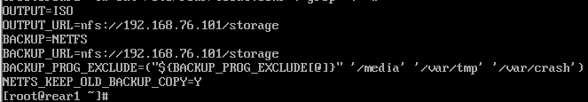

OUTPUT=ISO

OUTPUT_URL=file:///rear

BACKUP=NETFS

BACKUP_URL=file:///rear

BACKUP_PROG_EXCLUDE=("${BACKUP_PROG_EXCLUDE[@]}" '/media' '/var/tmp' '/var/crash')

NEFTFS_KEEP_OLD_BACKUP_COPY=Y

In Above configuration you can skip backup of any Filesystem with “BACKUP_PROG_EXCLUDE= <Filesystems>”

GENERATE BACKUP

Create the disaster recovery system and generate backup files.

~ ] # rear –d –v mkbackup

Rear will examine the current backup system and gather necessary information, like the disk layout, files to be excluded and the boot loader, etc. Then a bootable ISO image with disaster recovery system will be created under /var/lib/rear/output by default. At last the files to be backed up as well as the bootable ISO image will be transferred to the NFS server.

RESTORE BACKUP IMAGE

To recover a system using the image, you’ll need to transfer the ISO to a recovery device and boot with the backup ISO image (rear-rear1.iso), it will present following options on screen.

We chose Automatic Recover rear1, here rear1 is the hostname.

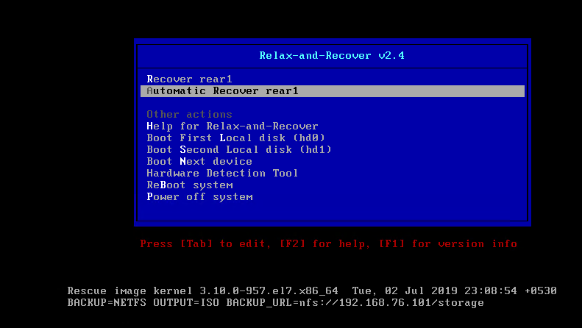

Restore/Migrate Started-

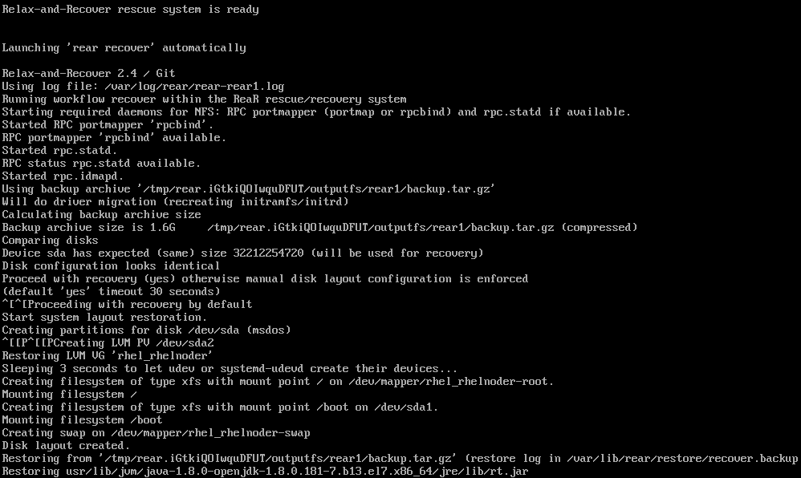

Post completed recovery, choose option 3 to Reboot.

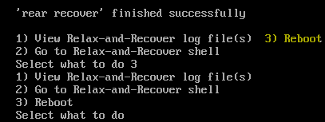

Restoration completed.

