1. Data Preparation
Your Prompt to GenAI
"Hi Gemini, for my data visualization class, I need help with data preparation for a Halloween dataset.
The assignment asks for the best way to merge trick-or-treat data with day-of-week data. My dataset already has 'Count' and 'Day of Week' columns. Is a merge necessary?"
AI's Suggestion
"Hello! Let's get this ready for your analysis.
Merging Data: Good news. Based on the HalloweenTableau2024.csv file, the Day of Week column is already in the same table as the Count column. You do not need to perform any merge or join for this; the data is already prepared.”
MY Interpretation :
The AI confirmed that merging the Day of Week field was unnecessary since it was already present in my dataset. Afterward, I merged all the CSV and Excel files to finalize the dataset for the competition and created additional columns, including a weekend flag, a temperature (integer) column, and a temperature category column to classify weather conditions as low, average, or warm and cleaned condition column too.
2. Timing & Flow
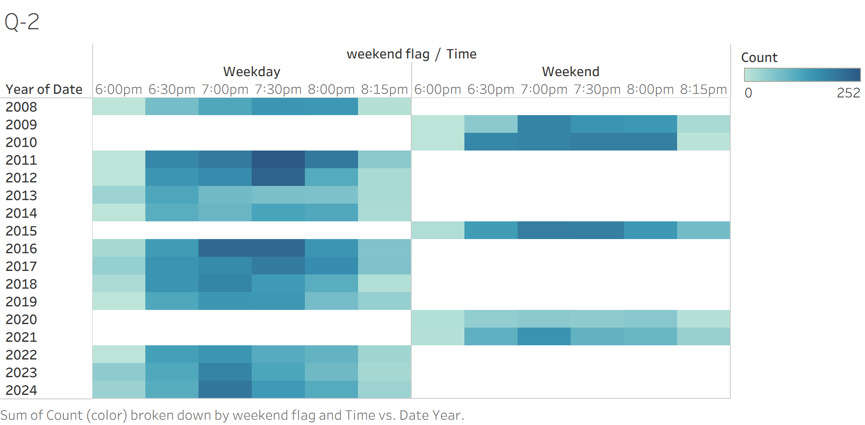
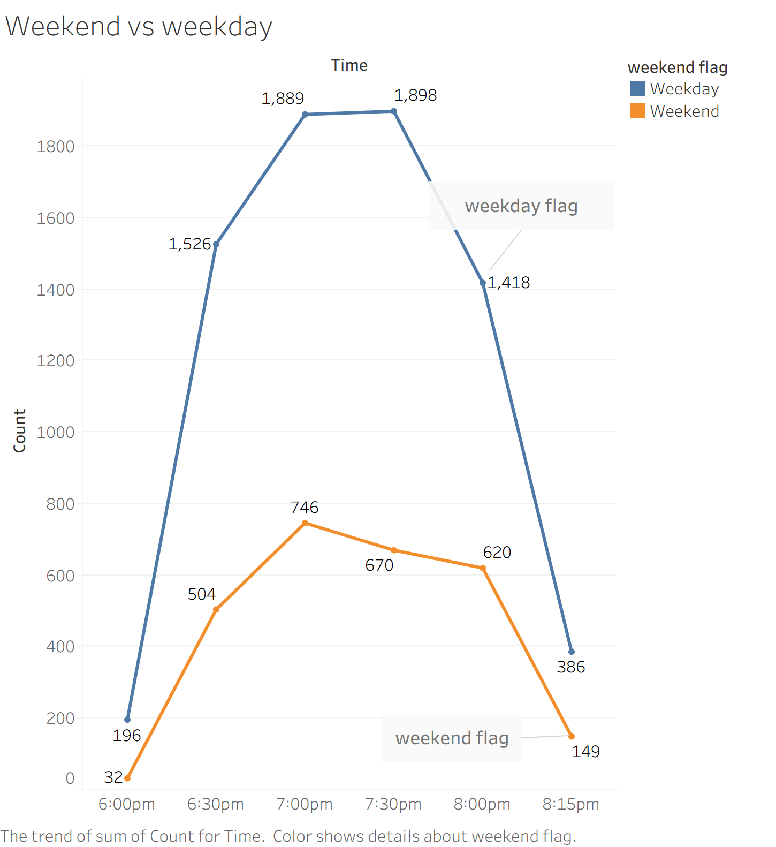
"Explain how weekend scheduling influences the pattern of trick-or-treaters."
AI-Generated Interpretation
Halloweens on weekdays (Monday-Thursday) tend to see a much higher concentration of activity, with a sharp, late peak around 7:30 PM. This is likely due to parents and children rushing to trick-or-treat after returning from work and school. In contrast, weekend (Friday-Sunday) Halloweens show a lower overall volume but with an earlier, broader peak around 7:00 PM, suggesting families have more flexibility and start earlier.
MY Interpretation
My heatmap shows 2011 and 2016 were exceptionally busy years, especially at 7:30 PM. My line charts confirm that weekdays are busier than weekends and that the vast majority of visitors arrive after sunset.

3. Sunset & Weather Analysis
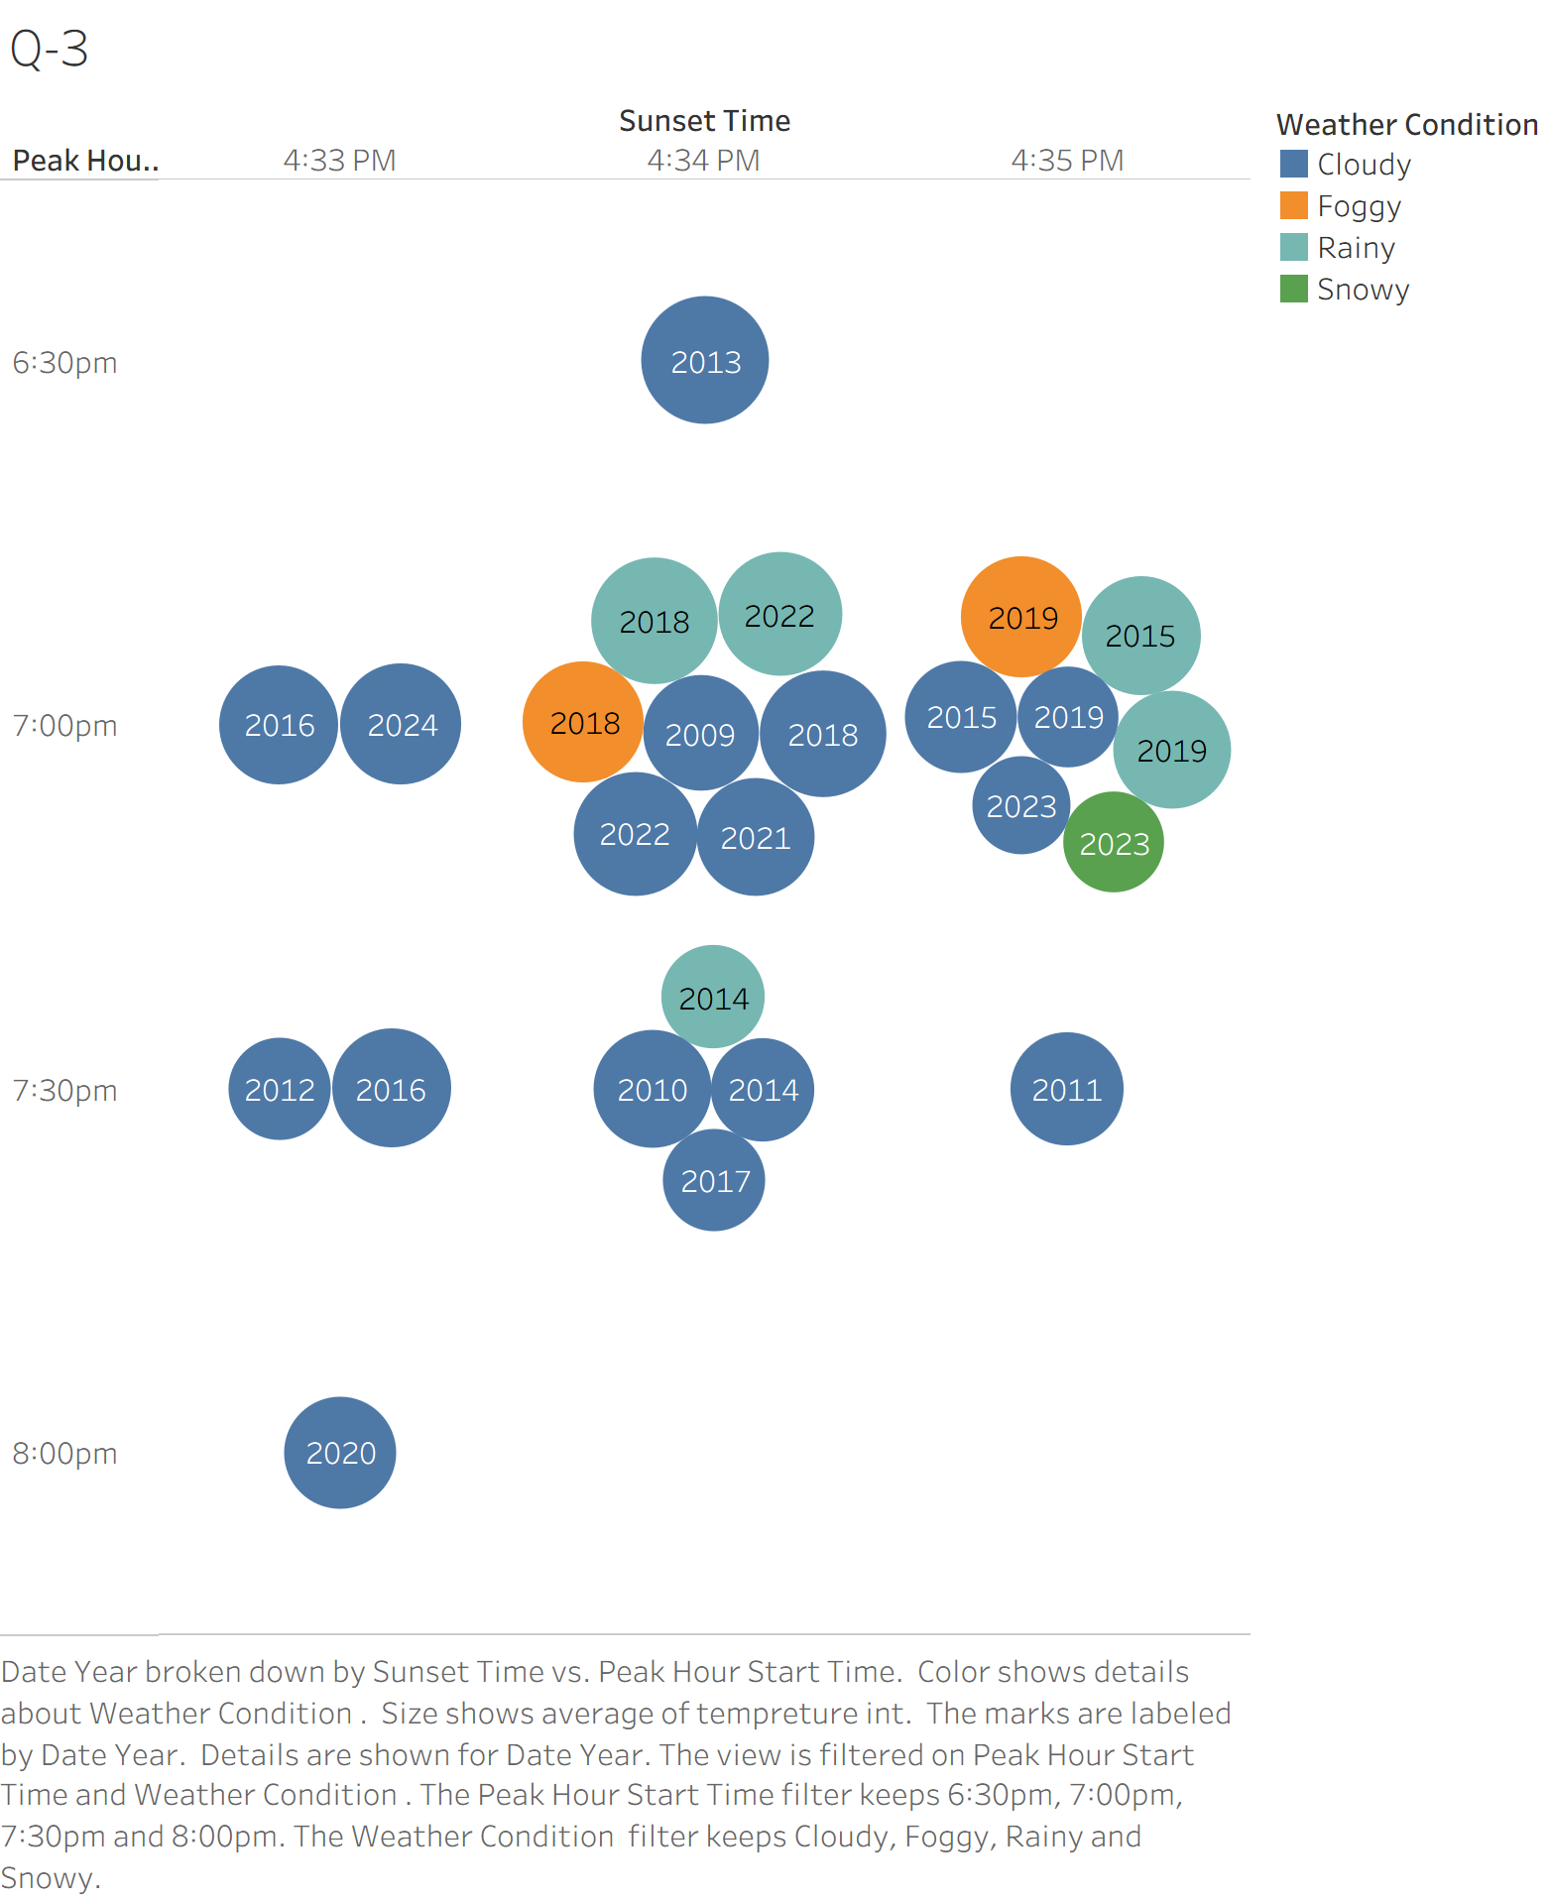
“Examine how temperature or rain interacts with sunset timing. For example, do colder or wetter evenings shift trick-or-treat peaks earlier? Create one visualization and interpret your findings.”
AI-Generated Interpretation:
"This visualization plots the relationship between the peak trick-or-treating hour, the sunset time, the average temperature, and the weather conditions for each year.
The chart's primary limitation for answering the prompt is immediately clear: the Sunset Time (x-axis) is almost constant, with all data points clustered between 4:33 PM and 4:35 PM. Because there is no meaningful variation, this visualization cannot effectively determine how changes in sunset timing interact with weather.
Instead, the chart primarily shows the relationship between temperature and the peak hour. When examining the prompt's hypothesis—"do colder or wetter evenings shift trick-or-treat peaks earlier?"—the data suggests the following:
- Temperature: The chart does not support the hypothesis. In fact, it shows the opposite: the single earliest peak (6:30 PM) corresponds to the largest bubble, which is the warmest average temperature (63.5°). Conversely, the latest peak (8:00 PM) is associated with a much colder temperature (a smaller bubble, 48.8°).
- Rain/Snow: The "Rainy" and "Snowy" data points are scattered at the 7:00 PM and 7:30 PM peaks along with all other weather types. There is no evidence that "wetter" evenings cause a consistent earlier shift.
In conclusion, the hypothesis that colder or wetter evenings shift peaks earlier is not supported by this data."
My Interpretation:
My interpretation is that sunset timing is not a useful predictor in this dataset, as it's nearly identical every year. The chart contradicts the prompt's hypothesis: the warmest year on record (the largest bubble at 63.5°) had the earliest peak at 6:30 PM. Colder and rainier years seem to cluster around the more traditional 7:00 PM and 7:30 PM peak times, suggesting that uncomfortable weather doesn't necessarily make people start earlier.

4. Weekend vs. Weekday Turnout
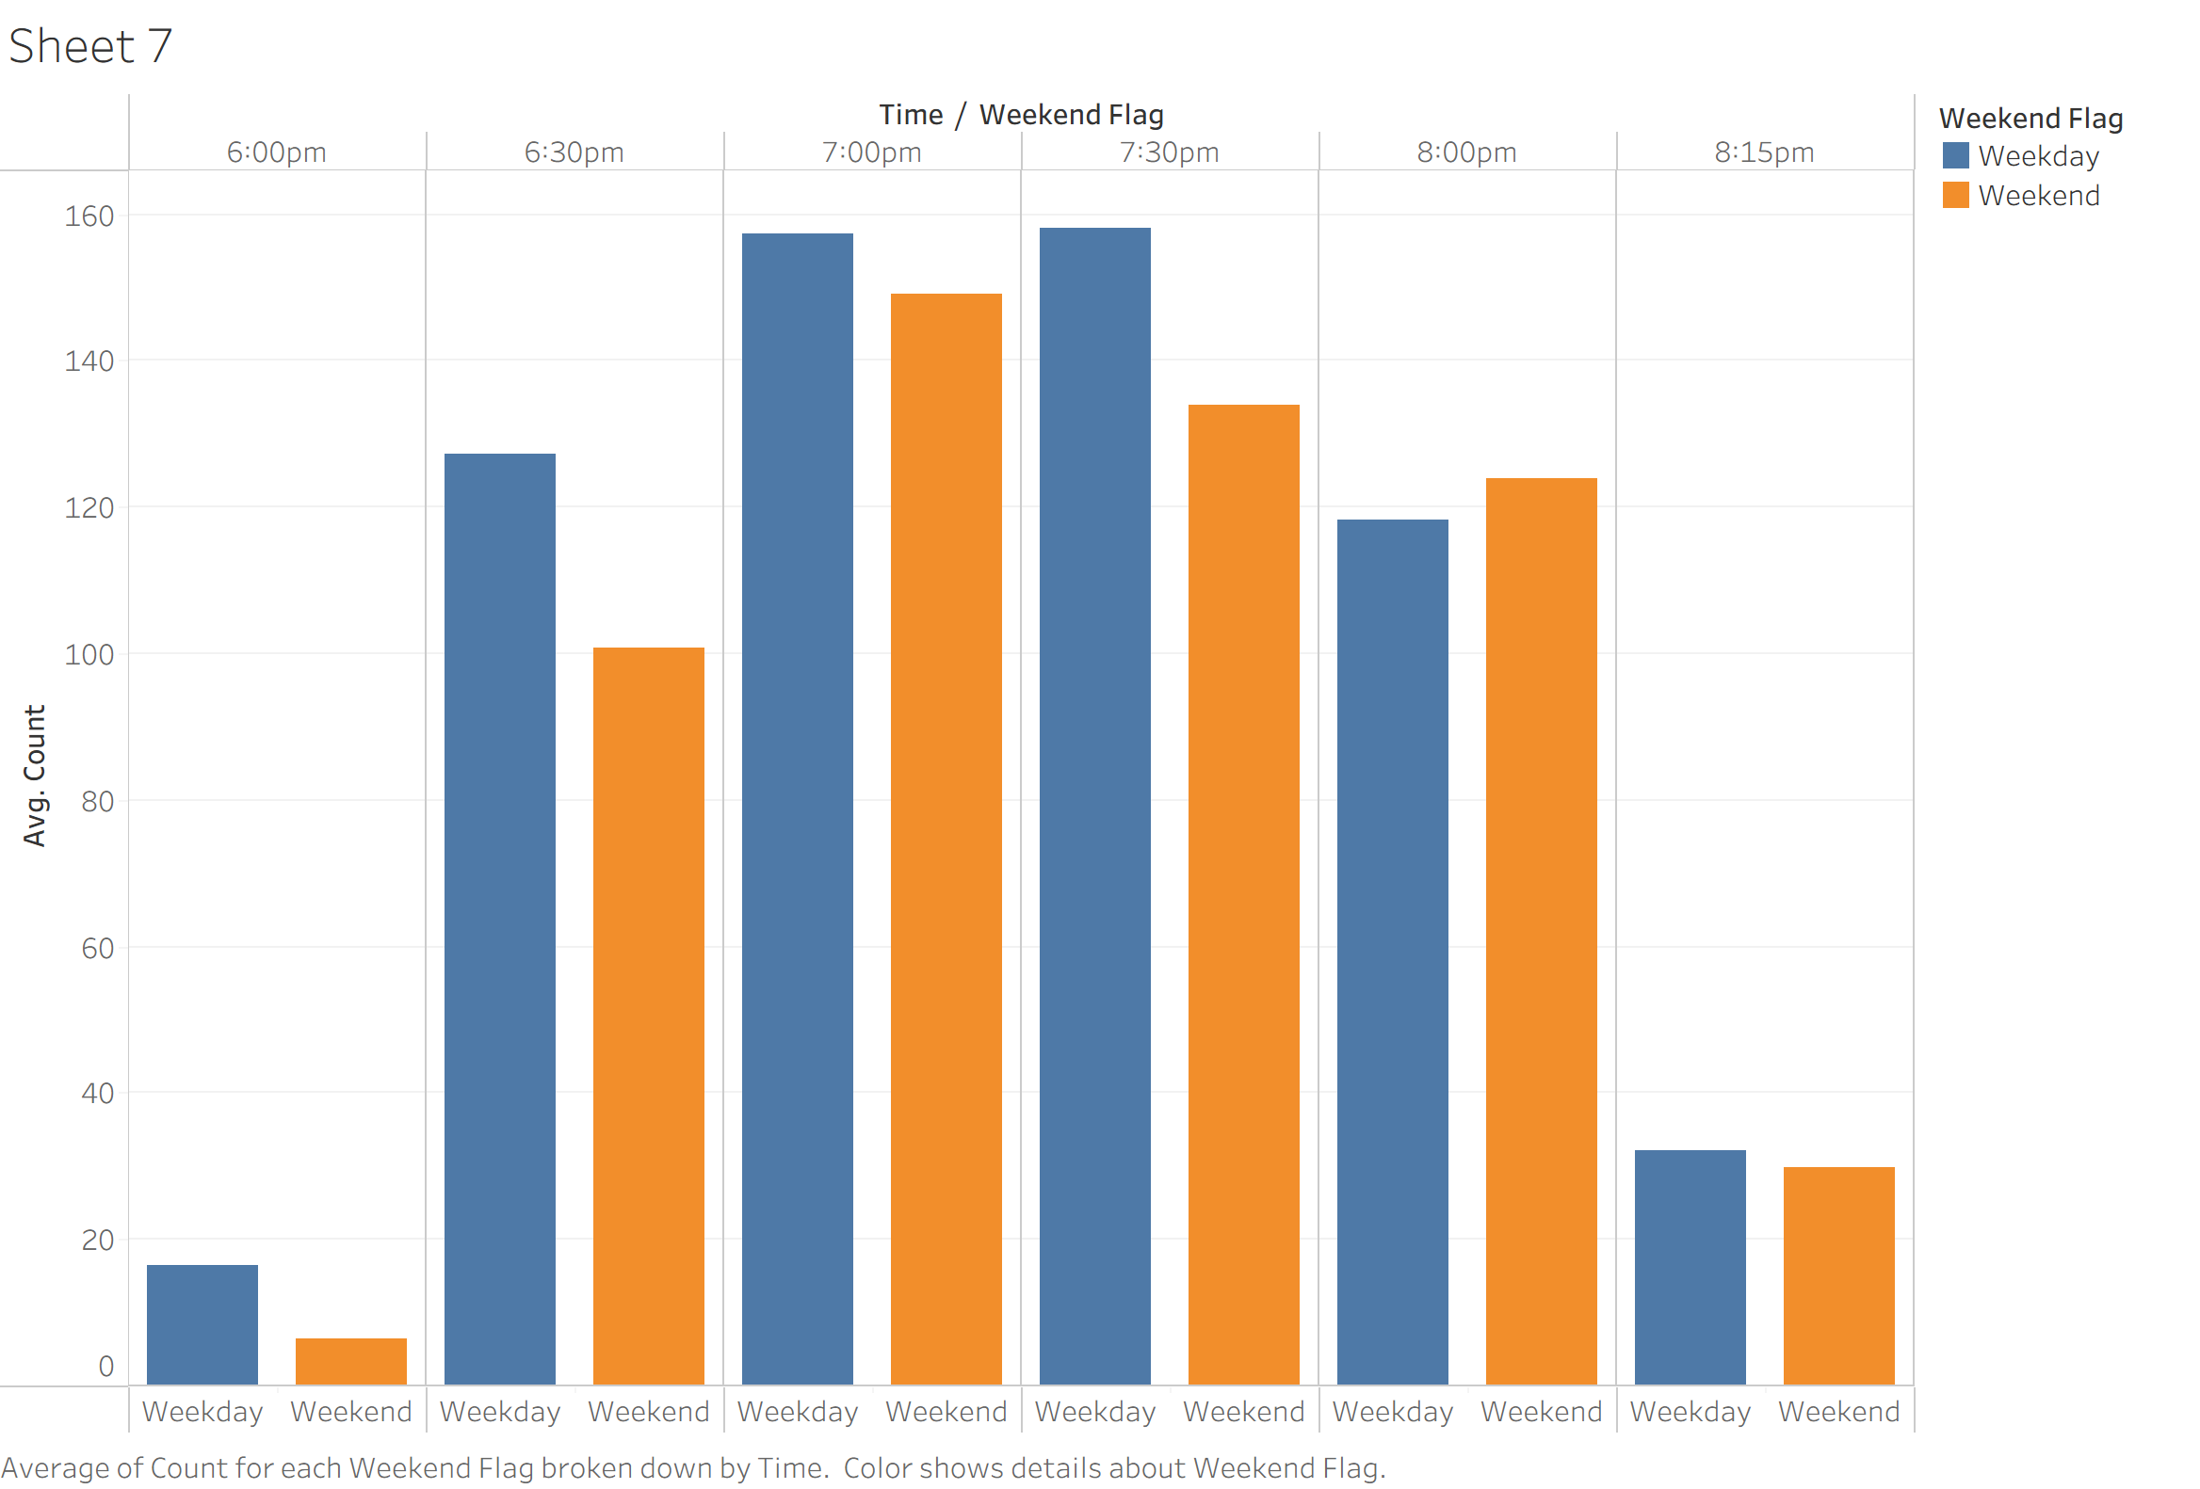
“Explain whether weekend Halloweens consistently attract more trick-or-treaters. What might cause exceptions?”
AI Interpretation
“Based on this specific visualization, weekend Halloweens do not consistently attract more trick-or-treaters at specific peak times.
The chart clearly shows that weekdays have a higher average count of visitors during the busiest periods: 6:30 PM, 7:00 PM, and 7:30 PM. Weekends only show a slight lead at 8:00 PM and have a significantly slower start at 6:00 PM. This suggests that weekday trick-or-treating is more compressed into a short, intense rush after work and school.
Several factors could cause exceptions or explain this pattern:
- Weather: This is the most powerful exception. A rainy, cold weekend will always have a lower turnout than a clear, mild weekday, disrupting the average.
- External Events: As mentioned in the assignment prompt, major disruptions like the COVID-19 pandemic in 2020 would completely override any normal weekday/weekend trend.
- Pacing vs. Total Count: This chart shows the average flow at specific time slots, not the total number of visitors for the whole night. It's possible that while weekends have a higher total count (as your previous chart suggested), that activity is more spread out, with people starting earlier or finishing later. Weekdays, by contrast, force everyone into the same 6:30 PM - 7:30 PM window, leading to a higher peak average.”
My Interpretation:
The data suggests that weekday trick-or-treating is more compressed, while weekend activity is more spread out. On weekdays, there's a clear rush between 6:30 PM and 7:30 PM, likely because families are trying to fit the activity in after work and school. On weekends, the start is much slower (6:00 PM is almost empty), and the activity extends later into the evening (like the 8:00 PM peak), suggesting families aren't as rushed.
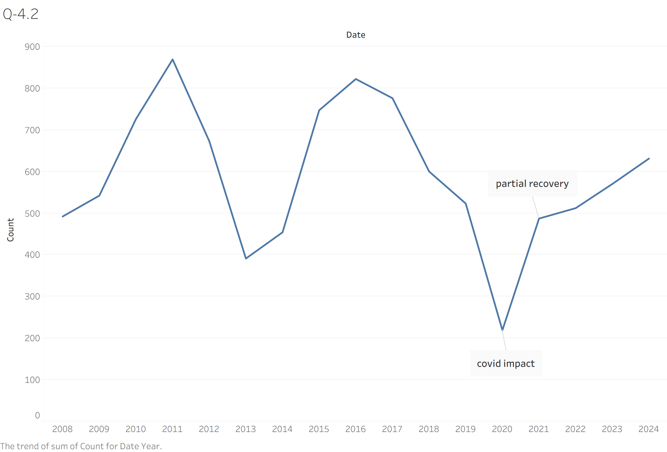
“Include 2020 as a reference year. If Halloween occurred on a weekend that year, did turnout still follow the weekend pattern, or was it disrupted by COVID?”
AI Interpretation
“As the visualization clearly illustrates, the 2020 turnout was severely disrupted by the COVID-19 pandemic.
According to the data, 2020 had the lowest turnout on record by a significant margin, with only 219 trick-or-treaters. While 2020's Halloween occurred on a Saturday (a weekend), it did not follow the typical weekend pattern of attracting a larger crowd. Instead, the global pandemic acted as a massive external factor, overriding the "weekend effect" and leading to the most severe drop in participation seen in the dataset.
The chart also shows that the recovery was not immediate; 2021 saw only a "partial recovery," with numbers (487) still well below pre-pandemic levels from 2015-2019, before returning to a more normal range in 2022.”
My Interpretation:
The chart clearly shows that the COVID-19 pandemic's impact in 2020 was severe, causing participation to plummet to 219, its lowest point in the entire 2015-2024 period. The recovery was clearly gradual, not immediately; 2021 saw only a partial rebound, failing to even reach 2019's pre-pandemic levels. It took two years, until 2022, for the visitor count to finally surpass the 2019 baseline and re-establish a normal upward trend.
