HR ANALYTICS: VISUALIZING EMPLOYEE ATTRITION DRIVERS

Presented By:
Sibangi Subhadarsani
Date: 12/06/2025

Introduction & Background
Motivation: Employee attrition is a significant and costly challenge for organizations worldwide. The loss of an employee results in direct costs related to recruitment and training for a replacement, as well as indirect costs from lost productivity and institutional knowledge. The motivation for this project is to use the power of data visualization to transform raw HR data into actionable insights that helps managers and HR personnel proactively address the factors leading to attrition and improve employee retention.
Context: This project will analyze a fictional HR dataset to identify the key factors and trends associated with employee turnover. By creating a series of targeted visualizations in Tableau, this analysis will explore the relationships between employee demographics, job roles, satisfaction levels, and the decision to leave the company.
Evolution of the Project: Since the initial proposal and Assignment 2, our project has evolved from a broad exploratory analysis into a targeted, narrative-driven investigation. Initially, our focus was simply visualizing the data columns. However, through iterative feedback loops with the Tableau Community (specifically Jim Dehner) and GenAI critiques, we shifted our focus to storytelling. We moved away from complex, "flashy" charts (like network graphs) toward clearer, more actionable visualizations that directly answer business questions.
Why This Topic Matters: Employee attrition remains a critical financial and operational risk. Replacing an employee costs significantly more than retaining one, involving recruitment fees, training costs, and lost productivity. This project moves beyond merely reporting who is leaving to diagnosing why and when, empowering HR stakeholders to intervene proactively with data-backed strategies regarding compensation, commute flexibility, and career progression.
Objectives & Refined Questions
Our analysis is structured around four thematic pillars, refined through feedback to ensure analytical depth rather than surface-level description.
Page 1: The Big Picture (Overview)
Initial Question: How many people left?
Refined Question: What are the top-level drivers of attrition, and how does our rate compare to the industry average?
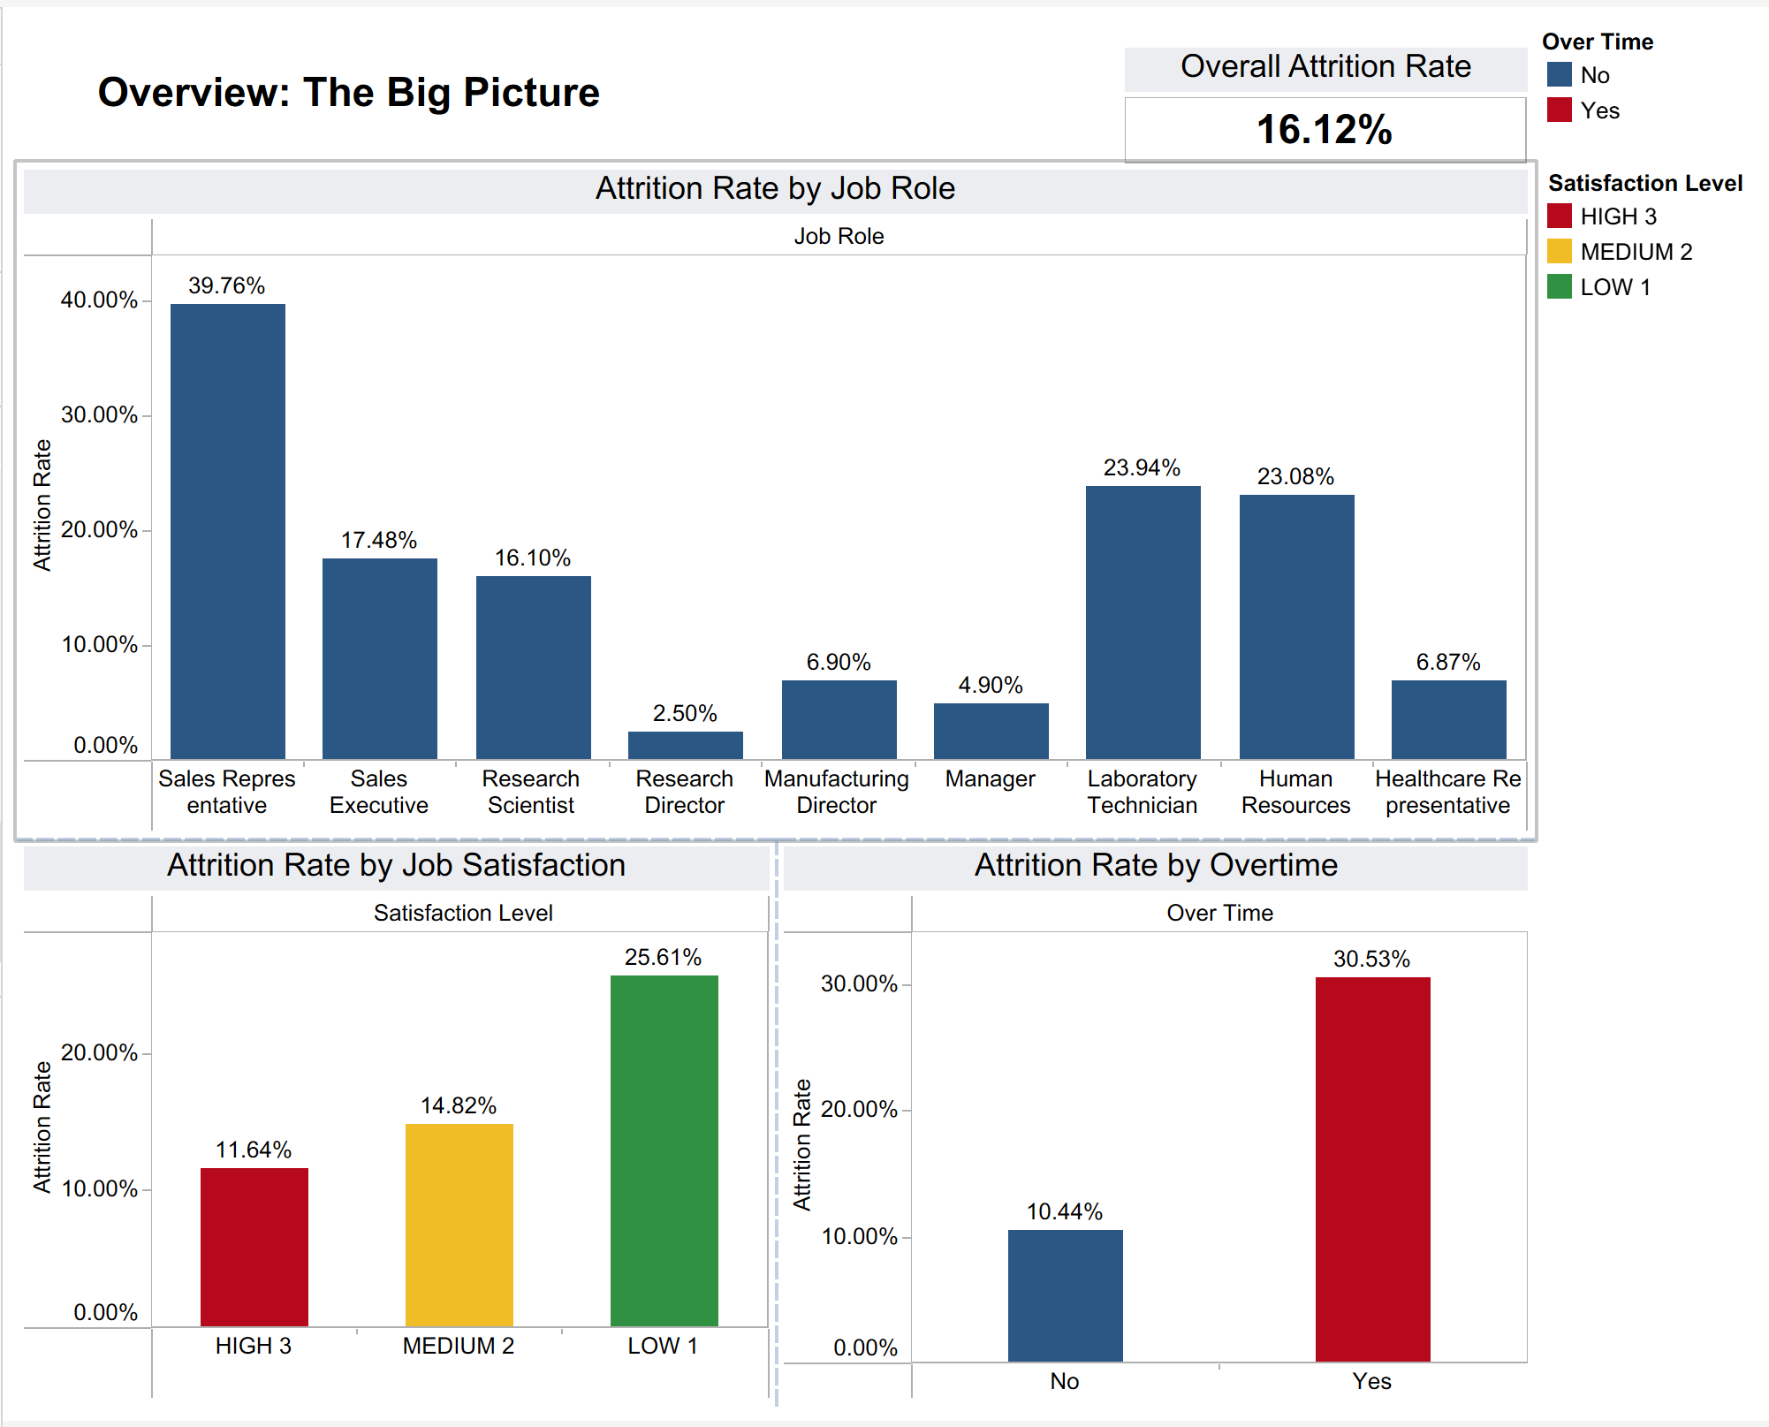
Fig. 1: Overview (The Big Picture)
Overview of the Attrition Problem
The first part of the analysis established what the main causes of employee turnover were and provided an explanation for the attrition problem faced by the organization. The analysis started with the basic question of how many people had left the organization by presenting the overall attrition rate through a KPI banner. It gives a view of the situation and therefore lays the foundation for further research. Following the examination of the overall turnover rate, questions moved from how many people had left to the high-level causes of employee turnover and how those compare to normative expectations from similar organizations to discover the main patterns behind turnover trends.
Question Q1: What's the company's overall attrition rate?
Fig. 2

Question Q7: Hypothesis: Employees who work Overtime are significantly more likely to leave.
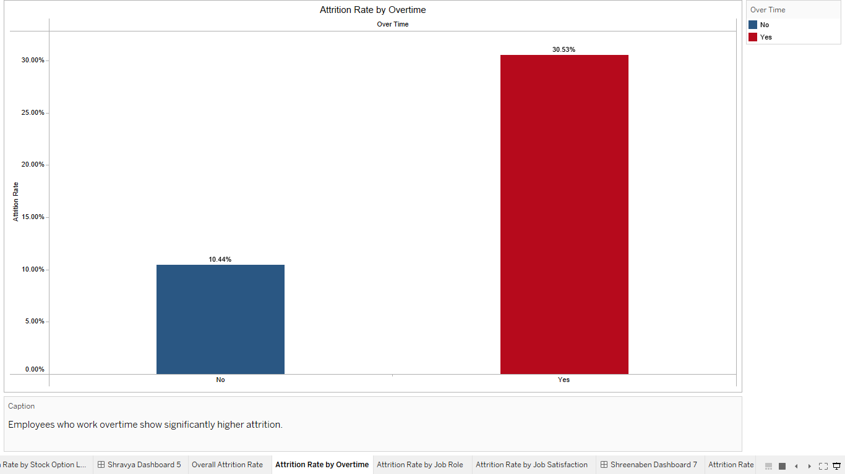
Fig. 3
I focused on three major early warning signs of attrition: overtime, job role, and work satisfaction. The first visualization, Attrition Rate by Overtime, depicted a surprising trend - the employees who regularly work overtime have a much higher attrition rate than those not working overtime. That could mean that the pressure of workload, burnout, or unrealistic expectations about the job will make them quit. Conveying this information upfront allows the stakeholders to recognize that there is a systemic problem in work-life balance that might hurt employee retention.
Question Q6: Which Job Roles have the highest and lowest attrition rates?
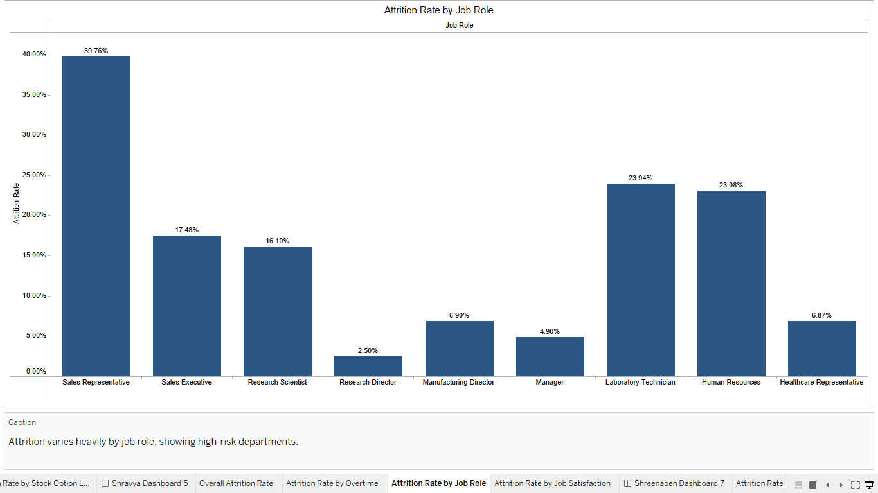
Fig. 4
The graph “Attrition Rate by Job Role” shows the variation in attrition rates across job roles. Sales representative and technical or laboratory job roles have an exceptionally higher attrition rate compared to other job roles. Such a variation may indicate that certain jobs are associated with high levels of stress, job dissatisfaction, uncertainty over career prospects, or an unhealthy working environment. This will portray these areas as having the highest labour volatility, without even considering them in relation to demographic and financial perspectives.

Question Q14: What is the impact of Job Satisfaction on attrition?
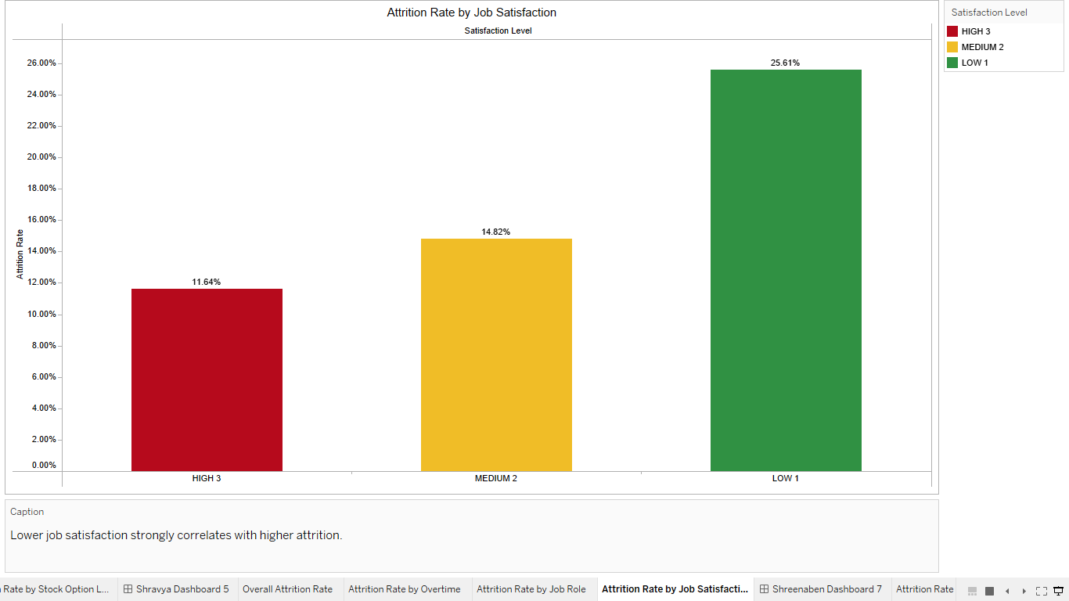
Fig. 5
Based on available data, job satisfaction was revealed to be one of the most critical factors affecting employee turnover, being considered as one of the most significant predictors. Data shows that dissatisfied employees leave their jobs more than twice as fast compared to those that are satisfied. This realization shifts the discourse from superficial analysis based on demographics to more profound and experience-based elements of the narrative. It affirms the importance of emotional and psychological links that individuals establish with work and puts forward the significance of seeking to create a meaningful job experience.
Page 2: The Attrition Profile (Who is leaving?)
Initial Question: Who is quitting?
Refined Question: How do demographic factors (Age, Marital Status) and Job Roles interact to create high-risk profiles?
Primary Business Objective
The primary objective of this analysis is to identify specific, high-risk employee cohorts to inform targeted retention strategies. Rather than viewing attrition as a uniform organizational problem, this report diagnoses distinct "risk profiles" by isolating the intersectionality between demographic factors (Age, Gender, Marital Status) and professional variables (Job Level, Department, Commute).
Evolution of Analysis & Feedback Integration
The first look at why people were leaving the company gave us a general idea, but I need better, cleaner information and clearer charts. I made the following changes, based on what the people who need this information told us, so the analysis can help them make good choices:
- Metric Accuracy: Old charts accidentally added up the Employee ID numbers on one side. We fixed this by counting the unique employees instead of adding their IDs. This now shows the correct number of people working and how many people left.
- Visual Clarity: Misleading stacked bar charts were converted to side-by-side comparisons to allow for a direct, accurate evaluation of gender disparities within departments.
- Benchmarking: Reference lines were adjusted to reflect true external industry standards (12%–18%) using constant values, rather than dynamic averages of the internal data, to prevent false positives in performance benchmarking.
Refined Analysis Questions & Supporting Visualizations
Following these data corrections, my analytical focus shifted from broad trends to intersectionality. The analysis answers three refined questions:
Question 3: Intersectionality of Gender & Department
- Analysis: Is attrition experienced uniformly across genders, or do specific departments harbour hidden disparities? We specifically investigated the anomaly within Human Resources, where preliminary data suggested a significant divergence between Male and Female attrition rates.
- Key Finding: Female attrition in HR (30%) is more than double that of Males in HR (13.95%).
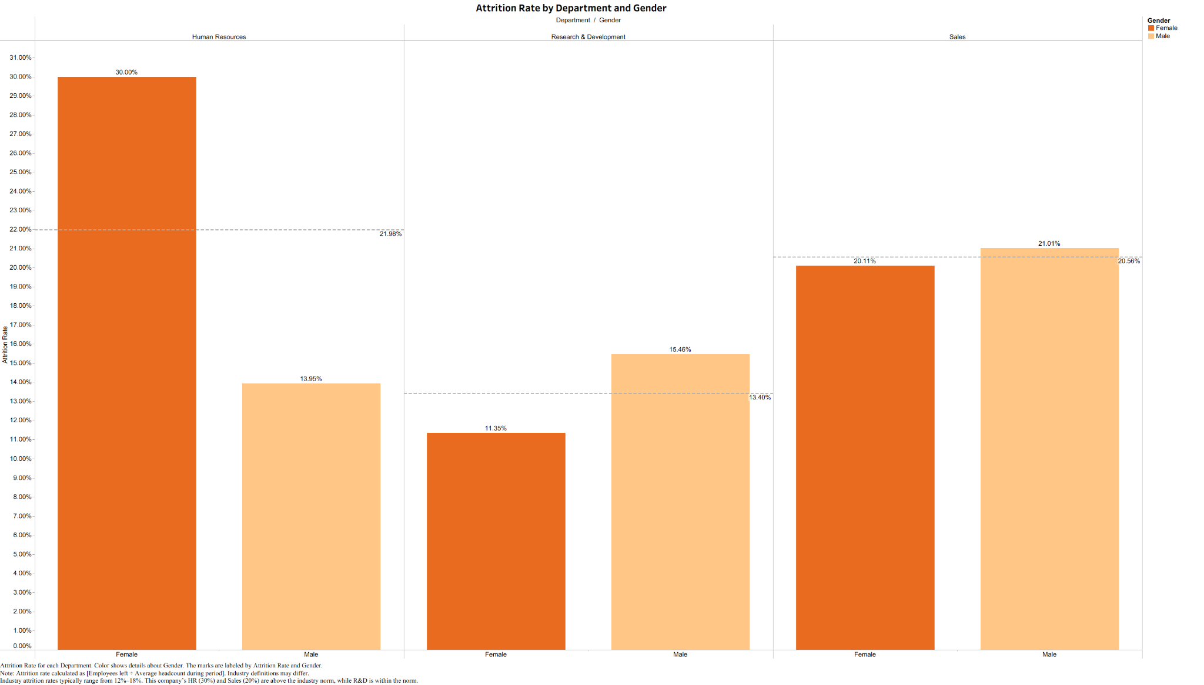
Fig. 6
- Analysis: How do personal demographic factors (specifically Age and Marital Status) compound the risk for employees in entry-level positions? We sought to determine if the "Job Level 1" attrition crisis is driven by a specific demographic profile.
- Key Finding: The highest risk profile is the "Entry-Level Crisis" (Job Level 1), particularly compounded by employees who are Single and under 25 years old.
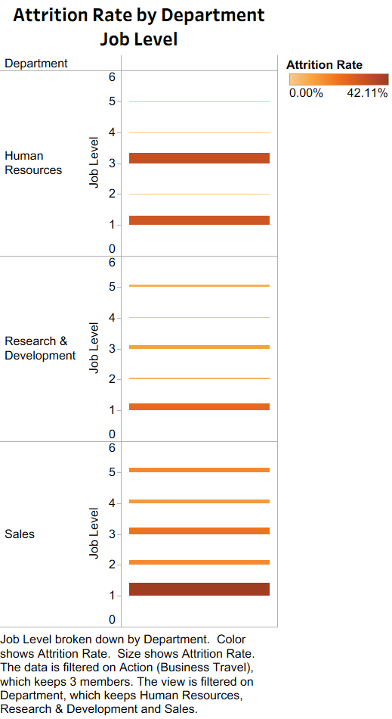
Fig. 7
- Analysis: To what extent do external stressors, specifically commute distance and business travel frequency, correlate with higher turnover rates? We analyzed the data to identify the "tipping point" where travel burden degrades retention.
- Key Finding: "Frequent Travelers" leave at a rate of 24.9%, and attrition rates spike significantly once commute distances enter the "Long" to "Very Long" categories.
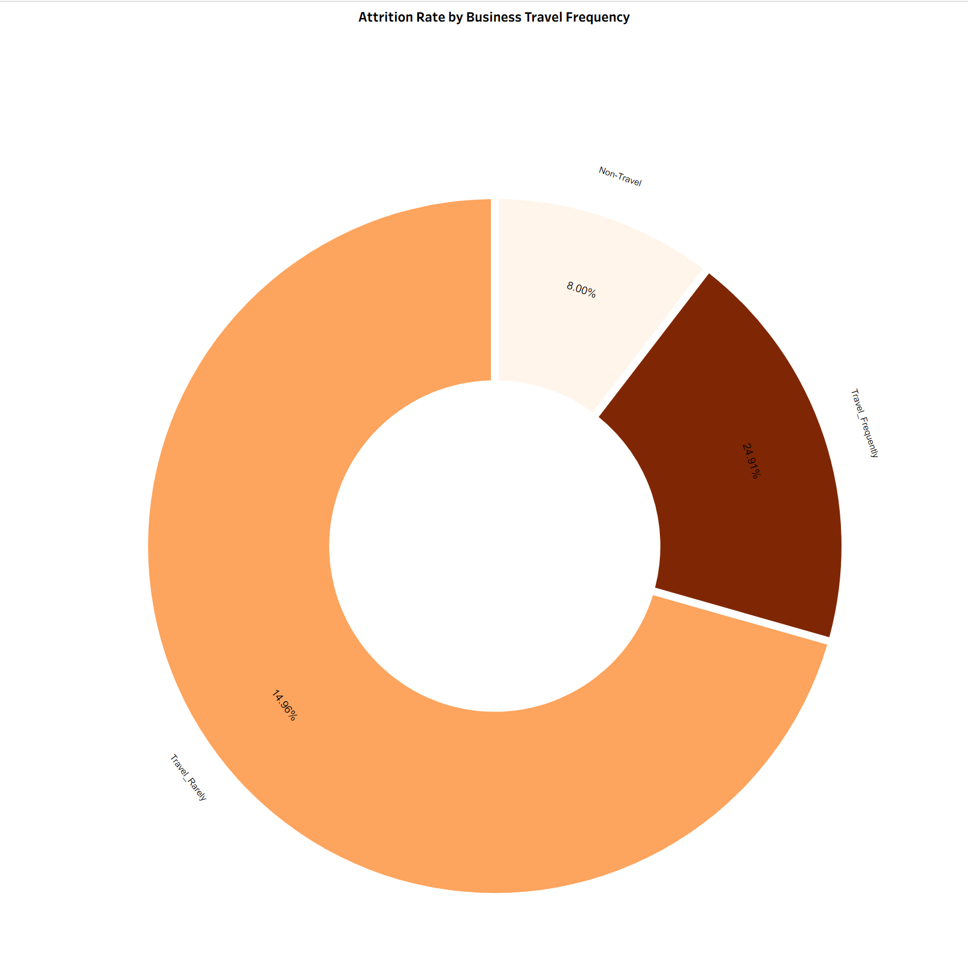
Fig. 8
The donut chart illustrating that Frequent Travelers are 3x more likely to leave than Non-Travelers.
Question 5: How does Distance From Home correlate with the likelihood of attrition?
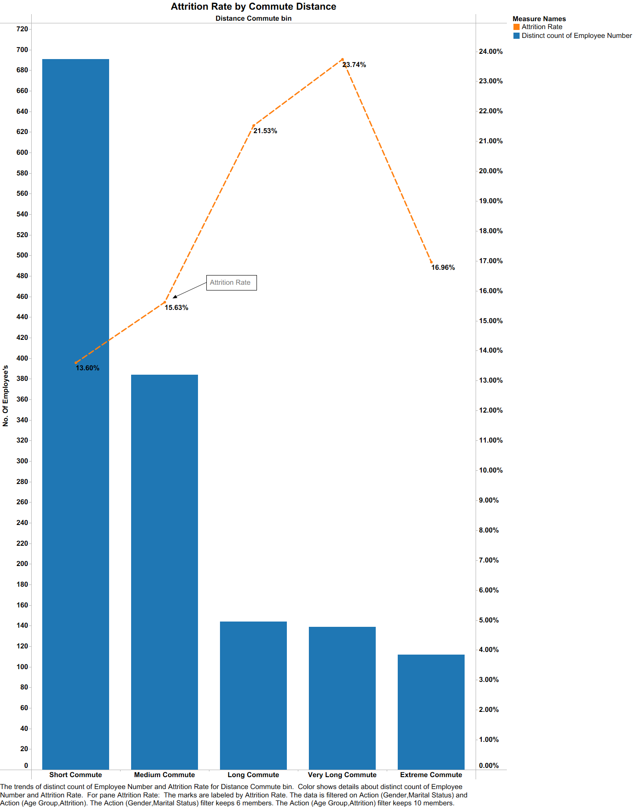
Fig. 9
Attrition Rate vs. Commute Distance, showing a clear correlation between distance and turnover risk.
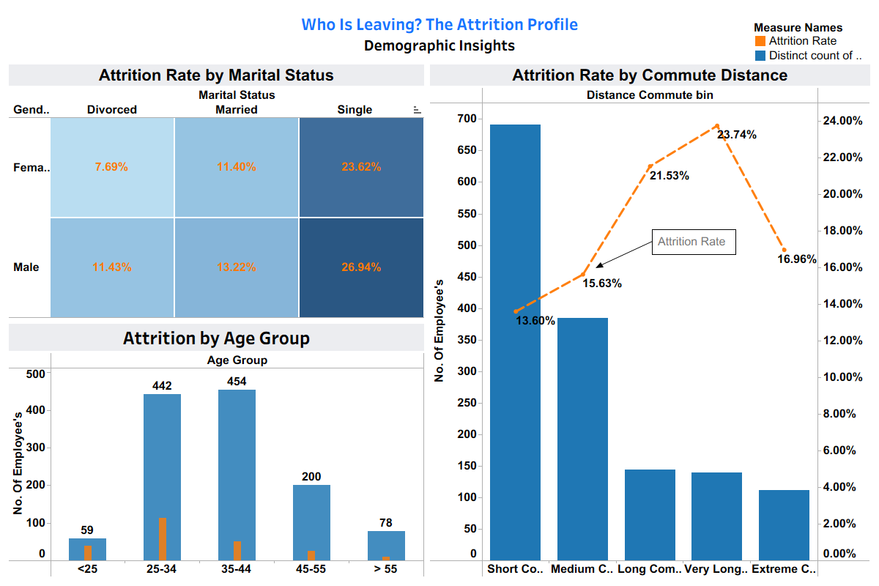 Fig. 10
Demographic Dashboard highlighting the 'Under 25' and 'Single' employee segments as the highest risk categories.
Evolution based on Feedback:
We initially displayed this using a Stacked Bar Chart with a reference band labeled "Industry Average." Feedback highlighted two critical flaws:
- Misleading Visualization: Stacked bars made it difficult to compare the "Male" vs. "Female" values directly. We shifted to a Side-by-Side comparison to decouple the groups.
- Incorrect Benchmarking: The reference line we used was actually an average of our own three departments, not a true "Industry Average," which was misleading. We removed this confusing metric to focus on comparing internal departments against each other.
- Aggregation Error: Feedback noted we were using SUM([Employee Number]) as an axis in early drafts. We corrected this to COUNTD([Employee Number]) to ensure we were counting actual people, not summing their ID codes.
Final dashboards after the analysis and feedback:

Fig. 11
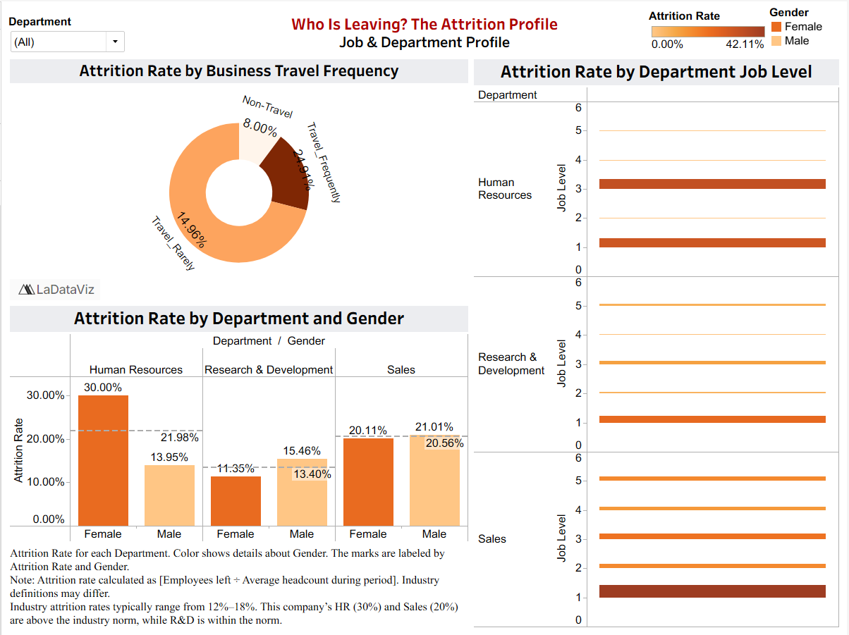
Fig. 12
Page 3 (Theme 3): Root Cause Analysis (Why are they leaving?)
Initial Question: Is salary important?

Refined Question: How do Monthly Income distributions, Stock Option tiers, and Salary hikes differ between retained and attrited employees?
Primary Business Objective
The primary business objective of this analysis is to identify whether compensation affects employees’ choice to leave the company, and which compensation factors matter the most – monthly income, salary hikes, stock option levels. Understanding these factors allows the company to recognize attrition patterns and develop retention strategies for them.
Evolution of Analysis & Feedback Integration
Visual Clarity: I received feedback on issues with colors blending, label visibility and unclear distinctions. I revised the labels to illustrate cleaner colors, rotated labels and added outlines to my histogram, making them easier to interpret at a first glance.
Analytical Accuracy: I added average attrition lines as reference for Visual 3 and Visual 4, based on feedback received. This helps the viewer have a reference point to compare attrition rates to, making for clearer comparisons.
Enhanced Cohesion: I adopted a singular color palette, which helped tie the different charts together and gave a more professional, clean look.
Refined Analysis Questions & Supporting Visualizations
Question 11: How does Monthly Income for employees who leave compare to those who stay?
- Analysis: The chart compares incomes between retained and retired employees and highlights the differences in median pay, spread, and overall compensation.
- Key finding: Compensation was found to be a contributing factor in attrition, with employees who leave more concentrated in lower income bands. Employees who stay have a higher median income and wider income range.

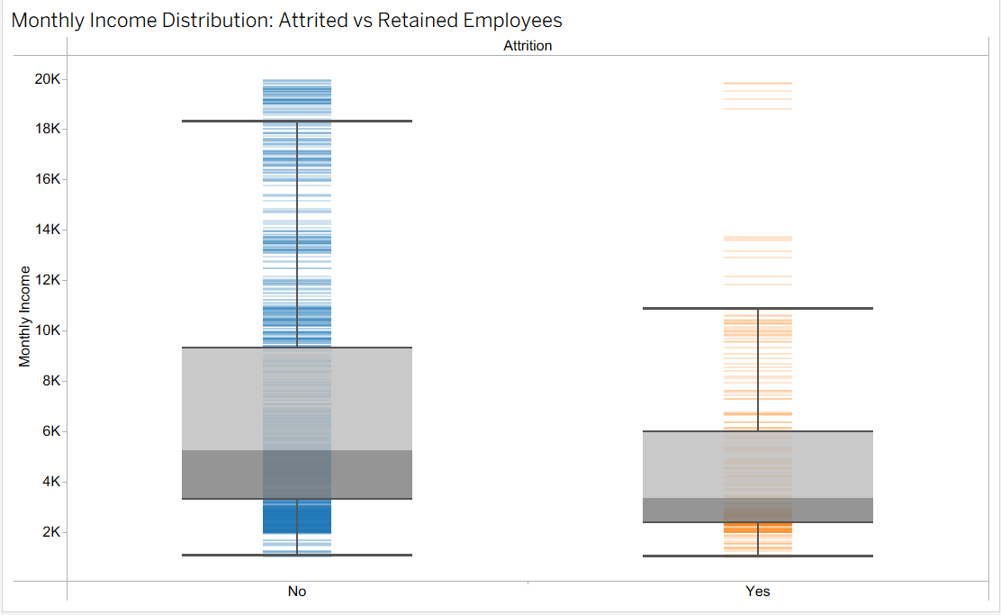
Fig. 13
Question 12: Does a lower Percent Salary Hike correspond to a higher probability of attrition?
- Analysis: The chart shows that attrition is high at low salary hikes, with a 10% hike having a 19.5% turnover rate, which is above the average. The trend dips at mid-range hikes and rises again at high-level hikes.
- Key finding: Small hike raises make employees more likely to leave. However, a 22% salary hike has the highest attrition rate, suggesting large raises are reactive measures to retain employees already at the risk of leaving.
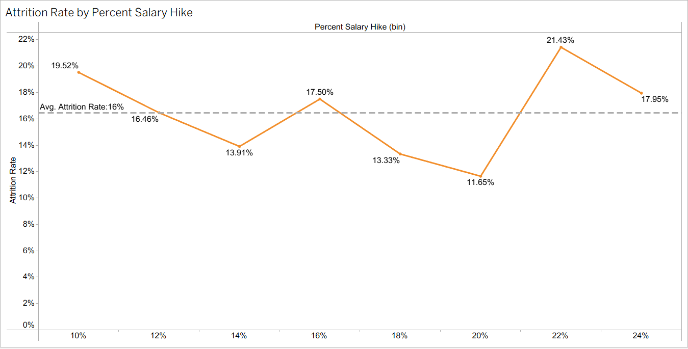
Fig. 14
Question 13: Does a higher Stock Option Level correlate with lower attrition?
- Analysis: The chart shows that attrition is highest at 24% for employees with no stock options. It then drops for Levels 1 and 2, and rises again for Level 3 at around 18%.
- Key finding: Higher stock option levels generally correlate with lower attrition, but the increase at Level 3 shows that stock options alone cannot retain employees with higher risk of attrition.
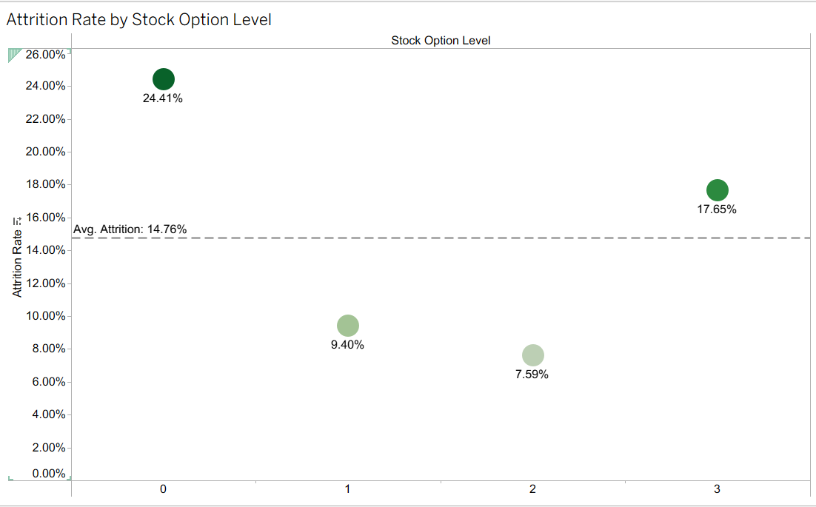
Fig. 15

Final dashboard after the analysis and feedback:
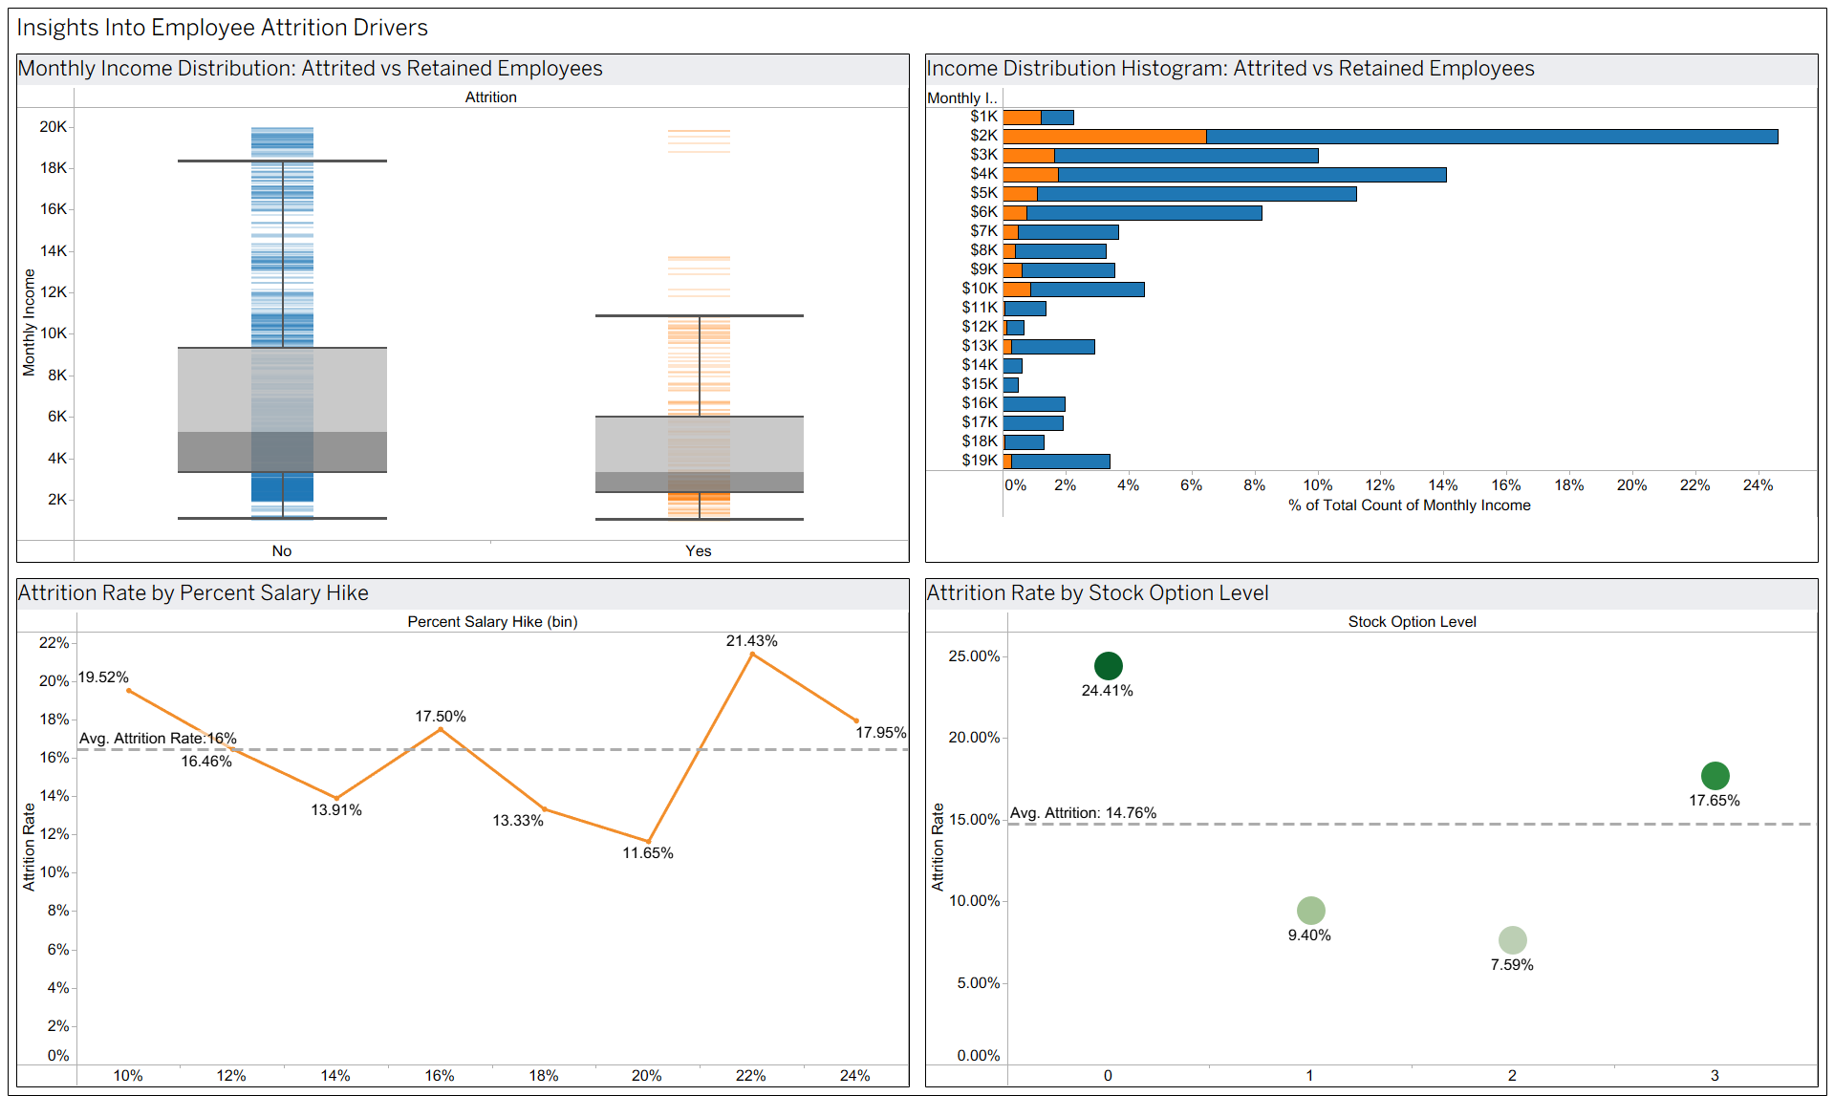
Fig. 16
Page 3 (Theme 4): The Employee Journey (When do they leave?)
Initial Question: When do employees decide to quit?
Refined Question: How do Work-Life Balance, Overall Satisfaction levels, and Performance Ratings differ between retained and attired employees, and what do these differences reflect when disengagement begins?
Primary Business Objective
The primary objective of this analysis is to identify the engagement that exceeds employee turnover. It evaluates Work–Life Balance, Overall Satisfaction, and Performance Rating to understand when disengagement occurs among employees. Comparing retained and attrited employees highlights where employees begin to disconnect from their roles, enabling HR to intervene and prevent voluntary exit.
Evolution of Analysis & Feedback Integration
Chart Purpose: The feedback pointed out that the original Performance Rating chart looked incorrect because Ratings 3 and 4 showed almost identical attrition rates. These were then confirmed to be the only ratings in the dataset, and the visual was rebuilt to clearly show that the performance rating does not meaningfully impact attrition and hence is not an important factor
Visual Simplification: The Overall satisfaction level chart used a vertical bar layout with a misleading reference line, which was the wrong average due to equal weighting. This was later changed into a horizontal bar with employee counts.
Risk Highlighting: To make the satisfaction insights more actionable, I added a “High Risk” field to flag satisfaction categories with elevated attrition, allowing to reflect risk.
Refined Analysis Questions & Supporting Visualizations
Question 16: How do Satisfaction Ratings differ between employees who stay and those who leave?
- Analysis: Do different satisfaction ratings show which employees are at higher risk of leaving? This chart compares each satisfaction level and makes it clear that attrition is highest at the lowest satisfaction scores. It helps us see exactly where disengagement begins, so leaders know which groups need support the most.
- Key finding: Attrited employees score lower than retained employees for all four satisfaction metrics. In every parameter, the orange bar (“Yes”) remains below the blue bar (“No”), where both groups fall below the healthy satisfaction threshold of 3.0. The gap is evident for Job Satisfaction and Environment Satisfaction, where attrited employees drop into the mid-2.4 range, indicating that dissatisfaction shows early in an employee's career journey and is a strong indicator for the future.
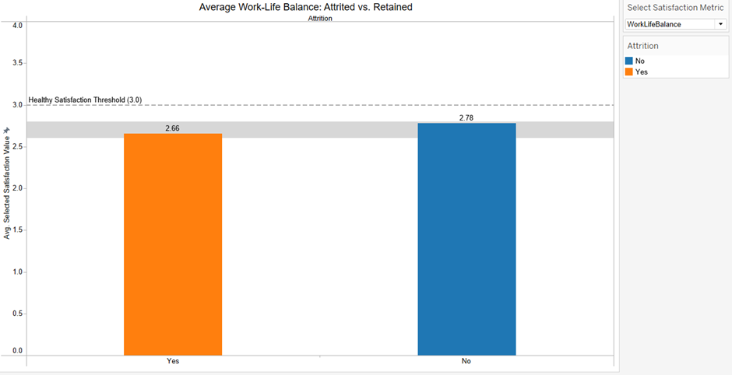
Fig. 17
Question 17: Is a low combined satisfaction score a strong indicator of potential attrition?
- Analysis: Does overall satisfaction predict which employees are at higher risk of leaving? This chart compares satisfaction levels and shows where attrition is at the lowest satisfaction levels, which helps leaders identify morale issues and create employee satisfaction programs before they decide to leave.
- Key finding: Employees in the lowest satisfaction tiers show the highest attrition risk, with Level 1 exceeding 50% turnover. Attrition drops as satisfaction levels are high, showing that overall satisfaction is a strong predictor of whether an employee will leave.
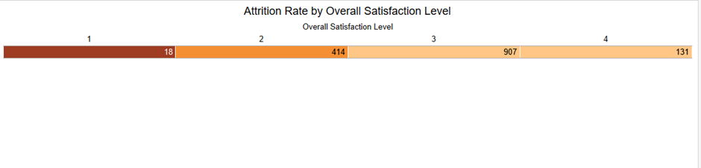Fig. 18
Question 18: Is there a connection between an employee's Performance Rating and their decision to leave?
- Analysis: High performers leaving the organization is expensive and damaging, and exploring if performance rating influences attrition helps determine top performers are disengaged, or at risk, and require strategies of recognition, reward, and career development.
- Key finding: High performers with Ratings 3 and 4 leave at almost the same rate (16.37% vs 16.08%). Confirming that performance rating is not a strong predictor of attrition in this dataset.
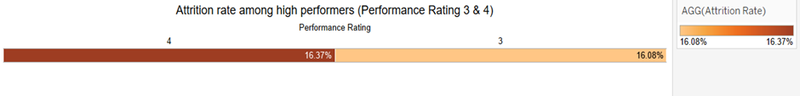Fig. 19

Final dashboard after the analysis and feedback:
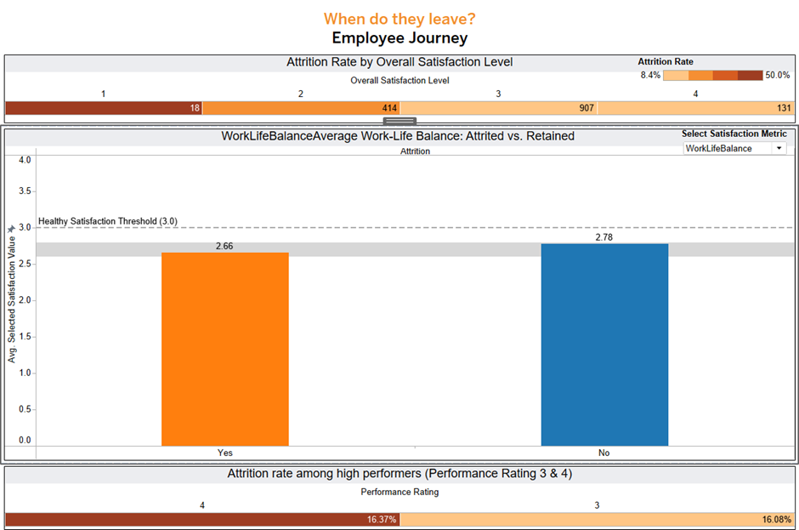 Fig. 20
Page 4: The Employee Journey (When do they leave?)
Attrition Rate by Employee Tenure
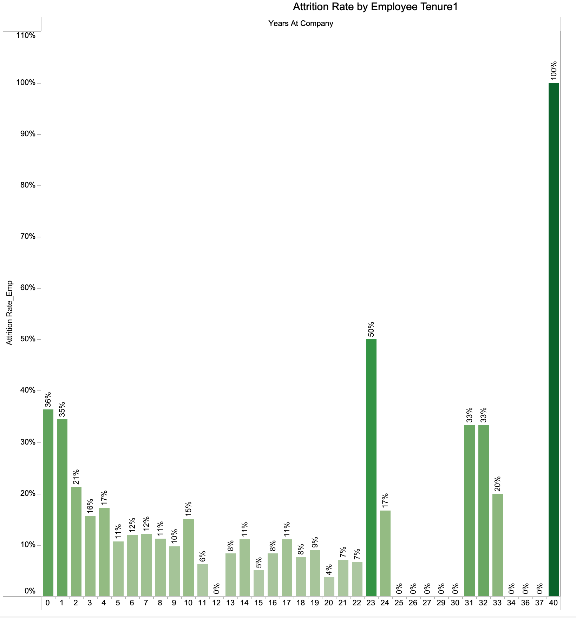
Fig. 21
Question 18: At what point in an employee's tenure (Years at Company) is attrition most likely to occur?
- Analysis: Visual evidence here speaks loudest: employees with shorter tenure are significantly more likely to quit. Those in their first year at the company show the highest likelihood of attrition, far exceeding the rates seen among mid- and long-tenured employees. As tenure increases, attrition rates decline steadily, reflecting a period of adjustment after which employees tend to become more stable and committed.
- Key finding: First-year employees are one to three times more likely to quit than employees with longer tenure. Attrition drops gradually as employees gain experience and integrate into the organization. The trend highlights the need for stronger onboarding, early engagement, and career support during the initial years of employment.

Attrition Rate by Years Since Last Promotion 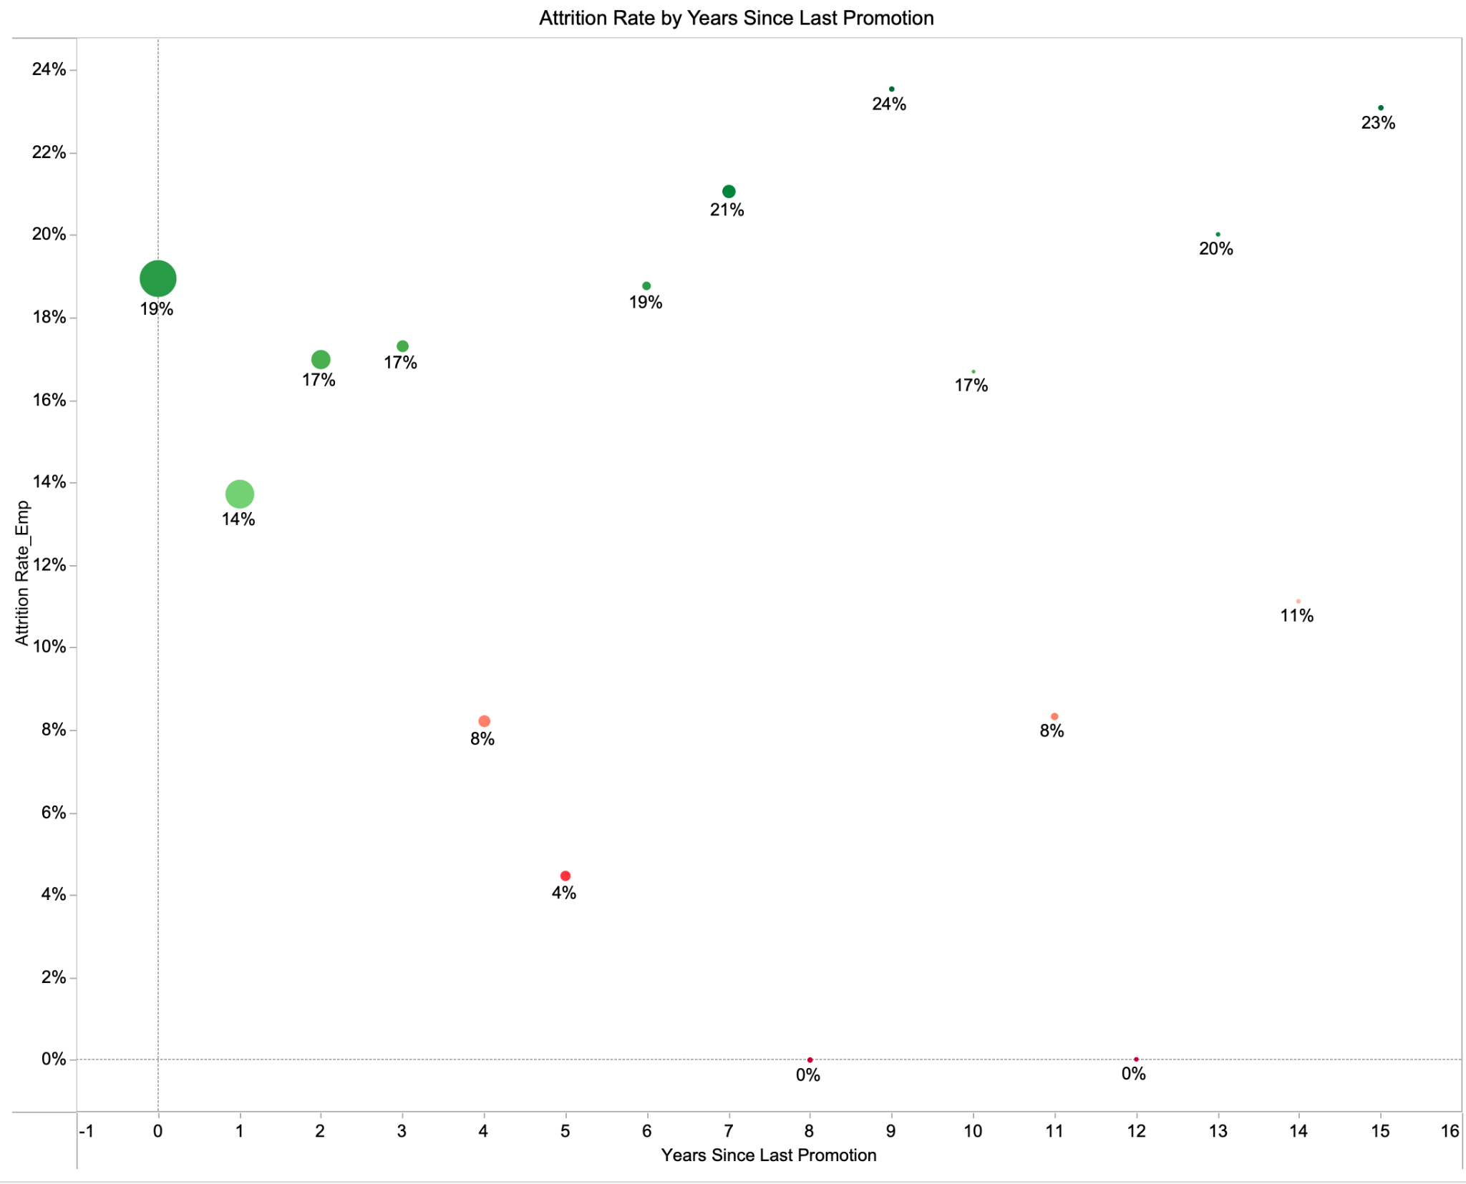
Fig. 22
Question 19: How does the time Years Since Last Promotion affect attrition rates?
- Analysis: The graph shows that employees become increasingly likely to quit the longer they go without a promotion, with attrition peaking between four and seven years since their last advancement. This indicates that career stagnation during this period is a major driver of turnover, while employees who receive timely promotions are less likely to leave.
- Key finding: Employees are most likely to quit 4–7 years after their last promotion, making lack of advancement a key factor in turnover. Fast-track or regular promotions reduce attrition, highlighting the need for clear development plans and transparent progression opportunities.
Attrition Rate by Number of Previous Companies
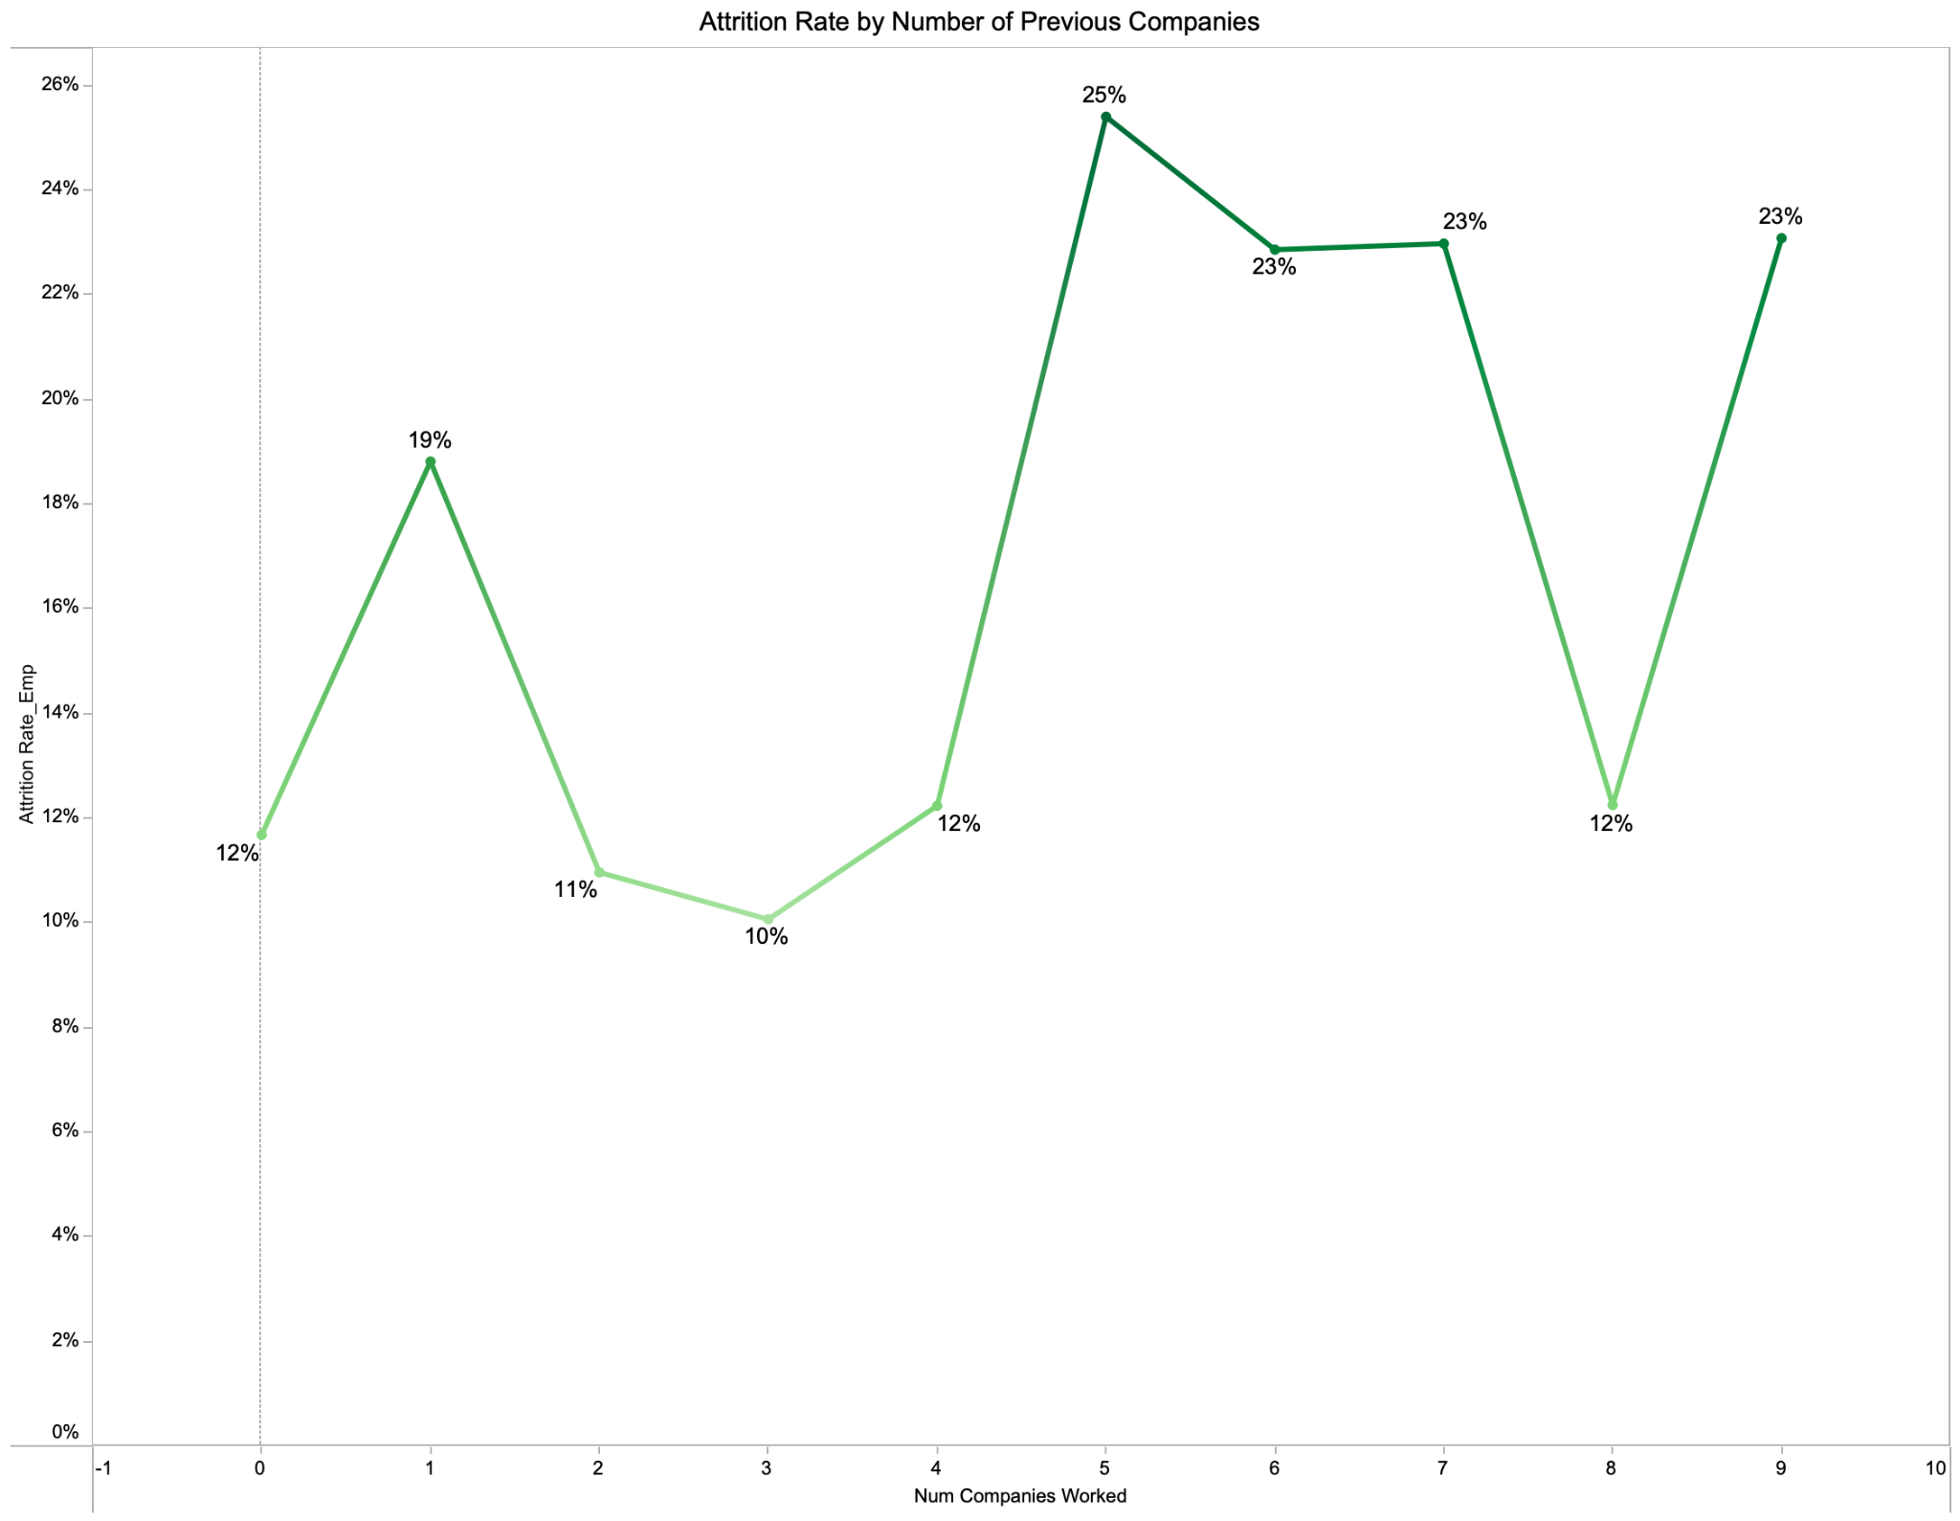
Fig. 23
Question 20: Do employees who have worked at more companies previously… have a higher attrition rate?
- Analysis: The graph examines attrition in relation to employees’ previous work history and shows that those with a higher number of prior employers—particularly five or more—exhibit significantly higher attrition rates. This suggests a clear mobility pattern, where frequent job changers are more prone to leave, while employees with fewer past employers tend to remain more stable.
- Key finding: Employees with five or more previous companies are the most likely to quit, indicating a strong link between extensive job-hopping history and attrition. Understanding these mobility patterns can help HR tailor retention strategies toward employees who are more likely to change jobs.
Final dashboard after the analysis and feedback:
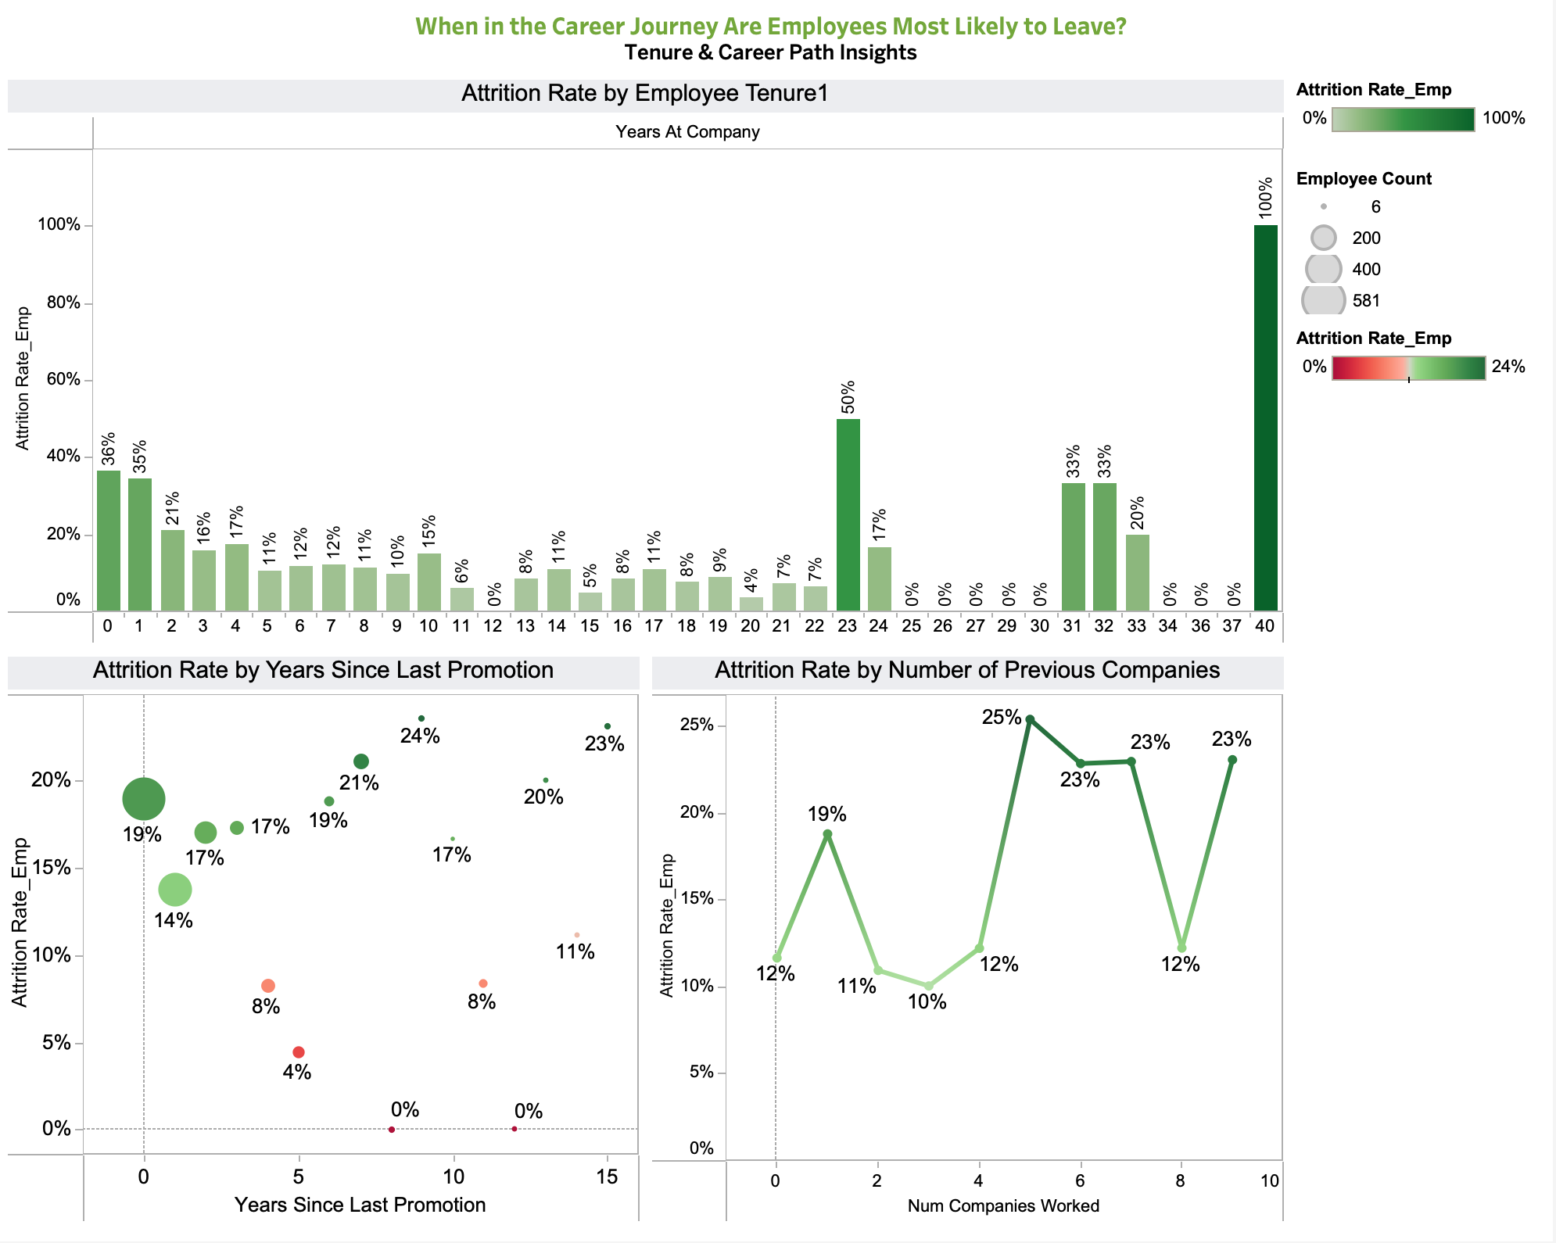
Fig. 24

Data & Preparation
Dataset Provenance: We utilized the IBM HR Analytics Employee Attrition & Performance dataset sourced from Kaggle (Rishikesh Konapure). It contains 1,470 records and 35 distinct variables.
Data Preparation & Value-Added Cleaning: Since Assignment 1, we performed significant data engineering to support our specific visualizations:
- Quantifying Attrition: Created an Attrition Numeric calculated field (Yes=1, No=0) to facilitate rate calculations.
- Binning for Clarity: Created bins for continuous variables to reveal trends that scatter plots missed:
- Age Groups (e.g., 25-34).
- Tenure Bins (0-2 years, 3-5 years).
- Distance Bins (Short, Medium, Long Commute).
- Income Bins (<$3k, $3k-$5k).
- Weighted Averages: Based on feedback regarding misleading reference lines, we created Level of Detail (LOD) expressions to calculate Weighted Average Attrition Rates per department, rather than simple averages of percentages.
- Satisfaction Scoring: Created a combined Overall Satisfaction metric by averaging Job, Environment, and Relationship satisfaction scores.
- Calculated Fields:
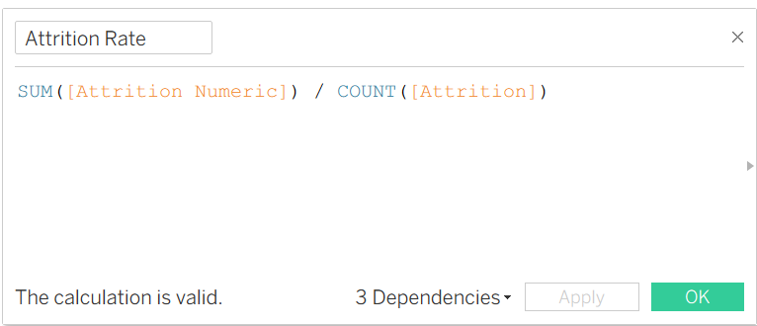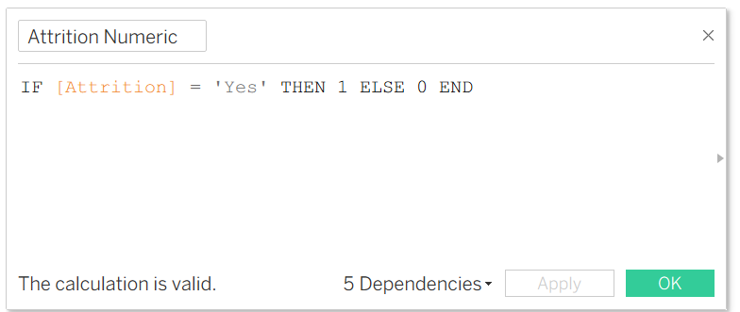
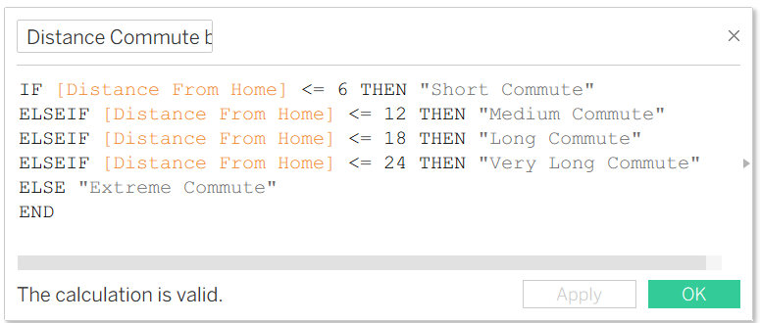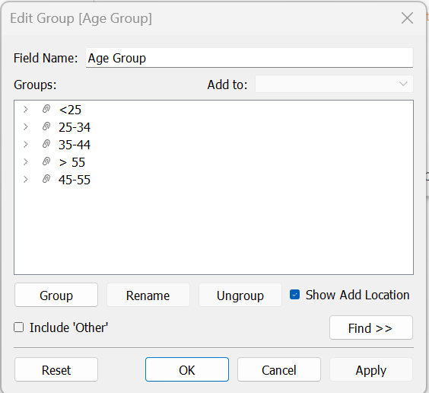
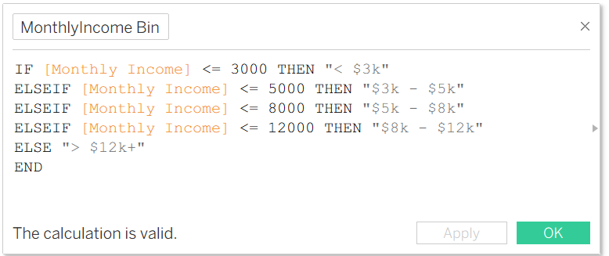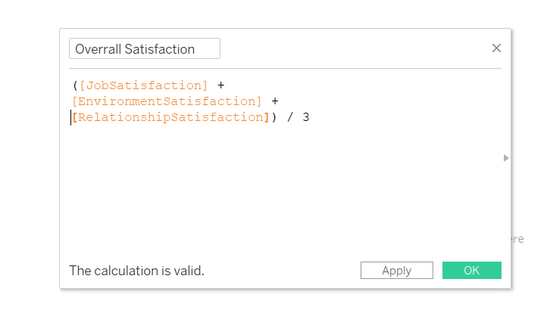
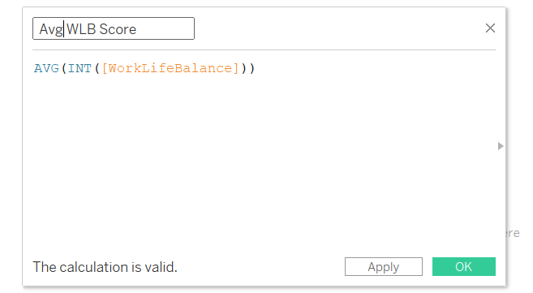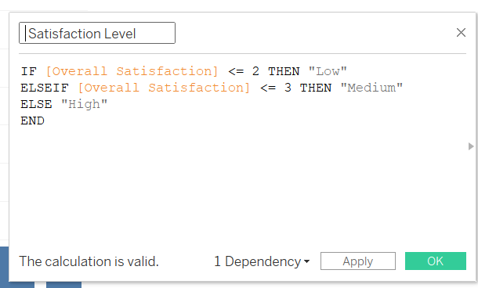
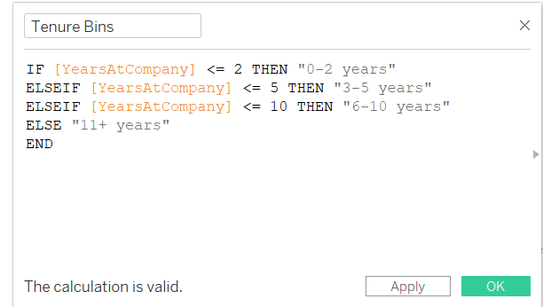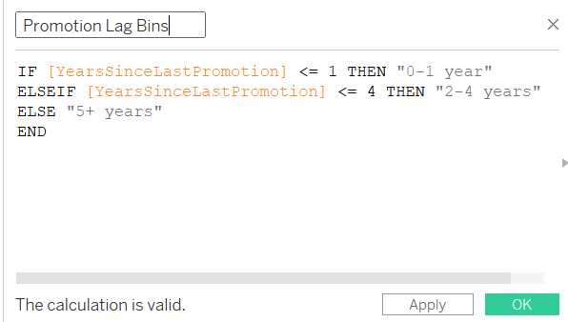
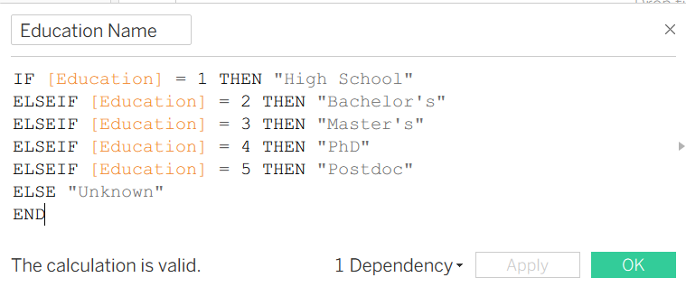
Fig. 25

Visualizations & Design Rationale
Our analysis is presented through a four-page Tableau Story, designed to guide the user from a high-level overview down to specific, actionable root causes. We adhered to a "Martini Glass" narrative structure, beginning with a broad overview (the wide top) and narrowing down to specific driver analysis (the stem).
Page 1: Overview: The Big Picture

A. Logical Arc & Objectives

This dashboard highlighted broad organizational drivers such as overtime, job role, and satisfaction, that applies lens to examine how different groups experience those drivers differently.
- Employees with similar job roles may not have the same risk level.
- Demographic factors such as age or marital status may amplify or reduce risk.
- Department-level culture, workload, and expectations may contribute to unequal attrition patterns.
This connection is important because it allows us to move from general insights (“overtime leads to higher attrition”) to specific, actionable risk profiles (“young, single employees working in Sales and traveling frequently are most likely to leave”).

B. Key Visuals & Feedback-Driven Iteration

Key Visual 1: Attrition Rate by Overtime (Bar Chart)
- Source Question: Are employees who work Overtime significantly more likely to leave?
- Insight: Overtime is a primary systemic driver. Employees who work overtime have a drastically higher attrition rate, pointing directly to burnout, unsustainable workloads, or poor work-life balance as a root cause.
- Design Principle (Direct Comparison): A simple, clean bar chart places the "Yes" and "No" categories side-by-side. The dramatic difference in bar height makes the severe risk associated with overtime immediately and unambiguously clear, requiring no complex interpretation.

Key Visual 2: Attrition Rate by Job Role (Sorted Bar Chart)
- Source Question: Which Job Roles have the highest and lowest attrition rates?
- Insight: Attrition risk is highly concentrated in specific functions. Sales Representatives and Laboratory Technicians show critically high rates, indicating role-specific issues such as high stress, unclear career paths, or compensation models that are not working.
- Design Choice: A sorted bar chart allows for easy, ranked comparison across all roles. The viewer's eye is instantly drawn to the longest bars on the top (the highest-risk roles), enabling rapid prioritization of which departments require immediate intervention.

Key Visual 3: Attrition Rate by Job Satisfaction (Lollipop or Bar Chart)
- Source Question: What is the impact of Job Satisfaction on attrition?
- Insight: Job Satisfaction is the strongest predictive factor. Dissatisfied employees leave at more than double the rate of satisfied ones. This shifts the narrative from external factors to the core emotional and psychological experience of work.
- Design Principle (Emphasizing Extremes): A bar chart effectively highlights the extreme ends of the scale. The vast gap between the "Low" and "High" satisfaction categories visually underscores that improving the employee experience is not a peripheral HR activity, but a central business imperative for retention.

Before:
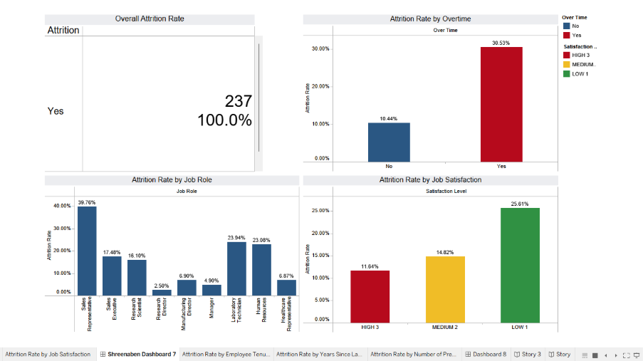
Fig. 26

After:

Fig. 27
Top: Attrition Rate by Job Role – highlights which job roles have the highest turnover rates.
Bottom Right: Attrition Rate by Overtime – compares attrition between employees working overtime vs. not working overtime.
Bottom Left: Attrition Rate by Job Satisfaction – shows that lower satisfaction levels correspond to higher attrition.

Page 2: The Attrition Profile (Who is leaving?)
This dashboard, titled "Who Is Leaving? The Attrition Profile," serves as the second chapter of our analysis, drilling down from high-level trends to specific, actionable segments.

A. Logical Arc & Objectives

Objective: To identify high-risk employee segments by analyzing demographic factors (Age, Marital Status, Commute) alongside structural factors (Department, Gender, Job Role). Logical Flow: The narrative progresses from broad personal factors (Page 1) to specific organizational friction points (Page 2).
- Theme 1 (Demographics): Focuses on who the employee is outside of work (Age, Marital Status, Commute Distance).
- Theme 2 (Job Profile): Focuses on where the employee sits within the company (Department, Travel Requirements, Job Level).

B. Key Visuals & Feedback-Driven Iteration

Theme 1: Demographic Insights
Key Visual 1: Attrition Rate by Commute Distance (Dual-Axis Chart)
- Insight: Long commutes are a significant retention risk. The attrition rate climbs steadily as commute distance increases, peaking at ~24% for "Very Long Commutes."
- Design Choice: A dual-axis chart combines the volume of employees (Bar) with the attrition rate (Line). This reveals that while the largest group of employees has short commutes (low risk), a significant minority faces long commutes with much higher risk.
Key Visual 2: Attrition Rate by Marital Status (Heatmap)
- Insight: Single employees have the highest attrition rate across genders, particularly Single Males (26.94%).
- Design Principle (Pretensive Attributes): We used color intensity to encode attrition rate. Darker blue immediately draws the eye to the "Single" column, making the high-risk segment instantly recognizable without needing to read every number.

Before:
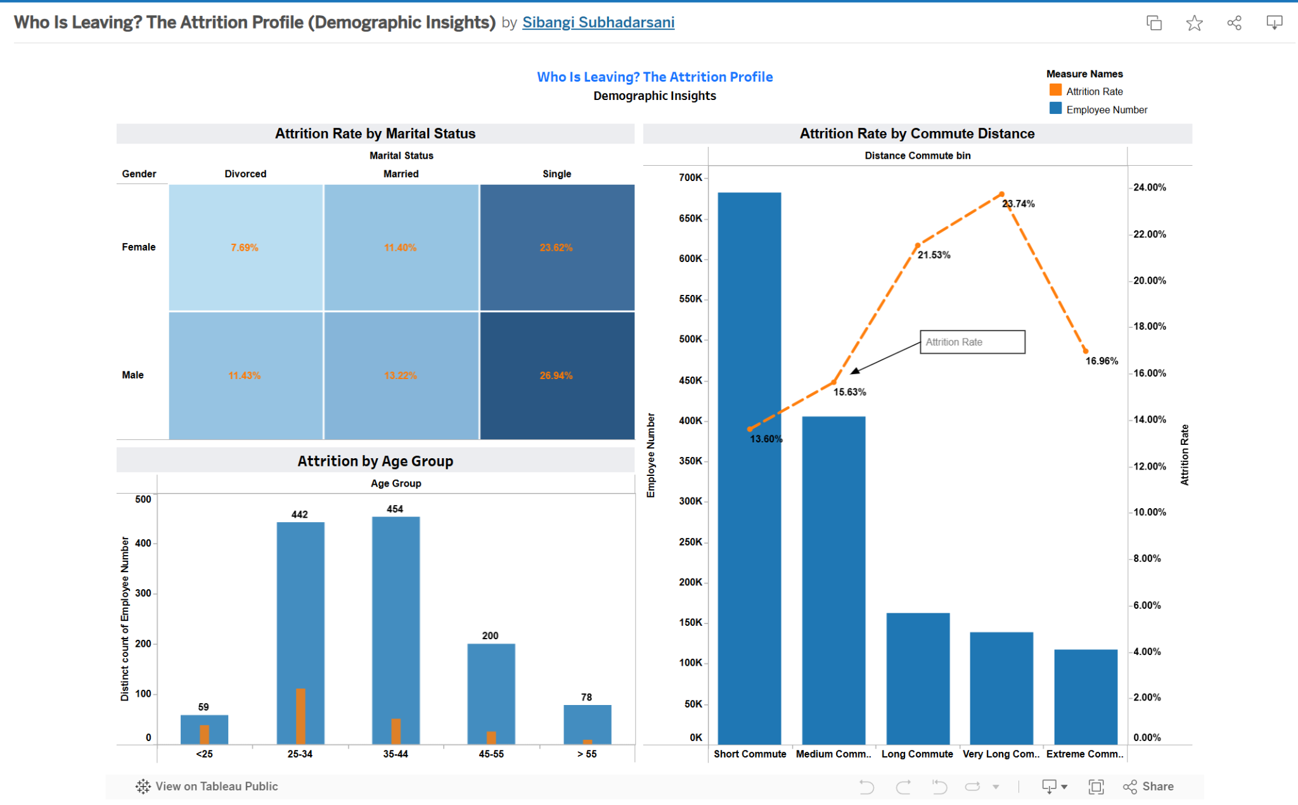
Fig. 28
After:
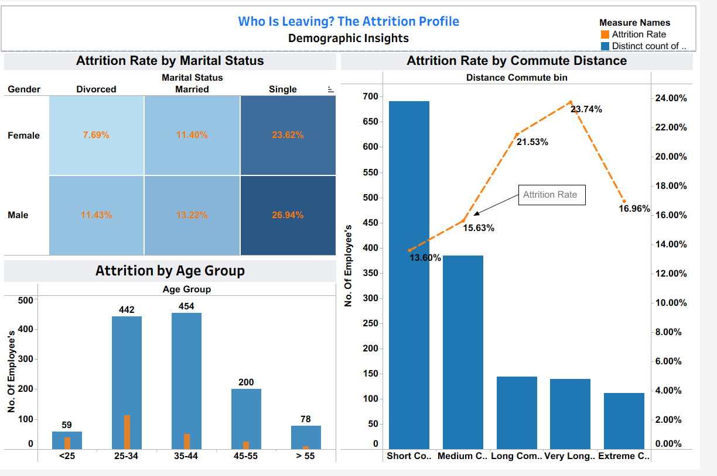
Fig. 29
Top Left: Attrition Rate by Marital Status & Gender (identifying high-risk demographics, specifically among single employees).
Bottom Left: Attrition by Age Group (analyzing workforce distribution and turnover volume across generational cohorts).
Right: Attrition Rate by Commute Distance (correlating commute length with retention risk using a dual-axis view).

Theme 2: Job & Department Profile
Key Visual 3: Attrition Rate by Business Travel Frequency (Donut Chart)
- Insight: Frequent travel is a major stressor; employees who "Travel Frequently" have the highest attrition rate (~24.9%).
- Transformation (Before/After):
Before: Initially used a "Viz Extension" for the donut chart. Feedback indicated this was problematic: "Tableau can’t export Viz Extensions," rendering the chart invisible to many viewers. Tooltips also displayed inconsistent proportions.
After: Used a "Viz Extension" as I was interested in using the donut chart and ensured 100% visibility, accurate tooltips, and clear labeling.

Key Visual 4: Attrition Rate by Department and Gender (Side-by-Side Bar)
- Insight: HR shows a critical gender disparity, with female attrition (30.0%) being double that of males.
- Transformation (Before/After):
Before: Used a Stacked Bar Chart with a solid reference band labeled "Industry Range." Feedback noted stacked bars obscured direct gender comparison, and the reference line was misleading (it was an internal average, not an industry benchmark).
After: We switched to a Side-by-Side Bar Chart to allow for direct, unhindered comparison of gender groups. We removed the misleading reference line entirely to adhere to data integrity standards, focusing instead on the clear internal disparity.

Key Visual 5: Attrition Rate by Department Job Level (Strip Plot)
- Insight: Isolates attrition hot-spots by seniority. For instance, R&D attrition is concentrated at Level 1 (early career).
- Correction: Feedback highlighted an aggregation error where we used SUM([Employee Number]) as an axis. We corrected this to COUNTD([Employee Number]) or the calculated Attrition Rate to ensure the visualization represents actual human capital density.

Before:
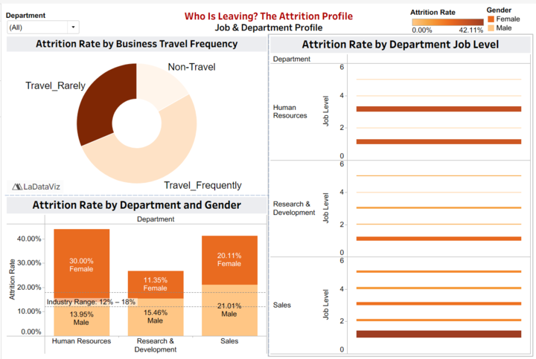
Fig. 30

After:
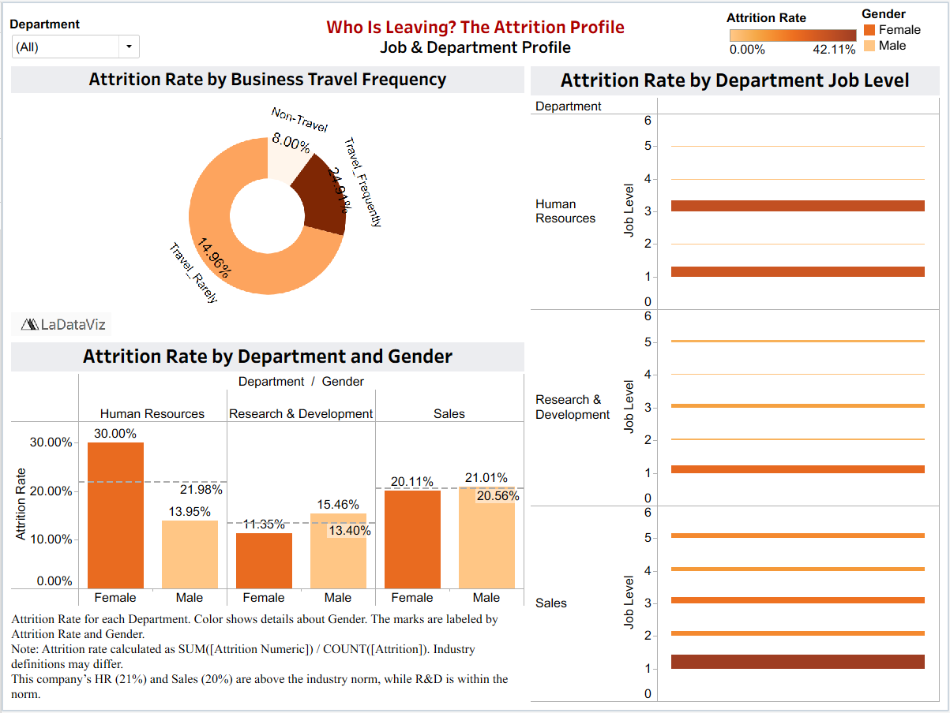
Fig. 31
- Top Left: Impact of travel frequency (a known stressor).
- Bottom Left: Attrition by Department & Gender (checking for disparities).
- Right: Specific Job Levels within departments (pinpointing hierarchy-based risk).

C. Explicit Design Principles Applied
- Tufte’s Graphical Integrity:
- Truth in Labeling: By removing the unverified "Industry Average" reference line, we adhered to Tufte’s principle that graphics must not quote data out of context (Tufte, 2001).
- Snapshot Context: Addressing the feedback that "data represents a single year," we moved the total employee count from hidden captions to visible KPI banners. This clarifies that the analysis is a cross-sectional snapshot, preventing users from inferring false historical trends (Tufte, 2001).
- Cole Nussbaumer Knaflic’s "Preattentive Attributes" (Color):
- Monochromatic Palettes: We used distinct monochromatic schemes for each theme to aid navigation (Knaflic, 2015).
Theme 2.1 (Blue): Dark Blue = High Risk (e.g., Single employees).
Theme 2.2 (Orange/Brown): Dark Brown = High Intensity (e.g., Frequent Travel).
- This consistent use of intensity leverages the intuitive "Darker = More" association, allowing stakeholders to scan dashboards and instantly spot high-risk segments (Knaflic, 2015).
- Gestalt Principle of Proximity:
- Charts are grouped by semantic category. In Theme 1, "Personal Demographics" (Age, Marital Status) are clustered together, distinct from "Commute." In Theme 2, "Departmental Structure" charts are grouped separately from "Job Level" detail. This spatial organization reduces cognitive load by creating clear analytical "zones" for the user (Knaflic, 2015).

Theme 3: Root Cause Analysis (Why are they leaving?)
- Objective and flow
Objective: To identify the root cause of employee attrition, focusing on income distribution, salary hikes, and stock option levels.
Logical Flow: The visualization follows a top-down approach. It starts with highlighting income differences between attrited and retained employees, before moving onto distribution level income, and then lastly salary hikes and stock option flow which explains why there is attrition.
- Key Visuals & Feedback
Before:
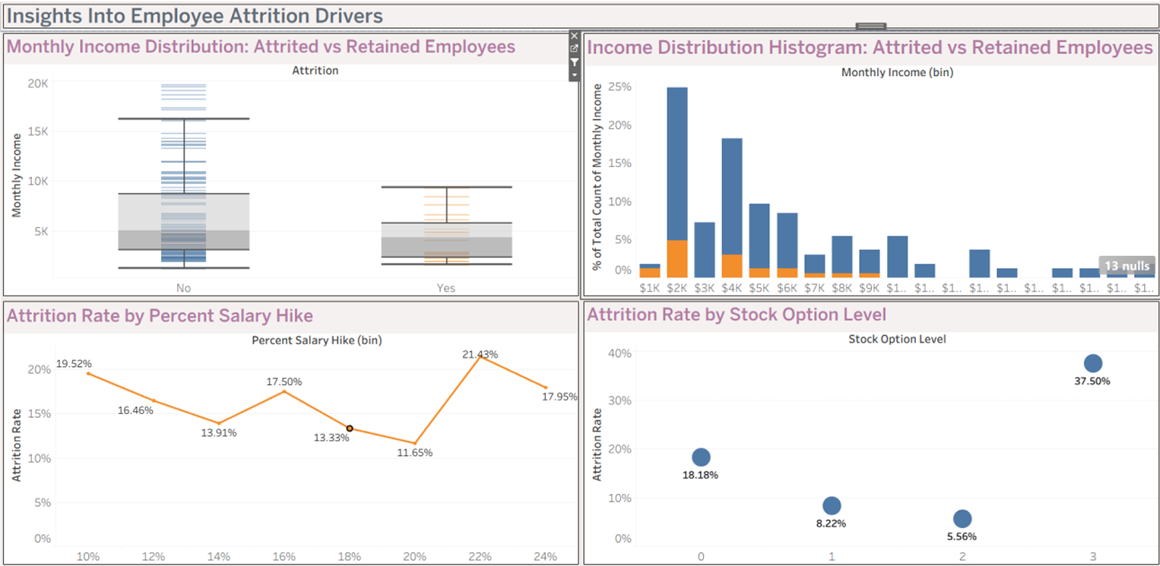
Fig. 32
After:
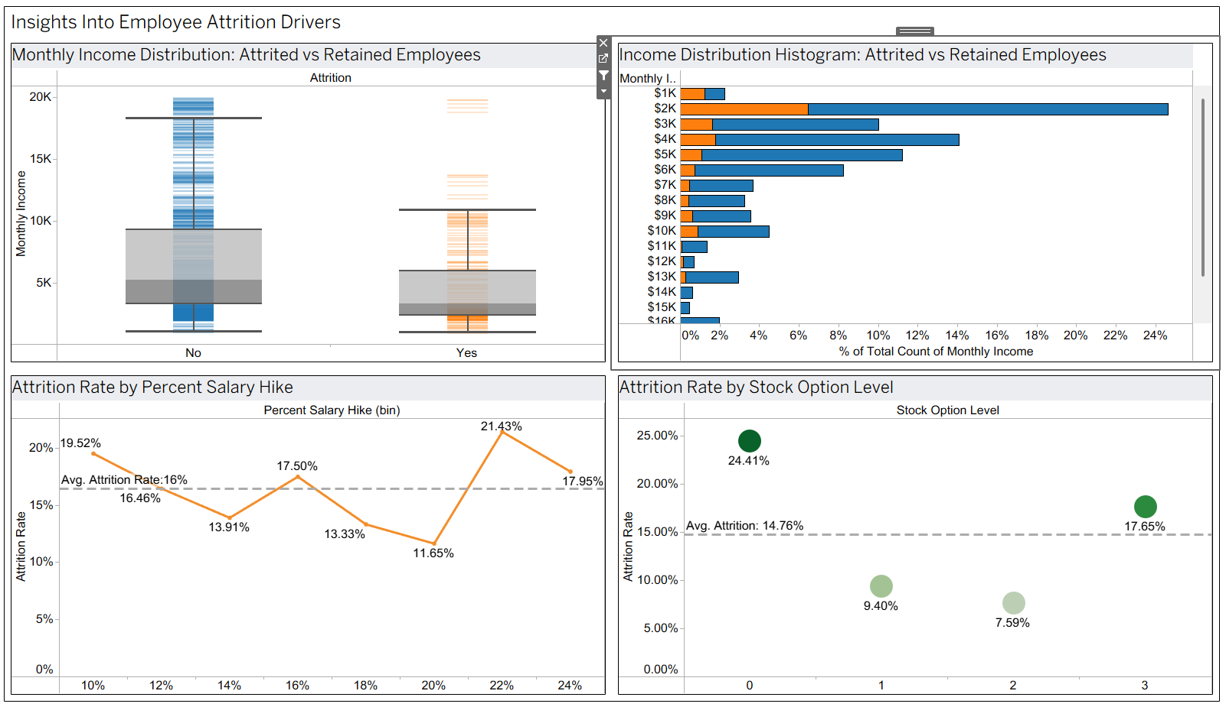
Fig. 33
Top Left: Monthly Income Distribution (visualized between attrited and retained employees)
Top Right: Income Distribution Histogram (visualized between attrited and retained employees)
Bottom Left: Attrition Rate By Percent Salary Hike (among only attrited employees)
Bottom Right: Attrition Rate By Stock Option Level (among only attrited employees)
Visual 1: Monthly Income Distribution
Insight: Employees leaving the company are mostly on the lower-income range with a lower median and narrow income distribution. It highlights that compensation is a big driver of attrition.
Transformation:
- Before: The visual had a purple title bar and lower opacity, make income groups harder to distinguish.
- After: The revised visual has cleaner colors with clearer shading in the boxplot, making the income differences stand out.

Visual 2: Income Distribution Histogram
Insight: Employees leaving the company are heavily concentrated in lower income bins, particularly between $1K and $4K. Attrition rates start dropping with the increase in income, reaffirming that compensation is an important factor.
Transformation:
- Before: The visual had vertical bars with labels on the x-axis not clearly visible.
- After: The revised visual has horizontal bars, bar outlines, and clearly visible labels making it easier to interpret.

Visual 3: Attrition Rate By Percent Salary Hike
Insight: Employees with small salary hikes have high attrition rates. What’s interesting is that attrition rises again with high salary hikes as well. This might be reactive salary hikes for employees already planning to leave the company.
Transformation:
- Before: The visual didn’t have a reference point of average attrition.
- After: The revised visual has an average attrition line.

Visual 4: Attrition Rate By Percent Salary Hike
Insight: Employees that have 0 stock options are mostly to leave the company. Attrition rises again at stock option 3, which could mean it is harder to retain senior employees.
Transformation:
- Before: The chart used the same color for all the same options and lacked a reference point.
- After: The revised visual uses a gradient color to signal intensity of attrition, while also having an average attrition line.

C. Design Principles Applied
- Tufte’s Principle
Visual 1 follows Tufte’s principle of minimizing clutter from the chart by presenting clean and simple box plot.
Visual 4 follows Tufte’s minimalism (Tufte, 1983) by showing how employees’ attrition rate gradually falls as their stock options increase.
- Cole Nussbaumer Knaflic’s Principle
Visual 4 shows how the dots are in a gradient green color which makes the attrition rate differences more clear, following Cole Nussbaumer’s principle of using color with purpose.
Theme 4: The Employee Journey (When do they leave?)
A. Objective and Flow
Objectives: to identify when disengagement occurs among employees analysing satisfaction levels, work - life balance and performance rating.
Logical Flow: The visualisation starts with satisfaction levels which are early signs of development narrowing into specific drivers like WLB, Job satisfaction, Environment Satisfaction, Relationship Satisfaction, and ending it with performance rating comparison confirming if performance predicts retention.
Before:
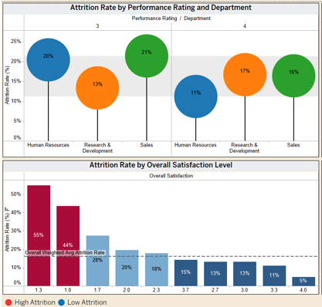
Fig. 34
After:

Fig. 35
- Top: Overall satisfaction levels - identifies where attrition is highest among low satisfaction.
- Middle: Satisfaction Metrics - parameter view comparing Work-Life, Job, Environment, and Relationship satisfaction for attrited vs retained employees.
- Bottom: Performance Rating - confirming rating 3 & 4 have same attrition rates.

B. Key Visuals & Feedback
Visual 1: Attrition Rate by Overall Satisfaction Level
Insight: Only 18 employees fall into the lower satisfaction tier, yet most of them leave because the attraction rate is 50%. While much larger employees (414 and 907) at scores 2 and 3 show lower attrition (25.8% and 12%) showing us how a small group of unhappy employees can lead to turnover.
Transformation:
- Before: A vertical bar chart with a wrong average reference line and performance rating of 16%
- After: A horizontal segment bar along with employee counts and calculated field of ‘High Risk’ to highlight low satisfaction scores.

Visual 2: Satisfaction Metrics
Insight: employees who leave score lower on every metric and every score is below 3.0. Job satisfaction shows the lowest among all at 2.47 for attrited employees which also is global HR research which identifies that low satisfaction as the number one driver of turnover.
Transformation:
- Before: each metric was a chart, making layout inconsistency and understanding of dissatisfaction
- After: bar comparison along with parameters and adding a reference line of 3.0 threshold.

Visual 3: Attrition Rate by Performance Rating
Insight: Performance rating 3 “Excellent” and 4 "Outstanding" have same attrition rates reflecting it is not a strong factor of turnover.
Transformation:
- Before: bubble chart showing department x performance rating, questioned if it was an error since they were identical.
- After: simplified side by side bar, with clear attrition percentages and clarified there are only 3 and 4 ratings.
C. Design Principles Applied
- Munzer’s Principle
  - Clarity over clutter: reduced information clutter based on feedback to focus on core insights, highlighting the idea that effective visuals should prioritize clarity over embellishment (Munzner, 2014).
  - Appropriate use of encodings: bars for comparing satisfaction groups, and a segmented chart for multi-dimensional comparisons, aligning with Munzner's recommendation to match the underlying question (Munzner, 2014)
- Few’s Principle
  - Accurate aggregation and statistical representation: removed wrong average references lines to avoid incorrect benchmarks. Fixed aggregation so attrition percentages are accurate. According to Few, inaccurate aggregation leads to false conclusions and violates foundational principles of honest visual communication (Few, 2012)
- Cole Nussbaumer Knaflic’s Principle
  - Pretensive Attributes: used a consistent diverging palate orange = attrited and blue retained which allows to spot easier risk areas.
Theme 5: The Employee Journey (When do they leave?)
A. Logical Arc & Objectives
Objective:
To reveal the career-path inflection points during which employees are most susceptible to exit the first involves during the initial period of tenure or following a lengthy period of stagnation or patterns of mobility due to the work history.
Logical Flow: Theme 5 (Career Path): Examines the dynamics of career mobility and progression, and it responds to the question when in their journey employees are most prone to leave.
Before:
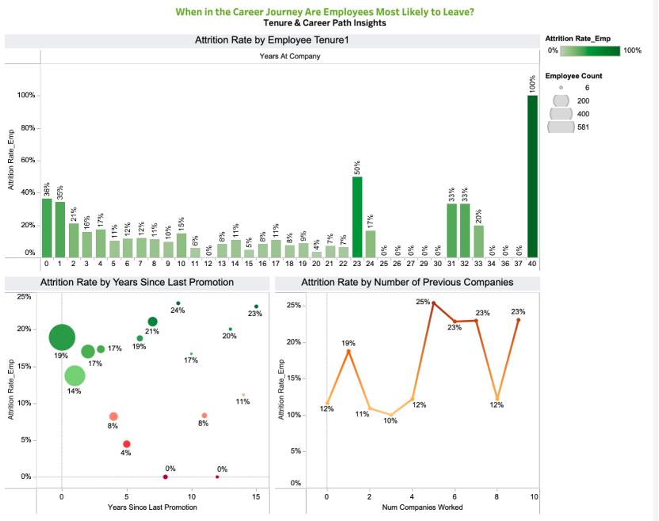
Fig. 36
After:
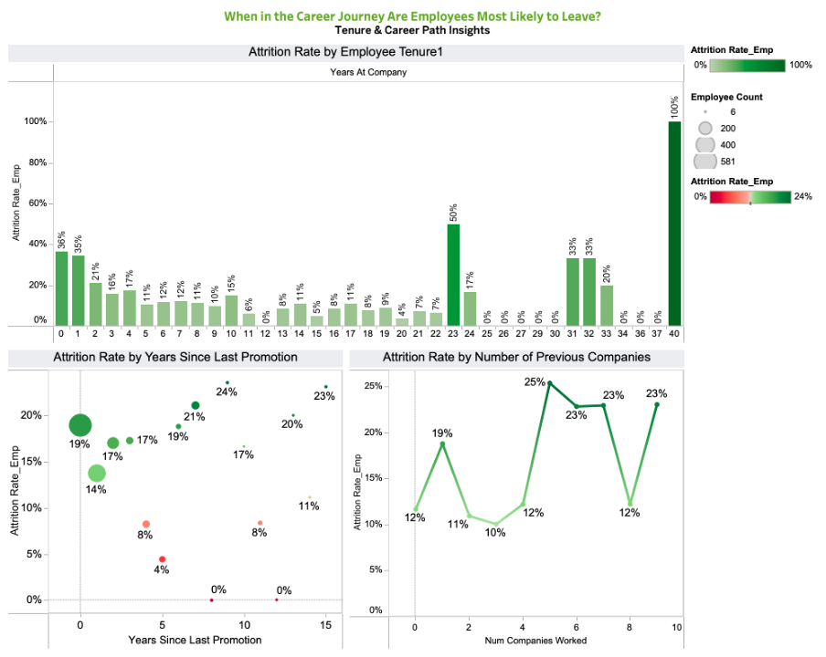 Fig. 37
B. Key Visuals & Feedback-Driven Iteration
Theme 5.1: Tenure-Based Patterns
Key Visual 1: Attrition Rate by Employee Tenure (Bar Chart)
Insight:
The attrition risk is of early concentration during the lifecycle of an employee. Employees in their first year show the highest turnover rates- over and above the rates of the majority of mid-career employees. Attrition decreases gradually after Year 2, which indicates the growing organizational attachment and job fit.
Design Rationale:
The sharp early decline can be physically conspicuous using a single-series bar chart. The labels of only significant peaks (Year 01) enhance better readability since it eliminates clutter.
Feedback Integration (Before/After):
- Before: Each of the 41 tenure values was shown with percentage labels which generated unwanted noise.
- After: Labels on only significant tenure peaks (e.g., 0, 1, 23, 31 -33) enhance visual attention and enhance the story on early-tenure attrition.
Theme 5.2: Promotion Stagnation & Career Progression

Key Visual 2: Attrition Rate by Years Since Last Promotion (Bubble Chart)
Insight:
The attrition of employees who have not received any promotion in 4-7 years increases drastically. To a great extent, this stagnation window is congruent with the career dissatisfaction curve in most of the organizations. The number of bubbles presents the number of employees impacted, which can be seen that this high-risk window has an impact on a significant part of the workforce.
Design Principle (Encoding):
We coded employee volume with bubble size and risk intensity with colour. The stagnation zone is instantly noticed by bigger and darker bubbles.
Feedback Integration (Before/After):
- Before: There was inconsistent variation in bubble colors, and this weakened the attribution of a severity of riskiness.
- After: A green-red gradient over all the bubbles indicates that the darker the color, the greater the attrition.
Key Visual 3: Attrition Rate by Number of Previous Companies (Line Chart)
Insight:
Workers that have had a minimum of five former employers have a significantly increased rate of attrition. These high-mobility workers show a very steady trend of job-hopping, and they are much more likely to reoffend.
Design Consideration:
A line chart that has been smoothed highlights the volatility in the attrition with the rise in the job history. The mobility trend is clear because each peak (2, 5, 7, 9 companies) is labeled without overcrowding the viewer.
Feedback Integration (Before/After):
- Before: Irregular line thickness and absence of peaks marking the positions of the mobility pattern made it blurred.
- After: ARRAY and targeted labelling help to identify the correlation between previous mobility and existing risk of attrition.
C. Explicit Design Principles Applied
Tufte’s Graphical Integrity
- Data-Ink Ratio: Removed unnecessary labels in the tenure chart in order to emphasise the steep upward pattern of the early tenure (Tufte, 2001).
- Truthful Encoding: To prevent alternative interpretations of the results, the calculations of attrition were displayed in both the tooltip and the annotation text.
Cole Nussbaumer Knaflic’s Pretensive Attributes
- Color Intensity:
  - The darker the tones, the greater is the attrition in all the three images.
  - Green (promotion competition-stable zones) to Red (risk zones).
  - This helps in real-time identification of career danger zones in career paths.
Gestalt Principles
- Proximity & Grouping:
  - Tenure, promotion and mobility representations were placed in a horizontal way forming a narrative that runs on history of entry progression.
  - The distance between the analytical lenses is evident yet the theme of the lifecycle remains overriding.
Cognitive Load Reduction
- The use of simplified labeling and color scales minimizes mental load so that users are able to concentrate on the time when the risk of attrition increases instead of spending their time on visual noise.

References

Google. (2025). Gemini [Large language model]. https://gemini.google.com/

Knaflic, C. N. (2015). Storytelling with Data: A Data Visualization Guide for Business Professionals. Wiley.

OpenAI. (2025). ChatGPT (October 2 version) [Large language model]. https://chat.openai.com/

Tufte, E. R. (2001). The Visual Display of Quantitative Information (2nd ed.). Graphics Press.

Tufte, E. R. (1983). The visual display of quantitative information. Cheshire, CT: Graphics Press.
Kaggle dataset
Konapure, R. (n.d.). HR analytics prediction [Dataset]. Kaggle. Retrieved September 15, 2025, from https://www.kaggle.com/datasets/rishikeshkonapure/hr-analytics-prediction/data
Tableau dashboards
Pradeepkumar, G. (n.d.). HR Attrition Dashboard RWFD [Visualization]. Tableau Public. Retrieved September 28, 2025, from https://public.tableau.com/app/profile/pradeepkumar.g/viz/HRAttritionDashboardRWFD_16570446563570/viz

Suglani, N. (n.d.). HR Attrition RWFD [Visualization]. Tableau Public. Retrieved September 28, 2025, from https://public.tableau.com/app/profile/naresh.suglani/viz/HRAttritionRWFD_16766412174060/HRAttrition

Tableau Datafam Slack. (n.d.). Slack archive: C08GUJGMKRN. Retrieved September 20, 2025, from https://tableau-datafam.slack.com/archives/C08GUJGMKRN/p1758412175661259

