Name of device: Splitting Gate Oxide Double Gate P–I–N Hetero-Vertical TFET(SGO-DG-PIN-Hetero-VTFET)
Dr. Rajesh Saha, Tushar Kanti Shill, Rajesh Das, Sibasish Dutta, Rahul K. Gupta, Chetan Chaudhary.
Abstract:
In this study, we have suggested intrinsic channel splitting gate oxide double gate (DG)-heterojunction Vertical Tunnel Field Effect Transistor based photo detector and analyzed its different parameters using the Sentauras TCAD simulation tool. Including an intrinsic channel, improves the switching performance and provides large ON state current. The splitting gate oxide (oxide layer induced in-between two high dielectric material) adopted in this structure, lowers the power utilization and the interface trap density. It also enhances the surface protection for effective tunnelling. The vertical device structure occupies smaller chip area than the horizontal device due to which higher density of transistors can be integrated in the same chip area. This study examines the electrical and optical operation of a special type of transistor, called splitting gate oxide double gate (DG)-heterojunction Vertical Tunnel Field Effect Transistor. The device was made using Gallium Antimonide (GaSb) and Silicon (Si). This study focused on the behaviour of transistors at three different wavelengths: 300, 500, and 700 nm. It concludes that 300 nm is the optimal wavelength in terms of optical parameters such as sensitivity, responsivity, noise factor, and overall efficiency. The splitting gate oxide thickness is maintained at 0.5 nm. The observed max spectral sensitivity and max ($\frac{I_{Light}}{I_{DarK}}$) ratio were 2.55 and 1.45 × 10⁶, respectively (at V_{GS} = 0.025V, V_{DS} = 0.5V, Intensity = 0.8 W/cm², Spectral wavelength $λ=300nm$).

1.Introduction:
Tunnel field-effect transistors (TFETs) have significant advantages over traditional MOSFETS due to their lower OFF state current (I_{OFF}), decreased power consumption, and subthreshold swing (SS) lower than 60mV/dec, which is often less than 40-50 mV/dec [2]. However, a primary drawback of TFETs is their lower ON current (I_{ON}) compared to that of conventional MOSFETs. To enhance this ratio, various device structures have been explored, such as vertical and source-pocket designs. It has been reported that staggered heterojunctions at the source-channel junction, with materials based on group III-V, which are suitable for operations dealing with low-voltages, balanced speed and power consumption [2]. The Vertical-TFET offers several utilities like a sharp sub-threshold slope, enhanced ON state current, reduced OFF state current, and lower power consumption [2]. Furthermore, adding high-κ improves tunnelling for ON state conduction and reduces undesired leakage, which helps lower OFF state leakage. By increasing the tunnelling probability (for a larger ON state current) and decreasing the OFF state current (for optimized energy utilization), high-κ dielectrics dramatically improve the TFET performance [2]. They are low-power transistors because they possess steeper potential gradient, lower subthreshold swing, and enhance gate control [2]. The proposed SGO-DG-PIN-Hetero-VTFET optical detector, improves the switching performance and subthreshold swing (SS) by strengthening the gate control [2]. The split oxide and two distinct gate areas enable improved band bending, increased tunnelling probability, and decreased leakage. Many device architectures have been studied to enhance charge tunnelling, mobility, and dependability [4]. This can be accomplished by sandwiching a high dielectric material, such as Ni₂O₅ (3 nm), with SiO2 (0.5 nm), in the middle of channel and gate [2].
In recent years, optical sensors have become important in many real-world applications, such as defence industry, medical diagnostics and treatment, security and surveillance, and so forth. The performance of a photodetector mainly depends on three key factors: minimal power utilization, high spectral sensitivity (Sn), and high SNR [3]. Traditional photodiodes often struggle with lower spectral sensitivity and significant power loss owing to design limitations. To overcome these limitations, photodetectors using field-effect transistors (FETs) have gained interest because they are compact and compatible with integrated circuit (IC) technology. MOSFET based photodetectors offer better noise immunity and integration capabilities; however, it has restricted spectral sensitivity as its lowest observed subthreshold swing is around 60 mV/dec at room temperature (300 K) [5]. Therefore, TFET has evolved as promising substitute because of its BTBT mechanism at the channel-source interface, which allows for a lower subthreshold swing and improved sensitivity [6]. Spectral sensitivity (Sn) is particularly important for detecting small differences in wavelength (approximately 100 nm) under lower illumination intensity (< 1 W/cm²) [7]. Another major challenge is minimizing dark current, the unwanted current that flows even when no light is present. In photodetector, high dark current hinders the ability of detecting weak light signals and hence lowers its SNR [3]. Hence, redesigning the device structure with advanced materials gives an edge in order to reduce the dark current, improve the sensitivity, and so forth.
This paper is constituted of three parts: part II explains the device structure and simulation setup, device dimensions, TCAD tool and calculating methods used, and operating principle. In part III, results of the optical specification of the sensor at various wavelengths have been discussed.
2. Device Structure and Simulation Setup:
2.1. Device Structure
The proposed device, named Splitting Gate Oxide Double Gate P–I–N Hetero-Vertical TFET (SGO-DG-PIN-Hetero-VTFET), is a vertical heterojunction TFET structure. It consists of a vertically stacked configuration with a P-type doped GaSb source, an intrinsic silicon channel, and an N-type doped Si drain, each with an equal length of 20 nm. The device incorporates a split-gate oxide design, where the gate dielectric consists of the high-k material Nb₂O₅, enhancing gate control and minimizing leakage [2]. GaSb, owing to its minimum energy bandgap, results in a narrow tunnelling width (tₚ), enabling a higher tunnelling probability even at lower gate voltages [1]. This property significantly enhances the ($\frac{I_{Light}}{I_{DarK}}$) ratio and thereby enhances the SNR of the proposed photodetector [3]. The optical performance of the device was analysed at the following wavelengths: 300nm, 500nm, 700nm to study its photo response across the visible spectrum. The radiant intensity was maintained at 0.8 W/cm², where the incident photons of sufficient energy break covalent bonds within the semiconductor, initiating carrier generation and recombination processes.
For photodetection to be effective, the energy of the illuminated photons ($\frac{hc}{λ}$) must be higher than the material's energy band gap (Eg). [3]. Furthermore, the effect of the splitting gate oxide thickness variation was examined by changing its value from 0.5 nm to higher levels, it was observed that increasing the oxide thickness caused a leftward shift in the I_{D}–V_{G} characteristics, indicating the requirement for an additional negative gate voltage to achieve the same tunnelling current.

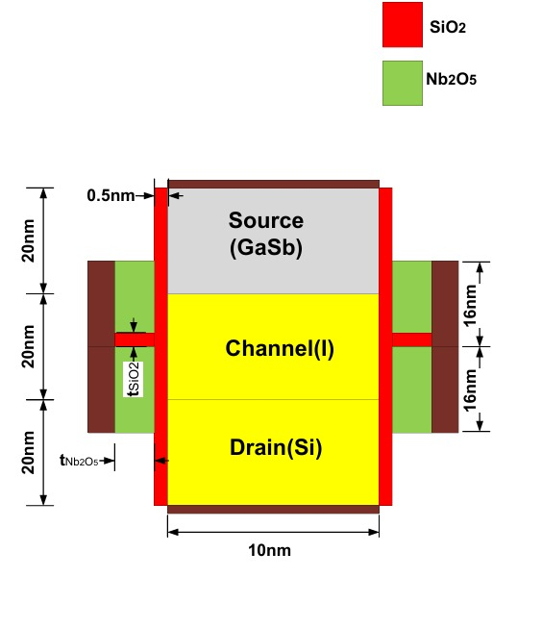

Parameters | Values (SGO-DG-PIN-Hetero-VTFET)
Silicon thickness (t_{si}) | 10 nm
SiO₂Nb₂O₅ thickness | 0.5nm
Nb₂O₅ thickness | 3 nm
Gate Length (L_{g}) | 32 nm
Substrate length (L_{si}) | 20 nm
Channel doping (N_{CH}) | Intrinsic
Source doping (P-type) | 1 × 1020 cm⁻³
Drain doping (N-type) | 5 × 1016 cm⁻³
Nb₂O₅ dielectric constant (K_{Ni2}o₅) | 15.69
SiO₂ dielectric constant (K_{SiO2}) | 3.7
GaSb Band gap | 0.72933
GaSb effective mass | 0.041m₀

Fig. 1. Visual structural representation of splitting gate oxide SG-DG-PIN-Hetero-VTFET

Table 1
Design parameters of SGO-DG-PIN-Hetero-VTFET:

2.2 Sentaurus (Simulation) Tool specifications:
Synopsys Sentaurus uses Svisual (Sentaurus Visual) as a Visualization plot tool. For the simulation and computation of the device parameters, Sentaurus Device (sdevice) incorporates the following core equations: Poisson’s Equation, Electron Continuity Equation, Hole Continuity Equation. It also uses the Finite Volume Method (FVM) for discretization and the Newton–Raphson method of coupled semiconductor equations (Poisson + carrier continuity). For time-dependent problems, implicit time integration schemes are applied to ensure numerical stability and accuracy. The Transfer Matrix Method (TMM) is used for the Optical analysis of the device. Using Sentaurus TCAD tool, we derived the following parameters: 1) I_{D}-V_{g} characteristics, 2) spectral sensitivity, 3) optical generation rate, 4) quantum efficiency, 5) SNR, and 6) responsivity.

3. Results and Discussion
In this section a comprehensive comparative study of the proposed SGO-DG-PIN-hetero-VTFET photodetector, focusing on the influence of light with various wavelengths on the device performance. The performance of a device constructed using a splitting gate oxide of SiO2 and Nb2O5 as a high-k dielectric material for the gate oxide is examined in this work. The evaluation considers important spectral performance parameters, such as the SNR and Spectral sensitivity (S_{n}), over a near-visible wavelength (λ) range of 300 nm to 700 nm. The photon-to-current conversion efficiency was evaluated by determining the responsivity (R) and quantum efficiency (η) under different illumination conditions.

3.1 Energy Band Diagram
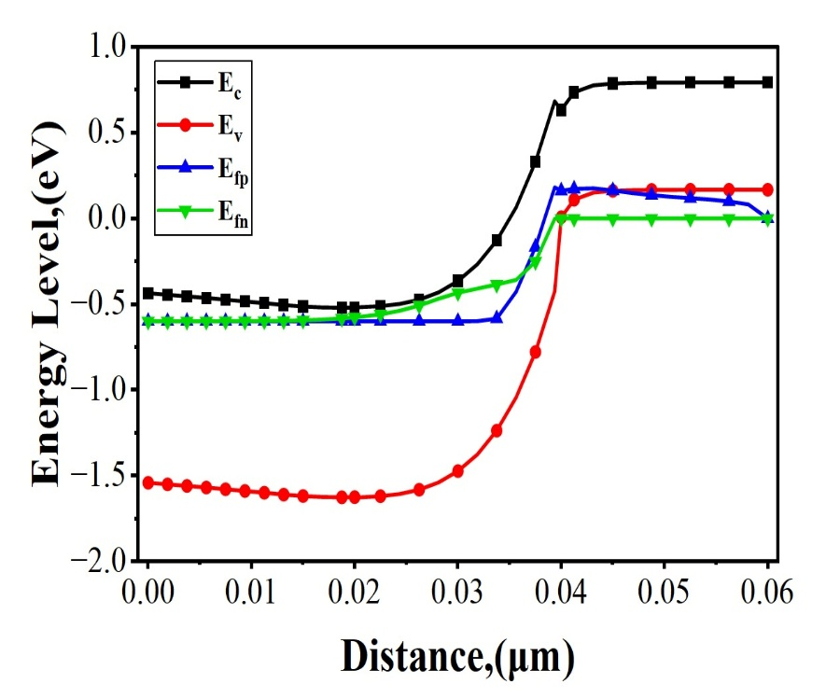
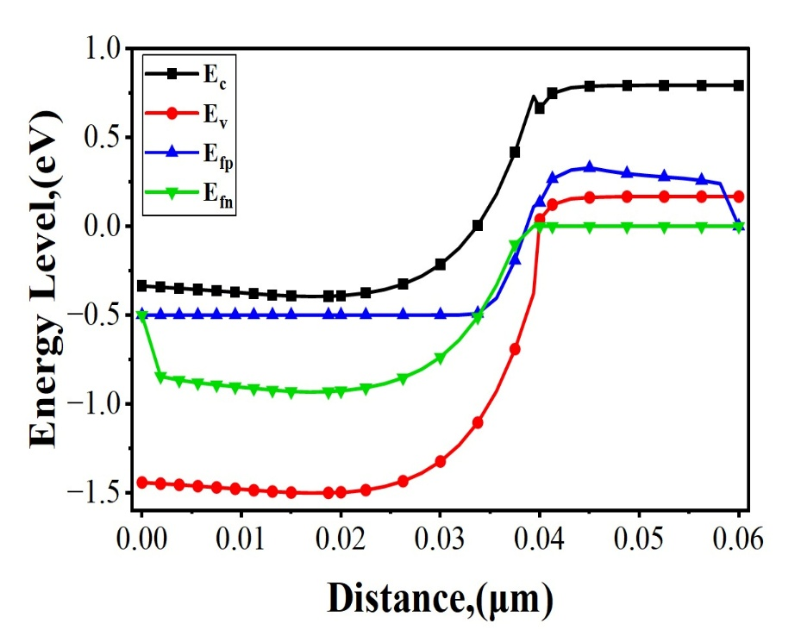
In this section, Fig. 2(a) & Fig. 2(b) indicates the variation of E_{fn} and E_{fp} in the energy band diagram in gate region under the dark and illumination conditions. Fig. 2(a) shows that E_{fp} and E_{fn} are merged together in dark state, this signifies that the photodetector is in thermal equilibrium, means there is no external energy applied (like light or voltage) which would not create any excess carriers. In contrary, when light is illuminated in photodetector gate region, both E_{fn} and E_{fp} splits into two part which leads to the generation of a photovoltage (V_{OP}) in the illuminated region as shown in Fig. 2(b). This induced V_{OP} improves the I_{ON} when compared to the dark state at lower V_{GS}. Furthermore, when λ is increased from 300 to 700 nm, the magnitude of V_{OP} inside the photodetector gate decreases, which is due to the generation of lower amounts of electron-hole pairs in the illuminated region for higher values of λ, ensuring a smaller separation between E_{fn} and E_{fp}, as shown in Fig. 2(b).
Fig.2(a): Energy Band diagram under dark condition Fig.2(b): Energy Band diagram under f illumination condition

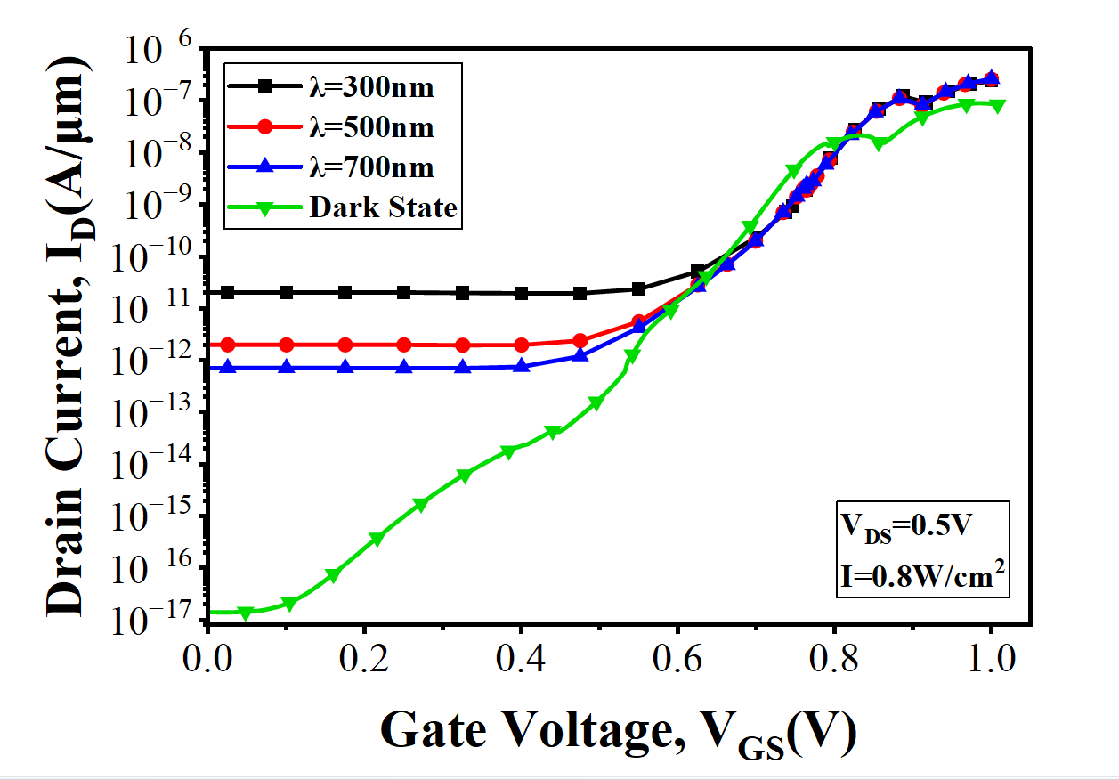
3.2 Transfer characteristics

Fig. 2(c): Transfer characteristics (I_{D} vs V_{g}) of the proposed photodetector at different wavelength

This graph plots the transfer characteristics (I_{D} vs. V_{GS}) of a device that functions as both a transistor and photodetector. Fig. 2(c) indicates that as with an increase in wavelength (λ) from 300 nm to 700 nm, drain current (I_{D}) reduces but is overall greater than the I_{D} in the dark state. In the dark state (green line), it shows excellent transistor behaviour: an extremely low "OFF" state leakage current (approximately10⁻¹⁷ A/$μm)$ I_{ph} that is many orders of magnitude larger than the dark current. This effect is wavelength-dependent: 300 nm UV light (black line) produces the highest photocurrent (approximately10⁻¹¹ A/$μm$). The 500 nm and 700nm visible light sources produced progressively smaller photocurrents, indicating that the device was a UV-selective phototransistor, made from a wide-bandgap semiconductor. Finally, at high gate voltages (above 0.8 V), the transistor is fully "ON," and the gate-controlled drift current (approximately 10⁻⁷ A/$μ$m) is so large that it completely overwhelms the comparatively small photocurrent, causing all the curves to converge.

3.3 Spectral Sensitivity: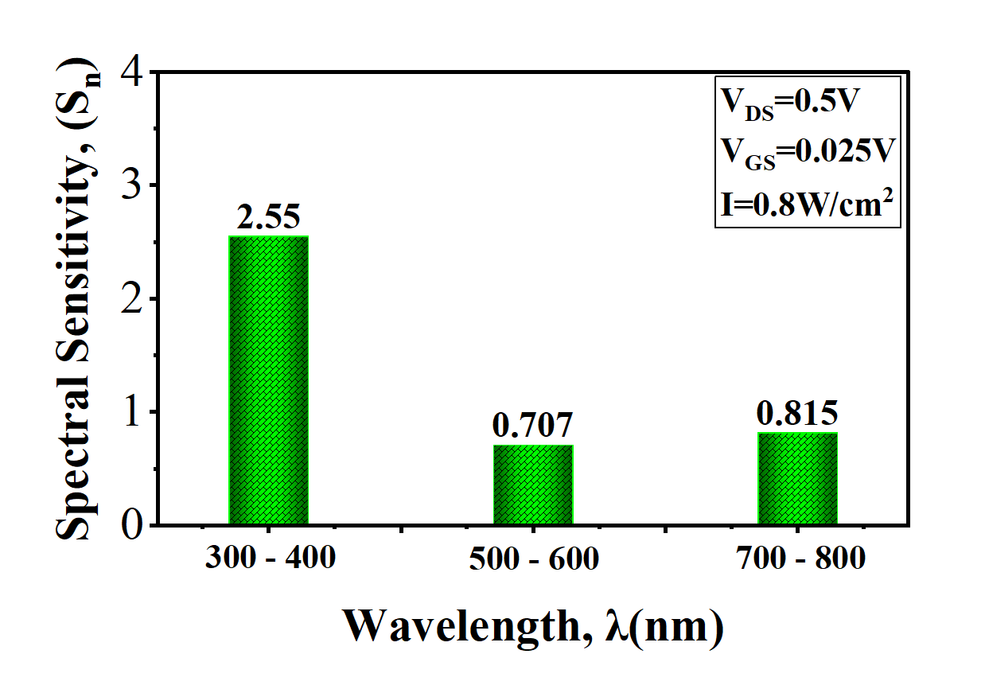 Fig.3: Variation of Spectral Sensitivity with incident Wavelength (λ = 300–700 nm) with 100 nm spaced wavelengths
Spectral sensitivity (Sn) is one of the most important parameters used to evaluate a photodetector’s ability to differentiate between closely spaced light wavelengths, typically within 100 nm, under lower illumination conditions (< 1 W/cm²) [8]. It represents the effectiveness with which the device converts incident photons into an electrical signal at different wavelengths, thereby indicating its wavelength-dependent performance. Sensitivity was calculated using the following expression:
$$s_{n}=\frac{I_{D}\left(λ_{1}\right)-I_{D}\left(λ_{2}\right)}{I_{D}\left(λ_{2}\right)}$$
where${ I}_{D}\left(λ_{1}\right)$ and $I_{D}\left(λ_{2}\right)$ represent the photocurrents at two different wavelengths $λ_{1}$and $λ_{2}$ [9]. This formula measures the amount of electrical response change in the device with respect to changes in the wavelength of light, measuring its spectral selectivity. In the bar graph fig.3, the spectral sensitivity (Sn) is plotted as a function of $λ$ at a fixed drain-source voltage V_{DS} = 0.5 V and illumination intensity I = 0.8 W/cm². The results show that the maximum sensitivity ${(s}_{n}$ = 2.55) occurs at 300 nm, and then it gradually decreases toward the near-visible range, (500–700 nm) with Sn values of 0.707 and 0.815, respectively. This decrease in value occurs because photon energy decreases with increasing wavelength $\left(E=\frac{hc}{λ}\right)$. At shorter wavelengths (e.g., 300 nm), photons have higher energy, generating more EHPs and resulting in higher photocurrent and sensitivity. As the $λ$ increases toward the visible range, the photon energy reduces, which leads to generation of lesser number of charge carriers and thus lower sensitivity. Hence, the photodetector shows a strong response in the near-visible range, with maximum spectral sensitivity at shorter wavelengths, which makes it fit for photo-sensing and optical detection.
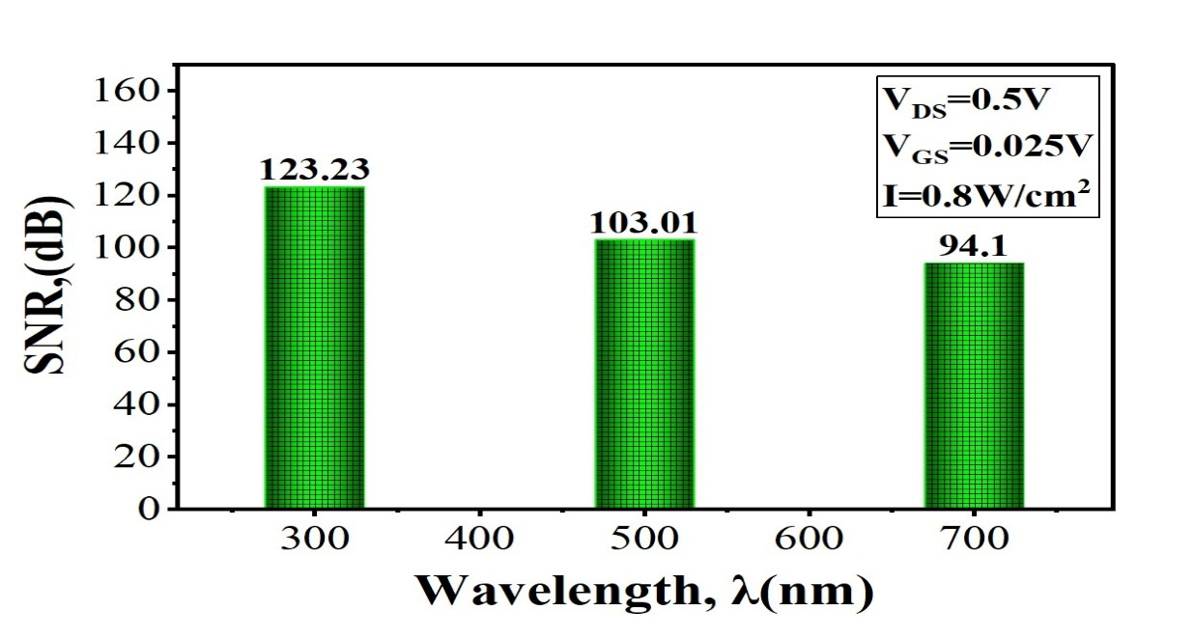
3.4 Signal to Noise Ratio (SNR):
Fig.4: SNR values at different incident wavelength
The SNR is a key parameter for photo detection, as it determines the ability of the device to supress unwanted dark current noise compared to light induced current. It is mathematically expressed as SNR=20∙log ($\frac{I_{Light}}{I_{DarK}}$ ), where a high value indicates strong noise suppression capability and enhanced signal strength [3]. The SNR strongly depends on the magnitude of light and dark currents; an increase in light current or a decrease in the dark current improves the ratio. As shown in fig. 4, the SNR has its highest value of 123.23 dB at 300 nm, which gradually decreases to 103.01 dB at 500 nm and 94.1 dB at 700 nm for (V_{GS}=0.025V, V_{DS}=0.5V) and (I=0.8 W/cm²). This decreasing in SNR with increasing wavelength is due to the decreasing photon energy ($E=\frac{hc}{λ}$), which leads to reduced electron–hole pair generation and a weaker photocurrent. Consequently, the photodetector exhibit maximum sensitivity in the near-visible region and minimized performance at longer wavelengths.

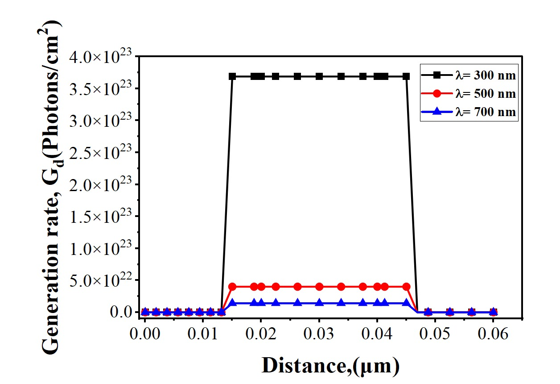
3.5 Optical Generation:
Fig 5: Generation rate (Gd) vs. distance for different incident wavelengths.
The optical generation rate (G_{d}) simulation provides an understanding the light-matter interaction of the device, indicate a strong spatial and spectral dependence [3]. A clearly defined active absorption region of about 33 nm, contained between 14 nm (0.014 µm) and 46 nm (0.046 µm) of the 60 nm vertical structure, was confirmed by the analysis. The bottom 6 nm of the GaSb Source, the entire 20 nm intrinsic channel (I), and the top 6 nm of the Si Drain are all critical heterojunctions of the device, and this active region overlaps with them. This finding establishes that optical generation is concentrated around the Source-Channel (GaSb-I) and Channel-Drain (I-Si) interfaces, showing a uniform and constant generation profile within this region.
The simulation showed a strong wavelength dependence on the generation magnitude, with a peak of ≈ 3.7 × 10²³ Photons/cm² at λ = 300 nm (UV). The rate drops sharply for visible light, falling by nearly an order of magnitude at $λ$ = 500 nm (≈ 4.0 × 10²² Photons/cm²). It is lowest at $λ$ =700 nm (≈ 1.5 × 10²² Photons/cm²). This strong wavelength dependence indicates the device is highly optimized for UV absorption. The higher generation of electron-hole pairs at the junctions, for 300 nm photons, predicts that the photo response of the device will exhibit a significant jump in the near-visible spectrum (see fig. 5).

3.6 Quantum Efficiency and Responsivity:
3.6.1 Quantum Efficiency
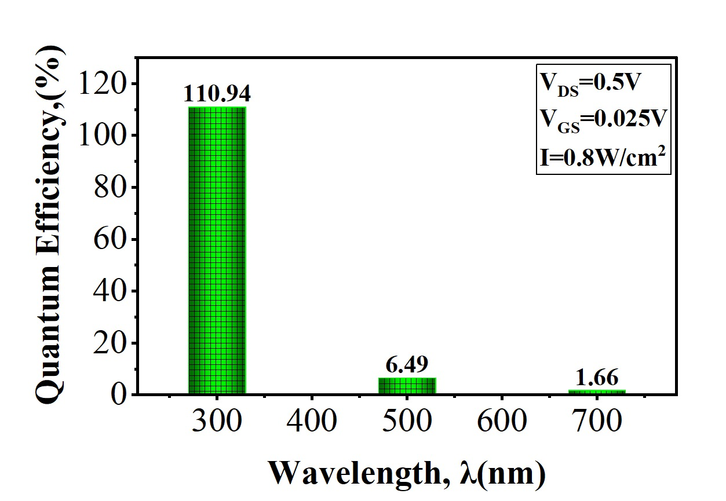Fig 6: Variation of Quantum Efficiency (%) with incident Wavelength (nm).
The Quantum Efficiency ($η$) quantifies the ability of photodetector to convert incident photons into EHPs [1]:
$η$ = $\frac{No. electron-hole pairs generated}{No. of incident photons }$ =$\frac{R(λ)∙h∙C}{q∙λ}$

Based on the data derived from the graph, for the 300 nm to 700 nm range, the device exhibits its peak performance in the near visible region, achieving an extremely high quantum efficiency of 110.94% at λ= 300 nm. This value being greater than 100%, which strongly suggests the presence of internal gain, where a single photon generates multiple charge carriers. However, as the wavelength increases and further shifts into the visible spectrum, the quantum efficiency shows a sharp decline to only 6.49% at 500 nm and reaches its minimum point in this range at 1.66% at $λ$ = 700 nm. This drop indicates a significant loss of efficiency in generating or collecting of electron-hole pairs for lower-energy photons compared to high-energy photons (see fig.6).

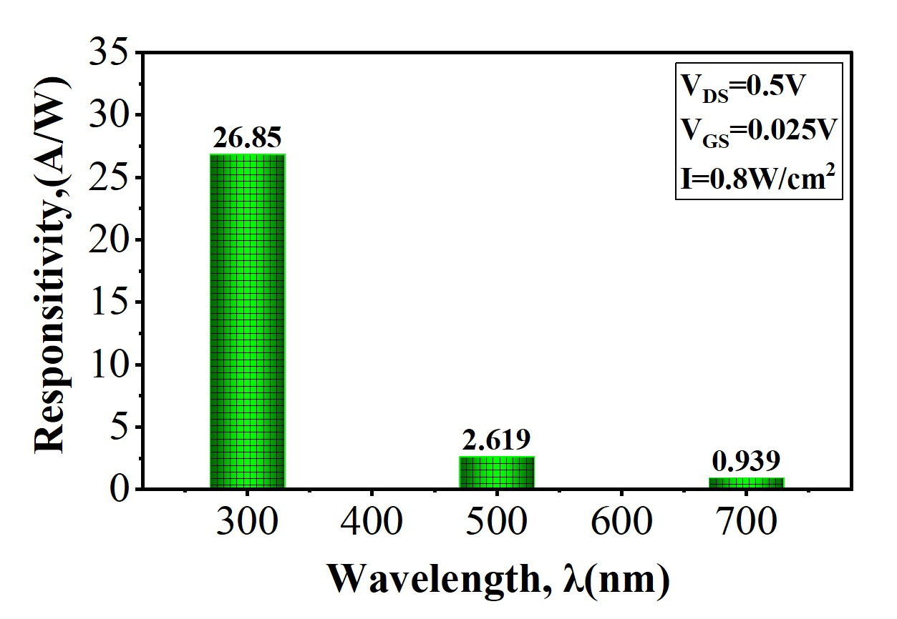
3.6.2 RESPONSITIVITY:

Fig 7: Variation of Responsivity (A/W) with incident Wavelength ($\lambda$).
Responsivity (R) is an optical parameter, which gives an idea regarding the effective illuminated light power conversion into photo current. It is calculated using the quantum efficiency ($η$) at a specific wavelength ($λ$) using the following relation [1]:
R = $\frac{Generated Photocurrent(I)}{Incident Optical Power(P)} =\frac{I\left(light\right)-I(dark)}{I⋅A}=η⋅\frac{q⋅λ}{h⋅C}$
Where I is the Intensity of light, A is Area of gate region, q is electron charge, h is Planck's constant, and C is the speed of light, respectively. The value of responsivity increases with increasing $η$ and $λ$. The value of responsivity (R) is directly proportional to both the quantum efficiency ($η$) and the wavelength $(λ$) [9]. Corresponding to the high quantum efficiency, the responsivity also shows a clear maximum in the UV region, peaking at 26.85 A/W at $λ$ = 300 nm. As the wavelength increases, the responsivity declines drastically, dropping to 2.619 A/W at $λ$= 500 nm and further to 0.939 A/W at $λ$ = 700 nm. Although the responsivity formula suggests an increase with wavelength, in this case, the drastic decrease in quantum efficiency ($η$) as $(λ$) moves from 300-700 nm, dominates the linear increase from the $λ$ term, resulting in an overall poor performance trend and significantly lower responsivity in the visible light range compared to the UV band (see fig. 7).
Table 2: List of values of all the deduced optical parameters.
Properties | Wavelength (in nm)
 | 300 | 500 | 700
Normalised Drain current (I_{D}) (A/µm) | 2.03 × 10⁻¹¹ | 1.98× 10⁻¹² | 7.10× 10⁻¹³
SNR (dB) | 123.22 | 103.01 | 94.10
Spectral Sensitivity (Sn) | 2.5489 | 0.7068 | 0.8758
Responsivity(R) (A/W) | 26.85 | 2.169 | 0.939
Quantum efficiency(n) | 110.98 | 6.49 | 1.66
Max Optical Generation Rate (G_{d}) (Photons/cm²) | 3.7 × 10²³ | 4.0 × 10²² | 1.5 × 10²²

4. CONCLUSIONS:
From the above experiment the optical parameters of the proposed Splitting Gate Oxide-Double Gate P-I-N Hetero-Vertical TFET-based photodetector in terms of Spectral Sensitivity (Sn), SNR, Responsitivity (R), and Quantum Efficiency(ƞ) is analysed by varying the incident light wavelength from 300-700 nm. However, at 0.5 nm oxide thickness and at 0V gate voltage, the device demonstrates the best performance, achieving a higher $\frac{I_{Light}}{I_{DarK}}$ ratio compared to thicker oxides, thus confirming that further increase in oxide thickness does not contribute to performance improvement. Consequently, the designed SGO-DG-PIN-Hetero-VTFET exhibits excellent performance as a photodetector operating in the near visible spectrum, with optimal tunnelling efficiency and strong photo response at minimal gate bias. The device's figures of merit at 300 nm were uniformly excellent. It achieved a higher Responsivity (R) of 26.85 $A∕W$, a Spectral Sensitivity (Sn) of 2.55, and a very high SNR (Signal to Noise Ratio) of 123.23 dB. Quantum Efficiency (QE) of 110.94% was calculated. This QE value, being greater than 100%, confirms the presence of a significant internal gain mechanism, where photogenerated carriers modulate the channel's tunnelling barriers, characteristic of a high-gain phototransistor. Due to its ultra-low power (pico-watt) tunnelling operation, the device generates negligible heat, which is effectively dissipated by the Si drain, ensuring high thermal stability.

5. REFERENCES:
[1] Shreyas Tiwari, Tarun Varma, Rajesh Saha, Optical assessment of vertical TFET based on heterojunction of GaSb-Si, Micro and Nanostructures 195 (2024) 207955.
[2] Sourav Das, Kunal Singh, Stacked split gate oxide DG P–I–N Hetero-Vertical TFET based gas sensor for sensing O2, H2 and NH3, Micro and Nanostructures 206 (2025) 208233.
[3] Anil Kumar Pathakamuri, Chandan Kumar Pandey1, Tammisetti Ashok, Performance analysis of highly sensitive vertical tunnel FET for detecting light in near‑IR range, J Mater Sci: Mater Electron (2024) 35:1238.
[4] R.D. Clark, Emerging applications for high K materials in VLSI technology Mater, 7 (2014), pp. 2913-2944, 7 (2014) 2913–2944.
[5] Mircea Dragoman, Mircea Modreanu, Ian M Povey, Martino Aldrigo, Adrian Dinescu and Daniela Dragoman, Electromagnetic energy harvesting based on HfZrO tunneling junctions, Citation Mircea Dragoman et al 2018 Nanotechnology 29 445203, DOI 10.1088/1361-6528/aada6a.
[6] Ranjith Kumar T & Lakshmi Priya G, Enhanced RF analog linearity in metal gate modulated heterojunction based uniform TFET for label-free detection of dengue NS1 protein, Scientific Reports volume 15, Article number: 24026 (2025).
[7] Chinna Baji Shaik, Chandan Kumar Pandey, Enhanced optical performance of a dual-drain vertical TFET photosensor for near-infrared light detection, Volume 198, February 2025, 208051.
[8] Raj Kumar, Shreyas Tiwari, Girdhar Gopal, Arun Kishor Johar, Rajendra Mitharwal, Tarun Varma, Unveiling optical FoMs of DSTC-VTFET for visible spectrum photosensor, Micro and Nanostructures, Volume 205, 2025, 208183, ISSN 2773-0123.
[9] Shreyas Tiwari, Rajesh Saha, Optical Performance of Split-Source Z-Shaped Horizontal-Pocket and Hetero-Stacked TFET-Based Photosensors, Volume 52, pages 1888–1899, (2023).

