Autonomic Governance for Agentic Systems
Sibasis Padhi, Staff Engineer – Walmart Global Tech

When “self-healing” becomes self-harm
The incident starts small. One dependency slows, tail latency grows, and a few requests time out. Then the platform does what we trained it to do. Customers automatically retry their failed requests. Very quickly there are way more retry attempts than real new customers trying to use the service. The autoscaling system sees the growing queue and thinks “traffic is exploding”, so it adds more servers, often putting them in the wrong place. That just sends even more work to the already overloaded spot. The bill keeps going up while the system handles less real work. Circuit breakers finally kick in and try to move traffic somewhere else, but those other paths were never built to handle a sudden flood. Everything still looks like it's "working" on paper, but the whole situation keeps getting worse. Now we are adding Agentic AI to operations - systems that plan multi-step operational responses, invoke external APIs (tools) and services autonomously, and act across service boundaries without requiring human direction for each individual step.
AI-driven operational automation can increase fragility when it increases the rate, scope, or coupling of production actions without bounded actuation (hard limits on change magnitude and change frequency per operational window), explicit constraints, and auditability. Under governance, the same automation can reduce fragility by enforcing safety envelopes (pre-execution limits on change magnitude, action frequency, and minimum confidence that must all be satisfied before any automated action executes) and reversible decision paths. Automation prevents far more incidents than it causes. Governance exists not to slow it down, but to ensure that when it acts under stress, it cannot make things worse faster than humans can respond.
This is not an argument against automation or AI. It is an argument that reliability engineering must evolve from managing distributed systems to governing the automation that manages them; especially under simultaneous Service Level Objective (SLO, a target for system performance and reliability), cost, and compliance (auditability) constraints. I call this discipline Autonomic Reliability Governance (ARG). ARG is not 'more automation'. It is an operating model that imposes pre-execution constraints, specifying which actions are permitted, in what volume, at what minimum confidence, and with what verified reversal path, before any actuation occurs. It ensures that AI-assisted or agentic operational decisions cannot escalate into amplification engines under stress.

Why reliability automation amplifies in microservice ecosystems
In microservice systems, outages rarely come from a single broken component. They emerge from how services interact, through feedback loops, dependencies, and cascading effects. Mechanisms that improve reliability in normal conditions can unintentionally amplify problems when the system is already under stress [1].

Retries: resilience that multiplies load under stress
Retries improve success rates when failures are transient and capacity is available. Under degradation, retries can become a multiplier [2].
A dependency slows → timeouts increase → retries surge → downstream work increases → queues grow → latency rises → more timeouts → more retries.
This is how a minor regression becomes a self-inflicted flood. Unbounded retries consume the remaining capacity of an already-constrained dependency. The root issue is not the retry mechanism; it is unbounded actuation without system-level constraints on scope, cost, and blast radius.

Autoscaling: a blunt actuator fed by ambiguous signals
Autoscaling adds or removes capacity based on signals like CPU usage, request rate, or queue length. During incidents those signals mislead: queue depth rises because a dependency is slow; CPU spikes from retries, not real workload; retried calls look like new traffic. A reactive autoscaler adds capacity in the wrong place, driving up cost while deepening pressure on the actual bottleneck.

Circuit breakers: essential safety with shock-wave potential
Circuit breakers are necessary. But without system-level coordination, they can create abrupt traffic shocks. If multiple clients trip simultaneously, alternate paths overload, creating secondary failures that appear unrelated to the original degradation.

The common pattern: unbounded actuation in a coupled system
Retries, autoscaling, and circuit breakers are not mistakes; they are essential reliability tools. Problems arise when they operate as independent reflexes without coordination or limits: no controls on frequency, scope, reversibility, or legibility. Managing this was already difficult with hand-written rules. It becomes more critical when AI agents make or trigger operational decisions.

Why agentic operations change the physics
Traditional automation (scripts, thresholds, fixed policies) is limited in scope and relatively legible. Agentic systems expand both capability and risk because they tend to:
- Increase velocity: propose actions faster than humans can validate non-local effects. At millisecond agent timescales, human-in-the-loop validation, the assumed backstop in most distributed transaction models, is structurally unavailable.
- Increase scope: coordinate actions across services, clusters, and regions. Saga patterns and nested rollbacks work when the developer defined the transaction boundary. Agents discover scope at runtime; governance must impose it pre-emptively.
- Optimize proxies: As Goodhart observed decades ago, “when a measure becomes a target, it ceases to be a good measure.” Optimizing latency or cost in isolation can degrade reliability unless constraints are explicit [3].
- Operate under uncertainty: incidents produce ambiguous signals; partial telemetry invites misdiagnosis and overcorrection. Unlike a code exception caught within a known path, an agent reasoning incorrectly about a three-service interaction introduces uncertainty at planning time, with no equivalent handler. ARG is that handler.
- Reduce legibility unless designed otherwise: without decision traces, you cannot reconstruct why the system acted or demonstrate compliance.
Any system combining autonomous planning with production actuation has the structural potential for all five properties; governance must account for them regardless of which are active. This is not the first time software engineering has faced emergent failure in tightly coupled systems. Perrow’s Normal Accident Theory [7] described how complex, tightly coupled systems produce failures by design, not by malfunction. The reliability engineering community responded with nested transaction models and saga patterns [8, 9] that prevent cascade by making rollback structure explicit. These mechanisms remain necessary and effective. ARG does not replace them.
The gap is not in rollback mechanics; it is in rollback eligibility and scope. Traditional nested rollback works because the action was deterministic, the transaction boundary was defined at design time, and the failure domain was known before execution. Agentic systems change all three. They discover and compose actions at runtime across services with no shared transaction context, making the action space itself emergent; this is a difference in kind, not in degree. The uncertainty is introduced at planning time, not execution time, across an unbounded space. ARG makes scope and nesting structure explicit before execution so that properly structured rollback remains possible when agents fail. Not all emergent behavior is harmful; progressive autonomy thresholds expand permitted actions as the agent demonstrates safe behavior, not before.
So, the risk is not "AI" in isolation, and it is not the absence of governance. Most production systems already have partial governance like SLOs, rate limits, change approvals, and circuit breakers. The risk is that existing governance was designed for deterministic, human-paced operations, not for autonomous agents that plan and act across service boundaries in milliseconds. ARG extends governance to that layer.

A practical lens: amplification
To manage automation safely, teams need a clear way to recognize when helpful mechanisms start making things worse. One useful way to think about this is amplification. Amplification, precisely defined, is the ratio of effective system load to intended load. The multiplier by which automation's feedback behavior scales a fault beyond its original scope. A reliability mechanism is helpful when it improves outcomes without adding too much extra load. It becomes harmful when it multiplies load, volatility, or system-wide effects beyond what the platform can handle. In practice, retries can multiply request volume, autoscaling can multiply capacity changes and cost, traffic shifts can increase pressure on dependencies, and aggressive fixes can create configuration churn. ARG is essentially the discipline of keeping these amplification effects under control.
In a controlled deterministic simulation of a 3× retry storm, a naive latency-reactive agent increased p99 latency by 58% by scaling concurrency and deepening the feedback loop. A governance-bounded agent detected the amplification, applied back-off, and recovered p99 latency by 75% (480 ms → 120 ms) while restoring throughput from 40 RPS to 78 RPS (see Table 1 and Figure 1). The scenario is reproducible using the open-source reference implementation [6]. This represents one class of production failure; validating governance behavior across a broader range of scenarios, including cases where conservative thresholds might slow a valid recovery, is an active direction for this work.
Stage | p99 Latency | RPS | Cause
Baseline | 80 ms | 100 | Normal operation
Storm onset | 480 ms | 40 | 3× retry amplification
Naive agent | 760 ms | 23 | Scale-up deepened the loop
ARG-governed | 120 ms | 78 | Backoff broke the loop
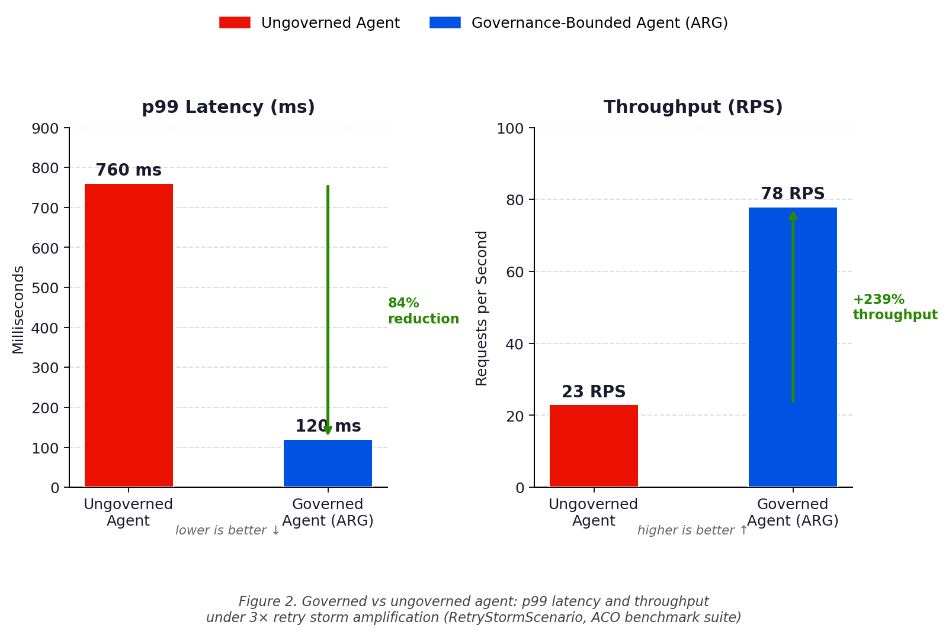
Figure 1. Governed vs ungoverned agent: p99 latency and throughput under 3× retry storm amplification (deterministic retry storm simulation).
Table 1. Retry storm scenario: deterministic simulation.

Autonomic Reliability Governance: governing automation itself
The notion that systems can manage themselves is not new; IBM's autonomic computing vision articulated this aspiration over two decades ago [4]. What is new is the velocity and scope of actuation introduced by Agentic AI. Autonomic Reliability Governance (ARG) is the discipline of designing and operating bounded, auditable, and reversible automation, including agentic operational decision layers, under explicit constraints. The term “autonomic” is used here in its broader sense: self-directed operation within explicit constraints, the layer that MAPE-K (Monitor-Analyze-Plan-Execute over a Knowledge base) assumed but did not define for AI-driven actuation.
- SLO constraints: latency ceilings, availability targets, error budgets
- Cost constraints: budget caps, unit-economics bounds, runaway scaling prevention
- Compliance constraints: auditability of decisions and actions
ARG is not a product. It is an operating model that defines the conditions under which automation is permitted to act, not merely the automation itself. ARG treats operational actuation, human or agentic, as a first-class risk surface with explicit safety envelopes.
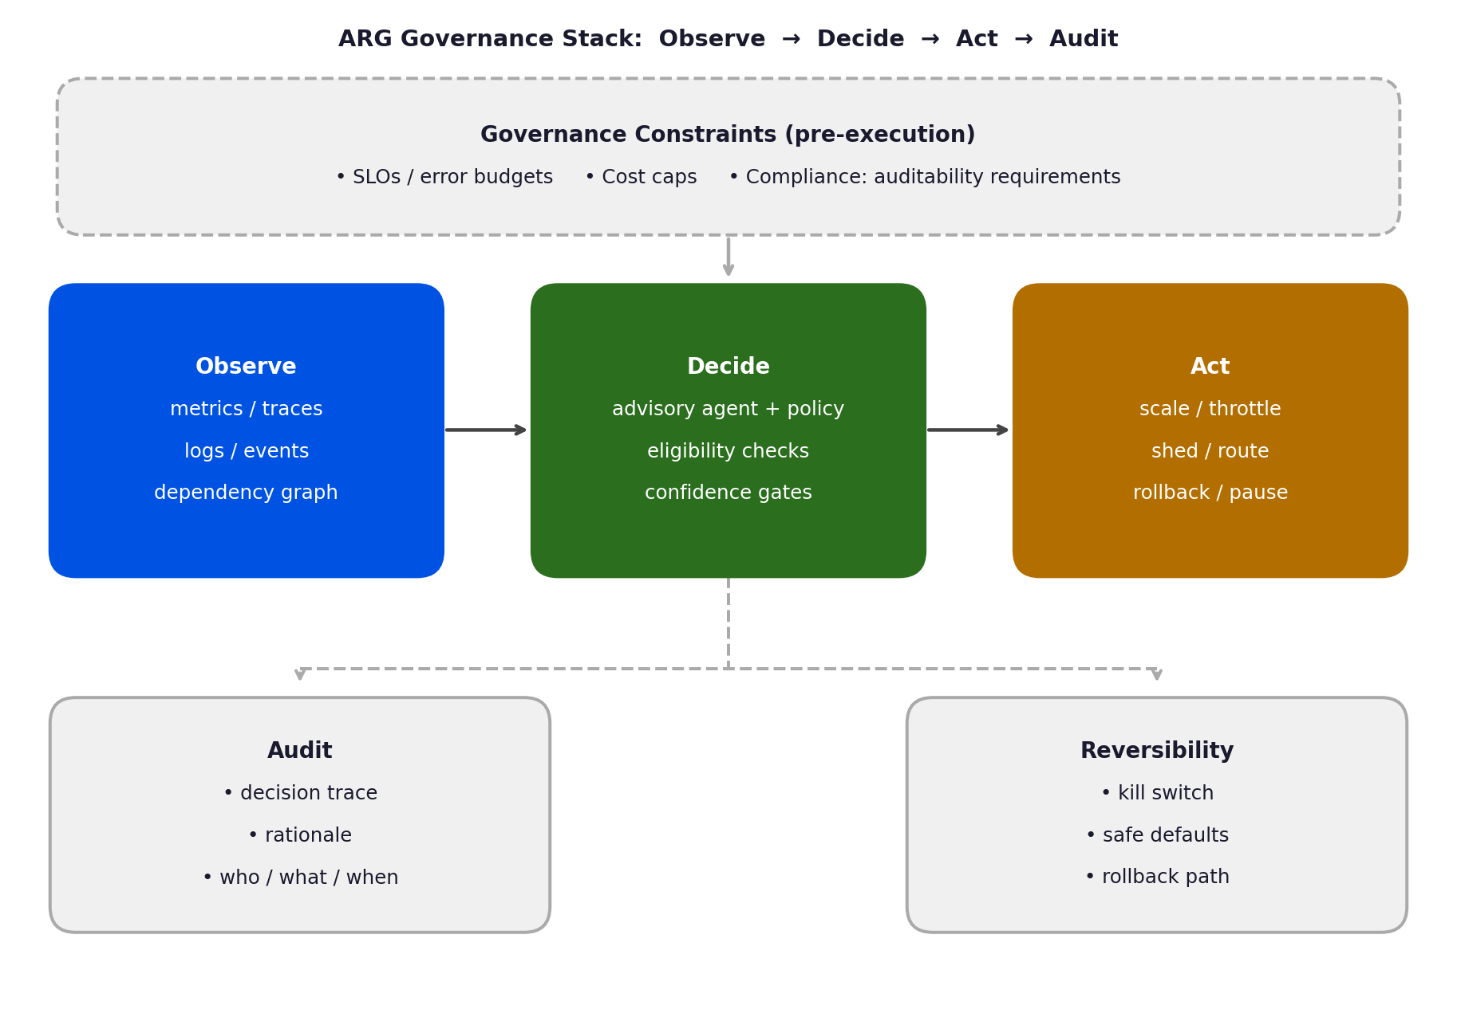
Figure 2. ARG governance stack: Observe → Decide → Act → Audit, with pre-execution governance constraints and mandatory audit and reversibility paths.

ARG is not a replacement for existing reliability practices; it is an extension of them to a layer they were not designed to govern. SRE change-management and progressive delivery govern human-initiated deployments; ARG governs autonomous agent decisions made in milliseconds during live incidents. Autoscaling guardrails constrain one specific mechanism; ARG constrains the full decision graph of an agent acting across multiple services simultaneously. Policy-as-code enforces structural constraints at deployment time; ARG enforces operational constraints at execution time, with real-time confidence gating and reversibility requirements. RBAC controls who may act; eligibility tiers control what automation may do and under what conditions. Each existing practice remains necessary. ARG addresses the layer none of them reach: autonomous decision-making at agent speed.

Governance primitives: what makes agentic operations safe
ARG becomes real when implemented through governance primitives that align with existing reliability practice (SLOs, error budgets, progressive rollout) while controlling actuation velocity and blast radius. Each primitive does one job and can be configured or replaced independently; together they compose a complete governance policy.

1) Actuation budgets: rate-limit the changes, not only the traffic
Most systems rate-limit user requests. Few rate-limit operational change. ARG introduces actuation budgets; limits on how frequently high-impact actions can occur. Scaling shifts, retry escalations, routing changes, and configuration flips consume tokens from a constrained budget. When the budget is exhausted, automation may still observe and recommend, but it cannot repeatedly perturb the system. When instability rises, slow the actuators before adding more intelligence.
# Example: actuation budget policy
actuation_budget:
max_changes_per_window: 3
max_parameter_shift_pct: 25
window_seconds: 300

confidence_gate:
min_score_low_risk: 0.75
block_without_rollback_path: true
These defaults reflect conservative starting values. Teams should calibrate them iteratively against their own operational history.

2) Blast radius governance: Scope every action
The difference between a safe fix and an outage multiplier is often scope. ARG constrains blast radius using canaries, segmentation (cells/regions), tiered permissions, and scoped rollouts with automatic halt conditions. Even correct actions can be wrong if applied globally in one step. Autonomy must always be localized before it is generalized.

3) Advisory-first agents and progressive autonomy
In high-stakes systems, autonomy should grow in steps. Starting in observe-only mode, the system progresses through advisory (recommendations only, human decides), auto-governed (low-risk actions within confidence thresholds), and fully policy-governed modes (all actions checked against rules and change budgets before execution). Progression between modes is a deliberate operator decision.

4) Eligibility tiers: Action-based permission models
Autonomy must be governed by explicit action tiers:
- Observational: detection and diagnosis (always allowed).
- Low-risk reversible actions: scoped and rollback-capable.
- Medium-risk actions: require high confidence and strict guardrails.
- High-risk actions: require human approval.
Autonomy becomes measurable when agents must “graduate” across tiers based on demonstrated safety. Unlike role-based access control which classifies who may act; eligibility tiers classify which actions may be automated. A concurrency adjustment reversible in milliseconds occupies a different tier than a schema migration that cannot be undone.

5) Confidence gates and evidence before execution
Agents should act only when evidence crosses defined thresholds:
- sufficient telemetry completeness
- credible dependency attribution
- system stability signals
- reversibility guarantees
- bounded failure domain
If uncertainty is high, remain advisory.

6) Auditability: Decision trace as first class artifact
Governed autonomy requires structured decision records:
- what was observed
- what was concluded (with uncertainty)
- what constraints were evaluated
- what action was taken or recommended
- what was expected
- what occurred
- how it can be reversed
Auditability is not bureaucracy. It is what enables learning, compliance, and safe expansion of autonomy.

7) Reversibility: Design for wrong decisions
Every operational action must have an undo path. Rollbacks, kill switches, and safe defaults are mandatory. Governance does not prevent all mistakes; it ensures failures remain bounded and recoverable. The reference implementation enforces actuation limits and rollback requirements as pre-conditions: the agent recommends; the governance layer decides whether it may act.
Governance itself can fail. Thresholds set too conservatively keep the system advisory when it should act; escalation paths create bottlenecks when operators are unavailable during an incident. Policy constraints calibrated for normal operations may block valid interventions at the worst moment. ARG addresses this through progressive autonomy: thresholds are explicitly configurable and must be revisited as the system demonstrates stability. A governance layer that is never recalibrated can become the failure mode it was designed to prevent.
The right threshold values cannot be prescribed universally. Start with conservative defaults calibrated against historical operational data, and relax them progressively as evidence of safe agent behavior accumulates. Treat thresholds as dynamic, first-class configuration that co-evolves with the system, not fixed at deployment.

Validating governance without private company data
ARG also needs ways to test ideas without using private company data. One practical approach is incident replay. You capture common failure patterns such as latency spikes, growing queues, retry storms, or autoscaling reactions, and replay them in a simulation or controlled environment. Then you compare how the system behaves under unbounded automation versus governed policies, checking whether the changes reduce amplification or make it worse. The goal is not to perfectly recreate production, but to learn in a measurable way: does this policy dampen instability or accelerate it? This can be reinforced with controlled stability drills, such as dependency injection, brownouts, or chaos experiments [5] to ensure automation stays controlled when conditions degrade.

What changes when ARG becomes normal practice
As systems become more autonomous, reliability work will increasingly focus on governing automation itself. This means turning constraints into enforceable policies, limiting and scoping automated actions, treating audit trails as essential system outputs, and introducing autonomy gradually rather than all at once. Reliability-critical platforms are likely to adopt this approach early because reliability targets, cost limits, and audit requirements are strict, and failures are expensive. In the end, agentic operations will not succeed simply by becoming more intelligent. They will succeed by becoming more governable.

Closing: Don’t Automate Reliability; Govern Automation
Retries and autoscaling will remain foundational. AI will increasingly enter operations. The question is not whether to govern AI in operations; most teams already govern automation in some form. The question is whether that governance reaches the agentic layer, where actions are faster, broader, and less predictable than anything existing controls were designed for. Where agentic systems operate without actuation bounds, the retry storm dynamics described earlier become more likely and more severe. The simulation evidence is one instance of a general pattern, not a worst-case outlier.Teams can begin without a full ARG implementation: pick the highest-velocity agent in production, impose an actuation budget calibrated against historical operational data, and expand scope only as evidence of safe behavior accumulates. The infrastructure for safe automation already exists in most engineering organizations; what agentic operations require is the governance discipline to apply it at agent speed.

References
- K. J. Åström and R. M. Murray, Feedback Systems: An Introduction for Scientists and Engineers, Princeton University Press, 2008.
- J. Dean and L. A. Barroso, “The Tail at Scale,” Communications of the ACM, 56(2), 2013.
- C. A. E. Goodhart, “Problems of Monetary Management: The U.K. Experience,” in Papers in Monetary Economics, Reserve Bank of Australia, 1975.
- J. O. Kephart and D. M. Chess, “The Vision of Autonomic Computing,” IEEE Computer, 36(1), 2003.
- A. Basiri et al., “Chaos Engineering,” IEEE Software, 33(3), 2016.
- S. Padhi, "Agentic Cloud Optimizer," open-source ARG reference implementation, 2025, https://github.com/sibasispadhi/agentic-cloud-optimizer
- C. Perrow, Normal Accidents: Living with High-Risk Technologies, Basic Books, 1984.
- J. E. B. Moss, Nested Transactions: An Approach to Reliable Distributed Computing, MIT Press, 1981.
- H. Garcia-Molina and K. Salem, "Sagas," ACM SIGMOD Record, 16(3), 1987.

Acknowledgements and disclosures
- Grammarly for English corrections were used to assist with drafting and editing; the author reviewed, revised, and assumes full responsibility for the final content.
- All examples and scenarios in this commentary are generalized and illustrative; they do not contain or disclose any proprietary or confidential information from any employer, customer, or organization.

