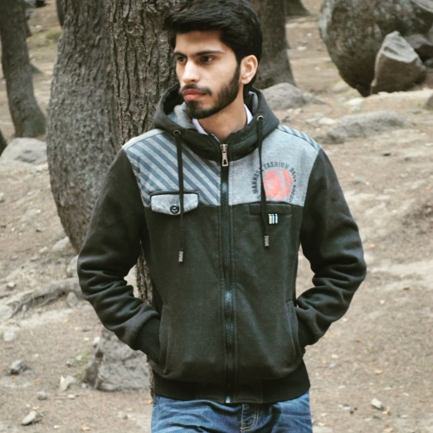
Certifications:
N/A
IN PROGRESS
Bachelor of Science
in Computer Science

BACHELOR DEGREE
WEB PROGRAMMER
Since 2019
WEB DEVELOPER
Dear Hiring Manager my name is SibghatUllah. I'm a front-end web developer. I'm an undergraduate student and I'm looking for a project. I have build many websites and I'm very passionate about my work, very much competent with, HTML5, CSS3, JavaScript, JQuery and React. I can convert any type of PSD design to web using these languages. Key contributor to startup company’s fast evolution from selling one niche product to offering a full solutions suite marketed to the global financial services industry.
Helped build and enhance highly available, scalable, real-time and secure systems used by customers worldwide.
Completed eight major projects, working closely with agile development team to develop, test and maintain Web- and desktop-based software applications.
Adhered to high-quality development standards while delivering solutions on-time and on-budget.
Collaborated in a team-focused
environment providing software solutions to diverse industry clients.
LANGUAGE
ENGLISH
URDU
PUNJABI
SKILLS
Attentive listening and effective
oral communication skills
Great at Problem Solving
Good Leadership Skills
Critical Thinker
Ability to quickly create and
apply ideas and solutions
2019 to 2020 |Iplex ,
Nawal Global Systems
Html5
Css4/Flexbox
Scss
Bootstrap
JavaScript
Jquery
React
Material UI
GitHub

House# 7D Block #10 Shah Faisal Colony RWP
sibbi166@gmail.com
WEB DEVELOPER
Date of Birth: May 31, 1999
Age: 21
Gender: Male
Birth Place: Islamabad
03155035206
Movies
Football
Cricket
Online Games
Problem Solving
Physical Activities

To be able to work for an encouraging and stable company that will assist me in developing, improving, and obtaining the necessary skills in order to become the best engineer possible.

ABOUT ME
CONTACT
INTERESTS
HOBBIES
EXPERIENCE
TECHNICAL
PROFICIENCIES:
EDUCATION
CAREER OBJECTIVE
SIBGHATULLAH uUllahULLAH

