CMPT 742: Practices in visual computing I
Assignment 2
Image segmentation
Sibei Zhou (301416917)

- Default Parameters + Horizontal/Vertical flip
Data augmentation strategies: Horizontal/Vertical flip
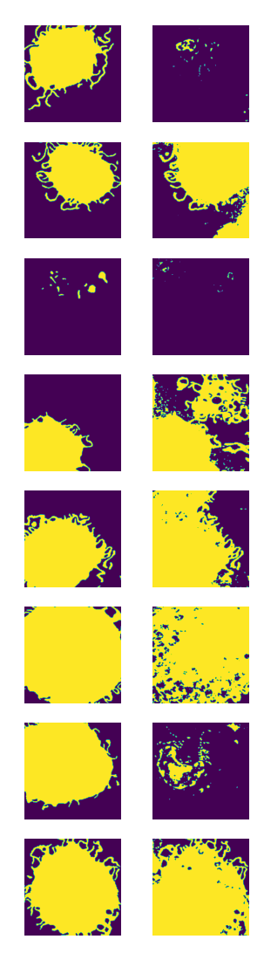
Size of the images: 572 Result:
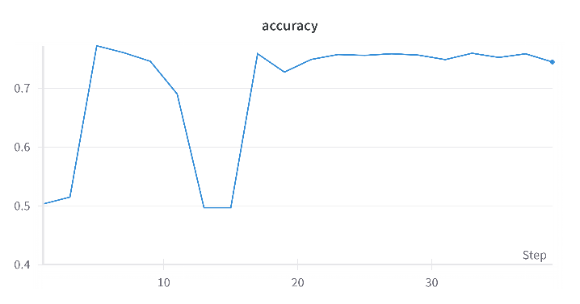
Number of Epochs: 20
Batch size: 4
Learning rate: 0.01
Times taken: 2m 27s
Final accuracy: 0.74458
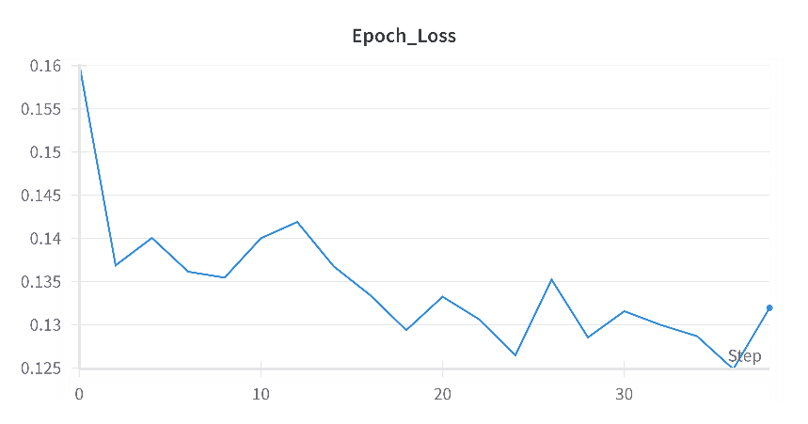

Train loss:

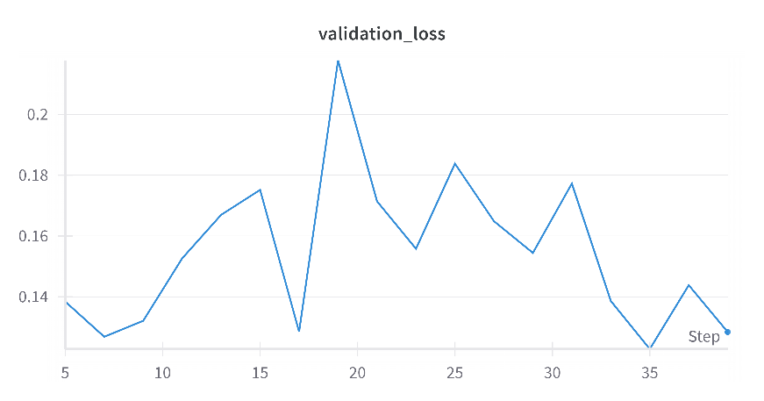

Test loss:

- Default Parameters + Rotation
Data augmentation strategies: Rotation
Size of the images: 572 Result:
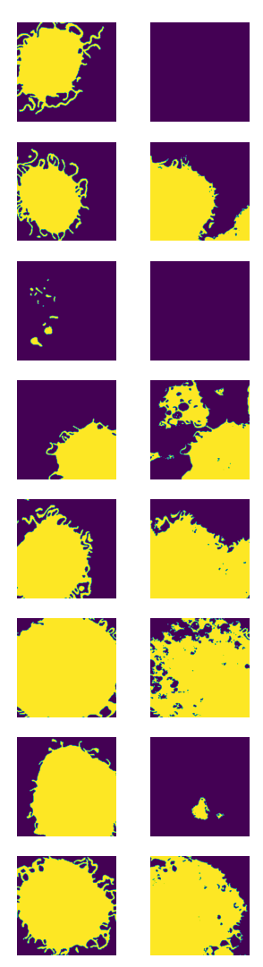
Number of Epochs: 20
Batch size: 4
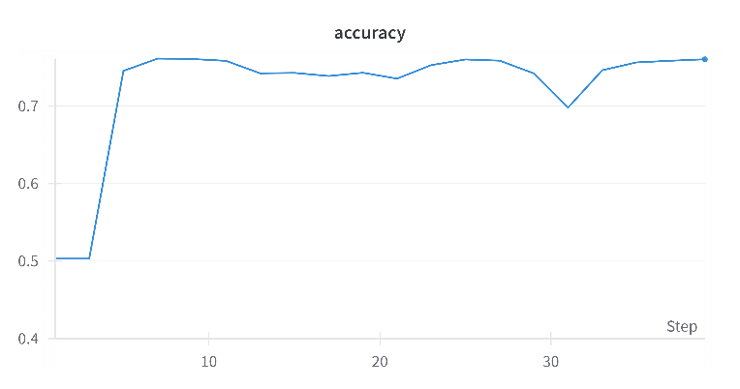
Learning rate: 0.01
Times taken: 1m 47s
Final accuracy: 0.76051

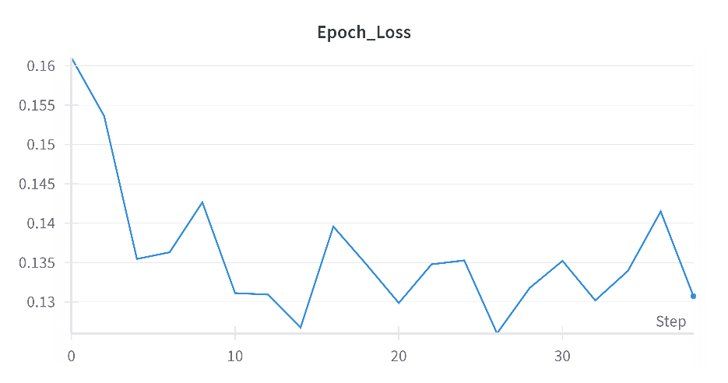

Train loss:

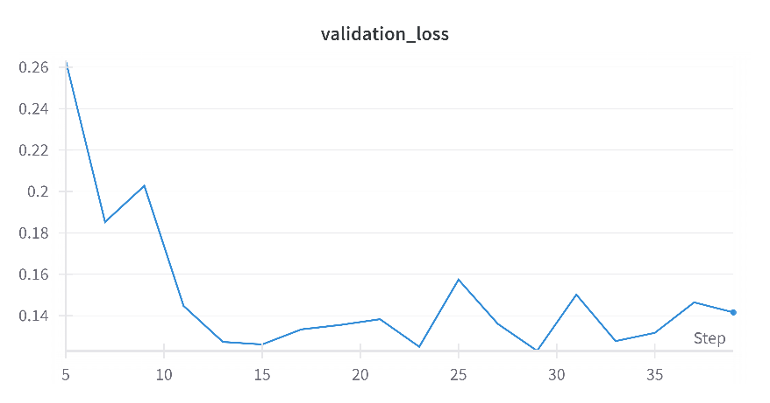

Test loss:

- Default Parameters + Gamma correction
Data augmentation strategies: Gamma correction
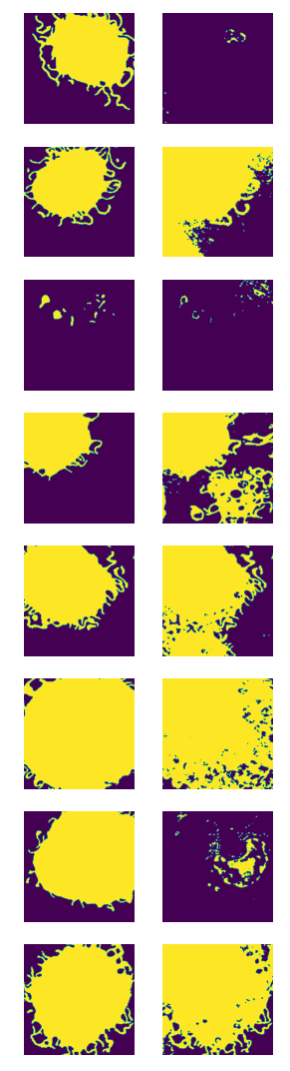
Size of the images: 572 Result:
Number of Epochs: 20
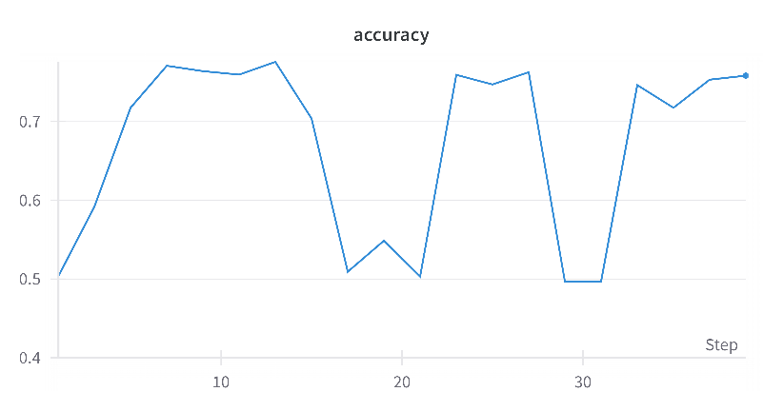
Batch size: 4
Learning rate: 0.01
Times taken: 2m 46s
Final accuracy: 0.75828

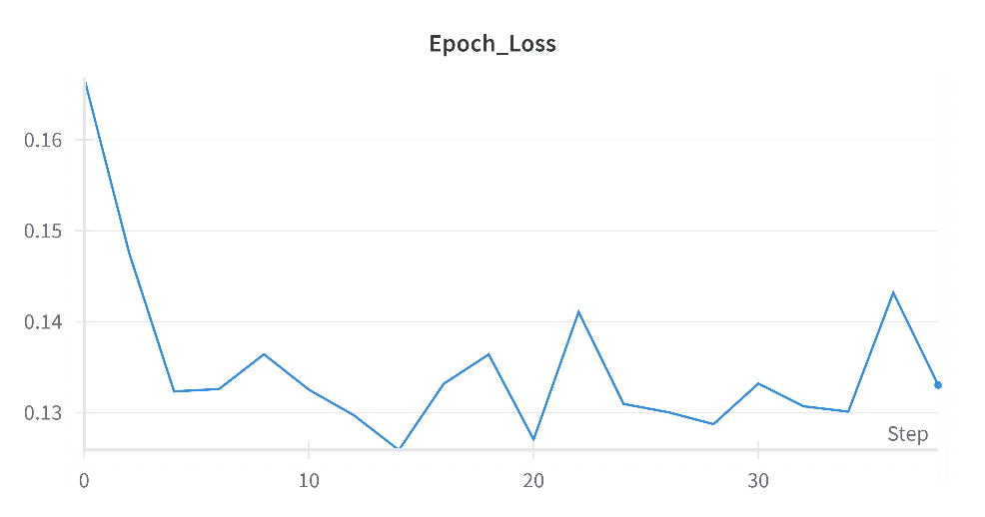

Train loss:

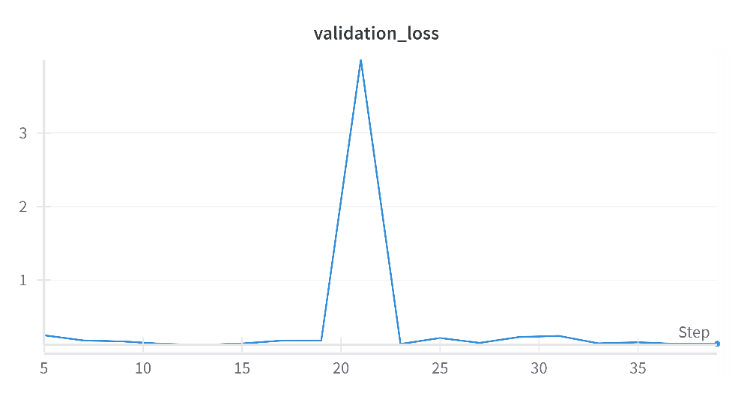

Test loss:

- Default Parameters + Elastic Transform
Data augmentation strategies: Elastic Transform
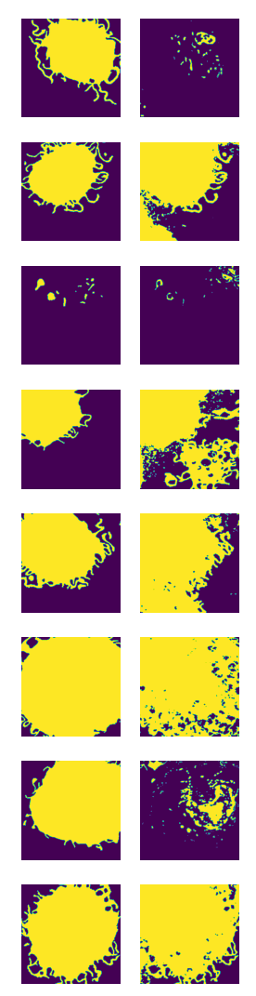
Size of the images: 572 Result:
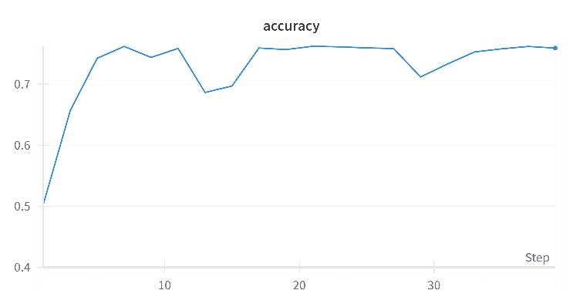
Number of Epochs: 20
Batch size: 4
Learning rate: 0.01
Times taken: 3m 31s
Final accuracy: 0.75897

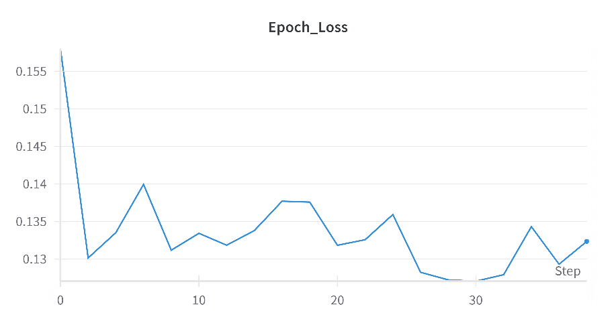

Train loss:

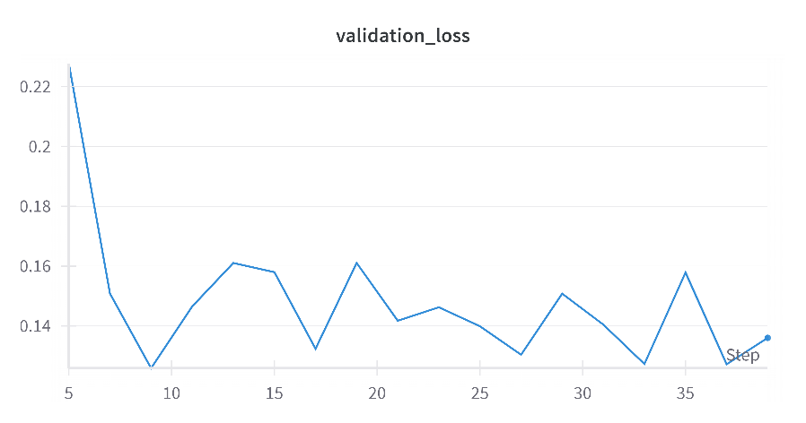

Test loss:

- Modified Parameters + Random augmentation
Data augmentation strategies: Random augmentation from all above
Size of the images: 572 Result:
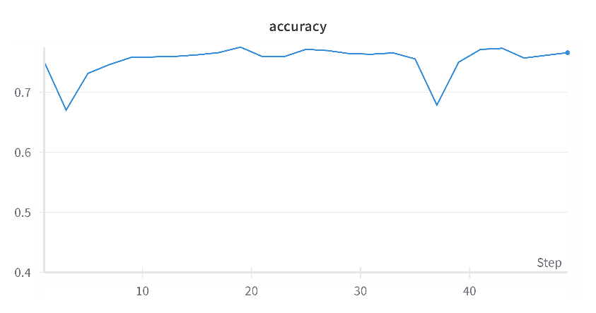
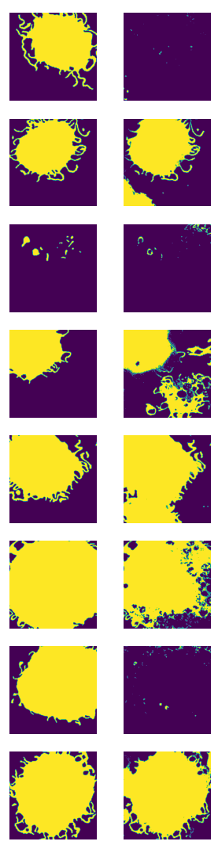
Number of Epochs: 25
Batch size: 2
Learning rate: 1e-5
Weight decay = 1e-7
Times taken: 2m 54s
Final accuracy: 0.76612
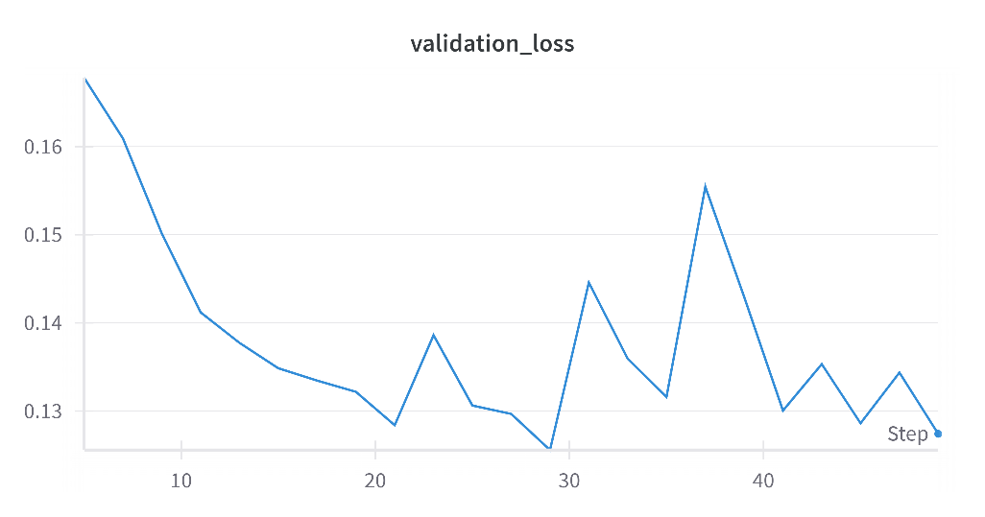

Train loss:

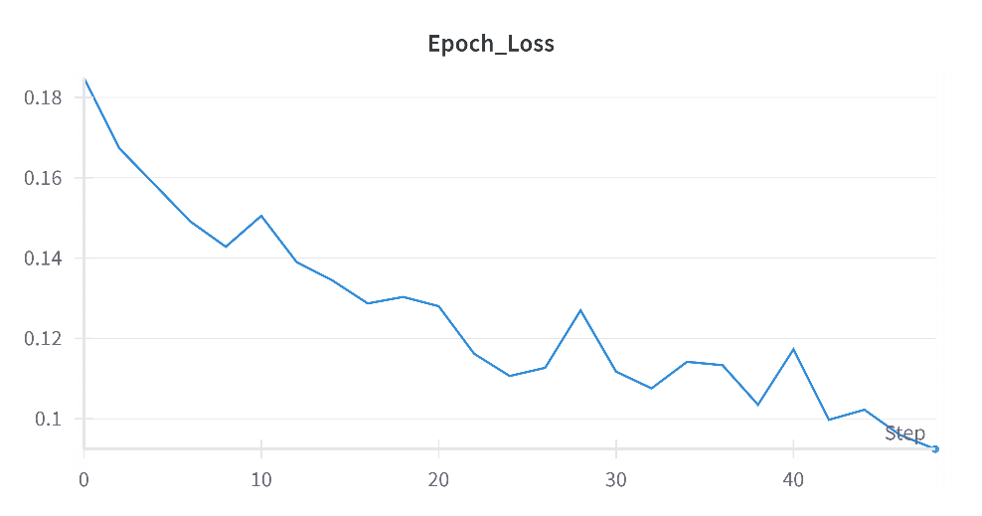

Test loss:

- Modified Parameters + Random augmentation
Data augmentation strategies: Random augmentation from all above
Size of the images: 572 Result:
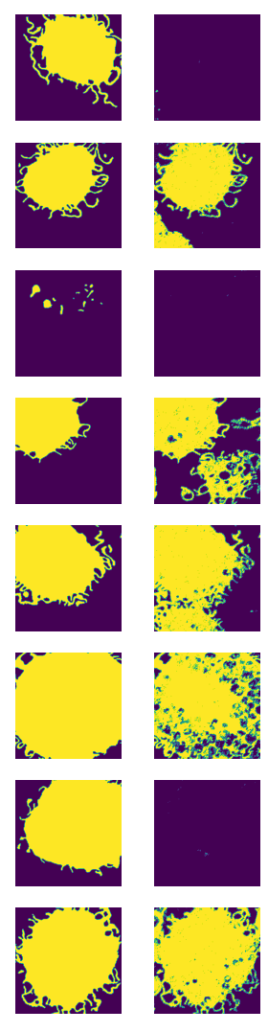
Number of Epochs: 30
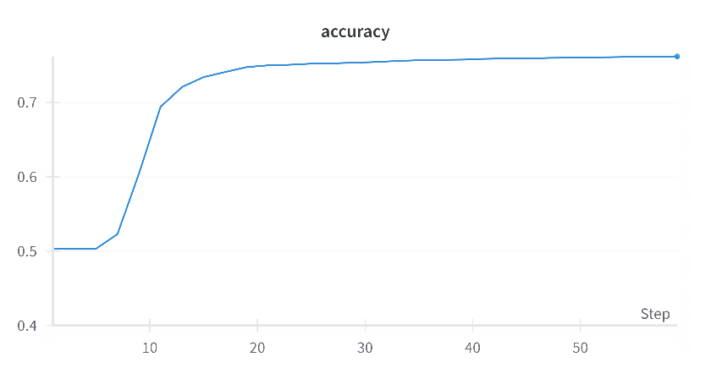
Batch size: 2
Learning rate: 1e-6
Weight decay = 1e-5
Times taken: 4m 16s
Final accuracy: 0.76204

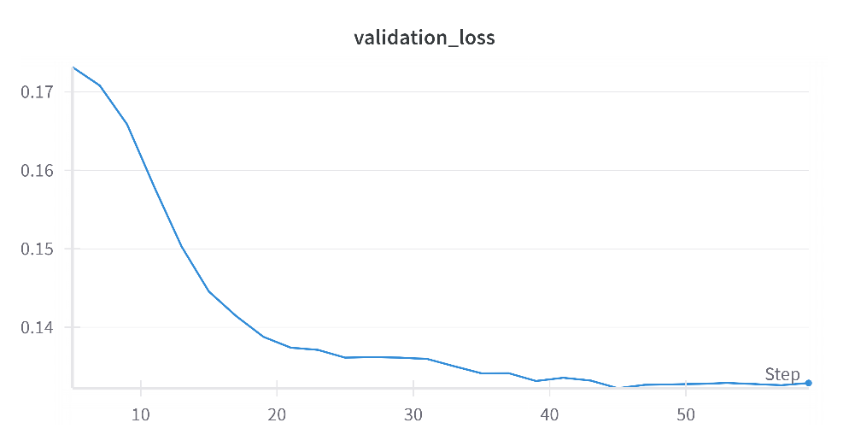

Train loss:

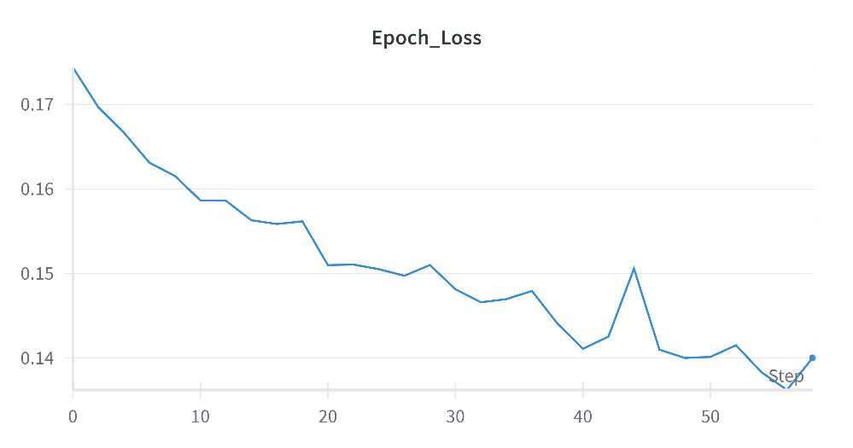
Test loss:

Compare all results with weights and biases:
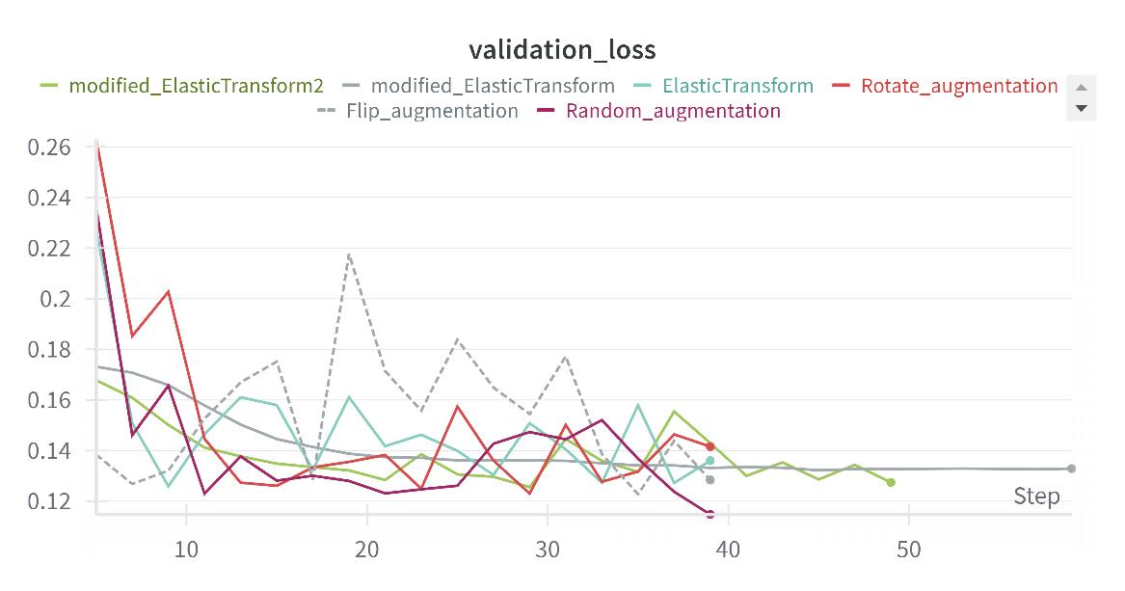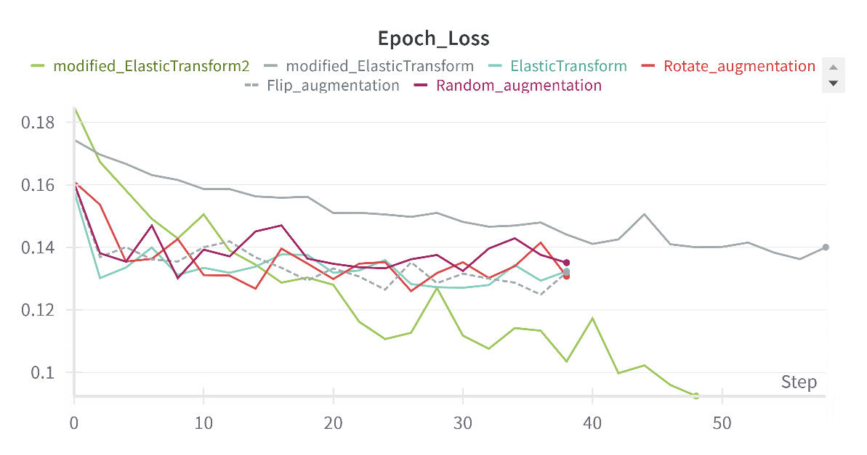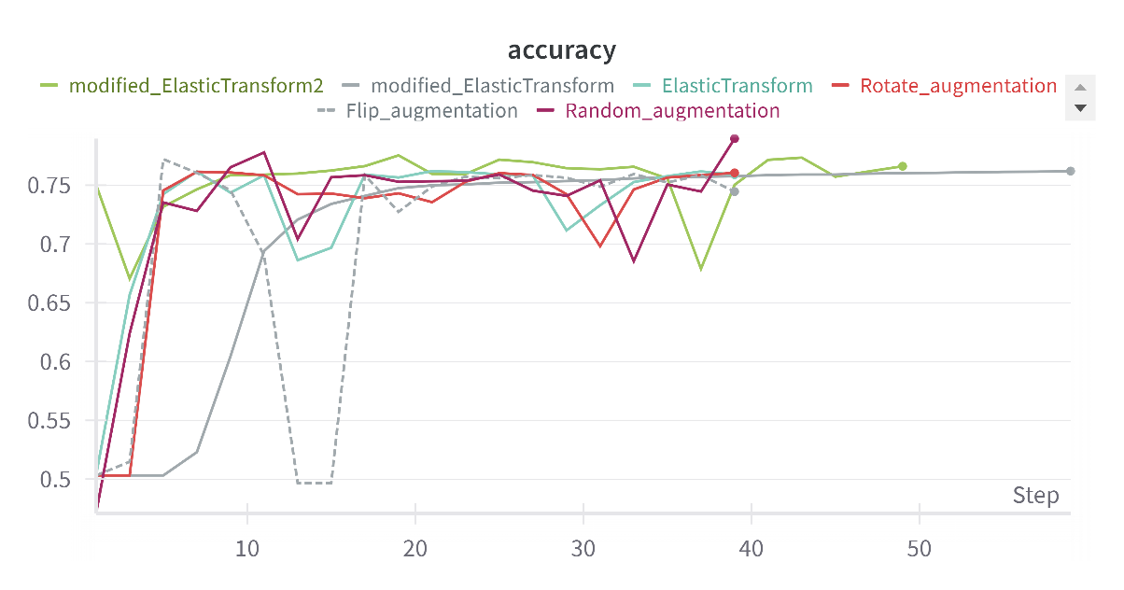
All above is done by Oct. 27, and I tried different methods including changing he parameters, modified the data augmentation strategies, and using different optimizer (Adam and SGD with scheduler, and their combination), and some deviate from the original architecture, but the accuracy still stays around 76-78%.
On the last day, I looked at the output test images carefully. The errors usually occurred in the first, third, and seventh images, which got blank masks.

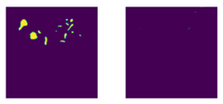


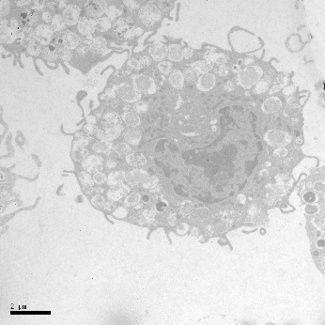
I originally thought that this was because the model was overfitting in the training set, but when I looked at the corresponding images in the test set, they had one thing in common: lighter colors/low grayscale values.
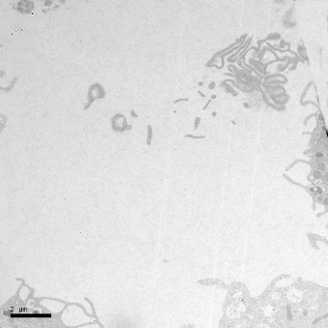
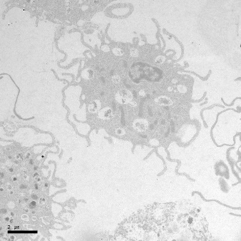

So, I performed data preprocessing (histogram equalization) in the data loader, which greatly improved the accuracy, and the final result was:
- Modified Parameters + Random augmentation + Histogram
Data augmentation strategies: Random augmentation from all above
Size of the images: 572 Result:
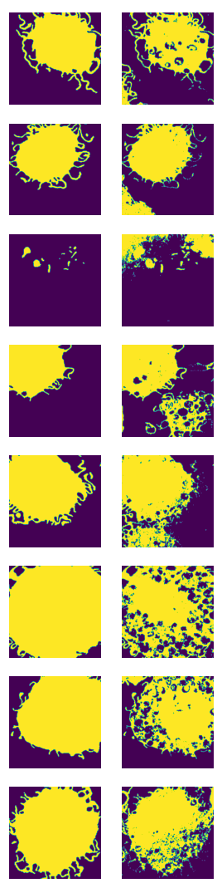
Number of Epochs: 25
Batch size: 2
Learning rate: 1e-6
Adam weight decay = 1e-5
SGD weight decay = 1e-4
Scheduler = StepLR(step_size=10, gamma=0.9)
Dropout rate= 0.2
Times taken: 2m 47s
Final accuracy: 0.85663
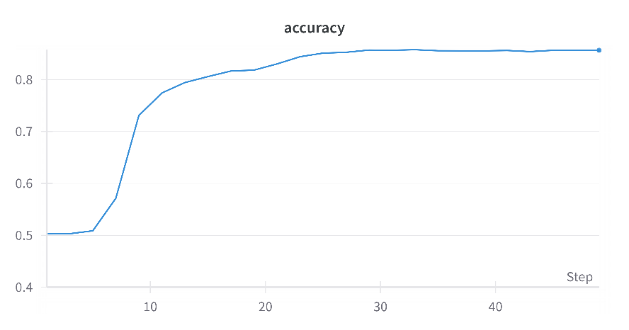

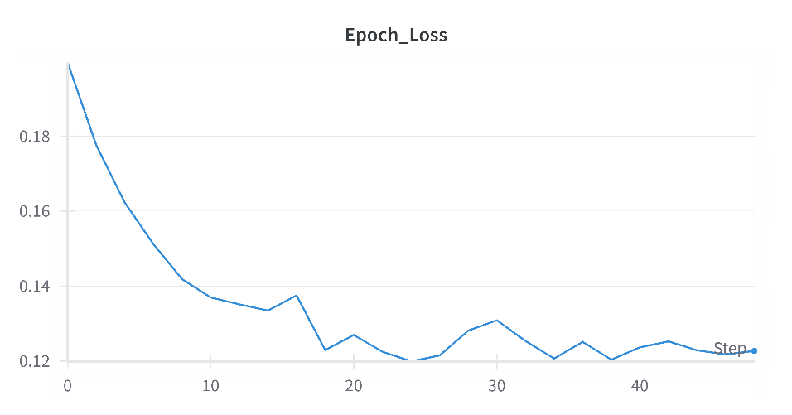
Train loss:

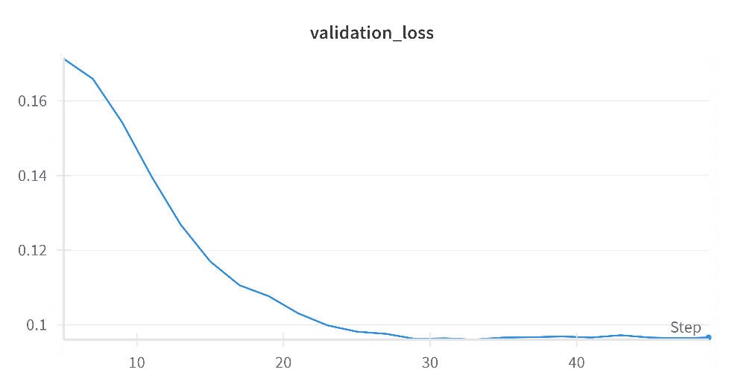
Test loss:

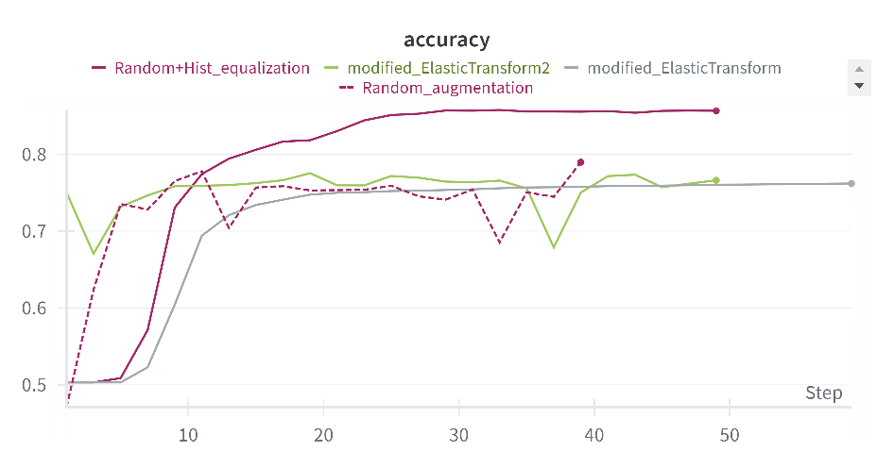
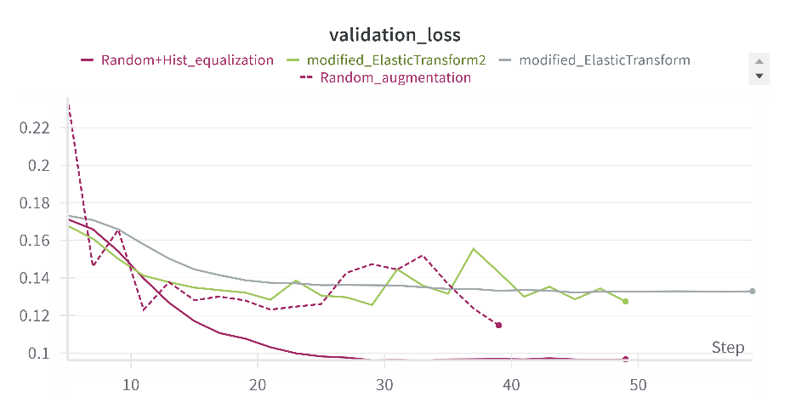
And again, compare it to the best 3 results with weights and biases:
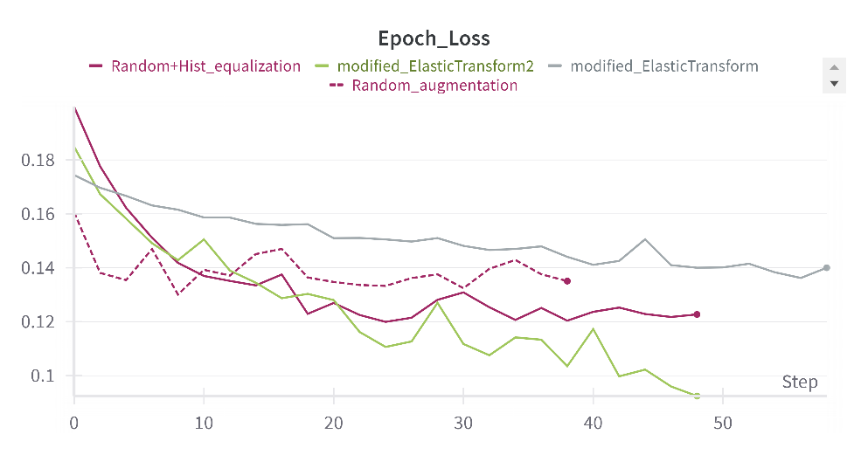
Obviously, after adding the preprocessed, the model got better performance on the accuracy and test loss.

