CMPT 742: Practices in visual computing I
Assignment 3
Object Detection with SSD
Sibei Zhou (301416917)

- Results of my model
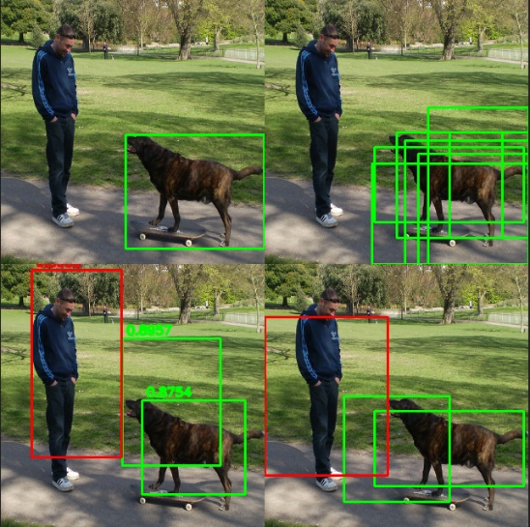
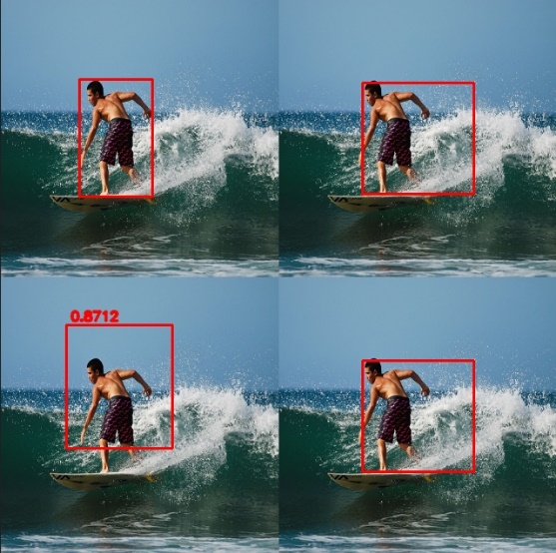
Part of results with training data:
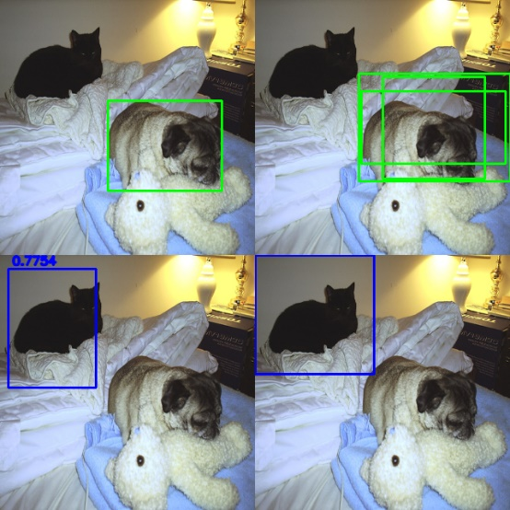
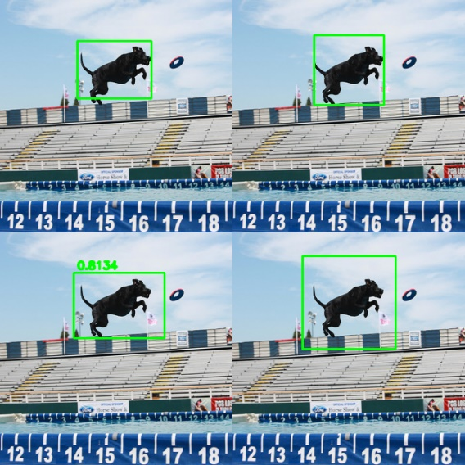
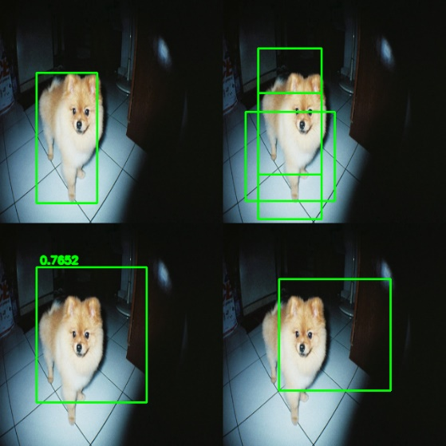
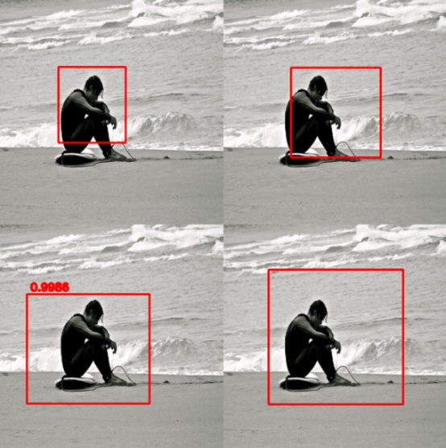

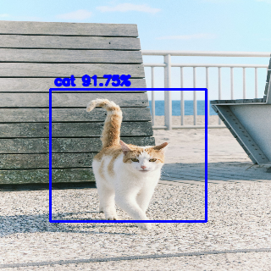
And the results of 10 images I chose:
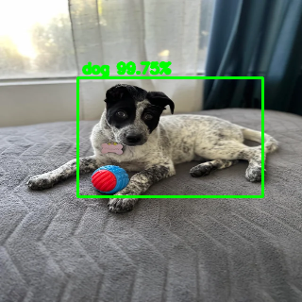

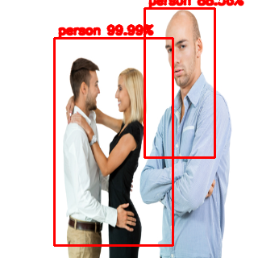
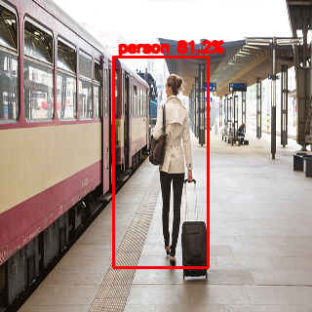

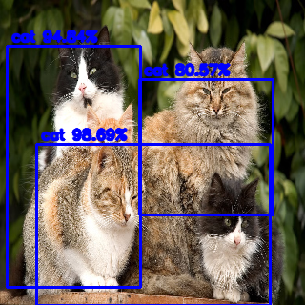
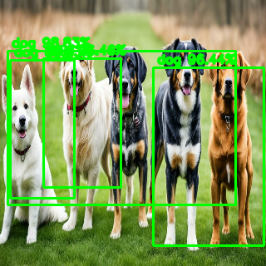

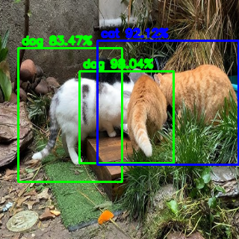
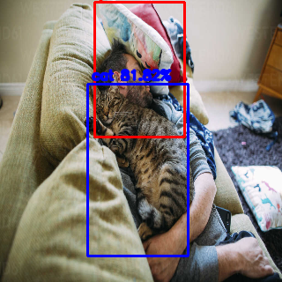
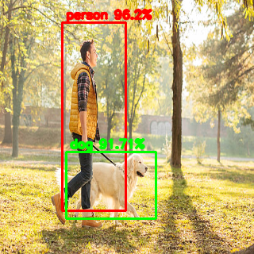
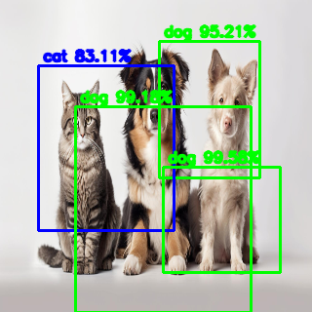
- Where and why does your model work and not work on the images you chose?
My model performs well in detecting images with a single person or a single animal (cat/dog). However, when there are multiple individuals of the same class in the image (e.g., more than one cats or dogs), the bounding box positions often become significantly inaccurate, and it may even merge two individuals into one. When multiple individuals of different categories appear in the same image, the model sometimes performs well, but it occasionally confuses cats and dogs. Despite these issues, the detection accuracy for people remains relatively high.

- What can be done to improve the results?
- Add different weights for different classes when calculating SSD_loss, improve the weights of the cat and dog classes:
class_weights = torch.tensor([2, 2.5, 0.5, 1.0], device=pred_confidence.device)
# Object Loss
conf_obj_loss = F.cross_entropy(
pred_confidence[obj_mask],
torch.argmax(ann_confidence[obj_mask], dim=1),
weight=class_weights
) if obj_mask.any() else torch.tensor(0.0, device=pred_confidence.device)

- Add a custom component mis_class_loss to SSD_loss to penalize incorrect class predictions
mis_class_loss = 0
for class_idx in range(num_of_classes - 1):
incorrect_mask = (
(torch.argmax(ann_confidence[obj_mask], dim=1) != class_idx) & # not in that class
(torch.argmax(pred_confidence[obj_mask], dim=1) == class_idx) # be predicted wrongly
)
mis_class_loss += F.cross_entropy(
pred_confidence[obj_mask][incorrect_mask],
torch.argmax(ann_confidence[obj_mask][incorrect_mask], dim=1)
) if incorrect_mask.any() else torch.tensor(0.0, device=pred_confidence.device)

- Use another optimizer AdamW with explicit weight decay (weight_decay=1e-2)
optimizer = torch.optim.AdamW(network.parameters(), lr=1e-4, weight_decay=1e-2)

- Data augmentation, especially for those classes with fewer data
- More training data

- What is the best confidence threshold for your model for the 10 images you chose.
The best confidence threshold is around 80%.

