**CS5542 Big Data Apps and Analytics**

**LAB ASSIGNMENT #2**

**Lab Submission through the following link before 2017/2/1(W) 11:59PM.**

[**https://goo.gl/forms/L5NVqbdwBwkwK2n13**](https://goo.gl/forms/L5NVqbdwBwkwK2n13)

1. **Spark Programming:**

**Write a spark program with an interesting use case using text data as the input and program should have at least Two Spark Transformations and Two Spark Actions.**

**Present your use case in map reduce paradigm as shown below (for word count).**

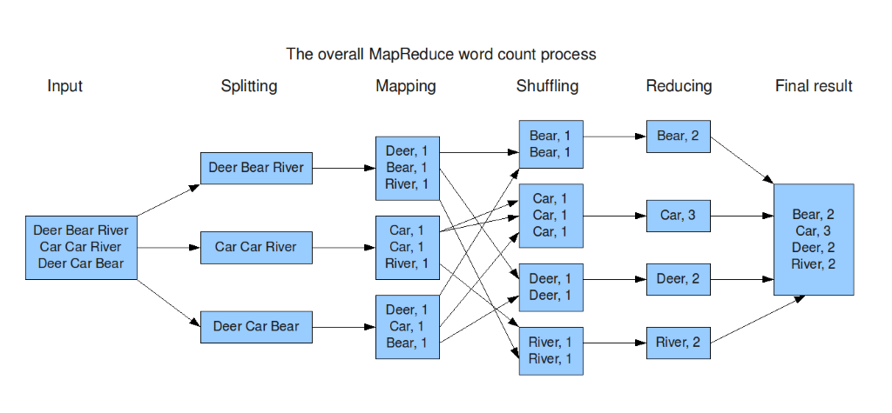

**Submit your Github project for Lab Assignments with source code, input and output data and wiki page containing the report for your lab Assignment including map reduce diagram.**