Workshop: End To End – Quiz System Fever
Workshop problem for the "JavaScript Applications" course @ SoftUni.
GitHub Resources: https://github.com/quiz-fever/quiz-fever.github.io.

Overview
Implement an application to see and manage the system for creating, managing, and completing free access tests. The app allows visitors to browse different types of quizzes. Users can register with an email, a username, and a password, which allows them to create their own quizzes. Authors can also edit or delete their quizzes at any time.

Functionality
The app should have:
- Login and Register
- Ability to view and solve quizzes by other users
- Various topics related
- Ability to filter by topic and search by title
- Statistics for each user and each quiz
- Interactive quiz editor
- Interactive UX
You should use:
- HTML, CSS, JavaScript
- lit-html, page.js
- GitHub Pages, Back4app

Implementation
Create Back4app app. You can see the documentation on Users here:
https://www.back4app.com/docs/get-started/read-and-write-data
Use Back4app for your collection:
- Sessions
- Users
{
email: String,
username: String,
password: String
}
- Quizzes
{
title: String,
topic: String,
questionCount: Number
}
- Questions
{
text: String,
answers: Array<String>,
correctIndex: Number,
quiz: Pointer<Quiz>
}
- Solutions
{
quiz: Pointer<Quiz>,
correct: Number
}

Application Requirements

Navigation Bar
Navigation links should correctly change the current page (view). The Quiz Fever link should redirect to the Welcome Screen.
A Guest (un-authenticated visitors) can see the links to the Browse page, as well as the link to the Sign-in page.

The logged-in user navbar should contain the links to the Browse page, the Create page, the Profile page, and a link for a Logout action.


Login User
The Login page contains a form for existing user authentication. By providing a username and a password, the user can log in in the system. The form should not accept any empty fields.
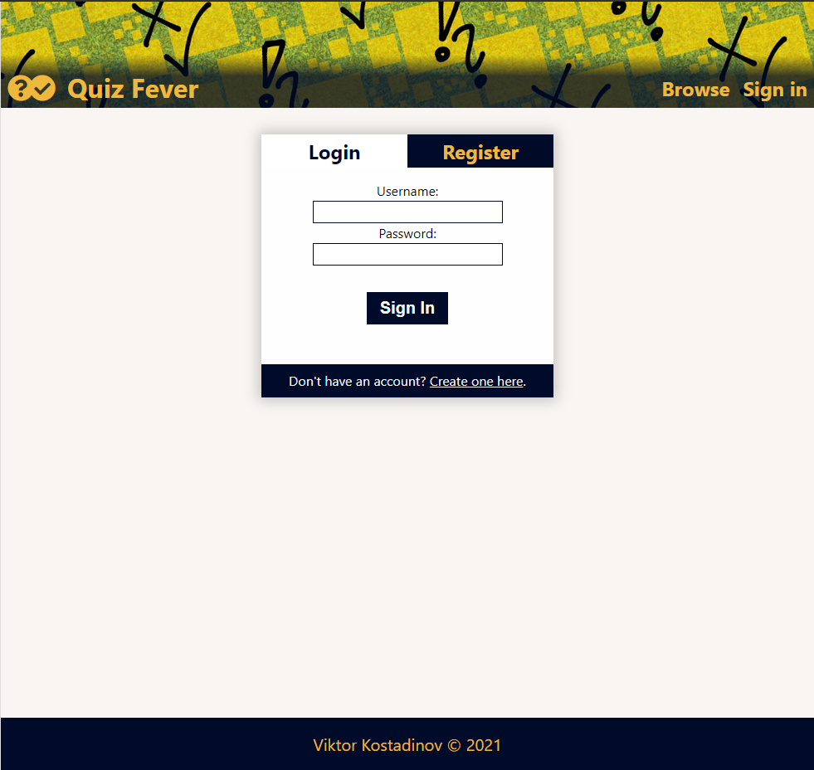

Register User
The Register page contains a form for new user registration. By providing an email, a username, and a password, the app should register a new user in the system if there are no empty fields.
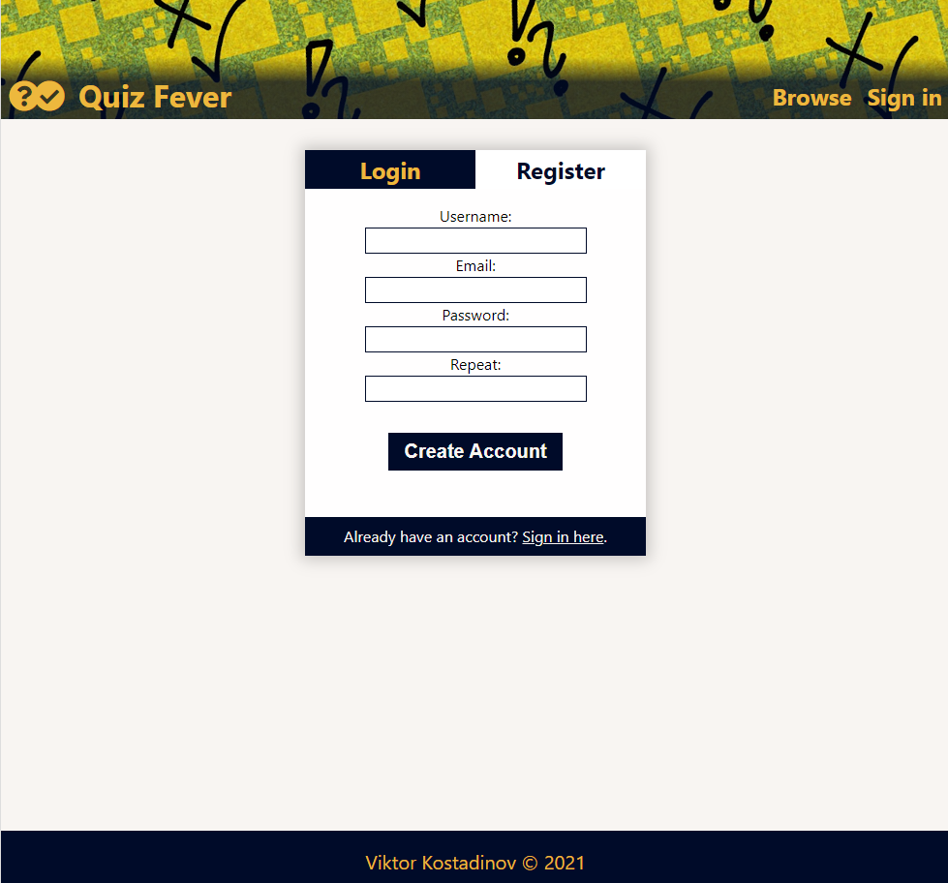

Logout
The logout action is available to logged-in users.

Welcome Screen
All users should be greeted from the loading page, where they should be able to see the most recent quizzes and button for all other quizzes.
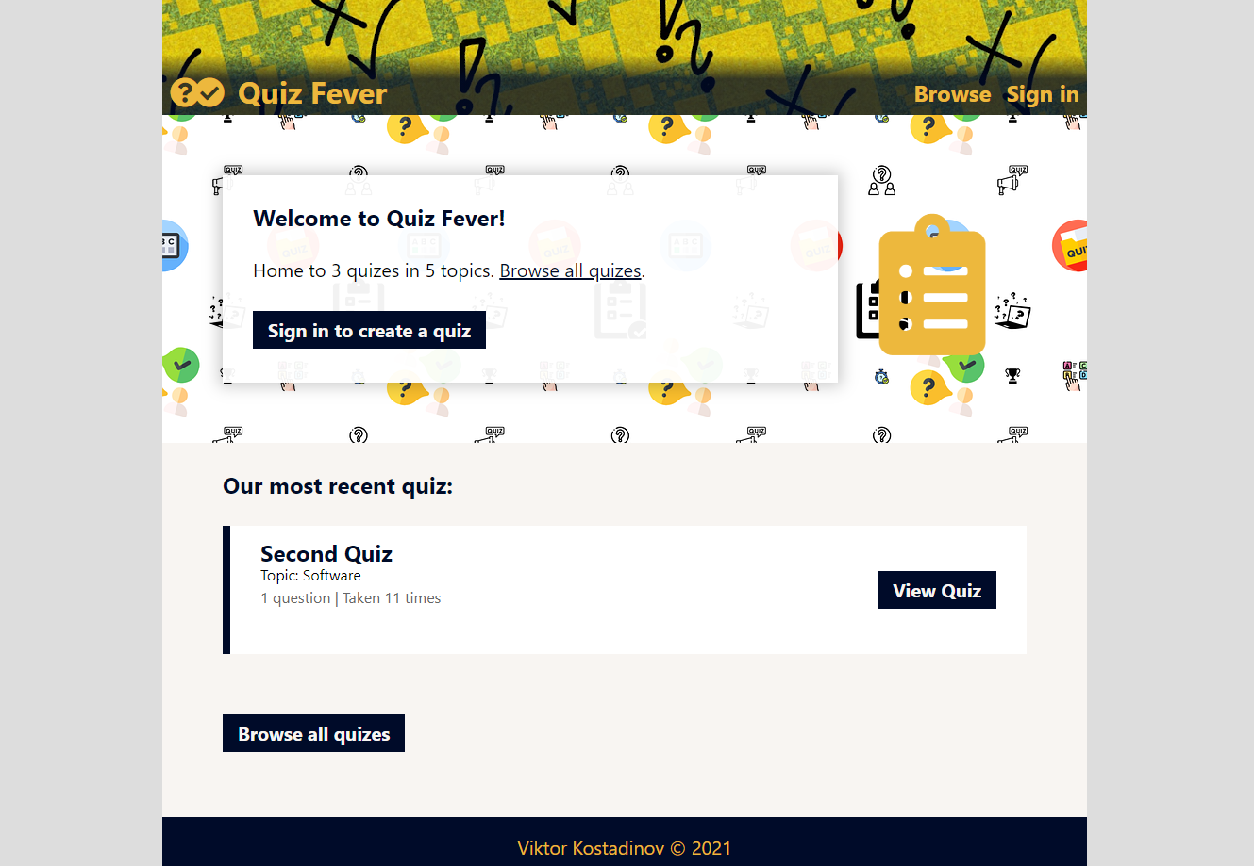

Quiz Browser
The Quiz Browser page includes a list of quizzes, and it's possible to search by titles and filter by topics. All visitors (Guests or Users) can view the catalog.
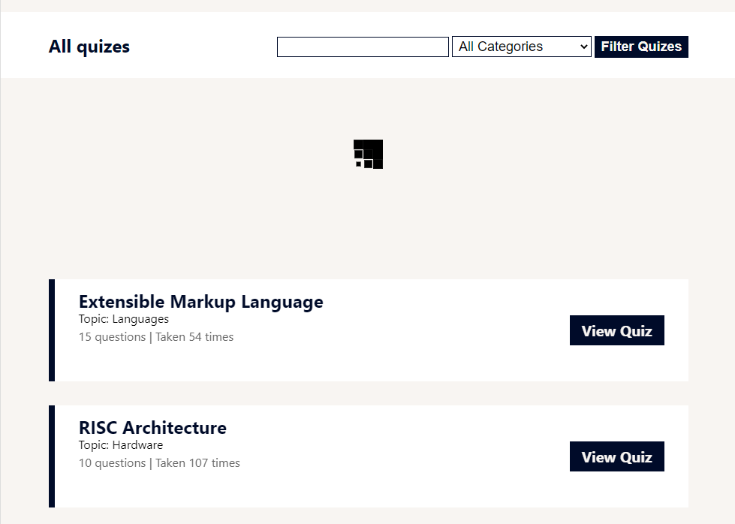

Quiz Details
The Quiz Details page contains the quiz' description, statistics, author information, and a start button. All visitors (Guests or Users) can view the details. But only Users can solve quizzes.


Quiz Contest Mode
The Contest Mode page contains questions and their answers. Every question has a separate view and an opportunity for passage from one question to another. There is a possibility to restart the test at any moment.
Only registered users can solve quizzes and view their results.
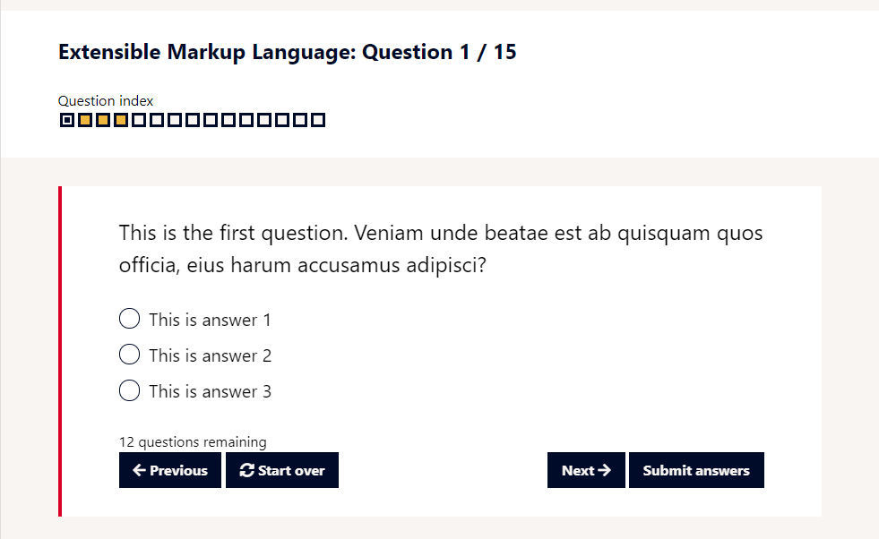

Quiz Result
The Quiz Result page contains a summary of the result and an opportunity to review the wrong questions.
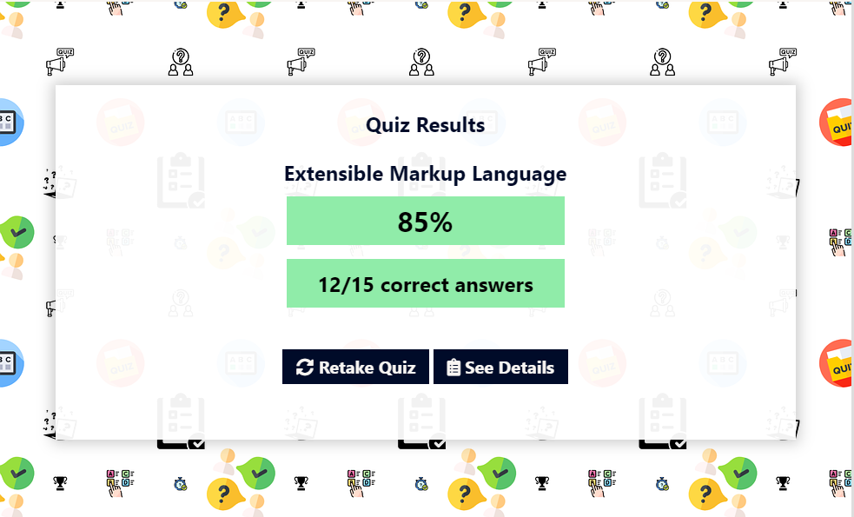
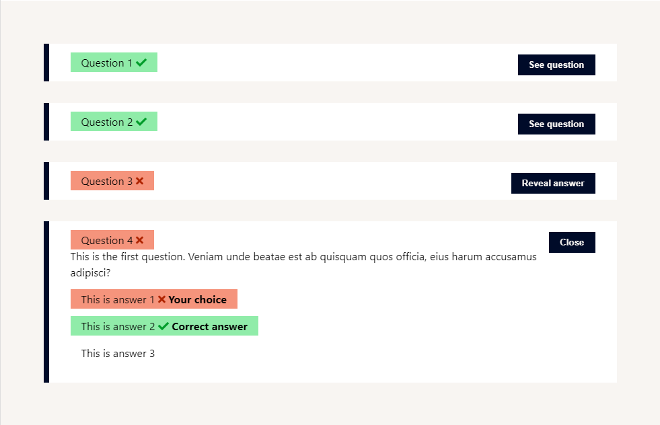

Profile Page
The Profile page holds information for all created and solved quizzes. All visitors (Guests or Users) can view creators' profile pages.
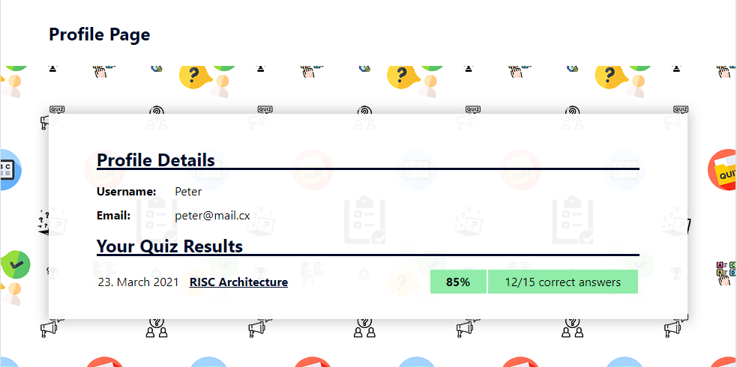
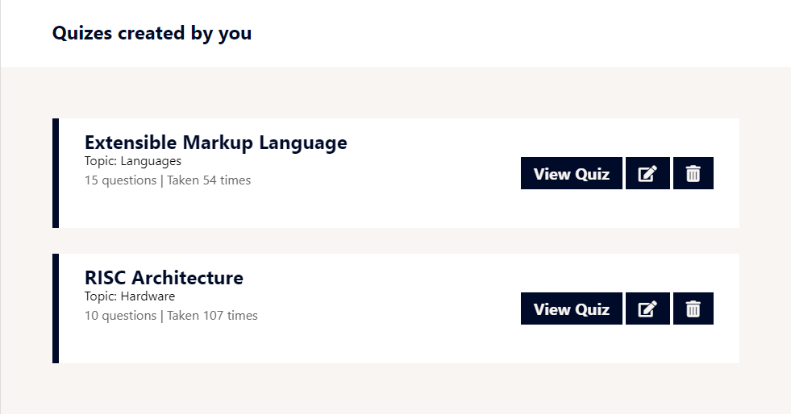

Quiz Editor
The Quiz Editor page is an integrated editor for tests, questions, and answers. Only the quiz' creator has access to this page and has the opportunity to edit and delete questions.
